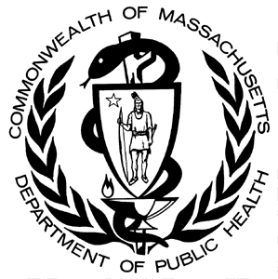
Data Brief:
Health Professions Data Series –
Registered Nurse 2014
Massachusetts Department of Public Health August 2016
The Massachusetts Health Professions Data Series: Registered Nurse 2014 Report provides data on workforce characteristics of registered nurses licensed to practice in Massachusetts. This report is part of the Department of Public Health’s Health Professions Data Series, which currently reports on seven licensed health professions: dentists, dental hygienists, pharmacists, physicians, physician assistants, registered nurses, and licensed practical nurses.
The Massachusetts Health Professions Data Series: Registered Nurse 2014 Report represents data from the third cycle of the health professional workforce data collection. This initiative was launched during the 2010 licensure renewal cycle in coordination with the Division of Health Professions Licensure.
Background
The Registered Nurse (RN) data in the Health Professions Data Series is derived from an online workforce survey that accompanies the online license renewal application for registered nurses licensed in Massachusetts (MA). RNs renew their license every two years, in even numbered years on their birthday. The data presented in this report represents the 2014 renewal cycle.
RNs who were administered a 2014 RN workforce survey:
- Registered nurses who were due to renew their license during the 2014 cycle and completed their license renewal application online through the MA Department of Public Health Online Licensing System.

RNs that were not administered a 2014 RN workforce survey:
- Registered nurses who submitted a paper license renewal application either in person or through the mail.
- Registered nurses who received their first MA RN license during the 2014 cycle and have a birthday within three months of the issue date are exempt from renewing their license during this cycle.

The 2014 RN workforce survey is administered during the online license renewal process. The survey consists of 27 questions divided into 4 sections:
- Demographics
- Education
- Employment characteristics
- Future plans

Nurses Surveyed
During the 2014 renewal cycle, a total of 91,877 RNs completed the 2014 RN workforce survey. This represents all registered nurses that renewed their RN license online and completed a workforce survey from October 2013 through March 2015.
In addition to the data collected from the RN workforce survey, the Division of Health Professions Licensure also maintains a nurse licensing database that contains information on all nurses licensed to practice in the state. This database was queried to find the total number of RNs in MA with an active license as of March 31, 2015. Both of these databases are updated in real time and the data in this report represent a point in time snapshot.
Below is a breakdown of all active RNs, those that renewed during the 2014 cycle, and those that completed a workforce survey, as of March 31, 2015:
The total number of RNs with an active MA license includes nurses maintaining their nursing license but may not be currently practicing in Massachusetts. Overall, approximately 74% of all RNs with an active MA license completed the 2014 RN workforce survey. Response rates for the workforce survey vary by age group (Figure 1). RNs in the younger and older age groups are underrepresented in the subset of nurses that completed the workforce survey.

# RNs Completed Survey | 683 | 6385 | 7823 | 8021 | 9468 | 11094 | 13408 | 15034 | 11701 | 5806 | 2454
Total # of RNs in Age Group | 3857 | 11081 | 11108 | 10028 | 11522 | 12665 | 15685 | 17658 | 15734 | 8994 | 5530

- Only 47% of RNs 30 years or younger completed a workforce survey. This group is underrepresented largely because many recent graduates that received their first RN license in 2014 are exempt from renewing their license during this cycle and therefore were not administered a survey.
- Only 57% of RNs over the age of 65 completed a workforce survey. A higher percentage of registered nurses in this age category opted to complete their license renewal application through a paper application and therefore were not administered a survey.
The data presented in the remainder of this report represents the 91,877 RNs that completed the 2014 workforce survey, unless noted otherwise.
Demographics
Figure 2 and Table 1 display the breakdown of RNs by sex and race/ethnicity, respectively. The data show that the nursing workforce in MA is predominately white (non-Hispanic) and female, with nearly 80% identifying as both. This is consistent with the RN workforce of the United States as a whole, which is 93% female and 83% white, non-Hispanic.

Table 1. 2014 RNs by Race and Hispanic/Latino Origin

Race/Ethnicity | RNs  n=86,886* | MA  Population
White, non-Hispanic (NH) | 89.8% | 75.0%
Black, NH | 4.6% | 6.4%
Asian, NH | 2.7% | 5.7%
American Indian/Alaska Native, NH | 0.3% | 0.1%
Native Hawaiian/Pacific Islander, NH | 0.1% | <0.1%
Hispanic/Latino | 1.0% | 10.2%
Multiracial | 0.5% | 0.6%
Other | 0.0% | 1.9%
Overall Diversity Index⁴ | 19.0 | 41.9
Table 1 shows the breakdown of RNs and MA residents by Race and Hispanic/Latino origin. The table indicates that several racial and ethnic groups are underrepresented in the nursing workforce. Diversity index is a measure of racial and ethnic diversity within a population on a scale of 0 to 100. A higher diversity index means there is higher racial and ethnic diversity within a group. The RN population in MA has a diversity index of 19.0 compared to the MA resident population diversity index of 41.9, indicating that the RN workforce overall is less diverse than MA residents.
* 5.4% of survey respondents declined to answer
Figure 3 takes a closer look at the percentage of practicing RNs and residents that identify as Hispanic/Latino in the five most populated cities in Massachusetts. All five of these cities have a higher percentage of residents that are Hispanic compared to the percentage of RNs that are Hispanic. These cities also have a higher percentage of black, non-Hispanic residents compared to black, non-Hispanic RNs.
Figure 4 illustrates the age distribution of all RNs in MA with an active license. This data in the figure comes from the Division of Health Professions Licensure (DHPL) and represents all licensed nurses in the state, including the ones that were not administered a workforce survey. The mean and median ages of RNs were 49 and 51, respectively.

Figure 5 displays the percent of RNs that are fluent in the three most common non-English languages spoken at home in MA.
- Over 500,000 residents of MA speak Spanish at home (8.3%), while only 4.4% of nurses are fluent in Spanish.
- Over 87% of RNs reported that they are only able to speak English.
- The most common languages that RNs in MA are fluent in are: Spanish (4.4%), French (2.0%), Portuguese (1.4%), and Haitian Creole (1.1%).
Education
Figure 6 displays the highest nursing degree attained by RNs in MA.
- Over 58% of RNs have a bachelor’s degree or higher, compared to the national percentage of 55.2%.⁸
- Over 16% of RNs have a master’s degree or higher, compared to the national percentage of 10.6%.
- 79.3% of RNs under the age of 35 have a bachelor’s degree or higher, compared to 50.1% of nurses 55 years and older.
A large percentage of RNs (10.3%) were also licensed as a Licensed Practical Nurse (LPN). Nearly 29% of RNs with an associate degree as the highest RN degree were also licensed as an LPN, compared to 7% of RNs with a bachelor’s degree or higher.

Figures 7 and 8 present data on the initial nursing degree obtained that qualified a nurse for their first US RN license. The majority of nurses obtained their RN license either through a diploma or associate degree program (Figure 7). However, Figure 8 shows that a much higher percentage of registered nurses under 35 are obtaining their initial RN degree through a Bachelor’s program or higher compared to older age groups.
Nearly 75% of RNs licensed in the state obtained their initial RN degree in Massachusetts and 23% in another US state or territory. The remaining 2% obtained their license in a foreign country.
Advanced Practice Registered Nurses
Advanced practice registered nurses (APRNs) are RNs who are authorized to engage in advanced practice nursing, such as advanced assessment, diagnosis, treatment including ordering tests and prescribing, referrals, and consultations. Figure 9 displays the breakdown of APRNs in MA by clinical categories.
- Of the 91,877 RNs that completed a workforce survey, 8,777 reported having APRN authorization (9.6%).
- 157 APRNs (1.8%) reported having more than one authorization type.
- Over 92% of APRNs reported having a master’s degree in nursing or higher.
Figure 10 breaks down nurse practitioners (NPs) by their reported certification specialty categories.
- Approximately 63% of all NPs specialize in adult or family care.
Employment Characteristics
Figure 11 displays a breakdown of the RNs that completed the workforce survey by employment status.
Figure 11. 2014 RNs by Employment Status
91,877
Total Survey Respondents
7,598
Primary Practice Location Outside of MA

11,168
Not Currently Practicing Nursing
(unemployed, retired, or employed in non-nursing field)
Full-time: 70.5%
Part-time: 23.0%
Per Diem: 8.6%
Volunteer: 0.4%

4,395
Did Not Report a Practice Location

80,709
Currently Practicing Nursing
68,716
Primary Practice Location in MA

The following data represents responses from the 68,716 nurses who reported working full-time, part-time, per diem, or volunteering in the nursing field in Massachusetts.
Primary Practice Setting
Figure 12 displays the ten most frequently reported primary practice settings. Over one-third of nurses reported that their primary practice setting is hospital-based.
Table 2. 2014 Most Frequently Reported Primary Practice Settings by Highest RN Degree
Highest RN Degree | Top 3 Most Frequently Reported Primary Practice Settings
 | #1 | #2 | #3
Diploma  (n=7,921) | Community Hospital/Inpt*  22.4% | Academic Medical Center/Inpt  13.2% | Ambulatory Care/Hospital-based  13.2%
Associate Degree  (n=20,078) | Community Hospital/Inpt  24.5% | Skilled Nursing / Extended Care  10.7% | Home Health Agency  10.3%
Baccalaureate Degree  (n=29,438) | Academic Medical Center/Inpt  23.2% | Community Hospital/Inpt  21.0% | Ambulatory Care/Hospital-based  12.6%
Master’s Degree  (n=10,670) | Academic Medical Center/Inpt  20.4% | Ambulatory Care/Hospital  13.7% | Physician Office  12.0%
Doctoral Degree  (n=350) | Academic Nursing Program  52.9% | Academic Medical Center/Inpt  17.7% | Ambulatory Care/Hospital-based  5.4%
Practice Doctorate  (n=259) | Academic Nursing Program  25.9% | Academic Medical Center/Inpt  15.8% | Ambulatory Care/Hospital-based  12.7%
* Inpt = Inpatient Setting
The breakdown of reported primary practice setting of RNs varies by nursing education levels. Table 2 shows the top three most frequently reported practice settings for each nursing degree group.
- Community Hospital/Inpatient was the most frequently reported practice setting for diploma RNs as well as nurses with an associate degree.
- Academic Medical Center/Inpatient was the most frequently reported practice setting for registered nurses with a Bachelor’s or Master’s degree.
- Nearly 80% of all RNs that reported working at an Academic Nursing Program have a Master’s degree or higher.

Primary Role
Figure 13 shows the five most frequently reported nursing roles that best describe their primary nursing positions.
- Over 58% of nurses with a Bachelor’s degree or below reported “staff nurse” as their primary role, compared to 11.7% of RNs with a Master’s degree or higher.
- “Instructor/Faculty” was identified as the primary role for 1.8% of RNs
  - Over 41% of RNs with a Doctoral degree reported “Instructor/Faculty” as their primary role.
- “Supervisor” was identified as the primary role for 2.8% of RNs.

Routine Direct Patient Care
Overall, 83% of RNs reported that they routinely provide direct patient care in their primary nursing position. Figure 14 breaks down this percentage by highest nursing degree obtained.
- Nurses with a Doctoral degree or a Practice Doctorate less frequently provide routine direct patient care compared to nurses with other nursing degrees.
- Nearly 95% of RNs under the age of 35 provide routine direct patient care compared to 79% of RNs 55 years or older.
Patient Populations Treated
Figure 15 displays the percentage of RNs that treat specific patient population groups in their primary nursing position.
- Approximately 20% of RNs reported treating all age groups in their primary position.
- The majority of RNs (93.4%) reported treating adults and/or elders.
- Excluding RNs that reported working with all age groups, 10.5% reported working specifically with neonatal/infants and 12.4% with children.
Areas of Practice
Figure 16 displays the most frequently reported areas of practice that best describe the RNs’ primary nursing position.
- Over 34% of RNs with a Doctoral degree in nursing reported “Education” as their area of practice.
- Primary care was the reported area of practice for 14.7% of RNs with a Master’s degree and 15.1% of nurses with a Practice Doctorate in nursing.
Second Nursing Position
Of the 68,716 RNs who are currently practicing in MA, 11,974 RNs reported have a second nursing position (17.4%). Figure 17 displays the most commonly reported roles in their second nursing position.
- As with the primary nursing roles, “Staff Nurse” is the most commonly reported role in second nursing position.
- Nearly 11% of RNs reported instructor/faculty as their second nursing role, compared to 1.8% of nurses for their primary nursing role.
Mental Health and Disability Training
RNs were asked what trainings they would be interested in attending regarding treating patients with disabilities and mental illness. Over 25% of RNs reported interest in training on mental illness. Other commonly requested training topics include: brain injuries (17.8%), intellectual or developmental disabilities (15.9%), mobility impairment (12.2%), deafness or hard of hearing (11.0%), blindness and low vision (8.4%), and epilepsy (7.0%).
Unemployment
Of the RNs that completed the workforce survey, 4.8% reported being currently unemployed.
Figure 18 displays the most commonly reported reasons for unemployment among RNs that completed the workforce survey. Nearly half of the unemployed RNs are 55 years of age or older (47.9%).
Future Plans
RNs were asked to report on their plans regarding their nursing practice within the next five years. Figure 19 is a breakdown of their responses.
For the RNs that reported that they were leaving the nursing field but do not plan to retire, 35% reported leaving due to dissatisfaction with job, 18% for family/personal reasons, and 11% due to the physical requirements of the job.
Geographic Distribution
Figure 20 displays a map of the RN to population ratios at the city/town level. Communities with a higher provider to population ratio are depicted in darker shades of blue, while communities with a lower provider to population ratio are in light blue. Communities where no RNs reported a primary practice location are depicted in white with red stripes.
Figure 20. 2014 Number of RNs per 1,000 Population at City/Town Level
n=68,160
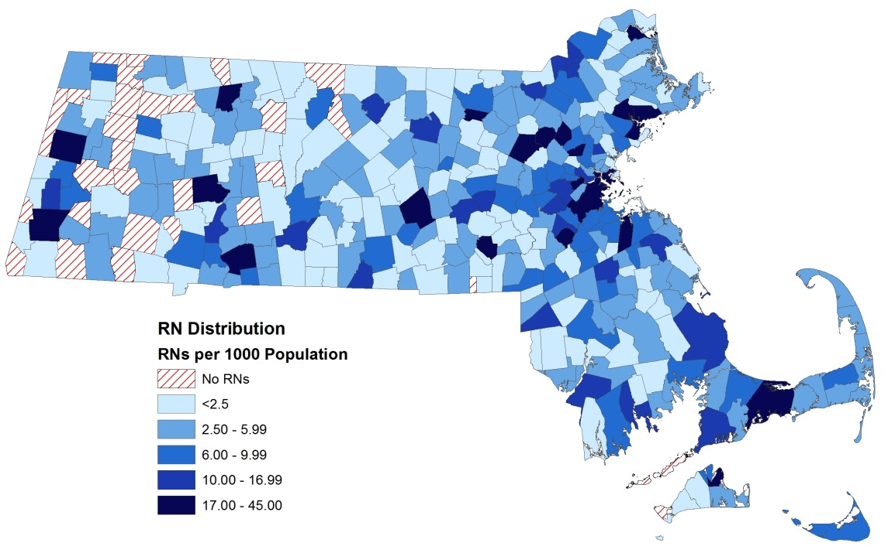

Figure 21 shows a hot spot analysis of RN to population ratios at the city/town level. The analysis identifies significant clusters of communities with high RN to population ratios (depicted in red) and low RN to population ratios (depicted in blue). Significant clusters of communities with higher RN density are located in the Boston, Metro West, and Northeast regions of the state. Clusters of communities with lower RN density are located in the Western and Central regions.
Figure 21. 2014 Clusters of Communities with High and Low RN to Population Ratios
n=68,160
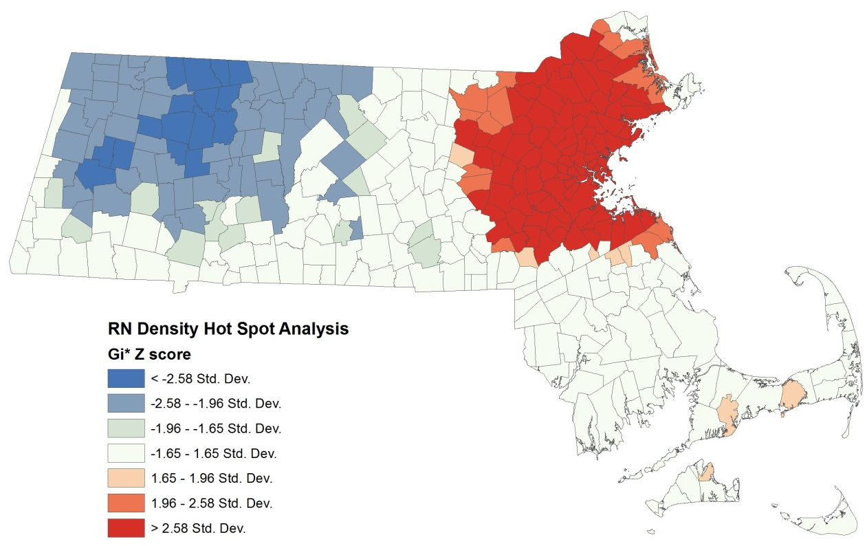
Cluster of Communities with Higher RN to Population Ratios
Cluster of Communities with Lower RN to Population Ratios

This report was developed by the
Massachusetts Department of Public Health

Bureau of Community Health and Prevention
Division of Health Access
Health Care Workforce Center

Bureau of Health Care Safety and Quality
Division Health Professions Licensure
Board of Registration in Nursing

For additional information about the Health Professions Data Series or this RN Report, please contact:

Massachusetts Health Care Workforce Center
at the
Massachusetts Department of Public Health

Website: mass.gov/dph/hcworkforcecenter
Email: HCWorkforceCenter@state.ma.us

Data from the Division of Health Professions Licensure. This is the total number of RNs with an active MA license as of March 31, 2015. This includes RNs that were exempt from renewing their license during the 2014 cycle.
2013 National Nursing Workforce Study, National Council of State Boards of Nursing
Source for resident race/ethnicity data: US Census Bureau, 2010-2014 American Community Survey 5-Year Estimates.
Diversity index is the likelihood that two persons chosen at random will differ by race/ethnicity. This is calculated by taking the sum of the squares of the percentages for each race/ethnicity category and then subtracting the total value from 1.
Data derived from DHPL nurse license database of RNs with an active license as of March 31, 2015
Source: US Census Bureau, 2010-2014 American Community Survey 5-Year Estimates
Language fluency is defined as the ability to communicate with and provide adequate care to patients without a translator
Health Resources and Services Administration: The U.S. Nursing Workforce: Trends in Supply and Education, October 2013
Percentages do not add up to 100% Respondents can be authorized in more than one clinical category.
Percentages do not add up to 100%. Respondents can choose more than one certification specialty.
Percentages do not add up to 100%. Respondents can choose more than one employment status
Percentages do not add up to 100%. Respondents can choose more than one practice settings and settings receiving fewer than 2% of responses are not represented in the figure.
The percentages displayed in Table 2 are the percent of all RNs within that education group that reported working at that particular practice setting.
Percentages do not add up to 100%. Roles that received less than 4% of responses were not included in the figure.
Percentages do not add up to 100%. RNs were able to report more than one population group that they treat. Each population category includes nurses that reported working with all age groups.
This percentage includes RNs that reported treating all age groups, but not specifically treating adults and/or elders.
Percentages do not add up to 100%. Areas of practice that received fewer than 4% of responses were not included in the figure.
Percentages do not add up to 100%. Roles that received less than 4% of responses were not included in the figure.
Percentages do not add up to 100%. Reasons for unemployment that received fewer than 6% of responses were not included.
Reported RN primary practice locations are used to calculate provider to population ratios for each city/town. The calculations do not take into account secondary practice locations.
Hot spot analysis (Getis-Ord GI*) was conducted using the fixed distance band method in ArcGIS 9.3.1.

