INDOOR AIR QUALITY ASSESSMENT

The Ralph J. Froio Senior Center
330 North Street
Pittsfield, Massachusetts 01201



Prepared by:
Massachusetts Department of Public Health
Bureau of Environmental Health
Indoor Air Quality Program
October 2008

Background/Introduction
At the request of Mr. Calvin Joppru, Senior Code Enforcement Inspector for the Pittsfield Health Department, the Massachusetts Department of Public Health (MDPH), Bureau of Environmental Health (BEH) provided assistance and consultation regarding indoor air quality concerns at the Ralph J. Froio Senior Center (RFSC) located at 330 North Street, Pittsfield, Massachusetts. The request was prompted by occupant complaints of air quality conditions within the building. On April 23, 2008, a visit to conduct an indoor air quality assessment was made to this building by Lisa Hébert, Regional Inspector in BEH’s Indoor Air Quality (IAQ) Program.
The RFSC is a three-story brick building containing a full basement. The building was constructed in the 1920s, for use as the Capitol Theatre, a 1,350 seat movie theater. The 15,000 square foot building closed in the 1980s, and fell into severe disrepair. In 1993, after extensive renovation, the building re-opened as the Ralph J. Froio Senior Center. The footprint of the building is roughly rectangular in shape. The marquee remains on the front of the building (Picture 1). The RFSC offers many services to Pittsfield’s residents, including woodworking and ceramics shops, arts and crafts, a billiards room, a computer lab and meals are prepared in one of two kitchens in the facility.
The building was previously evaluated by ATC Associates in April 2008. To address issues found at RFSC, ATC Associates listed the following corrective actions:
- improve the air circulation pathway in the building by facilitating the movement of air from offices to the return;
- set the air handling unit to “fan on” position when the building is occupied;
- prevent idling vehicles when dropping off passengers;
- review housekeeping methods;
- HEPA vacuum the building;
- review MSDS sheets to determine possible sources of VOCs found within the building; and
- consider re-arranging the timing of the opening and closing of the rear doors so that the outside door closes before the inside door opens.

Methods
Air tests for carbon dioxide, temperature and relative humidity were taken with the TSI, Q-TRAK,™ IAQ Monitor, Model 8551. Air tests for airborne particulate matter with a diameter less than 2.5 micrometers were taken with the TSI, DUSTTRAK™ Aerosol Monitor Model 8520. Screening for total volatile organic compounds (TVOCs) was conducted using a RAE Systems, MiniRAE 2000™ Portable VOC Monitor PGM-7600 Photo-Ionization Detector (PID). BEH staff also performed a visual inspection of building materials for water damage and/or microbial growth.

Results
The RFSC has an employee population of approximately 10 and an estimated 200-300 visitors daily. The tests were taken under normal operating conditions and results appear in Table 1. Areas where tests were taken are described in Table 1 by room/office function or occupant’s name.

Discussion
Ventilation
It can be seen from Table 1 that the carbon dioxide levels were below 800 parts per million (ppm) in all 21 areas tested, indicating adequate air exchange in all areas surveyed. It is important to note that several rooms had open windows and/or were empty/sparsely populated; each of these factors can result in reduced carbon dioxide levels. Carbon dioxide levels would be expected to increase with full occupancy and with windows closed.
An air handling unit (AHU) located within the first floor ceiling plenum provides air to the first floor and basement. Fresh air is introduced by an air intake on the exterior wall of the building, located above the main entrance and below an awning covering the building entrance (Figure 1; Pictures 2 and 3). Fresh air is distributed to occupied areas via ceiling-mounted air diffusers (Picture 4). Return air is ducted back to the AHU via ceiling-mounted return vents located in the main hallways on the first floor, and in the boardroom in the basement (Map 1). Maintenance staff reported that this AHU does not exhaust air to the outdoors; rather, it re-circulates air back to each floor. It is important to note that the sole exhaust for the basement is in the boardroom; therefore, when the doors to this and surrounding rooms are closed, return air cannot be removed from the basement. Local exhaust ventilation systems exist in both the wood shop and ceramics room located in the basement. In the wood shop, the local exhaust system removes sawdust/pollutants from wood-working equipment. A canopy hood exhausts the kiln in the ceramics room. These systems are described in detail under the Other Conditions section of this report.
A second AHU located on the roof provides and conditions air for the second and third floors. Ceiling mounted return vents are part of the ducted system which exhausts air from occupied areas and moves it to the rooftop unit. When examining the rooftop AHU, BEH staff found that this unit lacks an exhaust (Picture 5), which was confirmed by maintenance staff. Screens on the air intake were damaged, which can allow for materials to be drawn into the AHU and may result in damage to the heating coils and fan system (Picture 6). BEH staff found several air diffusers on the second and third floors deactivated at the time of the assessment. It was reported to BEH staff, that the rooftop AHU is controlled by a computer system.
To maximize air exchange, the MDPH recommends that both supply and exhaust ventilation operate continuously during periods of occupancy. In order to have proper ventilation with a mechanical supply and exhaust system, the systems must be balanced to provide an adequate amount of fresh air to the interior of a room while removing stale air from the room. It is recommended that HVAC systems be re-balanced every five years to ensure adequate air systems function (SMACNA, 1994). The date of the last balancing of the system was conducted in 1993 at the time of the building renovations.
The Massachusetts Building Code requires a minimum ventilation rate of 20 cubic feet per minute (cfm) per occupant of fresh outside air or have openable windows in each room (SBBRS, 1997; BOCA, 1993). The ventilation must be on at all times that the room is occupied. Providing adequate fresh air ventilation with open windows and maintaining the temperature in the comfort range during the cold weather season is impractical. Mechanical ventilation is usually required to provide adequate fresh air ventilation.
Carbon dioxide is not a problem in and of itself. It is used as an indicator of the adequacy of the fresh air ventilation. As carbon dioxide levels rise, it indicates that the ventilating system is malfunctioning or the design occupancy of the room is being exceeded. When this happens a buildup of common indoor air pollutants can occur, leading to discomfort or health complaints. The Occupational Safety and Health Administration (OSHA) standard for carbon dioxide is 5,000 parts per million parts of air (ppm). Workers may be exposed to this level for 40 hours/week, based on a time weighted average (OSHA, 1997).
The MDPH uses a guideline of 800 ppm for publicly occupied buildings. A guideline of 600 ppm or less is preferred in schools due to the fact that the majority of occupants are young and considered to be a more sensitive population in the evaluation of environmental health status. Inadequate ventilation and/or elevated temperatures are major causes of complaints such as respiratory, eye, nose and throat irritation, lethargy and headaches. For more information concerning carbon dioxide, consult Appendix A.
Temperature measurements ranged from 73º F to 82º F, which were within the MDPH recommended range for comfort in 13 of 21 areas surveyed. The MDPH recommends that indoor air temperatures be maintained in a range of 70º F to 78º F in order to provide for the comfort of building occupants. In many cases concerning indoor air quality, fluctuations of temperature in occupied spaces are typically experienced, even in a building with an adequate fresh air supply.
The relative humidity in the building ranged from 27 to 34 percent, which was below the MDPH recommended comfort range. The MDPH recommends a comfort range of 40 to 60 percent for indoor air relative humidity. Relative humidity levels in the building would be expected to drop during the winter months due to heating. It is important to note however, that relative humidity measured indoors exceeded outdoor measurements (range +2 - 9 percent) in all areas surveyed. This increase in relative humidity can indicate that the exhaust system alone is not operating sufficiently to remove normal indoor air pollutants (e.g., water vapor from respiration). Moisture removal is important since the sensation of heat conditions increases as relative humidity increases (the relationship between temperature and relative humidity is called the heat index). As indoor temperature rises, the addition of more relative humidity will make occupants feel hotter. If moisture is removed, the comfort of the individuals is increased. Removal of moisture from the air, however, can have some negative effects. The sensation of dryness and irritation is common in a low relative humidity environment. Low relative humidity is a very common problem during the heating season in the northeast part of the United States.

Microbial/Moisture Concerns
Several potential sources of water damage and/or mold growth were observed. Rainwater is drained from the roof by means of a scupper. Scuppers collect water from the roof and drain it through the building’s parapet to the exterior of the building. The RFSC does not supplement its scupper with a gutter/downspout; therefore, water empties against the exterior of the building and pools on the ground at the base of the building. As a result, surface discoloration and possible mold colonization were observed on the exterior brick at the base of the building (Pictures 7 and 8). Further, discoloration of the exterior brick was noted around the scupper (Picture 9).
BEH staff examined the exterior of the building to identify breaches in the building envelope that could provide a source of water penetration. Several potential sources were identified:
- missing/damaged exterior brick and mortar (Picture 10);
- shrubbery/trees growing in close proximity to the building, which can hold moisture against the building;
- missing/damaged sealant on the walkway to the building entrance (Picture 11); and
- open spaces along the base of the building and sidewalk, which can allow for water to pool against the foundation (Picture 12).
The aforementioned conditions represent potential water penetration sources. Over time, these conditions can undermine the integrity of the building envelope and provide a means of water entry into the building via capillary action through foundation concrete and masonry (Lstiburek & Brennan, 2001). The freezing and thawing action of water during the winter months can create cracks and fissures in the foundation. In addition, they can serve as pathways for insects, rodents and other pests into the building.
As previously mentioned, the AHU fresh air intake for the basement and first floor is the under the awning over the entrance. The awning is made of a canvas-like material that is water permeable. When wet, the awning may remain so for extended periods of hot and humid weather, which may result in mold growth on its surface. Mold spores can then be drawn into the fresh air intake and distributed through the building.
The US Environmental Protection Agency (US EPA) and the American Conference of Governmental Industrial Hygienists (ACGIH) recommend that porous materials be dried with fans and heating within 24 to 48 hours of becoming wet (US EPA, 2001; ACGIH, 1989). If not dried within this time frame, mold growth may occur. Once mold has colonized porous materials, they are difficult to clean and should be removed/discarded.
Several rooms contained plants. Moistened plant soil and drip pans can be a source of mold growth. Plants should be equipped with drip pans; the lack of drip pans can lead to water pooling and mold growth, particularly on carpeted floors. Plants are also a source of pollen. Plants should be located away from the air stream of ventilation sources to prevent the aerosolization of mold, pollen or particulate matter throughout the building.

Other IAQ Evaluations
Indoor air quality can be negatively influenced by the presence of respiratory irritants, such as products of combustion. The process of combustion produces a number of pollutants. Common combustion emissions include carbon monoxide, carbon dioxide, water vapor and smoke (fine airborne particle material). Of these materials, exposure to carbon monoxide can produce immediate, acute health effects upon exposure. To determine whether combustion products were present in the building environment, MDPH staff obtained measurements for carbon monoxide.

Carbon Monoxide
Carbon monoxide is a by-product of incomplete combustion of organic matter (e.g., gasoline, wood and tobacco). Exposure to carbon monoxide can produce immediate and acute health affects. Several air quality standards have been established to address carbon monoxide and prevent symptoms from exposure to these substances. The MDPH established a corrective action level concerning carbon monoxide in ice skating rinks that use fossil-fueled ice resurfacing equipment. If an operator of an indoor ice rink measures a carbon monoxide level over 30 ppm, taken 20 minutes after resurfacing within a rink, that operator must take actions to reduce carbon monoxide levels (MDPH, 1997).
The American Society of Heating Refrigeration and Air-Conditioning Engineers (ASHRAE) has adopted the National Ambient Air Quality Standards (NAAQS) as one set of criteria for assessing indoor air quality and monitoring of fresh air introduced by HVAC systems (ASHRAE, 1989). The NAAQS are standards established by the US EPA to protect the public health from six criteria pollutants, including carbon monoxide and particulate matter (US EPA, 2006). As recommended by ASHRAE, pollutant levels of fresh air introduced to a building should not exceed the NAAQS levels (ASHRAE, 1989). The NAAQS were adopted by reference in the Building Officials & Code Administrators (BOCA) National Mechanical Code of 1993 (BOCA, 1993), which is now an HVAC standard included in the Massachusetts State Building Code (SBBRS, 1997). According to the NAAQS, carbon monoxide levels in outdoor air should not exceed 9 ppm in an eight-hour average (US EPA, 2006).
Carbon monoxide should not be present in a typical, indoor environment. If it is present, indoor carbon monoxide levels should be less than or equal to outdoor levels. On the day of assessment, outdoor carbon monoxide concentrations were non-detect (ND). Carbon monoxide levels measured in the building were also ND.
BEH staff observed FRSC transportation vehicles parked near the building entrance, above which is located the fresh air intake for the AHU (Picture 13). At the time of the assessment, the vehicles were not operating; however, there is potential for carbon monoxide to become entrained (drawn into) the air intake when this equipment is operated. The opening of windows allows for unfiltered air to enter the building environment carrying with it exhaust emissions as well as airborne dirt, dust and particulates. Thus, opening windows along this area of the building should be done with caution.

Particulate Matter (PM 2.5)
The US EPA has established NAAQS limits for exposure to particulate matter. Particulate matter is airborne solids that can be irritating to the eyes, nose and throat. The NAAQS originally established exposure limits to particulate matter with a diameter of 10µg or less (PM10). According to the NAAQS, PM10 levels should not exceed 150 microgram per cubic meter (µg/m³) in a 24-hour average (US EPA, 2006). These standards were adopted by both ASHRAE and BOCA. Since the issuance of the ASHRAE standard and BOCA Code, US EPA established a more protective standard for fine airborne particles. This more stringent PM2.5 standard requires outdoor air particle levels be maintained below 35 µg/m³ over a 24-hour average (US EPA, 2006). Although both the ASHRAE standard and BOCA Code adopted the PM10 standard for evaluating air quality, MDPH uses the more protective PM2.5 standard for evaluating airborne particulate matter concentrations in the indoor environment.
Outdoor PM2.5 concentrations were measured at 39 μg/m³ (Table 1). PM2.5 levels measured in the building ranged from 22 to 40 μg/m³ (Table 1). Frequently, indoor air levels of particulates (including PM2.5) can be at higher levels than those measured outdoors. A number of mechanical devices and/or activities that occur in a building can generate particulate during normal operations. Sources of indoor airborne particulates may include but are not limited to particles generated during the operation of fan belts in the HVAC system, cooking in kitchen stoves and microwave ovens; use of photocopiers, fax machines and computer printing devices; operation of an ordinary vacuum cleaner and heavy foot traffic indoors.

Volatile Organic Compounds
Indoor air concentrations can be greatly impacted by the use of products containing volatile organic compounds (VOCs). VOCs are carbon-containing substances that have the ability to evaporate at room temperature. Frequently, exposure to low levels of total VOCs (TVOCs) may produce eye, nose, throat and /or respiratory irritation in some sensitive individuals. For example, chemicals evaporating from a paint can stored at room temperature would most likely contain VOCs. Indoor air concentrations can be greatly impacted by the use of TVOC containing products. In an effort to determine whether TVOCs were present, air monitoring for TVOCs was conducted in the building. An outdoor sample was taken for comparison. Outdoor TVOC concentrations were 0.5 ppm (Table 1). TVOC concentrations in the building ranged from 0.4 – 3.4 ppm (Table 1).
Both the men’s and women’s restrooms on the third floor had elevated TVOC concentrations; 2.8 and 3.4 ppm, respectively (Table 1). In these restrooms, BEH staff found air fresheners and deodorizing materials (Picture 14). These air fresheners and deodorizers were emitting very strong chemical odors. The strength of the odors could have been due, in part, to the deactivated exhaust vents. Therefore, the ability to remove and reduce bathroom odors, moisture and chemical odors was not available in these rooms at the time of the assessment. Air deodorizers contain chemicals that can be irritating to the eyes, nose and throat of sensitive individuals. Many air fresheners contain 1,4-dichlorobenzene, a VOC which may cause reductions in lung function (NIH, 2006). Furthermore, deodorizing agents do not remove materials causing odors, but rather mask odors that may be present in the area.
Several rooms contained dry erase boards and related materials. Materials such as dry erase markers and dry erase board cleaners may contain VOCs, such as methyl isobutyl ketone, n-butyl acetate and butyl-cellusolve (Sanford, 1999), which can be irritating to the eyes, nose and throat.

Other Conditions
As previously mentioned, the wood shop and ceramics room both lack general exhaust ventilation. Normal pollutants are removed from these rooms via exhaust vents in the boardroom; therefore, the doors to the wood shop and ceramics room as well as the boardroom must remain open (Map 1). When the doors are closed, the sole source for removing air from each shop is the dedicated local exhaust system. In order to remove air from these rooms, the local exhaust systems must be operating during times of occupancy.
Under normal circumstances, the local exhaust systems for both the wood shop and ceramics room are on a timer set to operate during the hours of occupancy. At the time of the assessment, the local exhaust for the wood shop equipment had not been functioning for an unknown period of time. The dust collection hoses were in disrepair, which could allow sawdust to enter the wood shop. Without proper ventilation and dust collection systems, sawdust can accumulate in the wood shop and may cause irritation of the eyes, nose and throat of sensitive individuals. In addition to being an irritant, sawdust is a fire hazard that needs to be cleaned from surfaces on a regular schedule.
The exhaust vents for the wood shop and the kiln in the ceramics room are located beneath the sills of first floor windows on either side of the building entrance (Pictures 15 and 16). As previously mentioned, the AHU fresh air intake is located above the entrance door and below an awning that protects the entrance to the building (Figure 1). Under certain wind and weather conditions, exhaust air from the kiln and wood shop can accumulate under the awning and become entrained in the fresh air intake.
The dumpster is in close proximity to the fresh air intake (Picture 17). Although no odors were noted at the time of the assessment, the potential exists for odors from the dumpster to be entrained by the AHU fresh air intake.
A number of local exhaust vents (custodial rooms, restrooms, storage rooms) were deactivated at the time of the assessment. BEH staff found these vents backdrafting air into the building, which can re-aerosolize accumulated dirt and dust.
In the mechanical room for the elevator, a leak of hydraulic fluid was noted (Pictures 18 and 19). It could not be determined how long this leak was present. Hydraulic fluid contains chemicals that may be irritating to the eyes and respiratory system.
Numerous floor drains with dry traps were noted throughout the building, including the boiler room and restrooms. The purpose of a drain trap is to prevent sewer system gases and odors from entering the occupied space. When water is poured into a trap, an air tight seal is created by the water in the U-bend section of the pipe. These drains must have water poured into the traps at least twice a week to maintain the integrity of the seal. Without water, the drain opens the room to the sewer system. Sewer gas odors can be irritating to the eyes, nose, and throat.
It was noted that a dry cleaning business was located next door to the RFSC. No chemical odors were observed on the exterior of the building at the time of the assessment. However, if odors from the dry cleaning shop become an issue in the future, the Massachusetts Department of Environmental Protection should be contacted in order to determine whether the business is operating within applicable air quality regulations.

Conclusions/Recommendations
The conditions related to indoor air quality problems at the RFSC raise a number of issues. The general building conditions, maintenance, work hygiene practices and the condition of HVAC equipment, if considered individually, present conditions that could degrade indoor air quality. When combined, these conditions can serve to further degrade indoor air quality. Some of these conditions can be remedied by actions of building occupants. Other remediation efforts will require alteration to the building structure and equipment. For these reasons, a two-phase approach is recommended. The first consists of short-term measures to improve air quality and the second consists of long-term measures that will require planning and resources to adequately address the overall indoor air quality concerns.

The following short-term measures should be considered for implementation:
- Continue to implement corrective actions listed in the ATC report.
- Contact an HVAC engineering firm to evaluate AHUs for exhaust capabilities, and to maximize the operation of the building’s HVAC system. Evaluate existing ductwork system for proper installation and function. In addition, the AHUs should be evaluated for their ability to provide adequate fresh air as well as their ability to remove contaminants from the building. For the rooftop AHU, ensure computerized aspects of AHU are performing in accordance with original design.
- Replace screens on rooftop air handling unit.
- Consider adopting a balancing schedule of every 5 years for the mechanical ventilation systems, as recommended by ventilation industrial standards (SMANCA, 1994).
- Change filters for air-handling equipment as per manufacturer’s instructions or more frequently if needed. Vacuum interior of unit periodically to prevent aerosolization of dirt, dust and particulates. Ensure filters fit flush in their racks with no spaces in between allowing bypass of unfiltered air into the unit.
- Operate supply and exhaust ventilation continuously during periods of occupancy.
- Use openable windows in conjunction with mechanical ventilation to supplement air exchange. Avoid opening windows during hot humid weather to avoid condensation problems. Care should also be taken to ensure windows are properly closed at night and weekends during winter months to avoid the freezing of pipes and potential flooding.
- For buildings in New England, periods of low relative humidity during the winter are often unavoidable. Therefore, scrupulous cleaning practices should be adopted to minimize common indoor air contaminants whose irritant effects can be enhanced when the relative humidity is low. To control for dusts, a high efficiency particulate arrestance (HEPA) filter equipped vacuum cleaner in conjunction with wet wiping of all surfaces is recommended. Drinking water during the day can help ease some symptoms associated with a dry environment (throat and sinus irritations).
- Install gutters/downspouts to direct rainwater from the roof away from the building.
- Repair missing/damaged exterior brick and mortar.
- Shrubbery/trees should be cut in a manner to maintain a space of five feet from the building.
- Replace sealant on sidewalk and eliminate open spaces along the base of the building and sidewalk.
- Consider elimination of dry erase boards, or alternatively, utilize dry erase markers and dry erase cleaners that emit fewer VOCs.
- Refrain from the use of air fresheners/deodorizers in the building.
- Avoid over-watering plants and examine drip pans periodically for mold growth. Disinfect with an appropriate antimicrobial where necessary.
- Repair hydraulic leak in elevator’s mechanical room. Clean dried spillage from the floor as well.
- Eliminate idling of vehicles in front of the air intake.
- Pour water into the floor drains at least twice a week to prevent dry traps and maintain the integrity of the seal.
- Repair/replace dust collection hoses in wood shop.
- Operate local exhaust systems in the wood shop and ceramics room during hours of occupancy.
- Ensure first floor windows adjacent to exhaust vents for kiln and wood shop remain closed when exhaust is operating.
- Consider relocation of dumpsters.
- Ensure exhaust ventilation is utilized in kitchen when meals are being prepared.
- Refer to resource manual and other related indoor air quality documents located on the MDPH’s website for further building-wide evaluations and advice on maintaining public buildings. These documents are available at: http://mass.gov/dph/indoor_air.

The following long-term measures should be considered for implementation:
- Consider either eliminating awning over air intake or replacing with an impervious material.
- Consider ducting exhaust from kiln and woodshop away from fresh air intake.
- Consider installing mechanical exhaust ventilation to increase air exchange and remove environmental pollutants.
- Consider having exterior walls re-pointed and waterproofed to prevent water intrusion. This measure should include a full building envelope evaluation.
References
ACGIH. 1989. Guidelines for the Assessment of Bioaerosols in the Indoor Environment. American Conference of Governmental Industrial Hygienists, Cincinnati, OH.

ASHRAE. 1989. ASHRAE Standard: Ventilation for Acceptable Indoor Air Quality. Sections 5.11, 5.12. American Society of Heating, Refrigerating and Air-Conditioning Engineers, Inc. Atlanta, GA.

BOCA. 1993. The BOCA National Mechanical Code/1993. 8th ed. Building Officials and Code Administrators International, Inc., Country Club Hill, IL. Section M-308.1.1.

Lstiburek, J. & Brennan, T. 2001. Read This Before You Design, Build or Renovate. Building Science Corporation, Westford, MA. U.S. Department of Housing and Urban Development, Region I, Boston, MA
MDPH. 1997. Requirements to Maintain Air Quality in Indoor Skating Rinks (State Sanitary Code, Chapter XI). 105 CMR 675.000. Massachusetts Department of Public Health, Boston, MA.
NIH. 2006. Chemical in Many Air Fresheners May Reduce Lung Function. NIH News. National Institute of Health. July 27, 2006. http://www.nih.gov/news/pr/jul2006/niehs-27.htm
OSHA. 1997. Limits for Air Contaminants. Occupational Safety and Health Administration. Code of Federal Regulations. 29 C.F.R 1910.1000 Table Z-1-A.

Sanford. 1999. Material Safety Data Sheet (MSDS No: 198-17). Expo® Dry Erase Markers Bullet, Chisel, and Ultra Fine Tip. Sanford Corporation. Bellwood, IL.

SBBRS. 1997. Mechanical Ventilation. State Board of Building Regulations and Standards. Code of Massachusetts Regulations. 780 CMR 1209.0

SMACNA. 1994. HVAC Systems Commissioning Manual. 1st ed. Sheet Metal and Air Conditioning Contractors’ National Association, Inc., Chantilly, VA.

US EPA. 2001. “Mold Remediation in Schools and Commercial Buildings”. Office of Air and Radiation, Indoor Environments Division, Washington, DC. EPA 402-K-01-001. March 2001. Available at: http://www.epa.gov/iaq/molds/mold_remediation.html
US EPA. 2006. National Ambient Air Quality Standards (NAAQS). US Environmental Protection Agency, Office of Air Quality Planning and Standards, Washington, DC. http://www.epa.gov/air/criteria.html.

Door
Vent from
wood shop
Air intake
Vent from kiln

Picture 1



Marquee on front of Senior Center

Picture 2

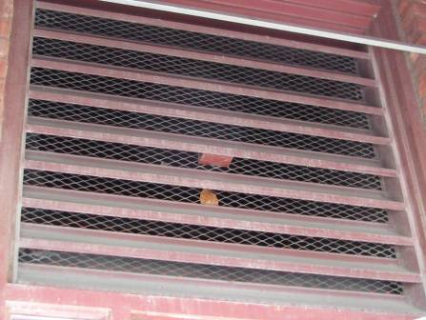

Fresh air intake located below awning

Picture 3



Air intake is located beneath awning above entrance door

Picture 4

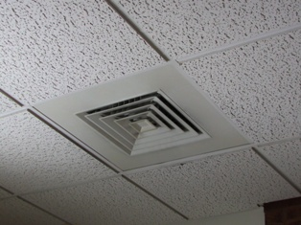

Ceiling-mounted air supply diffuser

Picture 5

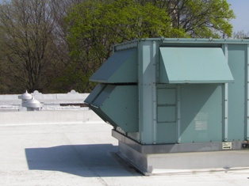

Rooftop AHU

Picture 6

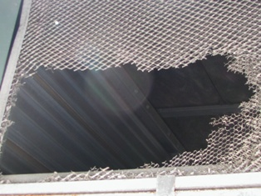

One of several damaged air intake screens on AHU

Picture 7

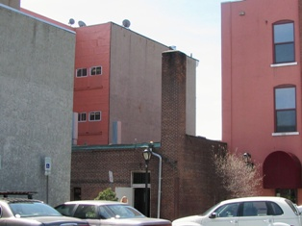

Rooftop scupper used to drain rainwater

Picture 8

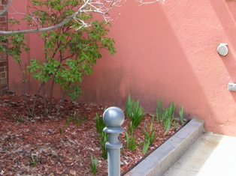

Discolorization, possible mold colonization at base of building below scupper

Picture 9

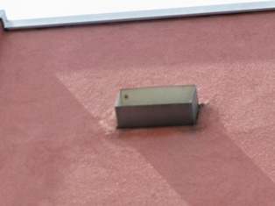

Discoloration of exterior wall around scupper

Picture 10



Missing/damaged brick and mortar

Picture 11

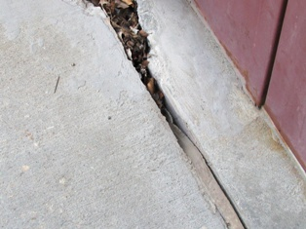

Sealant missing/damaged near entrance door
Note accumulation of organic debris in crevice

Picture 12

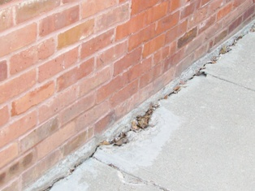

Open spaces along the base of the building and sidewalk
Picture 13



Transportation vehicle parked in front of air intake

Picture 14

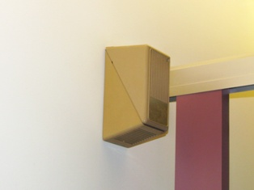

Wall mounted deodorizer

Picture 15

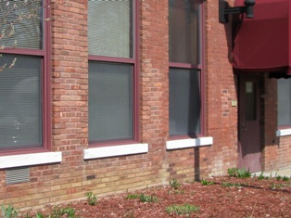

Exhaust vent from kiln

Picture 16

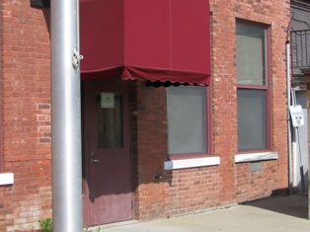

Exhaust vent from wood shop

Picture 17



Wooden enclosure surrounding dumpster near fresh air intake

Picture 18

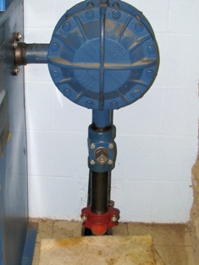

Saturated absorbent pad located below
hydraulic fluid leak in mechanical room of elevator
Picture 19

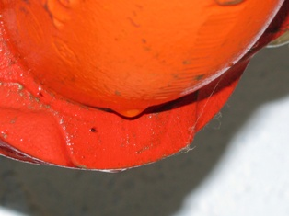

Leaking hydraulic fluid
Location/ Room | Occupants  in Room | Temp  (°F) | Relative  Humidity  (%) | Carbon  Dioxide  (ppm) | Carbon Monoxide  (ppm) | TVOCs  (ppm) | PM2.5  (µg/m³) | Windows  Openable | Ventilation |  | Remarks
 |  |  |  |  |  |  |  |  | Supply | Exhaust | Remarks
background |  | 80 | 25 | 431 | ND | 0.5 | 39
Basement
Board Room | 0 | 76 | 30 | 438 | ND | 0.6 | 35 | N | Y | Y | carpet, stone wall
Ceramics | 0 | 75 | 27 | 591 | ND | 0.6 | 29 | N | Y | N | Exhaust in boardroom
Wood Shop | 0 | 73 | 33 | 763 | ND | 0.7 - 0.8 | 32 | N | Y | N | Exhaust in boardroom
Storage Room | 0 | 73 | 32 | 435 | ND | 0.6 | 33 | N | N | N | Exhaust in boardroom; Carpets stored in room
Elevator Mechanical Room | 0 | 73 | 33 | 561 | ND | 0.7 | 40 | N | N | N | leaking hydraulic fluid
First Floor
Jean’s Office | 1 | 78 | 34 | 455 | ND | 0.5 | 29 | Y | Y | Y  In hall | DO, Plants, Bird Cage, Bird gone
Office | 0 | 80 | 31 | 540 | ND | 0.5 | 31 | N | Y | Y  In hall | DO
Senior Clerk | 0 | 79 | 30 | 563 | ND | 0.5 | 30 | N | Y | Y  In hall | DO, copier is in use
Front Office | 3 | 79 | 31 | 639 | ND | 0.6 | 30 | N | Y | Y  In hall | 2 open windows to the hallway
Joe’s Office | 1 | 79 | 31 | 602 | ND | 0.5 | 31 | Y | Y | Y  In hall | DO, plants
Computer lab | 0 | 79 | 30 | 443 | ND | 0.4 | 30 | Y | Y | Y  In hall | carpet, 6 comp.
Coffee shop | 20 | 79 | 31 | 581 | ND | 0.5 | 32 | N | Y | Y  In hall | DO
Second Floor
Living Room | 3 | 78 | 32 | 593 | ND | 0.4 | 30 | N | Y | Y  In hall | DO
Social Daycare | 8 | 79 | 31 | 794 | ND | 0.6 | 27 | Y | Y | Y | plants, fan, DEM
Main Room | 31 | 78 | 31 | 598 | ND | 0.6 | 31 | Y | Y | Y
Kitchen 2nd floor | 0 | 82 | 27 | 750 | ND | 0.6 – 0.7 | 30 | N | Y | Y | 1 DO
Third Floor
Group Office | 0 | 78 | 28 | 609 | ND | 0.6 | 24 | N | Y | Y  In hall
Game Room | 1 | 77 | 31 | 706 | ND | 0.6 - 0.7 | 25 | Y | Y | Y | DO, DEM
Craft Room | 1 | 76 | 30 | 731 | ND | 0.7 | 22 | Y | Y | Y | DO, paints stored in closet
3rd floor women’s room | 0 | 76 | 31 | 766 | ND | 2.8 | 27 | N | N | Y | strong odor of deodorizer, exhaust does not appear to be functioning.
3rd floor men’s room | 0 | 76 | 31 | 721 | ND | 3.4 | 26 | N | N | Y | strong odor of deodorizer, exhaust does not appear to be functioning.

