Standing Order for Community Dispensing of Naloxone

This Standing Order is issued to expand access to naloxone through a Statewide Standing Order, rather than requiring each community or program to secure and file one individually. This Standing Order authorizes persons specified in Attachment A to dispense naloxone rescue kits to a person at risk of experiencing an opioid-related overdose, or a family member, friend, or other person in a position to assist a person at risk of experiencing an opioid-related overdose.

Section 19B of Chapter 94C of the General Laws protects all practitioners prescribing or dispensing naloxone from criminal or civil liability or any professional disciplinary action. M.G.L. c. 94C, § 19B(f). In addition to the immunity established under M.G.L. c. 94C, § 34A, for persons assisting an individual appearing to experience an opioid- related overdose, Section 19B also provides criminal and civil immunity for anyone, acting in good faith, who administers an opioid antagonist to an individual appearing to experience an opioid-related overdose. M.G.L. c. 94C, § 19B(g).

For intranasal administration:
- Naloxone 4mg/0.1mL nasal spray Dispense 2 doses.
Directions for use: Administer a single spray of naloxone in one nostril. Repeat after 3 minutes if no or minimal response.
OR
- Naloxone 2mg/2mL single-dose Luer-Jet prefilled syringe
Dispense 2 doses.
Include one luer-lock mucosal atomization device (MAD 300) per dose dispensed.
Directions for use: Spray 1 mL in each nostril. Repeat after 3 minutes if no or minimal response.
OR
- Naloxone 8mg/0.1mL nasalspray
Dispense 2 doses
Directions for use: Administer a single spray of naloxone in one nostril. Repeat after 3 minutes if no or minimal response.

For intramuscular injection:
- Naloxone 0.4mg/mL in 1mL single dose vials
Dispense 2 doses.
Include one 3cc, 25 gauge, 1” syringe per dose dispensed.
Directions for use: Inject 1 mL IM in shoulder or thigh. Repeat after 3 minutes if no or minimal response.
OR
- Naloxone 5mg/0.5mL in a single dose pre-filled syringe
Dispense 2 doses
Directions for use: Inject the contents of one pre-filled syringe into thigh. Repeat after 3 minutes if no or minimal response.

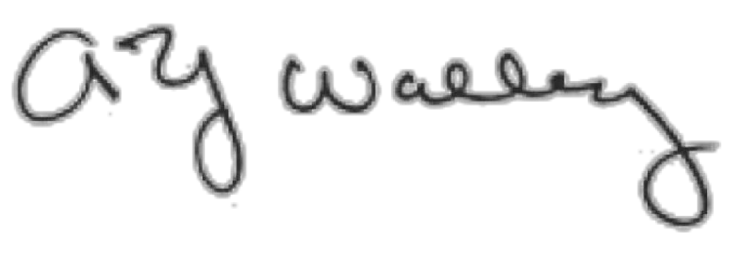July 27, 2022

Physician’s Signature
Date

Alexander Y. Walley, MD, MSc MA #221133
Physician’s Name and MA License No.

ATTACHMENT A: Public Health and Public Safety Personnel Authorized by Standing Order for Community Dispensing of Naloxone

Authorized personnel dispensing naloxone must receive training and remain up to date in their skills and knowledge, such that they are able to provide education to persons at substantial risk of opioid overdose and persons in a position to assist such persons at risk on how to respond to an overdose with naloxone and how to prevent overdose. Training must include, but not be limited to:

- proper storage, handling and return or disposal of naloxone;
- procedures for reducing the risk of an overdose;
- recognition of the symptoms of an opioid overdose;
- proper use of the naloxone available for community dispensing; and
- procedures for notification of emergency medical services and other appropriate persons following administration;

The following paid and volunteer staff are authorized to dispense naloxone under this Community Dispensing Standing Order:

- Police Department personnel;
- Fire Department personnel;
- BSAS-licensed/approved facility personnel;
- BSAS-contracted personnel;
- Any personnel working in Co-Response/Jail Diversion/Crisis Intervention Teams/Post Overdose Support and Response Teams;
- Criminal justice personnel (including but not limited to court, corrections, probation, and parole personnel);
- Licensed Alcohol and Drug Counselors;
- Health and Human Services program personnel serving people at risk for opioid overdose and/or their social networks (including but not limited to homeless shelters, drop-in centers, and soup kitchens);
- Substance use disorder family advocacy and support group personnel;
- Opioid Education and Naloxone Distribution program personnel; and
- Certified Community Health Workers.

