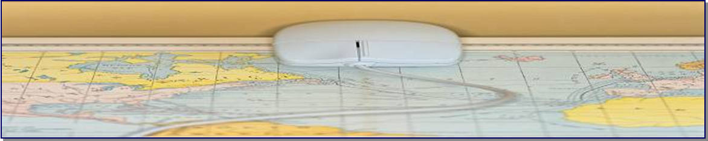

The Virtual Gateway’s
School Nutrition Program (SNP)
Road Map to Readiness Guide
Summer 2012

We welcome Massachusetts school districts who will use the Virtual Gateway to for Direct Certification, Direct Verification and Virtual Gateway Application Inbox for the School Nutrition Program (SNP). This Road Map to School Nutrition Readiness highlights the many resources available to help you manage the School Nutrition Program on the Virtual Gateway—from training through the start of the new school year.
Some steps are required for preparing to use the Virtual Gateway; others are recommended:
Step | Overview | Timeframe
Step 1 (required) | Complete computer based training (CBT) in our PACE learning management system. | CBT courses are available and instructions on how to access will be emailed to you.
Step 2 (required) | Receive your Virtual Gateway User ID or new role(s). | Access is granted shortly after CBTs are completed; login information is relayed to each user via email.

We offer several options for learning and working with the Virtual Gateway’s School Nutrition Program…
Resource | Before you go live | After you go live
Computer based (online) training courses in PACE (required for all users) | ☑ Learn how to use the Virtual Gateway’s School Nutrition Program for direct certification, direct verification and application inbox processes.* | ☑ Use courses as “refreshers” for any or all portions of the Virtual Gateway’s School Nutrition Program for direct certification, direct verification and application inbox processes.
Online Reference Guides and other materials (www.mass.gov/vg/snp) | ☑ Print the materials and keep them with you as you take your online courses to make notes or highlight important information | ☑ Materials provide quick references for Virtual Gateway logon, Direct Certification, Direct Verification and Application Inbox tasks.
ESE PACE Customer Service:  1-781-338-6113 or 1-781-338-6110  esepaceadministrator@doe.mass.edu | ☑ Call or email us if you have any questions related to PACE or required courses. | ☑ Call or email us as needed, to receive help from Customer Service with Virtual Gateway School Nutrition training questions or issues logging into the PACE.
*You will receive your Virtual Gateway Username and password approximately 5 business days after completing your training. Please contact Virtual Gateway Customer Service (number below) if yours is not received within this time frame.

Need more information?
You can quickly get to Virtual Gateway’s School Nutrition content online by entering www.mass.gov/vg/snp in your address bar
Have Virtual Gateway School Nutrition Program questions?
Call ESE PACE Customer Service at 1-781-338-6113 or 1-781-338-6110 Monday-Friday, 8:30 a.m. – 4:00 p.m.
(The Virtual Gateway’s School Nutrition Program Road Map to Readiness is sponsored by the Executive Office of Health and Human Services (EOHHS) Virtual Gateway in conjunction with the Department of Elementary and Secondary Education (DESE).
To learn more about the School Nutrition program, please visit the Department of Elementary and Secondary Education (DESE) website at http://www.doe.mass.edu/cnp.

