WHAT DO YOU WANT FOR THE FUTURE?
- A new career?
- Improved math or English skills?
- Job training?
- Job search help?

This program offered by the Department of Transitional Assistance and One-Stop Career Centers can help!
HOW?

Go to a One‐Stop Career
Center today.

Find one near you at mass.gov/careercenters.
THE WORK
PARTICIPANT PROGRAM

a partnership of

Questions ?
Other info:
TAFDC clients, contact your Full Engagement Worker.

SNAP-only clients, call a SNAP Employment & Training Specialist at 1-888-483-0255.

Helping TAFDC and SNAP clients find, get, and keep
good-paying jobs

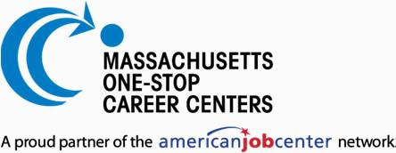
WPP (8/2018) 02-783-0818-05

WHO?
If you are a SNAP or TAFDC client, the Massachusetts Department of Transitional Assistance and One-Stop Career Centers will provide you with FREE comprehensive employment services.
WHY?
Find and get on a career path that will lead to a secure, successful future.
We will help you gain new skills and training so that you qualify for jobs that are in-demand and paying a wage that reflects your hard work.
WHAT?

JOB COACHING
Get counseling and a "career readiness"
assessment. A job counselor will help you reflect on your values, interests, personality, and skills to identify what will make you successful and satisfied in your work. Then get advice on how to navigate the job, training, and education processes in your chosen industry.

WORKSHOPS & TRAINING
You maybe eligible for training—ranging
from one-hour workshops to certificate
programs—based on your assessment and what's in current demand. Gain English
language skills or get credentialed in
machining, healthcare, HVAC, hospitality management, computer information
systems, and more, based on availability.

Digital resources and offline workshops on resume-writing, leadership, interviewing
techniques, professionalizing your online
presence, computer software programs, and entrepreneurship will give you the tools and talent that employers really want.

WHAT WILL BE EXPECTED OF YOU AT THE CAREER CENTER?
- Become a member (for free!) and register through mass.gov/jobquest.
- Attend an orientation.
- Meet with the job counselor for a “career readiness” assessment.
- Participate in weekly and monthly activities that may include meeting with a job counselor, job referrals, training, workshops, resume assistance, or job fairs.
Enrollment and active participation in this program will satisfy TAFDC and SNAP work requirements.

JOB SEARCHING
Find out the best way to look for a job.
Organize your search with access to
computers, internet, and statewide and national online job listings for 1000s of
openings for full-time and part-time work.

NETWORKING
Many people find and get jobs through
networked opportunities. Become a member of a job club and make useful business and employment connections that will grow your search and get you hired.

