INDOOR AIR QUALITY ASSESSMENT

Theodore Herberg Middle School
501 Pomeroy Avenue
Pittsfield, Massachusetts

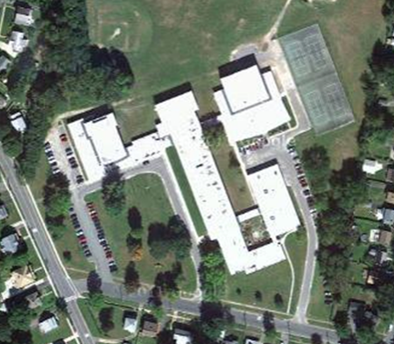

Prepared by:
Massachusetts Department of Public Health
Bureau of Environmental Health
Indoor Air Quality Program
July 2014

Background/Introduction
At the request of Cal Joppru (former Health Agent for the Town of Pittsfield) and the Pittsfield School Department, the Massachusetts Department of Public Health (MDPH), Bureau of Environmental Health (BEH) provided assistance and consultation regarding indoor air quality (IAQ) at the Theodore Herberg Middle School (HMS) located at 501 Pomeroy Ave, Pittsfield, Massachusetts.
On January 17, 2014, a visit was made to the building by Michael Feeney, Director of BEH’s IAQ Program and Kathleen Gilmore, Environmental Analyst/Regional Inspector for the BEH/IAQ Program to conduct an IAQ assessment of the entire building and to assess whether recommendations regarding abatement of the various odor sources were successful.
BEH staff have provided on-going assistance regarding a chronic odor complaint within various locations of the building beginning in June 2012. The BEH/IAQ Program initially visited the HMS on June 8, 2012, and a report was issued (MDPH, 2012). Appendix A describes actions that were taken in response to the recommendations in that report. Pittsfield Public Schools requested that BEH/IAQ staff return to the building after requesting assistance regarding odors in a room adjacent to the boiler room on May 24, 2013. At that time, Pittsfield health and school officials requested that a full IAQ assessment of the entire building be conducted the next school year in the building, after the heating system was activated. The initial date for this assessment was November 22, 2013. The November 2013 assessment was postponed due to a reported city-wide failure of the heating control system for Pittsfield schools. The assessment was then rescheduled for January 17, 2014.
The HMS is a two story brick building with a flat roof that was constructed in 1955 and underwent extensive renovations in 1999, including the addition of science and art classrooms and a media/technology center. A crawlspace exists under the building for utilities. Windows are openable throughout the building.

Methods
Air tests for carbon dioxide, carbon monoxide, temperature and relative humidity were conducted with the TSI, Q-Trak, IAQ Monitor, Model 7565. Air tests for airborne particle matter with a diameter less than 2.5 micrometers were taken with the TSI, DUSTTRAK™ Aerosol Monitor Model 8520. BEH/IAQ staff also performed visual inspection of building materials for water damage and/or microbial growth.

Results
The building is a middle school serving grades 6-8, with a student population of approximately 600 and a staff of approximately 70. Please note, that for the purposes of this report, the classroom that was the former art workshop is referred to Classroom A.

Discussion

Ventilation
It can be seen from Table 1 that carbon dioxide levels were above 800 parts per million (ppm) in 30 out of 48 areas surveyed indicating inadequate air exchange in nearly two-thirds of the building at the time of testing. It is important to note that several classrooms were sparsely populated which can reduce carbon dioxide levels. The elevated carbon dioxide levels measured are likely related to deactivated/non-functioning/poorly functioning ventilation equipment.
Fresh air to classrooms is supplied by unit ventilator (univent) system (Picture 1). A univent draws air from the outdoors through a fresh air intake located on the exterior wall of the building. Return air from the classroom is drawn through an air intake located at the base of the unit (Figure 1). Fresh and return air are mixed, filtered, heated and provided to classrooms through an air diffuser located in the top of the unit. Univents in several classrooms were found to be obstructed by furniture and other items on top of air diffusers and/or in front of return vents along the bottom of the units (Picture 2). In order for univents to provide fresh air as designed, they must remain on and operating while rooms are occupied. Furthermore, units must remain free of obstructions.
Exhaust ventilation is provided by ceiling-mounted exhaust vents powered by rooftop motors. A number of exhaust vents were not operating at the time of the assessment (Table 1) indicating that they had either been deactivated or had mechanical problems; this was also noted in the 2012 MDPH report. In addition, many exhaust vents were occluded by dirt and debris (Picture 3). As with univents, exhaust vents need to be activated to function as designed. Without adequate supply and exhaust ventilation, excess heat and environmental pollutants can build up and lead to indoor air/comfort complaints.
Mechanical ventilation for some areas of the building (science, media/technology, library, theater/stage and administrative) is provided by air-handling units (AHUs). Fresh air is drawn through air intakes on the exterior of the building and distributed via ceiling-mounted diffusers. Air is ducted back to AHUs via ceiling or wall-mounted return vent. Of note, BEH/IAQ staff observed an exhaust vent in Room 202 that was covered with plastic and tape (Picture 4). The plastic should be removed to ensure adequate air flow in this space.
To maximize air exchange, the MDPH recommends that both supply and exhaust ventilation operate continuously during periods of occupancy. In order to have proper ventilation with a mechanical supply and exhaust system, the systems must be balanced to provide an adequate amount of fresh air to the interior of a room while removing stale air from the room. It is recommended that heating, ventilating and air conditioning (HVAC) systems be re-balanced every five years to ensure adequate air systems function (SMACNA, 1994). The date of the last balancing of these systems was not available at the time of the assessment.
Minimum design ventilation rates are mandated by the Massachusetts State Building Code (MSBC). Until 2011, the minimum ventilation rate in Massachusetts was higher for both occupied office spaces and general classrooms, with similar requirements for other occupied spaces (BOCA, 1993). The current version of the MSBC, promulgated in 2011 by the State Board of Building Regulations and Standards (SBBRS), adopted the 2009 International Mechanical Code (IMC) to set minimum ventilation rates. Please note that the MSBC is a minimum standard that is not health-based. At lower rates of cubic feet per minute (cfm) per occupant of fresh air, carbon dioxide levels would be expected to rise significantly. A ventilation rate of 20 cfm per occupant of fresh air provides optimal air exchange resulting in carbon dioxide levels at or below 800 ppm in the indoor environment in each area measured. MDPH recommends that carbon dioxide levels be maintained at 800 ppm or below. This is because most environmental and occupational health scientists involved with research on IAQ and health effects have documented significant increases in indoor air quality complaints and/or health effects when carbon dioxide levels rise above the MDPH guidelines of 800 ppm for schools, office buildings and other occupied spaces (Sundell et al., 2011). The ventilation must be on at all times that the room is occupied. Providing adequate fresh air ventilation with open windows and maintaining the temperature in the comfort range during the cold weather season is impractical. Mechanical ventilation is usually required to provide adequate fresh air ventilation.
Carbon dioxide is not a problem in and of itself. It is used as an indicator of the adequacy of the fresh air ventilation. As carbon dioxide levels rise, it indicates that the ventilating system is malfunctioning or the design occupancy of the room is being exceeded. When this happens, a buildup of common indoor air pollutants can occur, leading to discomfort or health complaints. The Occupational Safety and Health Administration (OSHA) standard for carbon dioxide is 5,000 parts per million parts of air (ppm). Workers may be exposed to this level for 40 hours/week, based on a time-weighted average (OSHA, 1997).
The MDPH uses a guideline of 800 ppm for publicly occupied buildings. A guideline of 600 ppm or less is preferred in schools due to the fact that the majority of occupants are young and considered to be a more sensitive population in the evaluation of environmental health status. Inadequate ventilation and/or elevated temperatures are major causes of complaints such as respiratory, eye, nose and throat irritation, lethargy and headaches. For more information concerning carbon dioxide, consult Appendix B.
Temperature readings during the assessment ranged from 71°F to 74°F, which were within the MDPH recommended comfort range (Table 1). The MDPH recommends that indoor air temperatures be maintained in a range of 70°F to 78°F in order to provide for the comfort of building occupants. In many cases concerning indoor air quality, fluctuations of temperature in occupied spaces are typically experienced, even in a building with an adequate fresh air supply.
The relative humidity at the time of the assessment ranged from 21 to 28 percent, which was below the MDPH recommended comfort range. The MDPH recommends a comfort range of 40 to 60 percent for indoor air relative humidity. Relative humidity levels in the building would be expected to drop during the winter months due to heating. The sensation of dryness and irritation is common in a low relative humidity environment. Low relative humidity is a very common problem during the heating season in the northeast part of the United States.

Moisture/Microbial Concerns
As mentioned, concerns of odors and moisture concerns in the building prompted the assessment. In response to the 2012 MDPH visit (Appendix A), remediation efforts at HMS included sealing all holes and gaps surrounding utility pipes to reduce pathways for moisture, mold and associated odors from migrating from the crawlspace into occupied areas of the building.
Water-damaged ceiling tiles were found in several rooms (Table 1; Picture 5). Water-damaged ceiling tiles indicate leaks from either the roof or plumbing system. If repeatedly moistened, ceiling tiles can be a medium on which mold can grow. Water-damaged tiles should be replaced after a water leak is discovered and repaired.
Peeling plaster and paint was noted in the ceiling surrounding utility pipes and the exhaust vent in Classroom A (Picture 6). BEH/IAQ staff observed the space where the exhaust vent meets the roof line, which was filled with a spray foam sealant material, as reported by Pittsfield School Department staff. Spray foam sealant is not an appropriate mater to seal water leaks. The area should be inspected for water damage and repaired as needed including use of an appropriate sealant.
A strong musty odor was noted outside of a custodial closet on the first floor. Mops were found to be wet and mop buckets contained standing water (Picture 7). Both standing water and wet mops can serve as mediums for bacteria, mold growth and result in odors. Mop buckets should be emptied and dried after use. Mop heads should be dried as soon as practicable following use and cleaned regularly to prevent mold growth and associated odors.
Plants were observed in several rooms (Table 1, Picture 8). Plants, soil and drip pans can serve as sources of mold growth. Plants can also be a source of pollen. Plants should not be placed on porous materials, since water damage to porous materials may lead to microbial growth.

Odor Concerns
During the May 24, 2013 visit, school officials reported periodic episodes of propane/gas-like odors in Classroom A which is adjacent to the boiler room. BEH/IAQ staff observed holes and gaps surrounding utility pipes that penetrate the common wall of the boiler room and the classroom space. As these breaches can serve as pathways for air, odors and particulates to migrate from the boiler room into the classroom and it was recommended that all gaps and holes in this area be sealed with appropriate fire-resistant materials. In addition, the boiler room access door exists in this room. Light could be seen penetrating through the space underneath this door, indicating it is not airtight. As previously recommended in Appendix A, a door sweep and weather-stripping should be installed to render it airtight. According the school officials, remediation efforts were complete following the May 24, 2013 MDPH visit. During the January 17, 2014 visit, BEH staff observed that the doorway to the boiler room had a door sweep and weather stripping installed (Picture 9). It was not known if the remediation efforts to seal all breaches in the boiler room walls had been completed. In addition, school officials reported that school staff routinely use the emergency exit exterior door located in Classroom A to enter and exit the building. BEH/IAQ recommended that this door be kept closed except for use as an emergency exit as designed, to prevent the migration of odors, vapors and particulates into the classroom space.
Another area of concern was Room A140, where there were reported complaints of odors by school staff. As there was no identifiable source of the odors in the classroom itself, BEH/IAQ staff inspected the mechanical room directly above Room A140 which houses one of the main AHUs for the building. AHUs that provide air-conditioning require the installation of condensation drains to prevent water build up inside the casing and ductwork. The condensation drain for this unit terminates above a floor drain that is connected to the building drainage system (Picture 10). Drains are typically designed with traps to prevent sewer odors/gases from penetrating into occupied spaces. During air-conditioning operation, condensation enters the drain and the trap fills to form a watertight seal. Both the floor drains and condensation drains have traps. During the heating season, AHUs do not produce condensation, and the traps dry out. This AHU was found to be drawing air into the unit through the condensation drain and floor drain (Picture 11), which was observed to be corroded with scale and debris, thus distributing moisture and odors from the drain into the rest of the building. In order to maintain the watertight seal, water should be poured down the drain routinely (i.e. every other day) during the heating season or the drains should be sealed during the heating season.
Sewer/musty odors were also reported in a restroom on the second floor. Sewer gas odor was not detected in pipe chases behind toilets, suggesting that the source of odors is the toilet itself. If the wax seal holding the toilet to the floor is not airtight, sewer gas odors can be drawn from underneath the toilet. BEH/IAQ staff observed that wax ring/sealant was degraded and should be replaced. As noted in the 2012 MDPH report (Appendix A), several restroom exhaust vents were found to be not operating/deactivated and should be repaired. In addition, it was recommended that restroom doors be undercut by 2 inches to provide transfer air for the restroom to remove odors and water vapor. Some restroom doors were found to be undercut while several doors sealed completely.
The kitchen exhaust hood was not operating and was blocked with cardboard (Picture 12). The ovens and other appliances are fueled with natural gas. Kitchen exhaust vents must be functioning to prevent odors, vapors and products of gas consumption from migrating from the kitchen into surrounding areas.

Other IAQ Evaluations
IAQ can be negatively influenced by the presence of respiratory irritants, such as products of combustion. The process of combustion produces a number of pollutants. Common combustion emissions include carbon monoxide, carbon dioxide, water vapor and smoke (fine airborne particle material). Of these materials, exposure to carbon monoxide and particulate matter with a diameter of 2.5 micrometers (μm) or less (PM2.5) can produce immediate, acute health effects upon exposure. To determine whether combustion products were present in the indoor environment, BEH/IAQ staff obtained measurements for carbon monoxide and PM2.5.

Carbon Monoxide
Carbon monoxide is a by-product of incomplete combustion of organic matter (e.g., gasoline, wood and tobacco). Exposure to carbon monoxide can produce immediate and acute health effects. Several air quality standards have been established to address carbon monoxide and prevent symptoms from exposure to these substances. The MDPH established a corrective action level concerning carbon monoxide in ice skating rinks that use fossil-fueled ice resurfacing equipment. If an operator of an indoor ice rink measures a carbon monoxide level over 30 ppm, taken 20 minutes after resurfacing within a rink, that operator must take actions to reduce carbon monoxide levels (MDPH, 1997).
The American Society of Heating Refrigeration and Air-Conditioning Engineers (ASHRAE) has adopted the National Ambient Air Quality Standards (NAAQS) as one set of criteria for assessing indoor air quality and monitoring of fresh air introduced by HVAC systems (ASHRAE, 1989). The NAAQS are standards established by the US EPA to protect the public health from six criteria pollutants, including carbon monoxide and particulate matter (US EPA, 2006). As recommended by ASHRAE, pollutant levels of fresh air introduced to a building should not exceed the NAAQS levels (ASHRAE, 1989). The NAAQS were adopted by reference in the Building Officials & Code Administrators (BOCA) National Mechanical Code of 1993 (BOCA, 1993), which is now an HVAC standard included in the Massachusetts State Building Code (SBBRS, 2011). According to the NAAQS, carbon monoxide levels in outdoor air should not exceed 9 ppm in an eight-hour average (US EPA, 2006).
Carbon monoxide should not be present in a typical, indoor environment. If it is present, indoor carbon monoxide levels should be less than or equal to outdoor levels. The day of assessment, outdoor carbon monoxide concentrations were non-detect (ND) (Table 1). Levels of carbon monoxide in the building during the assessment were ND (Table 1).

Particulate Matter (PM2.5)
The US EPA has established NAAQS limits for exposure to particulate matter. Particulate matter is airborne solids that can be irritating to the eyes, nose and throat. The NAAQS originally established exposure limits to particulate matter with a diameter of 10 μm or less (PM10). According to the NAAQS, PM10 levels should not exceed 150 microgram per cubic meter (μg/m³) in a 24-hour average (US EPA, 2006). These standards were adopted by both ASHRAE and BOCA. Since the issuance of the ASHRAE standard and BOCA Code, US EPA established a more protective standard for fine airborne particles. This more stringent PM2.5 standard requires outdoor air particle levels be maintained below 35 μg/m³ over a 24-hour average (US EPA, 2006). Although both the ASHRAE standard and BOCA Code adopted the PM10 standard for evaluating air quality, MDPH uses the more protective PM2.5 standard for evaluating airborne particulate matter concentrations in the indoor environment.
Outdoor PM2.5 concentrations measured 13 μg/m³ on the day of the visit (Table 1). PM2.5 levels measured inside the building ranged from 5 to 12 μg/m³ (Table 1). Frequently, indoor air levels of particulate matter can be at higher levels than those measured outdoors. A number of mechanical devices and/or activities that occur in buildings can generate particulate during normal operations. Sources of indoor airborne particulates may include but are not limited to particles generated during the operation of fan belts in the HVAC system, use of stoves and/or microwave ovens in kitchen areas; use of photocopiers, fax machines and computer printing devices; operation of an ordinary vacuum cleaner and heavy foot traffic indoors.

Volatile Organic Compounds
Indoor air concentrations can be greatly impacted by the use of products containing volatile organic compounds (VOCs). VOCs are carbon-containing substances that have the ability to evaporate at room temperature. Frequently, exposure to low levels of total VOCs (TVOCs) may produce eye, nose, throat and/or respiratory irritation in some sensitive individuals. For example, chemicals evaporating from a paint can stored at room temperature would most likely contain VOCs. In an effort to identify materials that can potentially increase indoor VOC concentrations, BEH/IAQ staff examined the classrooms for products containing respiratory irritants.
Hand sanitizer was observed in some areas (Table 1, Picture 13). Hand sanitizer products may contain ethyl alcohol and/or isopropyl alcohol which are highly volatile and may be irritating to the eyes and nose, and may also contain fragrances to which some people may be sensitive.
Air deodorizing materials (scented incense sticks in oil) were observed in one classroom (Picture 14). Air deodorizers contain chemicals that can be irritating to the eyes, nose and throat of sensitive individuals. Many air fresheners contain 1, 4-dichlorobenzene, a VOC which may cause reductions in lung function (NIH, 2006). Furthermore, deodorizing agents do not remove materials causing odors, but rather mask odors that may be present in the area.
In an effort to reduce noise, tennis balls had been sliced open and placed on the base of desk/chair legs in some classrooms. Tennis balls are made of a number of materials that are a source of respiratory irritants. Constant wearing of tennis balls can produce fibers and cause VOCs to off-gas. Tennis balls are made with a natural rubber latex bladder, which becomes abraded when used as a chair leg pad. Use of tennis balls in this manner may introduce latex dust into the school environment. Some individuals are highly allergic to latex (e.g., spina bifida patients) (SBAA, 2001). It is recommended that the use of materials containing latex be limited in buildings to reduce the likelihood of symptoms in sensitive individuals (NIOSH, 1997).
Many classrooms contained dry erase boards and related materials. In some areas, dry erase debris was accumulated on the marker tray. Materials such as dry erase markers and dry erase board cleaners may contain VOCs, such as methyl isobutyl ketone, n-butyl acetate and butyl-cellusolve (Sanford, 1999), which can be irritating to the eyes, nose and throat
There are several photocopiers in the building. Photocopiers can be sources of pollutants such as VOCs, ozone, heat and odors, particularly if the equipment is older and in frequent use. Both VOCs and ozone are respiratory irritants (Schmidt Etkin, 1992). Photocopiers and laminators should be kept in well ventilated rooms, and should be located near windows or exhaust vents.

Other Concerns
Dust/debris was observed accumulated on univents cabinets, exhaust vents (Picture 3), as well as on the fan blades of personal fans. If rooftop exhaust motors are deactivated, back-drafting can occur, and materials accumulated on the exhaust vent can be re-aerosolized into occupied areas. Vents and fans should be cleaned periodically to prevent dust/debris from being aerosolized and redistributed throughout the room. Univents should be kept free of any foreign materials which may impair function or distribute contaminants and odors throughout the classroom.
In several rooms, items were observed on floors, windowsills, tabletops, counters, bookcases and desks. Large number of items stored in occupied areas provides a source for dusts to accumulate (Picture 15). These items (e.g., papers, folders, boxes) make it difficult for custodial staff to clean. Items should be relocated and/or be cleaned periodically to avoid excessive dust build up.
An ajar ceiling tile was observed in the principal’s office and a missing ceiling tile was found in another office. Ceiling tiles should be flush with the tile system to prevent movement of materials from the plenum into occupied space. Accumulated dust, dirt and particulates may be disturbed and serve as a source of eye and respiratory irritation.
An upholstered chair was observed in one classroom (Picture 16). Upholstered furniture pillows and cushions are covered with fabrics that are exposed to human skin. This type of contact can leave oils, perspiration, hair and skin cells. Dust mites feed upon human skin cells and excrete waste products that contain allergens. In addition, if relative humidity levels increase above 60 percent, dust mites tend to proliferate (US EPA, 1992). In order to remove dust mites and other pollutants, frequent vacuuming of upholstered furniture is recommended (Berry, 1994). It is also recommended that upholstered furniture (if present in schools), be professionally cleaned on an annual basis. If an excessively dusty environment exists due to outdoor conditions or indoor activities (e.g., renovations), cleaning frequency should be increased (e.g., every six months) (IICRC, 2000).

Conclusions/Recommendations
In view of the findings at the time of the visit the following recommendations are made:
- Continue implementing recommendations from the June 2012 MDPH report; refer to Appendix A.
- Examine all exhaust vents and repair as needed. Operate all exhaust vents including those in restrooms and custodial closets during school hours.
- Continue to seal all utility pipes, fire suppression system pipes, conduit and other penetrations in the ceiling and walls of the crawl space, in the boiler room, in the floor of classrooms, inside unit ventilators and plumbing using an expandable, fire-rated sealing compound.
- To maximize air exchange, operate existing ventilation equipment during periods of school occupancy. Ensure all supply and exhaust vents are operating. Keep classroom doors closed when possible to maximize the ability of the exhaust vents to remove pollutants from classrooms.
- Consider adopting a balancing schedule of every 5 years for all mechanical ventilation systems, as recommended by ventilation industrial standards (SMACNA, 1994).
- For buildings in New England, periods of low relative humidity during the winter are often unavoidable. Therefore, scrupulous cleaning practices should be adopted to minimize common indoor air contaminants whose irritant effects can be enhanced when the relative humidity is low. To control for dusts, a high efficiency particulate arrestance (HEPA) filter equipped vacuum cleaner in conjunction with wet wiping of all surfaces is recommended. Drinking water during the day can help ease some symptoms associated with a dry environment (throat and sinus irritations).
- Replace all water-damaged, missing and ajar ceiling tiles. Monitor for future leaks.
- Inspect the ceiling in Classroom A for water damage and/or degraded insulation/sealant. Repair as needed.
- Empty and rinse mop buckets after each use. Mops should be cleaned, disinfected and set up to dry between uses.
- Ensure plants have drip pans and avoid over-watering. Examine drip pans periodically for mold growth. Disinfect with an appropriate antimicrobial where necessary. Remove plants from univent air diffusers.
- Discourage regular use of emergency exit door in Classroom A and keep door closed.
- Pour water down the floor drain of the mechanical room every 2- 3 days to ensure a water tight seal during the heating season or temporarily seal the drains.
- Repair toilet and wax seal in second floor restroom.
- Undercut remaining restroom doors by two inches to provide transfer air for the restroom exhaust vents.
- Repair the kitchen hood exhaust vent to allow for removal of cooking pollutants from the building. Inspect exhaust ductwork for integrity and seal any breaches/seams as necessary.
- Refrain from using strongly scented materials (e.g., air fresheners/deodorizers) in classrooms.
- Replace tennis balls on chair legs with latex-free glides.
- Clean dry-erase marker trays of accumulated dust and debris regularly using a damp cloth.
- Clean exhaust/supply vents and personal fans periodically of accumulated dust/debris.
- Relocate or consider reducing the amount of stored materials to allow for more thorough cleaning. Clean items regularly with a wet cloth or sponge to prevent excessive dust build-up.
- Clean upholstered furniture/pillows/cushions and area rugs annually. If not feasible, consider removal.
- Refer to resource manuals and other related indoor air quality documents for further building-wide evaluations and advice on maintaining public buildings. These materials are located on the MDPH’s website: http://mass.gov/dph/iaq.

References
ASHRAE. 1989. Ventilation for Acceptable Indoor Air Quality. American Society of Heating, Refrigeration and Air Conditioning Engineers. ANSI/ASHRAE 62-1989.
Berry, M.A. 1994. Protecting the Built Environment: Cleaning for Health, Michael A. Berry, Chapel Hill, NC.
BOCA. 1993. The BOCA National Mechanical Code/1993. 8th ed. Building Officials & Code Administrators International, Inc., Country Club Hills, IL.
IICRC. 2000. IICRC S001 Reference Guideline for Professional On-Location Cleaning of Textile Floor Covering Materials Institute of Inspection, Cleaning and Restoration Certification. Institute of Inspection Cleaning and Restoration, Vancouver, WA.
MDPH. 1997. Requirements to Maintain Air Quality in Indoor Skating Rinks (State Sanitary Code, Chapter XI). 105 CMR 675.000. Massachusetts Department of Public Health, Boston, MA.
MDPH. 2012. Indoor Air Quality Assessment. Theodore Herberg Middle School, Pittsfield, MA. Massachusetts Department of Public Health, Bureau of Environmental Health, Boston, MA. July 2012.
NIH. 2006. Chemical in Many Air Fresheners May Reduce Lung Function. NIH News. National Institute of Health. July 27, 2006. http://www.nih.gov/news/pr/jul2006/niehs-27.htm
NIOSH. 1997. NIOSH Alert Preventing Allergic Reactions to Natural Rubber latex in the Workplace. National Institute for Occupational Safety and Health, Atlanta, GA. OSHA. 1997.
OSHA. 1997. Limits for Air Contaminants. Occupational Safety and Health Administration. Code of Federal Regulations. 29 C.F.R 1910.1000 Table Z-1-A.
Sanford. 1999. Material Safety Data Sheet (MSDS No: 198-17). Expo Dry Erase Markers Bullet, Chisel, and Ultra Fine Tip. Sanford Corporation, Bellwood, IL.
Schmidt Etkin, D. 1992. Office Furnishings/Equipment & IAQ Health Impacts, Prevention & Mitigation. Cutter Information Corporation, Indoor Air Quality Update, Arlington, MA.
SBAA. 2001. Latex In the Home And Community Updated Spring 2001. Spina Bifida Association of America, Washington, DC.
SBBRS. 2011. Mechanical Ventilation. State Board of Building Regulations and Standards. Code of Massachusetts Regulations. 780 CMR 1209.0.
SMACNA. 1994. HVAC Systems Commissioning Manual. 1st ed. Sheet Metal and Air Conditioning Contractors’ National Association, Inc., Chantilly, VA.
Sundell. 2011. Sundell, J., H. Levin, W. W. Nazaroff, W. S. Cain, W. J. Fisk, D. T. Grimsrud, F. Gyntelberg, Y. Li, A. K. Persily, A. C. Pickering, J. M. Samet, J. D. Spengler, S. T. Taylor, and C. J. Weschler. Ventilation rates and health: multidisciplinary review of the scientific literature. Indoor Air, Volume 21: pp 191–204.
US EPA. 1992. Indoor Biological Pollutants. US Environmental Protection Agency, Environmental Criteria and Assessment Office, Office of Health and Environmental Assessment, research Triangle Park, NC. EPA 600/8-91/202. January 1992.
US EPA. 2006. National Ambient Air Quality Standards (NAAQS). US Environmental Protection Agency, Office of Air Quality Planning and Standards, Washington, DC. http://www.epa.gov/air/criteria.html
Picture 1
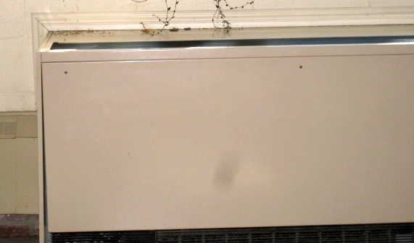
Classroom univent
Picture 2

Univent blocked by desk and materials

Picture 3
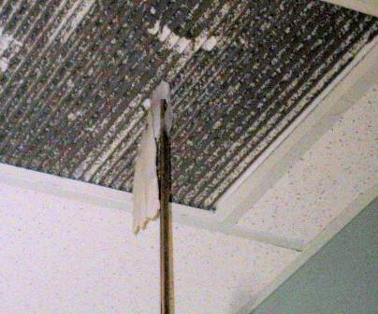
Dirty exhaust vent (note: not drawing air)
Picture 4
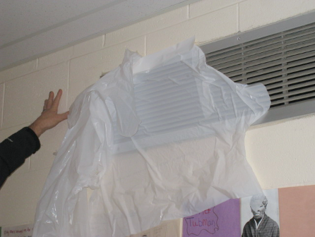
Exhaust vent covered with plastic

Picture 5
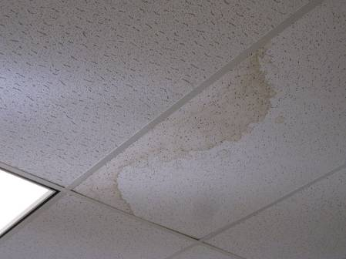
Water-damaged ceiling tile
Picture 6
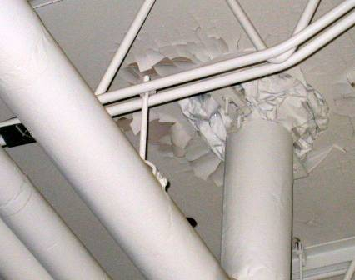
Peeling paint and plaster (note material surrounding ductwork)

Picture 7
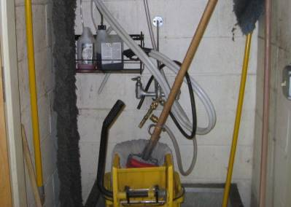
Custodial closet with wet mop and standing water in bucket
Picture 8
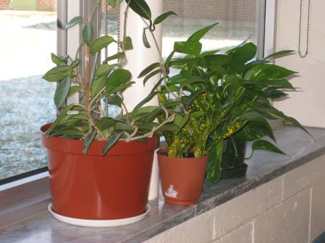
Plants in classroom

Picture 9
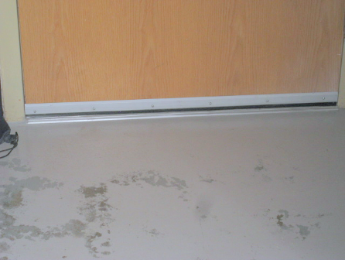
Boiler room door with door sweep
Picture 10
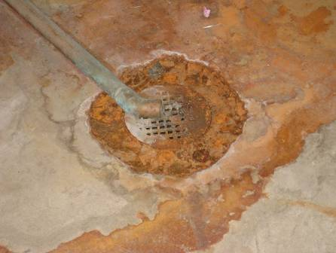
AHU condensation pipe terminating over floor drain (note scale and debris)

Picture 11
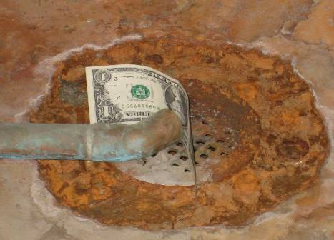
Condensation pipe and floor drain drawing air (depicted with dollar bill)
Picture 12
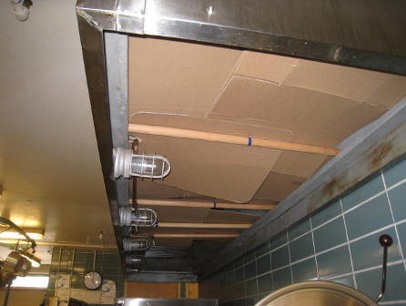
Kitchen hood blocked with cardboard

Picture 13
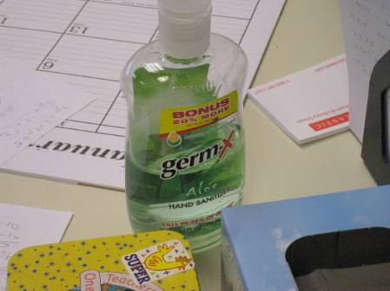
Hand sanitizer
Picture 14
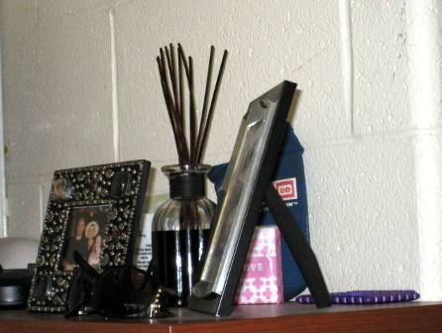
Scented incense sticks

Picture 15
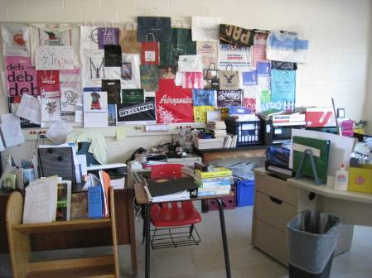
Classsroom cluttered with material and items
Picture 16
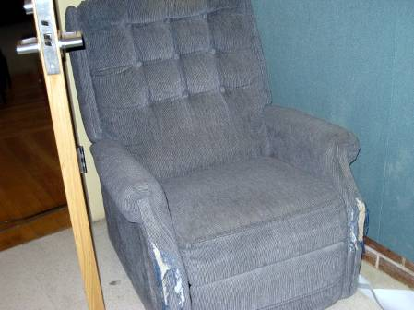
Upholstered chair
Location | Carbon  Dioxide  (*ppm) | Carbon Monoxide  (*ppm) | Temp  (°F) | Relative  Humidity  (%) | PM2.5  (ug/m3) | Occupants  in Room | Windows  Openable | Ventilation |  |  | Remarks
 |  |  |  |  |  |  |  | Intake | Exhaust |  | Remarks
Background | 632 | ND | 34 | 45 | 13 |  |  |  |  |  | Partly sunny
108 | 777 | ND | 72 | 24 | 7 | 14 | Y | Y |  | Y | UV blocked (desk/books, papers), clutter, DEM
109 | 680 | ND | 73 | 24 | 6 | 4 | Y | Y |  | Y (off)
110 | 759 | ND | 72 | 25 | 9 | 5 | Y | Y |  | Y | TB, DEM, WD CT, PF dirty, clutter
111 | 727 | ND | 72 | 24 | 6 | 0 | Y | Y |  | Y (off)
112 | 697 | ND | 72 | 24 | 10 | 16 | Y | Y |  | Y (off) | UV blocked, clutter, DEM, TB
113 | 658 | ND | 72 | 25 | 7 | 0 | Y | Y |  | Y | Exhaust dirty, TB
114 | 539 | ND | 73 | 23 | 8 | 21 | Y | Y |  | Y (off) | UV blocked, plants, clutter
115 | 664 | ND | 72 | 23 | 8 | 3 | Y | Y |  | Y | Exhaust dirty
116 | 1250 | ND | 73 | 26 | 9 | 13 | Y | Y |  | Y | DO, DEM, hand-sanitizer
117 | 789 | ND | 72 | 25 | 7 | 7 | Y | Y |  | Y
118 | 1134 | ND | 72 | 25 | 8 | 5 | Y | Y |  | Y (off) | Exhaust dirty
119 | 926 | ND | 72 | 24 | 8 | 7 | Y | Y |  | Y | TB
121 | 881 | ND | 73 | 25 | 12 | 11 | Y | Y |  | Y (off)
123 | 698 | ND | 74 | 22 | 10 | 0 | Y | Y |  | Y | DO, exhaust dirty, PC, WD CT
125 | 956 | ND | 72 | 24 | 9 | 20 | Y | Y |  | Y | Plants
127 | 1238 | ND | 72 | 27 | 5 | 18 | Y | Y |  | Y
131 | 732 | ND | 72 | 27 | 7 | 19 | Y | Y |  | Y | Plants, TB
133 | 1291 | ND | 72 | 24 | 6 | 20 | Y | Y (off) |  | Y
135 | 924 | ND | 72 | 28 | 8 | 2 | Y | Y |  | Y | Plants
137 | 1011 | ND | 72 | 25 | 6 | 10 | Y | Y |  | Y | WD CT
138 | 1129 | ND | 72 | 24 | 7 | 2 | Y | Y |  | Y | WD CT, kiln, PF dirty, PC, hand sanitizer
139 | 921 | ND | 72 | 26 | 7 | 11 | Y | Y |  | Y | UV blocked, PF dirty, plants, DEM, PC
140 | 720 | ND | 73 | 22 | 9 | 5 | Y | Y |  | Y (off) | Carpet, odor detected, PC, hand sanitizer
141 | 898 | ND | 73 | 24 | 10 | 0 | Y | Y |  | Y (off) | WDCT (3)
202 | 1222 | ND | 72 | 24 | 10 | 9 | Y | Y |  | Y | Plastic covering exhaust vent, PF dirty, PC, DEM
204 | 998 | ND | 73 | 25 | 8 | 5 | Y | Y |  | Y (off) | Exhaust dirty
205 | 1170 | ND` | 72 | 27 | 7 | 21 | Y | Y |  | Y
206 | 1273 | ND | 72 | 24 | 9 | 0 | Y | Y |  | Y | Exhaust dirty
207 | 1102 | ND | 71 | 25 | 8 | 20 | Y | Y |  | Y (off) | AD (incense sticks), clutter, hand sanitizer
208 | 979 | ND | 72 | 25 | 8 | 7 | Y | Y |  | Y (off)
209 | 1044 | ND | 72 | 24 | 7 | 21 | Y | Y |  | Y
211 | 1158 | ND | 72 | 25 | 8 | 13 | Y | Y |  | Y | TB
212 | 1201 | ND | 73 | 25 | 7 | 14 | Y | Y |  | Y (off) | Exhaust dirty
213 | 1302 | ND | 72 | 27 | 7 | 20 | Y | Y |  | Y
215 | 1131 | ND | 71 | 25 | 9 | 21 | Y | Y |  | Y (off)
217 | 1063 | ND | 72 | 24 | 8 | 19 | Y | Y |  | Y
219 | 688 | ND | 72 | 23 | 8 | 1 | Y | Y |  | Y
Cafeteria A | 944 | ND | 73 | 25 | 9 | >100 | Y | Y |  | Y
Cafeteria B | 1021 | ND | 73 | 24 | 7 | >100 | Y | Y |  | Y
Classroom A | 848 | ND | 72 | 24 | 7 | 5 | Y | Y |  | Y | DO, peeling paint/plaster on ceiling, PF dirty, PC
Gym | 719 | ND | 72 | 27 | 10 | 0 | N | Y |  | Y
Kitchen | 933 | ND | 74 | 25 | 5 | 6 | Y | Y |  | Y | Oven hood blocked with cardboard
Library | 1104 | ND | 72 | 23 | 9 | 0 | Y | Y |  | Y | Carpet, hand sanitizer
Mechanical room | 648 | ND | 71 | 22 | 7 | 0 | N | Y |  | Y | DO, condensation/floor drains corroded, drawing air
Music teacher’s office 1 | 592 | ND | 73 | 21 | 9 | 1 | N | Y |  | Y (off) | DO, WD CT, PC, MT
Music teacher’s office 2 | 678 | ND | 72 | 24 | 7 | 0 | N | Y |  | Y (off) | DO, WD CT, hand sanitizer
Nurse’s office | 678 | ND | 72 | 24 | 7 | 1 | Y | Y |  | N
Practice room | 673 | ND | 71 | 21 | 7 | 0 | N | Y |  | Y | DO, upholstered chair, PF dirty
Principal’s office | 653 | ND | 72 | 23 | 8 | 3 | Y | Y |  | Y | DO, AT
Restroom (boy’s)  1st floor | 741 | ND | 72 | 24 | 9 |  |  | N |  | Y (off) | Exhaust dirty
Restroom (boy’s)  2nd floor | 738 | ND | 72 | 25 | 10 | 0 |  | N |  | Y | Sewer odor
Restroom (girl’s)  1st floor | 696 | ND | 72 | 23 | 10 |  |  | N |  | Y (off) | Exhaust dirty
Restroom (girl’s)  2nd floor | 601 | ND | 72 | 24 | 10 |  |  | N |  | Y | Exhaust dirty
Restroom (men’s) | 606 | ND | 73 | 26 | 9 | 0 |  | N |  | Y (off) | Exhaust dirty
Restroom (staff) | 733 | ND | 72 | 26 | 7 |  |  | N |  | Y | Exhaust dirty
Restroom (women’s) | 737 | ND | 73 | 25 | 8 | 0 |  | N |  | Y | Exhaust dirty
Serving area | 998 | ND | 73 | 28 | 10 | 12 | N | Y |  | Y

Actions on MDPH Recommendations,
Pittsfield Theodore Herberg Middle School
501 Pomeroy Avenue, Pittsfield, MA

The following is a status report of action(s) taken on recommendations made in the 2012 MDPH IAQ report (in bold) based on reports from maintenance staff, and BEH/IAQ staff observations:

- During times of extended rainstorms, prior to school opening, it is advised that staff use floor fans to depressurize the crawlspace via the boiler room exterior door and to pressurize hallways by placing a floor fan at an exterior door to inject air into the occupied areas. This means to reduce odors should be employed until the pathways for odors to enter occupied space from the crawlspace are remediated.
- Action: This recommendation is implemented during hot, humid weather and following extensive rain storms.
- Open windows (weather permitting) to temper rooms and provide fresh outside air. Care should be taken to ensure windows are properly closed at night and weekends during winter months to avoid the freezing of pipes and potential flooding. In addition, keep windows closed during hot, humid weather to maintain indoor temperatures and to avoid condensation problems when air conditioning is activated.
- Action: No windows were found open during the assessment. It was reported that school staff open windows as needed.
- Seal all utility pipes, fire suppression systems pipes, conduit and other penetrations in the ceiling and walls of the crawlspace, in the floor of classrooms, inside unit ventilators and plumbing using an expandable, fire-rated sealing compound.
- Action: This work had been completed in the crawlspace and the boiler room. It was not known if remediation work in other areas of the school was completed.
- Undercut restroom doors by 2 inches to provide transfer air for the restroom exhaust vents.
- Action: This remediation had been partially completed. Some restroom doors remain closed over their frames.
- Install a door sweep beneath the boiler room door. Install weather-stripping around the door frame to render it airtight.
- Action: This work was completed.
- Operate restroom exhaust vents during schools hours. Repair as needed.
- Action: Some restroom exhaust vents were not operating.
- Examine all exhaust vents on the roof and repair as needed. Operate exhaust vents for custodial closets during school hours.
- Action: Numerous exhaust vents in the building were not operating, including the some custodial closet vents.
- Repair HFO leaks in elevator system.
- Action: This work was completed.
- Consider installing an exhaust motor on the vent for the elevator mechanical room.
- Action: This work was not done.
- Remove the large tree that abuts the side and rest on the roof of the building.
- Action: The tree was removed.

