INDOOR AIR QUALITY ASSESSMENT

Theodore Herberg Middle School
501 Pomeroy Street
Pittsfield, Massachusetts

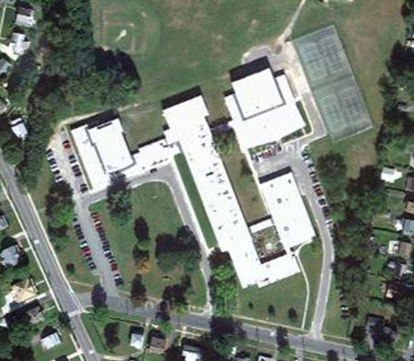

Prepared by:
Massachusetts Department of Public Health
Bureau of Environmental Health
Indoor Air Quality Program
July 2012

Background/Introduction
At the request of Mr. Calvin Joppru, Senior Code Enforcement Inspector for the Pittsfield Health Department, the Massachusetts Department of Public Health (MDPH), Bureau of Environmental Health (BEH) provided assistance and consultation regarding indoor air quality (IAQ) concerns at the Theodore Herberg Middle School (HMS) located at 501 Pomeroy St, Pittsfield, Massachusetts. The request was prompted by concerns of odors inside the building that reportedly occur after rain storms and potential mold growth. On June 8, 2012, a visit to conduct an IAQ assessment was made to the HMS by Michael Feeney, Director of BEH’s IAQ Program and Kathleen Gilmore, Environmental Analyst/Regional Inspector for BEH’s IAQ Program. Mr. Eric Brown of the Pittsfield Department of Public Works and Utilities accompanied BEH staff on the assessment.
The HMS was constructed as a junior high school in 1955 and underwent extensive renovation in 1999. A crawlspace exists under the building for utilities. Windows are openable throughout the building.

Methods
BEH staff performed a visual inspection of interior locations of reported odors, roof, grounds, boiler room and crawlspace during the visit. The inspection was conducted during normal operations at the school.

Results
The building is a middle school serving grades 6-8, with a student population of approximately 600 and a staff of approximately 70.

Discussion
Odor/Moisture/Microbial Concerns
As mentioned, concerns of odors and mold growth in the building prompted the assessment. HMS school officials reported periodic episodes of intense odors that appear to be associated with rain storms. BEH staff examined locations in the building that had reported incidents of odors including the boiler room and crawlspace.
Mold colonization/growth would be expected to be present in an unconditioned cement floor crawlspace that is subjected to moisture. Efforts should be made to reduce moisture, circulate air and reduce/eliminate potential pathways for mold, spores, and associated odors to migrate into occupied areas. The most obvious means for odors and pollutants to migrate between the crawlspace and occupied areas on the ground floor are holes and spaces surrounding utility pipes (e.g., fire suppression plumbing, radiators, univents) (Pictures 1-3). Airflow tends to rise and these breaches can serve as pathways to draw air, odors and particulates from the crawlspace into hallways and classrooms. This condition is known as the stack effect. All holes and gaps should be sealed with fire-rated sealant foam or other appropriate material.
BEH staff also examined a portion of the roof. The roof contained a significant number of exhaust vents (Picture 4) which were not operating at the time of the assessment. Exhaust ventilation systems must operate in order to remove water vapor, odors and other pollutants from restrooms, storerooms, custodial closets and other locations where odors and/or water vapor is present. Without an operating ventilation system, odors will tend to linger within the building.
In addition to the lack of operating exhaust vents, large trees directly abut the side of the building and rest on the roof (Picture 5). Pollen and debris from trees can clog ventilation systems or provide harborage for insects, rodents, birds and other pests resulting in a source of allergens and mold within the building. In addition, the growth of roots against exterior walls can bring moisture in contact with brick, eventually leading to cracks and/or fissures in the foundation below ground level. Over time, this process can undermine the integrity of the building envelope and provide a means of water entry into the building through capillary action through foundation concrete and/or masonry (Lstiburek & Brennan, 2001).
Also of note are restroom doors. In order for restroom exhaust vents to operate, an adequate source of transfer air needs to exist. The restroom doors examined during the assessment completely close over their frames, cutting off any source of transfer air from the hallway. This condition can then result in drawing air from floor drains if the traps are not wet appropriately. Lack of transfer air can also stress exhaust motors and cause them to burn out prematurely.
Concerns related to other odors independent from the crawlspace flooding were also expressed. An art workshop that is currently used for classroom space had reported propane-like odors. The boiler room access door exists in this room. Light could be seen penetrating through the space underneath this door, indicating it is not airtight (Picture 6). This door space is a likely pathway for boiler room odors to enter this room.
School officials report sewer odors in a science classroom. The source of the odors was believed to be an acid neutralization tank that was installed in the floor of this room without a trap (Picture 7). Without a trap, odors from the sewer system would back up into the acid neutralization tank and then into the classroom through the hatch in the floor. According the school officials, equipment to prevent this odor backup was installed following the BEH visit.
A significant odor of hydraulic fluid oil (HFO) was detected in the elevator machine room. This room has an exhaust vent that terminates on the roof to a non-motorized “candy cane” vent (Picture 8). The HFO odor indicated that a leak exists in the hydraulic system for the elevator and should be repaired. In its current condition, the exhaust vent provides little or no removal of air and odor from the elevator machine room. In addition, no means exists for transfer air to enter the elevator machine room to aid odor removal.

Conclusions/Recommendations
Based on these observations, there exist a number of sources of odors in the HMS. This assessment was limited to the areas examined. For these reasons, a two-phase approach is required for remediation. The first consists of short-term measures to improve air quality and the second consists of long-term measures that will require planning and resources to adequately address overall IAQ conditions.

Short-Term Recommendations
- During times of extended rainstorms, prior to school opening, it is advised that staff use floor fans to depressurize the crawlspace via the boiler room exterior door and to pressurize hallways by placing a floor fan at an exterior door to inject air into the occupied areas. This means to reduce odors should be employed until the pathways for odors to enter occupied space from the crawlspace are remediated.
- Open windows (weather permitting) to temper rooms and provide fresh outside air. Care should be taken to ensure windows are properly closed at night and weekends during winter months to avoid the freezing of pipes and potential flooding. In addition, keep windows closed during hot, humid weather to maintain indoor temperatures and to avoid condensation problems when air conditioning is activated.
- Seal all utility pipes, fire suppression systems pipes, conduit and other penetrations in the ceiling and walls of the crawlspace, in the floor of classrooms, inside unit ventilators and plumbing using an expandable, fire-rated sealing compound.
- Undercut restroom doors by 2-inches to provide transfer air for the restroom exhaust vents.
- Operate restroom exhaust vents during schools hours. Repair as needed.
- Install a door sweep beneath the boiler room door. Install weather-stripping around the door frame to render it airtight.
- Examine all exhaust vents on the roof and repair as needed. Operate exhaust vents for custodial closets during school hours.
- Repair HFO leaks in elevator system.
- Refer to resource manuals and other related indoor air quality documents for further building-wide evaluations and advice on maintaining public buildings. These materials are located on the MDPH’s website: http://mass.gov/dph/iaq.

Long-Term Recommendations
- Consider installing an exhaust motor on the vent for the elevator mechanical room.
- Remove large trees that abut the side and rest on the roof of the building.

References
Lstiburek, J. & Brennan, T. 2001. Read This Before You Design, Build or Renovate. Building Science Corporation, Westford, MA. U.S. Department of Housing and Urban Development, Region I, Boston, MA.

Picture 1

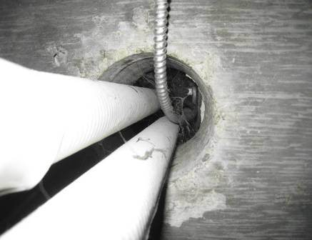

Unsealed Heating Pipe/Electrical Conduit Hole in Crawlspace

Picture 2

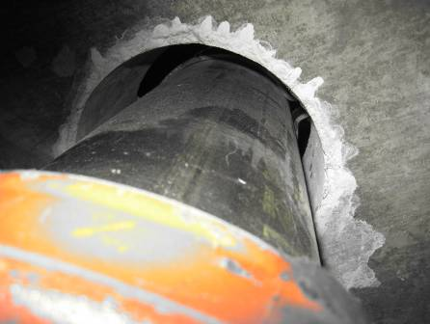

Unsealed Fire Suppression System Pipe Hole in Crawlspace
Picture 3

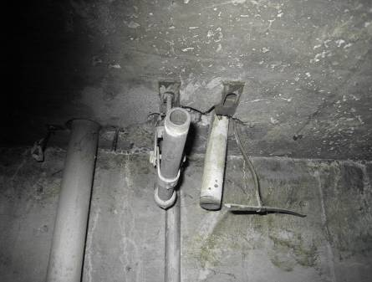

Open Abandoned Pipes in Crawlspace

Picture 4

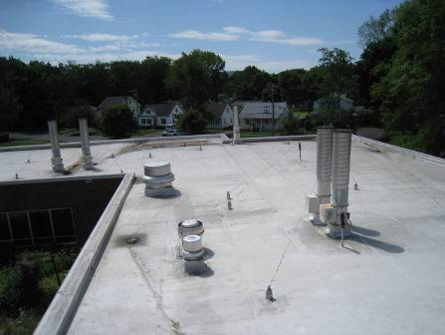

Roof Exhaust Vents

Picture 5

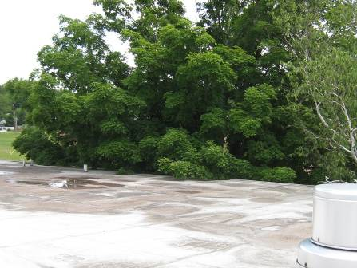

Trees Abutting and Leaning on Building Roof

Picture 6

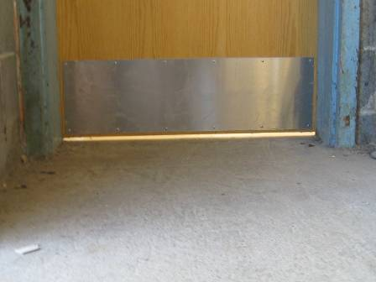

Space beneath Boiler Room Door

Picture 7

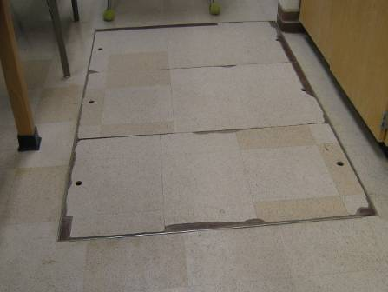

Access Hatch to Acid Neutralization Tank Installed in the Floor

Picture 8

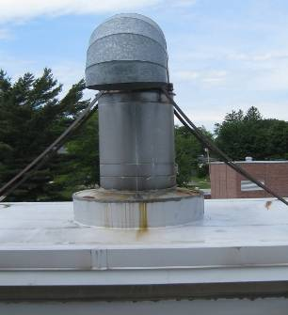

Non-Motorized “Candy Cane” Vent

Transfer air is air that passes from one ventilation zone to another or from one area to another, usually by a passive vent or opening.

