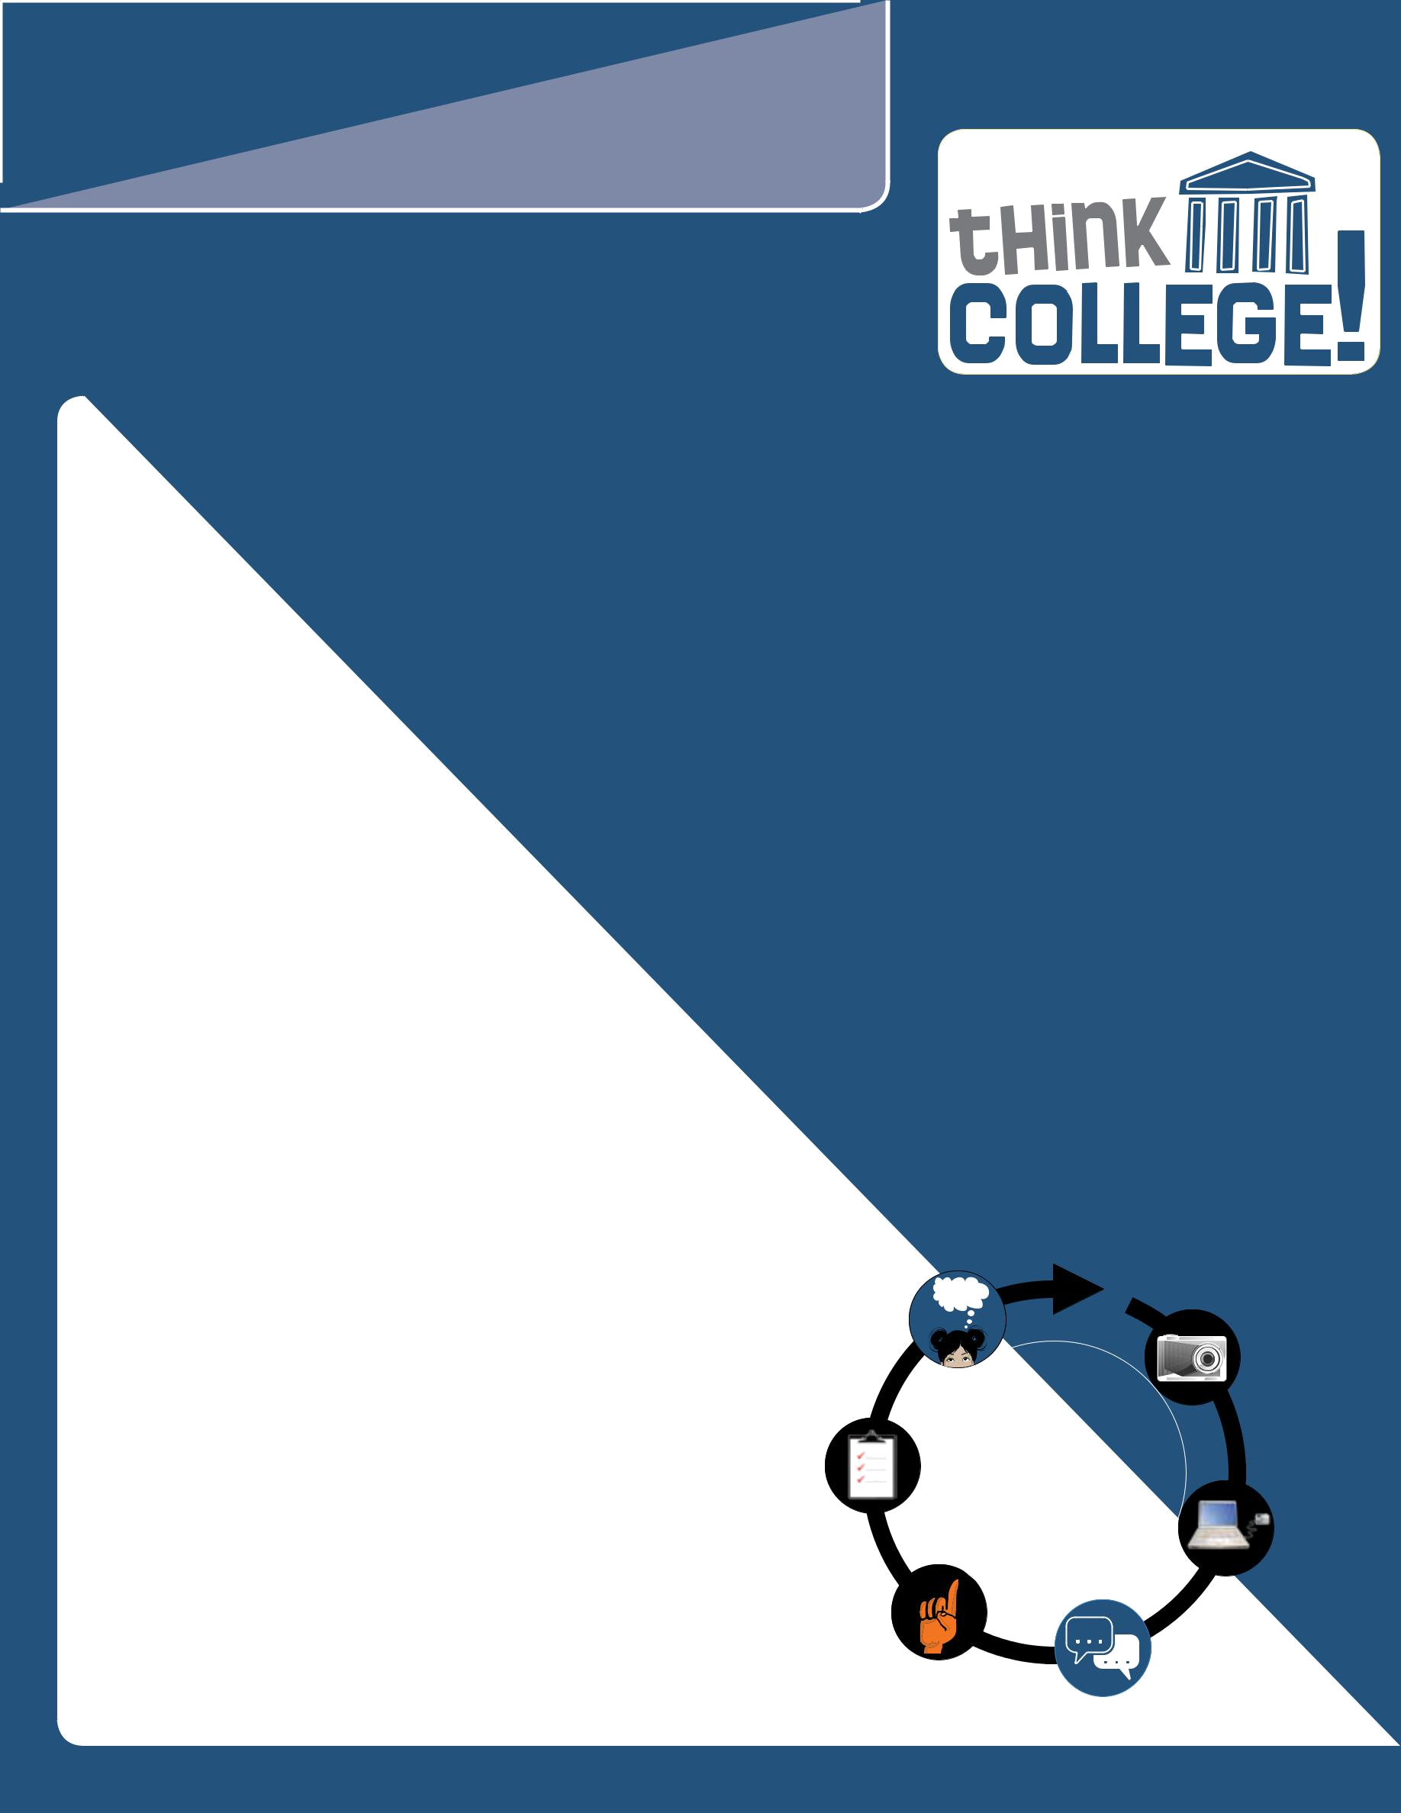
INSIGHT
A Think College Brief on Policy, Research, & Practice

Think, Hear, See, Believe College: Students Using Participatory Action Research to Document the College Experience
By Maria Paiewonsky, Allison Sroka, Meghan Ahearn, Antony Santucci, Grace Quiah, Cassidy Bauer, Joseph Fearebay, Stephan Wright, Christine Chu, and Wilson Lee

ISSUE NO. 5 NOVEMBER 2010

Introduction

Nine Massachusetts college students who have an intellectual disability (ID) conducted research on their experiences in college as part of the national Think College initiative. The purpose of Think College is to assist people with ID in going to college. Participatory action research (PAR) is a series of steps the students used to document their college experience. For their research, they used digital and video cameras to collect information. To share their experiences with each other, they also used VoiceThread, a digital storytelling website. This issue of Insight describes how students are using PAR and digital storytelling on VoiceThread to discuss their college experience.

Who are the researchers?

The student researchers are from four colleges that support

students with intellectual disabilities. The only requirement was that the

students had completed

at least one full semester

of college so they could comment on the whole experience.

What is Participatory Action Research?

Participatory action research is a way for a group of people to investigate issues of interest or concern. To do this kind of

Steps of Participatory Action Research
The students followed six steps beginning in January 2009. Starting with the camera illustration, and moving to the right, the Participatory Action Research figure shows the steps of the students’ work:

- In the first step, the students documented their college experiences with cameras or pocket video cameras.

- In the second step, the students shared their photos or video clips with the other students on the VoiceThread website.

- In the third step, the students discussed their data, commenting on their own and each other’s research.

- In the fourth step, the students made recommendations for changes that they thought could help improve the college experience.

- In the fifth step, the students decided on actions they could take as a result of their research.

- Finally, in the sixth step, the students reflected on their research and decided if more needed to be done.

PARTICIPATORY ACTION RESEARCH

REFLECT

DOCUMENT

research, people first describe the issues as thoroughly as possible and then brainstorm solutions. Then they try out some of their solutions to see if they are effective. After giving these solutions some time to work, the researchers get back together to reflect on what happened and to make a decision about what else needs to be done. For this research, students used PAR and digital storytelling to report on college. Both these methods encourage participants to take and share photographs that help other people understand their college experiences.

ACT

RECOMMEND

SHARE

DISCUSS

www.thinkcollege.net

Research in Action >>
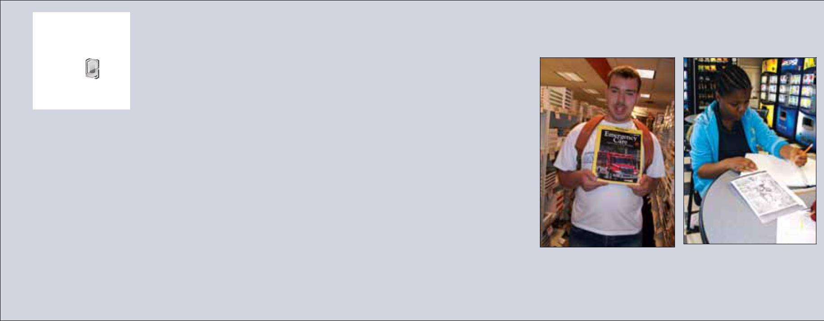
DOCUMENT | Step 1: Document College Experiences
 | To begin the research, Think College staff proposed a few
 | questions to the students as a way to think about organizing
 | their work. Some of these questions included:
xx What do you do at college?
xx How do you describe your college experience?
xx What is going well at college? What is difficult?
xx What suggestions do you have for younger students who haven’t thought about
college or are nervous about trying a class?
The students took over 250 photos and videos over the course of the spring semester |  | Joe Fearebay documented | Grace Quiah discussed
to document their college experiences. In the next phase of the work, the students |  | Joe Fearebay documented | Grace Quiah discussed
 |  | his determination to study | the academic challenges
selected what they wanted to share with their fellow researchers across the state. |  | to be an EMT at college
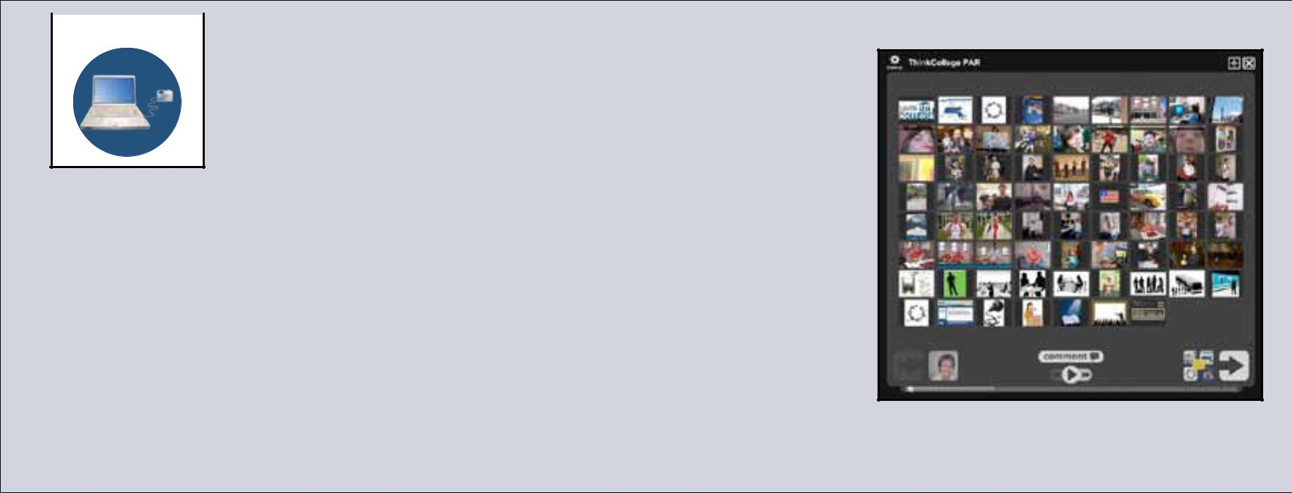

 | Step 2: Share Photos & Video Clips
SHARE | Step 2: Share Photos & Video Clips

Since the students live across Massachusetts, the group worked together online. A website called VoiceThread (http://voicethread.com/#home) allows people to create an online space to share photos and to comment on their

own and others’ photos. So, Think College staff joined VoiceThread so that the group could create their own VoiceThread (called Think College PAR) to upload their photos and stories and also to keep their work private.

In total, nine students uploaded over 50 photos and video clips onto the Think College PAR VoiceThread. Some images showed them using public transportation to get to college; others showed them using the library, the recreation center, or the student center. A few students posted about attending special events at the college, such as the Spring Fling, held right before the spring break.
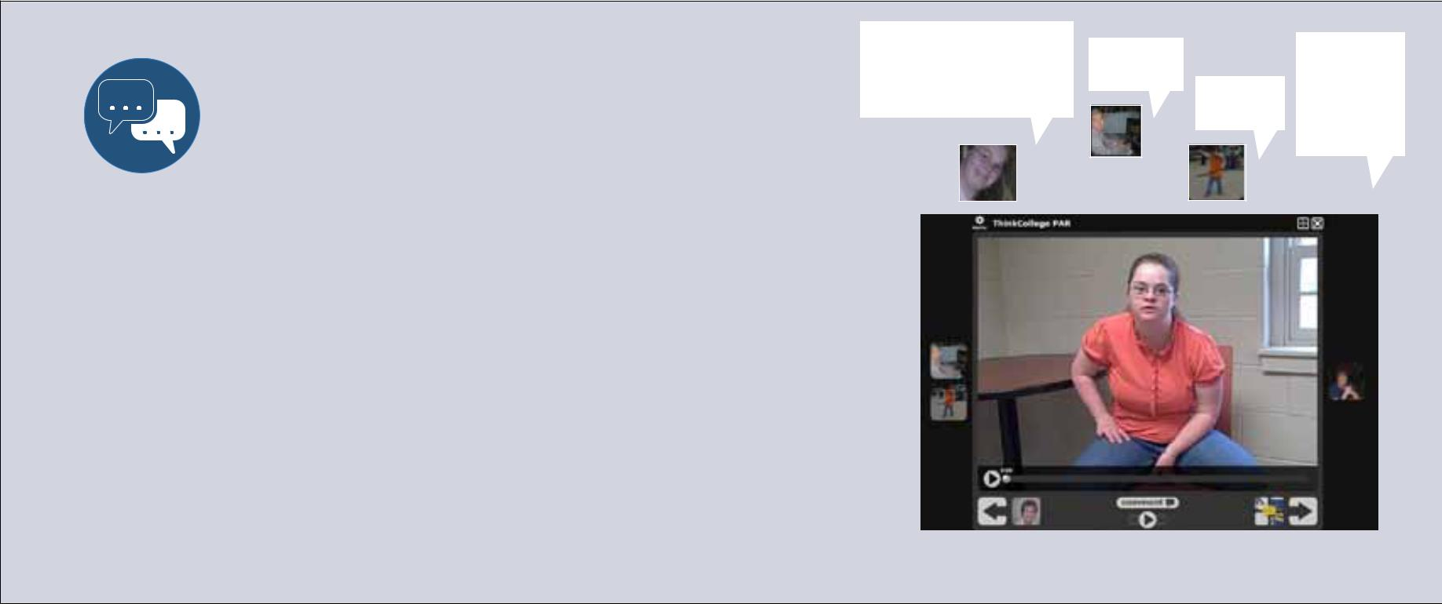

Student researchers posted images and video clips on the Think College Voicethread

DISCUSS | Step 3: Discuss Data
 | The students posted nearly 300 comments on
 | VoiceThread, using a keyboard, phone, webcam,
 | or computer microphone. Through this forum,
 | they were able not only to share their own

successes and challenges but also to learn about issues that vary throughout the state, such as transportation needs.

A major part of the VoiceThread discussion included figuring out how each student’s experiences compared with the other students. Think College staff working with the students reviewed the photos, video clips, and comments, and then helped organize the images to represent various themes. The students thought about these themes and commented on each of them. Table 1 on the following page shows a summary of student comments on these themes.

Cassidy: Take a simple class. We all have rights to go to college and have fun. Be independent more. Think about what you want to do in life.

Wilson:

I agree with her.

Allison: Good advice.

Antony: Wow, Cassidy, very good advice and I know me and a lot of other people could not agree with you more.

Cassidy Bauer offers advice to students who are unsure they should try college.

Student Findings>>
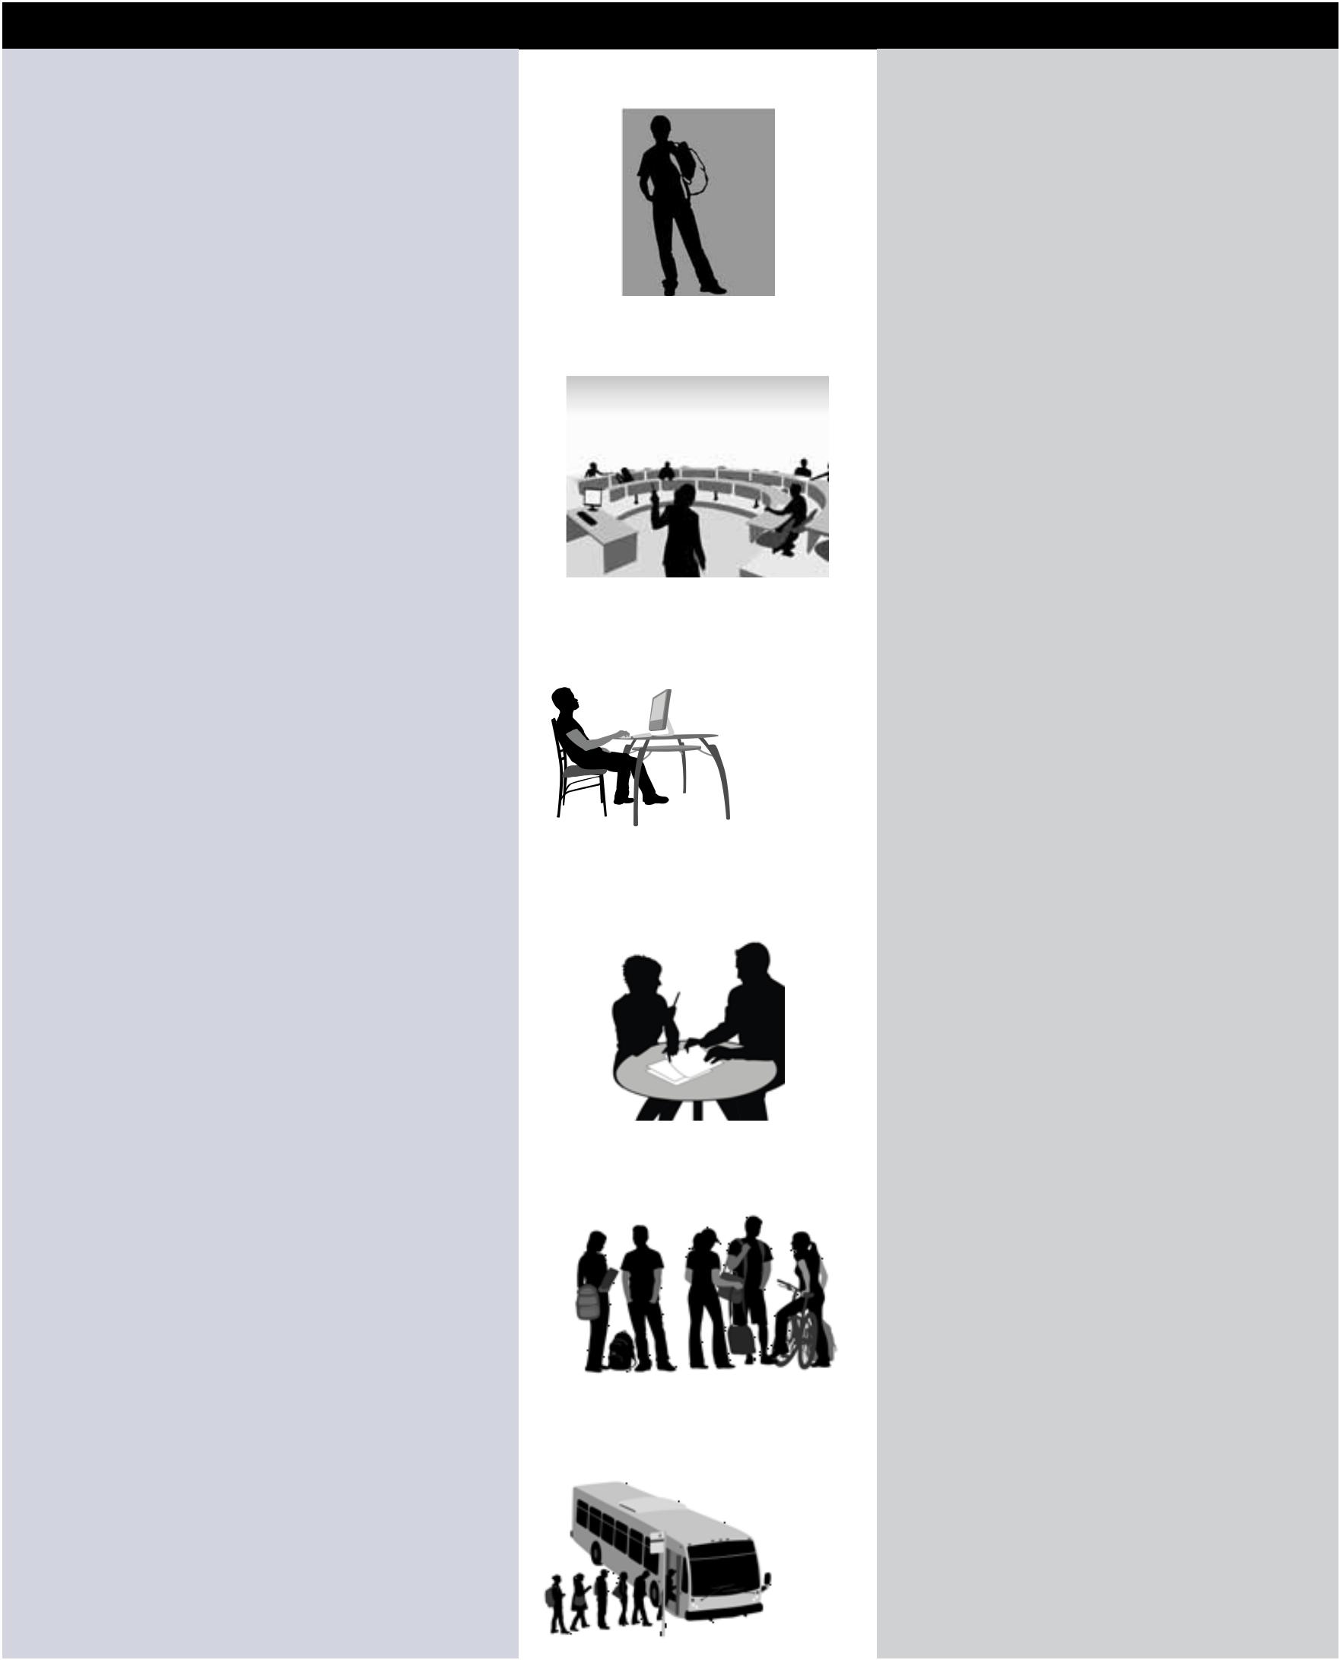
What Makes College Successful | Theme | What Needs To Improve
Having independence on campus | New Identity/Feeling Free | More opportunities for students to take
Choosing your own schedule |  | college classes
Being yourself or re-inventing yourself.
College can be a reset button
Being with other college students
Becoming an educated person
Very different courses than those offered in high | Access To Different Classes | Opportunities to talk to other students
school |  | about classes before enrolling in them
Courses more tied to student interests |  | Access to courses tied to career interests
Bigger selection of courses |  | More sections of classes offered
Opportunities to take classes at various times |  | Having support to take night and weekend
and in multiple ways (face-to-face/online) |  | classes
Classes give students an opportunity to discover
strengths and preferences
Being treated like an adult | Adjusting To New Expectations | Understanding student expectations before
Not babied in college—you’re on your own |  | going to college
Students learn to take responsibility for |  | Knowing how to organize schedule
themselves |  | Being familiar with college terms like
Less inhibiting to try things in college |  | syllabus, due date, and reading assignment
Having an educational coach can be very helpful | Working With Educational | Coaches need to let students do their own
Coaches can help you settle in | Coaches | work
Coaches can help you learn to get around the |  | Students need to try doing assignments on
Coaches can help you learn to get around the |  | their own before asking for help
campus |  | their own before asking for help
Coaches can help you figure out homework and |  | Coaches need to trust students do more
Coaches can help you figure out homework and |  | on their own
other assignments |  | on their own
Having time to stay on campus | Campus Life | Allow more time to be on campus
Using computers at the library to check email, |  | More support to take advantage of evening
access social media websites |  | and weekend college events
Using the recreation facilities to work out, take |  | More strategies to develop friendships with
fitness classes |  | college students
Hanging out at the student center, joining clubs
Meeting new and old friends at the cafeteria
Being able to use public transportation to get to | Transportation | More transportation options for students in
campus |  | rural areas
College shuttle
Taking care of your own transportation

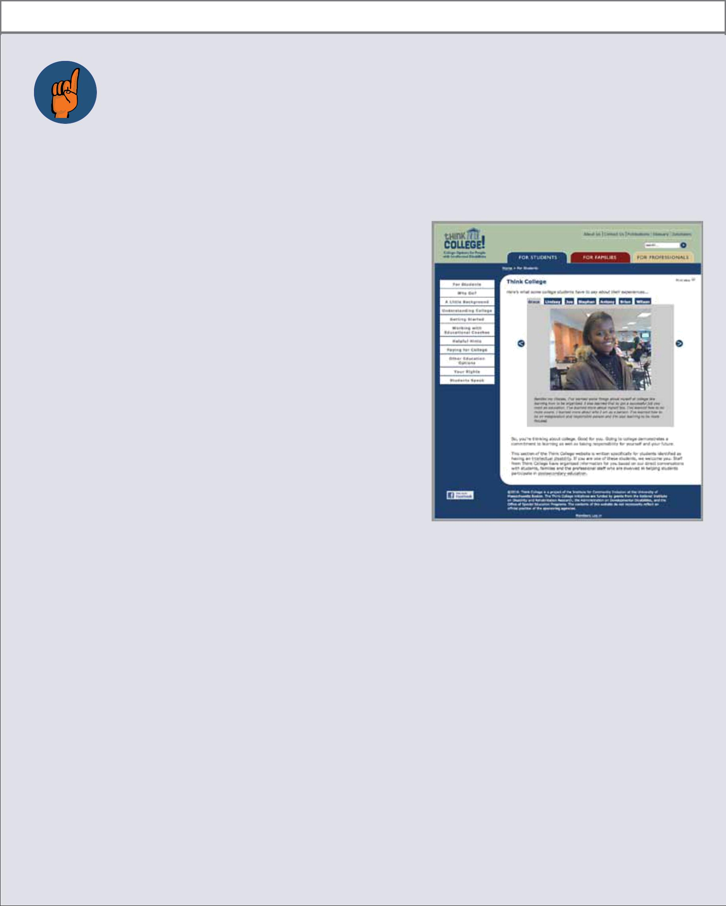
 |  | Step 4: Make Recommendations
 | RECOMMEND | Step 4: Make Recommendations
 |  | Based on the images and videos shared on VoiceThread, students
 |  | had many recommendations for potential college students:

1. For students who are not sure if college is right for them:

xx Come talk to us or to other students you know who have gone to college. xx Visit colleges and take a tour.

2. When selecting a class:

xx Talk to other students who have taken a class you are interested in to hear what it is like. You can talk to students at the student center, the fitness center, or the cafeteria.

xx Start with a simple class.

xx Think about taking an orientation to college class and a career class, to figure out what you like.

3. Working with educational coaches: xx Figure out how to work together.

xx Take responsibility for yourself and only ask the educational coach for help when you really need it.

xx Remember, educational coaches can’t help you with everything.

4. Doing college work:

xx Be prepared. Get all your supplies before the course starts. xx Get ready for lots of reading and homework.

xx You have to learn that college can be hard but it will get easier. xx College work is much harder than high school work.

xx Talk to somebody like your professor when you need help. xx Remember that you can go to disability services for help. xx Remember that you are responsible for your own work.

The student researchers agreed on several methods to share their research findings. These methods include (1) posting their work on the student section of the Think College website, (2) writing stories and articles and (3) presenting their work to younger peers as well as at conferences.

xx College professors won’t baby you. You have to read the syllabus and ask for help if you need it. xx Take your time with homework—don’t rush through it.

5. Spending time on campus

xx Make time to go to the cafeteria, student center, fitness center, and library. xx Make time to have fun on campus, even if it’s just hanging out with people.

6. Tips for starting new friendships with classmates or students you meet on campus xx Invite them to have lunch with you in the cafeteria.
xx Ask them about the classes they are taking.

xx Offer to exchange email addresses so you can stay in touch.

xx Ask them what they think about the college you are both attending.

www.thinkcollege.net

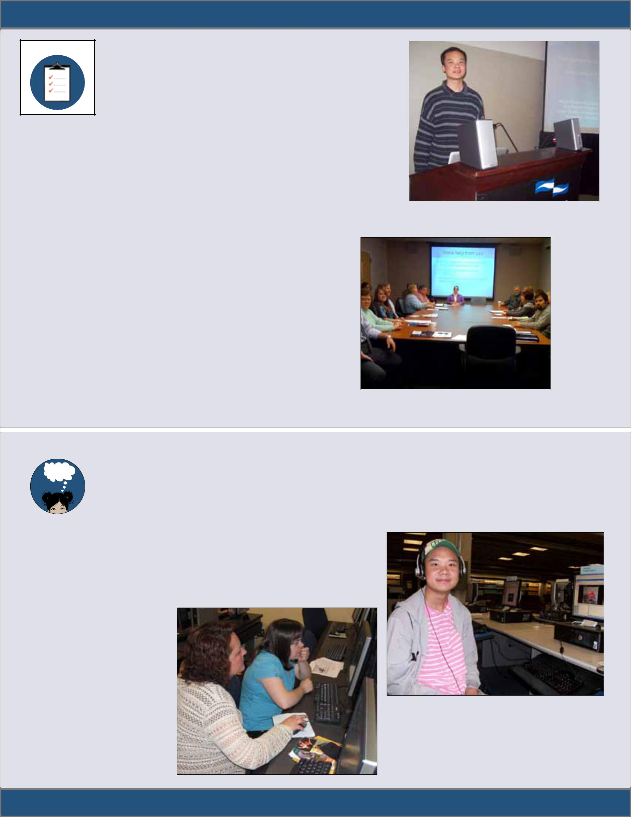
INSIGHT: A Think College Brief on Policy, Research, & Practice • Issue No. 5

ACT Step 5: Act on Results

Now that they had results from their research, the students decided on six ways to share their research and take action. They had a number of discussions with the research facilitator about the

importance of their work. The facilitator showed the group several ways that they could share their research results. The student researchers chose to take the following steps:

- Present information to the advisory board of Think College.

- Use research to make recommendations for improving the student section of the Think College website.

- Present work to younger students in high schools and middle schools.

- Develop digital stories about their college experiences that will be posted on the Think College website.

- Present their research at local conferences and to advocacy groups.

- Write short articles and briefs about their work to post on the student section of Think College.

Wilson Lee presented the research findings at a statewide conference for families and professionals

Cassidy Bauer presented at a college/school partnership meeting

 | Step 6: Reflect on Research
REFLECT | Step 6: Reflect on Research
 | In reflecting on the year’s research work, the students agreed that having the opportunity to do PAR
 | was important. They suggested that many more students should have this opportunity to document
 | and reflect on college. One student pointed out that
 | writing up an article is helpful, because then you have

something to show students who are thinking about college. Another said, “It’s important for students to have a chance to talk about their transition. Things change and students need to talk about their goals.” Some students said that doing research was easier than they thought. One student concluded,

“I think it would help students to do projects like this. Some people think going to college is a waste of time and I tell them it’s not. This gives me a chance to show people it’s a good idea.”

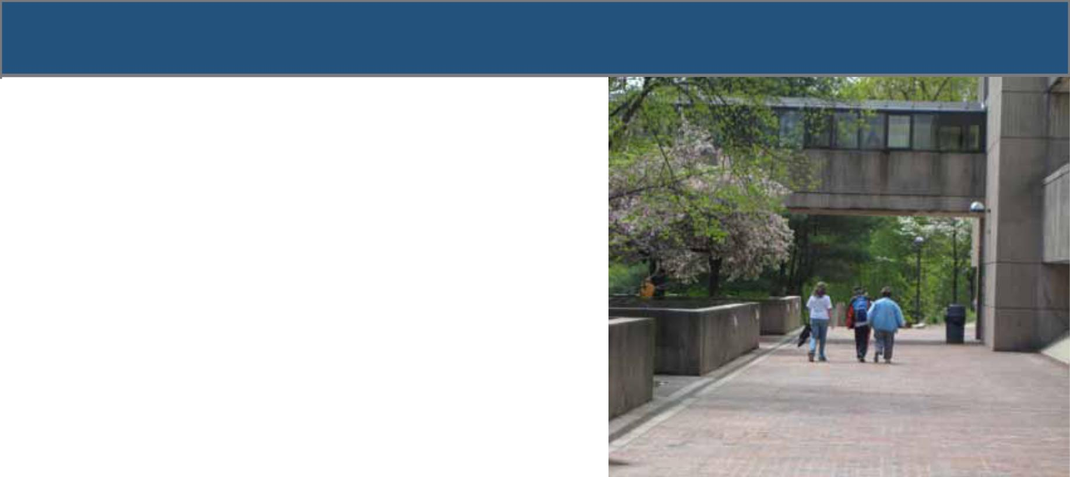
To learn more about college, visit these websites:

Think College

www.thinkcollege.net

Think College offers students, families, and teachers a lot of resources to prepare for and do well in college. One of the highlights of Think College is hearing first-hand from students about their college experiences. You can also look up colleges that support college students with intellectual disabilities.

Going to College
www.going-to-college.org/

Going to College features video clips of students talking about many different aspects of college, including planning for and applying to college, talking to professors, and requesting accommodations. This website also has a section called “My Portfolio” where students can keep track of their college planning activities.

College.gov
www.college.gov/wps/portal

College.gov provides information for students and families about preparing to go to college. In addition to video clips of students talking about college, this website has tips for high-school students, including how to apply to college and how to learn about financial aid.

College Planning Resources for Teens
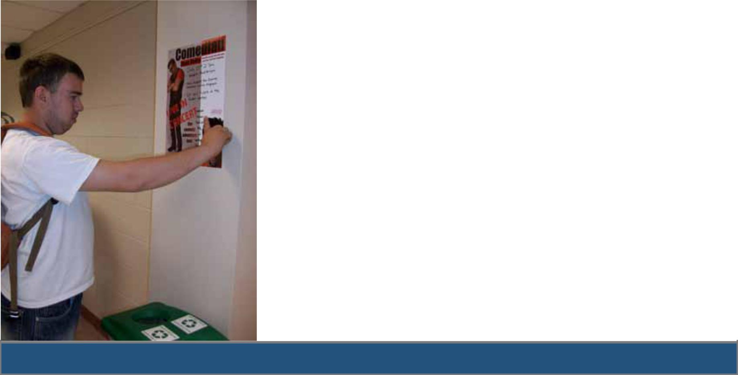
www.quintcareers.com/teen_college.html

College Planning Resources for Teens has tutorials that help students prepare for college. The tutorials focus on questions many students have about college planning. Topics include getting good recommendations, picking a major, and “twenty-five tips to survive and thrive in your first year of college and beyond.”

PepNet
www.pepnet.org/itransition.asp

PepNet focuses on helping transition-age students who are deaf or hard of hearing prepare for their transition from high school. The website offers lots of information on how to plan for and be successful in college, and discusses skills that are essential for campus living.

www.thinkcollege.net

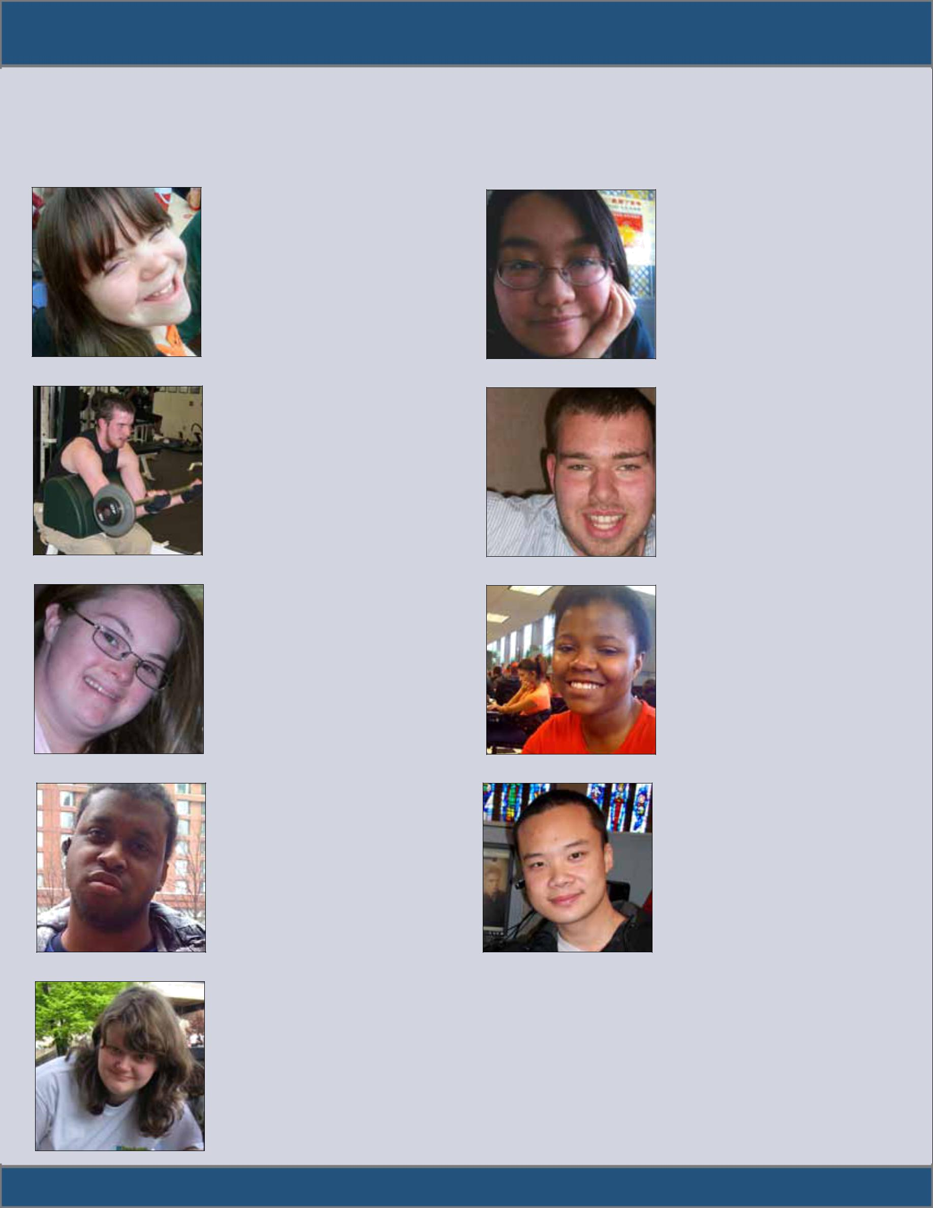
meet the student researchers>>

The students who participated in this project were concurrently enrolled in high school and college. This research project gave them an opportunity to document their college experiences and to highlight issues of importance to younger peers, professionals, and family members of people with intellectual disabilities.

Allison Sroka

Allison took a variety of courses at college, including theater arts, fine arts, fitness, and public speaking.
She focused her research on the new learning opportunities that students have at college.

Antony Santucci

When he enrolled at college, Antony intended to focus his studies on construction, but soon found his way to set design courses in the theater arts department. That led to a new interest in acting and performance courses. Antony focused some of his research on how college can be a fresh start for students.

Cassidy Bauer

Cassidy enrolled in college courses that helped her explore career interests in culinary arts, clerical skills, and fine arts. Her long-term involvement in a self-advocacy group is evident in her research, in which she encouraged younger peers to remember their right to pursue postsecondary education.

Stephan Wright

Stephan’s status as the only student researcher to take classes from two colleges gave him a unique perspective on postsecondary education. He focused much of his research on the importance of sticking it out in college, even when small things (slow public transportation) and bigger things (hard classes) are challenging.

Meghan Ahearn

Meghan enrolled in college courses related to her career interests, including culinary arts, visual arts, and human services. She used a video camera to record interviews with college students about their first year of college. Meghan also led a discussion about working with educational coaches.

Christine Chu

Christine Chu learned to take public transportation and a shuttle van to the college campus where she took courses in computers. Her dream is to work in an office. Christine made a number of recommendations to younger peers. One was that students do as much work on their own before asking for help.

Joseph Fearebay

Right from the start, Joe knew that he wanted to take a class that would
prepare him to be an emergency medical technician (EMT). His first course was a first aid class. Joe focused his research on two topics: the freedom students have on a college campus and strategies for making friends at college.

Grace Quiah

The first course Grace took was a career planning class. As a result of new job interests, she took an art class and computer course. Grace focused her research on her discovery that students can learn a lot about themselves in college.

Wilson Lee

Wilson took a variety of courses at college, including career planning, anatomy and physiology, and business and management. Although he took several courses that required a lot of time studying, he focused much of his research on the importance of finding time to hang out on campus.


Recommendations for student research

For those students who are interested in documenting their college experiences or discussing college with others, here are a few tips:

- Talk to someone who might be able to help organize a research project like this. Along with your request, you may give the person this brief to explain how participatory action research works.

- Choose your research theme. Here are some possible topics to get you started:

  - What college life looks like

  - People you have met at college

  - Where you go on campus

  - What you are learning at college

  - Something you wish was different about college

  - What younger students need to understand about college

- Next, decide how you want to document, or keep track of, your college experience. Consider using a digital camera or a pocket video camera. Do you want to record a story? A mini digital recorder is easy to use. If you prefer to write, start with a story about a great (or a not-so-great) campus experience.

- Remember to ask permission if you are going to take someone’s picture. Explain why you are taking the picture and how you might use it. If they don’t want you to take a picture, thank them. Then think of another way to express your thought or move on to your next idea.

- Decide how you want to share your photos or video clips with other people. Can you get together and show each other your work? Do you need to share your work online? If so, how (such as using email, Voicethread, a social media website)?

- Think about how each person will comment on other people’s work. Will you type comments or record them? Will you videotape responses? Do what is easiest.

- Think about common themes in all your work. What are you learning and what do you want to tell others about your work? Write down your themes, or record them another way, so that you can keep track of them.

- Who should know about your work and how will they learn about it? Will you invite people to a presentation? Will you write a story about your work? Decide how you will share your research with an audience.

- What do you want to do next? Take more pictures to document college, write about your college experience or present your work to others.

INSIGHT, Issue No. 5, November 2010

Insight is a publication of Think College, a project of the Institute for Community Inclusion at the University of Massachusetts Boston, funded by grants from the National Institute on Disability and Rehabilitation Research (CFDA #H133A80042), the Administration on Developmental Disabilities (CFDA# 93-632 Grant No. 90DD0659), and the Office of Special Education Programs (CFDA #H324CO40241).

Recommended citation for this brief: Paiewonsky, M., Sroka, A. Ahearn, M., Santucci, A., Quiah, G. Bauer, C., Fearebay, J., Wright, S., Chu, C. & Lee, W. (2010). Think, Hear, See, Believe College: Students Using Participatory Action Research to Document the College Experience. Think College Insight Brief, Issue No. 5. Boston, MA: Institute for Community Inclusion, University of Massachusetts Boston.

For more information, contact Maria Paiewonsky. Institute for Community Inclusion, UMass Boston (617) 287-7697 • maria.paiewonsky@umb.edu

This publication will be made available in alternate formats upon request.

www.thinkcollege.thinkcolege.net.net •• www.facebook.facebook.com/thinkcollege.co/thinkcolege

