INDOOR AIR QUALITY ASSESSMENT

Thomas Carroll School
60 Northend Street
Peabody, Massachusetts 01960



Prepared by:
Massachusetts Department of Public Health
Bureau of Environmental Health
Indoor Air Quality Program
December 2009

Background/Introduction
At the request of Sharon Cameron, Director of the Peabody Health Department (PHD), the Massachusetts Department of Public Health (MDPH), Bureau of Environmental Health (BEH) provided assistance and consultation regarding indoor air quality (IAQ) at the Thomas Carroll School (TCS), 30 Northend Street, Peabody, Massachusetts. On September 29, 2009, a visit to conduct an IAQ assessment was made to the TCS by Michael Feeney, Director of BEH’s IAQ Program. Mr. Feeney was assisted by Cory Holmes and Sharon Lee, Environmental Analysts/Inspectors within the IAQ Program. During the assessment, BEH staff were accompanied by various members of the school department, as well as by city officials. The request was prompted by concerns of mold growth on surfaces of building materials (e.g., walls) as well as various items (e.g., desks, bookcases) in below grade kindergarten classrooms.
The TCS is a three-story, red brick building that was completed in 2002-2003. The school consists of general classrooms, a gymnasium, cafeteria/auditorium, media center, art rooms, music/band rooms, teacher work rooms and office space. Windows are openable throughout the building.

Methods
Air tests for carbon dioxide, carbon monoxide, temperature and relative humidity were conducted with the TSI, Q-TRAK™ IAQ Monitor, Model 7565. Air tests for airborne particulate matter with a diameter less than 2.5 micrometers were taken with the TSI, DUSTTRAK™ Aerosol Monitor Model 8520. BEH staff performed a visual inspection of building materials for water damage and/or microbial growth.

Results
The TCS houses approximately 500 students in kindergarten through fifth grade and a staff of approximately 70. Tests were taken under normal operating conditions and results appear in Table 1.

Discussion

Ventilation
It can be seen from Table 1 that carbon dioxide levels were above 800 parts per million (ppm) in 5 of 61 areas, indicating adequate air exchange in the majority of the building on the day of the assessment. Mechanical ventilation for classrooms in this school is provided by a computerized heating, ventilating and air-conditioning (HVAC) system. Fresh outside air is drawn in through rooftop air-handling units (AHUs; Pictures 1 and 2) and then filtered, heated, and/or cooled before it is distributed to occupied areas via ceiling or wall-mounted air diffusers (Pictures 3 and 4). These units provide 100 percent fresh air to the building. Ceiling and wall-mounted exhaust vents on the first through third floors are ducted to rooftop fans, which exhaust air from the building. Exhaust for the ground floor is provided by grates which open to the ceiling plenum, where air is returned to the AHUs via ductwork (Picture 5). In many classrooms, supply or exhaust vents were located in close proximity to hallway doors (Picture 4). When the classroom door is open, a supply vent distributes air towards the hallway and an exhaust vent tends to draw air from the hallway. Open doors reduce the effectiveness of the vents to supply/exhaust air to the classrooms. Classroom doors should be closed to allow for proper ventilation.
Auxiliary heating/cooling and air circulation in classrooms is supplemented by fan coil units (FCUs) (Picture 6). FCUs do not provide fresh air to rooms; rather, they re-circulate air and provide auxiliary heating or cooling as needed. A FCU draws air from the room through an intake located at the base of the unit. Air is filtered and conditioned by a coil, then distributed back to the room through an air diffuser atop the unit (Figure 1). Each FCU is controlled by a switch with settings for “low”, “medium”, “high”, and “off”. In some classrooms, FCUs were off. FCU must be allowed to operate during periods of school occupancy to aid in ventilation/air movement within classrooms.
Fresh air for common areas such as the gymnasium, cafeteria, library, and administrative areas is provided by rooftop or ceiling-mounted air handling units (AHUs). These units were operating during the assessment.
To maximize air exchange, the MDPH recommends that both supply and exhaust ventilation operate continuously during periods of school occupancy. In order to have proper ventilation with a mechanical supply and exhaust system, the systems must be balanced to provide an adequate amount of fresh air to the interior of a room while removing stale air from the room. It is recommended that existing ventilation systems be re-balanced every five years to ensure adequate air systems function (SMACNA, 1994). The systems were believed to be balanced in 2002-2003 upon completion of the school construction.
The Massachusetts Building Code requires that each room have a minimum ventilation rate of 15 cubic feet per minute (cfm) per occupant of fresh outside air or openable windows (SBBRS, 1997; BOCA, 1993). The ventilation must be on at all times that the room is occupied. Providing adequate fresh air ventilation with open windows and maintaining the temperature in the comfort range during the cold weather season is impractical. Mechanical ventilation is usually required to provide adequate fresh air ventilation.
Carbon dioxide is not a problem in and of itself. It is used as an indicator of the adequacy of the fresh air ventilation. As carbon dioxide levels rise, it indicates that the ventilating system is malfunctioning or the design occupancy of the room is being exceeded. When this happens a buildup of common indoor air pollutants can occur, leading to discomfort or health complaints. The Occupational Safety and Health Administration (OSHA) standard for carbon dioxide is 5,000 parts per million parts of air (ppm). Workers may be exposed to this level for 40 hours/week based on a time weighted average (OSHA, 1997).
The MDPH uses a guideline of 800 ppm for publicly occupied buildings. A guideline of 600 ppm or less is preferred in schools due to the fact that the majority of occupants are young and considered to be a more sensitive population in the evaluation of environmental health status. Inadequate ventilation and/or elevated temperatures are major causes of complaints such as respiratory, eye, nose and throat irritation, lethargy and headaches. For more information concerning carbon dioxide, please see Appendix A.
Indoor temperature readings on the day of the assessment ranged from 66º F to 73º F, which were within or close to the lower end of the MDPH comfort guidelines. The MDPH recommends that indoor air temperatures be maintained in a range of 70 º F to 78 º F in order to provide for the comfort of building occupants. In many cases concerning indoor air quality, fluctuations of temperature in occupied spaces are typically experienced, even in a building with an adequate fresh air supply. A number of temperature and ventilation control complaints were expressed in the building.
The relative humidity measurements ranged from 45 to 59 percent, which were within the MDPH recommended comfort range the day of the assessment. The MDPH recommends a comfort range of 40 to 60 percent for indoor air relative humidity. Relative humidity levels in the building would be expected to drop during the winter months due to heating. The sensation of dryness and irritation is common in a low relative humidity environment. Low relative humidity is a very common problem during the heating season in the northeast part of the United States.

Microbial/Moisture Concerns
As previously mentioned, the assessment was prompted by concerns of mold growth observed on several surfaces, including walls, in below grade kindergarten classrooms. After its discovery, the surfaces with mold growth were reportedly cleaned and disinfected by school staff as well as by a professional cleaning/restoration firm (e.g., ServiceMaster). At the time of the assessment, BEH staff did not observe/detect visible mold or associated odors on these surfaces, with the exception of a small section near an aquarium (Picture 7). An interior wall cavity was also examined by BEH staff. There was no evidence of mold colonization within the wall cavity (Picture 8).
In order for building materials to support mold growth, a source of water exposure is necessary. Identification and elimination of the source of water moistening building materials is necessary to control mold growth. Between August 21, 2009 and August 25, 2009, the Northeast experienced a period of sustained elevated relative humidity (> 70%) during daylight and nighttime hours (Weather Underground, 2009). Relative humidity in excess of 70 percent for extended periods of time can provide an environment for mold and fungal growth on building materials (ASHRAE, 1989). As previously discussed, the TCS has an HVAC system that provides centralized air-conditioning (AC) during the summer months. AC systems are designed to provide cool air in part by removing moisture and reducing indoor relative humidity. It is likely that the mold growth occurred on these surfaces due to elevated relative humidity coupled with reduced activity of the HVAC system. Because these rooms are below grade, they are more susceptible to condensation due to cooling of the slab.
In addition, the ground directly outside the kindergarten classrooms slopes toward the building and is covered with thick vegetation, which can hold water against the exterior wall (Pictures 9 and 10). This section of shrubbery and sloped ground is framed by the building slab, the street sidewalk and an access ramp. Due to the slope of the ground, rainwater will tend to accumulate against the slab, which will lower its temperature and make the floor prone to condensation build up. While a drain exists in the ground at the south east corner of the building (Picture 10), the soil near the foundation has become compressed, leading to water pooling.
Each of the kindergarten rooms has a restroom (Picture 11). Each restroom is equipped with an exhaust vent, which is designed to draw moisture and odors. In order for exhaust vents to function properly, a source for makeup air must exist. The space between the door and the floor typically provides allows makeup air to be drawn. In this instance, the space beneath restroom doors likely needs to be increased to ease strain on the exhaust vents. In addition, if restroom exhaust vents were not activated during the summer, moisture from toilets, drains and other sources could increase the moisture load in the room, thereby increasing the relative humidity. Restroom vents should be operating continuously to remove unwanted moisture.
Several classrooms had water-damaged ceiling tiles which can indicate sources of water penetration from either the roof or the plumbing system (Picture 12/Table 1). Water-damaged ceiling tiles can provide a source of mold and should be replaced after a water leak is discovered and repaired.
The US Environmental Protection Agency (US EPA) and the American Conference of Governmental Industrial Hygienists (ACGIH) recommend that porous materials be dried with fans and heating within 24 to 48 hours of becoming wet (US EPA, 2001; ACGIH, 1989). If porous materials are not dried within this time frame, mold growth may occur. Water-damaged porous materials cannot be adequately cleaned to remove mold growth. The application of a mildewcide to moldy porous materials is not recommended.
A few classrooms had plants. Plants should be equipped with drip pans; the lack of drip pans can lead to water pooling and damage to wooden windowsills (Picture 13). Moistened plant soil and drip pans, however, can be a source of mold growth and should be cleaned periodically. Plants are also a source of pollen. Plants should be located away from the air stream of ventilation sources to prevent the aerosolization of mold, pollen or particulate matter throughout the classroom. One plant was observed in several inches of green, stagnant water and located on top of a FCU, which can aerosolize mold spores and/or associated odors.
BEH staff conducted a perimeter inspection of the building’s exterior to identify potential sources of water penetration. Weep holes are installed in exterior brick to remove water from the drainage plane (Figure 2). At the TCS, cloth wicks installed in weep holes were intended to enhance water movement from the drainage plane. However, over time, sediment accumulation can turn the wicks into stoppers, preventing water drainage from the exterior wall system (Figure 3). “[Use of] ropes or tubes for weep [hole]s” is not recommended (Nelson, 1999). Without appropriate drainage, moisture can build up inside the wall’s drainage plane, resulting in increased water/moisture problems in the exterior wall.
Also noted along the building’s exterior were spaces and a lack of caulking/sealant between window frames and exterior brick (Pictures 14 and 15). These breaches in the building envelope can result in damage and eventually provide a pathway for moisture, drafts and pests into the building.
Concerns were expressed regarding rust stains on exterior brick of the building (Picture 16). The source of the rust stains is likely the condensation drains for FCUs in each classroom. The pipe or fitting for the condensation drains are probably made from a non-galvanized steel product, which corrodes when subjected to prolonged exposure to water. While not a contributing factor to the condensation issues noted in this report, over time the corroding fittings may begin to leak inside the FCUs, thereby creating a water source for moistening building components.

Other IAQ Evaluations
Indoor air quality can be negatively influenced by the presence of respiratory irritants, such as products of combustion. The process of combustion produces a number of pollutants. Common combustion emissions include carbon monoxide, carbon dioxide, water vapor and smoke (fine airborne particle material). Of these materials, exposure to carbon monoxide and particulate matter with a diameter of 2.5 micrometers (μm) or less (PM2.5) can produce immediate, acute health effects upon exposure. To determine whether combustion products were present in the building, BEH staff obtained measurements for carbon monoxide and PM2.5.

Carbon Monoxide
Carbon monoxide is a by-product of incomplete combustion of organic matter (e.g., gasoline, wood and tobacco). Exposure to carbon monoxide can produce immediate and acute health affects. Several air quality standards have been established to address carbon monoxide and prevent symptoms from exposure to these substances. The MDPH established a corrective action level concerning carbon monoxide in ice skating rinks that use fossil-fueled ice resurfacing equipment. If an operator of an indoor ice rink measures a carbon monoxide level over 30 ppm, taken 20 minutes after resurfacing within a rink, that operator must take actions to reduce carbon monoxide levels (MDPH, 1997).
The American Society of Heating Refrigeration and Air-Conditioning Engineers (ASHRAE) has adopted the National Ambient Air Quality Standards (NAAQS) as one set of criteria for assessing indoor air quality and monitoring of fresh air introduced by HVAC systems (ASHRAE, 1989). The NAAQS are standards established by the US EPA to protect the public health from six criteria pollutants, including carbon monoxide and particulate matter (US EPA, 2006). As recommended by ASHRAE, pollutant levels of fresh air introduced to a building should not exceed the NAAQS levels (ASHRAE, 1989). The NAAQS were adopted by reference in the Building Officials & Code Administrators (BOCA) National Mechanical Code of 1993 (BOCA, 1993), which is now an HVAC standard included in the Massachusetts State Building Code (SBBRS, 1997). According to the NAAQS, carbon monoxide levels in outdoor air should not exceed 9 ppm in an eight-hour average (US EPA, 2006).
Carbon monoxide should not be present in a typical, indoor environment. If it is present, indoor carbon monoxide levels should be less than or equal to outdoor levels. On the day of assessment, outdoor carbon monoxide concentrations were non-detect (ND). No measurable levels of carbon monoxide were detected inside the building (Table 1).

Particulate Matter (PM2.5)
The US EPA has established NAAQS limits for exposure to particulate matter. Particulate matter is airborne solids that can be irritating to the eyes, nose and throat. The NAAQS originally established exposure limits to particulate matter with a diameter of 10 μm or less (PM10). According to the NAAQS, PM10 levels should not exceed 150 microgram per cubic meter (μg/m³) in a 24-hour average (US EPA, 2006). These standards were adopted by both ASHRAE and BOCA. Since the issuance of the ASHRAE standard and BOCA Code, US EPA established a more protective standard for fine airborne particles. This more stringent PM2.5 standard requires outdoor air particle levels be maintained below 35 μg/m³ over a 24-hour average (US EPA, 2006). Although both the ASHRAE standard and BOCA Code adopted the PM10 standard for evaluating air quality, MDPH uses the more protective PM2.5 standard for evaluating airborne particulate matter concentrations in the indoor environment.
The outdoor PM2.5 concentration the day of the assessment was 16 μg/m³. PM2.5 levels measured inside the school ranged from 1 to 18 μg/m³, which were below the NAAQS PM2.5 level of 35 μg/m³. Frequently, indoor air levels of particulates (including PM2.5) can be at higher levels than those measured outdoors. A number of mechanical devices and/or activities that occur in schools can generate particulate during normal operations. Sources of indoor airborne particulates may include but are not limited to particles generated during the operation of fan belts in the HVAC system, cooking in the cafeteria stoves and microwave ovens; use of photocopiers, fax machines and computer printing devices; operation of an ordinary vacuum cleaner and heavy foot traffic indoors.

Volatile Organic Compounds
Indoor air quality can also be impacted by the presence of materials containing volatile organic compounds (VOCs). VOCs are substances that have the ability to evaporate at room temperature. Frequently, exposure to low levels of total VOCs (TVOCs) may produce eye, nose, throat and/or respiratory irritation in some sensitive individuals. For example, chemicals evaporating from a paint can stored at room temperature would most likely contain VOCs. In an effort to identify materials that can potentially increase indoor VOC concentrations, BEH staff examined classrooms for products containing these respiratory irritants.
The majority of classrooms contained dry erase boards and related materials. Materials such as dry erase markers and dry erase board cleaners may contain VOCs, such as methyl isobutyl ketone, n-butyl acetate and butyl-cellusolve (Sanford, 1999), which can be irritating to the eyes, nose and throat.
Cleaning products were observed on sink countertops in a number of classrooms (Picture 17). Cleaning products contain chemicals that can be irritating to the eyes, nose and throat of sensitive individuals. Also of concern are unlabelled bottles and containers. Products should be kept in their original containers and be clearly labeled for identification purposes, especially in the event of an emergency.
Photocopiers and lamination machines are located in the teachers’ work rooms. Such equipment can produce waste heat, odors, VOCs and ozone, particularly if the equipment is older and in frequent use. VOCs and ozone are respiratory irritants (Schmidt Etkin, 1992). No dedicated local exhaust ventilation for the photocopiers exists. Without exhaust ventilation, pollutants generated by duplicating equipment will accumulate in the teachers’ room as these machines operate.
In an effort to reduce noise from sliding chairs and tables, tennis balls were sliced open and placed on chair legs in some classrooms (Picture 18). Tennis balls are made of a number of materials that are a source of respiratory irritants. Constant wearing of tennis balls can produce fibers and off-gas VOCs. Tennis balls are made with a natural rubber latex bladder, which becomes abraded when used as a chair leg pad. Use of tennis balls in this manner may introduce latex dust into the school environment. Some individuals are highly allergic to latex (e.g. spina bifida patients) (SBAA, 2001). It is recommended that the use of materials containing latex be limited in buildings to reduce the likelihood of symptoms in sensitive individuals (NIOSH, 1997). A question and answer sheet concerning latex allergy is attached as Appendix B (NIOSH, 1998).

Other Conditions
A FCU is normally equipped with a filter that strains particulates from airflow. FCUs at the TCS lack brackets necessary to hold conventional pleated filters. Due to the lack of brackets, wire mesh filters are installed in FCUs (Picture 19). Wire mesh filters do not filter respirable dust. In this condition, any airborne particles drawn into the hallway, the floor, wall cavities or other locations can be distributed via the ventilation system. Particle sources can include the FCU, photocopiers and materials stored in the mechanical rooms. In order to decrease aerosolized particulates, filters should be properly installed with correct filter brackets. The amount of airborne particles prevented from entering the air stream is determined by the dust spot efficiency. Dust spot efficiency is the ability of a filter to remove particulates of a certain diameter from air passing through the filter. Filters that have been determined by ASHRAE to meet its standard for a dust spot efficiency of a minimum of 40 percent would be sufficient to reduce airborne particulates (Thornburg, 2000; MEHRC, 1997; ASHRAE, 1992). Note that increased filtration can reduce airflow produced by the FCU by increased resistance (called pressure drop). Prior to any increase of filtration, the FCU should be evaluated by a ventilation engineer to ascertain whether it can maintain function with more efficient filters.
Upholstered furniture was seen in some classrooms. Upholstered furniture is covered with fabric that comes in contact with human skin. This type of contact can leave oils, perspiration, hair and skin cells. Dust mites feed upon human skin cells and excrete waste products that contain allergens. In addition, if relative humidity levels increase above 60 percent, dust mites tend to proliferate (US EPA, 1992). In order to remove dust mites and other pollutants, frequent vacuuming of upholstered furniture is recommended (Berry, M.A., 1994). It is also recommended that upholstered furniture (if present in schools), be professionally cleaned on an annual basis. If outdoor conditions or indoor activities (e.g., renovations) create an excessively dusty environment, cleaning frequency should be increased (every six months) (IICRC, 2000).
A number of personal fans, exhaust/return vent and supply diffusers were observed to have accumulated dust (Pictures 20 and 21). If exhaust vents are not functioning, backdrafting can occur, which can re-aerosolize accumulated dust particles. Re-activated air diffusers and fans can also aerosolize dust accumulated on vents/fan blades.

Conclusions/Recommendations
The mold growth in the kindergarten is likely the result of an unusual weather pattern of five consecutive days of outdoor relative humidity in excess of 70%, which presented the ideal conditions for moisture accumulation in areas that are prone to condensation (e.g., on slab or below grade spaces. Remediation efforts to remove mold contamination and clean the kindergarten appear to have been successful and the kindergarten classrooms have been successfully reoccupied. In order to avoid a reoccurrence of condensation in extended hot, humid conditions, a number of steps can be taken to increase air circulation in these classrooms, which are outlined in Appendix C. MDPH guidance on mold remediation is also attached as Appendix D. The MDPH has prepared these guidance documents in order to reduce or minimize exposure opportunities to mold in buildings and to prevent/reduce the migration of remediation-generated pollutants into occupied areas.
In view of the findings at the time of the visit, the following recommendations are made to improve general indoor air quality and to reduce the likelihood of future condensation incidents in the kindergarten classrooms:
- Monitor conditions in classrooms as needed to adjust the HVAC system to avoid elevated relative humidity (>70%) conditions that would be prone to condensation and/or mold growth.
- Examine areas prone to condensation/mold growth periodically during spring/summer moths and address as needed.
- Consider supplementing the HVAC system in below grade areas with portable dehumidifiers as needed during humid, spring/summer months. Ensure dehumidifiers are cleaned and maintained as per the manufacturer’s instructions to prevent standing water and mold growth.
- Ensure classroom doors are closed for proper operation of HVAC system and to maintain comfort. Increase space beneath restroom doors, and operate the restroom exhaust fans during occupancy.
- Install filter racks in FCUs Ensure FCU filters fit securely in their racks, making modifications (e.g., install clips, alter racks) as necessary. After filter racks are installed, replace wire mesh filters with an appropriate disposable filter.
- Use openable windows (weather permitting) in conjunction with mechanical ventilation to supplement air exchange. Care should be taken to ensure windows are properly closed at night and on weekends to avoid the freezing of pipes and potential flooding (during winter months) and during hot, humid weather (spring/summer months) to maintain indoor temperatures and to avoid condensation problems when air conditioning is activated.
- Consider adopting a balancing schedule of every 5 years for all mechanical ventilation systems, as recommended by ventilation industrial standards (SMACNA, 1994).
- For buildings in New England, periods of low relative humidity during the winter are often unavoidable. Therefore, scrupulous cleaning practices should be adopted to minimize common indoor air contaminants whose irritant effects can be enhanced when the relative humidity is low. To control for dusts, a high efficiency particulate arrestance (HEPA) filter equipped vacuum cleaner in conjunction with wet wiping of all surfaces is recommended. Avoid the use of feather dusters. Drinking water during the day can help ease some symptoms associated with a dry environment (throat and sinus irritations).
- Re-grade area outside of kindergarten classrooms; consider replacing vegetation with a tarmac material and/or install additional drainage to draw moisture away from the exterior of the building.
- Repair any remaining roof/plumbing leaks and replace water-damaged ceiling tiles.
- Consider providing plants with drip pans and avoid over-watering. Examine drip pans periodically for mold growth. Disinfect with an appropriate antimicrobial where necessary.
- Consider installing local exhaust ventilation in teacher work rooms to remove excess heat and odors from lamination machines and photocopiers.
- Store cleaning products properly and out of reach of students. Ensure spray bottles are properly labeled. Obtain Material Safety Data Sheets (MSDS) for all cleaning products used within the school and keep them in an area that is accessible to all individuals during periods of building operations as required by the Massachusetts Right-To-Know Act (MGL, 1983).
- Replace latex-based tennis balls with latex-free tennis balls or alternative “glides”.
- Professionally clean upholstered furniture annually or more frequently as needed.
- Clean personal fans, supply air diffusers and exhaust/return vents periodically of accumulated dust.
- For more information on mold consult “Mold Remediation in Schools and Commercial Buildings” published by the US Environmental Protection Agency (US EPA, 2001). This document can be downloaded from the US EPA website at: http://www.epa.gov/iaq/molds/mold_remediation.html.
- Consider adopting the US EPA (2000) document, “Tools for Schools”, to maintain a good indoor air quality environment on the building. This document can be downloaded from the Internet at: http://www.epa.gov/iaq/schools/index.html.
- Refer to resource manuals and other related indoor air quality documents for further building-wide evaluations and advice on maintaining public buildings. Copies of these materials are located on the MDPH’s website: http://mass.gov/dph/indoor_air

References
ASHRAE. 1989. Ventilation for Acceptable Indoor Air Quality. American Society of Heating, Refrigeration and Air Conditioning Engineers. ANSI/ASHRAE 62-1989
ASHRAE. 1992. Gravimetric and Dust-Spot Procedures for Testing Air-Cleaning Devices Used in General Ventilation for Removing Particulate Matter. American Society of Heating, Refrigeration and Air Conditioning Engineers. ANSI/ASHRAE 52.1-1992.
Berry, M.A. 1994. Protecting the Built Environment: Cleaning for Health, Michael A. Berry, Chapel Hill, NC.
BOCA. 1993. The BOCA National Mechanical Code/1993. 8th ed. Building Officials & Code Administrators International, Inc., Country Club Hills, IL.
IICRC. 2000. IICRC S001 Reference Guideline for Professional On-Location Cleaning of Textile Floor Covering Materials Institute of Inspection, Cleaning and Restoration Certification. Institute of Inspection Cleaning and Restoration, Vancouver, WA.
MDPH. 1997. Requirements to Maintain Air Quality in Indoor Skating Rinks (State Sanitary Code, Chapter XI). 105 CMR 675.000. Massachusetts Department of Public Health, Boston, MA.
MGL. 1983. Hazardous Substances Disclosure by Employers. Massachusetts General Laws. M.G.L. c. 111F.
MEHRC. 1997. Indoor Air Quality for HVAC Operators & Contractors Workbook. MidAtlantic Environmental Hygiene Resource Center, Philadelphia, PA.
Nelson, P.E. 1999. Brick Cavity Walls and Associated Flashings. Third Annual Westford Symposium on Building Science Course Book. Building Science Corporation, Westford, MA.
NIOSH. 1997. NIOSH Alert Preventing Allergic Reactions to Natural Rubber latex in the Workplace. National Institute for Occupational Safety and Health, Atlanta, GA.
NIOSH. 1998. Latex Allergy A Prevention. National Institute for Occupational Safety and Health, Atlanta, GA.
OSHA. 1997. Limits for Air Contaminants. Occupational Safety and Health Administration. Code of Federal Regulations. 29 C.F.R 1910.1000 Table Z-1-A.
Sanford. 1999. Material Safety Data Sheet (MSDS No: 198-17). Expo® Dry Erase Markers Bullet, Chisel, and Ultra Fine Tip. Sanford Corporation, Bellwood, IL.
SBAA. 2001. Latex In the Home And Community Updated Spring 2001. Spina Bifida Association of America, Washington, DC.
SBBRS. 1997. Mechanical Ventilation. State Board of Building Regulations and Standards. Code of Massachusetts Regulations. 780 CMR 1209.0.
Schmidt Etkin, D. 1992. Office Furnishings/Equipment & IAQ Health Impacts, Prevention & Mitigation. Cutter Information Corporation, Indoor Air Quality Update, Arlington, MA.
SMACNA. 1994. HVAC Systems Commissioning Manual. 1st ed. Sheet Metal and Air Conditioning Contractors’ National Association, Inc., Chantilly, VA.
Thornburg, D. 2000. Filter Selection: a Standard Solution. Engineering Systems 17:6 pp. 74-80.
US EPA. 1992. Indoor Biological Pollutants. US Environmental Protection Agency, Environmental Criteria and Assessment Office, Office of Health and Environmental Assessment, research Triangle Park, NC. EPA 600/8-91/202 January 1992.
US EPA. 2000. Tools for Schools. Office of Air and Radiation, Office of Radiation and Indoor Air, Indoor Environments Division (6609J). EPA 402-K-95-001, Second Edition. http://www.epa.gov/iaq/schools/tools4s2.html
US EPA. 2006. National Ambient Air Quality Standards (NAAQS). . US Environmental Protection Agency, Office of Air Quality Planning and Standards, Washington, DC. http://www.epa.gov/air/criteria.html.
Weather Underground, The. 2009. Weather History for Beverly, Massachusetts, August 21, 2009 through August 26, 2009. Available at: http://www.wunderground.com/history/airport/KBVY/
Picture 1

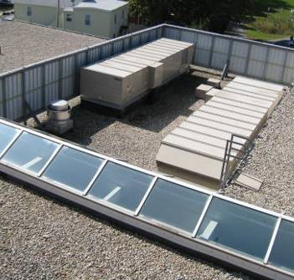

Rooftop AHUs

Picture 2

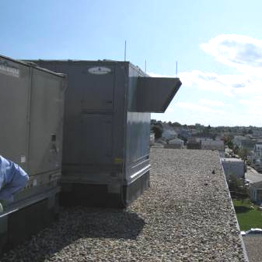

Rooftop AHU, Note Fresh Air Intake Protruding From Side of Unit

Picture 3

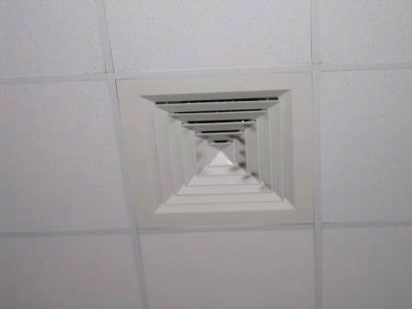

Ceiling-Mounted Supply Diffuser

Picture 4

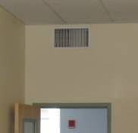

Wall-Mounted Supply Diffuser

Picture 5

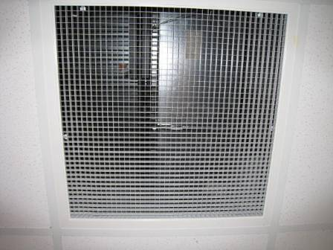

Return Vent to an Open Ceiling Plenum, Ground floor

Picture 6

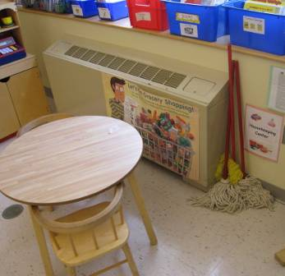

Classroom Fan Coil Unit Used To Facilitate Air Circulation

Picture 7

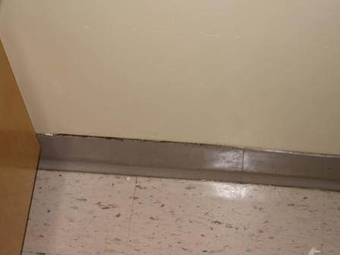

Mold on Coving near Aquarium

Picture 8

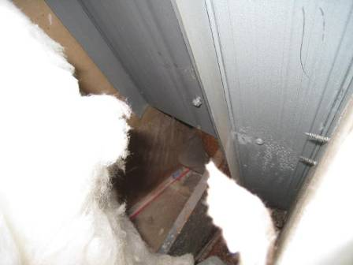

GW Inside Wall Cavity Free Of Mold Contamination

Picture 9

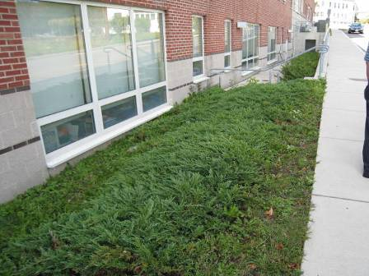

Vegetation Directly Outside Kindergarten Classrooms

Picture 10

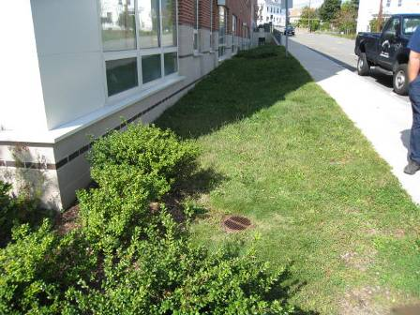

Vegetation and Drain outside Kindergarten Classrooms,
Note Terrain Slopes toward the Building and Drain in Foreground
Picture 11

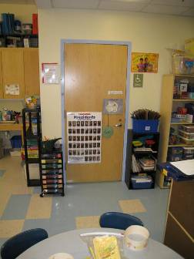

Kindergarten Restroom, Note Minimum Space between Door and Floor Which Limits Draw Of Air by the Restroom Exhaust Vent

Picture 12

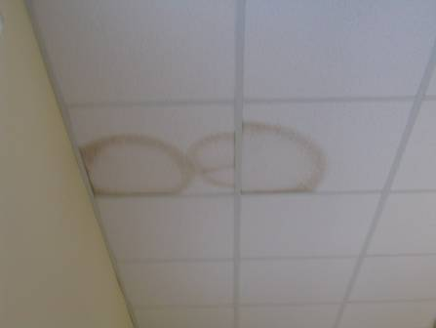

Water Damaged Ceiling Tiles along Exterior Wall of Classroom
Picture 13

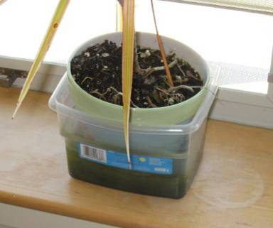

Plant in Container of Green/Stagnant Water Located Above FCU in Classroom, Note Damage to Window Sill

Picture 14

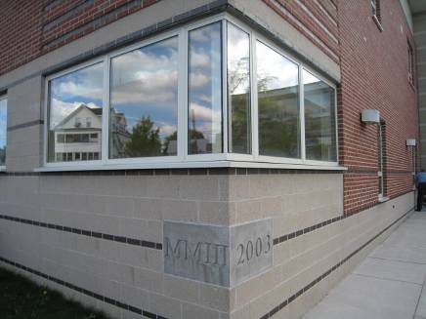

Corner of Building Where Spaces Were Noted Between
Window Frames and Exterior Brick
Picture 15

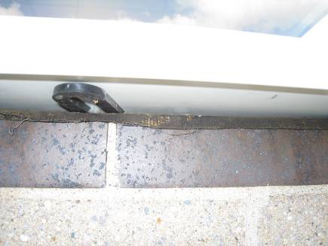

Close-Up of Spaces Were Noted Between
Window Frames and Exterior Brick

Picture 16

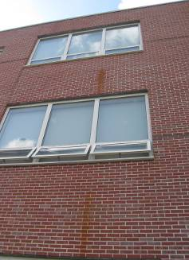

Water Staining On Exterior Brick from Condensation Drains of FCUs, Note Staining In Relation Top of Window Frames

Picture 17

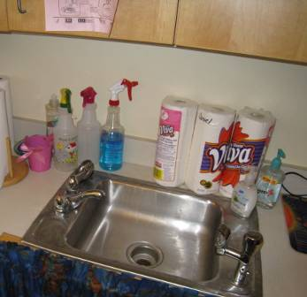

Cleaning Products and Unlabeled Spray Bottles on Sink Countertop

Picture 18

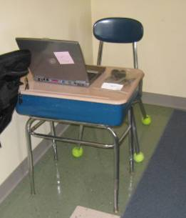

Tennis Balls on Chair Legs
Picture 19

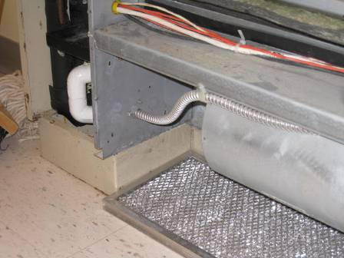

FCU Filters, Note Lack of Filter Rack to Hold Filter in Place

Picture 20

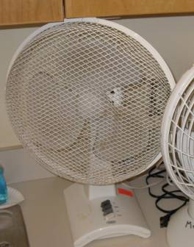

Accumulated Dust and Debris on Fan Blades/Screen

Picture 21

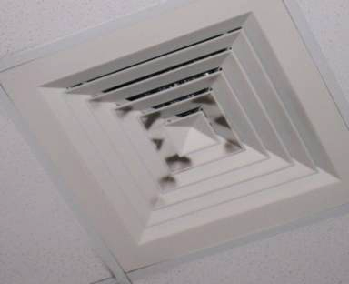

Accumulated Dust/Debris on Supply Diffuser

Location/ Room | Occupants  in Room | Temp  (°F) | Relative  Humidity  (%) | Carbon  Dioxide  (ppm) | Carbon Monoxide  (ppm) | PM2.5  (µg/m³) | Windows  Openable | Ventilation |  | Remarks
 |  |  |  |  |  |  |  | Supply | Exhaust | Remarks
background |  | 67 | 59 | 350 | 0 | 16 |  |  |  | Clear, sunny, wind -
Cafeteria | 200 | 71 | 45 | 489 | 0 | 4 | N | Y | Y  Off | DO
Gym | 22 | 69 | 50 | 380 | 0 | 8 | N | Y | Y
Library/Media Center | 0 | 69 | 57 | 490 | 0 | 2 | Y | Y | Y
Main office | 0 | 69 | 54 | 483 | 0 | 3 | N | Y | Y | DO, PC, vacuum, CLPs
Music | 21 | 69 | 50 | 469 | 0 | 4 | N | Y  Dust/debris | Y | 1 WD-CT
003 | 2 | 71 | 46 | 482 | 0 | 9 | N | Y | Y | DEM, TB, food storage
004 | 24 | 71 | 55 | 739 | 0 | 15 | Y | Y | Y | DO, TB
007 | 20 | 71 | 48 | 642 | 0 | 9 | Y  0/3 open | Y | Y | DO, AT, items, CLPs, FCU-off
008 | 20 | 71 | 53 | 659 | 0 | 10 | Y | Y | Y | DO
011 | 21 | 71 | 49 | 549 | 0 | 9 | Y | Y | Y
021 | 0 | 71 | 52 | 511 | 0 | 1 | N | Y | Y | DO, DEM, CLPs, coffeemaker
022 | 23 | 71 | 52 | 668 | 0 | 4 | N | Y | Y | DO, DEM, TB
023 | 8 | 71 | 55 | 604 | 0 | 2 | N | Y | Y | TB
103 | 22 | 71 | 55 | 585 | 0 | 9 | Y | Y | Y | DO
104 | 18 | 70 | 51 | 571 | 0 | 7 | Y | Y  Above door | Y | DO, inter-DO, DEM, CLPs
110 | 14 | 72 | 49 | 582 | 0 | 7 | Y | Y | N | FCU-plant, pillows, PF, DEM
111 | 19 | 73 | 50 | 525 | 0 | 7 | Y  1/4 open | Y | Y | DO, 1 WD-CT near window, aquarium, 1 plant (moldy container) over FCU
112 | 2 | 72 | 46 | 610 | 0 | 3 | N | Y | Y | DEM, TB, PF
114 | 0 | 71 | 45 | 413 | 0 | 3 | N | Y  Above door | Y | DEM, stuffed animals
115 | 6 | 72 | 53 | 675 | 0 | 15 | Y | Y | Y | DO, PC, laminator, no local exhaust immediate to laminator
117 | 0 | 71 | 46 | 466 | 0 | 5 | Y  4/4 open | Y | N | DO, DEM, CLPs
120 | 1 | 71 | 47 | 589 | 0 | 4 | N | Y | Y | CLPs
121 | 1 | 71 | 49 | 477 | 0 | 5 | N | Y | Y | DO
121 | 1 | 71 | 47 | 467 | 0 | 3 | N | Y  Off | Y | DO, PF, items,
122 | 24 | 70 | 49 | 787 | 0 | 8 | Y | Y  Above door | Y | DO, DEM, TB, crayon/wax odor
123 | 20 | 70 | 48 | 639 | 0 | 9 | N | Y  Above door | Y | TB, DEM
127 | 21 | 69 | 50 | 727 | 0 | 7 | Y | Y  Above door | Y | DO, TB, plants, DEM, FCU - items, CLPs, nests, pine cones
128 | 23 | 71 | 48 | 521 | 0 | 5 | Y  4/5 open | Y  Above door | Y | DO, TB, terra., CLPs
137 | 2 | 67 | 53 | 493 | 0 | 2 | Y | Y | Y | DO, DEM
138 | 0 | 66 | 55 | 457 | 0 | 1 | Y | Y | Y | DO, DEM
139 | 0 | 66 | 56 | 451 | 0 | 1 | Y | Y | Y
141 | 1 | 66 | 57 | 465 | 0 | 1 | Y | Y | Y | DO
142 | 0 | 66 | 58 | 476 | 0 | 1 | Y | Y | Y
143 (office) | 0 | 70 | 55 | 526 | 0 | 18 | Y | Y | N
144 (office) | 0 | 70 | 56 | 527 | 0 | 12 | N | Y | Y
144 conf rm | 0 | 69 | 57 | 529 | 0 | 5 | N | Y | Y
153 | 1 | 69 | 54 | 622 | 0 | 5 | N | Y | N | DO
154 | 1 | 70 | 54 | 602 | 0 | 4 | N | Y | N | DO
203 | 21 | 70 | 54 | 703 | 0 | 12 | Y | Y | Y | DO, TB, CLPs
204 | 19 | 71 | 54 | 703 | 0 | 8 | Y | Y | Y | DO, TB
210 | 20 | 71 | 49 | 526 | 0 | 5 | Y  1/4 open | Y | Y | DO, TB, breach between sink and backsplash, feather duster
211 | 23 | 70 | 52 | 642 | 0 | 8 | Y | Y | Y | DO, 1 WD-CT near window, PF-dusty
212 | 0 | 70 | 50 | 466 | 0 | 4 | N | Y | Y | DO
214 | 1 | 70 | 51 | 432 | 0 | 5 | N | Y | Y
215 | 5 | 72 | 46 | 452 | 0 | 6 | Y  1/3 open | Y | Y  Above door | DO, TB, plant, DEM, FCU off
217 | 7 | 70 | 54 | 562 | 0 | 7 | Y | Y | Y | DO, 2 WD-CT (Sprinkler Leak), TB
219 | 0 | 70 | 46 | 391 | 0 | 3 | N | Y | Y | DO, DEM, PF
220 | 0 | 70 | 48 | 395 | 0 | 3 | N | Y | Y | DO, 2 WD-CT, DEM, PF
221 | 1 | 70 | 52 | 612 | 0 | 4 | N | Y | Y | DO
222 | 21 | 73 | 49 | 622 | 0 | 7 | Y | Y | Y | DO, DEM, CLPs,
223 | 17 | 70 | 56 | 693 | 0 | 8 | Y | Y | Y | DO
227 | 20 | 70 | 54 | 936 | 0 | 6 | Y | Y | Y | DO, TB, DEM, PS
228 | 21 | 71 | 54 | 504 | 0 | 6 | Y  1/4 open | Y | Y | DO, TB
235 | 0 | 66 | 54 | 459 | 0 | 1 | N | Y | Y | DO, PC, PC odors, CLPs
236 | 0 | 69 | 59 | 488 | 0 | 2 | Y | Y | Y
237 | 0 | 67 | 50 | 462 | 0 | 1 | N | Y | Y  Above door | DO, DEM, 28 computers
303 | 22 | 72 | 55 | 850 | 0 | 12 | Y | Y | Y | DO
304 | 19 | 71 | 56 | 880 | 0 | 11 | Y | Y | Y | DO
310 | 21 | 72 | 48 | 563 | 0 | 8 | Y  4/4 open | Y  Above door | Y | TB, DEM, plants, FCU off
311 | 22 | 71 | 52 | 884 | 0 | 8 | Y | Y  Above door | Y | DO, TB, DEM, pillows
314 | 21 | 71 | 54 | 842 | 0 | 12 | Y | Y | Y | DO, DEM, TB

