Background/Introduction

INDOOR AIR QUALITY ASSESSMENT

Thornton Burgess Middle School
85 Wilbraham Road
Hampden, Massachusetts

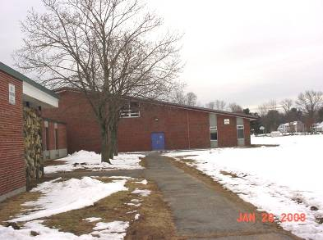

Prepared by:
Massachusetts Department of Public Health
Bureau of Environmental Health
Indoor Air Quality Program
April 2008

At the request of Paul Gagliarducci, Superintendent of Schools for the Hampden -Wilbraham Regional School District (HWRSD), the Massachusetts Department of Public Health (MDPH), Bureau of Environmental Health (BEH) provided assistance and consultation regarding indoor air quality issues relative to areas in and around the gymnasium and locker rooms at Thornton Burgess Middle School. The request from Superintendent Gagliarducci also included an evaluation of the ventilation system in the gymnasium, due to the concern of an observable film on the gymnasium floor.
On January 29, 2008, a visit was made to this school by Michael Feeney, Director, and Lisa Hébert, Inspector in BEH’s Indoor Air Quality (IAQ) Program. The school is a single story brick building constructed in 1967. The gymnasium is a two-story building that contains lockers rooms. The entire building was built on a slab.
Prior the BEH assessment, the HWRSD had the dust/film on the gymnasium floor tested by EMLab P&K from Billerica, Massachusetts. The tests utilized Polarized Light Microscopy (PLM) analysis. The results indicated that the dust consisted of a mix of sandy soil, mineral grains, synthetic and natural fibers, and no fibers consistent with asbestos.

Methods
Air tests for carbon dioxide, temperature, relative humidity and carbon monoxide were taken with the TSI, Q-Trak ™, IAQ Monitor Model 8551. Air tests for airborne particle matter with a diameter less than 2.5 micrometers were taken with the TSI, DUSTRAK™ Aerosol Monitor Model 8520. Air measurements were taken at 15 minute intervals over the course of several hours. The ventilation system was deactivated due to a multi-municipality power blackout the Hampden area at the time of the testing.

Results
The school provides services for children in grades five through eight and houses approximately 300 students. The tests were taken during normal operations at the school. It should be noted that during the assessment, the town of Hampden lost electrical power and therefore, during a portion of the assessment, the ventilation system was not functioning as a result of the power outage. Test results appear in Table 1.

Discussion
Ventilation
It can be seen from Table 1 that carbon dioxide levels were above 800 parts per million in two of eleven areas sampled. Although the results could be indicative of a ventilation problem in those two areas, they could also be a result of the lack of ventilation due to the power outage. The gymnasium results indicate a steep decline in the concentration of carbon dioxide over the course of the sampling period both during occupancy of the gymnasium as well as after the students left the gymnasium.
The gymnasium is supplied with fresh air through air handling units (AHUs) located in a mechanical room adjacent to the gymnasium. Fresh air is supplied to the AHU from fresh air intakes located on the roof (Picture 1). The air supply enters the gymnasium through ducts in the upper wall (Picture 2). Air exhausts the gymnasium through grates located on the wall at floor level (Picture 3) through a ducted system to the exhaust vent located on the roof (Picture 4).
One air handling unit in the attic space was missing an access cover, which was subsequently found on the floor nearby (Picture 5). Air filters appeared to be changed with some frequency as filters were dated by maintenance personnel (Picture 6). The filters observed on this visit had been replaced in December of 2007. It was observed that in some areas, there existed a sizable gap between the filter and the edge of the AHU that would allow air to bypass the filters(s) (Picture 7). Air filters should be sized and installed in the AHU in such a way to eliminate air bypass of the filter.
To maximize air exchange, the MDPH recommends that both supply and exhaust ventilation operate continuously during periods of school occupancy. In order to have proper ventilation with a mechanical supply and exhaust system, the systems must be balanced to provide an adequate amount of fresh air to the interior of a room, while removing stale air from the room. It is recommended that HVAC systems be re-balanced every five years to ensure adequate air systems function (SMACNA, 1994). The date of the last balancing was not available at the time of the assessment.
The Massachusetts Building Code requires a minimum ventilation rate of 15 cubic feet per minute (cfm) per occupant of fresh outside air or must have openable windows in each room (SBBRS, 1997). The ventilation must be on at all times that the room is occupied. Providing adequate fresh air ventilation with open windows and maintaining the temperature in the comfort range during the cold weather season is impractical. Mechanical ventilation is usually required to provide adequate fresh air ventilation.
Carbon dioxide is not a problem in and of itself at levels measured in this building. It is used as an indicator of the adequacy of the fresh air ventilation. As carbon dioxide levels rise, it indicates that the ventilating system is malfunctioning or the design occupancy of the room is being exceeded. When this occurs, a buildup of common indoor air pollutants can occur, leading to discomfort or health complaints. The Occupational Safety and Health Administration (OSHA) standard for carbon dioxide is 5,000 parts per million parts of air (ppm). Workers may be exposed to this level for 40 hours/week based on a time weighted average (OSHA, 1997).
The MDPH uses a guideline of 800 ppm for publicly occupied buildings. A guideline of 600 ppm or less is preferred in schools due to the fact that the majority of occupants are young and considered to be a more sensitive population in the evaluation of environmental health status. Inadequate ventilation and/or elevated temperatures are major causes of complaints such as respiratory, eye, nose and throat irritation, lethargy and headaches. For more information concerning carbon dioxide, consult Appendix A.
Temperature measurements in the school ranged from 57° F to 69° F, which were below the MDPH recommended comfort range in the majority of areas surveyed. The MDPH recommends that indoor air temperatures be maintained in a range of 70º F to 78º F in order to provide for the comfort of building occupants. In many cases concerning indoor air quality, fluctuations of temperature in occupied spaces are typically experienced, even in a building with an adequate fresh air supply.
The relative humidity measurements in the building ranged from 15 to 30 percent, which were below the MDPH recommended comfort range in all areas surveyed. The MDPH recommends a comfort range of 40 to 60 percent for indoor air relative humidity. Relative humidity levels in the building would be expected to drop during the winter months due to heating. The sensation of dryness and irritation is common in a low relative humidity environment. Low relative humidity is a very common problem during the heating season in the northeast part of the United States.
Other IAQ Evaluations
The gymnasium floor is covered with the originally installed floor tile. A film of similar appearance was observed on the floor and in the hallways, in particular, in the hallways that exhibited floor tiles similar in age and in composition to the gymnasium floor. In many areas, the film was observable in a sweeping pattern consistent with the school department’s floor washing equipment (Picture 10). A difference was not discernable between the film on observed on the floor of the gymnasium and the film observed on the floors of the affected hallways. During the course of this assessment, students were observed passing through the gymnasium after recess. Dust, dirt and other normally occurring debris from outdoors can be spread into the gymnasium to add to the observed dust.
The US EPA has established NAAQS limits for exposure to particulate matter. Particulate matter is airborne solids that can be irritating to the eyes, nose and throat. The NAAQS originally established exposure limits to particulate matter with a diameter of 10 μm or less (PM10). According to the NAAQS, PM10 levels should not exceed 150 microgram per cubic meter (μg/m³) in a 24-hour average (US EPA, 2006). These standards were adopted by both ASHRAE and BOCA. Since the issuance of the ASHRAE standard and BOCA Code, US EPA established a more protective standard for fine airborne particles. This more stringent PM2.5 standard requires outdoor air particle levels be maintained below 35 μg/m³ over a 24-hour average (US EPA, 2006). Although both the ASHRAE standard and BOCA Code adopted the PM10 standard for evaluating air quality, MDPH uses the more protective PM2.5 standard for evaluating airborne particulate matter concentrations in the indoor environment.
PM2.5 readings were taken in the gymnasium at approximately fifteen minute intervals for approximately two and one-half hours. Outdoor PM2.5 concentrations were measured at
42 μg/m³ (Table 1). PM2.5 levels measured in the school were between 27 to 41 μg/m³ (Table 1), which were below the NAAQS PM2.5 level of 35 μg/m³, with the exception of one reading. The elevated reading was taken while pupils were playing basketball in the gym, which would increase airborne particulate levels. The test results decrease as the number of students in the gymnasium decreases. All indoor readings were below the outdoor reading of 42 μg/m³.
Frequently, indoor air levels of particulates (including PM2.5) can be at higher levels than those measured outdoors. This was not the case in this instance. A number of mechanical devices and/or activities that occur in schools can generate particulate during normal operations. Sources of indoor airborne particulates may include but are not limited to particles generated during the operation of fan belts in the HVAC system, cooking in the cafeteria stoves and microwave ovens; use of photocopiers, fax machines and computer printing devices; operation of an ordinary vacuum cleaner and heavy foot traffic indoors. In the gymnasium, it is likely the foot traffic, coupled with the bouncing of basketballs (in addition to the lack of ventilation due to the power outage at the beginning of our assessment) caused the increase in the readings while students were in the gym.

Conclusions/Recommendations
In view of the findings at the time of the visit the following short-term recommendations are made to improve air quality at Thornton Burgess Middle School:
- Replace cover on AHU.
- Consider contacting HVAC contractor to properly size and install filters in AHUs to prevent air from bypassing filters.
- Remove any obstructions in front of ventilation returns in the gymnasium.
- For buildings in New England, periods of low relative humidity during the winter are often unavoidable. Therefore, scrupulous cleaning practices should be adopted to minimize common indoor air contaminants whose irritant effects can be enhanced when the relative humidity is low. To control for dusts, a HEPA filter equipped vacuum cleaner in conjunction with wet wiping of all surfaces is recommended. Drinking water during the day can help ease some symptoms associated with a dry environment (throat and sinus irritations).
- Consider changing floor cleaning products as well as the method/equipment currently utilized to clean floors.
- Consider sealing holes/penetrations in wall board located above temporary divider at the center of the gymnasium.
- Consider eliminating the practice of allowing street shoes in the gymnasium.
- Consider servicing and balancing the ventilation system every five years.
- Consider adopting the US EPA (2000) document, “Tools for Schools”, to maintain a good indoor air quality environment in the building. This document can be downloaded from the Internet at: http://www.epa.gov/iaq/schools/index.html.
References
BOCA. 1993. The BOCA National Mechanical Code/1993. 8th ed. Building Officials and Code Administrators International, Inc., Country Club Hill, IL.
OSHA. 1997. Limits for Air Contaminants. Occupational Safety and Health Administration. Code of Federal Regulations. 29 C.F.R 1910.1000 Table Z-1-A.
SBBRS. 1997. Mechanical Ventilation. State Board of Building Regulations and Standards. Code of Massachusetts Regulations. 780 CMR 1209.0.

SMACNA. 1994. HVAC Systems Commissioning Manual. 1st ed. Sheet Metal and Air Conditioning Contractors’ National Association, Inc., Chantilly, VA.
US EPA. 1992. Indoor Biological Pollutants. US Environmental Protection Agency, Environmental Criteria and Assessment Office, Office of Health and Environmental Assessment, Research Triangle Park, NC. ECAO-R-0315. January 1992.

US EPA. 2000. Tools for Schools. Office of Air and Radiation, Office of Radiation and Indoor Air, Indoor Environments Division (6609J). EPA 402-K-95-001, Second Edition. http://www.epa.gov/iaq/schools/tools4s2.html
US EPA. 2006. National Ambient Air Quality Standards (NAAQS). US Environmental Protection Agency, Office of Air Quality Planning and Standards, Washington, DC. http://www.epa.gov/air/criteria.html

Picture 1

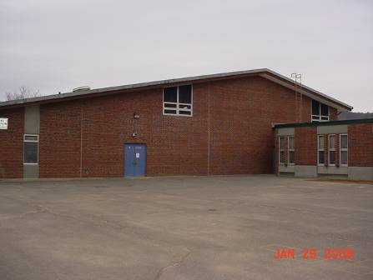

Air supply enters gymnasium through fresh air intake on roof

Picture 2

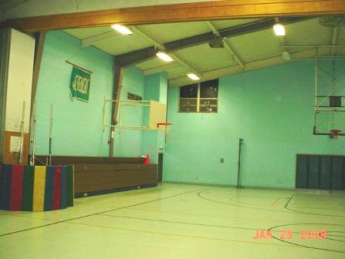

Gymnasium air supply
Picture 3

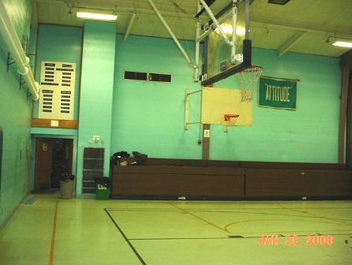

Partially obstructed exhaust in gymnasium

Picture 4

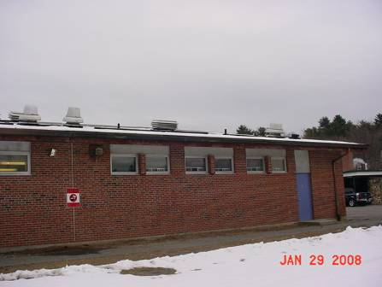

Typical “mushroom” exhaust vent

Picture 5

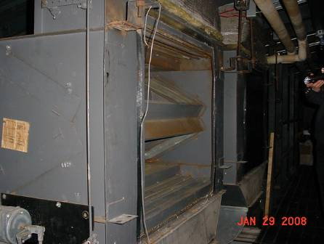

Air handling unit lacking cover

Picture 6

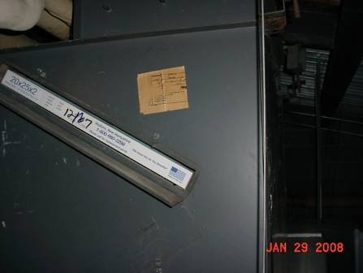

Air filter (dated 12/07) in air handling unit

Picture 7

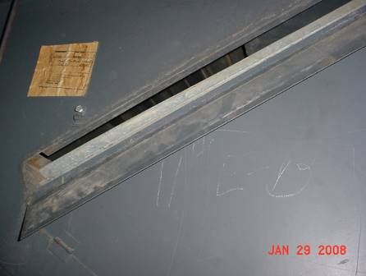

Gap observed adjacent to air filter

Picture 8

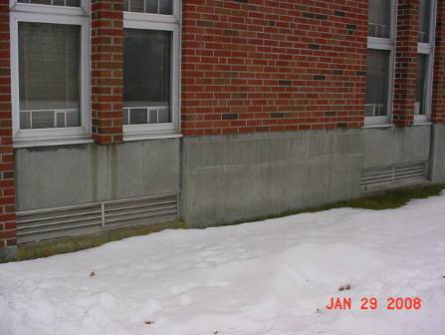

Univents in the classrooms

Picture 9

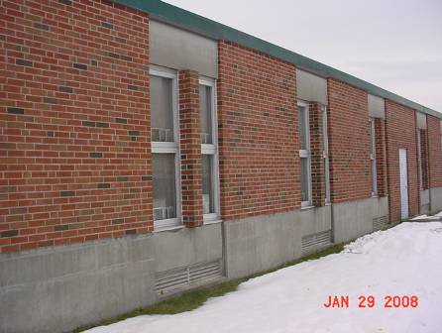

Pilasters on exterior of the building

Picture 10

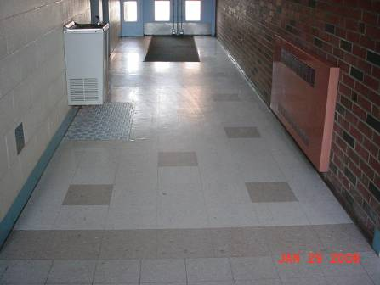

Pattern of floor washing equipment is visible on floor tiles
Location/ Room | Occupants  in Room | Temp  (°F) | Relative  Humidity  (%) | Carbon  Dioxide  (ppm) | Carbon Monoxide  (ppm) | PM2.5  (µg/m3) | Windows  Openable | Ventilation |  | Remarks
 |  |  |  |  |  |  |  | Supply | Exhaust | Remarks
Outdoors |  | 24 * | 23 | 371 | ND | 42 |  |  |  | *via Weather Underground
Gymnasium initial reading | 10 | 57 | 30 | 751 | ND | 31 | N | Y | Y | Door open
Gymnasium  15 min. | 26 | 69 | 17 | 852 | ND | 36 | N | Y | Y | Door open
Gymnasium  30 min. | 12 | 69 | 18 | 778 | ND | 41 | N | Y | Y | Door open
Gymnasium  45 min. | 4 | 69 | 16 | 740 | ND | 34 | N | Y | Y | Door open
Gymnasium  60 min. | 0 | 68 | 16 | 685 | ND | 32 | N | Y | Y | Door open
Gymnasium  75 min. | 0 | 68 | 16 | 631 | ND | 30 | N | Y | Y | Door open
Gymnasium  90 min. | 0 | 68 | 15 | 572 | ND | 29 | N | Y | Y | Door open
Gymnasium  105 min. | 0 | 68 | 15 | 535 | ND | 27 | N | Y | Y | Door open
Gymnasium  120 min. | 0 | 68 | 15 | 486 | ND | 28 | N | Y | Y | Door open
Hall outside Gym | 0 | 63 | 24 | 764 | ND | 32 | N | N | N
Hall outside E11 | 0 | 68 | 24 | 1077 | ND | 29 | N | N | N

