Attachment APR

Delivery System Reform Incentive Payment (DSRIP) Program
Accountable Care Organization (ACO) PY1 Annual Progress Report Response Form

General Information
Full ACO Name: | Tufts Health Together with Boston Children’s ACO
ACO Address: | 705 Mount Auburn Street  Watertown, MA 02472

PY1 Progress Report Executive Summary

ACO Goals from its Full Participation Plan
The ACO has six PY2 goals. Of note, the number of goals has been reduced from the 20 goals that were submitted in prior Full Participation Plans and referenced in prior Progress Reports. . Table 1 presents the alignment of PY2 goals with previously submitted PY1 goals.
Table 1. BCH ACO PY1 and PY2 Goals Alignment
PY2 Goals (December 2018 FPP) | Descriptions | PY1 Goals (February 2019)
#1 | Cost & Utilization management: Maintain TCOC at the BCH ACO MassHealth benchmark (i.e., capitation rate) in Years 1 – 5 | #1 Establish and maintain an accurate list of patients enrolled in (attributed to) the BCH ACO over the five years of the program.
 |  | #2 Import claims and other data into the BCH ACO data warehouses and validate for use in analytic and operational activities over the five years of the program.
 |  | #3 Use innovative analytic tools to better understand our population and inform the design and implementation of interventions to connect them to appropriate/needed resources
 |  | #4 Establish and maintain processes for analysis of pharmacy utilization and utilization management to reduce prescription expense
 |  | #6 Identify and implement targeted care interventions for children with complex medical conditions to improve care coordination and reduce impactable costs by 3-5% in this population by Year 5
 |  | #10 Promote innovation and care transformation throughout the ACO by providing grant funding for pilot projects to enhance care coordination and reduce TME
 |  | #18 Enhance BCH ACO capacity to manage accountable care contracts, programs and performance
#2 | Access: In Years 1 and 2, expand behavioral health services delivered in the primary care setting and enhance access to community-based therapists and CBHI. By the end of Year 5, ACO members receive optimal behavioral health services across the full care continuum, including appropriate use of acute behavioral health services. | #8 Expand access to primary care-based behavioral health treatment to all BCH ACO primary care practices by end of Year 5; expand access to behavioral health care coordination to reach 20% of patients with high risk behavioral health needs by Year 5
#3 | Quality: In Years 1 and 2, develop systems to measurably improve delivery of preventive services, chronic disease management, and clinical integration. In Years 3-5, narrow gap in quality measure performance between Medicaid and commercial populations, and between racial/ethnic groups. | #16 Conduct quality measurement to evaluate and monitor progress on state prescribed quality measures and on internal quality improvement efforts
 |  | #19 Expand and maintain primary care-based medical home care coordination activities
#4 | Member Experience: By the end of Year 4, achieve or surpass benchmarks for priority MassHealth primary care child member experience measures (e.g., knowledge of patients, integration of care, access to care, willingness to recommend). | #13 Build and deliver communications about existing and new programs available to patients within the BCH ACO including care management when applicable
 |  | #14 Implement new and expanded patient pediatric care management outreach for prevention, wellness, and population management
 |  | #17 Facilitate a smooth insurance transition for patients
#5 | Integration of Physical Health, BH, LTSS, and Health-Related Social Services: In Years 1 and 2, develop integration between primary care medical home, regional care management, THPP care management, LTSS CPs, and other care partners (e.g., schools). By the end of Year 5, implement sustainable model of pediatric care integration. | #7 Expand primary care and community-based asthma programming to reach over 60% of patients with asthma by end of Year 5
 |  | #9 Improve integration and coordination of primary and specialty care
 |  | #11 Implement and maintain connections to LTSS Community Partners and community service agencies for Behavioral Health.
 |  | #19 Expand and maintain primary care-based medical home care coordination activities
 |  | #20 Ensure delivery of required care management services
#6 | Other: By the end of Year 3, understand distribution of health-related social needs and associated health disparities within the BCH ACO population and begin to develop targeted interventions and approaches (including resource allocation and system responses) to address identified needs and disparities. In Years 4-5, refine and expand successful/promising approaches. | #12 Understand and address the impact of social determinants of health (SDOH) on this patient population
 |  | #15 Expand culturally and linguistically appropriate services
 |  | #19 Expand and maintain primary care-based medical home care coordination activities

PY1 Investments Overview and Progress toward Goals
The ACO has invested in seven target areas: complex care; behavioral health; social determinants of health; overall population management; data, IT analytics and reporting; governance, compliance, and member protections; and key payer functions (Figure 1).

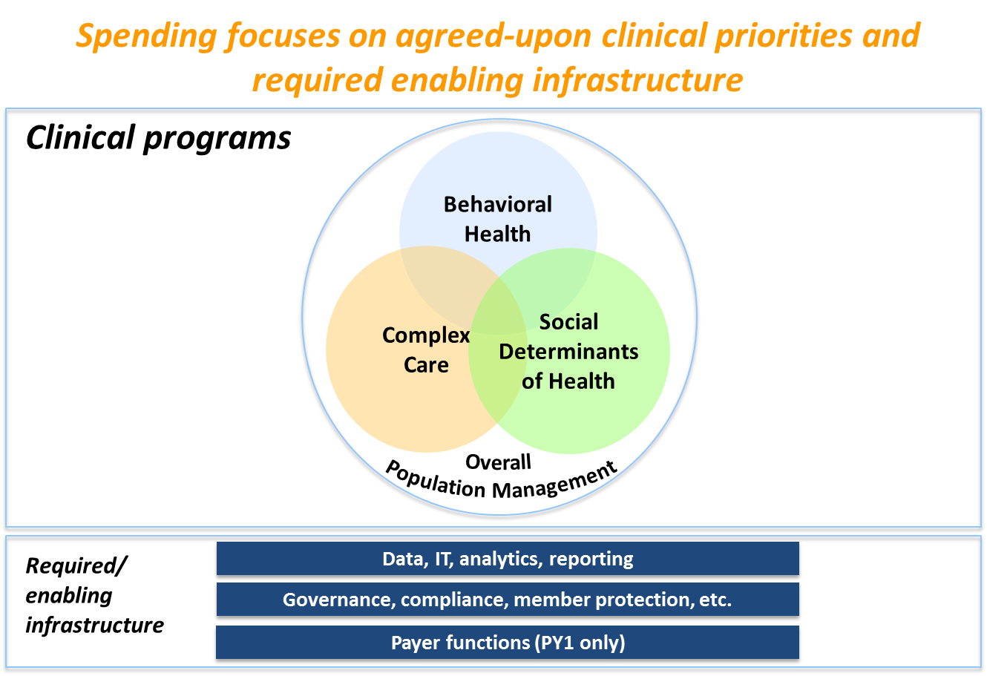
Figure 1: BCH ACO PY1 Investment Strategy

Each of these investment areas is linked to one or more specific identified goal. Investments in complex care, for example, are linked to Goal #1: Cost & Utilization: Maintain TCOC at the BCH ACO MassHealth benchmark (i.e., capitation rate) in Years 1 – 5. In this section we describe four examples of investments that contributed to progress in advancing the ACO goals.

- Complex Care
Investments related to management of the BCH ACO complex patient population support BCH ACO Goal #1: Cost and Utilization Management. In PY1, one area of focus for this investment was the reduction of the average monthly rate of BCH inpatient days per 100 BCH ACO complex patients in the BCH Primary Care Longwood practice by 2% by September 2018, which was successfully achieved. The practice has over 800 complex ACO patients and continues to monitor this measure through its complex care initiative.

2. Social Determinants of Health
Investments related to understanding the impact of social determinants of health (SDOH) in the BCH ACO population support BCH ACO Goal #6: Other. In PY1, progress was made toward screening for SDOH needs among the BCH ACO population. Specifically, practices participating in the BCH ACO developed and began implementation of MassHealth-approved health related social needs screening tools. Between June 2018 and December 2018, a total of 15,828 health needs assessments were completed by BCH ACO patients and families in PPOC practices and results were documented in the EHR. When electronic screening tools are fully implemented in PY2, the ACO will be better positioned to identify, analyze, and address the social needs of its patients and families. These activities are critical for the design and implementation of the Flexible Services Program.

- Behavioral Health
Expansion of behavioral health services for the BCH ACO population supports BCH ACO Goal #2: Access. In PY1 progress was made toward expansion of access to behavioral health services. Over the course of the year the PPOC’s Behavioral Health Integration program expanded to additional practices and primary care providers. Over 50% of practices have integrated BH providers. Significant progress was also achieved in monitoring and evaluating initiatives aimed at providing coordinated access to behavioral health care for BCH ACO patients with behavioral health needs.

- Integration
Efforts to integrate care for the BCH ACO population support BCH ACO Goal #5: Integration of Physical Health, BH, LTSS, and Health-Related Social Services. In PY1, progress was made toward collaboration among internal and external stakeholders to improve integration between care partners for patients managed in multiple settings. BCH Primary Care-based care coordinators, PPOC Regional Support Teams, the THPP Care Management team, and LTSS Community Partners made progress in designing and implementing processes to enhance communication and to facilitate workflow integration.

Successes and Challenges of PY1
Successes
- Member Enrollment
The transition of over 80,000 patients into the BCH ACO was a success. During PY1, dedicated resources supported the smooth transition of patients into the ACO program, including ensuring continuity of care during this transition. Following the launch of the ACO program, the ACO successfully built and refined standard membership/enrollment data management and reporting processes, and achieved relatively stable membership by the fourth month of the program. The individual PCP practices in the ACO each have different ways of attributing members to PCP’s and storing insurance information, even with the PPOC’s move to a single EMR. This presented a challenge in establishing and maintaining processes for monitoring, validating, and distributing complex and at times volatile membership information; work is ongoing to address this challenge during PY2.

- Clinical Programs
Throughout PY0 and PY1, a total of 19 clinical programs have launched in six different locations across primary and specialty care settings. Each program targets a specific patient population and has associated goals, interventions, and measures of success. With continued focus on these programs, the ACO is well positioned to deliver results in Years 3 -5. In PY2, these programs will focus on continued delivery of services as well as evaluation activities and sustainability planning.

- Data and Population Health Analytics
In order to better understand our population and meet their needs through ACO initiatives, we have been able to consolidate and analyze claims data from both THPP and MassHealth into a single platform. This was a resource intensive effort, and we plan to leverage this consolidated data to refine our analytics of ACO operations.

Challenges
- Hiring
Hiring staff with claims and EMR data experience that can support analyses of interest to the ACO can be difficult in the current market.

- Pediatric ACO Nuances
As a result of being a pediatric and young-adult ACO, we have had challenges with areas that require pediatric nuance. Examples of this have been newborn enrollment due to default attribution to the mother’s plan, managing parity in quality metrics, as well as creating access to pediatric patients to PCPs in the current service area construct.

