Attachment APR

Delivery System Reform Incentive Payment (DSRIP) Program

Accountable Care Organization (ACO) PY2 Annual Progress Report Response Form

Part 1: PY2 Progress Report Executive Summary

General Information
Full ACO Name: | Tufts Health Together with Boston Children’s ACO
ACO Address: | 705 Mount Auburn Street  Watertown, MA 02472

Part 1. PY1 Progress Report Executive Summary

1.1 ACO Goals from its Full Participation Plan
The ACO has eight PY3 goals. Of note, the goals were revised in January 2020 as part of the Full Participation Plan deliverable. Table 1 presents the alignment of PY3 goals with previously submitted PY2 goals. Please note that the COVID-19 pandemic is expected to impact the ACO’s ability to reach certain performance targets (e.g., quality measure targets); in this submission, the performance targets have not been adjusted.

Table 1. BCH ACO PY2 and PY3 Goals Alignment
ACO Program Goals
Goal # | PY3 Goal Category & Description | PY2 Goal Category & Description
1 | Cost and Utilization Mgmt (Medical Trend): Maintain TCOC at the BCH ACO MassHealth benchmark (i.e., capitation rate) in PY3 – PY5. | Cost & Utilization management: Maintain TCOC at the BCH ACO MassHealth benchmark (i.e., capitation rate) in Years 1 – 5
1.a | Sub goal #1: Reduce low acuity ED (per NYU algorithm) utilization rate by 1.5% vs. PY2 rate by the end of PY3, and by 3% vs. PY2 rate by the end of PY5. | n/a
1.b | Sub goal #2: Reduce rate of inpatient events per 1,000 BCH ACO complex patient member months by 0.5% vs. PY2 rate by the end of PY3, and by 1% vs. PY2 rate by the end of PY5. | n/a
1.c | Sub goal #3: Reduce acute behavioral health utilization* rate by 1% vs. PY2 rate by the end of PY3, and by 2% vs. PY2 rate by the end of PY5. Note: Access to services is often a barrier to achieving targeted reductions in utilization among patients with severe behavioral health conditions; this goal will be influenced by the success of EOHHS’ initiatives related to urgent assessment and treatment, ED boarding, and inpatient resources for children who cannot be maintained safely in a home/acute care hospital environment. | n/a
2 | Cost and Utilization Mgmt (Operational efficiency): Identify at least two operational efficiency opportunities and measurable targets by the end of PY3. Note: BCH ACO has begun working on prior authorization efficiencies, e.g., in the area of diabetes; additional analyses are planned during PY3 to refine the focus areas for operational efficiency efforts and to identify measureable targets. | n/a
3 | Quality: By the end of PY3, increase behavioral health screening (and documentation of response, if positive screen) (ACO measure #5) from 45% of BCH ACO patients age ≥ 12 years who have a well visit to at least 50%. By the end of PY5, increase performance to reach or surpass MassHealth ACO attainment threshold. | Quality: In Years 1 and 2, develop systems to measurably improve delivery of preventive services, chronic disease management, and clinical integration. In Years 3-5, narrow gap in quality measure performance between Medicaid and commercial populations, and between racial/ethnic groups.
4 | Quality: By the end of PY3, increase health-related social needs screening (ACO measure #15) from 15% of the BCH ACO population to at least 30%. By the end of PY5, increase performance to reach or surpass MassHealth ACO attainment threshold. | Quality: In Years 1 and 2, develop systems to measurably improve delivery of preventive services, chronic disease management, and clinical integration. In Years 3-5, narrow gap in quality measure performance between Medicaid and commercial populations, and between racial/ethnic groups.
5 | Quality: By the end of PY3, increase adolescent vaccination rates (ACO measure #2) from 36% of BCH ACO patients to 40% among the BCH ACO population. By the end of PY5, increase performance to reach or surpass MassHealth ACO goal benchmark. | Quality: In Years 1 and 2, develop systems to measurably improve delivery of preventive services, chronic disease management, and clinical integration. In Years 3-5, narrow gap in quality measure performance between Medicaid and commercial populations, and between racial/ethnic groups.
6 | Member experience: By the end of PY5, achieve or surpass MassHealth benchmarks for priority MassHealth primary care child member experience measures (knowledge of patients, integration of care, communication, willingness to recommend). | Member Experience: By the end of Year 4, achieve or surpass benchmarks for priority MassHealth primary care child member experience measures (e.g., knowledge of patients, integration of care, access to care, willingness to recommend).
7 | Integration of physical health, BH, LTSS, and health related social needs: In each MassHealth region, establish at least one standard process for referral, co-management, and loop closure/graduation between primary care practices and community-based organizations (CBHI, LTSS CPs, Flexible Services Program social service organizations) by the end of PY3, and scale as standard work across all practices and community-based organizational partners by the end of PY5. | Integration of Physical Health, BH, LTSS, and Health-Related Social Services: In Years 1 and 2, develop integration between primary care medical home, regional care management, THPP care management, LTSS CPs, and other care partners (e.g., schools). By the end of Year 5, implement sustainable model of pediatric care integration.
8 | Other: By the end of PY3, establish a system to track responses to positive health-related social needs screening response and associated health outcomes. By the end of Year 5, improve behavioral health symptoms among ACO members receiving social needs response (including Flexible Services) compared to baseline (pre-intervention/receipt of services to address social need). | Other: By the end of Year 3, understand distribution of health-related social needs and associated health disparities within the BCH ACO population and begin to develop targeted interventions and approaches (including resource allocation and system responses) to address identified needs and disparities. In Years 4-5, refine and expand successful/promising approaches.

*defined as behavioral health or substance use inpatient hospitalization in the last 24 months, behavioral health or substance use partial/diversionary event in the last 24 months, and/or two or more behavioral health or substance use-related ED events in the past 24 months, or two or more BEST/ESP services in the past 12 months

1.2 PY1 Investments Overview and Progress toward Goals
The ACO has invested in seven target areas: complex care; behavioral health; social determinants of health; overall population management; data, IT analytics and reporting; governance, compliance, and member protections; and key payer functions (Figure 1).

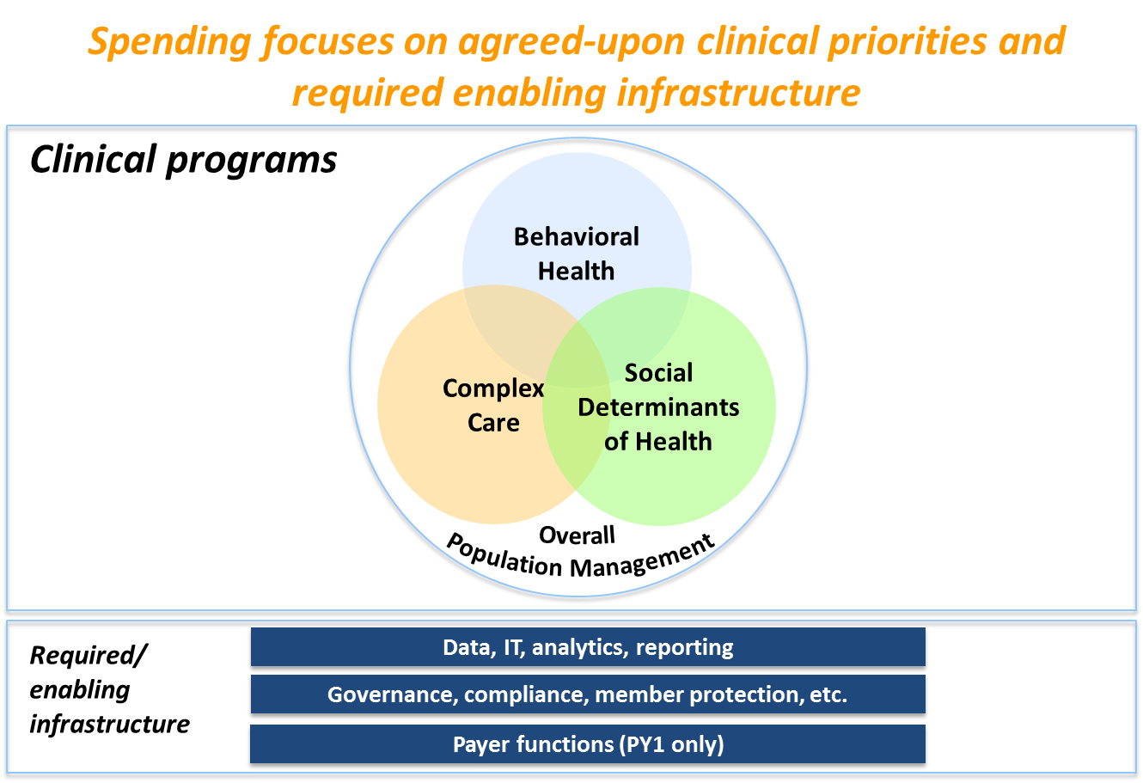
Figure 1: BCH ACO PY1 Investment Strategy

Each of these investment areas is linked to one or more specific identified goal. Investments in complex care, for example, are linked to Goal 1.b, to reduce average monthly rate of BCH inpatient events per 1,000 BCH ACO complex patients. In this section four examples of investments that contributed to progress in advancing the ACO goals during PY2 are described.

- Complex Care
Investments related to management of the BCH ACO complex patient population align with BCH ACO goal 1.b, to reduce the rate of inpatient events among complex patients over the five-year period of the ACO. Progress towards this goal is supported by investments in care management for complex patients. In the BCH Primary Care practices (Children’s Hospital Primary Care Center, Martha Eliot Health Center, and the Adolescent and Young Adult Practice), mechanisms for defining and systematically tracking the complex patient population were refined throughout PY2 for the purposes of care management intervention and measurement of investment impact. At the Pediatric Physician’s Organization at Children’s (the PPOC), progress was made in understanding the alignment of the Regional Support Team model with the needs of the PPOC’s complex patient population. During PY2, patients were primarily referred to the Regional Support Team for assistance with behavioral and social needs and were less likely to be referred for medical needs alone. The team’s leadership used this information and experience to modify team workflows and structure to include additional resources for common needs. The BCH ACO is also exploring other avenues for management of the medically complex patient population, informed by care management activities occurring within Boston Children’s Hospital subspecialty services.

2. Social Determinants of Health
Investments related to responding to identified health-related social needs align with BCH ACO goal 8, to establish a system to track responses to positive health-related social needs screening response and associated health outcomes. In PY2, significant progress was made in launching health-related social needs screening workflows, examining and understanding the needs that were identified through screening, and developing workflows for responses to address identified needs. New systems to measure responses to positive screens and associated health outcomes will be built on the foundation of these workflows. In PY2, planning also began for the launch of the Flexible Services program. Although this program will not receive DSRIP funding until PY3, collaborations between primary care practices and the Flexible Services team have already begun, illustrating progress towards BCH ACO goal 7, to improve integration of physical health, behavioral health, LTSS, and health-related social needs.

- Behavioral Health
Investments related to behavioral health align with BCH ACO goal 1.c, to reduce acute behavioral health and substance use-related utilization such as inpatient, ED, partial/diversionary services, and ESP services as well as goal 7, to improve integration of physical health, behavioral health, LTSS, and health-related social needs. Progress towards these goals is supported by investments in management of patients with behavioral health and substance use needs in the primary care and community settings. In PY2, the team administering the BCH ACO made significant progress in standing up partnerships between primary care practices and Children’s Behavioral Health Initiative (CBHI) agencies. Four practice-agency partnerships have been formed to date. These partnerships are facilitated by a BCH ACO Senior Project Manager and seek to improve access to low acuity behavioral health services and to support meaningful integration between primary care and community-based behavioral health entities.

- Population Management
Investments related to population management align with BCH ACO goals 3, 4, and 5, to improve performance on three MassHealth ACO quality measures (Immunizations for Adolescents, Depression Screening and Follow-up Plan, and Health-Related Social Needs Screening). In PY2, primary care practices worked towards improved performance on these quality measures through prioritization of workflows and documentation necessary for measure compliance. For example, increasing the percentage of patients who received their first HPV immunization by age 11 was a PPOC-wide quality goal in 2019. Across all primary care practices, provider training and EMR modifications were implemented to increase rates of depression screening and appropriate documentation of follow-up plans. At BCH primary care practices, MassHealth-approved health-related social needs screening tools were rolled out in February, May, and July of 2019.

1.3 Successes and Challenges of PY1
Successes

- Clinical Programs
BCH ACO has succeeded in expanding and/or maintaining 20 clinical programs across five focus areas and seven investment locations since PY0. In PY2, these programs measured progress towards program-level process goals and to use lessons learned to modify interventions for continuous programmatic improvement. Clinical program leadership worked with the team administering the BCH ACO to ensure program-level alignment with BCH ACO goals. Several programs have also made progress working collaboratively in PY2, streamlining workflows and measurement where appropriate. Last, clinical programs have made progress with sustainability planning, which will be a focus in PY3-PY5.

- Data and Population Health Analytics
The BCH ACO has succeeded in utilizing a new data analytics platform to better understand the ACO population and to tailor ACO initiatives to meet population needs. During PY2, the BCH ACO analytics team made progress in building routine reports and refining analytic operations.

Challenges

- PCP Assignment
Accurate PCP assignment of new members or retuning members within the BCH ACO is an ongoing challenge. Two factors directly contribute to this issue. First, MassHealth systems have improved in identifying member PCPs, but do not consistently provide PCP selection data as part of the 834 process. Second, THPP has not yet refined their internal system to assign returning members to their previously selected primary care practice and physician, thereby undoing efforts of assignment that may have previously occurred.

- Sustainability
BCH ACO anticipates challenges in planning for sustainability of BCH ACO programming beyond the DSRIP funding period. Further, the financial and policy structure of MassHealth ACOs has not adequately supported unique pediatric nuances and needs. As such, BCH ACO and other pediatric market stakeholders have been working with MassHealth to outline modifications of the current model that would ensure that the financial, operational, and clinical structures of ACOs serving pediatric members adequately support the care needs of this population and ACO policy objectives. Changes to primary care reimbursement and risk, complex care coordination, and administration of community supports would enhance the ability of ACOs to sustainably deliver care to pediatric patients.

- Pediatric ACO Nuances
The implementation, operations, and financial characteristics of the MassHealth ACO model often does not account for pediatric nuances. Continued collaboration between the BCH ACO and MassHealth is needed to sufficiently address pediatric needs in several areas, including primary care investment and access, newborn enrollment/assignment, pediatric relevant quality metrics and/or benchmarks, management of complex pediatric patients, school-based initiatives, and family-based investments.

