Attachment APR

Delivery System Reform Incentive Payment (DSRIP) Program
Accountable Care Organization (ACO) PY3 Annual Progress Report Response Form

Part 1: PY3 Progress Report Executive Summary

General Information
Full ACO Name: | Tufts Health Together with Boston Children’s ACO
ACO Address: | 705 Mount Auburn Street  Watertown, MA 02472

PY3 Progress Report Executive Summary

ACO Goals from its Full Participation Plan
BCH ACO has eight PY3 goals, presented in Table 1. These goals were revised as of March 2020 as part of the PY3 Full Participation Plan deliverable. During PY3 the COVID-19 pandemic impacted BCH ACO’s ability to reach certain performance targets; in this submission, the performance targets have not been adjusted.

Table 1. BCH ACO PY3 Goals
Goal # | PY3 Goal Category & Description
1 | Cost and Utilization Mgmt (Medical Trend): Maintain TCOC at the BCH ACO MassHealth benchmark (i.e., capitation rate) in PY3 – PY5.
1.a | Sub goal #1 Reduce low acuity ED (per NYU algorithm) utilization rate by 1.5% vs. PY2 rate by the end of PY3, and by 3% vs. PY2 rate by the end of PY5.
1.b | Sub goal #2: Reduce rate of inpatient events per 1,000 BCH ACO complex patient member months by 0.5% vs. PY2 rate by the end of PY3, and by 1% vs. PY2 rate by the end of PY5.
1.c | Sub goal #3: Reduce acute behavioral health utilization* rate by 1% vs. PY2 rate by the end of PY3, and by 2% vs. PY2 rate by the end of PY5. Note: Access to services is often a barrier to achieving targeted reductions in utilization among patients with severe behavioral health conditions; this goal will be influenced by the success of EOHHS’ initiatives related to urgent assessment and treatment, ED boarding, and inpatient resources for children who cannot be maintained safely in a home/acute care hospital environment.
2 | Cost and Utilization Mgmt (Operational efficiency): Identify at least two operational efficiency opportunities and measurable targets by the end of PY3. Note: BCH ACO has begun working on prior authorization efficiencies, e.g., in the area of diabetes; additional analyses are planned during PY3 to refine the focus areas for operational efficiency efforts and to identify measureable targets.
3 | Quality: By the end of PY3, increase behavioral health screening (and documentation of response, if positive screen) (ACO measure #5) from 45% of BCH ACO patients age ≥ 12 years who have a well visit to at least 50%. By the end of PY5, increase performance to reach or surpass MassHealth ACO attainment threshold.
4 | Quality: By the end of PY3, increase health-related social needs screening (ACO measure #15) from 15% of the BCH ACO population to at least 30%. By the end of PY5, increase performance to reach or surpass MassHealth ACO attainment threshold.
5 | Quality: By the end of PY3, increase adolescent vaccination rates (ACO measure #2) from 36% of BCH ACO patients to 40% among the BCH ACO population. By the end of PY5, increase performance to reach or surpass MassHealth ACO goal benchmark.
6 | Member experience: By the end of PY5, achieve or surpass MassHealth benchmarks for priority MassHealth primary care child member experience measures (knowledge of patients, integration of care, communication, willingness to recommend).
7 | Integration of physical health, BH, LTSS, and health-related social needs: In each MassHealth region, establish at least one standard process for referral, co-management, and loop closure/graduation between primary care practices and community-based organizations (CBHI, LTSS CPs, Flexible Services Program social service organizations) by the end of PY3, and scale as standard work across all practices and community-based organizational partners by the end of PY5.
8 | Other: By the end of PY3, establish a system to track responses to positive health-related social needs screening response and associated health outcomes. By the end of Year 5, improve behavioral health symptoms among ACO members receiving social needs response (including Flexible Services) compared to baseline (pre-intervention/receipt of services to address social need).
*defined as behavioral health or substance use inpatient hospitalization in the last 12 months, behavioral health or substance use partial/diversionary event in the last 12 months, and/or two or more behavioral health or substance use-related ED events in the past 12 months

PY3 Investments Overview and Progress toward Goals
The ACO has invested in seven target areas: complex care; behavioral health; social determinants of health; overall population management; data, IT analytics and reporting; governance, compliance, and member protections; and key payer functions (Figure 1).

Figure 1: BCH ACO Investment Strategy
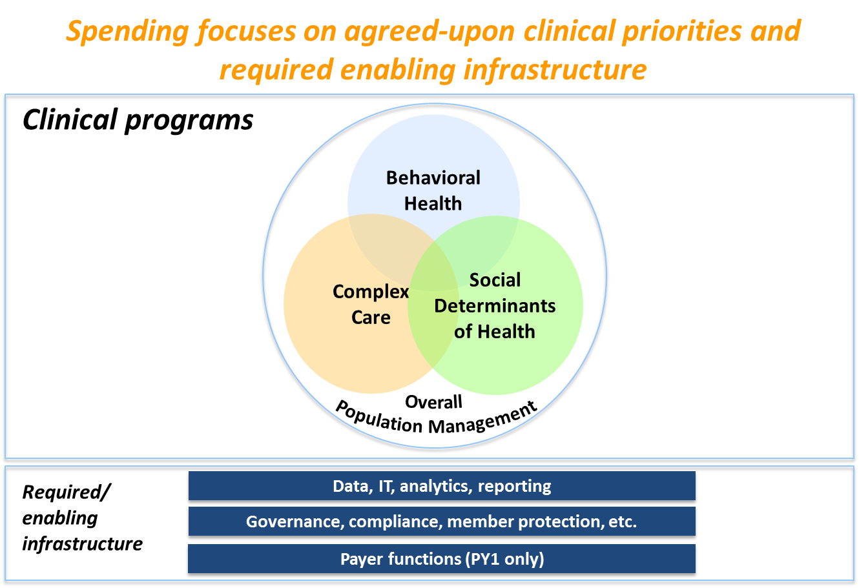

Each of these investment areas is linked to one or more BCH ACO goals. Investments in complex care, for example, are linked to Goal 1.b, to reduce the rate of inpatient events per 1,000 BCH ACO complex patient member months. In this section four examples of investments that contributed to progress in advancing the ACO goals during PY3 are described. As noted above, PY3 progress towards BCH ACO goals was significantly impacted by the COVID-19 pandemic. In March 2020 staff shifted to remote work, in-person clinical workflows and patient family utilization of health services were disrupted, and programs that were underway or planned for the year needed to be reprioritized. Despite this, BCH ACO made progress towards several goals.

- Commitment to identifying and eliminating child health disparities
In August 2020 Boston Children’s Hospital (BCH) formally published a declaration on Equity, Diversity, and Inclusivity (EDI) indicating a commitment to elevate equity, diversity and inclusivity as enterprise priorities. A set of specific goals were set forth that included commitments to enterprise leadership in development, implementation, and tracking of metrics for equity, diversity, and inclusion as well as leadership in eliminating child health disparities. The BCH ACO is well positioned to ensure that its approach to ACO program implementation and its DSRIP investment aims align with this institutional commitment and prioritization. In several clinical investment areas, as well as within the BCH ACO administrative and analytic investments, there was new focus in PY3 on identifying and eliminating child health disparities and increasing staff education related to health disparities. Planning and implementation of these specific efforts is described in Part 2 of this report. Commitment to identifying and eliminating child health disparities is expected to impact all PY3 DSRIP goals, and in particular goals related to health services utilization, quality of care, and member experience. In preparation for PY4 BCH ACO revised the DSRIP goals and leading indicators submitted as part of the Full Participation Plan (FPP) to explicitly state this newly identified high priority.
- Integration of behavioral health and health-related social needs with primary care
Investments in the integration of primary care and community organizations in PY3 contributed to significant progress towards DSRIP goal 7 “integration of physical health, BH, LTSS, and health-related social needs” as well as DSRIP goal 8 establishing a “system to track responses to positive health-related social needs screening response and associated health outcomes.” With increased need for support among patients and families during the COVID-19 pandemic BCH ACO strengthened processes for connection with appropriate resources. In June 2020 BCH ACO launched its Flexible Services program, connecting patients experiencing food insecurity or housing instability with partner social services organizations and co-managing service delivery with the social service organization. The BCH ACO Flexible Services program is specifically focused on patients with behavioral health conditions. With referral and co-management processes in place, BCH ACO has begun systematically documenting responses to identified food and housing needs and expects to expand such documentation beyond the Flexible Services program in PY4. In partnership with the Flexible Services program as well as independently, the PPOC’s Regional Support Team (RST) also bolstered processes to connect patients with appropriate resources in PY3. The RST restructured at the start of PY3 to better accommodate a growing volume of referrals from primary care and has become better aligned with the PPOC’s behavioral health integration program.
- Interpreter Services

After several delays, the Interpreter Services program launched as a pilot and then fully scaled to all PPOC practices over the course of PY3. This accelerated approach in response to the COVID-19 pandemic resulted in more progress than expected toward DSRIP leading indicator 6 to “pilot new interpreter services platform in 5 clinic locations by Q2 of PY3, and expand to at least 5 additional practices by the end of PY3” and “expand video-enabled interpreter services to 90% of all practices by the end of PY5.” These leading indicators support DSRIP goal 6 to achieve or surpass MassHealth benchmarks for priority MassHealth primary care child member experience measures. Details on the process of launching and scaling the Interpreter Services program are described in Part 2 of this report (see S/O D: 16). BCH ACO expects that this program will not only improve member experience, but also increase access to telehealth for patients whose preferred language is not English, as the program was deliberately designed to be interoperable with the PPOC’s virtual visit platform.

- Patient engagement after acute events
Population health management investments in PY3 supported outreach to patients, specifically targeting patients who experienced an inpatient hospitalization or ED event. While overall progress towards DSRIP goals 1a, 1b, and 1c related to inpatient and ED utilization was not possible to ascertain by comparing PY2 to PY3 due to the major disruption of the COVID-19 pandemic, population health management teams were able to make progress outreaching to patients after such events and continued to document this outreach throughout PY3. Interim data (through September 2020) indicate that performance on ACO quality measures Follow up after ED Visit for Mental Illness (7-day) and Follow up after Hospitalization for Mental Illness (7-day) remained steady compared to PY2 performance. These metrics comprise DSRIP leading indicator 1c in the PY3 FPP. Clinical programs that routinely track follow up after hospitalization and ED visits reported increased follow up outreach in PY3 compared to PY2 (see S/O PC:1 and S/O PC:7 below). Clinical programs also increased proactive outreach to high risk patients during PY3 (see S/O PC: 4 below). In PY4 BCH ACO plans to continue tracking changes in rates of ED visits and inpatient hospitalizations over time for the BCH ACO population overall and for subpopulations of interest. Additionally, BCH ACO expects to see further progress in outreach after acute events with the rollout of a new event notification system which launched in December 2020 and will be scaled throughout PY4.

Successes and Challenges of PY3
In addition to the PY3 progress towards goals described above, BCH ACO saw several key successes and challenges through PY3. These successes and challenges are described in further detail in Part 2 of this report.

Successes

- Maintenance of key aspects of primary care delivery through the COVID-19 pandemic

Despite the extraordinarily challenging circumstances brought on by the COVID-19 pandemic, BCH ACO was successful in maintaining many key aspects of care delivery, in particular the delivery of preventive care. Primary care practices conducted extensive outreach and adhered to recommended precautions to safely administer scheduled vaccinations. PY3 data (interim performance 10/1/2019 – 9/30/2020) show that 57% of patients were in compliance with the ACO quality measure Childhood Immunization Status, the same rate as in PY2 (preliminary performance 1/1/2019 – 12/31/2019). Similarly, 46% of patients were in compliance with the ACO quality measure Immunizations for Adolescents in PY3 (interim performance 10/1/2019 – 9/30/2020) compared to 44% in PY2 (preliminary performance 1/1/2019 – 12/31/2019). Health-related social needs screening rates saw only a small drop in performance from 43% in PY2 (preliminary performance 1/1/2019 – 12/31/2019) to 38% in PY3 (interim performance 10/1/2019 – 9/30/2020). Asthma management was similarly successful in pivoting rapidly to accommodate COVID-19 safety guidelines, maintaining activities such as proactive outreach, patient family education, and distribution of supplies through virtual and socially distant care. See S/O PC:4 for further detail on the new approaches to care delivery that asthma management teams developed and rolled out throughout PY3.

- Complex Care

BCH ACO made PY3 investments in care management for complex patients within primary care, at Boston Children’s Hospital, and in collaboration with LTSS Community Partners. Analytic resources were also deployed to better understand the BCH ACO complex population, in particular, patients who are high utilizers of specialty services. During PY3 BCH ACO was successful in leveraging learnings from clinical initiatives and analyses of the medically complex population to improve definitions of medical complexity and identify four domains of integrated care management for this population. These domains will be used as a framework for testing a specialty-based integrated care model for complex patients. Investments in PY4 are planned to support the piloting of this model.

Challenges

- Impact of COVID-19 pandemic on evaluation of BCH ACO programs
Changes in healthcare utilization brought about by the COVID-19 pandemic in PY3 were pervasive and immediate. Use of health care services dropped dramatically in the spring of 2020 and remained low for the remainder of PY3. Other unique patterns of utilization may become clear as full year 2020 claims data become available. Specifically, for 3 months, primary care utilization dropped by almost 50% and then recovered to approximately 90% of 2019 utilization with telehealth expansion. Inpatient utilization remained well below especially with dramatic reductions in influenza and asthma with social isolation reducing overall respiratory infections. Prevalence and/or severity of certain diagnoses, in particular behavioral health diagnoses, may also be different from past years as a result of the pandemic and may continue to differ in the future. A considerable increase in health-related social needs has also been observed. All of these abnormalities create challenges for BCH ACO in understanding the impact that the DSRIP-funded programming may have on quality of care, utilization, and total cost of care. The occurrence of a pandemic in the middle of the five years of DSRIP funding causes a disruption in data that may otherwise demonstrate the impact of BCH ACO DSRIP-funded work. DSRIP goals 1a, 1b, and 1c related to inpatient and ED utilization will be notably difficult to assess. BCH ACO will continue to monitor changes over time to better understand utilization of inpatient, ED, and other services through the COVID-19 pandemic. Additionally, metrics demonstrating care processes, health outcomes, and member experience will be used to monitor BCH ACO interventions.

- BH ED boarding and BH exacerbation
In PY1-PY3, DSRIP funds were invested in several clinical programs related to behavioral health. These programs were primarily aimed at integrating behavioral health with primary care, promoting behavioral health care coordination, and developing partnerships with community organizations (i.e., CBHI agencies). In PY3 there was renewed focus on ED boarding as a pressing concern for the population of pediatric and young adults with behavioral health symptoms or conditions. While ED boarding is not a new challenge, it is one that has been exacerbated by the COVID-19 pandemic (currently boarding volume at BCH is three times the baseline volume) and is expected to continue to grow as a problem in future years if system-level changes are not implemented in a timely way. Addressing the ED boarding crisis is particularly challenging because factors such as limited availability of appropriate care, compounding impacts of health-related social needs on behavioral health, and limitations of data to inform timely action. For BCH ACO there is an added layer of complexity in ED boarding as it pertains to children, adolescents, and young adults in particular. BCH ACO is working with internal and external partners to collaboratively understand and address the behavioral health ED boarding crisis.

