FATALITY INVESTIGATION REPORT
FACE Facts

Occupational Health Surveillance Program Massachusetts Department of Public Health
April 2000 Vol. 3, No. 1

Three Massachusetts Forklift Operators Killed

Background. Forklift style trucks are used in many industries across Massachusetts. Recently three Massachusetts forklift operators died in three separate forklift-related incidents. One victim fell from and was crushed by a forklift truck that tipped over, a second victim fell from a raised order picker forklift truck, and the third was caught between the mast and safety cage of a forklift truck.
All three incidents took place in Massachusetts warehouses. Each of the three companies had been in business over 10 years with one. company in business for more than 20 years. The victims' experience with forklift trucks ranged from 4 - 20 years. Two of the three companies had written comprehensive safety programs.
Investigation #1. The victim was a 22-year-old male carpel installer who also worked in the warehouse section of the carpet company. The victim worked for the company approximately four years. Driving a three-wheeled forklift truck in the parking lot, he took a sharp turn to the left while moving at 9 mph, the maximum speed. The vehicle tipped to the right and the operator fell out of the vehicle; it landed on top of him and crushed him. He was not wearing the seat belt.
Investigation #2. The victim was a 49-year-old male inventory control clerk for a food storage warehouse, who worked for the company approximately 20 years. He was using a high lift order picker truck. which is a style of forklift truck that raises the operator's work area along with the truck's forks. He was using the vehicle in the raised position to apply barcode labels to upper shelves in the warehouse freezer section. To reach the next barcode location, he stepped from the operator's area onto a box of product on a shelf. The box shifted and the victim fell 12 feet to the ground. He was wearing a body harness and a lanyard but did not have the lanyard attached to the anchor point above the operator's area on the order picker truck.
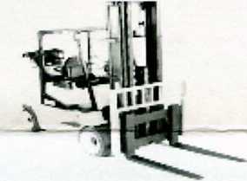

High Lift Order Picker Truck
Investigation #3. The victim was a 40-year-old male forklift truck operator for a food production and distribution company, who worked for the company approximately seven years. The day of the incident he was performing the typical task of moving product to a different row of the warehouse using a forklift truck. During this task, the load of product became caught in the narrow aisles and the victim lowered the load back to the ground. He tilted the must forward and stood between the mast and the cage looking over the load to see the obstacle that was preventing him from placing the product on the shelf. His foot caught the lever, which controlled the mast causing it to tilt back toward the cage. He tried to duck out of the way. but was unsuccessful; his head was crushed between the mast and cage.
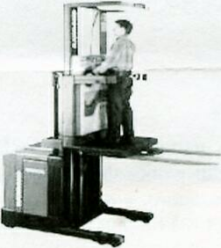

Four Wheel forklift Truck
Recommendations for Forklift Operators.
To prevent future fork lift-related injuries employers should:
• Enforce operator restraint use. This includes seatbelts for forklifts and body harnesses and lanyards for high lift order pickers.
• Eliminate hazardous conditions such as narrow aisles, objects on the floor, and incorrectly positioned loads.
• Equip forklifts with backup alarms and flashing lights to warn pedestrians.
• Ensure a properly designed forklift personnel platform is used when lifting workers,
• Develop and enforce a forklift safety program that is annually reviewed and updated which includes, hut is not limited to, worker training in forklift use and hazards.

New Regulations (29 CFR 1910.178). The federal Occupational Safety and Health Administration (OSHA) recently published the Powered Industrial Truck Operators Training standard. These regulations cover all powered industrial truck operators in the general industry, construction, and maritime industries. For more information call OSHA at (202) 693-1888 (Publication # 6742) or visit the OSHA web-site at www.osha..gov
Summary: OSHA Powered Industrial Truck Operator Training Standard.
• Operators must successfully complete a training program as outlined in the OSHA standard and pass a performance evaluation.
• Training must include classroom and "hands-on" instructions.
• Once certified, operators must be re-evaluated at least every three years.
• Operators must be retrained if involved in an accident. near miss incident, or if observed or received an evaluation of operating in an unsafe manner.
• Operators must be retrained if the equipment or workplace has significantly changed.
• Employers must certify that the training and evaluations have been done.
For National Institute for Occupational Safety and Health(NIOSH) Forklift Injury Prevention
Strategies. Call 1-800-35-NIOSH (Publication # 2000-112) or visit the NIOSH web-site at www.cdc.gov/niosh
Fatality Assessment and Control Evaluation (FACE) Project • 617-624-5627

