Tick Removal 101
((Adapted with permission from the CDC website)
If you find a tick attached to your skin, there's no need to panic. Several tick removal devices are available on the market, but a plain set of fine-tipped tweezers will remove a tick effectively.

How to remove a tick:
- Use fine-tipped tweezers to grasp the tick as close to the skin's surface as possible.
- Pull upward with steady, even pressure. Don't twist or jerk the tick; this can cause the mouth-parts to break off and remain in the skin. If this happens, remove the mouth-parts with tweezers. If you are unable to remove the mouth easily with clean tweezers, leave it alone and let the skin heal.
- After removing the tick, thoroughly clean the bite area and your hands with rubbing alcohol, an iodine scrub, or soap and water.
- Dispose of a live tick by submersing it in alcohol, placing it in a sealed bag/container, wrapping it tightly in tape, or flushing it down the toilet. Never crush a tick with your fingers.

Helpful Hint:
Avoid folklore remedies such as "painting" the tick with nail polish or petroleum jelly, or using heat to make the tick detach from the skin. Your goal is to remove the tick as quickly as possible--do not wait for it to detach.

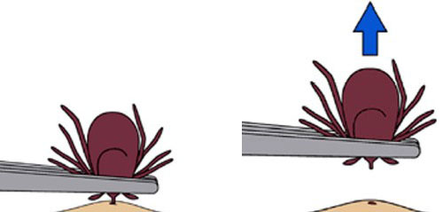

Follow-up:

Seal the tick in a zip lock baggie or closed container in case the HCP wants to see it. Contact your Health Care Provider (HCP) or the individual’s HCP to inform them that there has been a tick bite. The HCP will determine if immediate follow up is needed. If you develop a rash or fever within several weeks of removing a tick, see your doctor. Be sure to remind the HCP about your recent tick bite, when the bite occurred, and where you most likely acquired the tick.

