Bureau of Infectious Disease and Laboratory Sciences
Tickborne Disease Surveillance Summary, 2020
Suggested citation:
Massachusetts Department of Public Health, Bureau of Infectious Disease and Laboratory Sciences.
Tickborne Disease Surveillance Summary, 2020.
https://www.mass.gov/lists/tick-borne-disease-surveillance-summaries-and-data
Bureau of Infectious Disease and Laboratory Sciences
Massachusetts Department of Public Health
Jamaica Plain Campus/State Public Health Laboratory
305 South Street
Jamaica Plain, MA 02130

To speak to the on-call epidemiologist

Tel: (617) 983-6800

Questions about infectious disease reporting

Tel: (617) 983-6801

Requests for additional data

https://www.mass.gov/infectious-disease-surveillance-reporting-and-control
Acknowledgments
This report was prepared by the following MDPH staff:
Erin Mann, MPH
Juliana Jacoboski, MPH
Brandi Hopkins, MPH
Matthew Osborne, MPH
Catherine M. Brown, DVM, MSc, MPH

Massachusetts Department of Public Health
Bureau of Infectious Disease and Laboratory Sciences
2020 Tickborne Disease Surveillance Summary
Introduction

The 2020 Tickborne Disease Surveillance Summary provides data on infections reported to the Massachusetts Department of Public Health (MDPH), Bureau of Infectious Disease and Laboratory Sciences by healthcare providers and laboratories per regulation (105 CMR 300.000). This report focuses on a subset of four tickborne diseases:
- Babesiosis
- Human granulocytic anaplasmosis (HGA)
- Borrelia miyamotoi infection
- Powassan virus infection

Babesiosis, HGA, and Borrelia miyamotoi are tickborne diseases that are endemic to the Commonwealth. Powassan virus is a rare tick-borne flavivirus that can cause neuroinvasive disease in humans. Transmission of all four diseases can happen when an individual is bitten by a black-legged (deer) tick (Ixodes scapularis). Powassan virus can also be transmitted by the woodchuck tick (Ixodes cookie). Most infections occur in the warm spring and summer months when young (nymph) ticks are most active, though adult ticks may feed on humans and transmit disease year-round if temperatures are above freezing. Black-legged ticks are most commonly found in grassy or wooded areas where deer and mice are present. Because these diseases (and others including Lyme disease) are all transmitted by the same species of tick there is risk of co-infection with multiple pathogens from the same bite.

For more information about these and other tickborne diseases, please visit https://www.mass.gov/tick-borne-diseases.

Surveillance Highlights

Babesiosis
- Babesiosis is a disease caused by a microscopic parasite (Babesia microti) that infects red blood cells.
- 580 confirmed and probable cases of babesiosis were reported in Massachusetts in 2020, with an additional 407 cases classified as suspect.
- Statewide, babesiosis incidence dropped from 9.2 cases to 8.3 per 100,000 residents compared to 2019; however, these data may be impacted by the COVID-19 pandemic. The greatest incidence rate continues to be identified in Dukes and Nantucket counties.
- The majority of cases occurred between the months of June and August.
- When asked about awareness of a recent tick bite prior to symptom onset, 33% of cases confirmed to have a tick bite, 45% reported no tick bite, while 22% were not sure.
- Individuals between the ages of 55 and 74 years of age are at greatest risk of contracting the disease with the mean age for cases being 59 years old. Males are more likely than females to be infected, accounting for 61% of cases in the state.
- The most commonly reported symptoms include: fatigue (91%), fever (75%), headache (67%), chills (63%), and joint pain (57%); 29% of cases were hospitalized and there were two reported deaths.
- The primary source of transmission is via tick-bite; however, because it infects red blood cells, Babesia can also be transmitted from person-to-person through blood transfusions and organ donations. In 2020, two confirmed cases had received a blood transfusion in the six months prior to becoming ill.

Figure 1: Five-year babesiosis incidence rates per 100,000 population by city/town, Massachusetts, 2016-2020
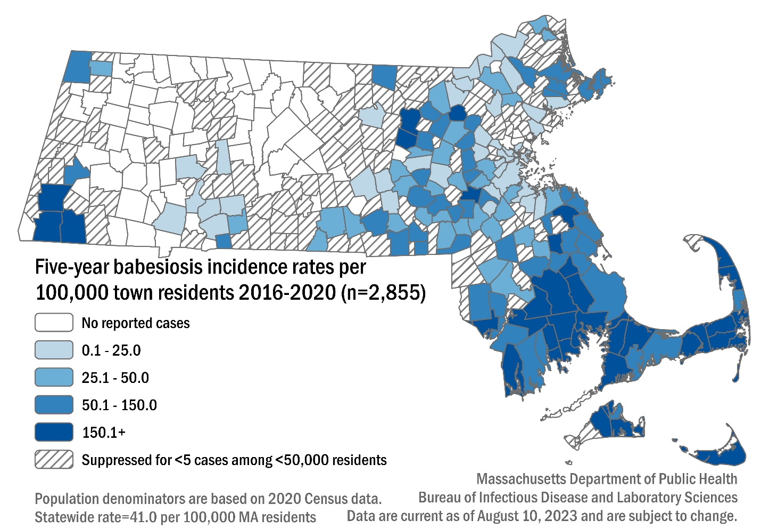

Table 1: Babesiosis confirmed and probable cases and incidence rates per 100,000 population by county, Massachusetts, 2020
County | 2020 Cases | 2020 Incidence Rate per 100,000
Barnstable | 78 | 34.1
Berkshire | 13 | 10.1
Bristol | 120 | 20.7
Dukes & Nantucket | 62 | 177.9
Essex | 32 | 4.0
Franklin | 2 | 2.8
Hampden | 10 | 2.1
Hampshire | 0 | 0.0
Middlesex | 66 | 4.0
Norfolk | 34 | 4.7
Plymouth | 96 | 18.1
Suffolk | 11 | 1.4
Worcester | 56 | 6.5
State Total | 580 | 8.3

Figure 2: Number of confirmed and probable babesiosis cases by month of symptom onset, Massachusetts, 2020, (n= 580)
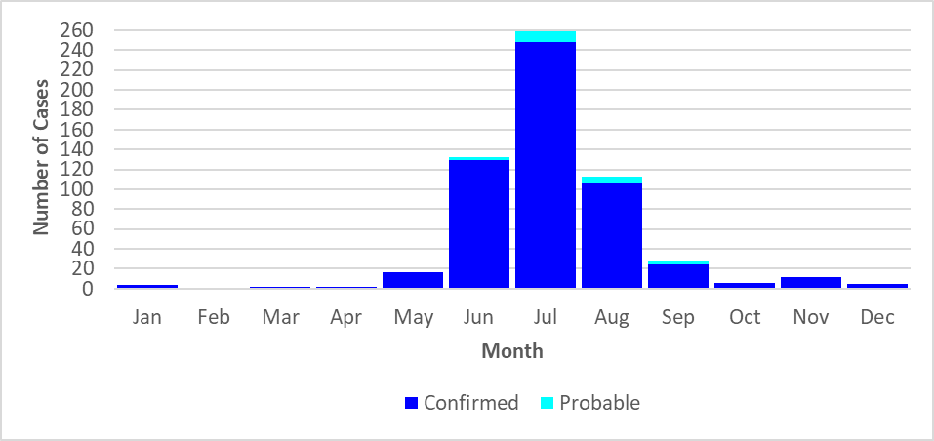

Figure 3: Rate (per 100,000 population) of confirmed and probable babesiosis cases by age group, Massachusetts, 2020, (N=580)
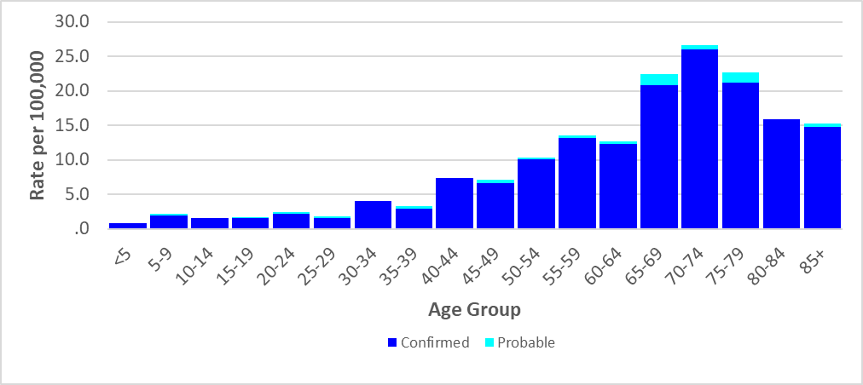

Figure 4: Number of confirmed and probable babesiosis cases by year, Massachusetts, 2016-2020, (N=2,855)
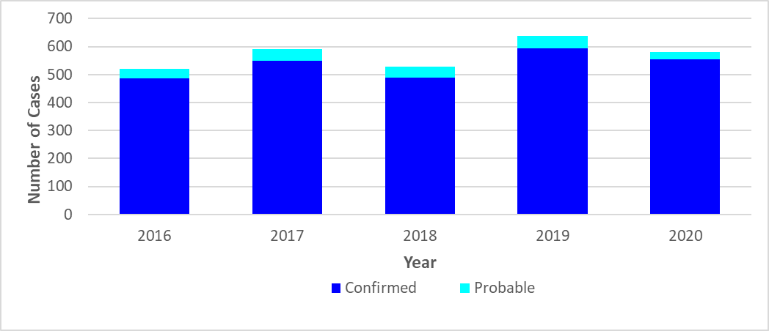

Human Granulocytic Anaplasmosis (HGA)
- Anaplasmosis is a disease caused by the bacterium Anaplasma phagocytophilum.
- 740 confirmed and probable cases of HGA were reported in Massachusetts in 2020, with an additional 721 cases classified as suspect.
- Statewide, HGA incidence increased from 10.1 to 10.5 cases per 100,000 residents compared to 2019. The highest incidence rate was seen in Franklin county (60.5), followed closely by Dukes and Nantucket (60.2) and Berkshire county (52.7).
- The majority of cases occurred between the months of May and July, when nymphal black-legged ticks are most active.
- When asked about awareness of a recent tick bite prior to symptom onset, 46% of cases confirmed to have a tick bite, 34% reported no tick bite, while 20% were not sure.
- Individuals from the ages of 55 to 74 make up 396 of the 740 cases (54%), thus are at greatest risk of contracting the disease with the mean age for cases being 61 years old. Males were more likely than females to be infected, accounting for 60% of cases in the state.
- The most commonly reported symptoms include: fever (100%), malaise (89%), muscle pain (79%), headache (76%), and joint pain (66%); 35% of cases were hospitalized and there was one reported death.

Figure 5: HGA incidence rates per 100,000 population by city/town, Massachusetts, 2016-2020

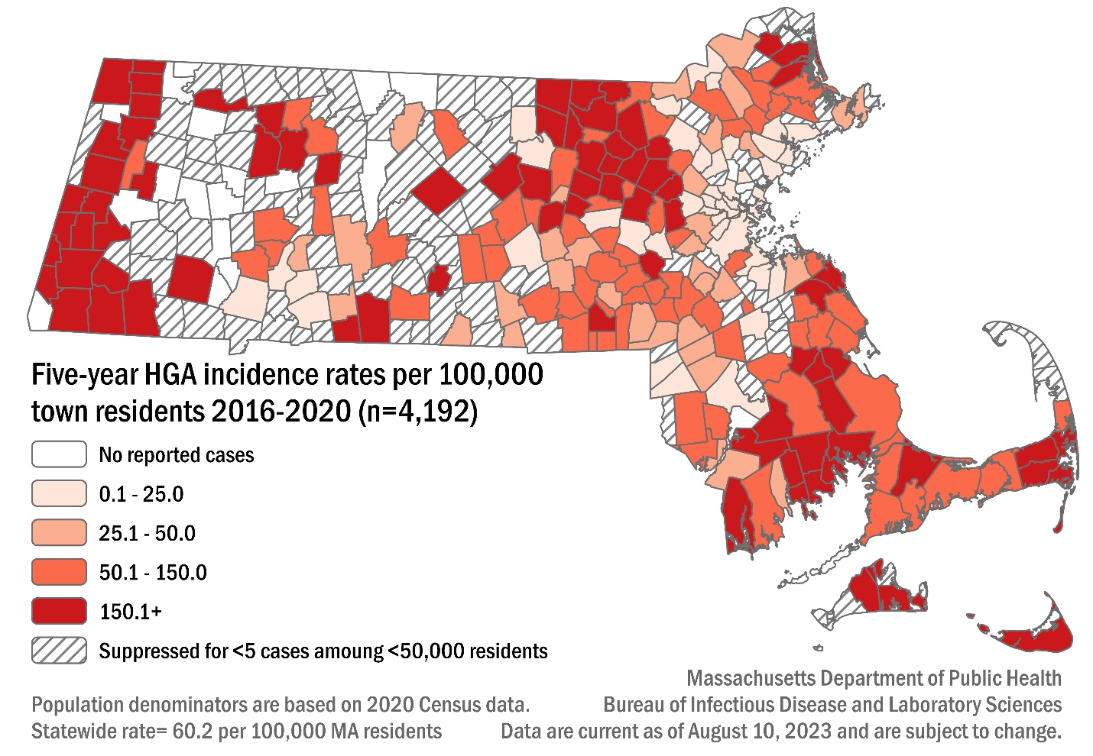

Table 2: HGA confirmed and probable cases and incidence rates per 100,000 population by county, Massachusetts, 2020
County | 2020 Cases | 2020 Incidence Rate per 100,000
Barnstable | 45 | 19.7
Berkshire | 68 | 52.7
Bristol | 82 | 14.2
Dukes & Nantucket | 21 | 60.2
Essex | 51 | 6.3
Franklin | 43 | 60.5
Hampden | 29 | 6.2
Hampshire | 32 | 19.7
Middlesex | 137 | 8.4
Norfolk | 37 | 5.1
Plymouth | 98 | 18.5
Suffolk | 6 | 0.8
Worcester | 91 | 10.6
State Total | 740 | 10.5

Figure 6: Number of confirmed and probable HGA cases by month of symptom onset, Massachusetts, 2020, (n=740)
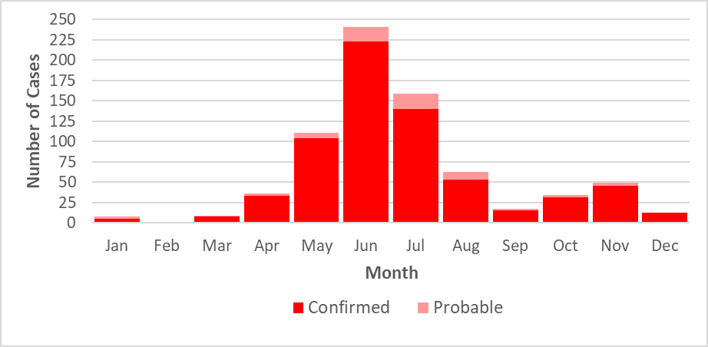

Figure 7: Rate (per 100,000 population) of confirmed and probable HGA cases by age group, Massachusetts, 2020, (N=740)
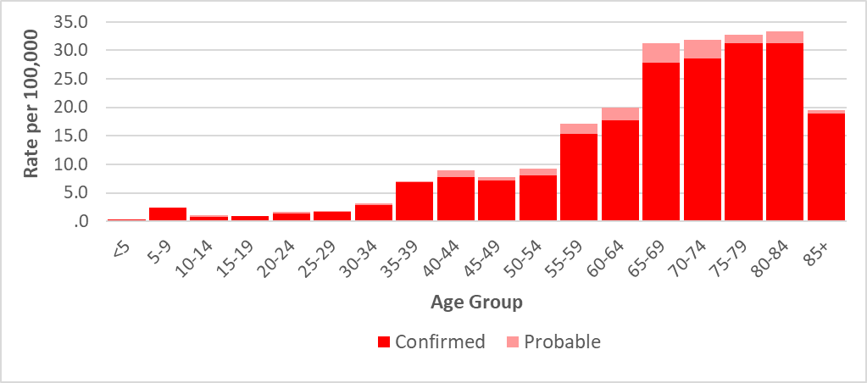

Figure 8: Number of confirmed and probable HGA cases by year, Massachusetts, 2016-2020 (N= 4,192)
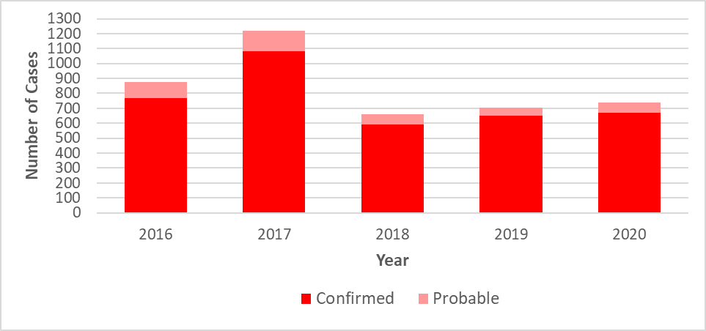

Borrelia miyamotoi infection
- Borrelia miyamotoi is a type of spiral-shaped bacteria that is closely related to the bacteria that cause tickborne relapsing fever. Infection is often referred to as borreliosis.
- B. miyamotoi is a relatively new, emerging disease, with the first recorded cases identified in New England in 2011.
- Eleven confirmed and probable cases of Borrelia miyamotoi were reported in 2020, representing a 66% decrease in cases compared to 2019; however, these data may be impacted by 2020 being a pandemic year. There were an additional 27 cases classified as suspect in 2020.
- The majority of reported cases occurred in August, otherwise there is no notable trend due to small sample size.
- When asked about awareness of a recent tick bite prior to symptom onset, 37% of cases confirmed to have a tick bite, 27% reported no tick bite, while 36% were not sure.
- The mean age of cases was 44 years old. Males and females were affected equally.
- Among cases where data was able to be collected, the most common symptoms reported included: fatigue (100%), joint pain (100%), muscle pain (100%), headache (100%), chills (80%), and fever (67%).
- No cases were hospitalized and there were no known deaths.

Figure 9: Borrelia miyamotoi cases by county of residence, Massachusetts, 2016-2020
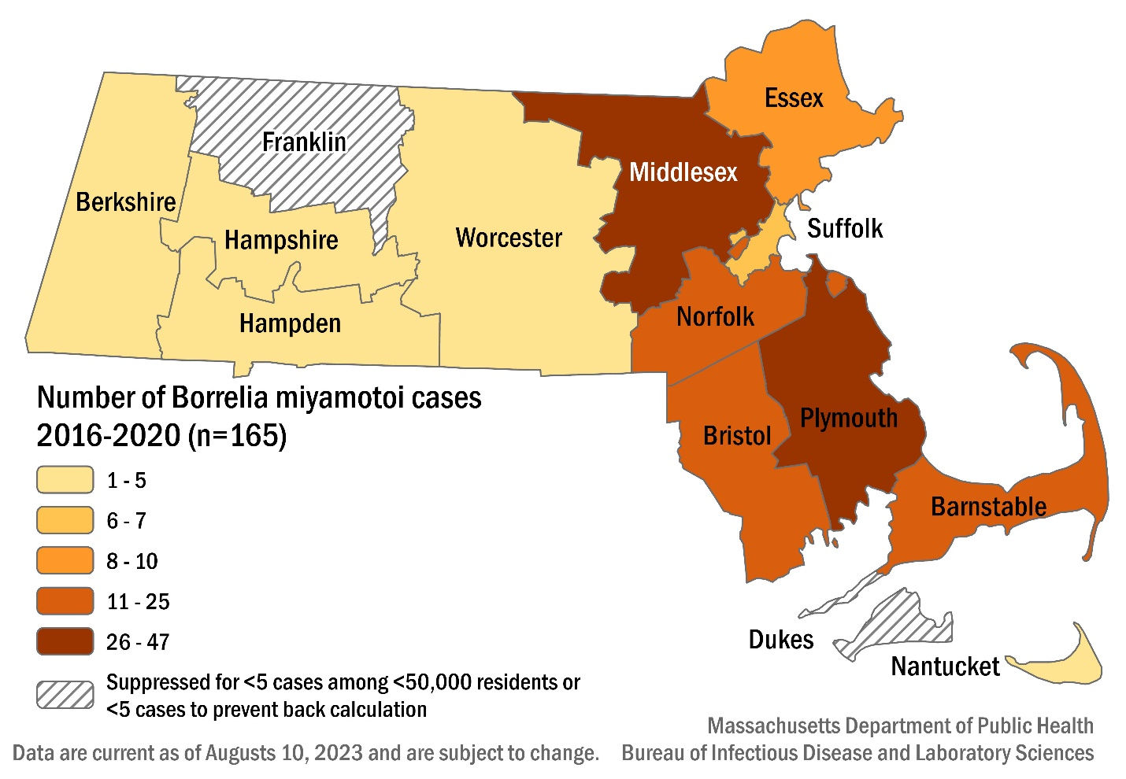

Table 3: Borrelia miyamotoi confirmed and probable cases by county, Massachusetts, 2020
County | 2020 Cases | Frequency (%)
Barnstable | 2 | 18
Berkshire | 0 | 0
Bristol | 0 | 0
Dukes & Nantucket | 0 | 0
Essex | 1 | 9
Franklin | 1 | 9
Hampden | 1 | 9
Hampshire | 0 | 0
Middlesex | 1 | 9
Norfolk | 2 | 18
Plymouth | 0 | 0
Suffolk | 1 | 9
Worcester | 2 | 18
State Total | 11 | 100

Figure 10: Number of confirmed and probable Borrelia miyamotoi cases by month of symptom onset, Massachusetts, 2020, (N=11)
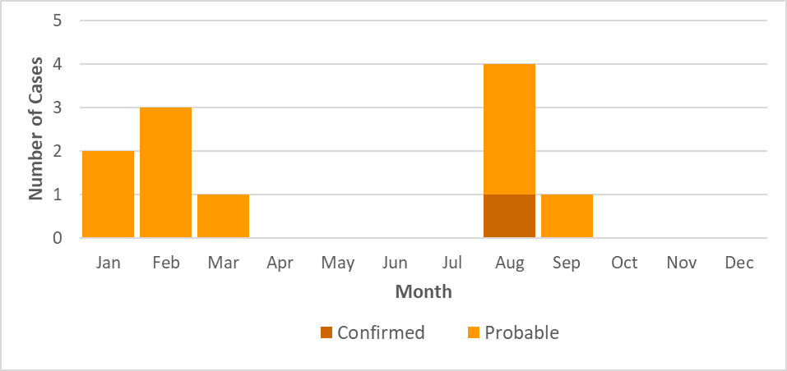

Figure 11: Number of confirmed and probable Borrelia miyamotoi cases by age group, Massachusetts, 2016-2020, (N=165)
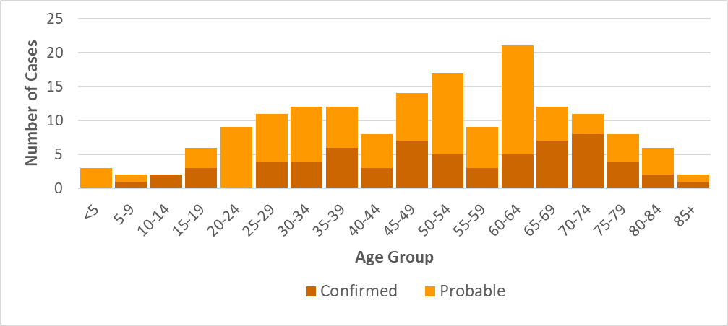

Figure 12: Number of confirmed and probable Borrelia miyamotoi cases by year, Massachusetts, 2016-2020, (N=165)
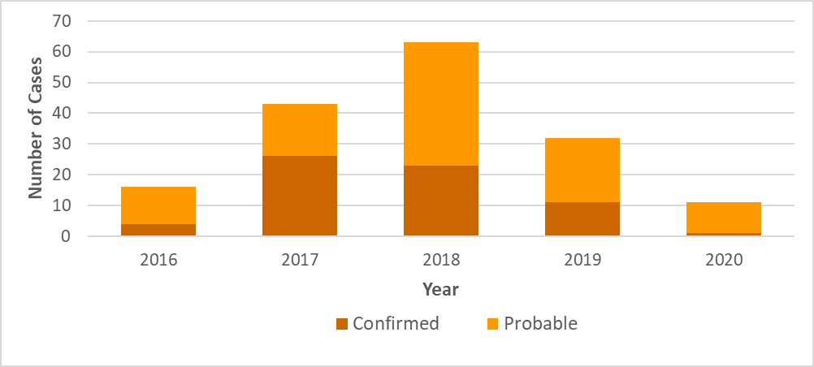

Powassan virus
- There are two types of Powassan virus in Massachusetts. Type one is found in ticks that feed on woodchucks (groundhogs); while type two is carried by black-legged ticks.
- Cases of Powassan virus infection were first confirmed in Massachusetts via laboratory testing in 2013.
- Between 2013 and 2020, 39 cases of Powassan virus infection were detected in Massachusetts residents. Of those cases, 77% are 50 years of age and older, and overwhelmingly male at 77%.
- Known tick bites before the onset of symptoms were reported in 25.6% of cases.
- The most common symptoms reported were headache (96.6%), fever (94.9%), change in mental status (84.6%), mental confusion (83.3%), muscle weakness (78.3%), and vomiting (58.3%).
- The primary types of infection reported were encephalitis (60.5%), meningoencephalitis (29.0%), and meningitis (7.89%).
- Most cases (92.3%) required hospitalization due to the severity of their symptoms.
- Seven individuals (17.9%) were hospitalized more than once.
- There were eight fatalities.

Figure 13: Powassan virus cases by city/town of residence, Massachusetts, 2013-2020
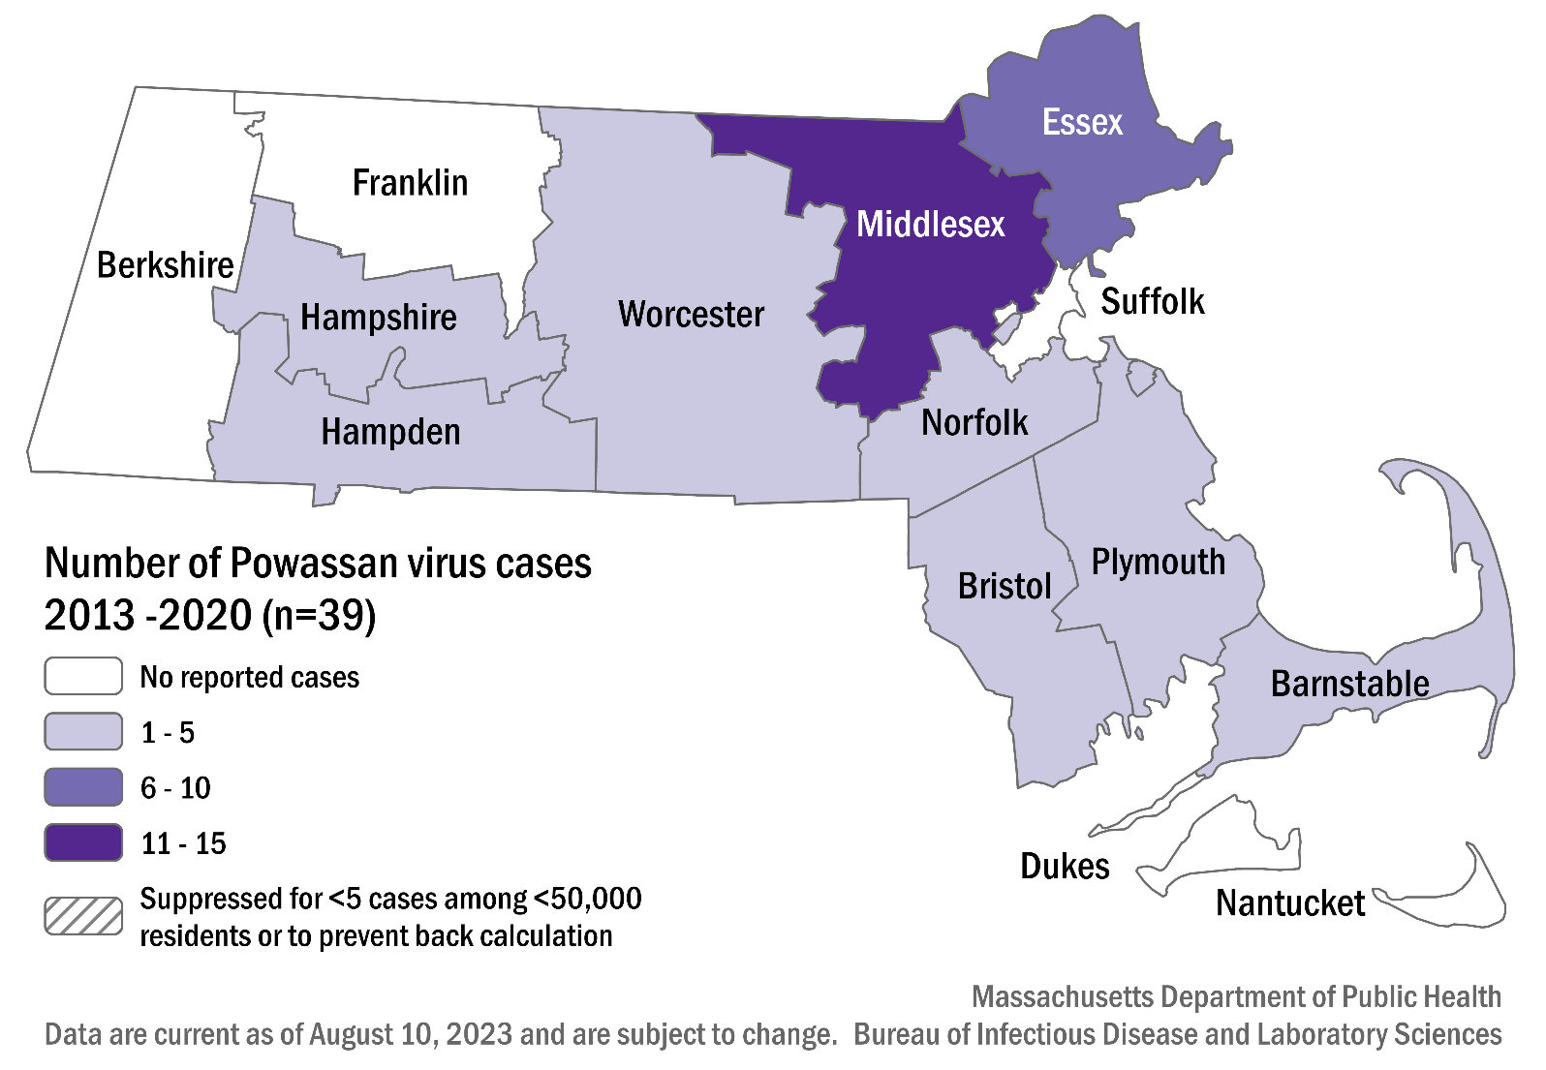

Table 4: Number of confirmed and probable Powassan virus cases by county, Massachusetts, 2013-2020
County | Cases
Barnstable | 5
Berkshire | 0
Bristol | 1
Dukes & Nantucket | 0
Essex | 9
Franklin | 0
Hampden | 2
Hampshire | 1
Middlesex | 13
Norfolk | 3
Plymouth | 1
Suffolk | 0
Worcester | 4

Figure 14: Number of confirmed and probable Powassan virus cases by month of symptom onset*, Massachusetts, 2013-2020, (N = 39)
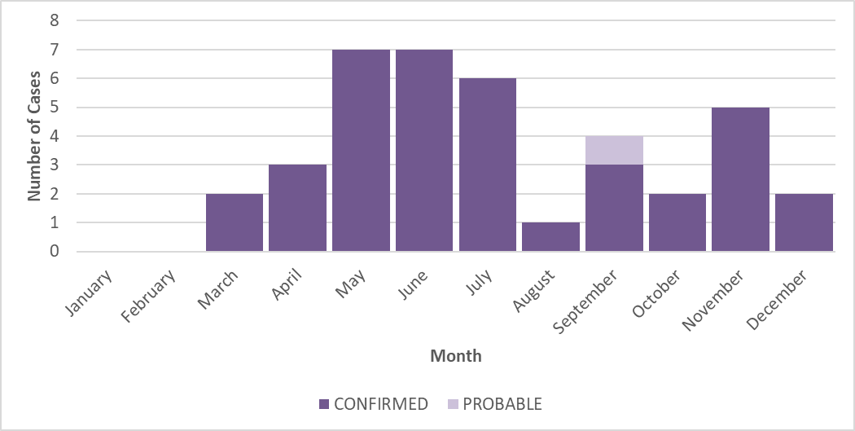

* Symptom onset date not reported for every confirmed and probable case.

Figure 15: Number of confirmed and probable Powassan virus cases by year, Massachusetts, 2013-2020, (N = 39)
