INDOOR AIR QUALITY ASSESSMENT

**Timony Grammar School**

45 Pleasant View Street

Methuen, MA

**April 2025**

Aerial view of Timony Grammar School
45 Pleasant View Street
Methuen, MA


Prepared by:

Massachusetts Department of Public Health

Bureau of Climate and Environmental Health

Division of Environmental Health Regulations and Standards

Contents

EXECUTIVE SUMMARY 3

BACKGROUND 5

RESULTS AND DISCUSSION 6

Ventilation 6

HVAC System Maintenance 7

HVAC Types and Specific Conditions 8

Water Damage and Moisture Concerns 8

Sources of Respiratory Irritants/Possible Asthma Triggers 12

Other IAQ Issues 15

CONCLUSIONS AND RECOMMENDATIONS 15

Short-term Recommendations 15

Long-term Recommendations 20

REFERENCES 21

FIGURES 23

PICTURES 24

Ventilation Pictures 24

Water Damage pictures 30

Table 1 40

Table 2A 53

Table 2B 54

Table 2C 55

Table 3 56

Table 4 58

# EXECUTIVE SUMMARY

The Massachusetts Department of Public Health’s (MDPH) Division of Environmental Health, Regulations and Standards (EHRS) conducted an Indoor Air Quality (IAQ) assessment of Timony Grammar School located at 45 Pleasant View Street in Methuen on February 28, 2025. This assessment was requested by Superintendent Dr. Brandi Kwong and the Methuen City Mayor, DJ Beauregard’s Office. It is also important to note that prior to the MDPH assessment, the Mayor has created a School Health and Safety Task Force ([School Health and Safety Task Force | Methuen, MA](https://www.cityofmethuen.net/875/School-Health-and-Safety-Task-Force)) the goal of which is to “…*address long-standing facilities-related issues in Methuen's public schools. The goal of this page is to provide the entire community with a transparent overview of what has been done to begin addressing those problems - and what is being done to ultimately fix them”.*

Any building can have IAQ issues. These issues can be made worse through conditions common to marginalized communities (Environmental Justice communities or EJ) such as inequitable exposure to outdoor air pollution and a greater likelihood of poor building conditions leading to deterioration of IAQ resulting in higher asthma rates. The city of Methuen contains a number of EJ communities (<https://matracking.ehs.state.ma.us/Environmental-Data/ej-vulnerable-health/environmental-justice.html>). Note that the pediatric asthma rate for this school as of 2023 is 6.8%. Which is statistically significantly lower than the statewide pediatric asthma prevalence rate of 9.6% (MAEPHT, 2024).

The assessment was conducted by evaluating several key elements within the school: a visual inspection of the heating, cooling, and ventilation (HVAC) systems, water/microbial damage, cleanliness, point sources of respiratory irritants such as chemicals, and electronic measurement of carbon dioxide (CO2), carbon monoxide (CO), temperature, relative humidity (RH), and small particulate matter (PM2.5) all taken with a Qtrak XP monitor. Data is collected in this manner to identify potential asthma triggers, allergens, and other environmental factors that can cause indoor air quality symptoms. Please refer to the [Indoor Air Quality Manual](https://www.mass.gov/lists/indoor-air-quality-manual-and-appendices#indoor-air-quality-manual-) on the MDPH website for methods, sampling procedures, and interpretation of results.

It is important to note that the Methuen Public School District has made an important commitment to improving IAQ by replacing some HVAC components and control systems. However, during the assessment many supply and exhaust components of the mechanical ventilation system were deactivated or not operating. This limits capacity to dilute and remove typical indoor pollutants as well as outdoor pollutants, such as vehicle exhaust, pollen, mold spores, and wildfire smoke. In addition, excess water vapor during hot, humid weather may also build up in the building and lead to water damage/mold growth to building materials over summer months. Several areas with visible water damage and signs of mold growth were noted during the assessment. MDPH staff provided verbal recommendations at the time, which are reiterated in this report. (Results and Discussion).

Like many school buildings in the Commonwealth, it is also important to note that some building components, such as windows, parts of the heating, ventilation, and air conditioning (HVAC) system and the roof are past their service life and in need of replacement.

As a result of this assessment, there are several findings typical of elementary schools of this age and type. Upon review of these findings, several primary recommendations are made to optimize existing systems and improve indoor air quality. (Conclusions and Recommendations)

* Operate all supply and exhaust ventilation equipment *continuously* during occupied hours.
* Repair exhaust vents or activate them, and ensure they are not blocked by items.
* Work with an HVAC engineering firm to determine the operational lifespan of existing equipment (e.g., unit ventilators and air handling units) and the feasibility of repair vs. replacement.
* Use air purifiers in occupied rooms to supplement mechanical ventilation.
* Remediate water-damaged/mold-colonized items and building materials using the US EPA’s “Mold Remediation in Schools and Commercial Buildings”. Available at: <http://www.epa.gov/mold/mold-remediation-schools-and-commercial-buildings-guide>
* Replace original windows with modern energy efficient ones.
* Make repairs to the building envelope to restore watertight integrity.
* Ensure the principles of integrated pest management (IPM) are followed in accordance with state regulations.

As climate change and global warming intensifies, the urgent need for modern, energy-efficient solutions becomes clear, without significant repair of the building envelope and repair/upgrade of interior HVAC components, building conditions and indoor air quality will continue to degrade.

(Conclusions and Recommendations)

Please note: this report contains a series of recommendations that should serve as *Best Practices* that apply to most public-school buildings across the Commonwealth and should be shared amongst other buildings in the school district.

# BACKGROUND

|  |  |
| --- | --- |
| Building: | Timony Grammar School (TGS) |
| Address: | 45 Pleasant View Street, Massachusetts |
| Coordinated Via: | Superintendent and Mayor’s Office |
| Reason for Request: | Rodent issues and general indoor air quality (IAQ) concerns |
| Date of Assessment: | February 28, 2025 |
| Massachusetts Department of Public Health/Bureau of Climate and Environmental Health (MDPH/BCEH) Staff Conducting Assessment: | Cory Holmes, Amy Riordan, Ruth Alfasso, Kerry Wagner, Bharathi Patimala-Dipali, and Thomas Murphy, Division of Environmental Health Regulations and Standards (EHRS) |
| Building Description: | The TGS is a two-story red brick building originally constructed in 1964. The building underwent renovations in 1996-1997. The building contains general classrooms, music room, library, art rooms, office space, kitchen, cafeteria, gymnasium, and an auditorium. |
| Windows: | Windows in the building are openable. |

# RESULTS AND DISCUSSION

The following is a summary of indoor air testing results (Table 1)

|  |  |  |
| --- | --- | --- |
| * ***Carbon dioxide (CO2)*** | *a measure of the adequacy of ventilation* | Levels were above the MDPH guideline of 800 parts per million (ppm) in more than half of the areas surveyed, indicating a lack of air exchange in these areas. |
| * ***Temperature*** | *a measure of comfort* | Most areas measured were within the MDPH recommended range of 70°F to 78°F, however some were above and some below that range. |
| * ***Relative humidity*** | *a measure of comfort and, when in excess for an extended period, a way to reflect the potential for mold and fungal growth* | Was below the MDPH recommended range of 40 to 60% in areas tested. Low relative humidity is common indoors during the heating season. Relative humidity would be expected to be higher during hot, humid weather. |
| * ***Carbon monoxide***   ***(CO)*** | *a product of combustion that can result in acute and long term cardiovascular, respiratory, and neurological symptoms* | Levels were non-detect (ND) in all areas tested. |
| * ***Particulate matter (PM2.5)*** | *a way to measure inhalable particle distribution in the air* | Concentrations were below the National Ambient Air Quality Standard (NAAQS) of 35 micrograms per cubic meter (μg/m3) in all areas tested. |

## Ventilation

Ventilation refers to both the supply of fresh air and the removal of stale air from a room. The introduction of fresh air into an occupied space will dilute normally occurring pollutants that are generated by occupancy and other activities. In addition, an HVAC system will remove pollutants from a building if operating appropriately. All ventilation systems throughout the building should operate continuously during periods of occupancy.

The majority of classrooms are equipped with unit ventilators (univent, Picture 1). Univents bring in fresh air from a vent on the outside of the building (Picture 2), filter it, heat or cool it, and supply the air through a vent on the top. Some room air is recirculated along with the fresh air through a vent at the bottom (Figure 1).

Ventilation for interior rooms and common areas is provided by rooftop air handling units (AHUs) (Picture 3). Fresh air is drawn in through air intakes and distributed to classrooms and common areas via ceiling or wall-mounted air diffusers (Picture 4).

Wall or ceiling-mounted exhaust vents remove stale air from classrooms to provide air exchange (Picture 5). Many exhaust vents were not active during the assessment. (Table 1). It was not known whether these vents were not functional or just deactivated.

Two rooms were equipped with mini-split (ductless) air conditioners located in the ceiling (Table 1). While these units are effective at cooling, they do not provide any fresh air.

Most classrooms are equipped with openable windows (Table 1). Windows can introduce fresh air into classrooms when outdoor conditions are amenable. Windows should not be opened during very hot, very cold, or very humid conditions and should also stay closed when outdoor air quality is poor due to smoke, high pollen counts, or outdoor maintenance activities.

Without proper supply and exhaust ventilation, normally occurring environmental pollutants can build up and lead to indoor air quality/comfort complaints. In addition, without proper exhaust ventilation, excess moisture cannot be removed from the building, which can lead to mold growth conditions over the summer.

The various types of ventilation components as well as devices that can move/redirect airflow that were identified in the building are listed in Table 2A, Table 2B and Table 2C.

### HVAC System Maintenance

* During the assessment, some univents were deactivated (Table 1), therefore no means of mechanical fresh air was being provided.
* The univents are reported to be controlled by a computerized management system.
* MDPH recommends that filters of at least a Minimum Efficiency Rating Value (MERV) of 8 be used as these are adequate to filter out pollen, mold, and similar particulates (ASHRAE, 2012). A few univents were opened and the filter examined (Picture 6). MERV 8 filters in good condition were found. Facility staff report that these are changed 2-4 times a year.
* It was reported that MERV 13 filters (Picture 7) are used in roof-mounted AHUs and replaced quarterly. MDPH recommends that filters be changed two to four times a year or as per the manufacturers’ recommendations.
* It was reported that rooftop AHU are equipped with sensors for carbon dioxide.
* Many univents were blocked with items and furniture along the top or front (Picture 8). Blocked univents are much less effective at circulating air through a classroom. In addition, items such as plants (Picture 9), cardboard, and plastic can be a source of odors which can be distributed throughout the room by the operation of the univent, especially when heated.
* Many wall-mounted exhaust vents were blocked by furniture or items, often a white storage cabinet found in most classrooms (Picture 10). Blocked exhaust vents do not function well to remove stale air.
* Some ceiling-mounted vents were blocked by items piled on top of furniture (Picture 11). This not only reduces the effectiveness of the vent but items this close to the ceiling may be against the fire code.
* Conditions were found that would compromise the function of the rooftop AHUs. The equipment was showing signs of age including rust and ductwork falling away from the main units (Picture 12).
* Newer insulation had been added to the units, but it had holes and gaps. This appears to be damage done by animals.

### HVAC Types and Specific Conditions

(see Ventilation pictures)

**Additional HVAC Conditions:**

* **As mentioned, a number of univents and exhaust vents appeared to be in the off-cycle or not functioning at the time of assessment** (Table 1). To maximize air exchange, BCEH recommends that both supply and exhaust ventilation operate *continuously* during periods of occupancy.

**Balancing**

To have proper ventilation with a mechanical supply and exhaust system, a system must be balanced to provide an adequate amount of fresh air to the interior of a room while also removing stale air from the room. It is recommended that HVAC systems be re-balanced every five years to ensure adequate air systems function (SMACNA, 1994).

* **The system should be balanced** once the installation and programming of new electronic HVAC thermostats and controls are complete.
* **Any carbon dioxide sensors in AHUs or elsewhere should be calibrated or replaced as recommended by the manufacturer.**
* **Both univents and rooftop AHUs are likely beyond their service life.** According to the American Society of Heating, Refrigeration, and Air-Conditioning Engineering (ASHRAE), the service life of this type of unit is 15-20 years, assuming routine maintenance of the equipment (ASHRAE, 1991).

## Water Damage and Moisture Concerns

Please note that the MDPH does not recommend conducting mold testing in a typical water damage remediation. For details, please consult [Guidance Regarding Testing for Mold in Water-Damaged Public Buildings](https://www.mass.gov/info-details/guidance-regarding-testing-for-mold-in-water-damaged-public-buildings) | Mass.gov

The application of a mildewcide to moldy porous materials is not recommended.

Molds are found naturally in our environment both indoors and outdoors. Inside, mold growth may occur when items, particularly porous products such as paper or gypsum wallboard, are exposed to moisture. Typical water sources include leaks, floods, and condensation. To avoid mold growth, dry all water-damaged items and affected areas within 24-48 hours and reduce indoor humidity. Some people with chronic respiratory conditions, such as asthma, are more likely to experience health symptoms associated with molds, including allergic reactions and respiratory irritation. Controlling moisture is the key to preventing mold growth and potential health symptoms.

Hot humid summers are becoming more frequent due to climate change. Massachusetts has experienced hot, humid, and rainy summers in 2018, 2021, and 2023. July of 2021 was the wettest ever recorded in Massachusetts, and the three-month period from June through August, known as the meteorological summer, was the fourth wettest on record, according to the National Oceanic and Atmospheric Administration’s (NOAA) Centers for Environmental Information (NOAA, 2021). The summer of 2023 was also hot, and wet, being measured as the second rainiest on record (WBUR, 2023). The summer of 2024 also had significant stretches of hot, humid weather. These conditions are challenging for buildings, particularly those without central air conditioning.

During these hot and wet summers, extended periods of outdoor relative humidity above 70% occurred. Under these weather periods, public buildings experienced extended periods of water vapor exposure from high relative humidity. When exposed to these conditions, porous materials such as gypsum wallboard, cardboard, and other materials may become prone to developing mold colonization, particularly if located in areas that are prone to developing condensation on floors and walls (e.g., below grade space).

It was reported that a number of proactive actions were taken by Administrative and Custodial staff to reduce moisture/leaks, monitor conditions, and help prevent mold growth in the building. These included:

* Frequent walkthroughs of the building, particularly after rain events to note areas of water infiltration;
* The deployment of dehumidifiers in classrooms most susceptible to moisture. These dehumidifiers are stationed on countertops to allow continuous drainage into sink drains;
* Long-term replacement of carpeting;
* The use of MERV 13 filters in HVAC equipment; and
* Making high-efficiency particulate arrestance (HEPA) air purifiers available for use. These remove up to 99% of airborne contaminants as small as 0.1 microns including airborne mold spores.

In addition to these steps, If possible, this computerized system should be utilized to monitor *real-time measurements* for temperature to track trends and take actions to prevent excess moisture conditions that can lead to mold growth over summer months.

All rooms examined were assessed for the presence of either mold or visible water damage and the following issues were noted.

* **Water-damaged ceiling tiles were found in some locations (Pictures 13 and 14; Table 1),** which can indicate current/historic roof/plumbing leaks or other water infiltration. Water-damaged ceiling tiles can provide a source of mold and should be replaced after a water leak is discovered and repaired.
* **Water-damaged plaster/efflorescence was noted (Picture 15), and other water stains on building materials (Picture 16).**
* **Active leaks were noted in a few rooms (Table 1)** and buckets were being used to catch water. Active leaks should be repaired as soon as possible to avoid ongoing water damage as well as slipping hazards.
* **On the ground floor, evidence of water damage in areas close to classroom exterior doors was noted**. Various water-damaged materials were found including walls, coving, cabinets, and ceilings (Pictures 17 and 18). While majority of the materials found around the exterior doors were mostly non-porous and not conducive to mold growth (e.g., concrete and tile), this area should be kept clean of dust and debris (which can grow mold) and should be monitored after heavy rains to ensure prompt clean up and drying, and avoid moisture spreading to other areas with porous building materials, which may be conducive to mold growth.
* **Two ground floor classrooms had wall-to-wall carpeting.** The carpeting may not be insulated underneath between the floor and the soil. Therefore, during hot, humid weather, the ground may be cold enough to develop condensation. Porous items on the floor, including carpeting and classroom materials, may become water-damaged and mold-colonized. Wall-to-wall carpeting is generally not recommended for classrooms, especially on the ground floor due to this and other issues. However, the carpeting in these rooms did not have odors and showed no other signs of water damage.
* **Many classrooms had sinks. Damaged backsplashes were observed in some sinks (Picture 19).** If a backsplash is damaged, it becomes very difficult to keep clean, and can lead to additional damage to the material underneath.
* **Cabinets for classroom sinks were often in poor condition.** Water damaged building material was found underneath many of them (Picture 20). Many doors on sink cabinets could not be opened and closed properly. Uneven surfaces cannot be adequately cleaned, and any breaches can serve as pathways for pests and rodents into occupied areas.
* **In addition to water-damaged building materials, porous items were found under many sinks (Picture 21).** Storing items in a moist environment can create conditions conducive to mold growth. An excess of items can also prevent leak detection and allow rodents a place to hide.
* **Some sinks also could not be turned off completely (Table 1)** which adds moisture to the environment. Plumbing leaks should be repaired.
* **Plants were found in some classrooms and offices (Picture 9; Table 1**). Plants should not be placed on ventilation equipment, should be well-maintained, and placed on non-porous drip pans that are cleaned frequently.
* **Bowed ceiling tiles (Picture 22; Table 1) were noted in many classrooms and hallways.** This is a sign of chronic exposure to high humidity. In some cases, the tiles were warped enough that they no longer fit securely in the ceiling tile grid. This can allow dust and debris from above the ceiling tile grid into occupied spaces.

An exterior evaluation was also conducted to identify potential pathways for water penetration and pest entry. The following issues were noted.

* **While most of the brickwork was in good condition, some was water-stained or damaged (Picture 23).**
* As a part of the rodent exclusion efforts for Methuen schools**, heavy-duty metal door sweeps were added to exterior doors in this building.** No light was visible beneath them. Good door-sweeps/weatherstripping can not only exclude pests but can keep unconditioned outside air and moisture from entering the building.
* **Damaged wood and delaminating paint/stain were found along the roof eaves and trim around windows (Picture 24),** which can accelerate water damage and rot allowing a pathway for drafts, moisture, and pest entry into the building.
* **Large trees were noted in the courtyard of the building and near the exterior (Picture 25 and 26). Ivy was noted growing on the building in one area.** Plants near or on the building can cause water damage to brickwork and mortar. In addition, plants shading exterior walls can slow drying. Water can eventually penetrate the brick, subsequently freezing and thawing during the winter. This freezing/thawing action can weaken and damage bricks and mortar.
* **Trees overhanging the roof may also be providing transportation to pests** leading to damage noted to AHU insulation.
* **The presence of trees near the building along both the exterior and the courtyard pose several hazards/issues:**
  + Leaves and other debris accumulate around roof drains, which inhibits rainwater drainage from the roof. Ineffective drains can lead to water leaks inside the building.
  + Trees prevent sunlight from drying walls and soil.
  + The trees are a possible danger due to the distance from exterior walls:
  + The recommended safe distance that any tree should be planted is the minimum of the expected maximum growth height of the species from the exterior of a building (BI, 2015).
  + Soil subsidence may also be caused by tree roots, which can undermine the structure of a building to cause wall and floor cracking and related damage. To prevent subsidence, a sufficient distance appropriate for the tree species is recommended (Williams, 2006).
  + Severe weather may result in the tree falling onto the building or the tree roots damaging the foundation. Due to the height of the trees, each is likely located closer than recommended distances.
  + In general, a tree root system will spread out in all directions from its trunk. In some cases, tree roots can extend for over 100 feet from its trunk. Any structure disrupting the root structure may make the tree unstable if subjected to high winds from a certain direction. Based on the location, the foundation walls likely disrupt the roots of several trees.
  + The Federal Emergency Management Agency (FEMA) provides several recommendations to prepare for severe thunderstorms. Of note FEMA recommends “Cut down or trim trees that may be in danger of falling on your [building]” (FEMA, 2018). Given the proximity to exterior walls, removal of trees from the exterior should be strongly considered.

These conditions represent potential water penetration sources. Over time, these conditions can undermine the integrity of the building envelope and provide a means of water entry into the building via capillary action through foundation concrete and masonry (Lstiburek & Brennan, 2001).

A list of water damage issues identified inside and outside the building is included as Table 3.

(see Water Damage Pictures)

**Mold Growth**

Porous materials (e.g., gypsum wallboard, ceiling tiles and carpeting) can be dried with fans and heating within 24 to 48 hours of becoming wet (US EPA, 2008).

If porous materials are not dried within this time frame, mold growth may occur.

## Sources of Respiratory Irritants/Possible Asthma Triggers

Asthma is a lung disease that can make breathing difficult. Without careful management of asthma, some people can have symptoms, like a tight feeling in the chest, shortness of breath, coughing, or wheezing. Although there is no cure for asthma, people with asthma can live healthy, active lives. A safe and healthy environment helps to reduce asthma symptoms.

**Comparison of Local and State-wide Asthma Rates (2023-2024 school year/MAEPHT 2025)**

6.8% of children

have asthma.

**Timony Grammar School**

9.6% of children

have asthma.

**Massachusetts**

8.5% of children

have asthma.

**Methuen**

* **Sometimes, learning tools and personal items in a classroom can be a source of irritants.** For example, a bird or insect nest is a great learning tool for students but may harbor microbes and allergens, as does a fish tank which could be a source of odors. Similarly, food-based projects can attract pests that carry disease or trigger allergies.
* **Dust, a common respiratory and eye irritant, can collect on surfaces and items.** Although janitorial and maintenance staff perform routine cleaning in classrooms, they may not be able to clean as effectively if classroom items are not picked up or surfaces are cluttered.
* Even with a properly functioning ventilation system, it is necessary to reduce the use of materials that can be a source of respiratory irritants to prevent symptoms in individuals who have sensitivity to such pollutants. **Without operational mechanical exhaust in most areas, irritants can linger.**

For guidance on maintaining an asthma-friendly healthy school environment, please consult the MDPH Asthma Prevention and Control Program’s [Clearing the Air: An Asthma Toolkit for Healthy Schools](https://www.maasthma.org/schooltoolkit).

Possible asthma triggers and/or airborne pollutants exist in the building. These are listed below as well as in (Table 4).

(see Sources of Respiratory Irritant Pictures)

* **It was reported that rodent infestation is a concern for schools in the district.** Note that rodent infestation, because of materials present in wastes, can produce indoor air quality-related symptoms. Mouse urine contains a protein that is a known sensitizer (US EPA, 1992). A sensitizer is a material that can produce symptoms in exposed individuals (e.g. running nose or skin rashes) after repeated exposures. To reduce issues related to rodents, the animals first need to be excluded from and removed from a building. Then thorough cleaning needs to be performed to remove wastes and dander. The district has been working with a professional pest contractor to institute a pest management plan. Removing and excluding rodents will be an ongoing process. Occupants can assist by:
* Keeping all food and food waste in tightly-closed mouse-proof containers,
* Cleaning crumbs and removing trash daily,
* Ensuring doors are closed tightly and open windows are equipped with intact screens, and
* Reporting pest sightings or new gaps in the building envelope to facility management.
* **Some areas are covered with wall-to-wall carpet that is soiled/stained and past its service life (Picture 27).** Carpeting has a service life of approximately 10-11 years (IICRC, 2002). Carpeting that is beyond its service life becomes increasingly difficult to clean and may release fibers which can be irritating if airborne. Carpets should be vacuumed regularly with a high efficiency particulate arrestance (HEPA) filter equipped vacuum cleaner and cleaned annually (or semi-annually in soiled/high traffic areas) in accordance with Institute of Inspection, Cleaning and Restoration Certification (IICRC) recommendations (IICRC, 2012).
* **Area rugs and plush items were also noted in some classrooms (Picture 28; Table 8).** These need to be cleaned regularly to remove dust and debris. Area rugs should be stored rolled up off the floor in a dry area during the summer. Used area rugs and plush items should not be brought into schools to prevent transferring allergens such as pet hair.
* **Plug-ins and other air fresheners were noted in classrooms (Picture 29; Table 1). Exposure to low levels of total volatile organic compounds (TVOCs)** may produce eye, nose, throat, and/or respiratory irritation in some sensitive individuals. MDPH staff examined rooms for products containing VOCs and noted hand sanitizers, air fresheners, cleaners, and dry erase materials in use within the building (Picture 32). These products have the potential to be irritants to the eyes, nose, throat, and respiratory system of sensitive individuals. Consult “[Clean Air Is Odor Free](https://www.mass.gov/doc/clean-air-is-odor-free-removing-fragrances-to-improve-indoor-air-quality-in-schools-and-offices-0/download)” for more information on fragrances in schools and other building.
* **Cleaning products, including unlabeled bottles or bottles where the labels had worn off were found in many classrooms, frequently under the sink (Picture 21).** Cleaning products should be kept out of the reach of children. All products used in the school should have Safety Data Sheets (SDS) available in case of spills or misuse. All bottles should be properly labeled as to contents.
* **Supply, exhaust, return vents and surrounding ceiling tiles had accumulations of dust and debris (Pictures 30 and 31; Table 1).** This dust/debris can be aerosolized under certain conditions, and should be cleaned periodically (e.g., during regular filter changes). It is important to note that the location of these tiles *directly in the airstream* of mechanical ventilation makes them more susceptible to collecting dust due to constant airflow over the surface of the tile. If these tiles cannot be adequately cleaned, they should be replaced.
* **High-efficiency particulate arrestance (HEPA) air purifiers, were in use in several classrooms (Table 1).** HEPA units remove up to 99% of airborne contaminants as small as 0.1 microns including airborne mold spores. These are good choices for use in occupied areas. Air purifiers that may produce ozone should not be used (EPA, 2003). All air purifiers should be cleaned and maintained in accordance with manufacturers’ instructions.
* **In a few classrooms, tennis balls were found sliced open and placed on chair legs to reduce noise (Table 1).** Tennis balls are made of materials that may be a source of respiratory irritants. Constant wearing of tennis balls can produce fibers and off-gas VOCs. Tennis balls are made with a natural rubber latex bladder, which becomes abraded when used as a chair leg pad. Use of tennis balls in this manner may introduce latex dust into the school environment. Some individuals are highly allergic to latex (e.g., spina bifida patients) (SBAA, 2001). It is recommended that the use of materials containing latex be limited to reduce the potential for symptoms in sensitive individuals (NIOSH, 1997). Latex-free glides should be used for this purpose.
* **A washer and dryer were noted in a room off a former home economics classroom.** The washer was in use at the time of the assessment. Clothes dryers need to be vented outside the building, which this one appeared to be. A build-up of lint in a long dryer vent hose can reduce the effectiveness of the dryer and can be a fire hazard. In addition, the terminus of the exhaust vent needs to be inspected and cleared periodically to ensure proper removal of pollutants.

## Other IAQ Issues

*Radon*

Radon is a naturally occurring radioactive gas that seeps into buildings from the surrounding soil and at elevated levels can increase the risk of lung cancer.

The Environmental Protection Agency (EPA) conducted a National School Radon Survey “in which it discovered nearly one in five schools has at least one schoolroom with a short-term radon level above the action level of 4pCi/L (picocuries per liter) – the level at which the EPA recommends that schools take action to reduce the level” (US EPA, 1993).

**The MDPH therefore recommends that every school be tested for radon, and that this testing be conducted during the heating season while school is in session in a manner consistent with US EPA radon testing guidelines**. Radon measurement specialists and other information can be found at [www.nrsb.org](http://www.nrsb.org) and <http://aarst-nrpp.com/wp>, with additional information at: <https://www.mass.gov/radon>.

# CONCLUSIONS AND RECOMMENDATIONS

Please note: this report contains a series of recommendations that should serve as *Best Practices* that apply to most public-school buildings across the Commonwealth and should be shared amongst other buildings in the Methuen School District. Note that activities that require removal/replacement of building materials may generate dust, debris, or odors, and should be conducted while areas are unoccupied.

**Short-term recommendations** can be implemented as soon as practicable, however **long-term measures** are more complex and will require planning and resources to adequately address overall indoor air quality issues within the building.

|  |  |  |  |
| --- | --- | --- | --- |
| Short-term Recommendations | | | |
|  | **HVAC System** | | **Helpful Links** |
|  | Continue to use the electronic HVAC management system to control, track and help staff to determine proper temperature regulation and comfort control. |  | |
|  | Operate all supply and exhaust ventilation equipment continuously during occupied hours. |  | |
|  | Periodically check the function of all classroom and restroom exhaust vents and repair as needed. |  | |
|  | Close classroom doors for improved exhaust vent function and air exchange. |  | |
|  | Remove blockages from univents and exhaust vents, including classroom storage cabinets and ceiling-high stacks of stored materials. |  | |
|  | Change HVAC filters 2-4 times a year using MERV 8 or the best MERV-rating that can work with current equipment. | [ANSI/ASHRAE Standard 52.2-2017](https://www.ashrae.org/File%20Library/Technical%20Resources/COVID-19/52_2_2017_COVID-19_20200401.pdf) | |
|  | During filter changes, clean dust and debris from the inside of univent and HVAC system cabinets. |  | |
|  | Repair damage to rooftop AHU ducts and insulation. |  | |
|  | Use openable windows for additional fresh air during temperate weather when outdoor air quality is good. Tightly close windows at the end of the day and avoid opening windows when air conditioning is in use to prevent condensation and mold growth and during extreme cold to prevent freezing of pipes. | <https://www.airnow.gov/> | |
|  | Air purifiers that use HEPA filters, with or without carbon filters, are good choices for occupied areas. Units that may produce ozone should not be used. Maintain all in accordance with the manufacturer’s instructions. | <https://www.epa.gov/indoor-air-quality-iaq/ozone-generators-are-sold-air-cleaners> | |
|  | Clean dust and debris from vents and surrounding ceiling tiles periodically. If ceiling tiles cannot be adequality cleaned, replace. |  | |
|  | **Water damage** | | |
|  | Remove or clean any mold-contaminated material in accordance with the US EPA’s “Mold Remediation in Schools and Commercial Buildings”.   * When performing activities that may generate large amounts of airborne dust/debris, seal off area (if possible) and deactivate HVAC system (or seal vents) and/or use *depressurization* techniques to vent away from occupied areas and out of the building (if possible). * When removing/replacing water-damaged materials items should be placed in plastic bags for transport. * Operate/flush out the HVAC system and change filters prior to reoccupancy. * Once remediation activities are concluded, clean all items and surfaces with a high efficiency particulate arrestance (HEPA) filter equipped vacuum cleaner combined with wet wiping prior to reoccupation. | <http://www.epa.gov/mold/mold-remediation-schools-and-commercial-buildings-guide> | |
|  | Ensure any roof and plumbing leaks are repaired promptly and replace any remaining water-damaged suspended ceiling tiles or other porous building materials. |  | |
|  | Clean and patch water-damaged plaster to remove efflorescence. |  | |
|  | Continue to monitor areas of active leaks until repairs to building envelope are complete. Any buckets or hoses used to capture water should be emptied and cleaned at least daily to prevent odors. |  | |
|  | Remove and replace water-damaged particleboard under sinks. Clean and repair any water-damaged metal materials. |  | |
|  | Replace missing/damaged caulking around classroom sinks or reseal with appropriate material. |  | |
|  | Avoid storing porous items or large amounts of items under sinks. |  | |
|  | Repair plumbing so all sinks shut off easily. |  | |
|  | Keep classroom plants in good condition, avoid overwatering, and place on non-porous drip pans away from the airstream of univents. |  | |
|  | Conduct a thorough building envelope evaluation to make repairs/repointing efforts to eliminate leaks. Building occupants should ensure they report active leaks to building management for investigation and repairs. |  | |
|  | Repair/refinish delaminated wood around window frames to prevent water damage and wood rot. |  | |
|  | Remove trees and plants from away from exterior walls to allow for better drying of building materials and prevent pollen and odors from being drawn into the building. Consider removing large trees from the courtyard. |  | |
|  | Use the computerized HVAC management system to monitor real-time measurements for temperature and relative humidity to track trends and take actions to prevent excess moisture conditions that can lead to mold growth. |  | |
|  | Do not store books, cardboard, or other porous items directly on ground-level floors or up against walls to prevent mold growth due to condensation on cool surfaces, Elevate items with pallets or store on shelving. |  | |
|  | During summer months, pull furniture away (1 to 2 inches) from walls to prevent mold growth due to lack of airflow and remove impermeable wall coverings that can trap moisture such as laminated posters. |  | |
|  | Continue to use dehumidifiers in combination with fans and AC during summer months/periods of elevated relative humidity. Clean and maintain portable dehumidifying units in accordance with manufacturers’ recommendations or drain into sinks/floor drains to reduce daily maintenance. |  | |
|  | **Respiratory Irritants/Possible Asthma Triggers** | | |
|  | Clean supply, return, exhaust vents and surrounding ceiling tiles regularly to remove accumulated dust/debris. If ceiling tiles cannot be adequately cleaned, replace. |  | |
|  | Reduce use of products and equipment that create irritating volatile organic compounds (VOCs) and only use in well-ventilated areas. Minimize the use of air fresheners (e.g., plug-ins), deodorizers and scented products. | <https://www.mass.gov/cleaner-greener-healthier-schools>  [Clean Air Is Odor Free](https://www.mass.gov/doc/clean-air-is-odor-free-removing-fragrances-to-improve-indoor-air-quality-in-schools-and-offices-0/download) | |
|  | Use only District-approved cleaning products. Keep spray bottles properly labeled and out of the reach of children. |  | |
|  | Reduce clutter. Periodically remove unwanted items. Store remaining items neatly and off the floor. Where rooms have a history of moisture issues, consider storing items in waterproof totes. |  | |
|  | Supplement mechanical ventilation with portable air purifiers equipped with high efficiency particulate arrestance (HEPA) filters. While these do not supply fresh air, they can remove particles including mold spores and microbes. If used, ensure filters are changed and equipment is cleaned in accordance with manufacturers’ instructions. |  | |
|  | Ensure the principles of integrated pest management (IPM) are followed in accordance with state regulations. Continue with district-wide plans to work with a professional pest contractor to address rodent infestation issues, including:   * reducing harborages inside and outside the building, * sealing breaches and pathways of entry, * centralizing food prep appliances to central location, * reducing/eliminating eating in classrooms, and * improving cleaning protocols | <https://massnrc.org/ipm/docs/ipmkitforbuildingmanagers.pdf> | |
|  | Remove tennis balls from chair legs and use latex-free glides. |  | |
|  | Ensure exhaust ducts for clothes dryers are vented to the outside the building, and exhaust ductwork and terminus are inspected and cleared periodically to ensure proper removal of pollutants. |  | |
|  | **Other Recommendations to Improve Air Quality Conditions** | | |
|  | Test the school for radon by a certified radon measurement specialist during the heating season when school is in session. | Radon measurement specialists and other information can be found at: [www.nrsb.org](http://www.nrsb.org), and <http://aarst-nrpp.com/wp> | |
|  | To learn more about radon, review the MDPH’s Radon in Schools and Childcare Programs factsheet. | <https://www.mass.gov/info-details/radon-in-schools> | |
|  | Utilize the US EPA’s (2000), “Tools for Schools” as an instrument for maintaining a good IAQ environment in the building. | <https://www.epa.gov/iaq-schools>. | |
|  | For guidance on maintaining an asthma-friendly healthy school environment, please consult the MDPH Asthma Prevention and Control Program’s Clearing the Air: An Asthma Toolkit for Healthy Schools. | <https://www.maasthma.org/schooltoolkit> | |
|  | Include an IAQ component in the school’s Wellness Advisory Committee program. An IAQ plan should have an IAQ liaison/teacher representative, a member of maintenance/facilities and administration that conduct regular walk-throughs to identify on-going and/or potential environmental issues. |  | |
|  | Long-term Recommendations | | |
|  | Replace original single-paned windows with modern energy efficient windows. |  | |
|  | Work with an HVAC engineering firm to determine the operational lifespan of existing equipment (e.g., AHUs, univents, and exhaust motors) and the feasibility of repair vs. replacement. |  | |
|  | Replace roof. |  | |

# REFERENCES

ASHRAE. 1991. ASHRAE Applications Handbook, Chapter 33 “Owning and Operating Costs”. American Society of Heating, Refrigeration and Air Conditioning Engineers, Atlanta, GA.

ASHRAE. 2012. American Society of Heating, Refrigeration and Air Conditioning Engineers (ASHRAE) Standard 52.2-2012 -- Method of Testing General Ventilation Air-Cleaning Devices for Removal Efficiency by Particle Size (ANSI Approved).

BI. 2015. A List of Trees and the Recommended Safe Distance from Buildings. Bickers Insurance, Littlehampton, West Sussex, UK. <https://www.bickersinsurance.co.uk/about-us/latest-news/property-owners-news/a-list-of-trees-and-the-recommended-safe-distance-from-buildings/>

FEMA. 2018. How to Stay Safe When a Thunderstorm Threatens. Federal Emergency Management Agency, Washington, DC. FEMA V-1009/May 2018.

IICRC. 2002. Institute of Inspection, Cleaning and Restoration Certification. A Life-Cycle Cost Analysis for Floor Coverings in School Facilities.

IICRC. 2012. Institute of Inspection, Cleaning and Restoration Certification. Carpet Cleaning: FAQ.

Lstiburek, J. & Brennan, T. 2001. Read This Before You Design, Build or Renovate. Building Science Corporation, Westford, MA. U.S. Department of Housing and Urban Development, Region I, Boston, MA

MAEPHT. 2024. Massachusetts Environmental Public Health Tracking. Massachusetts Department of Public Health – Bureau of Climate and Environmental Health. <https://matracking.ehs.state.ma.us/>

NIOSH. 1997. NIOSH Alert Preventing Allergic Reactions to Natural Rubber latex in the Workplace. National Institute for Occupational Safety and Health, Atlanta, GA.

NOAA. 2021. Summer 2021 neck and neck with Dust Bowl summer for hottest on record. National Oceanic and Atmospheric Administration, 1401 Constitution Avenue NW, Room 5128, Washington, DC 20230 <https://www.noaa.gov/news/summer-2021-neck-and-neck-with-dust-bowl-summer-for-hottest-on-record>

SBAA. 2001. Latex In the Home And Community Updated Spring 2001. Spina Bifida Association of America, Washington, DC.SMACNA. 1994. HVAC Systems Commissioning Manual. 1st ed. Sheet Metal and Air Conditioning Contractors’ National Association, Inc., Chantilly, VA.

SMACNA. 1994. HVAC Systems Commissioning Manual. 1st ed. Sheet Metal and Air Conditioning Contractors’ National Association, Inc., Chantilly, VA.

US EPA. 1993. Radon Measurement in Schools, Revised Edition. Office of Air and Radiation, Office of Radiation and Indoor Air, Indoor Environments Division (6609J). EPA 402-R-92-014.

US EPA. 1992. Indoor Biological Pollutants. US Environmental Protection Agency, Environmental Criteria and Assessment Office, Office of Health and Environmental Assessment, research Triangle Park, NC. EPA 600/8-91/202 January 1992.

US EPA. 2000. Tools for Schools. Office of Air and Radiation, Office of Radiation and Indoor Air, Indoor Environments Division (6609J). EPA 402-K-95-001, Second Edition. <https://www.epa.gov/iaq-schools>.

US EPA. 2003. “Ozone Generators that are Sold as Air Cleaners: An Assessment of Effectiveness and Health Consequences”. United States Environmental Protection Agency, Office of Air and Radiation, Indoor Environments Division, Washington, DC. Last updated September, 2018. <https://www.epa.gov/indoor-air-quality-iaq/ozone-generators-are-sold-air-cleaners>

US EPA. 2008. Mold Remediation in Schools and Commercial Buildings. US Environmental Protection Agency, Office of Air and Radiation, Indoor Environments Division, Washington, D.C. EPA 402-K-01-001. <http://www.epa.gov/mold/mold-remediation-schools-and-commercial-buildings-guide>.

WBUR. 2023. “It’s been a summer of rain and flooding misery in Mass.” WBUR local news. September 12, 2023. <https://www.wbur.org/news/2023/09/12/summer-flooding-rain-massachusetts>

Williams. 2006. The Distance at Which Trees Can Affect a Building is Quite Significant. The Architects’ Journal. <https://www.architectsjournal.co.uk/home/the-distance-at-which-trees-can-affect-a-building-is-quite-significant/130858.article>

(Click to link back to report)

# FIGURES

**Figure 1**

**Unit Ventilator (Univent)**

Mixed Air

Air Diffuser

**Outdoors Indoors**

Fan

Heating/Cooling Coil

Air Mixing Plenum

Filter

Outdoor Return

Air Air

Air

Flow

Control

Louvers

**Air Flow**

= Fresh Air/Return Air

= Mixed Air

# PICTURES

## Ventilation Pictures

**Picture 1**

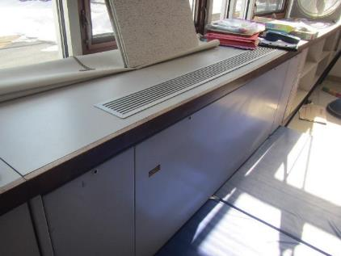

**Classroom unit ventilator (univent)**

**Picture 2**

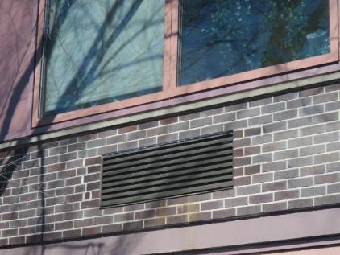

**Univent vent on the outside of the building**

**Picture 3**

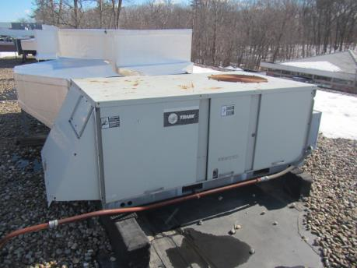

**Air handing unit on the roof**

**Picture 4**

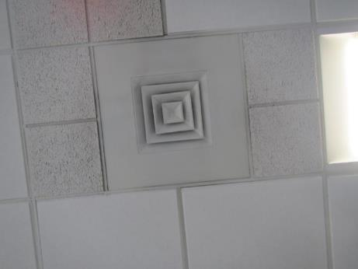

**Typical supply vent**

**Picture 5**

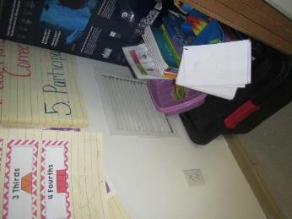

**Typical classroom exhaust vent**

**Picture 6**

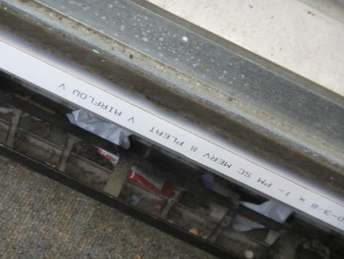

**MERV 8 univent filter**

**Picture 7**

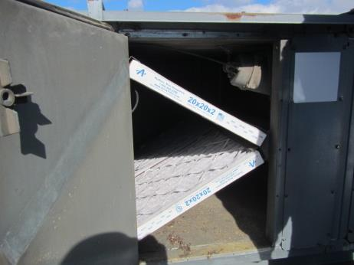

**MERV 13 filter in rooftop AHU**

**Picture 8**

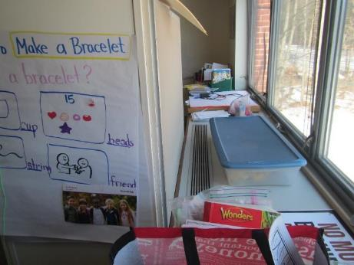

**Univent (on the right side of picture) blocked by furniture**

**Picture 9**

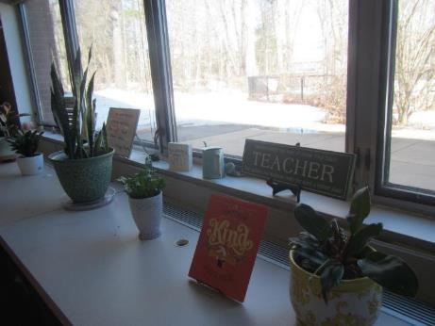

**Plants on a univent**

**Picture 10**

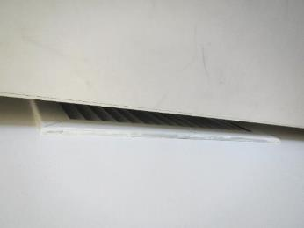

**Exhaust vent blocked by a cabinet**

**Picture 11**

**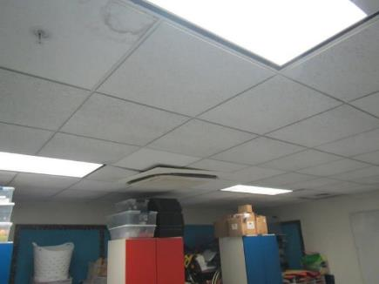  
items piled near ceiling and supply vent**

**Picture 12**

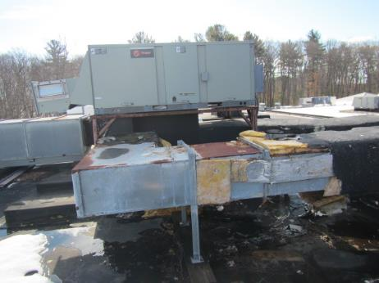

**Damaged ductwork for rooftop AHU**

## Water Damage pictures

**Picture 13**

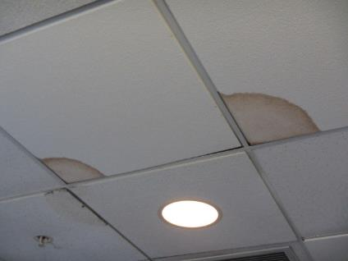

**Water-damaged ceiling tiles**

**Picture 14**

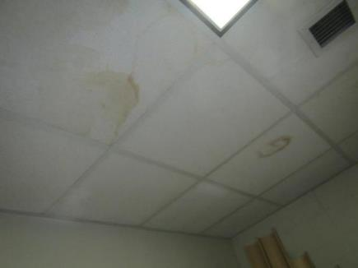

**Water-damaged ceiling tiles**

**Picture 15**

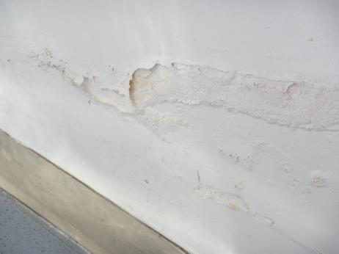

**Water-damaged plaster**

**Picture 16**

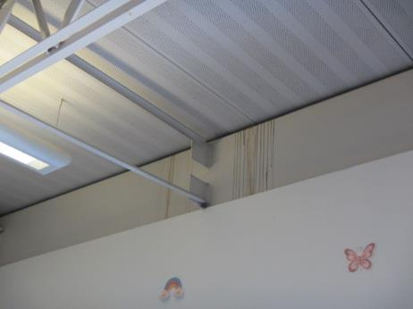

**Staining from roof leak on wall in room 203**

**Picture 17**

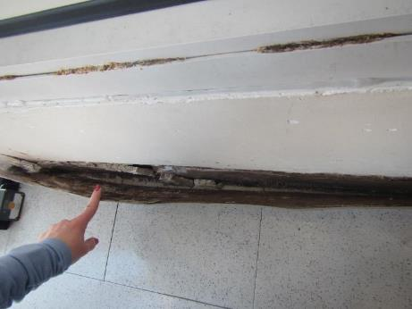

**Water-damaged wall on the lower level**

**Picture 18**

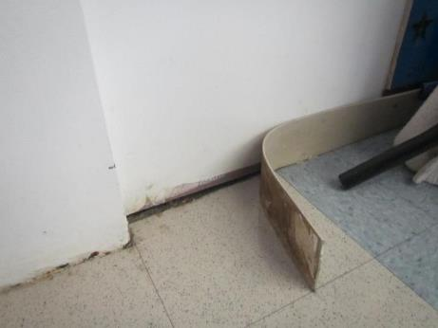

**Water-damaged wall and loose coving on the lower level**

**Picture 19**

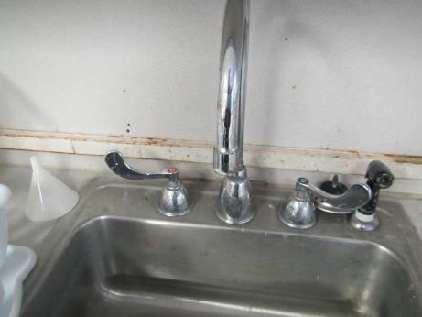

**Water-damaged backsplash on a classroom sink**

**Picture 20**

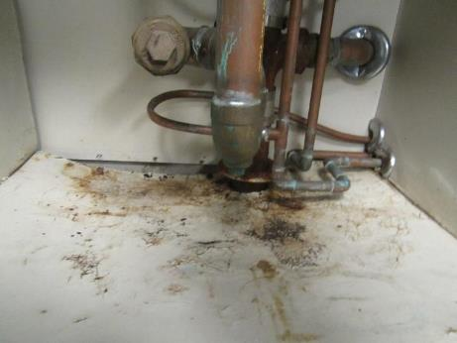

**Water-damaged, rusted, and bent material underneath a classroom sink**

**Picture 21**

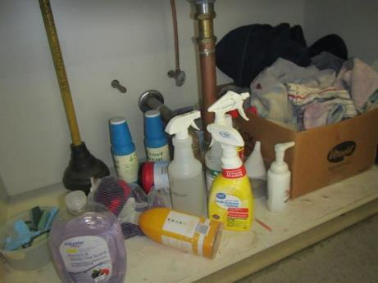

**Items, including porous items, cleaning products, and unlabeled bottles under a classroom sink**

**Picture 22**

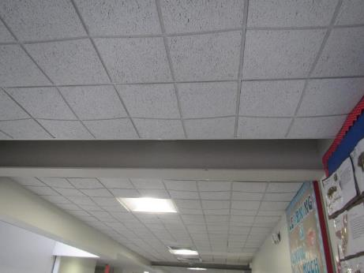

**Bowing ceiling tiles in a hallway**

**Picture 23**

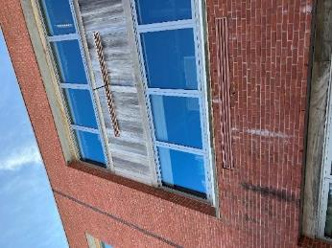

**Water damage and stains on brickwork**

**Picture 24**

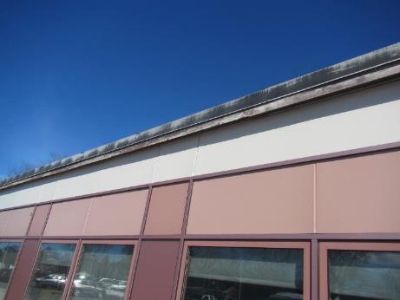

**Damaged wooden trim and eves at the top of the building edge**

**Picture 25**

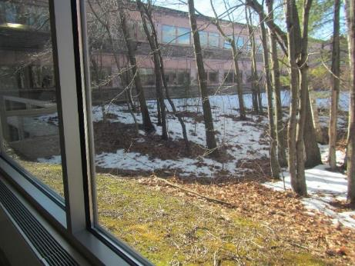

**Large trees in the courtyard**

**Picture 26**

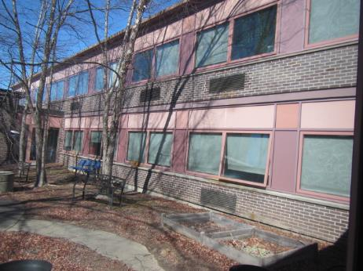

**Large trees in the courtyard**

Respiratory Irritant Pictures

**Picture 27**

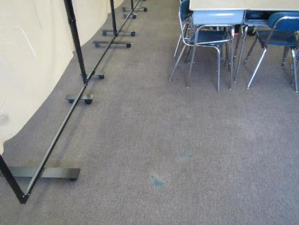

**Threadbare, worn carpet**

**Picture 28**

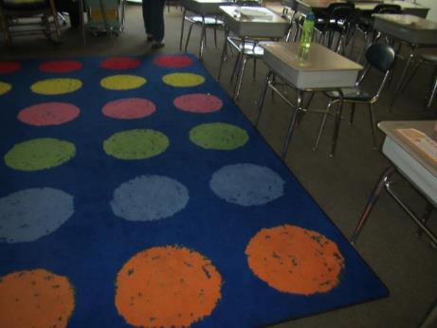

**Area rug in a classroom**

**Picture 29**

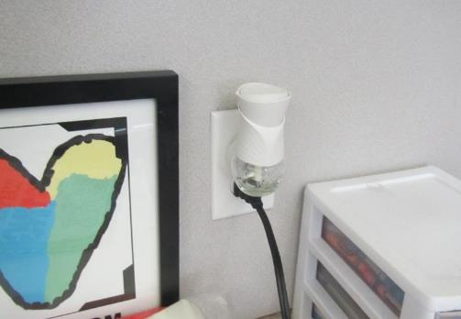

**Plug-in air freshener**

**Picture 30**

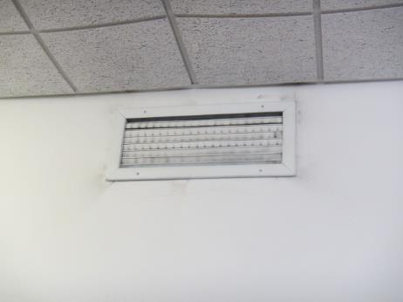

**Dusty exhaust vent**

**Picture 31**

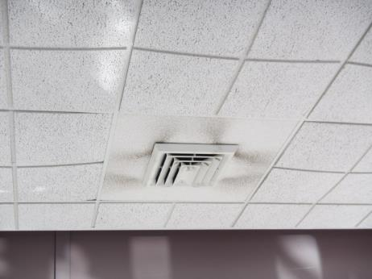

**Dusty vent with dusty tiles**

Click to link back to report

# Table 1

| **Location** | **Carbon**  **Dioxide**  **(ppm)** | **Carbon Monoxide**  **(ppm)** | **Temp**  **(°F)** | **Relative**  **Humidity**  **(%)** | **PM2.5**  **(µg/m3)** | **Occupants**  **in Room** | **Windows**  **Openable** | **Ventilation** | | **Remarks** |
| --- | --- | --- | --- | --- | --- | --- | --- | --- | --- | --- |
| **Supply** | **Exhaust** |
| Background (outside) | 430 | ND | 45 | 45 | 2 |  |  |  |  |  |
| Ground floor | | | | | | | | | | |
| 1 | 526 | ND | 73 | 35 | ND | 0 | Y | Y on | Y | BCT, area rug |
| 2 | 544 | ND | 72 | 31 | ND | 2 | Y | Y | Y off | WD CT, PF, WD around exterior door |
| 3 | 833 | ND | 77 | 27 | ND | 25 | Y open | Y | Y off, dusty | BCT, dehumidifier, area rug, |
| 4 | 1094 | ND | 75 | 34 | ND | 20 | Y | Y | Y off | BCT, dehumidifier, area rug, attached restrooms |
| 5 | 963 | ND | 72 | 34 | ND | 16 | Y | Y | Y off, dusty | WD CT, BCT, area rug, upholstered furniture, attached restrooms |
| 6 | 764 | ND | 70 | 34 | ND | 0 | Y | Y blocked | Y off, dusty | BCT, dirty area rug, dehumidifier, furniture, PF |
| 7 | 695 | ND | 69 | 29 | ND | 0 | Y open | Y | Y off, dusty | WD CT, BCT, area rug, dehumidifier, WD materials, peeling ceiling |
| 8 | 1019 | ND | 70 | 36 | ND | 0 | Y | Y blocked | Y off | BCT, dehumidifier, area rug, dry erase markers |
| 9 | 582 | ND | 70 | 30 | ND | 0 | Y | Y partially blocked | Y dusty | BCT, dehumidifier filter dirty, area rug, cleaning wipes |
| 10 | 654 | ND | 75 | 30 | ND | 16 | Y | Y | Y dusty | BCT, area rug, HS, furniture, cleaning wipes, efflorescence on interior brick, tile floor next to exterior door temp 58, area rug temp 71 |
| 11 | 575 | ND | 72 | 26 | ND | 2 | Y | Y not UV | Y off, dusty | Wall to wall carpeting, no exterior door, UV off, dehumidifier, carpet floor temp 67 |
| Hallway between room 11 and 13 |  |  |  |  |  |  |  | Y | Y off dusty | BCT |
| 13 | 637 | ND | 72 | 27 | ND | 1 | N | Y | Y dusty | BCT, missing CT, dehumidifier |
| 14 | 987 | ND | 72 | 34 | ND | 13 | N | Y | Y off, dusty | BCT, hole in CT, peeling coving in at least 2 areas, furniture, dusty PF, peeling material from metal ceiling, flies around exterior door |
| 15 | 750 | ND | 72 | 34 | ND | 16 | Y | Y | Y off, dusty | BCT, hole in CT, HS, refrigerator, hole in coving, area rug |
| 16 | 1048 | ND | 73 | 36 | ND | 22 | Y | Y min. airflow | Y off, dusty | Wall to wall carpeting, plants, dehumidifier, mold on pipe material near upper back right ceiling corner, BCT, scent odor, no exterior door |
| First floor | | | | | | | | | | |
| 100 | 930 | ND | 74 | 25 | ND | 0 | Y | Y |  | Plug-in, area rug, sweeper (not-HEPA), fridge on carpet, food |
| 101 | 902 | ND | 74 | 26 | ND | 0 | N | Y covered | Y off | PF, NC, DEM, plant |
| 102 | 820 | ND | 73 | 24 | ND | 20 | Y | Y on | Y off, blocked | Area rug, WD under sink |
| 103 | 824 | ND | 73 | 26 | ND | 2 | Y | Y on | Y off, blocked | Carpet and area rugs, sink, loose carpet |
| 104 | 1028 | ND | 73 | 26 | ND | 21 | Y | Y on | Y off, blocked | Sink with items underneath, CP, area rugs, DEM |
| 105 | 1407 | ND | 74 | 28 | ND | 23 | Y | Y | Y off, blocked | Carpet and area rug, sink, bowed CT, DEM |
| 106 | 1011 | ND | 73 | 26 | ND | 25 | Y | Y on | Y on | Carpet, sink, PF, AP, items |
| 107 | 937 | ND | 73 | 27 | ND | 0 | Y | Y on | Y on blocked | Carpet, area rug, items under sink |
| 108 | 722 | ND | 74 | 24 | ND | Entering | Y | Y on | Y on | Carpet and area rug, items/CP under sink |
| 109 | 1064 | ND | 77 | 24 | ND | 16 | Y 1 open | Y on | Y | PF, DEM, paper under sink, sink dripping, HS |
| 110 | 781 | ND | 76 | 24 | ND | 2 | Y 2 open | Y | Y off, blocked | Carpet, area rug, upholstered items |
| 111 | 766 | ND | 76 | 22 | ND | 0 | Y | Y on | Y blocked | Carpet and area rug, sink with bottles (unlabeled) |
| 112 | 849 | ND | 79 | 23 | ND | 0 | Y | Y on | Y off, blocked | Carpet and area rug, DEM, electrical outlet box ajar |
| 113 | 826 | ND | 73 | 26 | ND | 1 | Y | Y on, blocked | Y off, dusty | Worn carpet, DEM, CPs, HS |
| 114 | 737 | ND | 73 | 26 | ND | 0 | Y | Y UV blocked | Y on | Sink (dripping), dehumidifier, worn carpet, DEM, items under sink, CPs |
| 115 | 802 | ND | 73 | 26 | ND | 1 | N | Y | Y | Sinks, 3 WD CT, WD floor, small fridge, microwave |
| Lower gym | 915 | ND | 74 | 27 | ND | 30 | N | Y | Y |  |
| Girls’ restroom |  |  |  |  |  | 0 | N |  | Y on |  |
| Staff restroom |  |  |  |  |  |  |  |  | Y off | AF |
| 120 | 1063 | ND | 73 | 25 | ND | 21 | Y | Y | Y very dusty | 2 sinks, DEM, stove (not used), NC. |
| 121 | 1092 | ND | 72 | 28 | ND | 20 | Y | Y on | Y on | Washer and dryer, dryer vented into ceiling |
| 122 | 1555 | ND | 73 | 29 | ND | 21 | Y | Y on | Y on | Worn carpet, DEM |
| 123 | 1615 | ND | 73 | 28 | ND | 19 | Y | Y on | Y on | DEM, worn carpet |
| 124 | 1474 | ND | 74 | 31 | ND | 21 | Y | Y | Y on | DEM, worn carpet |
| 125 | 1569 | ND | 73 | 30 | ND | 22 | Y | Y on | Y off | Worn carpet |
| Band | 838 | ND | 74 | 23 | ND | 26 | Y | Y | Y | Carpet |
| Music office | 845 | ND | 74 | 22 | ND | 0 | N | Y | Y | 4 WD CT, carpet, items, |
| Custodian’s office | 807 | ND | 74 | 23 | ND | 2 | Y | Y |  |  |
| Concert sp? | 785 | ND | 74 | 23 | ND | 0 | N | Y | Y | AF strong odor, plants, carpet |
| 130 Art | 642 | ND | 60 | 34 | ND | 6 | Y | Y | Y | NC, dirty floor, sink drips. Art storage is full |
| 131 | 860 | ND | 72 | 26 | ND | 18 | Y | Y damaged, on | Y | NC, sinks with items underneath |
| 132 | 901 | ND | 74 | 24 | ND | 0 | N | Y | Y | DEM, NC, dirty floor |
| 133 | 614 | ND | 74 | 21 | ND | 1 | Y | Y on | Y dusty | Buckets for active leaks from roof, DEM, sink cabinet damaged |
| 134 | 567 | ND | 70 | 22 | ND | 0 | Y | Y on | Y | NC, DEM |
| 136 | 586 | ND | 70 | 21 | ND | 2 | Y | Y | Y dusty | NC |
| Auditorium | 631 | ND | 70 | 27 | ND | 0 | N | Y | Y off | Carpet, upholstered seats |
| PTO closet |  |  |  |  |  | 0 | Door |  |  | items |
| Custodian storage |  |  |  |  |  | 0 | N |  |  | WD CT with mold stains |
| Upper Gym | 804 | ND | 70 | 30 | ND | 2 | N | Y | Some off, some on |  |
| Big storage area |  |  |  |  |  | 0 | Doors |  |  | Some missing CTs, perfume odor |
| 140 music | 748 | ND | 73 | 23 | ND | 0 | Y and door | Y off | Y | Worn carpet |
| 141 | 793 | ND | 73 | 24 | ND | 0 | Y | Y on | Y on | Carpet, DEM, plant |
| 142 | 754 | ND | 75 | 19 | ND | 3 | Y | Y on | Y | New carpet, AF (aromatherapy unit), plants, mats |
| 143 | 722 | ND | 79 | 19 | ND | 1 | Y | Y on | Y | Plug-in, carpet and area rug, plant |
| 144 | 660 | ND | 77 | 22 | ND | 0 | N | Y | Y | Storage near ceiling, PF, WD CT, mini-splits in ceiling |
| 145 | 920 | ND | 80 | 23 | ND | 5 | Y | Y | Y | Carpet |
| 147 | 653 | ND | 79 | 19 | ND | 0 | Y | Y on | Y off | Carpet and area rug, DEM |
| 148 | 695 | ND | 76 | 23 | ND | 0 | N | Y dusty | Y | Mini-splits in ceiling, new carpet |
| Upper CAF | 865 | ND | 75 | 23 | ND | ~150 | Doors | Y | Y |  |
| Faculty dining | 610 | ND | 79 | 18 | ND | 1 | Doors | Y | Y | NC |
| Lower CAFE | 865 | ND | 78 | 22 | ND | ~120 | Doors | Y | Y |  |
| Media Center | 552 | ND | 73 | 30 | ND | 0 | Y | Y | Y | Wall to wall carpeting, WD CT, cardboard boxes on floor, |
| Media Center Office # 2 | 730 | ND | 73 | 32 | ND | 1 | N | Y | Y | Air purifier, carpeted, electrostatic dust on supply vent and ceiling |
| Media Center Workroom | 653 | ND | 73 | 30 | ND | 0 | N | Y | Y | Refrigerator, dirty microwave, electrostatic dust on ceiling |
| Media Center Office # 1 | 617 | ND | 74 | 30 | ND | 1 | N | Y | Y | Electrostatic dust on ceiling |
| Upper School Office | 663 | ND | 75 | 30 | ND | 0 | Y | Y | Y | Plants, NC, copier |
| Upper School Associate Principal | 622 | ND | 77 | 28 | ND | 0 | Y | Y | Y | BCT, Area rug, hole in CT, NC |
| Upper School Conference Room | 631 | ND | 77 | 29 | ND | 0 | Y | Y | Y | WD CT, missing CTs, reported persistent water leak from ceiling, NC, electrostatic dust on ceiling |
| Main Office | 752 | ND | 76 | 26 | ND | 1 | Y | Y | Y | BCT, area rug, copier |
| Main Office -Office # 1 | 759 | ND | 76 | 27 | ND | 0 | Y | Y off | Y off | BCT, carpeted |
| Main Office Conference Room | 715 | ND | 75 | 27 | ND | 0 | N | Y off | Y off | BCT, missing CT, NC |
| Main Office – Office # 2 | 716 | ND | 75 | 27 | ND | 0 | Y | Y off | Y off | BCT, carpeted |
| Dragon’s Lair | 621 | ND | 73 | 25 | ND | 0 | Y | Y | Y | NC |
| Nurse’s Office | 858 | ND | 74 | 33 | ND | 9 | Y | Y | Y off |  |
| Conference Room – left side | 732 | ND | 73 | 28 | ND | 1 | Y | Y | Y | WD CT, carpeted |
| Other Conference Room | 708 | ND | 73 | 26 | ND | 0 | N | Y | Y | WD CT, BCT, carpeted |
| Staff Workroom | 677 | ND | 73 | 27 | ND | 1 | N | Y | Y | NC, copier, scanner |
| Guidance | 665 | ND | 77 | 26 | ND | 0 | N | Y | Y | Carpeted, copier, scanner |
| Guidance Room # 4 | 658 | ND | 77 | 25 | ND | 3 | Y open | Y | Y off | Carpeted |
| Lower School Office | 677 | ND | 76 | 25 | ND | 1 | Y | Y | Y dusty | Electrostatic dust on supply, BCT, plants |
| Lower School Associate Principal | 1062 | ND | 76 | 29 | ND | 3 | Y | Y | Y | Area rug, peeling coving |
| Second floor | | | | | | | | | | |
| 200 | 954 | ND | 80 | 24 | ND | 3 | Y | Y off | Y off | WD CT, dust/debris around vent |
| 201 | 533 | ND | 78 | 21 | ND | 0 | Y | Y | Y | 2 plug-ins, strong odors |
| 202 | 508 | ND | 77 | 17 | ND | 8 | Y | Y | Y weak | 5 WD CT, carpet, dust/debris duct leaks |
| 203 | 974 | ND | 73 | 23 | ND | 18 | Y | Y | Y | Area rug, stains over window from roof leak, rec painting, WD under sink |
| 204 | 931 | ND | 73 | 27 | ND | 18 | Y | Y | Y | Carpet (old, worn, stained), WD under sink/leak, 4 WD CTs |
| 205 | 999 | ND | 73 | 28 | ND | 20 | Y | Y | Y off | Carpet, area rug |
| 206 | 1295 | ND | 73 | 31 | ND | 18 | Y | Y | Y off | Spray CPs under sink, carpet, area rug |
| 207 | 996 | ND | 73 | 28 | ND | 0 | Y | Y | Y | Occupants at lunch, plants, mouse droppings under sink, leaky sink, dirty sink |
| 208 | 850 | ND | 73 | 26 | ND | 0 | Y | Y | Y weak | Occupants at lunch, carpet |
| 209 | 998 | ND | 73 | 27 | ND | 1 | Y | Y | Y dusty | Carpet, CP, occupants at lunch |
| 210 | 1005 | ND | 73 | 29 | ND | 0 | Y | Y | Y | Carpet, area rug, hole around pipes under sink, hole in CT, mouse droppings under sink |
| 211 | 1143 | ND | 74 | 29 | ND | 0 | Y | Y | Y off | Plug-in, carpet, faucet leaking |
| 212 | 608 | ND | 77 | 20 | ND | 1 | Y open | Y | Y off | Heat complaint, DO, carpet tiles, 2 WD CT, AF plug in, bowed CTs |
| 213 | 1389 | ND | 75 | 30 | ND | 29 | Y | Y | Y off | Plug-in, area rug, CP under sink, WD CT |
| 214 | 1304 | ND | 73 | 30 | ND | 19 | Y | Y | Y off | DO, carpet, MT, area rug, WD under cabinet, CP/paint |
| 215 | 1204 | ND | 73 | 30 | ND | 21 | Y | Y | Y off | Carpet, area rug, 2 WD CT |
| 216 | 1185 | ND | 73 | 30 | ND | 0 | Y | Y | Y | Area rug |
| 220 | 1358 | ND | 73 | 25 | ND | 13 | Y | Y on | Y on | Old carpet |
| 226 | 1018 | ND | 73 | 29 | ND | 0 | Y | Y | Y | Carpeted, cardboard boxes on floor |
| 231 | 859 | ND | 74 | 22 | 1 | 0 | Y | Y on | Y dusty | Old carpet, DEM |
| 232 | 860 | ND | 72 | 24 | ND | 1 | Y | Y | Y, blocked with furniture | 2 occupants just left, plants, carpet |
| 233 | 816 | ND | 76 | 16 | ND | 0 | Y 2 open | Y on | Y on, dusty | NC, DEM |
| 234 | 547 | ND | 72 | 21 | ND | 0 | Y | Y | Y | NC |
| 235 | 1160 | ND | 77 | 22 | ND | 0 | Y | Y on | Y part blocked and off | Old carpet, plug-in |
| 236 | 664 | ND | 72 | 19 | ND |  | Y | Y | Y | Plants, dusty vents, sinks |
| 237 | 695 | ND | 73 | 19 | ND | 0 | Y | Y | Y | Science sinks |
| 238 | 602 | ND | 72 | 23 | ND | 20 | Y | Y | Y off | Carpeted, plug-in |
| 239 | 867 | ND | 74 | 19 | ND | 5 | Y | Y | Y | Old carpet, DEM |
| 240 | 1153 | ND | 73 | 22 | ND | 22 | Y | Y | Y | NC, DEM, plant |
| 241 | 1585 | ND | 73 | 25 | ND | 20 | Y | Y | Y off | NC |
| 242 | 2381 | ND | 75 | 26 | ND | 26 | Y | Y | Y off |  |
| 243 | 1125 | ND | 72 | 22 | 1 | 1 | Y | Y | Y | Reports of cold temps |
| 244 | 1780 | ND | 73 | 30 | ND | 24 | Y open | Y | Y | Tennis balls as chair glides, PFs, plants |
| 245 | 1950 | ND | 73 | 28 | ND | 21 | Y | Y | Y | DEM |
| 246 | 1227 | ND | 74 | 28 | ND | 20 | Y | Y | Y | Dusty PF |
| English zone | 749 | ND | 74 | 16 | 1 | 0 | Y 1 open | Y dusty |  | NC, DEM |

(Click to link back to report)

# Table 2A

|  |  |  |  |  |  |
| --- | --- | --- | --- | --- | --- |
| **Equipment Present in Building**  **(X = Yes)** | **Type of Heating/Cooling Ventilation**  **Equipment** | **Fresh**  **Air**  **Supply**  **(X = Yes)** | **Type of Location(s)** | **Air Filters Installed**  **MERV Rating**  **(1-15, U*)**  **(X = Yes)** | **Comments** |
| X | Univents | X | Classrooms | 8 |  |
| X | Rooftop Air Handling Units | X | Various rooms & common areas | 13 |  |
|  | Outdoor, Ground-Installed Air Handling Units |  |  |  |  |
|  | Attic/Crawlspace Air Handling Units |  |  |  |  |
|  | Ceiling-Mounted Air Handling Units (including inside plenum) |  |  |  |  |
|  | Basement/Crawlspace-Installed Air Handling Units |  |  |  |  |
|  | Mechanical Room-installed Air Handling Units |  |  |  |  |
|  | Fan Coil Units |  |  |  |  |
|  | Window-Mounted Air Conditioners |  |  |  |  |
|  | Portable air conditioners |  |  |  |  |
|  | Wall Louver-Controlled Gravity Air Supply |  |  |  |  |
| X | Windows | X | Most rooms |  |  |
|  | Fan in window (blowing in) |  |  |  |  |
|  | Built in wall fan (switched) |  |  |  |  |
|  | Heat recovery ventilator unit |  |  |  |  |
|  | Energy recovery ventilator unit |  |  |  |  |
|  | Chilled Beam |  |  |  |  |
|  | Passive combustion supply vent in basement/boiler room |  |  |  |  |

*U = Filter Rating underdetermined due to inaccessibility during building visit

# Table 2B

|  |  |  |  |  |
| --- | --- | --- | --- | --- |
| **Equipment Present in Building**  **(X = Yes)** | **Type of Exhaust Ventilation**  **Equipment** | **Ducted**  **To Outdoors**  **(X = Yes)** | **Type of Location(s)** | **Comments** |
| X | Rooftop Motors/Fans | X | Classrooms and common areas | Many not functioning |
|  | Unit Exhaust |  |  |  |
| X | Ceiling Return Vent |  |  |  |
|  | Ceiling Return Vent, Plenum |  |  |  |
|  | Wall Return Vent |  |  |  |
|  | Kitchen Stove Hood |  |  |  |
| X | Restroom Exhaust Vent | X |  |  |
|  | Photocopier Exhaust Vent |  |  |  |
|  | Garage |  |  |  |
|  | Chemical Hood(s) |  |  |  |
|  | Locker Rooms |  |  |  |
|  | Showers |  |  |  |
| X | Clothes Dryers | X | Home ec classroom |  |
|  | Gas Water Heaters |  |  |  |
|  | Furnace-Flue to Chimney |  |  |  |
|  | Furnace/Boiler direct vent or power vent (no combustion air supply) |  |  |  |
|  | Kiln, Pottery |  |  |  |
|  | Dark Room |  |  |  |
|  | Generator Room |  |  |  |
|  | Wood Shop Dust Collector |  |  |  |
|  | Spray Paint Booths |  |  |  |
|  | Fan in window (blowing out) |  |  |  |

# Table 2C

|  |  |  |  |
| --- | --- | --- | --- |
| **Equipment Present in Building**  **(X = Yes)** | **Type of Equipment** | **Type of Location(s)** | **Comments** |
|  | Floor Fans, pedestal |  |  |
| X | Floor Fans, portable | Classrooms, offices |  |
| X | Air Purifier (HEPA, other) | Classrooms, offices |  |
|  | Floor heaters, portable |  |  |
| X | Refrigerators, Cold Beverage Vending Machines |  |  |
|  | Radiator, wall-mounted |  |  |
|  | Radiator, floor-mounted |  |  |
|  | Passive Vents (Wall/Door) |  |  |

(Click to link back to report)

# Table 3

| **Found in Building**  **X = Yes** | **Water-Damaged Materials, Building Components or Stored Materials** | **Location** | **Visible Microbial Growth?**  **X = Yes** | **Musty odor detected?**  **X = Yes** | **Comments** |
| --- | --- | --- | --- | --- | --- |
|  | Books-other bound materials |  |  |  |  |
| X | Brick walls – broken, missing mortar | Exterior |  |  |  |
|  | Brick walls – blocked weep holes |  |  |  |  |
|  | Cardboard boxes |  |  |  |  |
|  | Carpet tiles |  |  |  |  |
| X | Carpet - Area rugs | Various classrooms & rooms |  |  |  |
| X | Carpet wall-to-wall | Various classrooms & rooms |  |  |  |
|  | Ceiling tiles - affixed directly to ceiling surface |  |  |  |  |
| X | Ceiling tiles - bowing-in suspended ceiling | Classrooms and hallways |  |  |  |
|  | Ceiling tiles - water-stained in splined ceiling |  |  |  |  |
| X | Ceiling tiles - water-stained in suspended ceiling | Classrooms and hallways |  |  |  |
| X | Chairs - laminated |  |  |  |  |
|  | Cloth |  |  |  |  |
| X | Countertops (around sinks) | Classrooms |  |  |  |
|  | Curtains |  |  |  |  |
|  | Dust/debris within AHU, uninvent, HVAC, chilled beam units, etc. (WD through condensation, humidity, or leaks) |  |  |  |  |
| X | Efflorescence (i.e., mineral deposits) | 200A, 10, exterior brick |  |  |  |
| X | Engineered woods - particleboard, plywood, Masonite | Classrooms and Media Center | X |  | Many water-damaged areas under sinks in classroom, cabinets |
|  | Flooring – loosened tiles |  |  |  |  |
|  | Flooring - wooden |  |  |  |  |
|  | Furniture - laminated |  |  |  |  |
|  | Furniture - upholstered |  |  |  |  |
| X | Gypsum wallboard - ceiling |  |  |  |  |
|  | Gypsum wallboard - restroom wall |  |  |  |  |
|  | Gypsum wallboard - interior wall |  |  |  |  |
|  | Gypsum wallboard – located on exterior wall |  |  |  |  |
|  | HVAC drain pan – lack of draining |  |  |  |  |
|  | HVAC filters |  |  |  |  |
|  | Insulation- attic (paper-backed) |  |  |  |  |
|  | Insulation - inside air handling unit |  |  |  |  |
|  | Insulation - on pipe(s) fiberglass |  |  |  |  |
| X | Insulation - on pipe(s) other/plaster-like material |  |  |  |  |
|  | Insulation - wall cavity |  |  |  |  |
|  | Insulation – ceiling plenum |  |  |  |  |
|  | Modular furniture – walls/cloth partitions |  |  |  |  |
|  | Musical instrument cases |  |  |  |  |
|  | Plaster ceilings |  |  |  |  |
|  | Records/files |  |  |  |  |
|  | Refrigerator - door gasket |  |  |  |  |
|  | Refrigerator - drip pan |  |  |  |  |
|  | Refrigerator - Interior surfaces |  |  |  |  |
|  | Room divider - ceiling-mounted, sliding |  |  |  |  |
| X | Sink backsplash | Classroom |  |  | Damaged caulking |
|  | Tables – laminated |  |  |  |  |
|  | Wallpaper |  |  |  |  |
|  | Wood - attic/roof materials |  |  |  |  |
|  | Wood - floor joists in basement ceiling |  |  |  |  |
|  | Wood - wall framing |  |  |  |  |
|  | Wood - window sills |  |  |  |  |
|  | Wood - window-mounted air conditioner framing |  |  |  |  |
| X | OTHER | Exterior trim |  |  | Delaminating |

WHAT ARE ENVIRONMENTAL ASTHMA TRIGGERS?

Asthma triggers are any chemical, pollutant, or allergen that can make your asthma worse. Asthma triggers can also be strong chemical smells, dust, or pets. Your asthma triggers may be different from those of other people. Not all asthma triggers affect people the same way. Environmental asthma triggers are found both indoors and outdoors. DPH link: [Asthma and Your Environment (mass.gov)](https://www.mass.gov/doc/asthma-and-your-environment-english/download)

(click to link back to report)

# Table 4

| **Condition Present**  **X = Yes** | **Possible asthma symptom-inducing environmental pollutant** | **Recommendation to reduce or eliminate the pollutant** |
| --- | --- | --- |
| X | Water Damage and/or Mold  (allergen) | Identify water source and repair to eliminate.  Clean non-porous materials.  Remove and replace porous materials susceptible to mold growth.  Perform regular water damage assessments as a tool to ensure timely mitigation as needed.  Use NIOSH water damage assessment protocol as a guide: [NIOSH water damage assessment guideline](https://www.cdc.gov/niosh/docs/2019-115/pdfs/2019-115.pdf?id=10.26616/NIOSHPUB2019115&inf_contact_key=241b5c2ed98c27d94b530dedc36f1623f651f238aa2edbb9c8b7cff03e0b16a0). |
| X | Moistening of building components during hot, humid weather (>2 days in length) (mold, allergen) | Remove materials not dried in <2 days in a manner consistent with [US EPA Mold Removal in Commercial Buildings guideline](https://www.epa.gov/mold/pdf-version-checklist-mold-remediation-mold-remediation-schools-and-commercial-buildings).  Use dehumidification in occupied basement areas and other areas with chronic dampness. |
| X | Vegetation against exterior of building (water damage-mold) | Remove all vegetation preventing building exterior drying.  Remove all vegetation capable of falling onto a building or depositing debris onto the roof. |
|  | Personal humidifiers (lack of proper maintenance)  (pollutant and allergen) | Clean and maintain properly.  Use distilled water to eliminate metal and water treatment odors.  Maintain hydration by increasing water consumption. |
| X | Drains: Floor drains, Sink drains (abandoned use)  Water bubblers (abandoned use) | If in use, pour water into drain at least twice a week.  If not in use, seal the drain with an appropriate material in accordance with Massachusetts Plumbing Code (248 CMR 10.00). |
|  | Live Animals (turtles, gerbils, birds, rabbits, etc.) | Ensure cleanliness or remove animals from the location. |
|  | Improperly maintained aquariums and terrariums (allergen) | Maintain such equipment properly to eliminate odor.  Discontinue use. |
| X | Plants and flowers  (allergen and mold) | Keep indoor plants well maintained and not overwatered. Monitor for signs of mold and pests.  Ensure water for cut flowers does not become stagnant.  Ensure dried plant material is free of odors, mold, and pests and handled carefully  If asthma risks are high, eliminate plants and flowers. |
| X | HVAC system moisture issues  (mold, allergen) | Consult ASHRAE’s minimum standards for HVAC maintenance and inspection of commercial HVAC systems (<https://www.ashrae.org/technical-resources/bookstore/standards-180-and-211>). |
|  | HVAC system contaminant issues (allergen) | Consult ASHRAE’s minimum standards for HVAC maintenance and inspection of commercial HVAC systems (<https://www.ashrae.org/technical-resources/bookstore/standards-180-and-211>). |
|  | Indoor swimming pool odors outside of swimming pool (mold, chemical) | Maintain and operate pool HVAC systems to vent odors from building.  Ensure locker room exhaust vents are operating during building hours.  All doors leading to pool should be rendered airtight and be closed. |
| X | Pollen (allergen) | Recommend installation of MERV 8 or better filters if HVAC engineer confirms HVAC system can be so equipped without adversely affecting function.  Cut grass after hours.  Cut grass in a pattern to direct clippings away from exterior wall.  Remove trees and shrubs from in front of windows and air intakes. |
| X | Dry air | Maintain hydration.  Avoid overheating of air. |
| X | Dust mites  (allergen) | Recommendation to remove non-official upholstered furniture, area rugs, pillows, cushions, etc.  Cleaning with use of HEPA-filtered vacuum cleaner.  Eliminating clutter, storing items in dust and moisture-proof containers, and regularly removing dust through wet wiping. |
| X | Pests, including rodents and cockroaches  (allergen) | Use of integrated pest management guidelines, including:   * Proper disposal of food containers * Proper storage of food products in airtight containers * Elimination of use of food as art projects * Remove pest harborages/clutter * Regular monitoring for pests   [EPA IPM guideline link](https://www.epa.gov/ipm/introduction-integrated-pest-management) |
| X | Latex-containing materials | Remove tennis balls from furniture legs. |
| X | Fragrances  (chemical) | Eliminate point sources, such as:   * Plug-in air fresheners * Aroma/oil reed diffusers * Scented sprays * Discontinue use of other scented materials * Consult DPH fragrance guideline: [*Clean air is odor-free*](https://www.mass.gov/doc/clean-air-is-odor-free-removing-fragrances-to-improve-indoor-air-quality-in-schools-and-0/download) |
| X | Strong smells from /use of Chemicals (such as cleaning products)  (chemical) | Use building-issued cleaning products.  Use products in accordance with manufacturer’s instructions including dilution, application, and ventilation.  Avoid using products that are stronger than needed for the situation. |
|  | Strong odors from new building materials (carpeting/furniture)  (chemical) | Use low VOC-emitting materials.  Air out materials (outside or in unoccupied area) prior to installation. |
|  | Tobacco smoke  Secondhand Smoke  (pollutant) | Eliminate tobacco smoking.  Seal all shared wall penetrations. |
| X | Products with a strong odor such as paint, perfume, hairspray, air fresheners, bug-spray, laminators, candles, wax melters, dry erase markers and other VOC-containing products  (chemical) | If essential:   * Provide proper exhaust ventilation to eject aerosolized product directly outdoors. * Avoid/reduce use during occupied hours.   If not necessary, remove and eliminate. |
|  | Vehicle exhaust  (pollutant) | Enforce anti-idling regulations and post signs to give notice.  Relocate vehicles away from fresh air intakes.  Require cars to park face-in at building walls.  [MA anti-idling law FAQs](https://www.mass.gov/files/documents/2018/02/20/idling-faq.pdf#:~:text=The%20Massachusetts%20Anti-Idling%20Law%20The%20goal%20of%20the,sometime%20wonder%20when%20idling%20might%20be%20considered%20necessary.) |
|  | Vapors and or fumes from gas, oil, or kerosene stoves  (pollutant) | Operate stove hood when stove in use.  Install stove hood if not present.  Ensure equipment is in good working order. |
|  | Ozone (pollutant) | Eliminate use of ozone generating equipment. |
|  | Window Air Conditioners (if not properly maintained) (allergen) | Equip with proper filter and clean periodically.  Clean drip pans.  Install in window with weathertight, non-mold-growth sustaining material. |
|  | Pottery (pollutant) | Do not operate kiln during occupied hours.  Operate kiln with exhaust system activated.  Seal all seams and holes in kiln vent.  Ensure kiln exhaust discharge terminates outdoors. |
| X | Carpeting (allergen) | Clean carpeting in a manner consistent with IICRC standards, including regular vacuuming with a high efficiency particulate air (HEPA) filtered vacuum in combination with annual cleaning or semi-annual cleaning in soiled high traffic areas. |
|  | Sweeping/dusting vs HEPA vacuuming/wet wiping  (allergen or pollutant) | Refrain from using feather dusters or brooms.  Utilize HEPA vacuums and wet wiping to minimize aerosolizing particulate matter. |
| X | Lack of adequate air exchange/mechanical ventilation | Make repairs as necessary and ensure all HVAC system components are operating continuously when building is occupied. |
|  | Lack of local exhaust at source of pollution (vocational shop activities, kitchen exhaust hood) (all) | Recommend installation of exhaust ventilation to direct pollutants directly outdoors. |
|  | Renovating buildings while occupied  (chemical) | Use all SMACNA guidelines for Renovation While Buildings Are Occupied. For information, visit <https://www.mass.gov/service-details/construction-and-renovation-generated-pollutants-in-occupied-buildings>. |
|  | Chemistry program chemical storage  (chemical) | Repair (if needed) and operate chemical storeroom vents appropriately.  Reduce or eliminate unneeded or overstocked chemicals.  Store all chemicals in a manner to separate incompatible chemicals.  Keep chemical storerooms clean. |
| X | Photocopiers/duplicating machines | All machines should have dedicated exhaust vents. |