Tip 3: Organizational and Workforce Approaches to Person-Centered Care

Description
The Centers for Medicare & Medicaid Services (CMS) defines person-centered care as the need “to focus on the resident as the locus of control and support the resident in making their own choices and having control over their daily lives.”103 This can represent a major shift in how processes, routines, and priorities are organized and may be a departure from the typical approach of many clinicians and staff in the health care and long-term care systems.104 Approach OUD and StUD like any other chronic disease or health condition. After OUD and StUD are recognized and treated, individuals can stabilize, their symptoms can go into remission, and they can make strides towards recovery.105 Person-centered care is especially relevant to residents with OUD and StUD, as the concepts embedded in that care are also key drivers of recovery.106 Person-centered care means trying to identify and understand a resident’s goals for recovery and identifying appropriate interventions, with those goals in mind, to ensure safety and maximum quality of life.
To develop a culture of person-centered care, staff should review their overall mission and vision statements, cultural competency of the organization, and approaches to staff training. As you establish a person-centered approach to care, specifically for residents with OUD and StUD, it is important to review your vision and mission statements. Consider revising them to reflect a person-centered orientation. Ensure they fit the needs of your residents both culturally and linguistically. Vision is a mental image of the ideal state an organization wishes to achieve, both inspirational, and aspirational. Mission is a concise explanation of an organization's reason for existence, describing purpose and overall intention.107
Tips for Vision and Mission Statements108 is a helpful resource to assist in crafting or revising your vision and mission statements.
Taking steps to ensure the adoption of trauma-informed care practices throughout the organization is vital to fully integrating person-centered care. Tip 2 discusses the importance of a therapeutic approach by using PFACs and developing more wellness activities; this Tip will look at a more organizational-wide approach. Here are some helpful websites for more information on person-centered care:
- Action Pact 109
- Developing Trauma-Informed Organizations110
- Institute for Person-Centered Care111
- PioneerNetwork112
- Planetree113
- The Green House Project114

Goal
This section aims to help LTCF staff establish a multi-layered, interdisciplinary, person-centered approach to supporting residents with OUD and StUD that meets residents’ linguistic and cultural needs.

Objectives
At the end of this section, participants will be able to:
- Ensure vision and mission statements reflect a person-centered approach embedded into your policy and practice.
- Recognize key components of trauma-informed care, the effects of trauma on one’s life, and how to individualize care through a trauma-informed care lens.
- Understand how to reflect and incorporate Culturally and Linguistically Appropriate Services (CLAS) concepts in policies, language, practices into overall operations.

Policies
- Review and incorporate a person-centered approach into existing policies and procedures.
- Develop a policy around training staff on trauma-informed care.
- Integrate CLAS into policies and procedures.

Person-Centered Approach - Changing Your Culture

Engage Resident
It is important to establish a positive relationship with your residents. Discovering your resident’s habits, beliefs, passions, preferences, and health goals will help foster the partnership. Some ideas:
- Think about their room, their first day, their first encounters with others.
- What can you do to positively impact their time with you?
- What are the snacks they like? What is the one thing they can’t live without? Coffee or tea?
- Who are their supportive people?
- What do they need at their bed stand that brings them comfort?

Engage Staff
Stepping back to discuss what person-centered care means to your staff provides opportunities to engage in this crucial part of organizational culture. Involvement of front-line staff members is powerful, providing them with key opportunities to review how person-centered care helps support residents with OUD and StUD. Additionally, bolstering staff engagement helps reduce staff turnover, thus providing consistency and continuity for residents and many other positive effects.115 Some ideas:
- Solicit the input of all levels of staff on vision and mission statement discussions.
- Illustrate how to shift the culture and care of your residents to help it resonate with staff members.
- Identify a champion who will assist in creating culture change.

Staff Recruitment
When recruiting and interviewing staff, introducing person-centered care questions into the process will enable you to set expectations for necessary values and culture. It will also help you strategically bring individuals on board who already possess the required person-centered orientation.
Recruitment efforts may prioritize building a diverse workforce or reflective of the community, especially regarding CLAS considerations around language and culture.

See sample person-centered care interview questions for recruiting. These questions are behavior-based, focusing on teamwork, patient care, adaptability, time management, communication style, motivation, and core values. It is positive to see applicants share examples of difficult past conflicts with colleagues and focusing on what they learned from the experiences. Applicants should also be prepared to share what motivates them and share situations in which they took the initiative to start a project or complete a project.116
- Sample Interview Questions (Appendix 3)

Staff Training
It is beneficial to focus on crucial areas supporting a person-centered approach to care and areas specifically relevant to the care of residents with OUD and StUD. The list below offers training tools and resources to help staff members and residents.
Training should include education on OUD, MOUD, StUD and the skills and awareness required to best support residents (see Tip 4 for staff competencies). Training should also include education around co-occurring OUD and StUD, identifying skills necessary to support these residents. In addition, it will be helpful to set up ongoing case reviews or staff member peer-sharing to address potential stress, isolation, or negative feelings.
- MOUD approach and efficacy117
- Empathy Techniques (Appendix 2)
- Changing the Conversation: The Importance of Language118
- Providers Clinical Support System119
- Partners in Calm Cooperative De-escalation120
- Review Addressing Stigma in Tip 1

Trauma-Informed Care
Individuals and residents with OUD and StUD benefit from trauma-informed care. The impact of trauma on individuals, families, and communities can be dramatic and impact physical and psychiatric health. Establishing and promoting trauma-informed care as part of organizational culture aligns with a person-centered approach.
Research shows a link between OUD, StUD, and other risky health behaviors and traumatic experiences.121 Discussions around trauma-informed care can accompany the vision and mission review. Core principles of trauma-informed care include safety, trustworthiness, choice, collaboration, and empowerment.122 The following short videos and kit are helpful resources:
- What is Trauma-Informed Care?123 (3 minutes)
- What is Trauma?124 (2 minutes)
- Relationships between trauma and addiction125 (11 minutes)
- Developing Trauma-Informed Organizations126
The change package indicated below provides resources and guidance on trauma-informed care focusing on person-centered care. Phase 2 details how to educate staff on trauma-informed care foundational principles.
- Trauma-Informed Care: Change Package for Nursing Centers127

Adverse childhood experiences (ACEs), have been connected to specific health risk behaviors (such as OUD128), chronic health conditions, and early death.129 (Figure 5).
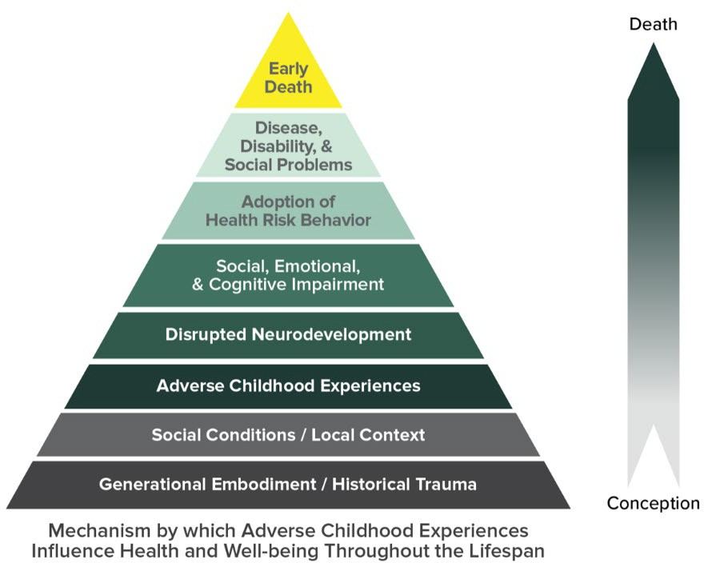
Figure 5

Source: CDC-Kaiser ACE Study, https://www.cdc.gov/violenceprevention/childabuseandneglect/acestudy/
Many individuals with SUD experienced traumatic events that contributed to the development of a SUD and are associated with many negative health outcomes, including cardiovascular disease, pulmonary disease, addiction, cancer, and premature death. Universal trauma precautions are important to exercise because trauma often precedes addiction. Once someone develops a SUD, risk of new trauma also increases. It is important to train staff to recognize ACEs as part of the person-centered care approach. The following resources can help with this:
- Take the ACE Quiz — And Learn What It Does and Doesn't Mean130
- Finding your ACE Score131

Engagement of Family and Caregivers
As mentioned in Tip 2, engagement with the resident’s family, caregiver, or friends is an important step. If possible, provide information on family and caregiver support resources available within the community. Often, taking advantage of support resources will help the family or caregivers develop healthy boundaries with the resident, which can help support their recovery through reinforcement of acceptable behaviors and interactions.
As a result of the ACEs study, we learned many residents come from chaotic or traumatizing households. These households have a history of instability or trauma; therefore, it is important to recognize that family is not always a source of support for residents. Healthy boundaries can also protect the family or caregiver’s mental and emotional health.132 Staff must obtain a signed release by the resident, explicitly addressing SUD care, before staff can share information with family or other caregivers.

There are a variety of groups available for support of the family, caregiver, or friends. Notably, Learn to Cope133 operates throughout Massachusetts, with weekly meetings, online support, education, and training. Familiarize yourself with these resources and offer or guide families to them.
- Learn to Cope: 508-738-5148134
- Allies in Recovery (AIR)135
- Center for Motivation and Change136
- Massachusetts Helpline: 800-327-5050137

Non-pharmacological Approaches
While medications help with the physical symptoms, including cravings and withdrawal, many residents with OUD and StUD may have other psychological, behavioral, and social needs that staff should address. Currently, there are no evidence-based medications to support the physical symptoms for residents with StUD that are FDA approved. However, residents with OUD and StUD should have access to behavioral health services as needed, medical care, and addiction counseling. They should also have access to recovery support services to supplement medications.138 As previously mentioned, care for residents with OUD and StUD is similar to care for residents with other chronic conditions.
A wide range of providers—social workers, counselors, peer recovery support specialists, outreach workers, physicians, nurses, and advanced practice professionals—can deliver non-pharmacological therapy. Some will require connection to external resources, while others perform therapy onsite via facility staff or with an integrated or collaborative care model. Local providers and community-based organizations are key partners. See Tip 5 for further details.
- Careers of Substance139 offers staff training resources, an event calendar, and a training calendar.
With the goal of supporting the treatment of a resident with OUD in a person-centered way, it is important to review approaches in addition to MOUD and understand how and when to utilize them. Other approaches include counseling, psychiatry, and peer support. MOUD, in combination with these other therapy approaches, provides a “whole-person” approach to the treatment of OUD. Staff can combine the following therapeutic approaches with MOUD for holistic treatment:
- Counseling/therapy (individual, group) should be included in the residents’ care plan, which is developed in partnership with the OTP or OBOT/OBAT
- Psychiatry, if applicable
- Peer support or peer recovery coaching are good resources to connect a resident to upon discharge
- Mutual help group programs
- Contingency management
There are many evidence-based non-pharmacological therapies for StUD treatment. However, staff can use contingency management across genders, ages, races, and ethnicities in individual and group settings. 140
Other therapeutic approaches to the treatment of StUD include motivational interviewing, exercise supported recovery, trauma-informed care seeking safety, community reinforcement approach, and cognitive behavioral therapy. Different residents will have different needs. It is important to stay away from a “one-size-fits-all” approach. Consider the resident’s preferences on how they want to receive support and treatment. While some residents may benefit from individual therapy, a group therapy approach may work better for others. A group approach incorporates peer feedback and an opportunity to use reflective listening.

As part of the resident’s care plan, the resident and team should discuss the most appropriate, effective approach to supporting the resident’s recovery process. Tip 5 offers further details and a discussion of online or telehealth options.
The relationship built between residents and staff can be a powerful tool for change and recovery. One effective technique to aid relationship-building is motivational interviewing (MI). MI is a counseling style and way of interacting with residents throughout their recovery process. MI is collaborative, goal-oriented, and activates the resident’s inherent capacity for positive change in an accepting, compassionate manner.141
Here are some MI resources:
- The Bureau of Substance Addiction Services (BSAS)-funded resource: Massachusetts Screening, Brief Intervention, and Referral to Treatment Training and Technical Assistance (MASBIRT TTA) will offer MI training in-person for 15-20 people.
- Motivational interviewing
  - Cheat Sheet142
  - Quick Reference Sheet143
  - Resource Guide144
  - Network of Trainers145

Culturally and Linguistically Appropriate Services
The National CLAS Standards in Health Care establish principles an organization can “provide effective, equitable, understandable and respectful quality care and services, responsive to diverse cultural health beliefs and practice, preferred languages, health literacy, and other communication needs.”146 Cultural identity includes race, ethnicity, language, education, health literacy, gender, religion, sexual orientation, disability status, and access to care. The principle behind cultural competence is providing person-centered care.147
The MDPH Office of Health Equity created a guide for providing CLAS. Making CLAS Happen: Six Areas for Action divides the standards into six chapters:148
- Foster cultural competence
- Build community partnerships
- Collect and share diversity data
- Benchmark: plan and evaluate
- Reflect and respect diversity
- Ensure language access

Education and Resources
- SAMHSA: Cultural Competence for Clinicians Manual149
- SAMHSA: KAP KEY for Clinicians Manual150
- U.S. Department of Health & Human Services (HHS): Think Cultural Health151
- HHS: Office of Minority Health152
- Appendix 13: Additional Resources

Implementation: Key Points

Tip 3: | Organizational and Workforce Approaches to Person-Centered Care
Policies | - Incorporate a person-centered approach into existing policies.  - Develop a policy around training staff on trauma-informed care.  - Integrate CLAS into policies and procedures.
Interventions | Topic and Potential Staff
Developing Mission and Vision Statements | - Corporate or Leadership  - Review Tips for vision and mission statements. Incorporate a person-centered approach.  - All Staff, Residents, Families, and Caregivers  - Engage staff in creating vision and mission. Identify a champion to assist with development.
Staff Recruitment and Training | - Leadership  - As part of staff recruitment, review sample interview questions (Appendix 3).  - Make sure to include the following as part of staff training:  - The Medication Assisted Treatment (MAT) Tool Box  - Tip 1: review of stigma, OUD and StUD overview, managing difficult behaviors, what to do in case of overdose or withdrawal  - Empathy Techniques (Appendix 2)  - The Importance of Language  - De-escalation: Partners in Calm Cooperative De-escalation  - Train staff on trauma-informed care.
Trauma- Informed Care | - All Staff  - Watch videos: What Is Trauma? and What is Trauma-Informed Care?  - Review Trauma-Informed Care Change Package and follow steps.  - Review Institute for Health and Recovery.  - Take the ACE Quiz.  - Case Management, Social Work, or Nursing  - Incorporate non-medication approaches, including exercise supported recovery and cognitive behavioral therapy.  - Incorporate the following resources into the residents’ care plan, in partnership with OTP or OBOT/OBAT and community resources:  - Counseling  - Peer Support/Peer Recovery  - Mutual Help Group Programs  - Train staff on motivational interviewing to build relationships with residents
CLAS | - Leadership  - Conduct a CLAS Standards Needs Assessment.  - Implement annual mandatory cultural competence trainings.  - All Staff  - Develop cultural competence by completing annual cultural competence trainings.
Regulatory Considerations | Review CMS federal requirements on trauma-informed care in Phase 3.

