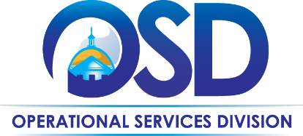
The Commonwealth of Massachusetts Operational Services Division Office of Vehicle Management

Tires Overview

Tires: Tire repair and replacement is handled by vendors on Statewide Contract VEH109 Tires, Tubes and Services (currently Goodyear and Bridgestone/Firestone). To purchase tires, take the vehicle to any authorized dealer. A list of authorized dealers may be found within the corresponding MBPO:

Below are links to the VEH109 Master Blanket Purchase Order (MBPO) details and the Contract User Guide (CUG) within COMMBUYS:
Contract ID# | Description | MBPO Links | CUG Link
VEH109 | Tires | Bridgestone MBPO  Goodyear MBPO | VEH109 CUG

- Drivers of Department-owned vehicles must follow their department’s procedures for providing a purchase order number and billing address to the vendor at time of service. Departments should be billed directly by the vendor and are responsible for any payment or follow up required to complete the transaction.

- If a vehicle is enrolled in the OVM Lease Program tire replacement is covered for the length of the lease. Drivers should visit the most appropriate VEH109 authorized dealer and instruct them to contact OVM at (617) 720-3154 prior to the start of any work. An OVM representative will review proposed repairs and issue a purchase order for payment. Note: Tires damaged due to negligence or neglect are the responsibility of the leasing agency.

Individual Agencies/Departments may have additional processes to follow. Check with your Agency Fleet Manager.

Last Updated 06-2022

