INDOOR AIR QUALITY ASSESSMENT

Tisbury School
Little White House (Modular Building)
40 W William St,
Vineyard Haven, MA

Prepared by:
Massachusetts Department of Public Health
Bureau of Environmental Health
Indoor Air Quality Program
June 2019

Background
Building: | Tisbury School Little White Building (Modular Building)
Address: | 40 W William St., Vineyard Haven
Reason for Request: | General indoor air quality (IAQ) assessment
Date of Assessment: | April 11, 2019
Massachusetts Department of Public Health/Bureau of Environmental Health (MDPH/BEH) Staff Conducting Assessment: | Mike Feeney, Director, IAQ Program
Building Description: | The modular classroom portion of the Tisbury School is a stand-alone building containing 4 classrooms. It has siding and a pitched roof.
Windows: | Openable

Methods
Please refer to the IAQ Manual for methods, sampling procedures, and interpretation of results (MDPH, 2015).

IAQ Testing Results
The following is a summary of indoor air testing results in both suites (Table 1).
- Carbon dioxide levels were above the MDPH guideline of 800 parts per million (ppm) in all areas surveyed, indicating a lack of air exchange at the time of the assessment.
- Temperature was within or very close to the recommended range of 70°F to 78°F in all areas tested.
- Relative humidity was below the recommended range of 40 to 60%.
- Carbon monoxide levels were non-detectable (ND) in all areas tested.
- Fine particulate matter (PM2.5) concentrations measured were below the National Ambient Air Quality Standard (NAAQS) limit of 35 μg/m³ in all but one indoor area tested. Levels were above the NAAQS limits outside.

Ventilation
A heating, ventilating, and air conditioning (HVAC) system has several functions. First it provides heating and, if equipped, cooling. Second, it is a source of fresh air. Finally, an HVAC system will dilute and remove normally-occurring indoor environmental pollutants by not only introducing fresh air, but by filtering the airstream and ejecting stale air to the outdoors via exhaust ventilation. Even if an HVAC system is operating as designed, point sources of respiratory irritation may exist and cause symptoms in sensitive individuals.
Ventilation in the modular classrooms is provided by one air handling unit (AHU), which was deactivated at the time of the assessment. Fresh air intake and exhaust vents are located on the south exterior wall (Picture 1).

Microbial/Moisture Concerns
The Modular Building Institute (Stewart, 2002) released guidance concerning mold growth prevention in modular classrooms in March 2002. According to this guidance, the following improvements can be made to avoid microbial growth within these structures:
- Ensure structures are constructed with a sloped roof with a properly installed gutter and downspout system to drain rainwater.
- Site modular structures on well-drained surfaces.
- Direct surface water run-off away from the structure.
- Ventilate the crawlspace under the structure.
- Examine all caulking and/or flashing around windows and service posts, especially after moving a structure.
- Maintain ventilation according to American Society for Heating, Refrigerating and Air-conditioning Engineers (Stewart, 2002).
As previously mentioned, the AHU was deactivated during the assessment, resulting in no source of mechanical ventilation for the building.
One room had a distinct mold odor upon entry (Table 1). The source of this odor was the floor, which was covered with wall-to-wall carpeting. Carpeting that is chronically moistened through either water leaks or exposure to high humidity may become colonized with mold. BEH/IAQ staff examined the modular unit by using the guidelines above as evaluation points. The following conditions concerning water drainage around the structure may have contributed to increased water vapor and water penetration in the building:
- The roof of the modular building does not have gutters and downspouts along the edge of the roof except for entrances (Picture 2).
- The modular building was partially installed on a slope, which directs rainwater under the building. Over time, rainwater has compacted the soil below exterior walls, creating troughs in which water may accumulate against the exterior wall and pool beneath the modular structure.
- The soil at the front of the modular structure is not graded to slope away from the building. Without grading the soil, rainwater cannot readily drain away from the front of the structure.
- The accumulation of water at the base of the modular building causes chronic wetting of the exterior wall. Downspouts should be designed to direct rainwater away from the base of the exterior walls to prevent rainwater from penetrating beneath the building. Wetting of exterior walls and soil beneath the building can result in mold growth.
- The rear of the building has large holes in its skirting (Picture 3). The prevailing winds in Massachusetts tend to be from the west. Moist weather tends to travel in a northeasterly track, up the Atlantic Coast towards New England (Trewartha, 1943). Wet weather systems generally produce south/southwesterly winds. Driving rain is most likely to strike this door during wet weather patterns which can inject water under the building through the skirting holes.
Splashing rainwater can lead to chronic moistening of the exterior wall and doors, which in turn moistens carpet installed against the doorframe. The American Conference of Governmental Industrial Hygienists (ACGIH) and the US Environmental Protection Agency (US EPA) recommend that porous materials be dried with fans and heating within 24 to 48 hours of becoming wet (ACGIH, 1989; US EPA, 2001). If carpets and other porous materials are not dried within this time frame, mold growth may occur. Water-damaged carpeting cannot be adequately cleaned to remove mold growth and should be replaced. The application of a mildewcide to moldy carpeting is not recommended.

Other Concerns
Exposure to low levels of total volatile organic compounds (TVOCs) may produce eye, nose, throat, and/or respiratory irritation in some sensitive individuals. BEH/IAQ staff examined spaces for products containing VOCs. BEH/IAQ staff noted hand sanitizers, cleaning products, and dry erase materials.

Conclusions/Recommendations
Based on observations at the time of assessment, the following is recommended:
- Operate supply and exhaust ventilation continuously in all areas during occupied periods. Ensure all HVAC equipment is cleaned/maintained in accordance with manufacturer’s instructions.
- Balance the HVAC system every 5 years in accordance with Sheet Metal and Air Conditioning Contractors’ National Association (SMACNA) recommendations (SMACNA, 1994).
- Repair the skirting around the building.
- Consider installing gutter and downspout system to drain water away from the building.
- Examine for means to regrade the soil around the building to drain water away from the building.
- Consider removing carpeting and replacing with a water impermeable floor coving.
- For buildings in New England, periods of low relative humidity during the winter are often unavoidable. Therefore, scrupulous cleaning practices should be adopted to minimize common indoor air contaminants whose irritant effects can be enhanced when the relative humidity is low. To control for dusts, a high efficiency particulate arrestance (HEPA) filter equipped vacuum cleaner in conjunction with wet wiping of all surfaces is recommended. Avoid the use of feather dust during the day can help ease some symptoms associated with a dry environment (throat and sinus irritations).
- Reduce the use of cleaning products, sanitizers, and other items that contain VOCs.
- Refer to resource manual and other related IAQ documents located on the MDPH’s website for further building-wide evaluations and advice on maintaining public buildings. These documents are available at: http://mass.gov/dph/iaq.

References
ACGIH. 1989. Guidelines for the Assessment of Bioaerosols in the Indoor Environment. American Conference of Governmental Industrial Hygienists, Cincinnati, OH.
IICRC. 2012. Institute of Inspection, Cleaning and Restoration Certification. Carpet Cleaning: FAQ.
MDPH. 2015. Massachusetts Department of Public Health. Indoor Air Quality Manual: Chapters I-III. Available at: http://www.mass.gov/eohhs/gov/departments/dph/programs/environmental-health/exposure-topics/iaq/iaq-manual/.
SMACNA. 1994. HVAC Systems Commissioning Manual. 1st ed. Sheet Metal and Air Conditioning Contractors’ National Association, Inc., Chantilly, VA.
Stewart, B. 2002. Preventing Mold Growth in Temporary School Structures. Modular Building Institute, Charlottesville, VA. March 2002. http://www.mbinet.org/web/magazine/mold01_02.html?style=printable
US EPA. 2008. Mold Remediation in Schools and Commercial Buildings. US Environmental Protection Agency, Office of Air and Radiation, Indoor Environments Division, Washington, D.C. EPA 402-K-01-001. http://www.epa.gov/mold/mold-remediation-schools-and-commercial-buildings-guide
Picture 1
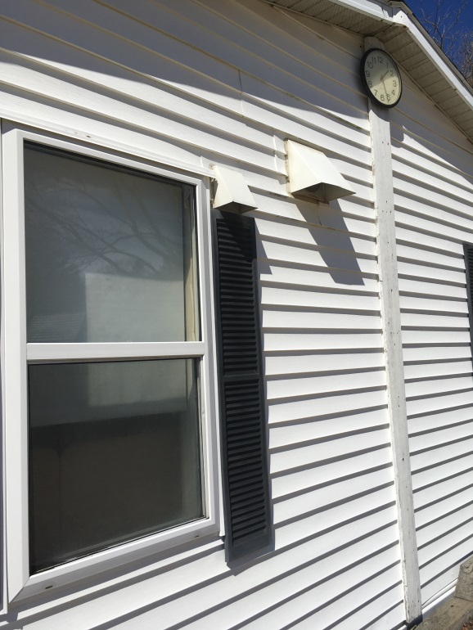
Fresh air supply and exhaust vent for AHU
Picture 2
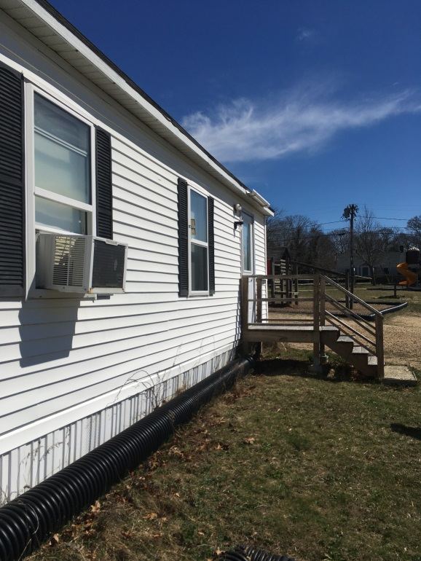
No gutter/downspouts along entire roof edge
Picture 3
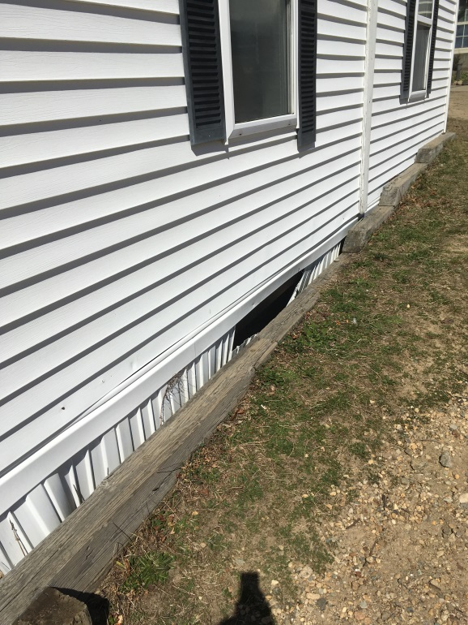
Hole in skirting

Location | Carbon  Dioxide  (ppm) | Carbon Monoxide  (ppm) | Temp  (°F) | Relative  Humidity  (%) | PM2.5  (µg/m3) | Occupants  in Room | Windows  Openable | Ventilation |  | Remarks
 |  |  |  |  |  |  |  | Supply | Exhaust
Background (outdoors) | 303 | ND | 62 | 15 | 5
K-4 | 942 | ND | 68 | 32 | 3 | 1 | Y | Y | N
K-6 | 935 | ND | 71 | 30 | 3 | 0 | Y | Y | Y | Window-mounted air conditioner
Classroom NE corner | 1223 | ND | 71 | 30 | 3 | 3 | Y | Y | N | Window-mounted air conditioner
Classrooms NW corner | 946 | ND | 71 | 29 | 3 | 0 | Y | Y | N | Window-mounted air conditioner, mold odor

