INDOOR AIR QUALITY ASSESSMENT

Tisbury School
40 West William Street
Vineyard Haven, Massachusetts

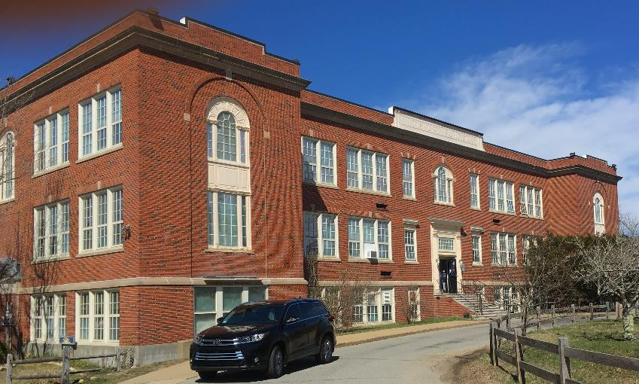

Prepared by:
Massachusetts Department of Public Health
Bureau of Environmental Health
Indoor Air Quality Program
June 2019

Background

Building: | Tisbury School (TS)
Address: | 40 West William Street, Tisbury, MA
Reason for Request: | General indoor air quality (IAQ) and water damage/mold concerns
Date(s) of Assessment: | April 11, 2019
Massachusetts Department of Public Health/Bureau of Environmental Health (MDPH/BEH) Staff Conducting Assessment: | Michael Feeney, Director, IAQ Program
Date of Building Construction: | The TS was constructed in 1929. An auditorium was added in 1938. In 1993, a two-story wing of classrooms was added to the 1925 building in 1993. A used modular unit was added, reportedly in the 2000s, which is the subject of a separate report.
Building Description: | Brick and concrete construction; ceilings are concrete, walls are cinderblock and floors are tile.
Windows: | Openable, although some in disrepair due to age (original metal framed, single-paned windows).

IAQ Testing Results
Please refer to the IAQ Manual for methods, sampling procedures, and interpretation of results (MDPH, 2015). The following is a summary of indoor air testing results (Table 1).
- Carbon dioxide levels were above the MDPH guideline of 800 parts per million (ppm) in more than half of the locations assessed, indicating a lack of air exchange, mainly due to sealed fresh air intakes and deactivated/outdated ventilation components. This is explained further in the Ventilation section of this report.
- Temperature was within or close to the recommended range of 70°F to 78°F the day of assessment. Note it is difficult to control temperature/maintain comfort without operating the mechanical ventilation systems as designed.
- Relative humidity was below the recommended range of 40 to 60% the day of assessment in all but one area.
- Carbon monoxide levels were non-detectable (ND) in all indoor areas tested.
- Fine particulate matter (PM2.5) concentrations measured were below the national ambient air quality standard (NAAQS) limit of 35 μg/m³ in all areas tested.

Ventilation
A heating, ventilating and air conditioning (HVAC) system has several functions. First it provides heating and, if equipped, cooling. Second, it is a source of fresh air. Finally, an HVAC system will dilute and remove normally occurring indoor environmental pollutants by not only introducing fresh air, but by filtering the airstream and ejecting stale air to the outdoors via exhaust ventilation. Even if an HVAC system is operating as designed, point sources of respiratory irritation may exist and cause symptoms in sensitive individuals.
Mechanical ventilation equipment was deactivated in almost every area throughout the building the day of assessment in both classrooms and common areas (e.g., cafeteria, gym, and library) (Table 1).
Fresh air in classrooms is supplied by a unit ventilator (univent) system (Figure 1). Univents draw air from outdoors through a fresh air intake located on the exterior walls of the building (Picture 1) and return air through an intake located at the base of each unit. Fresh and return air are mixed, filtered, heated and provided to classrooms through an air diffuser located in the top of the unit. Univent fresh air intakes throughout the building were sealed (Picture 1). By sealing the fresh air intakes, no mechanical source of fresh air exists. Each classroom was originally equipped with exhaust ventilation, which would vent normally occurring indoor pollutants from the room, and in combination of the operation of a fully functional univent, create airflow. Exhaust vents in classrooms were sealed (Picture 2) and repurposed for use as cable runs for computers. Based on this condition, the TS does not have a functional source of fresh air supply or exhaust ventilation. All univents provide only heat and recirculate air. Many univents had various materials stored in front of the return vent or on top to block diffusers. Odors from stored materials can become aerosolized by the operation of univents and be irritating to the eyes, nose and respiratory system to sensitive individuals.
The building appears to be originally designed to provide fresh air by opening windows and transoms during temperate weather. The TS was configured in a manner to use cross-ventilation to provide comfort for building occupants. The building is equipped with windows on opposing exterior walls. In addition, the building has hinged windows located above hallway doors. This hinged window (called a transom) (Picture 3) enables the classroom occupant to close the hallway door while maintaining a pathway for airflow. This design allows for airflow to enter an open window, pass through a classroom, pass through the open transom, enter the hallway, pass through the opposing open classroom transom, into the opposing classroom and exit the building on the leeward side (opposite the windward side) (Figure 2). With all windows and transoms open, airflow can be maintained in a building regardless of the direction of the wind. The system fails if the windows or transoms are closed (Figure 3). All transoms in the building were sealed, which prevents cross-ventilation in the 1929 building as originally designed. The 1993 building has no transoms. Without proper supply and exhaust ventilation, normally occurring environmental pollutants can build-up and lead to indoor air quality/comfort complaints.
In order to have proper ventilation with a mechanical supply and exhaust system, these systems must be balanced to provide an adequate amount of fresh air to the interior of a room while removing stale air from the room. It is recommended that existing ventilation systems be re-balanced every five years to ensure adequate air systems function (SMACNA, 1994). In its current condition, the HVAC system cannot be balanced.
With regard to HVAC system function, according to the American Society of Heating, Refrigeration and Air-Conditioning Engineers (ASHRAE), the service life for a unit heater, hot water or steam is 20 years, assuming routine maintenance of the equipment (ASHRAE, 1991). Despite attempts to maintain the univents (e.g., oiling bearings, changing filters regularly), the operational lifespan of this equipment has been exceeded in all areas for the TS. Maintaining the balance of fresh to exhaust air will become more difficult as the equipment ages and as replacement parts become increasingly difficult to obtain.

Microbial/Moisture Concerns
The TS appears to have a number of breaches/conditions through the building envelope that allows water to penetrate into the building, including:
- A section of walls around the gymnasium wing are cracked (Picture 4).
- A window frame in the front of the building has rotted wood and a damaged sill (Picture 5). It appears that spray foam insulation was applied which would hold water behind the window frame and wall cavity. (Spray foam insulation is a water impermeable material that would dam water behind brick and mortar. Brick and mortar are porous materials through which water may pass).
- Condensation on the inside of energy efficient windows indicates that the gaskets have failed, allowing moisture penetration (Picture 5).
- It appears the side entrances to the 1929 wing were reconfigured during the 1993 addition construction (east and west entrances). A significant amount of water-damaged plaster exists in the east entrance. Water damage inside this entrance appears to be directly below the junction of the roof of the east entrance and 1929 building (Pictures 6). The water leak appears to be related to the wall above the east entrance, which likely originally had an awning-shaped roof sheltering this doorway (Picture 7). A line of sealant is visible on the brickwork above the entrance as well as vertical black stains on brickwork flanking the sealant which suggest the removal of such an awning. Of note is a quality of brick called porosity. If the bricks used to seal the area above the entrance are more porous than surrounding brick, wind-driven rainwater may pass though the brick to accumulate inside the exterior wall to possibly cause the damage shown in Picture 6.
- Water damage inside the east entrance may also be related to the lack of gutters, drip edge or sealant where the entrance roof and wall meets.

In addition to these conditions, water-damaged ceiling tiles were noted in a number of areas (Table 1). This water damage may be the result of water penetration through the building envelope by roof leaks or leaks through failing window frames.
Each of these conditions can result in moistening of building materials. Porous materials such as cellulose ceiling tiles and gypsum wallboard (GW) can support mold growth. In order for building materials to support mold growth, a source of water exposure is necessary. The US Environmental Protection Agency (US EPA) and the American Conference of Governmental Industrial Hygienists (ACGIH) recommends that porous materials (e.g., wallboard, carpeting) be dried with fans and heating within 24 to 48 hours of becoming wet (US EPA, 2008; ACGIH, 1989). If porous materials are not dried within this time frame, mold growth may occur. It is important to note that the majority of building materials observed were non-porous surfaces (i.e., cinder block, concrete, floor tiles), which are not conducive to mold growth as opposed to porous materials such as gypsum wallboard, carpet and fibrous ceiling tiles.
A mold odor was detected in the chemistry storeroom, which was traced to an unused dish washer. In addition, the chemistry lab has a floor drain. In both of these instances, the drain trap is likely dry. The purpose of a drain trap is to use water to prevent gases and other odors from the sewer/septic system from entering occupied space. In order to maintain the air seal on the drain trap, water must be poured down a drain at least twice a week. If drains are unused, then sealing drains is recommended.
Plants were observed in a number of areas (Table 1). Plants can be a source of pollen and mold, which can be respiratory irritants to some individuals. Plants should be properly maintained and equipped with drip pans and should be located away from air diffusers to prevent the aerosolization of dirt, pollen and mold.
A variety of air conditioning (AC) units are used in classrooms, including window units, wall-mounted and portable air conditioners (Table 1). ACs collects condensation that should be drained to prevent water damage and microbial growth. Condensation collection pans/vessels and drains should be inspected for leaks and clogs and cleaned periodically to prevent stagnant water and debris that can lead to odors and microbial growth.

Other IAQ Evaluations
Exposure to low levels of total VOCs (TVOCs) may produce eye, nose, throat, and/or respiratory irritation in some sensitive individuals. To determine if VOCs were present, BEH/IAQ staff examined rooms for products containing VOCs. BEH/IAQ staff noted hand sanitizers, cleaners, air fresheners and dry erase materials in use within the building. All of these products have the potential to be irritants to the eyes, nose, throat, and respiratory system of sensitive individuals. Given that the building does not have functional, mechanical fresh air supply or exhaust ventilation, use of these products would likely result in lingering odors to cause irritation to building occupants.
Photocopiers and laminators were located in the Main Office and a few other areas. Photocopiers can emit ozone and TVOCs, especially when they are older or heavily used, laminators give off waste-heat and plastic odors. It is recommended that this equipment be used in a well-ventilated area, preferably with local exhaust ventilation.
Most classrooms had carpeting that appeared to be several decades old. In many areas, this carpeting was visibly very worn, frayed, wrinkled and stained. The service life of carpeting in schools is approximately 10-11 years (IICRC, 2002). Aging carpet can produce fibers that can be irritating to the respiratory system. In addition, tears or lifting carpet can create tripping hazards. Carpeting should be cleaned annually or semi-annually in soiled high traffic areas as per the recommendations of the Institute of Inspection, Cleaning and Restoration Certification (IICRC, 2012). Non-carpeted surfaces are recommended for most areas of schools.
A kiln in the art room had no exhaust ventilation (Picture 8) and was located directly inside the classroom. Exhaust ventilation for kilns is necessary to remove heat and odors during operation. Consider installing a direct exhaust vent for the kiln and ensure it is used every time the kiln is in operation.
A kiln is used to heat the pottery to the desired firing temperature. The most common type is electric kilns. Heating elements heat the kiln as electric current passes through the coils. The temperature rises until the kiln is shut off. Firing temperatures can vary from as low as 1382°F for raku and bisque wares, to as high as 2372 °F for stoneware, and 2642 °F for certain porcelains... The early stages of bisque firing involve the oxidization of organic clay matter to carbon monoxide and other combustion gases. Sulfur breaks down later producing highly irritating sulfur oxides. Also, nitrates and nitrogen-containing organic matter break down to nitrogen oxides. In addition low grade fire clays can release toxic gases and fumes during glaze firings. Carbonates, chlorides, and fluorides are broken down to releasing carbon dioxide, chlorine, and fluorine gases (Princeton U., 2019).

Depending on the composition of the clay fired, a variety of pollutants can exit the kiln and linger in the indoor environment, since the building does not have functioning mechanical supply or exhaust ventilation.
The TS also contains a wood shop, which has a wood dust collector unit (Picture 9). In order for the wood dust collector to work properly, an adequate amount of make-up air is needed to maximize the airflow. Aside from opening windows, no source of make-up air was identified during this assessment.
Of note was the presence of peeling paint in a number of locations (Picture 10, Table 1). IAQ staff could not identify whether the paint may contain lead. Given age of the TS, is possible that classroom paint contains lead and would be require remediation in a manner consistent with Massachusetts lead paint laws and regulations.
The 1929 building was also built at a time when asbestos was used to insulate heat pipe. The Asbestos Hazard Emergency Response Act (AHERA) requires that all asbestos containing materials be identified and reassessed every three years by a licensed asbestos inspector. If the asbestos-containing materials is in a form that can cause exposure (called friable), then it must be remediated in a manner consistent with federal and Massachusetts asbestos laws and regulation.
Note that the Environmental Protection Agency (EPA) conducted a National School Radon Survey in which it discovered nearly one in five schools had “…at least one frequently occupied ground contact room with short-term radon levels above 4 [picocuries per liter] pCi/L” (US EPA 1993). The BEH/IAQ Program therefore recommends that every school be tested for radon, and that this testing be conducted during the heating season while school is in session in a manner consistent with USEPA radon testing guidelines. Radon measurement specialists and other information can be found at www.nrsb.org and http://aarst-nrpp.com/wp, with additional information at: http://www.mass.gov/eohhs/gov/departments/dph/programs/environmental-health/exposure-topics/iaq/radon.

Conclusions/Recommendations
The conditions related to IAQ problems at the TS raise a number of significant issues. At this point, the school has had its mechanical HVAC systems rendered incapable of providing fresh air and exhaust ventilation. This condition can allow for normally occurring indoor air pollutants to build up to cause symptoms. Without properly function mechanical ventilation, sources of odors and chemical vapors can then be trapped inside the building. The TS also has a number of water penetration issues which can moisten materials that can then become mold-colonized.
The general building conditions, maintenance, work hygiene practices, and the condition of HVAC equipment, if considered individually, present conditions that could degrade IAQ. When combined, these conditions can serve to further degrade IAQ. Some of these conditions can be remedied by actions of building occupants. Other remediation efforts will require alteration to the building structure and equipment. For these reasons, a two-phase approach is required for remediation. The first consists of short-term measures to improve air quality and the second consists of long-term measures that will require planning and resources to adequately address overall IAQ concerns.
- In order to provide fresh air, appropriate use of windows at all times during the school years is necessary.
- Consider contracting with a ventilation engineer to assess the feasibility of restoring the ventilation system to adequate function. Such methods may include:
  - Remove all blockages from univent fresh air intakes.
  - Installing a hood to shelter the intake from direct wind impingement to prevent coil freeze.
  - Improve filtration in univents.
  - Examine the feasibility of restoring the function of all exhaust vents in classrooms, common areas, restrooms and internal rooms.
  - Once mechanical fresh air and exhaust vents are restored to proper function, consider adopting a balancing schedule of every 5 years for all mechanical ventilation systems, as recommended by ventilation industrial standards (SMACNA, 1994).
- Once the ventilation is restored, operate all ventilation systems throughout the building (e.g., gym, cafeteria, classrooms) continuously during periods of school occupancy and independent of thermostat control.
- Remove all stored materials in front of and on top of univents to prevent odor distribution.
- Remove the spray foam insulation from exterior walls. Repoint with mortar.
- Repair all wooden window frames.
- Replace the stone windowsill in Picture 5.
- Consider having a building engineer:
  - Examine the wall above the east entrance to ascertain whether the brickwork is intact and has appropriate porosity.
  - Determine if the sealant is the appropriate method to seal the mortar joints.
  - Determine the extent of mortar repointing necessary for exterior walls around the entire exterior wall.
  - Examine the feasibility of restoring the integrity of windows.
- Examine the roof for leaks and repair as needed.
- Replace water-damaged ceiling tiles and paint/refinish areas with water stains, etc.
- Avoid storage of any porous materials in areas of known leaks or in unconditioned spaces.
- If the dishwasher and/or floor drain in chemistry room are unused, pour water down drains periodically to maintain the trap seal. Consider sealing permanently (plumbing cut and capped) to prevent the presence of odors/pests.
- Ensure that condensation from AC equipment is draining properly. Check collector pans, piping and any associated pumps for clogs and leaks and clean periodically to prevent stagnant water build-up and remove debris that may provide a medium for microbial growth.
- Properly maintain plants, including drip pans, to prevent water damage to porous materials. Plants should also be located away from air diffusers to prevent the aerosolization of dirt, pollen, and mold.
- Reduce use of products and equipment that create VOCs. Avoid the use of air freshening products including plug-ins and sprays.
- Use photocopiers and laminators in well-ventilated areas.
- Discontinue use of pottery kiln until proper exhaust ventilation is installed.
- Consider upgrading to a pleated filter of minimum efficiency rating value (MERV) 8 in univents and AHUs, if these can be used with the current equipment. Change filters 2-4 times a year or as per the manufacture’s recommendations.
- For buildings in New England, periods of low relative humidity during the winter are often unavoidable. Therefore, scrupulous cleaning practices should be adopted to minimize common indoor air contaminants whose irritant effects can be enhanced when the relative humidity is low. To control for dusts, a high efficiency particulate arrestance (HEPA) filter-equipped vacuum cleaner in conjunction with wet wiping of all surfaces is recommended. Avoid the use of feather dusters. Drinking water during the day can help ease some symptoms associated with a dry environment (throat and sinus irritation).
- Replace outdated carpeting past its useful life. Consider using non-carpet flooring in classroom areas. Note due to the age of the building; ensure it is known prior to carpet removal if asbestos-containing materials are present.
- Clean carpeting and area rugs annually or more often in high-traffic locations in accordance with IICRC recommendations (IICRC, 2012) and discard those that are worn out or too soiled to be cleaned.
- Determine if peeling paint in the gyms contain lead. If paint contains lead, remove paint in a manner consistent with Massachusetts lead paint laws and regulations. If no lead is present, remove peeling paint.
- Consider reducing the amount of items stored in classrooms/offices to make cleaning easier. Periodically move items to clean flat surfaces.
- Encourage faculty to report classroom/building related issues via a tracking program.
- Continue to follow AHERA regulations including 3-year inspections and updates/availability of the school’s asbestos management plan.
- Consider adopting the US EPA (2000) document, “Tools for Schools”, as an instrument for maintaining a good IAQ environment in the building available at: http://www.epa.gov/iaq/schools/index.html.
- For more information on mold consult with “Mold Remediation in Schools and Commercial Buildings” published by the US Environmental Protection Agency (US EPA, 2008). http://www.epa.gov/mold/mold-remediation-schools-and-commercial-buildings-guide.
- The school should be tested for radon by a certified radon measurement specialist during the heating season when school is in session. Radon measurement specialists and other information can be found at: www.nrsb.org, and http://aarst-nrpp.com/wp/.
- Refer to resource manual and other related IAQ documents located on the MDPH’s website for further building-wide evaluations and advice on maintaining public buildings. These documents are available at: http://mass.gov/dph/iaq.

Long-term Recommendations
- Contact an HVAC engineering firm for an assessment of the ventilation system’s components and control systems (e.g., controls, air intake louvers, thermostats). Based on the age, physical deterioration, and availability of parts for ventilation components, such an evaluation is necessary to determine the operability and feasibility of repairing/replacing the equipment.
- Install local exhaust ventilation for areas with stoves, wood shop, photocopiers and lamination machines.

References
ACGIH. 1989. Guidelines for the Assessment of Bioaerosols in the Indoor Environment. American Conference of Governmental Industrial Hygienists, Cincinnati, OH.
ASHRAE. 1991. ASHRAE Applications Handbook, Chapter 33 “Owning and Operating Costs”. American Society of Heating, Refrigeration and Air Conditioning Engineers, Atlanta, GA.
Claybricks & Tiles Sdn. Bhd. 1998-2007. ClayBricks The Basics of Bricks. http://www.claybricks.com/more_info/basic-of-bricks.html
IICRC. 2002. Institute of Inspection, Cleaning and Restoration Certification. A Life-Cycle Cost Analysis for Floor Coverings in School Facilities.
IICRC. 2012. Institute of Inspection, Cleaning and Restoration Certification. Carpet Cleaning: FAQ.
MDPH. 2015. Massachusetts Department of Public Health. “Indoor Air Quality Manual: Chapters I-III”. Available at: http://www.mass.gov/eohhs/gov/departments/dph/programs/environmental-health/exposure-topics/iaq/iaq-manual/.
Princeton U. 2019. Ceramics. Princeton University, Environmental Health and Safety, Princeton, NJ. https://ehs.princeton.edu/health-safety-the-campus-community/art-theater-safety/art-safety/ceramics
SMACNA. 1994. HVAC Systems Commissioning Manual. 1st ed. Sheet Metal and Air Conditioning Contractors’ National Association, Inc., Chantilly, VA.
US EPA. 1993. Radon Measurement in Schools, Revised Edition. Office of Air and Radiation, Office of Radiation and Indoor Air, Indoor Environments Division (6609J). EPA 402-R-92-014. https://www.epa.gov/sites/production/files/2014-08/documents/radon_measurement_in_schools.pdf
US EPA. 2000. Tools for Schools. Office of Air and Radiation, Office of Radiation and Indoor Air, Indoor Environments Division (6609J). EPA 402-K-95-001, Second Edition. http://www.epa.gov/iaq/schools/index.html.
US EPA. 2008. Mold Remediation in Schools and Commercial Buildings. US Environmental Protection Agency, Office of Air and Radiation, Indoor Environments Division, Washington, D.C. EPA 402-K-01-001. http://www.epa.gov/mold/mold-remediation-schools-and-commercial-buildings-guide.
Picture 1
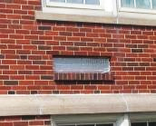
Sealed univent fresh air intake
Picture 2
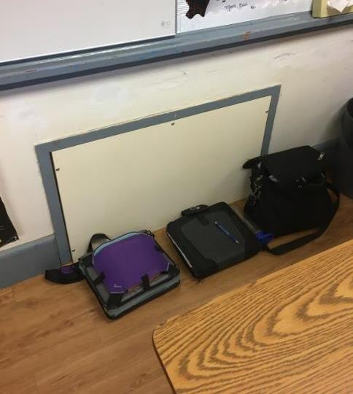
Sealed exhaust vent
Picture 3
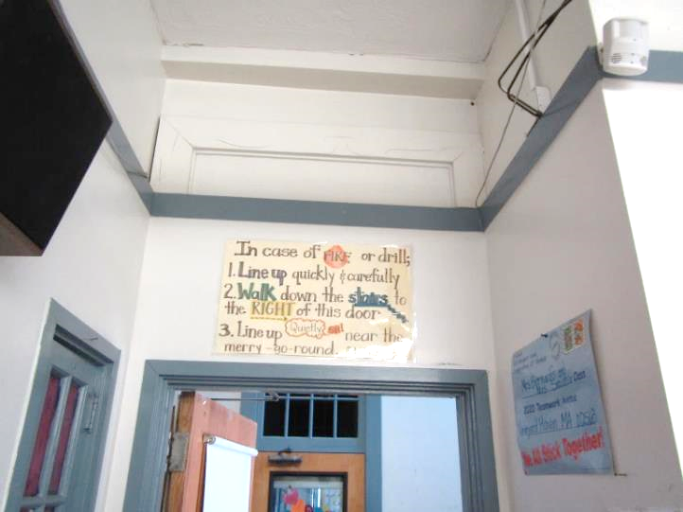
Sealed transom (arrow)
Picture 4
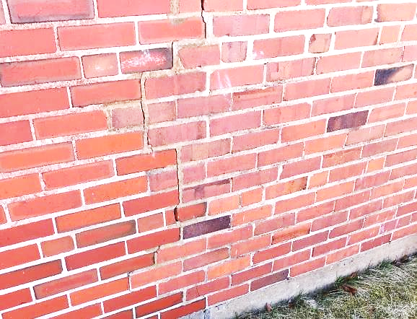
Gymnasium wing exterior wall cracks
Picture 5
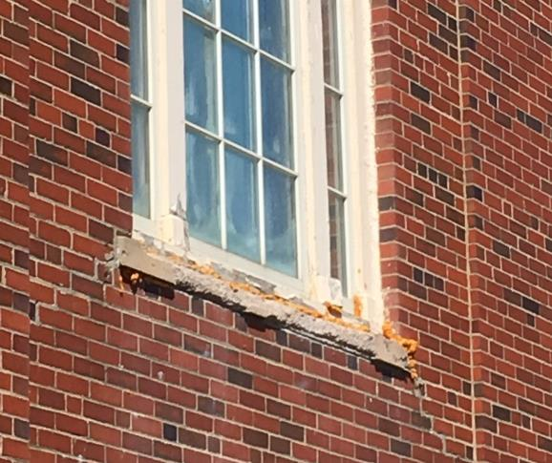
Damaged window frame and sill with spray foam insulation
Picture 6
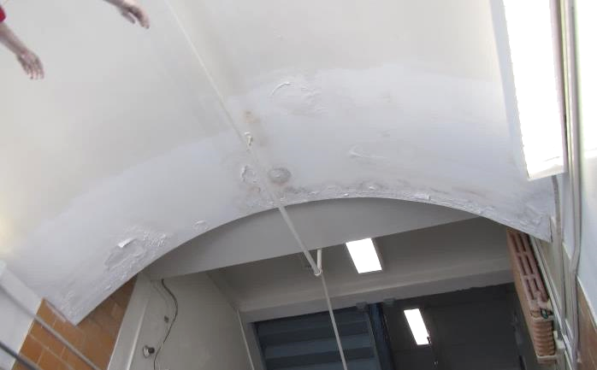
Water damage inside the east entrance
Picture 7
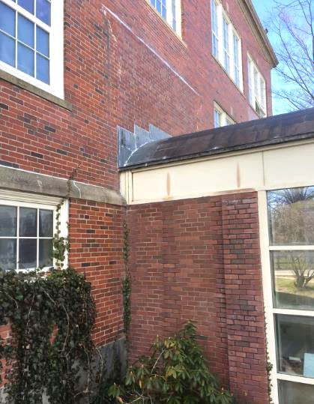
Sealed opening in brick above the east entrance
(Note sealant and blackened brick above entrance roof)
Picture 8
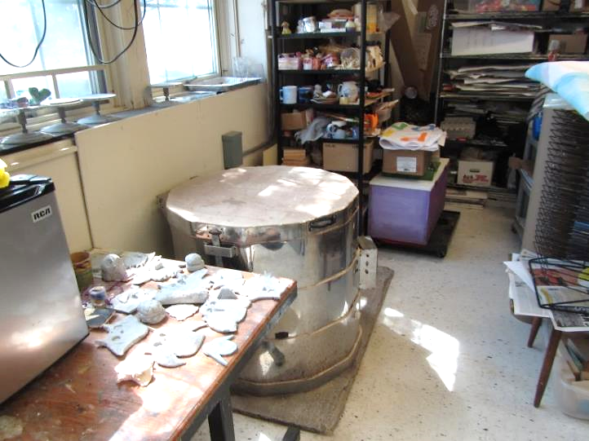
Kiln in art room with no dedicated exhaust vent
Picture 9
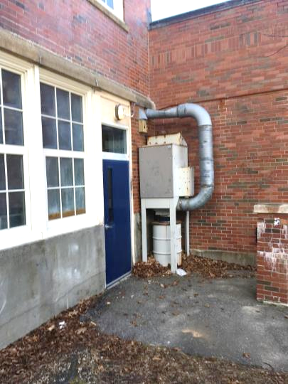
Wood dust collector
Picture 10
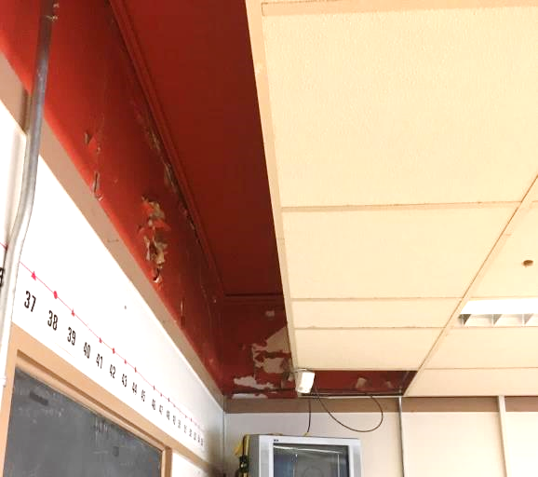
Example of peeling paint in 1929 wing classroom
Location | Carbon  Dioxide  (ppm) | Carbon Monoxide  (ppm) | Temp  (°F) | Relative  Humidity  (%) | PM2.5  (µg/m³) | Occupants  in Room | Windows  Openable | Ventilation |  |  | Remarks
 |  |  |  |  |  |  |  | Intake | Exhaust
Background | 303 | ND | 62 | 15 | 5
Library | 1119 | ND | 75 | 24 | 7 | 30+ | Y | Y |  | Y | Hole in ceiling, UF
101 | 506 | ND | 71 | 24 | 7 | 10 | Y | Y |  | N | Kiln-no local exhaust vent
104 | 476 | ND | 73 | 22 | 9 | 1 | Y | Y |  | N
111 | 1175 | ND | 75 | 26 | 7 | 16 | Y | Y |  | N
112 | 631 | ND | 73 | 23 | 3 | 2 | Y | Y |  | Y
113 | 1231 | ND | 74 | 27 | 4 | 16 | Y | Y |  | N
118 | 512 | ND | 73 | 23 | 4 | 1 | Y | Y |  | Y
201 | 736 | ND | 75 | 23 | 7 | 10 | Y | Y |  | N | Peeling paint
202 | 618 | ND | 74 | 22 | 6 | 0 | Y | Y |  | N
203 | 690 | ND | 76 | 23 | 7 | 10 | Y | Y |  | N
204 | 635 | ND | 74 | 20 | 5 | 0 | Y | Y |  | N
208 | 670 | ND | 74 | 21 | 6 | 3 | Y | Y |  | N
211 | 1491 | ND | 75 | 31 | 6 | 1 | N | Y |  | Y
216 | 1295 | ND | 74 | 26 | 5 | 20 | Y | Y |  | N | Peeling paint
218 | 844 | ND | 74 | 23 | 6 | 1 | N | Y |  | Y
217 | 835 | ND | 73 | 23 | 6 | 0 | Y | Y |  | Y | Mold odor
222 | 826 | ND | 74 | 22 | 6 | 0 | Y | Y |  | Y | Carpet
Nursing | 807 | ND | 75 | 23 | 7 | 2 | Y | N |  | N
Entrance |  |  |  |  |  |  |  | N |  | N | WD plaster
Kitchen | 457 | ND | 75 | 21 | 7 | 4 | Y | Y |  | Y
Gym/Auditorium | 347 | ND | 75 | 21 | 3 | 16 | Y | Y |  | Y
Music 002 | 501 | ND | 74 | 20 | 3 | 15 | Y | Y |  | Y
Music 004 | 345 | ND | 74 | 17 | 3 | 1 | Y | N |  | N
Music Room | 373 | ND | 72 | 17 | 1 | 0 | Y | N |  | N
Wood Shop | 389 | ND | 72 | 21 | 5 | 0
Bowr | 1505 | ND | 74 | 19 | 5
Principal | 943 | ND | 73 | 33 | 8 | 2 | Y | Y |  | Y | Peeling paint
Main Office | 910 | ND | 75 | 25 | 7 | 2 | N | Y |  | Y | 1 WD CT, AP
Finance | 876 | ND | 73 | 25 | 5 | 0 | Y | Y |  | Y | PC
Foyer | 707 | ND | 75 | 21 | 5 | 0 | N | N |  | N
301 | 1102 | ND | 74 | 27 | 6 | 21 | Y | Y |  | N | Peeling paint,  Plants
302 | 1054 | ND | 75 | 27 | 6 | 10 | Y | N |  | N | FCU, peeling paint
303 | 1019 | ND | 75 | 25 | 8 | 13 | Y | Y |  | N
304 | 1179 | ND | 75 | 27 | 10 | 10 | Y | Y |  | N | 23 computers, plants, MT
307 | 843 | ND | 74 | 23 | 6 | 1 | Y | N |  | N | 2 WD CT
308 | 778 | ND | 76 | 23 | 9 | 3 | Y | Y |  | N | Plants
309 | 705 | ND | 74 | 21 | 6 | 3 | Y | Y |  | N
312 | 853 | ND | 73 | 25 | 7 | 3 | Y | Y |  | N | Peeling paint
Office | 773 | ND | 73 | 24 | 7 | 0 | Y | N |  | N
313 | 1003 | ND | 73 | 26 | 5 | 4 | Y | Y |  | N | Plants
314 | 893 | ND | 73 | 23 | 6 | 0 | Y | Y |  | N | Peeling paint
315 | 770 | ND | 74 | 24 | 7 | 0 | Y | Y |  | Y
316 | 973 | ND | 74 | 25 | 7 | 1 | N | Y |  | Y | WD CT
318 | 848 | ND | 74 | 24 | 6 | 2 | Y | Y |  | Y | 7 WD CT
319 | 736 | ND | 74 | 21 | 7 | 0 | Y | Y |  | Y | Unused dishwasher with mold odor
K-4 | 942 | ND | 68 | 32 | 3 | 1 | Y | Y |  | N
K-6 | 935 | ND | 71 | 30 | 3 | 0 | Y | Y |  | N | WAC
Spanish | 1228 | ND | 71 | 30 | 3 | 0 | Y | Y |  | N | WAC
Language | 946 | ND | 71 | 29 | 3 |  | Y | Y |  | N | WAC, mold
Main office | 713 | ND | 74 | 43 | 11 | 3 | Y | Y |  | Y | PC, HS, plants, dusty vents

Porosity is an important characteristic of brick. In contrast to other moulded or pre-cast building materials, the porosity of brick is attributed to its fine capillaries. By virtue of the capillary effect, the rate of moisture transport in the brick is ten times faster than in other building materials. Moisture is released during day-time and re-absorbed during night-time. The ability to release and re-absorb moisture (a "breathing" process) by capillary effect is one of the most useful properties of brick that helps to regulate the temperature and humidity of atmosphere. This distinctive property makes brick an admirable building material…[c]n the other hand, all porous materials are susceptible to chemical attacks and liable to contamination from weathering agents like rain, running water and polluted air. Porosity of building material is an important factor to consider in respect its performance and applications. Experiment results show that bricks with water absorption rate at 8% is 10 times more durable in resisting salt attack than that with water absorption rate at 20%. Well burnt brick has a normal water absorption rate less than 10% in contrast to that of concrete block and cement mortar exceeding 15%. This explains why brick walls require comparatively minimum maintenance in the course of time (Claybricks & Tiles Sdn. Bhd., 1998-2007).

