The Commonwealth of Massachusetts
Executive Office of Health and Human Services
Department of Public Health - Bureau of Environmental Health
Food Protection Program
305 South Street, Jamaica Plain, MA 02130
Phone: 617-983-6712 Fax: 617-524-8062

MARYLOU SUDDERS
Secretary
MONICA BHAREL, MD, MPH Commissioner

Tel: 617-624-6000
www.mass.gov/dph

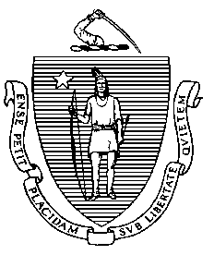

CHARLES D. BAKER
Governor
KARYN E. POLITO
Lieutenant Governor

TO: Local Boards of Health and Health Departments

FROM: Michael Moore, MDPH/BEH Food Protection Program
DATE: October 2, 2018
RE: Vendors Approved by MDPH to Provide Allergen Awareness Training

The following two vendors are approved by Massachusetts Department of Public Health (MDPH) to issue certificates of allergen awareness training in accordance with 105 CMR 590.011(C)(3)(a).
- Compliance – To comply with 105 CMR 590.011(C)(3)(a), at least one certified food protection manager per food establishment must obtain an allergen awareness certificate from one of these three MDPH-approved vendors.
- Online Training – To obtain an allergen awareness certificate over the Internet, visit a vendor’s website, pay $10, and follow the instructions for watching the allergen awareness video.
- Classroom Training - To obtain an allergen awareness certificate in a classroom setting, contact a vendor and ask for information about available classroom trainings.

Berkshire Area Health Education Center  1350 West Street  Pittsfield, MA 01201 | Options to be trained by Berkshire AHEC:  • Visit their website at http://www.berkshireahec.org/  • Contact AHEC at sdargie@berkshireahec.org  • Call (413) 236-4500
Massachusetts Restaurant Association  160 East Main St. - Suite 2  Westborough, MA 01581 | Options to be trained by MRA:  • Visit the MRA website at http://www.themassrest.org/  • Call 508-303-9905

