
Introduction to cTORQ
Facilitator’s Guide Version 04/23/2014

Overview
This Facilitator’s Guide is to be used in conjunction with the PowerPoint presentation of the Introduction to cTORQ workshop.

This course introduces customers to the Labor Market Information tool known as cTORQ.

• Prior to delivering this workshop, facilitators should have been trained in the use of cTORQ and should review the contents of the PowerPoint presentation and Facilitator’s Guide to familiarize themselves with the presentation of this tool to customers.

• Career Centers may add slides to the PowerPoint presentation as needed.

• The PowerPoint presentation will be used in conjunction with a live demonstration of the cTORQ tool and a discussion of the final output known as a Personal Employment Plan.

Materials
Be sure to have handout materials printed in a large font to meet ADA regulations (size 18 font). A few copies of the presentation in the larger font should be made available.

Welcome Packet (This will include all required handouts as well as any Career Center specific handouts that are added and discussed in the workshop.)

Welcome Packet
Required
Key Terms/TORQ Score Handout

Optional
Materials, continued
cTORQ Next Steps Action Plan
cTORQ Navigation Flow Chart
cTORQ PowerPoint as a Handout


There are notes for the facilitator, which are highlighted by the notepad icon
General Information
throughout this guide. The icon will be an indication to the facilitator that he/she needs to give participants additional information on that particular topic/bulleted point. In some cases, there are notes embedded in the talking points section and these are identified by BOLD ALL CAPS font.

Throughout this presentation, the facilitator can continually remind participants that in order to ensure successful use of this tool they should not jump ahead of the facilitator when navigating.

There are cues that guide the facilitator in advancing the slide. The mouse icon highlights these cues.

The information in the Introduction to cTORQ PowerPoint presentation and the Facilitator’s Guide cannot be removed; however, slides can be added to meet your Career Center and customer needs.

BEGIN SESSION: Advance to SLIDE 1


SLIDE 1
NOTES:

Introduce yourself and explain the purpose of the workshop. Mention the ground rules of your classroom and training session, explain where they can find bathrooms or if they need to get a drink of water.

SAY:
Welcome to the Introduction to cTORQ workshop. Some of you may be here to improve your job search, others may be here to learn how cTORQ can help you plan a career change or transition, while others may be interested in becoming familiar with a tool that helps you explore your labor market. So today we are going to show you how this tool can help you with all of these objectives.

Advance to SLIDE 2

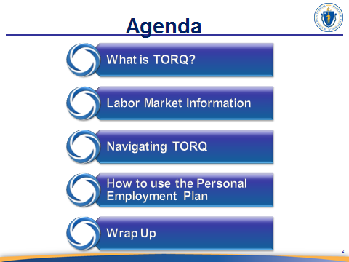
SLIDE 2

NOTES:
Follow the discussion points on the agenda slide. Emphasize the fact that a brief explanation on labor market information is needed to put this tool into the context of being an LMI tool.

In the fourth talking point, mention that they will walk away with a report known as a Personal Employment Plan that will be discussed during the first part of the presentation.

Advance to SLIDE 3

Continued on next page
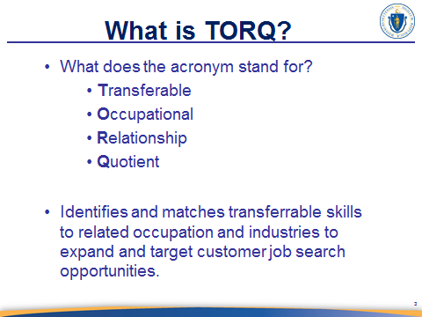
SLIDE 3

NOTES:
Talk about what it TORQ is and what it does. Discuss that the value of this tool is:
- It is a source of LMI information
- The tool applies LMI information to their job search automatically.
- Learn how their skills transfer and relates to other opportunities not previously considered.

SAY:
Most people do not know where to find user-friendly labor market information and TORQ is one valuable resource that job seekers can use to explore their labor market.

The first thing to know about TORQ is that it is not just a simple job search engine. This is a tool that helps to improve your job search by pulling occupational information and compares it to your knowledge, skills, and abilities (KSAs) to find jobs that best fit your work experience. It does this by using labor market information from O*Net. So let’s talk about this and other beneficial features of this tool.

Advance to SLIDE 4
Continued on next page
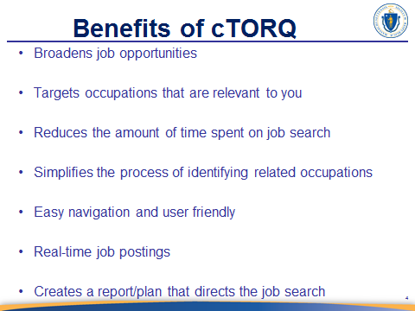
SLIDE 4

Introduce the slide as seen in the ‘SAY’ section and then discuss the bullet
NOTES:
point.
Click to advance through each bulleted talking point.

SAY:
TORQ is much more efficient at applying labor market information (LMI) to your job search and provides information on multiple job types in less time than researching the internet and O*Net on your own. TORQ specializes in identifying your skills, transferrable skills, skill gaps, and opportunities for bridging any skill gaps. We will discuss each of these terms shortly before demonstrating how to navigate the system.

TORQ can be more accurate in analyzing transferrable skills. For instance, one could spend a lot of time comparing a specific set of skills and related job titles; however, there is a risk that a person could misinterpret what is transferrable and what is not. A person may not fully understand what is transferrable or a skills gap. TORQ analyzes this for them and allows for additional skill gap filters, which we will review shortly. But first, what is LMI and how does TORQ use it?
Advance to SLIDE 5
Continued on next page
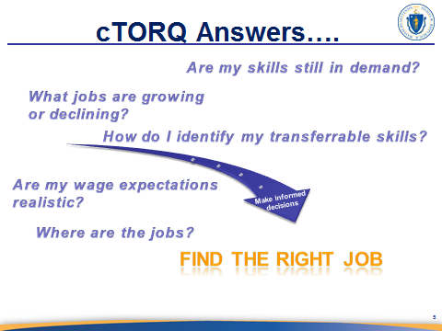
SLIDE 5

The focus of this slide is to help participants understand in simple terms what constitutes labor market information and how TORQ uses it to improve the job search. Point out the fact that the answers to the questions in the slide is labor market information and that TORQ provides these answers.
NOTES:

Be sure to explain how TORQ is an LMI tool.

SAY:
Labor market information helps you to understand the workplace and the dynamics that influence your job search and career choices by taking your skills and interests into account to guide your job search.

So what do we mean by this? Well, every job search needs an action plan and LMI is simply the answers to key questions that guide that action plan. TORQ is an LMI tool because it answers many of these questions that help you to plan the direction of your job search. This is especially true for people who are making a career change or looking to apply their experience to a new market.

So let’s look at some of the basic questions that you can start with and how TORQ helps to answer them.

- TORQ examines your skills and identifies occupations and jobs that utilize those skills. This determines the level of demand for your skills, in a given occupation or industry, and identifies which of these skills you may need to further develop to meet the demands.

- TORQ includes LMI filters, one of which is a wage filter that helps you to explore the availability of related occupations at various wage ranges. This can tell you if your wage expectation is realistic, it will also tell you if you are perhaps undervaluing your experience. This also helps you prepare for interviews so that you can negotiate pay in an informed way.

- TORQ identifies jobs that use your KSA’s that are in demand, the number of jobs that are listed in a geographic area gives you a clear picture of those jobs/industries that are hiring and growing and those that are not.

- Wouldn’t you want to know where the jobs are in relation to where you live? Well TORQ includes zip code, mileage, and keyword (i.e., location) filters that will help you answer this question.

- As discussed earlier, TORQ uses LMI to identify which of your skills easily transfer into other occupations. This helps you consider occupations in which you had not previously thought you could work, thereby helping you expand your job search in a targeted way.

Individually, each of these elements makes TORQ a valuable tool. But when you use these features together you will find that TORQ is a very powerful tool to move your job search forward and find the job that best fits your needs and experience.

Advance to SLIDE 6

Continued on next page

SLIDE 6
NOTES:
Inform participants that you are now going introduce them to some key concepts that they will need to navigate TORQ; after which you will begin a live demonstration of the tool navigation.

SAY:
I just want to briefly introduce some key concepts or terms that you will see and hear a lot as you navigate through this tool.

Advance to SLIDE 7

Continued on next page
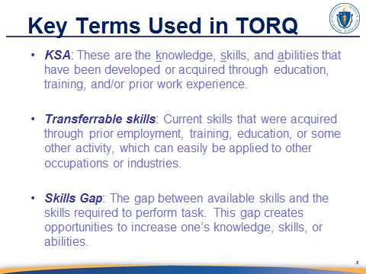
SLIDE 7

NOTES:
Review each bullet and term. Do not assume that participants will know what these terms mean. It is important that they understand these terms prior to navigating TORQ.

SAY:
It is important to know some key terms that you will see as you navigate TORQ as they will help you understand what you are doing when you use this tool. Remember this is more than just looking at a job listing page. [DISCUSS AS SEEN ON SLIDE].

Advance to SLIDE 8

Continued on next page

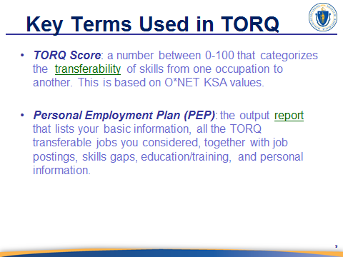
SLIDE 8

NOTES:
Discuss definition of TORQ Score and be sure to check participant understanding of the term transferability as you follow TORQ score portion of dialog below. Ensure that the participant knows what O*Net is and that it is where TORQ pulls the information about each occupation.

Review the PEP definition on slide and then say what is in the PEP dialog below.

SAY:
What do you think is meant by the term transferability? [HOLD FOR ANSWERS AND TRY TO SOLICIT ANSWERS] By looking at the transferability of your KSAs you open up your job search to greater, but targeted, opportunities that you may not have previously considered. This also saves you time and effort, rather than weeding through volumes of job listings that don’t even apply to you just to find the one job that does.

As you enter your information and navigate TORQ you will find that you are actually creating a report that we call a Personal Employment Plan (or PEP) which is designed to (among other things) support a guided discussion between you and career staff that you can use to further navigate your job search. This is really part of your job search action plan.
Continued on next page

So how does it work? Well, basic information about you is entered into the tool such as your name, zip code, education, and current occupation. TORQ uses this information to help identify a ‘Short List’ of similar occupations in demand in the area and for which you are qualified. The focus then changes to the identification of job postings that are of interest to you as well as training programs that you may want to consider before pursuing the jobs included in the ‘Short List’.

Let’s briefly take a look at a sample TORQ Personal Employment Plan just to show you what you will be creating as you navigate through this tool.
Advance to SLIDE 9

Continued on next page

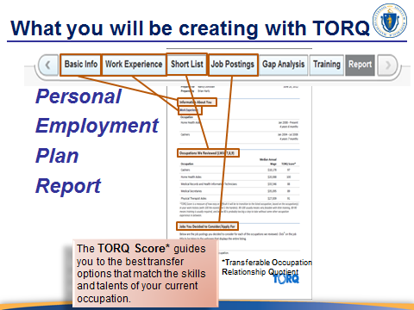
SLIDE 9

NOTES:
This is a slide that contains animated transitions. Be sure to practice the animation sequence with your clicker or mouse prior to delivering this workshop.

Explain the correlation between the navigation tabs on TORQ and the section headers in the Personal Employment Plan.

SAY:
So let’s look at what your entered information will look like as a final product and what you are creating as you navigate through TORQ. This is what a sample section of your final product will look like after you finish entering all of your information and complete your TORQ navigation. You can see that the report is divided into sections. Each of these sections mirror each of the navigation tabs as seen here .

Stay on SLIDE 9

Continued on next page
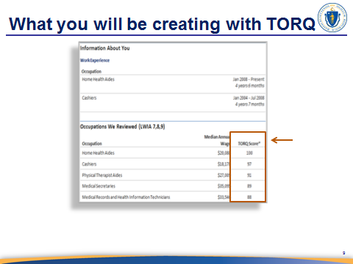
SLIDE 9

NOTES:
This is a slide that contains animated transitions. Be sure to practice the animation sequence with your clicker or mouse prior to delivering this workshop.

SAY:
You will also notice the TORQ score that we mentioned earlier and how each listed occupation has an assigned score indicating the compatibility between this person’s skills and the listed occupations of interest .

Stay on SLIDE 9

Continued on next page
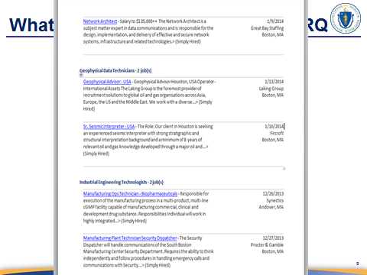
SLIDE 9

NOTES:
This is a slide that contains animated transitions. Be sure to practice the animation sequence with your clicker or mouse prior to delivering this workshop.

SAY:
As you navigate TORQ you find yourself on the job posting page that will be based on the information that you entered. As you identify the job listings that match your skills you can save them so that they will show up on your Personal Employment Plan as seen here. The great thing about this function is that it also saves the link to the actual job listing so that all you have to do is click on the link (as seen in blue) and it will take you to the online job listing. We will show you how that works later on in this presentation.

And remember these job listings are based on the match between your skill set and those needed for a given job. This relies on the TORQ score that was assigned to the occupation in which a job posting is associated (we will discuss this shortly). So let’s review how to interpret TORQ scores so that you understand how your skills relate to other occupations.

Advance to SLIDE 10

Continued on next page
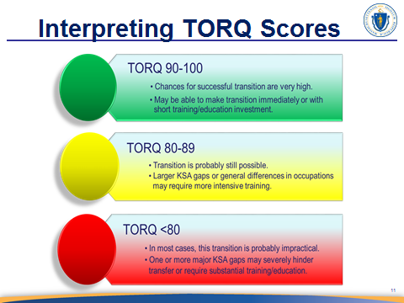
SLIDE 10

This is a slide that contains animated transitions. Be sure to practice the
NOTES:
animation sequence with your clicker or mouse prior to delivering this
workshop.

SAY:
TORQ Score is a measure of how easy or difficult it will be to transition to the occupation in which you are interested, based on the occupation(s) in your work history (with 100 being the easiest and 1 being the hardest). Scores of 90-100 usually mean feasible transition that requires little to no training; while scores between 80 – 90 means training is usually required, and below 80 is probably too big a step to take without some other occupation experience or significant training in between. We will discuss how to use these scores more during the live demonstration of the tool, which we will do next.

Advance to SLIDE 11

Continued on next page


SLIDE 11

NOTES:
This is the point at which you will begin showing the class how to navigate cTORQ. Explain the format that you will use (i.e., you navigate while they watch, then they will start the hands-on portion and navigate the tool with your instruction and guidance.

After entering the basic information (profile building), when presenting a live TORQ demonstration, briefly return to PowerPoint slide number 11 before navigating through the live Shortlist screen. Doing this will help break down the screen into different sections. This will help participants to understand how they will use the information on the screen.

SAY:
So let’s actually take a look at how to use this tool. In this section I will demonstrate how the tool works, after which you will have an opportunity to enter your own information and create a Personal Employment Plan. Every Screen has a help video as you move to each screen at home take time to view each video.

Advance to TORQ website www.torqworks.com

Continued on next page

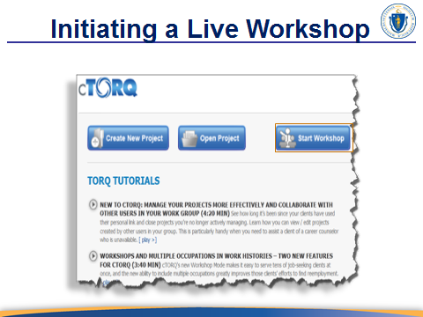
SET UP A WORKSHOP

NOTES:
Complete this screen prior to beginning the workshop so that participants do not become confused thinking that this is a screen that they must complete.

Advance Selecting a Labor Market Area screen

Continued on next page

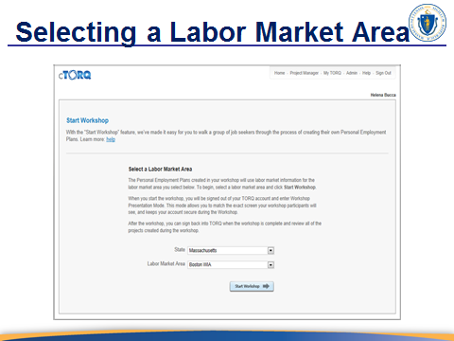
SELECT LABOR MARKET AREA

This slide includes a screenshot of the live screen that you will be presenting. This is only for the purpose of ensuring that the sequence of this facilitator’s guide mirrors the sequence that you will present during your training session. In this example we have already filled out the information, but you can navigate the live tool entering your own sample information as you choose.
NOTES:

Complete this screen prior to beginning the workshop so that participants do not become confused thinking that this is a screen that they must complete.

Advance to Create a New Project screen

Continued on next page

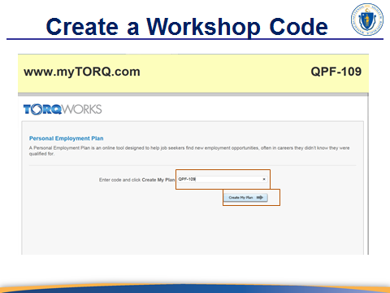
CREATE A WORKSHOP CODE

You will need to walk your customers through the process of entering the
NOTES:
code for the Workshop. Have customers enter the following URL to get
started with the workshop: www.mytorq.com.

SAY:
This workshop code will allow the TORQ facilitator to set up a Personal Link to
Your e-mail entered on the next screen. Now enter the 6 digit code exactly as seen on the upper right corner.

Advance to Entering Your Information screen

Continued on next page

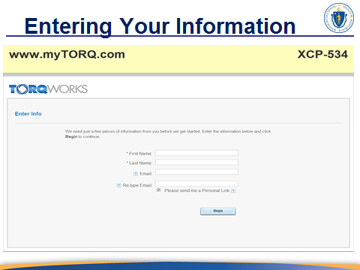
ENTERING YOUR INFORMATION

Explain to the participants the importance of using their primary e-mail
NOTES:
To ensure that they recall their e-mail login. As a prerequisite it is best for the participant to have access to an e-mail.

SAY:
On this screen you will need to input all your personal information
including your e-mail. TORQ will send a Personal link to the e-mail address
entered on this page.

Advance to Personal Link screen

Continued on next page

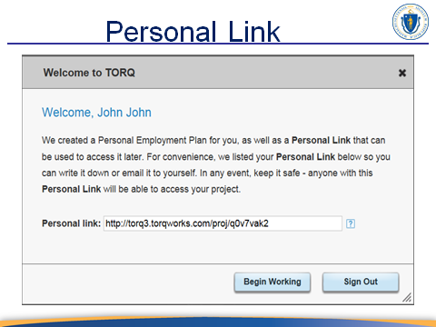
PERSONAL LINK

NOTES:
This is a slide that contains the personal link the customer will access
using the information entered in the e-mail address.

You are now sending this personal link to the email account that you entered earlier. Make sure to check your spam folder just if you cannot find the email that contains your link. Once you find it, simply click on it to access your project. This link is active indefinitely so you don’t have to worry about losing your project.
SAY:

Advance to Creating a Project screen

Continued on next page

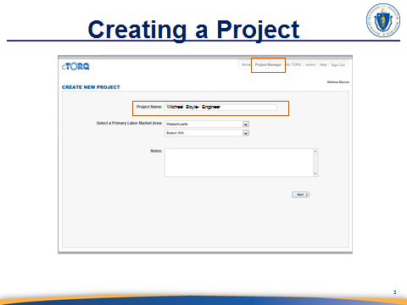
CREATE A NEW PROJECT

This is a screenshot of the live screen that you will be presenting. This is only for the purpose of ensuring that the sequence of this facilitator’s guide mirrors the sequence that you will present during your training session. In this example we have already filled out the information, but you can navigate the live tool entering your own sample information as you choose.
NOTES:

SAY:
To create your project you will need to name your project. It is best give it a name that makes it easy for you and your career center staff to recognize who it belongs to and the occupation that this project is focused on. In this sample case Michael Boyle wants to find occupations that use many of the skills that he acquired in his current occupation as an engineer. [REPLACE THIS SAMPLE INFORMATION WITH YOUR OWN SAMPLE IF YOU PRESENT A DIFFERENT CASE TO YOUR CLASS]

Advance to Basic Information screen

Continued on next page

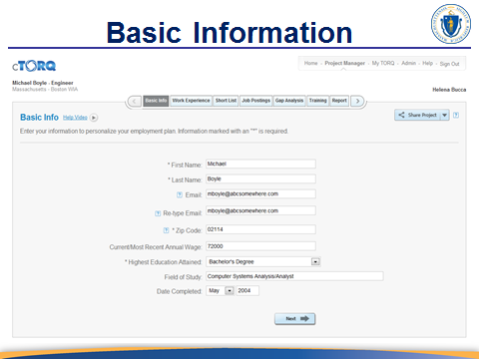
BASIC INFORMATION

Note that when selecting college level education from the drop down on this screen the field of study line item will pop-up. This is a new feature in TORQ that will facilitate more accurate information in one’s profile.
NOTES:

SAY:
We will begin creating a Personal Employment Plan. As we demonstrated on the sample Personal Employment Planner (PEP), your PEP will contain your personal information. Once we have completed today’s project you will be able to review, e-mail, or print a copy of your Personal Employment Plan (PEP). So to begin click on the Basic Tab.

You will need to enter all of your information on this screen. Enter the e-mail address where you would like to have the final Personnel Employment Plan delivered. This should be an e-mail address that you use regularly.
Enter the Zip Code of your primary address. It is used to find occupation information based on this zip code. Also enter your current or most recent annual wage (This can be adjusted while building your profile as needed).

Using the drop down arrow choose the education level attained. All of your information entered on the ‘Basic Tab’ will show up on the beginning of the report as demonstrated earlier on the sample PEP.
TORQ does not store, share, use, or distribute any personally identifiable information in any way. See the TORQworks privacy policy on the home page.

Advance to Work Experience screen

Continued on next page
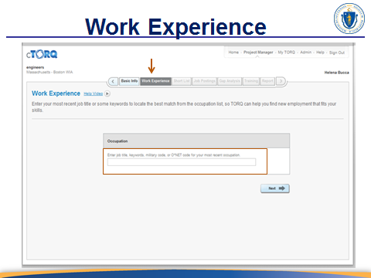
WORK EXPERIENCE

NOTES:
Explain that this is the screen where they will build their profile. Their profile is a list of occupation titles that best match their prior job titles.

Emphasize the fact that they can enter their last job title to see what shows up in the drop down list, but the best approach is to have a resume, prior job description, or a list of skills and tasks that they routinely used and were responsible for while performing a prior job. This is important because the strength of this tool is its ability to compare one’s skills with the skills needed to perform in a different occupation. This tool will only be as accurate as the information that is entered on this screen. The more they build their profile the more occupation alternatives they will find and the more accurate they will be.
SAY:
The Personal Employment Planner (that you are creating) will suggest the list of alternative occupations for you to consider based on the work experience you enter on this page. You can input your work experience by entering your previous occupation titles.

Stay on Work Experience screen
Continued on next page

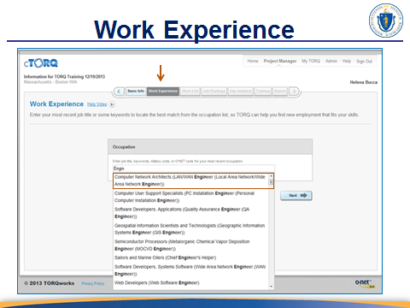
WORK EXPERIENCE

NOTES:
Start your participants on this screen. Discuss layering your work experience to help build your profile. Explain to the participants that they may need to view keyword to help build their project. Their job title may not include all their responsibilities entering information supplied on their resume may help them layer their work experience.

SAY:
Begin typing in the title that best describes your current or most recent occupation. Identify the most relevant choice from the filtered list by highlighting the occupation and click the mouse to select.

Stay on Work Experience screen

Continued on next page
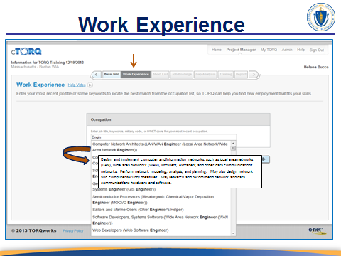
WORK EXPERIENCE

NOTES:
Be sure to demonstrate the drop down list to find a relevant occupation title. Also demonstrate how one can hover over an occupation title in order to trigger a pop-up description of the skills and knowledge needed for that occupation.

SAY:
If you hover over any of the suggested titles you will see a longer description pop up on the screen. Select the occupation title that is the best match for you. Note that you can follow this step to add multiple titles to your occupation list, thus building a more accurate profile.

However, if your job title does not appear in the drop down selection (that appears after typing something in the occupation field), then use key words such as skills and tasks that you used in your last job.

Stay on Work Experience screen

Continued on next page

SAY:
Remember, that what you did in our last job may be title something else in a different industry or company. It would be useful if you use a resume or previous job description from which to pull key terms. You may find that skills and knowledge that you used in a previous job under a different job title (even one with which you are completely unfamiliar). This is okay, just select it to build your profile. This is a ‘layering’ technique that can be used when your previous job title is not included in the drop down list. This allows you to focus on the skills, knowledge, and abilities that you have used in the past. This will help the TORQ system to identify a list of other job titles that use the same skills, knowledge, and ability sets.

Stay on Work Experience screen

Continued on next page

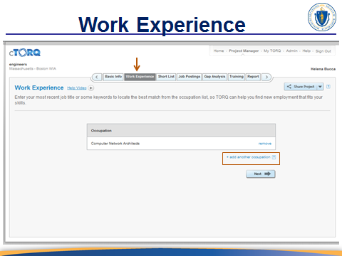
WORK EXPERIENCE

NOTES:
Add a couple of more prior work experience samples so as to demonstrate how a profile is built.

SAY:
To add more work experience click on the +add another occupation button then follow the same process that we just completed. This is the process of building your profile.

Stay on Work Experience screen

Continued on next page
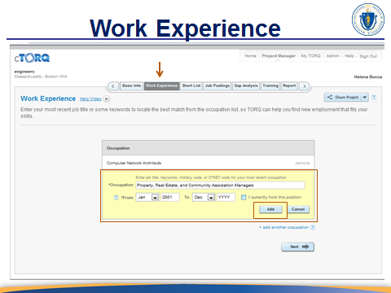
WORK EXPERIENCE

NOTES:
Explain how this process will provide what will look like a beginning of a resume in their PEP report.

SAY:
When you add another work experience, you can identify the years you have held this position. TORQ will evaluate the time for which you have performed each job, how long ago you performed the job, and take into account the current standards required to perform the job. This way TORQ can also identify the KSAs that may have depreciated over time. This evaluation will allow TORQ to determine if there are any gaps during the time periods covered since performing the jobs listed in your occupation list.

Stay on Work Experience screen

Continued on next page
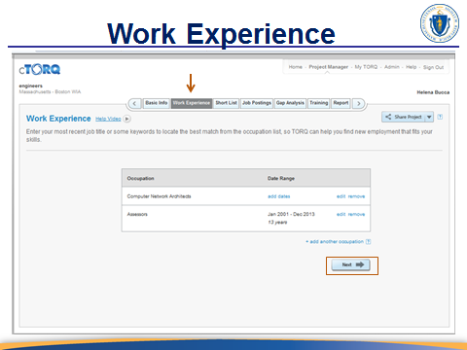
WORK EXPERIENCE

NOTES:
Start your participants on this screen.

SAY:
As you build your profile you will notice that is starts to look like a basic resume. When you are finished building your profile just click on the next button seen at the bottom right of your screen. If you remember a work experience that you want to add to your profile, don’t worry you can always come back to this screen and add it by clicking on the Work Experience tab at the top of the page.

Advance to Slide 12

Continued on next page
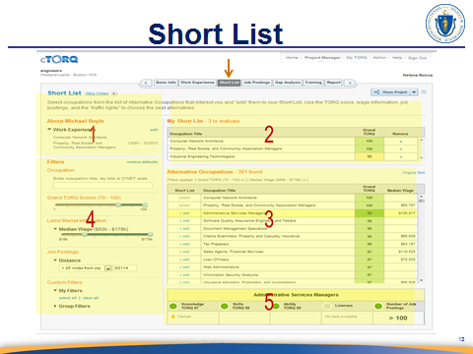
SLIDE 12

NOTES:
This slide should be used to visually categorize the different information sections on this screen. This is one of the two most detailed screens to understand, so be sure to take extra time to explain it by section.

SAY:
So before we work with Shortlist screen lets take a look how it is set up. First, you will notice that section consists of the basic information that you just entered in the prior screen. This is where you started to develop your profile. Section two contains the occupation titles that you entered as part of this profile. This is also what we like to call your shopping cart because your next move is to pull occupation titles of interest to you from section three into your shopping cart. We will demonstrate this in a moment. Section three is a list of alternate occupations that use many of the skills that were identified with your prior occupations. This is where the transferability of skills we discussed earlier comes into play. TORQ compares the skills that you used in your prior occupations to the skills needed for various occupation and then lists alternate occupation titles that match these skills.

Section four contains your filters of particular interest are the wage filter, distance filter, and TORQ score filter as these are what we call the LMI filters. Section five provides a brief overview of skill matches and gaps associated with an occupation that you click on from your shortlist. Does everyone understand how these sections are broken down?

[ONCE EVERYONE UNDERSTANDS] Now let’s go to the live version of this page and see how you use it.

Advance to live Shortlist Screen

Continued on next page
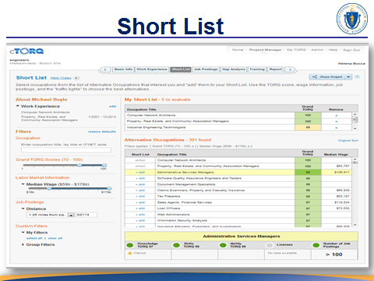
SHORT LIST

NOTES:
Be sure to demonstrate how to use each section in the sequence that you discussed in the Short List slide. A good analogy to use is to refer to the ‘Alternate Occupation’ section as the shopping aisle at a grocery store, each alternate occupation is a grocery item, and the ‘My Short List’ section is their shopping cart into which the alternate occupation is added when they select add.

Demonstrate the filters on the side. Although the Median wage filter is designated as the Labor Market Information, the other filters are also considered to be sources of Labor Market Information.

Utilize the talking points for this section then personalize your talking points once you become familiar with the main points of this screen.

SAY:
Your task on this page is to select a few alternative occupations that are your best opportunity for future employment. Select the occupations that may be a good fit and add them to your “Short List” for further review in the next steps of your personal employment plan. This page is designed to make easy decisions and to quickly determine and discard those alternatives that are not a good fit. It also list occupations that you may not have considered, or perhaps those you never would have thought about. (but your skills may be an equal match)
The screen consists of five sections:

Section 1 [BE SURE TO CLICK ON THE DROP DOWN ARROW NEXT TO EDUCATION AND WORK EXPERIENCE] In the upper left is the Work Experience section and simply restates the information you entered on earlier pages.

Section 2 includes the Short List, which you can think of as your shopping cart, that you need to fill with alternative occupations from the third section on this page, which is just below this section.

Section 3 displays a long list of pre-filtered and pre-sorted alternative occupations that are based on the KSAs that are associated with job titles that you entered into your profile. Think of this as your grocery aisle. Hovering over any of the titles will display a short description.

Section 4, found on the left side, contains data filters that allow you to manipulate the long list of alternative occupations (that you plan to add to the Short List).

Section 5 is a brief summary of skill gaps that are identified when you click on an ‘alternative occupation’ title; this is illustrated by the ‘signal light’ indicator. This serves as a quick ‘Go / No-Go’ review tool, for each of the occupations in the Short List. In other words, this takes that alternative job title and compares it’s associated KSAs with the Short List job title selected to identify some skills gaps in order to determine if you want to add that job to your Short List. By reviewing the alternative occupations displayed you will notice that they have already included your current occupation in the short list, as in most circumstances, the best choice for employment is your current area of expertise and experience. We wanted to make it as easy as possible to review the opportunities that exist for you. The long list of alternative occupations is pre-filtered and pre-sorted by something we call the "Grand TORQ Score."
The ‘Grand TORQ Score’ describes how easy or difficult it will be to make the transition from one occupation to another based on the knowledge, skills and abilities required by those occupations. Remember, as I said before, the ‘Grand TORQ Score’ is a number, from 1 to 100. The higher the number the greater the skills match between the two occupations. The current occupation at the top of the list has a Grand TORQ score of 100 because it is a direct match the one that you selected.

As a rule, a Grand TORQ Score between 90 and 100 should be a relatively easy transition to make as far as knowledge, skills and abilities requirements are concerned. They are color-coded green in this list. If the Grand TORQ score is between 80 and 89, it will be a tougher transition, but still “possible”, depending on where those skills gaps are. So Grand TORQ scores between 80 and 89 are colored coded yellow. If the Grand TORQ score is below 80 and color coded red, given the skills requirements the transition will likely be less feasible. So if that occupation is indeed your goal, you should consider a different occupation that will serve as an interim role for you while working towards attaining that final goal.

Navigating the filters:
The long list of alternative occupations is pre-sorted by Grand TORQ score, pre-filtered to include those TORQ scores between 80 and 100, and pre-filtered by median wage to those TORQ scores between 80 and 100, and include median wages above and below the median wage of your current occupation. You can always tell which filters are applied to the long list by looking at these filter settings. Manipulating the sliders on the left will adjust those filters.

Skill Gap Overview (Signal Light Section): There are 5 signals to review. KSA’s, licenses, and jobs. The easiest way to use this page is to select an alternative occupation and look at the five ‘signal lights,’ each of which assists you to make a quick Go/No-Go decision to include or not include the occupation in your short list. The first three are TORQ scores, in specific areas of knowledge, skills and abilities. Each of those categories includes tens of individual elements that are considered, and if any of those elements are particularly challenging, they will be noted below the category TORQ score. In this example of [SELECT OCCUPATION TO REVIEW] the knowledge TORQ score is [REFER TO TORQ SCORE ASSOCIATED WITH SELECTED OCCUPATION.] largely because of a severe gap in [IDENTIFY THE RELEVENT GAP] in one of the KSA’s. If you consider yourself to have adequate qualifications in this area, based on previous jobs or hobbies, then you can dismiss the warning. The point here is to give you enough information, without having to wade through pools of data or answer long questionnaires to make a decision.

The fourth signal light, Licenses, will indicate if your state has any licensing requirements to perform that occupation.

The fifth signal is, whether or not there are any current job postings, for this occupation within a certain mileage from your zip code. This will obviously play a key role in your decision to include that occupation in your short list. If there are no jobs available in the region, then it does not make sense to add it to your short list unless you are willing to travel to a location where there are jobs available in that occupation. This feature does a real-time review of job posts, and shows you how many are currently available.

You can adjust the filters for distance by selecting a different zone from the dropdown list. So by filtering and sorting the list of alternative occupations and then reviewing the signal light indicator for a quick Go/No-Go decision you can easily review alternatives.

And for those you wish to add to your short list simply click on ‘add’. If there is a particular occupation of interest you can type a descriptive word for it in the occupation search box to filter down the list. For example, if you are interested in becoming an Occupational Therapist, type in Occupational Therapist then remove any TORQ score filters by clicking on the ‘x’ (as seen below the Alternative Occupations header) and remove the median wage filter as well.

You will quickly discover that the transition from Computer Network Architects to Occupational Therapist is quite daunting [DEMONSTRATE SKILLS GAP OVERVIEW TO ILLUSTRATE THIS COMPARISON]. Once you’ve gone through what you consider to be an adequate review of the alternatives, and you have a few occupations in your short list, click on the Job Postings tab in the navigation menu to move to the next step of your Personal Employment.

Advance to Job Posting screens

Continued on next page

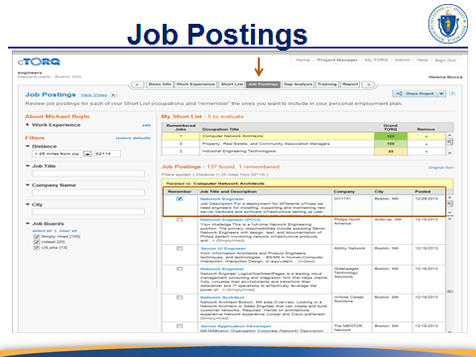
JOB POSTINGS

NOTES:
Demonstrate each section on this screen taking note that the filters on this screen are not the same filters as the previous screen.

SAY:
First, you will notice we have combined postings from several different sources on the internet (i.e., Simply Hired, Indeed, and US Jobs) which saves you hours of extra work trying to accomplish job post searches. Second, you can quickly scan the title, short description, hiring or posting company, and the most recent date to confirm that the job was still available. This is usually enough information to determine if you are interested in applying.

If so, just click on the Remember box next to the job title. When you do that you will notice that the job posting jumps to the top of the overall list and, at the same time, the Remembered Jobs counter, shown in the short list, increases by one, much like a shopping cart found on many websites. If you need more information in order to decide if this posting is of adequate interest, click on the job title and the actual posting will appear.

Remember, the focus here is whether or not you want to apply. So if yes, click on the remember box and then the ‘x’ to close the window. You will be given an opportunity to come back and actually apply for all of these remembered jobs at the end of the process. It’s much more effective to pull your full list together before you take the time to actually apply for individual jobs. You can then scroll down the list of job postings and decide which ones you want to remember. All of your remembered posts will be stored for later retrieval in the Report tab which displays your PEP. [REITERATE DON’T FOCUS ON APPLY HERE.]

On the left side of the screen you will notice additional filters available to make searches of particularly long lists of job postings more effective. If you want to filter down by keywords within job titles, type it in the Job Title filter. If you are interested to see postings from only one particular company, or in one particular city, type that in the respective filter box. Be sure to review postings for each of the occupations you selected in the short list by clicking on that occupation title and waiting for the system to return the results. After you have reviewed the job postings for all of the occupations in your short list, and you have remembered several job postings, click on Gap Analysis in the navigation menu, for the next step in your Personal Employment Planner.

Advance to Gap Analysis screen

Continued on next page

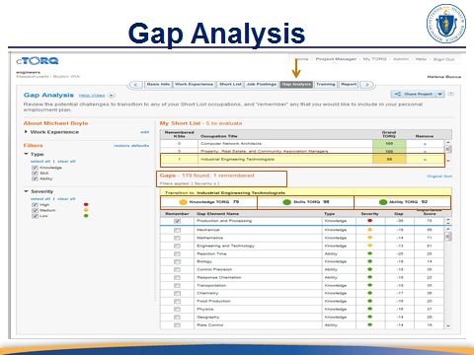
GAP ANALYSIS

NOTES:
This is the second of the two most detailed screens to understand, so be sure to take extra time to explain it by section.

SAY:
The primary task on the Gap Analysis page is to review any significant gaps in knowledge, skills, or abilities when moving from your current or most recent occupation to any of the occupations in your short list and to remember those gaps you consider important to document for your Personal Employment Plan. A gap analysis is a valuable tool because it allows you to identify what improvements you will need to make in order to advance into a the chosen occupation. Performing a gap analysis gives you an edge in assessing your professional development needs to reach your goal. A successfully performed gap analysis will give you a clear path for professional improvement.

Stay on Gap Analysis screen

Continued on next page

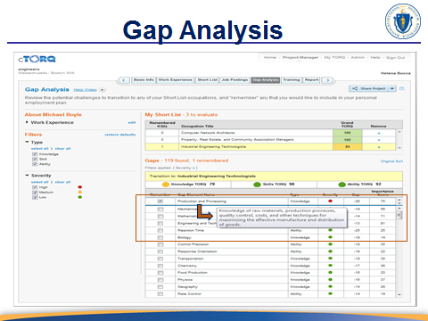
Gap Analysis

NOTES:
Continue to explain clearly each section of this screen.

SAY:
Next, review the three categories of TORQ scores to see where the gaps are. In this case a Knowledge score of [FILL HERE AS SEEN ON SCREEN] , a Skills score of [FILL HERE AS SEEN ON SCREEN], and an Ability score of [FILL HERE AS SEEN ON SCREEN]. (You will recall that any TORQ score of 90 or above coded in green, should represent few challenges in making the transition. While scores between 80 and 89, coded in yellow, might be more problematic.) It’s important to recognize that knowledge and skills gaps are often bridged through training and education). Ability gaps are not really trainable as they usually reflect a physical capability. Low ability TORQ scores require particular focus, to ensure that they can be bridged. The list maps all of the elements the O*NET system considers when assessing an occupation’s knowledge, skills and abilities requirements. Like any description screen, hover over any element title, and a short description will appear. The list is initially sorted by the severity of the gap, (coded red for high, yellow for medium, and green for low.) The higher the severity, the bigger the challenge there is in overcoming the gap. The severity is determined by how big the actual skill gap is, according to O*NET, and how important that particular skill element is to this particular occupation.

Advance to Training screen

Continued on next page

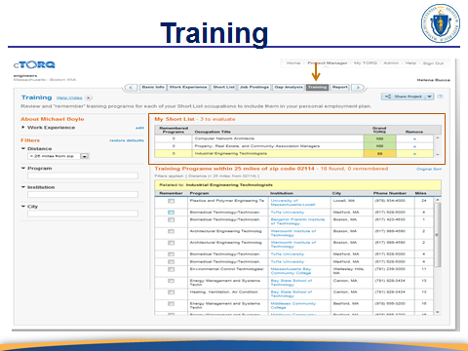
TRAINING

NOTES:
Be sure to point out that the training list presented on this screen is based on the training needs identified during the gap analysis and is shown as it relates to the occupation that is currently highlighted in the short list. When a different short list occupation is highlighted the list of training institutions and associated training programs will change accordingly.

SAY:
The main task on the Training Page of the Personal Employment Planner is to review the training programs available in your area for the occupations in your short list. If you are interested in attending any of them, you can ‘remember’ (or save) them in your plan, and refer to them in your final report.

First, select the occupation in the short list for which you want to review training programs. The system will display those programs within the distance filter set on the left. You can set different distance filters by selecting a different zone in the dropdown listing. This relates back to the Labor Market discussed earlier in this presentation.

Stay on Training screen

Continued on next page
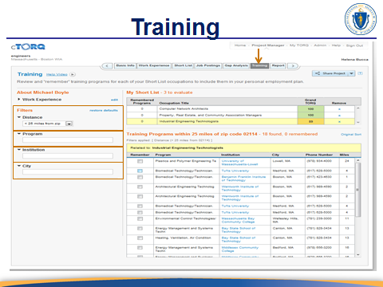
TRAINING

NOTES:
Demonstrate the use of the filters to meet the training search criteria that a job seeker may have.

SAY:
The system will display those programs within the distance filter set on the left. You can set different distance filters by selecting a different zone in the dropdown listing. This relates back to the Labor Market discussed earlier in this presentation.

Stay on Training screen

Continued on next page
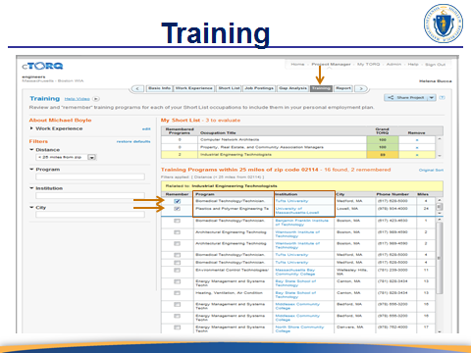
TRAINING

NOTES:
Demonstrate how to save a training program of interest by clicking on ‘remember’ and click on the training institution to demonstrate that it is hyperlinked to that institution’s website.

SAY:
Locate a program you are interested in and check off the remember box.
If you’d like more information on any particular institute, then click on the institution title and it will take you to that school’s or that program’s web page where you will see more detailed information. If you are interested to apply for a program click on the remember box and then click on ‘x’ to close it. You can repeat this process for each occupation in your short list. In the next step of your Personal Employment Planner, you will be able to review a report with all of your remembered training programs included. To go to that next step, click on Report in the navigation menu.

Advance to Personal Employment Plan screen

Continued on next page
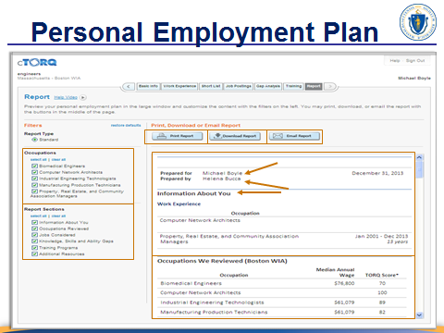
PERSONAL EMPLOYMENT PLAN

NOTES:
Demonstrate how to download and/or share (via email) the report, how the different sections can be shown or hidden based on a person’s preference, and walk the class through the different sections of the report.

Be sure to demonstrate that all of the items that they entered and/or saved is on this report including the job postings that an individual is interested in looking at or applying for. It is important to show them how these postings are hyperlinked to the actual job announcement in the internet.

Stay on Personal Employment Plan screen

Continued on next page
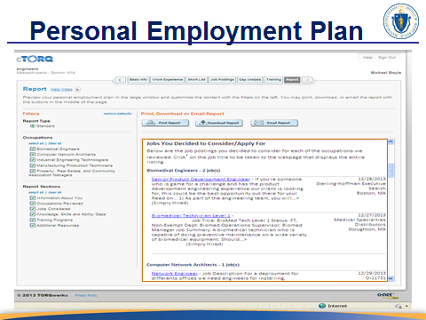
PERSONAL EMPLOYMENT PLAN

NOTES:
Scroll down to the Jobs You Decided to Consider/Apply For. Discuss this section and point out that the jobs that they saved or ‘remembered’ will show up here.

Stay on Personal Employment Plan screen

Continued on next page
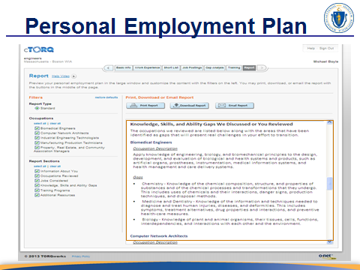
PERSONAL EMPLOYMENT PLAN

NOTES:
Review Knowledge, Skills, and Ability Gaps We Discussed or You Reviewed section of the PEP with the participants.

Stay on Personal Employment Plan screen

Continued on next page
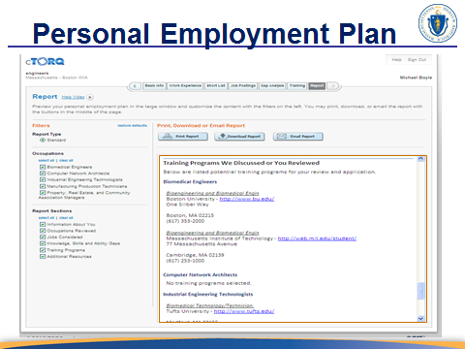
PERSONAL EMPLOYMENT PLAN

NOTES:
Demonstrate the hyperlinks see on the PEP report.

Advance to SLIDE 13

Continued on next page


SLIDE 13

NOTES:
If the context allows try to initiate a conversation with the participants about what they think their next steps should be.

SAY:
So now that you created a Personal Employment Plan with cTORQ, do you know what to do with it? What do you think your next step should be?

Advance to SLIDE 14

Continued on next page
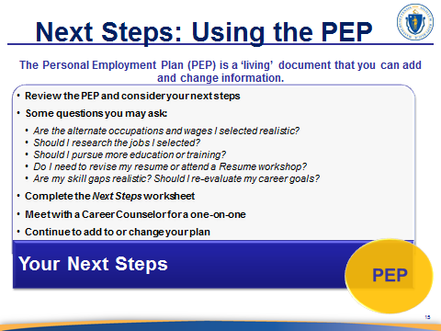
SLIDE 14

NOTES:
Start with the dialog below and then discuss the bullets on the slide.

Note that the last bullet should be explained to the participants. This is important because they will not be able to add to, change their plan or profiles on their own; rather this will require that a staff member to initiate a new project under their name.

SAY:
Start exploring jobs that match your skills based on the information you gathered during the Labor Market phase of your job search process. This helps you to broaden your opportunities and look for jobs in related/alternative occupations or industries. As you use your PEP for this process you will want to think about how this helps with the next steps in your job search. As mentioned in the beginning of today’s class, this should involve developing a job search/career transition action plan.

Let’s take a look at some possible next steps.

Advance to SLIDE 15

Continued on next page
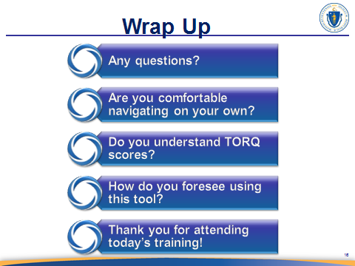
SLIDE 15

NOTES:
When asking participants if they are comfortable with navigating on their own, be sure to ask specific questions about the Shortlist and Gap Analysis screens, and then follow up by asking how they plan to use their PEP.

Follow the items on the screen to encourage discussion.

Be sure that each participant is able to print their PEP prior to leaving.

Add talking points as needed.
SAY:

End of presentation

