INDOOR AIR QUALITY ASSESSMENT

Annex Building
272 Main Street
Townsend, Massachusetts

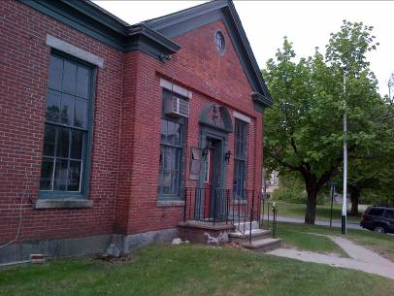

Prepared by:
Massachusetts Department of Public Health
Bureau of Environmental Health
Indoor Air Quality Program
June 2015

Background/Introduction
At the request of Mark Mercurio, Facility Manager, Town of Townsend, the Massachusetts Department of Public Health (MDPH), Bureau of Environmental Health (BEH) provided assistance and consultation regarding conditions of an unoccupied building at 272 Main Street, Townsend, MA. The space is proposed to serve as a youth activity center and for storage of town records. The request was prompted by concerns of possible water damage/mold growth in the building.
On May 15, 2015, Michael Feeney, Director of BEH’s Indoor Air Quality (IAQ) Program visited the Annex to assess possible mold growth and water penetration into the building. The building is a one-story brick structure with attic constructed as a bank in the early 1900’s. The interior walls mostly consist of plaster. The building was vacant at the time of the assessment.

Methods
Mold evaluation included visual observations of the building interior and exterior. Moisture content of selected porous building materials was measured with a Tramex Encounter Plus, Non-Destructive Moisture Meter.

Results/Discussion
The building was evaluated on a hot clear day, with an outdoor temperature of 68˚F and relative humidity of 28 percent. In an effort to ascertain moisture content of selected wall materials, moisture content was measured with a Tramex Moisture Detector. All areas had normal moisture content. However, signs of moisture penetration were present throughout the basement in multiple areas, namely:
- Musty/mold-like odors in carpeted areas of the building, particularly inside of the bank vaults (Picture 1).
- Water-damaged interlocking ceiling tiles (Picture 2).
- Peeling paint and efflorescence were observed on all plaster walls (Picture 3).
Water penetration through a variety of openings in the building envelope is the likely source for moisture. BEH staff examined the exterior of the building to identify conditions in or around the building that could provide sources of water penetration. Numerous potential sources were identified:
- Cracked, missing mortar was observed.
- Efflorescence was observed on exterior masonry (Picture 4), which is indicative of chronically moistened materials but is not mold.
- Crawlspace vents were clogged with leaves (Picture 5) which can prevent the venting moisture from beneath the building.
- Window frames are deteriorated; some have holes.
- Part of the roof system at the rear of the building lacks gutter/ downspouts (Picture 6) which allows water to be deposited directly onto the exterior wall.
- A night deposit box exists in the exterior wall of the building (Picture 7). This opening can allow for hot, moist air to enter the interior of the building.
The aforementioned conditions represent a variety of water penetration sources. Over time, these conditions can undermine the integrity of the building envelope and provide a means of water entry into the building via capillary action through concrete and masonry (Lstiburek & Brennan, 2001). In addition, these breaches may provide a means for pests/rodents to enter the building.
The US Environmental Protection Agency (US EPA) and the American Conference of Governmental Industrial Hygienists (ACGIH) recommend that porous materials be dried with fans and heating within 24 to 48 hours of becoming wet (US EPA, 2001; ACGIH, 1989). If not dried within this time frame, mold growth may occur. Once mold has colonized porous materials, they are difficult to clean and should be removed/discarded.

Other Conditions
Other conditions that can affect indoor air quality were observed during the assessment.
Damaged or missing floor and ceiling tiles were observed in some areas. These floor and ceiling tiles may contain asbestos. Intact asbestos-containing materials do not pose a health hazard. If damaged, asbestos-containing materials can be rendered friable and become aerosolized. Friable asbestos is a chronic (long-term) health hazard, but it is not generally associated with acute (short-term) health effects (e.g., headaches). These types of symptoms are more typically associated with buildings believed to have suboptimal ventilation or more general indoor air quality problems. If asbestos-containing materials are found damaged, these materials should be removed or remediated in a manner consistent with Massachusetts asbestos remediation laws (MDLI, 1993).

Conclusions/Recommendations
The conditions within the annex will require remediation. Once the mold colonized/water-damaged materials are removed and the integrity of the building envelope is re-established, water penetration with the potential to cause microbial growth should be reduced/eliminated. In view of the findings at the time of the assessment, the following recommendations are made:
- Ensure all water-damaged porous materials (e.g., carpet) are removed from the building and all mold-colonized nonporous surfaces are cleaned in accordance with EPA Guidance for Mold Remediation in Schools and Commercial Buildings (US EPA, 2001).
- Repair water-damaged plaster.
- Replace damaged exterior wall surfaces.
- If damaged ceiling or floor tiles contain asbestos, remediate in conformance with state and federal asbestos remediation and hazardous waste disposal laws.
- Design and provide gutter/downspout system that deposits rainwater as far as practicable from the foundation.
- Refer to resource manual and other related indoor air quality documents located on the MDPH’s website for further building-wide evaluations and advice on maintaining public buildings. These documents are available at: http://mass.gov/dph/iaq.

References
ACGIH. 1989. Guidelines for the Assessment of Bioaerosols in the Indoor Environment. American Conference of Governmental Industrial Hygienists, Cincinnati, OH.
Lstiburek, J. & Brennan, T. 2001. Read This Before You Design, Build or Renovate. Building Science Corporation, Westford, MA. U.S. Department of Housing and Urban Development, Region I, Boston, MA
MDLI. 1993. Regulation of the Removal, Containment or Encapsulation of Asbestos, Appendix 2. 453 CMR 6,92(I)(i).
US EPA. 2001. “Mold Remediation in Schools and Commercial Buildings”. Office of Air and Radiation, Indoor Environments Division, Washington, DC. EPA 402-K-01-001. March 2001. Available at: http://www.epa.gov/mold/mold_remediation.html.
Picture 1
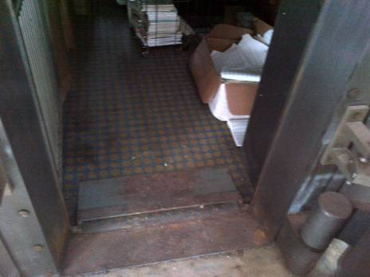
Carpeting inside bank vault
Picture 2
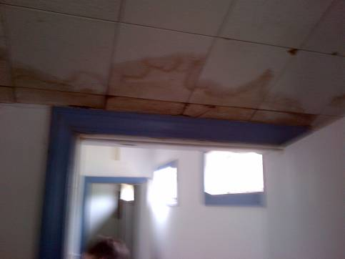
Water-damaged interlocking ceiling tiles
Picture 3
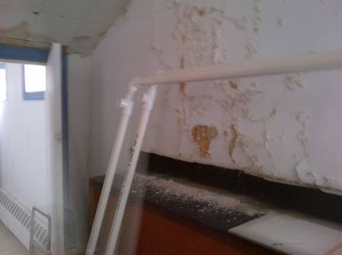
Peeling paint, plaster walls with efflorescence
Picture 4
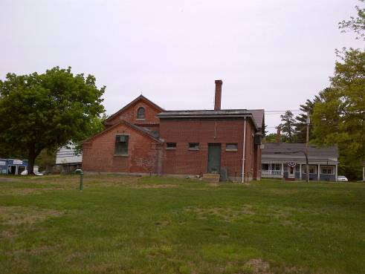
Efflorescence was observed on exterior masonry
Picture 5
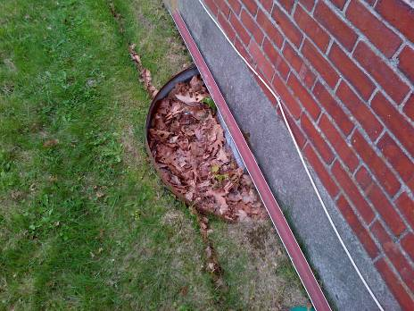
Crawlspace vent clogged with leaves
Picture 6
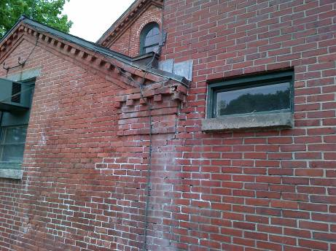
Part of the roof system at the rear of the building lacks gutter/ downspouts
Picture 7
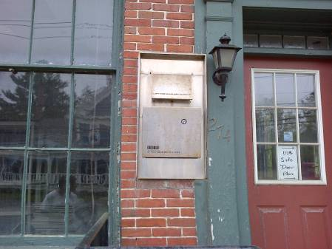
Night deposit box

Efflorescence is a characteristic sign of water damage to building materials, but it is not mold growth. As moisture penetrates and works its way through building materials, water-soluble compounds dissolve, creating a solution. As this solution moves to the surface, the water evaporates, leaving behind white, powdery mineral deposits.

