INDOOR AIR QUALITY REASSESSMENT

Annex Building
272 Main Street
Townsend, Massachusetts

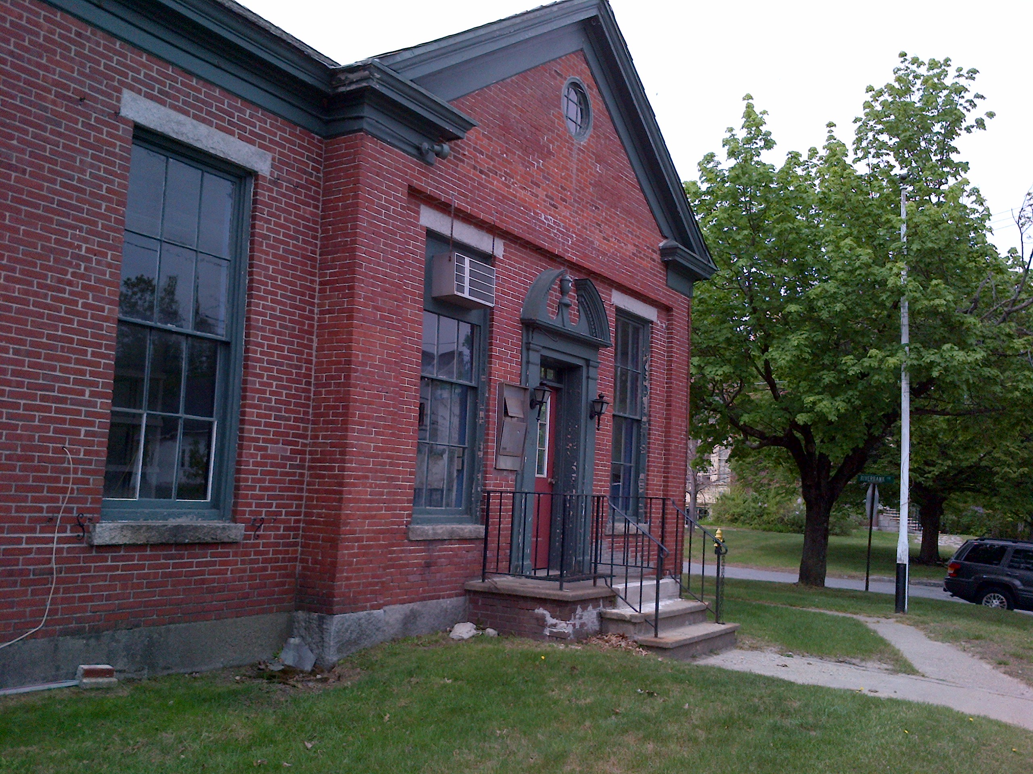

Prepared by:
Massachusetts Department of Public Health
Bureau of Environmental Health
Indoor Air Quality Program
February 2017

BACKGROUND
Building: | The Annex
Address: | 272 Main Street, Townsend, MA
Assessment Requested by: | Emy Hoff, Recreation Director,  Town of Townsend, MA
Reason for Request: | Assessment of remediation efforts in response to recommendations from an Indoor Air Quality (IAQ) Program report dated June 2015.
Date of Assessment: | January 6, 2017
Massachusetts Department of Public Health/Bureau of Environmental Health (MDPH/BEH) Staff Conducting Assessment: | Michael Feeney, Director, IAQ Program
Date of Building Construction: | 1900s
Building Description | The building is a one-story brick structure with attic constructed as a bank in the early 1900s. The interior walls mostly consist of plaster. The building was vacant at the time of the assessment
Windows | Openable

Methods
Please refer to the IAQ Manual and appendices for methods, sampling procedures, and interpretation of results (MDPH, 2015).
Note that this building was previously visited by the BEH/IAQ Program in May of 2015, and a report on that visit was released in June of 2015. This report can be viewed here: http://www.mass.gov/eohhs/gov/departments/dph/programs/environmental-health/exposure-topics/iaq/iaq-rpts/cities-and-towns-t-u.html.

Response to Conclusions/Recommendations
The following activities were completed in response to the recommendations made in the June 2015 assessment:
- Ensure all water-damaged porous materials (e.g., carpet) are removed from the building and all mold-colonized nonporous surfaces are cleaned in accordance with EPA Guidance for Mold Remediation in Schools and Commercial Buildings (US EPA, 2001).
Action: Water-damaged materials were removed from the building.
- Repair water-damaged plaster.
Action: Water-damaged plaster was repaired.
- Replace damaged exterior wall surfaces.
Action: Damaged exterior surfaces were repointed.
- If damaged ceiling or floor tiles contain asbestos, remediate in conformance with state and federal asbestos remediation and hazardous waste disposal laws.
Action: Ceiling and floor tiles were remediated.
- Design and provide gutter/downspout system that deposits rainwater as far as practicable from the foundation.
Action: Plans are in progress to identify the best method for reducing water exposure to the building’s exterior.
Based on these actions observed by BEH/IAQ staff at the time of this assessment, repairs made at the Annex meet the recommendations made in the IAQ report issued June 2015. The mold-colonized/water-damaged materials were removed and the integrity of the building envelope was re-established. For additional information and guidance, refer to IAQ documents on the MDPH’s website, available at: http://mass.gov/dph/iaq.

References
MDPH. 2015. Massachusetts Department of Public Health. Indoor Air Quality Manual: Chapters I-III. Available at: http://www.mass.gov/eohhs/gov/departments/dph/programs/environmental-health/exposure-topics/iaq/iaq-manual/.

