Adding a Reference Number to Your Invoice or SDR
You can enter provider-specific reference numbers to the bills you create:  - Add one to an invoice if you are doing cost reimbursement (CR) or accommodation rate (AR) billing.  - Add one to a Service Delivery Report (SDR) if you are using unit rate (UR) billing.  Reference numbers may be used later to search for a PRC (Payment Request for Commodity), as shown on page two.  Adding a Reference Number to a New CR Invoice  - Access the Billing module.  - Access Invoice Search and click .  - Select a contract and click .  - Complete required fields.  - Enter the internal tracking number you wish to use in the Invoice Reference Number field.  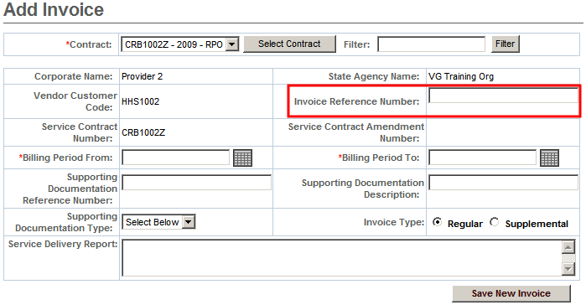  - Click.  The Invoice Summary page appears.  - Complete data entry and click .  Note: The flow for adding an Invoice Reference Number to a new AR invoice would be the same. | Adding a Reference Number to a New SDR  - Access the Billing module.  - Access Service Delivery Report Search from the menu.  - Click .  - Select a contract and click .  - Select an activity code and click .  - Select service period and click .  The Service Delivery Report Summary page appears.  - Click an SDR link in the Status column.  The Service Delivery Summary page appears.  - Enter the internal tracking number you wish to use in the SDR Reference Number field.  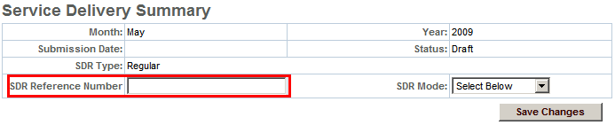  - Click . This saves only changes to the SDR Reference Number and/or the SDR Mode.  Tip: A reference number may be added to an existing invoice or SDR, but only if it is in “Draft” status. To do so, access the relevant Invoice Summary or SDR Summary screen.  Tip: Once a reference number has been added to an invoice or SDR, a user may search for it using the number assigned.

Using Your Reference Number to Find a PRC
Invoice/SDR Reference Number may be used to conduct a PRC search and determine payment status.  - Access the Billing module.  - Select PRC Search from the menu.  The PRC Search page appears.  - Enter the Invoice/SDR Reference Number to search against.  - Within the Select Below field, choose the billing document your reference number pertains to: AR invoice, CR invoice, or UR SDR.  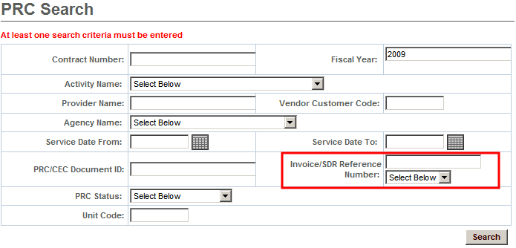  - Click .  The Search Results table appears.  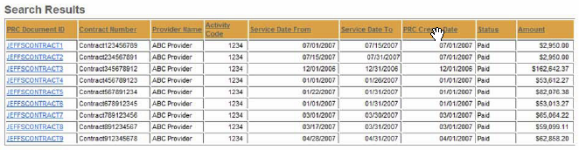  Note: Results will include any PRCs via which partial or complete payment was made for the Invoice/SDR Reference Number entered. If no results are returned, PRC processing is probably still underway. | - Click the PRC Document ID link within the Search Results that you wish to view.  The PRC Update page appears.  - Available information includes the status of the PRC, the MMARS EFT/Check Number, and the Document Total Amount (total reimbursable amount).  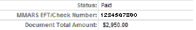  - Report Links are also available on the page, which allow you to view the original invoice or SDR for which you are checking payment status.  - Click the Commodity Link within the Commodity Accounting Line Information for additional information (including Ready Pay reconciliation details, if it is a Ready Pay contract).  Note: If multiple Reference Numbers are associated with the PRC, they will appear in the Invoice/SDR Reference field on the PRC Update page, separated by commas.
Refer to the Payment Tracking Report Job Aid for instructions on how to run and use the Payment Tracking Report.
Refer to EIM/ESM CBT #158 for more information.
Questions or need assistance?
Call Virtual Gateway Customer Service
1-800-421-0938
(617-847-6578 - TTY for the deaf and hard of hearing)
8:30 am to 5:00 pm Monday through Friday

