What are the School Breakfast and National School Lunch Programs?
The School Breakfast Program (SBP) and the National School Lunch Program (NSLP) are federally assisted meal programs operating in public and nonprofit private schools and residential child care institutions. The SBP began as a pilot project in 1966, and was made permanent in 1975. The NSLP was established under the National School Lunch Act in 1946 and signed by then President Harry Truman who said,
"Nothing is more important in our national life than the welfare of our children, and proper nourishment comes first in attaining this welfare."
School Nutrition Program Background
The U.S. Department of Agriculture, through its Food and Nutrition Service (formerly the Food and Consumer Service), administers the program at the Federal level. At the State level, the SBP and NSLP are administered by State education agencies, which operate the programs through agreements with local school districts.
School districts and independent schools that choose to take part in the breakfast and/or lunch programs receive cash reimbursement from USDA for each meal they serve. In return, they must serve meals that meet Federal nutrition requirements, and they must offer free and reduced-price meals to eligible children.
All schools participating in the SBP or NSLP must make free and reduced price meals available to eligible children.
LEAs must provide free and reduced price benefits to eligible children in accordance with the statutory and regulatory requirements as detailed in the “Eligibility Manual for School Meals” which can be found at http://www.fns.usda.gov/cnd/Lunch/.
To ensure Local Education Agencies (LEAs) are aware of Federal and State requirements pertaining to free and reduced price meals, State agencies that administer the school meals programs must issue free and reduced price policy guidance and any other necessary instructions.
Direct Certification
By law, all LEAs participating in the National School Nutrition Program must utilize the direct certification process.
Direct Certification is the process where Local Educational Agencies (LEAs) verify children who are members of households receiving assistance under the Supplemental Nutrition Program (SNAP), TANF/TAFDC or FDPIR as eligible for SNP - eliminating the need for further application by the child’s household. Certification is based on information provided by the state agencies administering these programs. Directly certified determinations supersede any meal benefit applications received from the household.
Unless the children in a household are determined eligible through direct certification, the family must submit an application (paper or electronic) to receive free or reduced price meals.
The Medicaid Program cannot be used as a source for direct certification.
Direct certification is accomplished by an LEA identifying a child as eligible for free meals through a computer match with SNAP/TAFDC or FDPIR information. Verification of eligibility is not required for a child who has been directly certificated through a computer match.
Once a child is directly certified, the LEA must notify the household that:
- The child is eligible for free meals
- No further application is necessary
- The process to follow if the household does not want the directly certified child to receive free meals.
The LEA must provide benefits promptly. Eligible children may receive benefits immediately and the LEA may assume consent if a refusal has not been received within a certain number of days, as determined by the LEA. If the household refuses benefits, the LEA must discontinue benefits immediately and must document the refusal.
Both program records and the current year’s fiscal records must be retained for three (3) years after the submission of the final claim for reimbursement for the fiscal year. If there is an open audit for any fiscal year, all records must be retained until closure notification of the audit.
The direct certification documentation must be maintained either at the district or school level. If the direct certification documentation is maintained at a district level, children’s eligibility status must be readily retrievable by each school.
The LEA must also ensure all changes and transfers in and out of the district/school are accurately and promptly updated.
For more information on Direct Certification, refer to the Eligibility Manual for Schools Meals which can be found at http://www.fns.usda.gov/cnd/lunch/.
Unless the children in a household are determined eligible through direct certification, the family must submit an application (paper or electronic) to receive free or reduced price meals.
Annual Eligibility Verification
Annually, every LEA must verify program eligibility for a sample of children from households whose applications have been approved for free and reduced price meal benefits for that school year.
For households selected for eligibility verification, Massachusetts requires all LEAs to conduct direct verification using the Executive Office of Health and Human Services (EOHHS) Virtual Gateway. Continued program participation for a household is based on Direct Verification through use of records from public agencies to verify household income.
A Verification Summary Report must be submitted to Department of Elementary and Secondary Education (DESE) by the established annual due date. Direct verification must be conducted through the EOHHS Virtual Gateway prior to contacting households to request verification documentation. Only households with students who cannot directly verify through the Virtual Gateway are required to submit paper verification documentation.
LEAs must not verify more than or fewer than the required number of applications that were determined to be needed for the verification sample. Verification conducted ‘for cause’ is completed in addition to the required verification sample.
The LEA must only submit the names for school children certified for free or reduced price meal benefits listed on the application. The names of other household members (all adults, children who are not attending school, or children not approved for free or reduced price meals) cannot be submitted for direct verification purposes.
When information obtained through direct verification of an application indicates a child is participating in a SNAP, TAFDC or FDPIR program, no additional verification is required and the eligibility status of the child or children listed on the application is considered verified.
The information used for direct verification is the most recent information available which is defined as data which is no older than 180 days prior to the date of the free and reduced price application.
For more information on direct verification or how to determine your verification sample size, refer to the Eligibility Manual for Schools Meals which can be found at http://www.fns.usda.gov/cnd/lunch/.
To learn more about the School Nutrition Program, please visit the Department of Elementary and Secondary Education (DESE) website at http://www.doe.mass.edu/cnp.
Using the Virtual Gateway for Direct Certification and Direct Verification
The Virtual Gateway is an internet portal designed by the Executive Office of Health and Human Services to provide the general public, medical providers, community-based organizations, school districts and state agency staff with online access to health and human services. By consolidating information and online services in a single location on the internet, the Virtual Gateway simplifies the process of connecting people to critical health and human services programs and information.
The School Nutrition Program (SNP) is now part of the Virtual Gateway and is used by LEAs for the direct certification and direct verification processes.
The Virtual Gateway also provides households with school age children, the option of applying online for the free or reduced price meals program. Households now have the option of how they want to apply (paper or online via the internet). All policies and procedures surrounding the School Nutrition Program still apply.
The School Nutrition Program (SNP) is now part of the Virtual Gateway and will be used by LEAs for the direct certification and direct verification processes. The Virtual Gateway will also provide households, with school age children, the option of applying online for the free or reduced price meals program. Households will have the option of how they want to apply (paper or online via the internet). All policies and procedures surrounding the School Nutrition Program still apply.
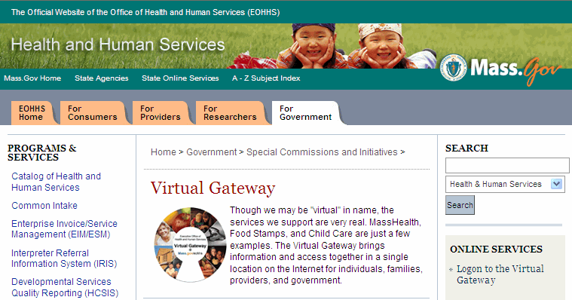

Virtual Gateway – Using the My Account Page for Direct Certification
School districts and LEAs must use the Virtual Gateway My Account Page (MAP) to directly certify their student enrollment roster for the free school meals program. The Virtual Gateway provides real time, up-to-date access to SNAP/TAFDC data.
As a result of using MAP, school districts have the ability to directly certify more students for free school meals. ESE recommends that LEAs run their direct certification against the current student enrollment roster on a regular basis (i.e. weekly) in order to directly certify as many students as possible for the current school year.
As all direct certifications are processed through MAP, the Department of Elementary and Secondary Education (ESE) will no longer publish the Department of Transitional Assistance (DTA) SNAP file on their ESE security portal.
Once a student is directly certified through MAP, the household will receive notification from the school district that they have been directly certified to receive free school meals for the current school year.
School districts should continue to follow all policy and procedures surrounding the direct certification process, and continue notifying households that they have been directly certified for the benefit.
Refer to the Eligibility Manual for Schools Meals which can be found at http://www.fns.usda.gov/cnd/lunch/.
The Virtual Gateway MAP application allows users to choose how they want to input data to run the Direct Certification process:
- Manual Data Entry: The manual data entry process allows users to directly enter the required student data into MAP. Users can enter 10 records at a time.
- File Batch Upload: The file batch upload process allows users to insert the required student data into a predefined enrollment template. The Direct Certification Enrollment Template allows for 15000 rows (3 MB) per file to be uploaded into MAP.
Both the manual and file upload check against real time SNAP/TAFDC data and return the results to the user.
To learn more about how to use the Direct Certification process, refer to online course 403 Using My Account Page (MAP) for Direct Certification and Direct Verification Process.
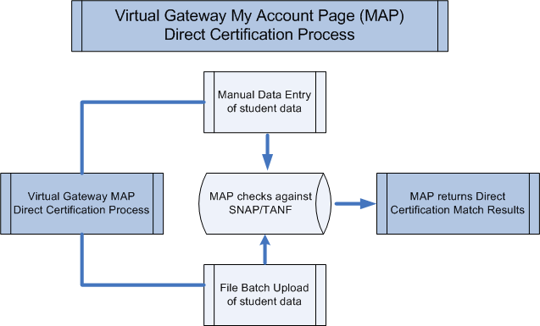
Virtual Gateway – Using the My Account Page for Annual Verification
School districts and LEAs use the Virtual Gateway's My Account Page (MAP) for their annual verification process. School districts should continue to follow all policies and procedures surrounding the sample verification pool as outlined in the Eligibility Manual for Schools Meals which can be found at http://www.fns.usda.gov/cnd/lunch/.
Every school district is directed to randomly select 3% of their approved free or reduced price meals applications (as of October 1st of each school year) to conduct an income verification.
The Virtual Gateway MAP application is used for this direct verification process. If information obtained through direct verification indicates a household is eligible for free or reduced price meals, no additional verification is required and the eligibility status of the child or children listed on the application is considered verified for the current school year.
If MAP cannot verify the data for a student, the school direct is directed to follow normal procedures of contacting the household for more information.
The Virtual Gateway MAP application allows users to choose how they want to input data to run the Direct Verification process:
- Manual Data Entry: The manual data entry process allows users to directly enter the required student data into MAP. Users can enter 10 records at a time.
- File Batch Upload: The file batch upload process allows users to insert the required student data into a predefined enrollment template. The Direct Verification Enrollment Template allows for 5000 rows (1 MB) per file to be uploaded into MAP.
Both the manual and file upload check against real time SNAP/TAFDC/Medicaid data and returns the results to the user.
To learn more about how to use the Direct Verification process, refer to online course 403 Using My Account Page (MAP) for Direct Certification and Direct Verification Process.
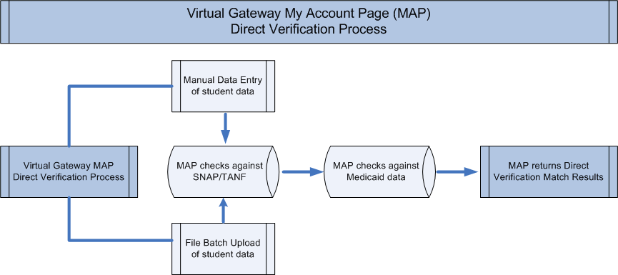
Virtual Gateway – Online Household Application for SNP Benefits
Households in Massachusetts who wish to apply for free or reduced-priced meals now have two options when applying for this benefit.
The household can either submit a paper application, which is provided to every student at the start of the school year, or they can use the Virtual Gateway's Self Service site, which allows households to complete and submit the application on the Internet.
When a household applies for the free or reduced-priced meals on the Virtual Gateway, those applications are submitted electronically to an application tool called the Common Intake Application Inbox.
The Common Intake Application Inbox is an online tool that participating school districts/LEAs use to retrieve Virtual Gateway online applications that have been submitted by households. LEAs will continue to enter data from all received applications (paper and Virtual Gateway) for the free or reduced-priced meals program into their districts computer system.
The Virtual Gateway’s Common Intake Application Inbox is used to retrieve applications submitted online. When the Virtual Gateway distributes application information, it provides only the information necessary for that child at the noted school and school district.
The Application Inbox is accessed through your Virtual Gateway logon and retrieving application is similar to checking your e-mail. All LEA staff use the Application Inbox to retrieve and print online applications that were submitted by households for the free or reduced-priced meals program.
Once retrieved and printed, LEAs should follow normal procedures for the review and determination process by the school district. On a regular basis, LEAs are reminded to logon to the Common Intake Application Inbox to retrieve new applications that have been submitted by households for the free or reduced-priced meals program.
Applications must be reviewed in a timely manner. An eligibility determination must be made and implemented within 10 working days of the receipt of the application. Whenever possible, applications should be processed immediately, particularly for children who do not have approved applications on file from the previous year.
Benefits of Using Common Intake Application Box
The Virtual Gateway sends only complete applications to your Application Inbox. School districts and schools, if applicable, can access each submitted online application through their Application Inbox. Users can view applications, print applications, change the status of an application, and forward new applications to other schools, if received in error.
To learn more about how to use the Virtual Gateway's Application Inbox, refer to online course 405 Using the Application Inbox.
Additional Resources:
For more information about the School Breakfast Program visit http://www.fns.usda.gov/cnd/breakfast/.
For more information about the National School Lunch Program visit http://www.fns.usda.gov/cnd/lunch/.
For more information on Direct Certification and Direct Verification, refer to the Eligibility Manual for Schools Meals which can be found at http://www.fns.usda.gov/cnd/lunch/.
To learn more about the School Nutrition program, please visit the Department of Elementary and Secondary Education (ESE) website at http://www.doe.mass.edu/cnp.
To learn more about the Virtual Gateway, please visit the Executive Office of Health and Human Services Virtual Gateway website at http://www.mass.gov/vg.

Acknowledgements
This project has been funded through the Direct Certification and Verification Grant award from the United States Department of Agriculture (USDA), Food and Nutrition Service and we wish to thank the following for their guidance and support in the development of this project:
Massachusetts Department of Elementary and Secondary Education (DESE)
Massachusetts Executive Office of Health and Human Services (EOHHS)
Massachusetts Department of Transitional Assistance (DTA)

