Massachusetts Hemovigilance Program
Transfusion-Associated Circulatory Overload (TACO) Event Summary
January 1, 2017 – December 31, 2022
Data were extracted from NHSN on June 21, 2023.
Important Note: From 2017-2020, the 2011 case definition was used to classify TACO events in NHSN. In 2021, NHSN began using the 2018 case definition to classify TACO events.

Figure 1: TACO Events and Total Transfusion Volume by Year, 2017-2022
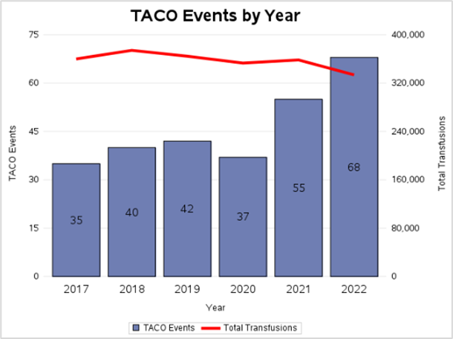
Gender | Total | Percent
Female | 154 | 56%
Male | 123 | 44%
Table 1: TACO Events by Gender

Figure 2: TACO Events by Age, 2017-2022

Figure 3: TACO Events by Bed Size Group (2017-2022)

Figure 4: TACO Events Rates by Bed Size Group
(Rate per 10,000 Products Transfused)

Figure 5: TACO Events by Location and Bed Size Group
(2017-2022)

Summary and Recommendations
Summary: Transfusion-associated circulatory overload (TACO) manifests as cardiogenic pulmonary edema in transfusion recipients unable to compensate for additional blood product volume. Since 2011, an international case definition for the diagnosis and reporting of TACO in patients required at least 4 defined symptoms occurring within 6 hours of transfusion. In 2018, a revised international case definition for TACO, specified that at least 3 specific clinical criteria must be met within 12 hours of transfusion, including a pulmonary component (respiratory distress or pulmonary edema based on either chest imaging OR clinical examination)1. The international working party also stressed the possibility, and the need for awareness, of the occurrence of a transient elevated temperature rise in the context of the transfusion in some patients with TACO. Other possible criteria include cardiovascular conditions, fluid overload, and associated biomarkers. This revised case definition was incorporated into the NHSN Hemovigilance Module in January 2021.

Recommendations: Practitioners should consider the following for fluid management of patients at risk for TACO: Utilization of slower infusion rates and “split units”; minimization of crystalloid intravenous fluids in the pre-transfusion period, use of diuretic medications if not contraindicated, and promotion of a single-unit PRBC strategy rather than multiple-unit PRBC transfusions. As always, report any unusual or unexpected response to blood product transfusion to your Blood Bank.

Surveillance Knowledge Check: NHSN TACO Classification Criteria Tables*
 | Definitive | Probable | Possible
Case Definition | New onset or exacerbation of 3 or more of the following within 12 hours of cessation of transfusion: (At least 1 of the following:)  - Evidence of acute or worsening respiratory distress (dyspnea, tachypnoea, cyanosis and decreased oxygen saturation values in the absence of other specific causes) and/or  - Radiographic or clinical evidence of acute or worsening pulmonary edema (crackles on lung auscultation, orthopnea, cough, a third heart sound and pinkish frothy sputum in severe cases); or both AND  - Elevated brain natriuretic peptide (BNP) or NT-pro BNP relevant biomarker  - Evidence of cardiovascular system changes not explained by underlying medical condition (Elevated central venous pressure, evidence of left heart failure including development of tachycardia, hypertension, widened pulse pressure, jugular venous distension, enlarged cardiac silhouette and/or peripheral edema)  - Evidence of fluid overload | N/A | N/A
Imputability | No other explanations for circulatory overload are possible. | Transfusion is a likely contributor to circulatory overload  AND EITHER  - The patient received other fluids as well  OR  The patient has a history of cardiac insufficiency that could explain the circulatory overload, but transfusion is just as likely to have caused the circulatory overload. | The patient has a history of preexisting cardiac insufficiency that most likely explains circulatory overload.
*These surveillance case definitions can be found on page 9 of the February 2023 National Healthcare Safety Network Biovigilance Component Hemovigilance Module Surveillance Protocol and are not intended for clinical decision-making.
Resources:
NHSN Hemovigilance Module Surveillance Protocol: https://www.cdc.gov/nhsn/pdfs/biovigilance/bv-hv-protocol-current.pdf
MDPH Hemovigilance Data: https://www.mass.gov/service-details/reporting-requirements-for-blood-banks-and-hemovigilance-in-massachusetts
1. Wiersum-Osselton JC et al. Revised international surveillance case definition of transfusion-associated circulatory overload: a classification agreement validation study. Lancet Haematol. 2019 Jul;6(7):e350-e358. doi: 10.1016/S2352-3026(19)30080-8. Epub 2019 May 9. PMID: 31080132.

