Massachusetts HIV Epidemiologic Profile
Data as of 1/1/2023
Population Report: Transgender Individuals, Accessible Version
MS Word Version, optimized for screen reader use
Please note that while the content of this report is the same as the pdf version, the format and pagination have been modified significantly to optimize use with screen readers to ensure access for blind or visually impaired audiences.
Suggested citation:
Massachusetts Department of Public Health, Bureau of Infectious Disease and Laboratory Sciences. Massachusetts HIV Epidemiologic Profile: Data as of 1/1/2023, Population Report: Transgender Individuals, https://www.mass.gov/lists/hivaids-epidemiologic-profiles Published March 2024. Accessed [date].
Bureau of Infectious Disease and Laboratory Sciences
Massachusetts Department of Public Health
Jamaica Plain Campus/State Public Health Laboratory
305 South Street
Jamaica Plain, MA 02130
Questions about this report
Tel: (617) 983-6560
To reach the Reporting and Partner Services Line
Tel: (617) 983-6999
To speak to the on-call epidemiologist
Tel: (617) 983-6800
Questions about infectious disease reporting
Tel: (617) 983-6801
HIV Data Dashboard
https://www.mass.gov/info-details/hiv-data-dashboard
Requests for additional data
https://www.mass.gov/lists/infectious-disease-data-reports-and-requests
Slide sets for HIV Epidemiologic Profile Reports
https://www.mass.gov/lists/hivaids-epidemiologic-profiles

TRANSGENDER PEOPLE

Transgender is an umbrella term for people whose current gender identity differs from the sex they were assigned at birth. Transgender can also describe people whose gender identities do not exist within a gender binary structure (e.g., people who are non-binary or gender fluid), though not all these individuals identify as transgender. Transgender woman describes a person assigned male at birth who currently identifies as a woman. This identity can also refer to someone who was surgically assigned male at birth, in the case of intersex people, but whose current gender identity is female. Transgender man describes a person assigned female at birth who currently identifies as a man. This identity can also refer to someone who was surgically assigned female at birth, in the case of intersex people, but whose current gender identity is male.
DATA COLLECTION
While questions about gender identity are often missing from national population assessments such as the US Census, Massachusetts has been a leader in adding these questions to local surveys. The Massachusetts Child and Youth Violence Prevention Services Program began collecting transgender-inclusive gender identity in 2005, as did the Massachusetts Behavioral Risk Factor Surveillance System (BRFSS) and the Massachusetts Department of Public Health (MDPH) Office of HIV/AIDS in 2007. The MDPH HIV/AIDS Surveillance Program began collecting transgender-inclusive gender identity in 2009. In 2013, the Massachusetts Youth Risk Behavior Survey (MYRBS), Youth Health Survey (YHS), and MDPH Bureau of Substance Addiction Services also began collecting transgender-inclusive gender identity.
These surveys, surveillance systems, and programmatic data systems provide important opportunities to monitor population health and the specific impacts of policies (e.g., marriage equality, universal health care access, anti-bullying legislation, extension of nondiscrimination protections to transgender individuals) and other macro-level changes and interventions on population health and health inequities.
REPORTING OF TRANSGENDER IDENTITY
Massachusetts Behavioral Risk Factor Surveillance System (BRFSS): An annual anonymous telephone survey of adults ages 18 and older that collects data on a variety of health risk factors, preventive behaviors, chronic conditions, and emerging public health issues.
- Reported rates of transgender identity in Massachusetts adults are higher than national estimates: 0.9% (about 50,000) (95% Confidence Interval [CI]=0.7%–1.1%) of Massachusetts adults reported identifying as transgender (from 2019 to 2021), compared to 0.5% (about 1.3 million) of all US adults, as estimated by the Williams Institute.
Data Source: Health Survey Program, Office of Data Management and Outcomes Assessment, Massachusetts Behavioral Risk Factor Surveillance System (BRFSS). For more information, see: Health Survey Program, Office of Data Management and Outcomes Assessment, Massachusetts Department of Public Health. A Profile of Health Among Massachusetts Adults, 2021, Results from the Behavioral Risk Factor Surveillance System, January 2023, https://www.mass.gov/doc/a-profile-of-health-among-massachusetts-adults-2021-0/download
Massachusetts Youth Risk Behavior Survey (YRBS): An anonymous survey of public high school students conducted every odd year that collects data on health-related behaviors that may threaten the health and safety of young people.
- Reported rates of transgender identity in Massachusetts youth are also higher than national estimates. Among public high school students in 2021, 2.6% (95% CI=1.7%–3.5%, n=3,083) reported identifying as transgender, compared to 1.4% of US youth aged 13–17 years, as estimated by the Williams Institute.
Data Source for Youth Risk Behavior Survey Data: Office of Data Management and Outcomes Assessment, Department of Public Health and Massachusetts Department of Elementary and Secondary Education. For more information, see https://www.doe.mass.edu/sfs/yrbs/. 2019 data are used because 2021 data were not yet available at the time of publication.
Transgender people, particularly transgender women, are among the groups most disproportionately affected by HIV in the U.S. Accurate and timely data are needed to create and evaluate HIV prevention and treatment programs to address this disparity. Therefore, assessing HIV incidence and prevalence in transgender populations is of critical importance.
HIV INCIDENCE AND PREVALENCE AMONG TRANSGENDER INDIVIDUALS
N = 14,* 1% of 1,419 new HIV diagnoses from 2019–2021 were among transgender individuals
N = 138,* 1% of 23,393 persons living with HIV infection in MA as of 12/31/2021 were transgender individuals
* Reported numbers among transgender individuals are likely to be underestimates due to underreporting of current gender.
The following data presentations include transgender women only due to small numbers among transgender men (N=8 transgender men reported as living with HIV infection in Massachusetts as of 12/31/2021).
EXPOSURE MODE
FIGURE 1. Transgender women living with HIV infection by exposure mode, Massachusetts 2021 (N=130)
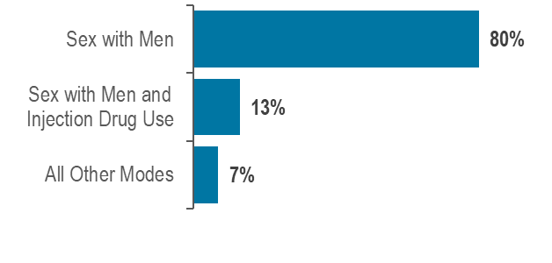
Figure 1 Notes:
Sex with Men: For the purposes of categorizing sexual risk in transgender women reporting sex with men only, this exposure mode category is reported on this fact sheet as “sex with men”. For the purposes of official reporting in the MA HIV/AIDS Surveillance System and to CDC, exposure mode for transgender women is based on sex assigned at birth and therefore would be reported as male-to-male sex.
Sex with Men and Injection Drug Use: For the purposes of categorizing sexual risk in transgender women reporting both sex with men and injection drug use, this exposure mode category is reported on this fact sheet as “sex with men and injection drug use”. For the purposes of official reporting in the MA HIV/AIDS Surveillance System and to CDC, exposure mode for transgender women is based on sex assigned at birth and therefore would be reported as male-to-male sex/injection drug use.
- Sex with men was the exposure mode for the majority (80%) of transgender women reported to be living with HIV infection. By comparison, male-to-male sex was the leading exposure mode for all persons living with HIV infection at 39%.

RACE/ETHNICITY
FIGURE 2. Persons living with HIV infection on December 31, 2021 by race/ethnicity: transgender women (N=130), cisgender women (N=6,763), and Massachusetts total (N=23,393)
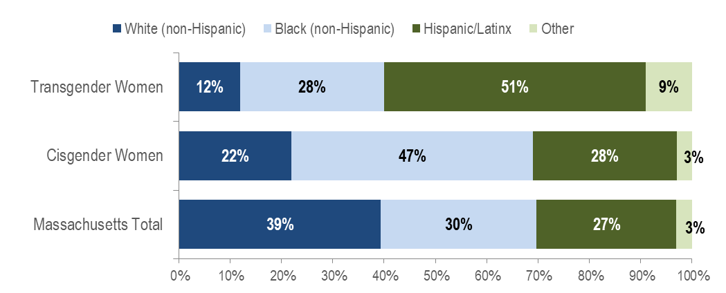KEY FINDING
- Fifty-one percent of transgender women living with HIV infection were Hispanic/Latina, compared to 28% of cisgender women and 27% of all persons living with HIV infection.
AGE
FIGURE 3. Persons living with HIV infection on December 31, 2021 by age (years): transgender women (N=130), cisgender women (N=6,763), and Massachusetts total (N=23,393)
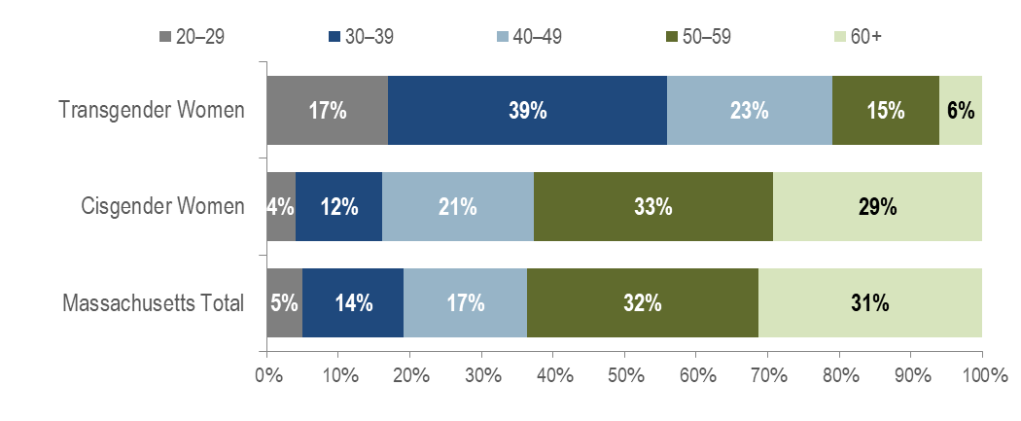Figure 3 Note: Ages 0-19 not shown due to small numbers.
KEY FINDING
- The majority of transgender women living with HIV infection in Massachusetts were under 40 years old. A total of 56% of transgender women were ages 20–39 years old as of December 31, 2021, compared to 16% of cisgender women and 19% of all persons living with HIV infection in Massachusetts.
PLACE OF BIRTH
FIGURE 4. Persons living with HIV infection on December 31, 2021 by place of birth: transgender women (N=130), cisgender women (N=6,763), and Massachusetts total (N=23,393)
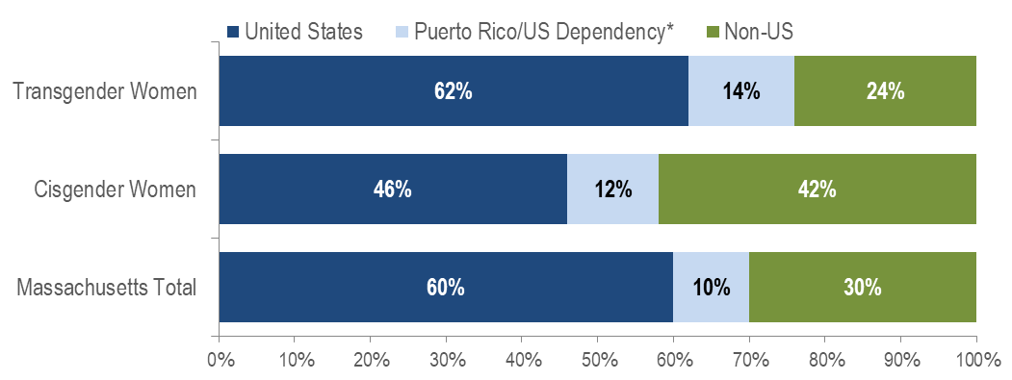
* Figure 4 Note: 98% of individuals living with HIV infection on 12/31/2021 who were born in a US dependency were born in Puerto Rico
- The distribution of place of birth among transgender women living with HIV infection on December 31, 2021 was more similar to that of all persons living with HIV infection (PLWH) in Massachusetts than cisgender women. Sixty-two percent of transgender women were born in the United States compared to 60% of all PLWH and 46% of cisgender women.

AREA OF RESIDENCE
FIGURE 5. Persons living with HIV infection on December 31, 2021 by Health Service Region (HSR) of residence: transgender women (N=130), cisgender women (N=6,763), and Massachusetts total (N=23,393)
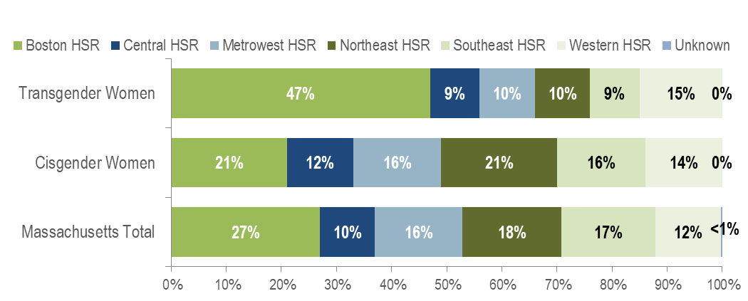
- Forty-seven percent of transgender women reported to be living with HIV infection in Massachusetts on December 31, 2021 were living in the Boston HSR, compared to 21% of cisgender women and 27% of all persons living with HIV infection. A total of 14% of transgender women were living in the Western HSR, 10% in both the Metrowest and Northeast HSRs, and 9% in both the Central and Southeast HSRs.
HIV Surveillance Data Source: MDPH Bureau of Infectious Disease and Laboratory Sciences, data are current as of 1/1/2023 and may be subject to change

Providers may use this number to report individuals newly diagnosed with a notifiable sexually transmitted infection, including HIV, or request partner services. Partner services is a free and confidential service for individuals recently diagnosed with a priority infection. The client-centered program offers counseling, linkage to other health and social services, anonymous notification of partners who were exposed and assistance with getting testing and treatment. For more information, see: https://www.mass.gov/service-details/partner-services-program-information-for-healthcare-providers
Note: please interpret estimated rates of transgender identity with caution due to the high and differential non-response rates to this question. Additionally, BRFSS estimates cannot take into account whether or not a person’s decision to respond is related to their gender identity. Also, please consider the impact of the COVID-19 pandemic on infectious disease screening, treatment, and surveillance in the interpretation of 2020 and 2021 data.
Herman, J.L., Flores, A.R., O’Neill, K.K. (2022). How Many Adults and Youth Identify as Transgender in the United States? The Williams Institute, UCLA School of Law, available at: https://williamsinstitute.law.ucla.edu/wp-content/uploads/Trans-Pop-Update-Jun-2022.pdf
Herman, J.L., Flores, A.R., O’Neill, K.K. (2022). How Many Adults and Youth Identify as Transgender in the United States? The Williams Institute, UCLA School of Law, available at: https://williamsinstitute.law.ucla.edu/wp-content/uploads/Trans-Pop-Update-Jun-2022.pdf
Centers for Disease Control and Prevention. Issue Brief: HIV and Transgender Communities, available at: https://www.cdc.gov/hiv/pdf/policies/data/cdc-hiv-policy-issue-brief-transgender.pdf
Please consider the impact of the COVID-19 pandemic on infectious disease screening, treatment, and surveillance in the interpretation of 2020 and 2021 data.
Please consider the impact of the COVID-19 pandemic on infectious disease screening, treatment, and surveillance in the interpretation of 2020 and 2021 data.
Please consider the impact of the COVID-19 pandemic on infectious disease screening, treatment, and surveillance in the interpretation of 2020 and 2021 data.
Cisgender describes persons whose current gender identity corresponds with their sex assigned at birth
Please consider the impact of the COVID-19 pandemic on infectious disease screening, treatment, and surveillance in the interpretation of 2020 and 2021 data.
Please consider the impact of the COVID-19 pandemic on infectious disease screening, treatment, and surveillance in the interpretation of 2020 and 2021 data.

