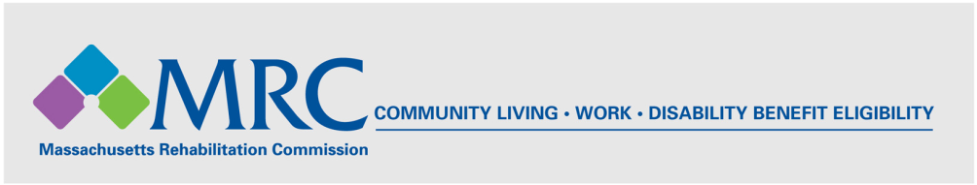
MRC TRANSPORTATION RESOURCE: The Transportation Access Pass (TAP)

The Massachusetts Reduced Fare Program: Transportation Access Pass (TAP):

What is the Transportation Access Pass (TAP)?
A Transportation Access Pass (TAP) entitles you to reduced fares on all Massachusetts Regional Transit Authority (RTA) buses, trains, rapid transit, trackless trolleys, commuter rail and commuter boats. The TAP CharlieCard is issued to applicants with disabilities who find it moderately or severely difficult to wait for a bus, hear announcements, read signs, understand or follow directions, maintain stamina, function in crowds, walk certain distances, etc. The TAP CharlieCard is not issued based on income level.

TAP CharlieCards are available at the MBTA CharlieCard Store in the underground concourse of the Downtown Crossing station, open Monday through Friday 8:30am - 5:00pm. Medicare card holders are automatically eligible. For more information call 617-222-5976, 617-222-5854 (TTY), or 1-800-543-8287, or visit the MBTA Website at: http://www.mbta.com/fares_and_passes/reduced_fare_programs/.

How to Apply
Return a completed application to the provided MBTA address (next page). You must present a current photo ID when picking up an approved pass (MA license, State ID, or Passport). No photocopies or faxes are accepted. You will receive an Application Status Letter in 4 to 6 weeks. Paste the link below into your browser to access the TAP CharlieCard application form (also available at the MBTA link above).

TAP CharlieCard Application: http://www.mbta.com/uploadedFiles/documents/ACCESS_PASS.pdf

Automatically Eligible Applicants
Applicants who meet the criteria below are automatically eligible for a TAP CharlieCard. If you meet one of these criteria, complete PART A of the application, check off the category that applies to you, and provide the required information or documents.
- Medicare Card holder
- Current customer of THE RIDE
- Client of DMH/Department of Mental Health
- Client of DDS/Department of Developmental Services
- Veteran with a disability rating 70% or greater
- Out-of State/Area reduced fare card holder
- Seniors (65+)

All Other Applicants
If you do not meet one of the above criteria, complete PART A of the application and have your licensed health care professional complete PART C of the application.

Massachusetts Bay Transportation Authority (MBTA) Contact Information

MBTA CharlieCard Store
Downtown Crossing Station, Chauncy Underground Concourse,
7 Chauncy St., Boston, MA 02111
(617) 222-3200, TTY: (617) 222-5854
http://www.mbta.com/

Massachusetts Regional Transit Authorities (RTAs)

Boston Area Transit Authorities:
- Massachusetts Bay Transportation Authority (MBTA): (617) 222-3200, TTY: (617) 222-5854
- Metrowest Regional Transit Authority (MWRTA): (508) 935-2222, Toll Free: (888) 996-9782

Northern Massachusetts:
- Cape Ann Transit Authority (CATA): (978) 283-7916
- Lowell Regional Transit Authority (LRTA): (978) 459-0152
- Merrimack Valley Regional Transit Authority (MVRTA): (978) 469-6878

Central Massachusetts:
- Montachusett Regional Transit Authority (MART): (800) 922-5636, (978) 345-7711
- Worcester Regional Transit Authority (WRTA): (508) 752-9283

Southeastern Massachusetts:
- Brockton Area Transit Authority (BAT): (508) 588-1000
- Greater Attleboro-Taunton Regional Transit Authority (GATRA): (800) 483-2500
- Southeastern Regional Transit Authority (SRTA): (508) 997-6767

Cape Cod & the Islands:
- Cape Cod Regional Transit Authority (CCRTA): (508) 775-8504
- Martha’s Vineyard Transit Authority (VTA): (508) 693-9440
- Nantucket Regional Transit Authority (NRTA): (508) 325-9571

Western Massachusetts:
- Berkshire Regional Transit Authority (BRTA): (800) 292-2782, (413) 499-2782
- Franklin Regional Transit Authority (FRTA): (413) 774-2262
- Pioneer Valley Transit Authority (PVTA): (413) 781-7882

