MASSACHUSETTS DEPARTMENT OF PUBLIC HEALTH

Office Of Emergency Medical Services 67 Forest Street, Marlborough, MA 01752

Statewide Trauma Field Triage Criteria and Point of Entry Plan for Adult and

Pediatric Patients

\*\* MDPH designated, or ACS verified if out of state.

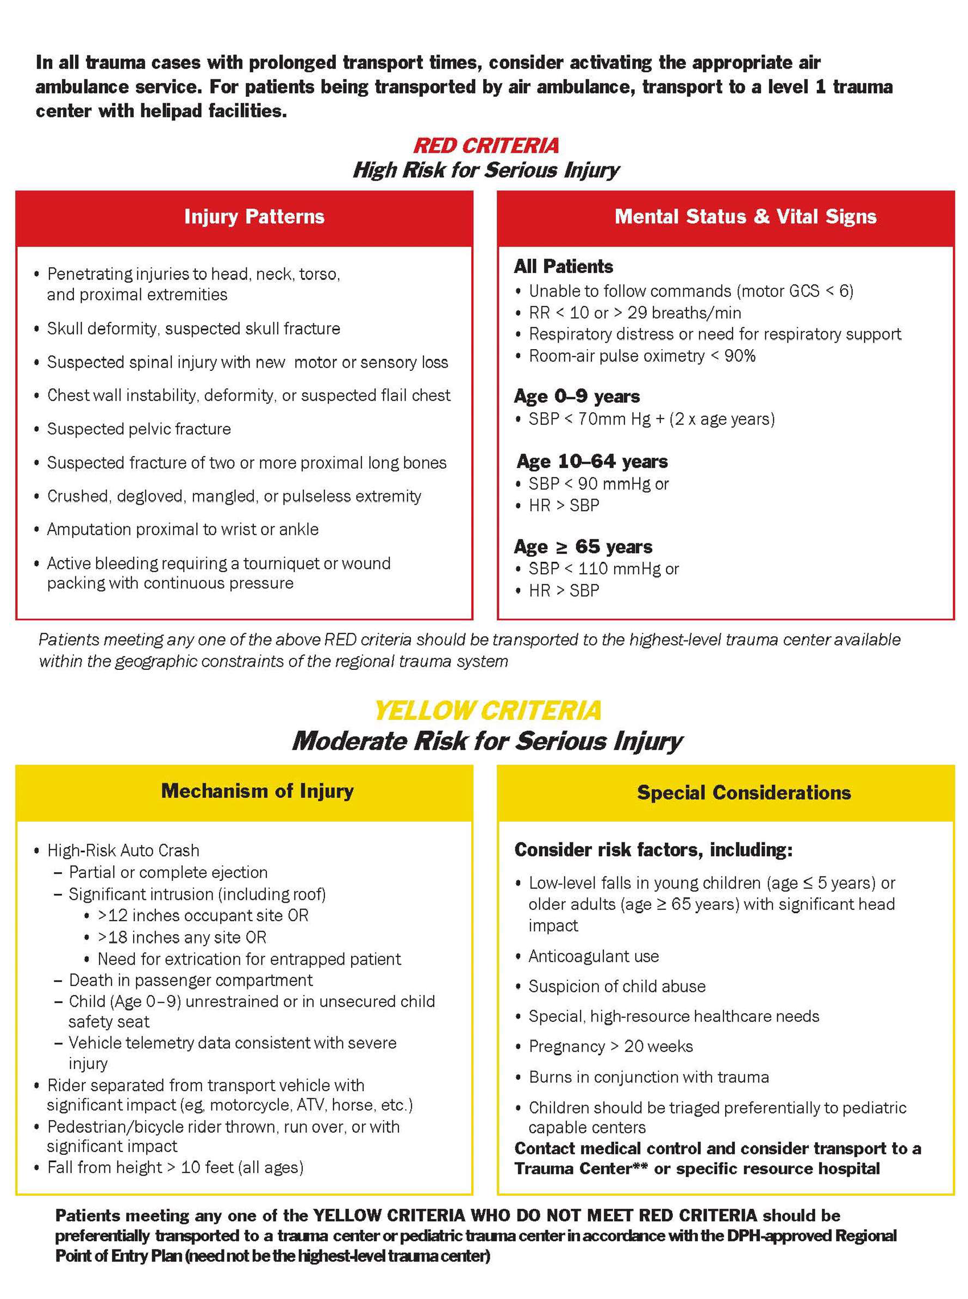

Date updated: 1/16/2024