

TRAUMA SYSTEMS COMMITTEE

January 30, 2025

*Bureau of Health Care Safety and Quality Massachusetts Department of Public Health*

Meeting Agenda

Massachusetts Department of Public Health | mass.gov/dph

2

* Department Updates
* Trauma Registry Update
* Trauma summary statistics report (01/2021-12/31/2023) in Massachusetts presentation
* Prehospital blood transfusion discussion

Department Update

Massachusetts Department of Public Health | mass.gov/dph

3

* Teryl Smith, Bureau Director, Bureau of Health Care Safety and Quality
* New Trauma System Committee Members:
  + Abigail Wertz, Trauma Program Manager, Lawrence General Hospital
  + Elizabeth Henderson, Trauma Program Manager, Cape Cod Hospital
  + Mohammed Bawazeer, MD, Co-director of Trauma, Melrose Wakefield Hospital

Open Meeting Law: G.L. c. 30A, §§ 18-25

Massachusetts Department of Public Health | mass.gov/dph

4

* The purpose of open meeting law (OML) is to ensure transparency in the deliberations on which public policy is based.
  + This requires that meetings of public bodies be open to the public.
* All meetings of a public body must be open to the public.
  + A meeting is any deliberation by a public body with respect to any matter within the body’s jurisdiction.
  + A deliberation is a communication between members among members of a public body.
* A public body is any multi-member board, commission, committee or subcommittee within the executive or legislative branches (except the Legislature) of state government
  + This includes any body created to advise or make recommendations
* Under OML the public is permitted to attend meetings.
  + Individuals in meetings may not address the public body without the permission of the chair.
  + Public participation is allowed at the discretion of the chair.
* For more information on Open Meeting Law, please visit:
  + https://[www.mass.gov/the-open-meeting-law](http://www.mass.gov/the-open-meeting-law)

Massachusetts Trauma Registry Updates

Massachusetts Department of Public Health | mass.gov/dph

5

* All data through Calendar Year (CY) 2024 Quarter 3 were due December 14, 2024
* Quality improvement activities are ongoing
* CY 2025 data specifications will be posted after registry vendor implements updates, expected spring 2025

|  |  |  |
| --- | --- | --- |
| **Quarter** | **Reporting Period** | **Data Submission Deadline** |
| CY 2025 Q1 | January 1-March 31 | June 13 |
| CY 2025 Q2 | April 1-June 30 | September 12 |
| CY 2025 Q3 | July 1-September 30 | December 12 |
| CY 2025 Q4 | October 1-December 31 | March 13 |

*All dates are subject to change by the Department.

Trauma Registry Data Submissions from Community Hospitals

Massachusetts Department of Public Health | mass.gov/dph

6

* Community Hospitals continue to receive support from DPH and the vendor ESO to improve reporting
  + This includes reviewing specifications, feedback on submission files and data quality reporting
* Nearly all community hospitals that have submitted data have completed submissions
* 3 community hospitals have not made successful Trauma Registry submissions

|  |  |  |  |
| --- | --- | --- | --- |
| Count of Community Hospital Trauma Registry Submissions by Year | | | |
| Year | Number of Facilities | # Community Hospitals Reporting some Quarters | # Up to Date |
| FFY 2021 | 44 | 0 | 42 |
| FFY 2022 | 44 | 0 | 42 |
| CY2022 Q4 (10/1/2022-12/31/2022) | 44 | 0 | 42 |
| CY 2023* | 44 | 2 | 42 |
| CY2024 Q1-Q3 | 44** | 0 | 38 |

*Signature Brockton Hospital exempt from CY2023 Q2 through CY2024 Q2 due to Feb 2023 fire

**Melrose Wakefield Hospital became designated trauma center Jan 2024,

**North Adams Regional Hospital became community hospital June 2024 Data Source: Massachusetts Trauma Registry, extracted 01/13/2025

Trauma Registry Data Submissions from Designated Trauma Centers

Massachusetts Department of Public Health | mass.gov/dph

7

* Nearly all Massachusetts Trauma Centers have successfully submitted data to Trauma Registry CY2024 Q1 through Q3
* CY2024 Q4 (10/01/2024-12/31/2024) data submission is due March 16, 2025
* Submissions are being reviewed for data quality

|  |  |  |  |
| --- | --- | --- | --- |
| Count of Trauma Center Registry Submissions by Year | | | |
| Year | Number of Facilities | # Trauma Centers reporting some Quarters | # Up to Date |
| CY 2024 Q1-Q3 | 18 | n/a | 17 |

Data Source: Massachusetts Trauma Registry, extracted 01/13/2025

Massachusetts Trauma Updates

Massachusetts Department of Public Health | mass.gov/dph

8

Updated trauma center destination maps and list by EMS Region with trauma level designation

|  |  |  |  |
| --- | --- | --- | --- |
| **EMS Region** | **Trauma Center** | **Adult Trauma Level** | **Pediatric Trauma Level** |
| **Region 1 - Western MA** | Baystate Medical Center | Level I | Level II |
| Berkshire Medical Center | Level III |  |
| **Region 2- Central MA** | UMASS Memorial Medical Center | Level I | Level I |
| **Region 3 - Northeastern MA** | Beverly Hospital | Level III |  |
| Lawrence General Hospital | Level III |  |
| Lowell General Hospital | Level III |  |
| Melrose Wakefield Hospital | Level III |  |
| Salem Hospital | Level III |  |
| **Region 4 - Metropolitan Boston** | Beth Israel Deaconess Medical Center | Level I |  |
| Boston Children's Hospital |  | Level I |
| Boston Medical Center | Level I | Level I |
| Brigham and Women's Hospital | Level I |  |
| Lahey Hospital and Medical Center | Level I |  |
| Massachusetts General Hospital | Level I | Level I |
| South Shore Hospital | Level II |  |
| Tufts Medical Center | Level I |  |
| **Region 5 - Southeastern MA/Cape Cod** | Good Samaritan Medical Center | Level III |  |
| Southcoast Health - St. Luke's Hospital | Level II |  |
| Cape Cod Hospital | Level III |  |



MA State Trauma Registry

Statistical summary report, 01/01/2021-12/31/2023

**Jiankun Kuang MS, Leah Pinckney MPH, Katherine Saunders MS**

Bureau of Health Care Safety & Quality

Massachusetts Department of Public Health mass.gov/dph 9

# MA State Trauma Registry Overview



* Introduction
* Facility information (maps, listed by region)
* Overall case counts
* Patient characteristics
* Injury summary
* Hospital and regional statistics

DRAFT - For Policy Development Only 10

# Introduction



* This report is to present summary statistics of trauma-related injuries and outcomes of the care provided in facilities (designated trauma centers and community hospitals) in Massachusetts for calendar years (CY) 2021-2023.
* Spring 2020 marked the beginning of the Covid-19 pandemic which significantly affected trauma incidence and is reflected in this report. Some of the statistical reporting could have been affected by the Covid-19 pandemic.
* Trauma clinicians, administrators and policy makers may use this report to enhance systems development and for clinical quality improvement. The public may use this report to learn more about the trauma system in MA.

DRAFT - For Policy Development Only 11

# Data Sources



* + **Trauma Registry -** Established in 2008, the MA Trauma Registry (TR) receives reports from designated trauma centers and community hospitals on patients identified and treated for traumatic injury
  + **Data submitted from designated trauma centers and community hospitals in MA** which contain variables specified by the TR including patients’ demographic clinical characteristics, diagnoses, treatment, and discharge information.

DRAFT - For Policy Development Only 12

# Inclusion Criteria- ICD diagnosis code

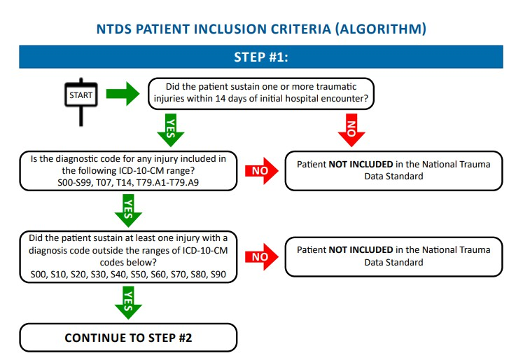

DRAFT - For Policy Development Only 13

# Inclusion Criteria- Admission



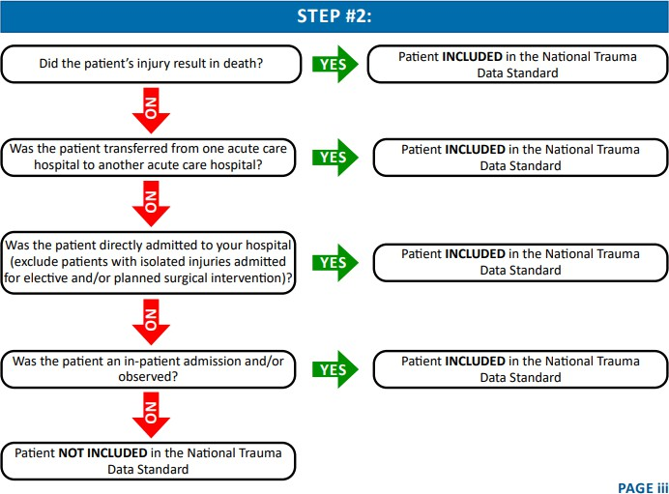

DRAFT - For Policy Development Only 14

# Facility Information - Statewide

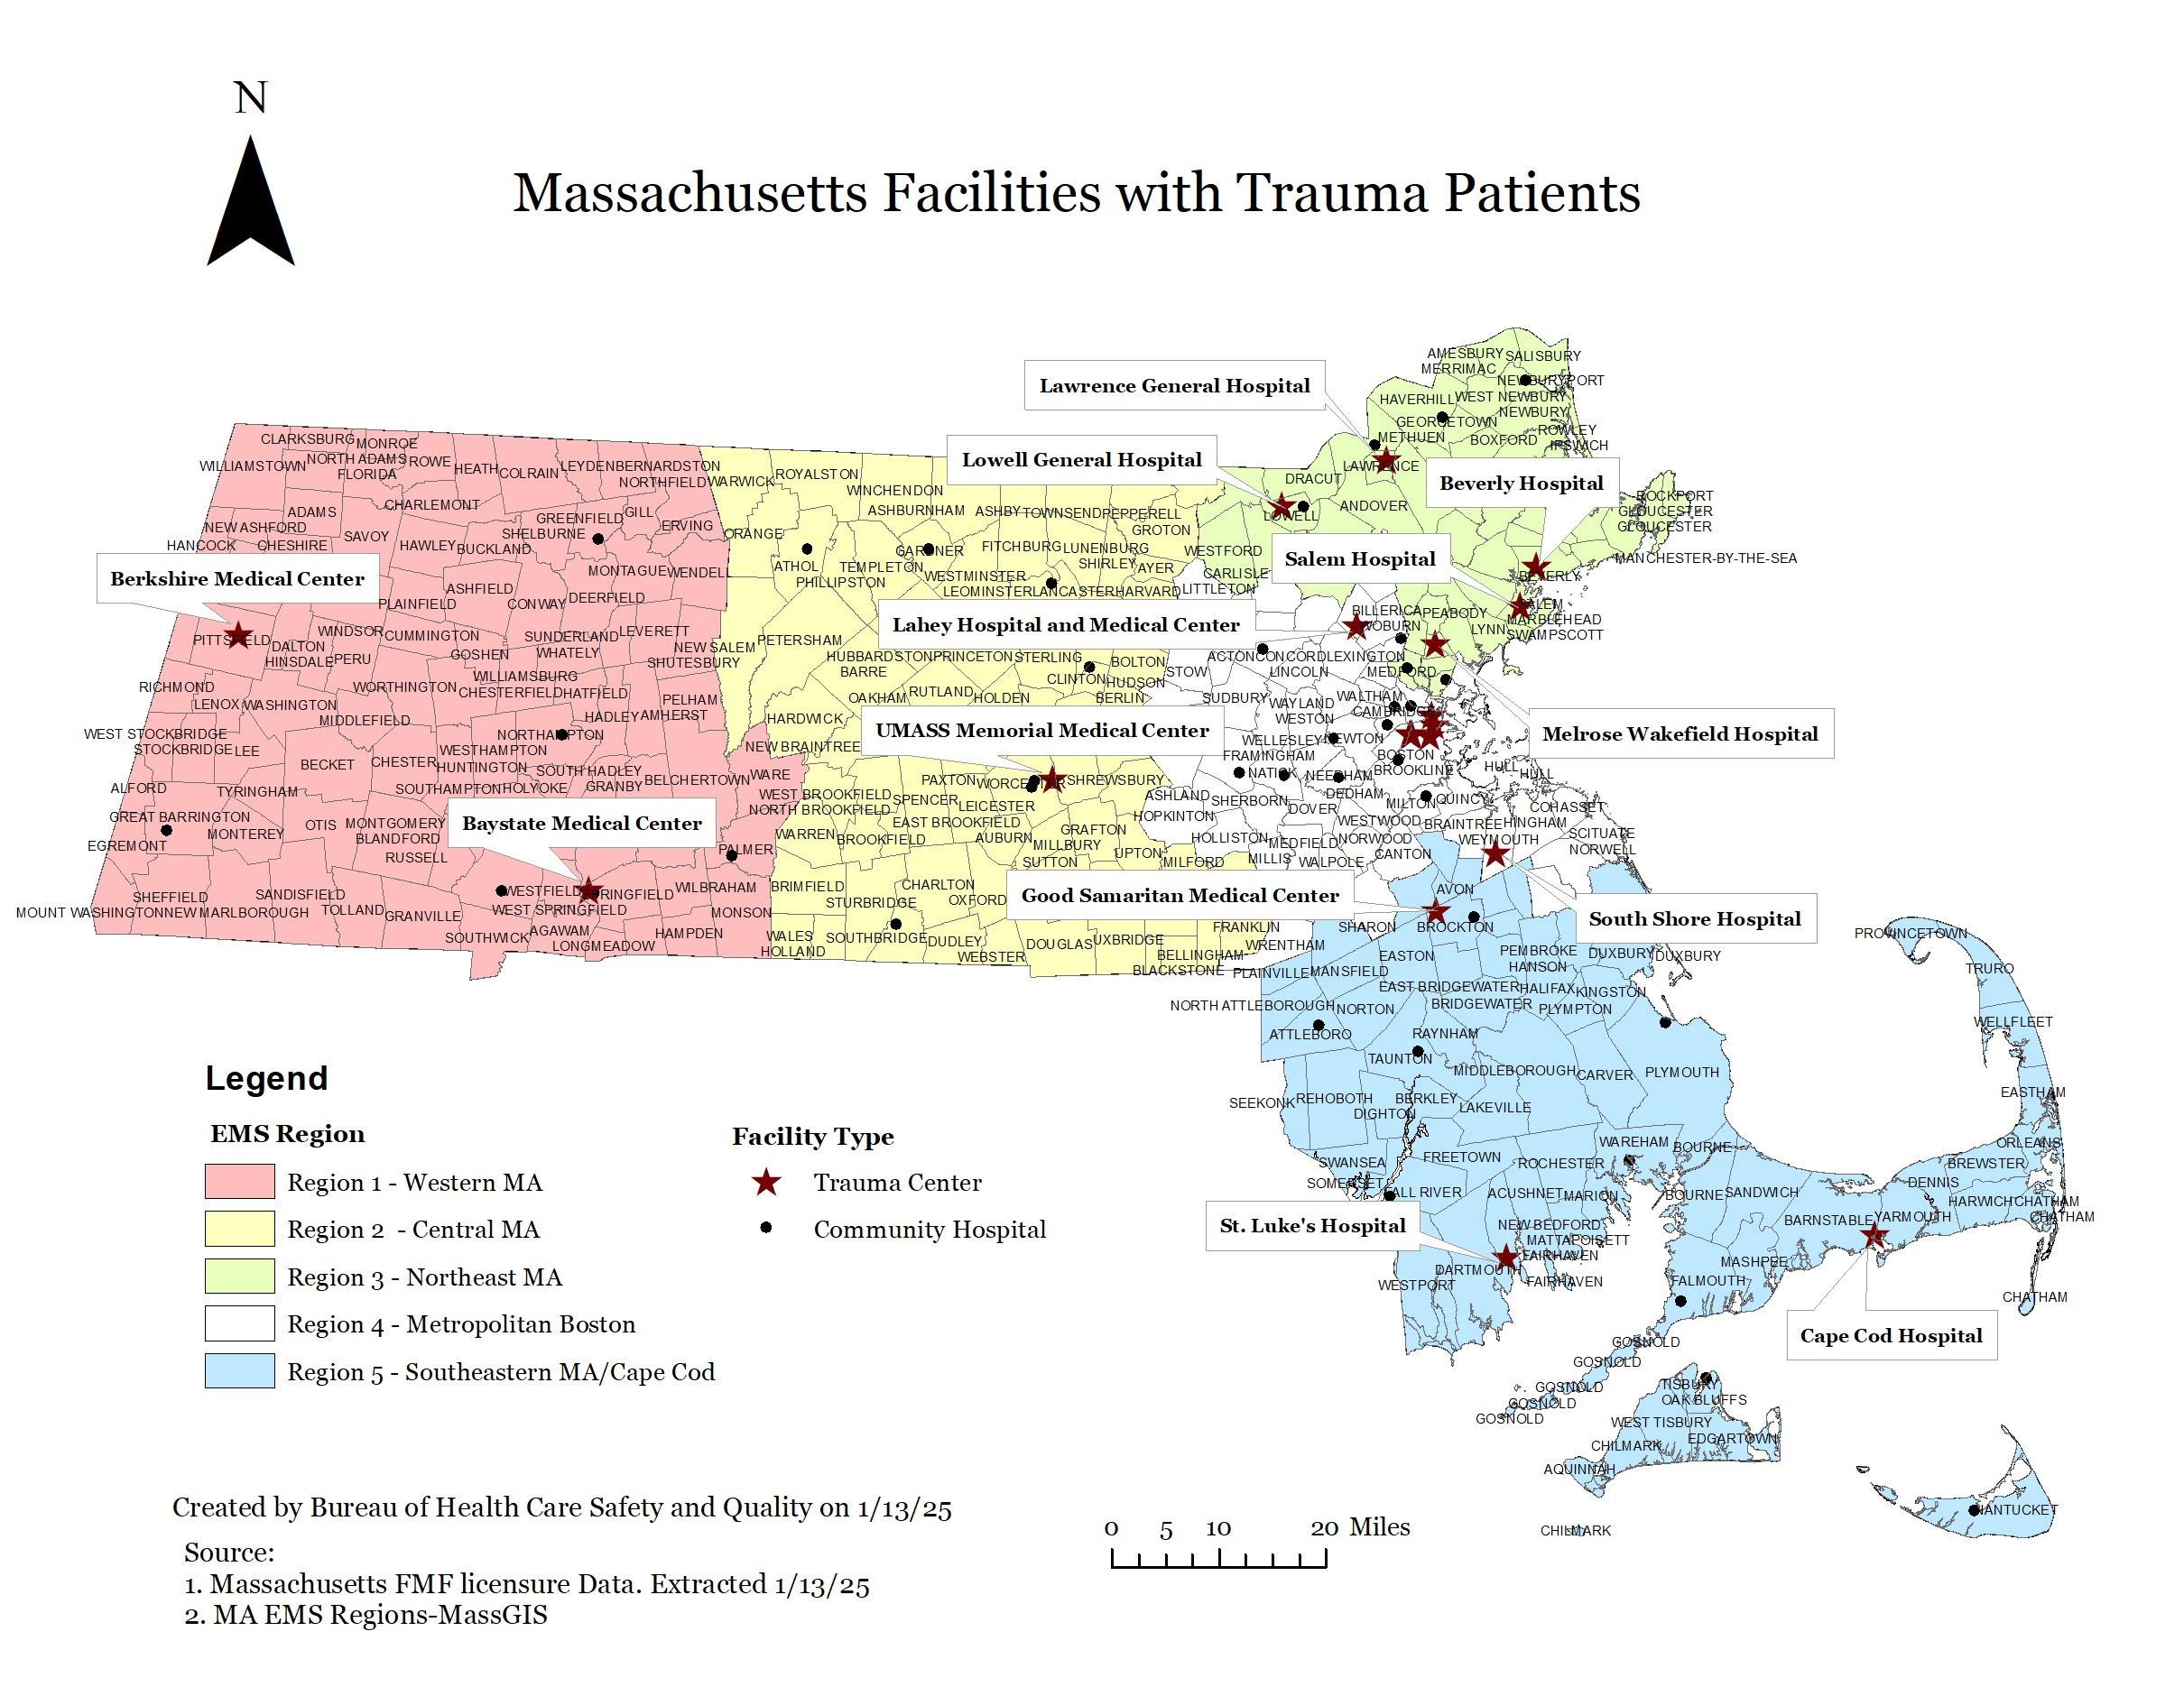

DRAFT - For Policy Development Only 15

Facility information – Boston

DRAFT - For Policy Development Only 16

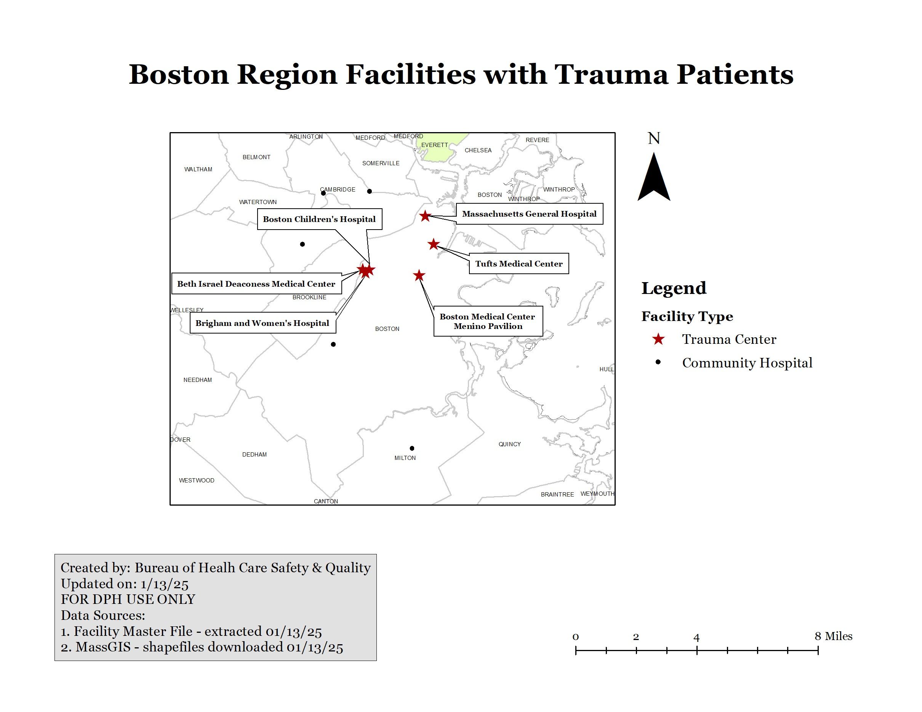

# Facility Information - Case Counts

Overall Trauma Case counts by Facility EMS Region

60,000

50,000

4,358

40,000

30,000

1,796

20,000

1,049

1,123 1,105

10,000

22,086

11,288

11,742

16,217

0

Western MA

Central MA Northeastern Metropolitan Southeastern

MA Boston MA/Cape Cod

Facility EMS Region

Adult cases Pediatric cases

47,084

Case counts

* For CY 2021-2023, MA TR received a total of 117,848 cases submitted by the 18 trauma centers and 43 community hospitals across the state with case fatality rate of 2.6%
* Metro Boston and Southeastern MA/Cape Cod account for the majority trauma cases (64%)

Facility Information - Case Counts

Manner of Injury

## • The leading causes of trauma were falls (67.0%) and motor vehicle traffic (12.9%)

Overall Trauma Case Counts by Manner of Injury

Fall

Motor Vehicle Traffic

69319, 67.0%

13376, 12.9%

Struck By, Against

Cut or Pierce Unspecified

Firearm Motor Vehicle Nontraffic Pedal Cyclist, Other

Other Specified, classifiable Natural or Environmental

Overexertion Pedestrian, Other

Fire, Burn, or Hot Substance

Machinery Other Land Transport Transport, Other Drowning or Submersion

Suffocation

4997, 4.8%

3315, 3.2%

2479, 2.4%

1587, 1.5%

1585, 1.5%

1557, 1.5%

1304, 1.3%

999, 1.0%

870, 0.8%

525, 0.5%

479, 0.5%

439, 0.4%

424, 0.4%

134, 0.1%

76, 0.1%

33, 0.0%

0

10,000

20,000

30,000

40,000

Case counts

50,000

60,000

70,000

80,000

Annual Trauma Cases by Facility EMS Region and Year

20,000

18,000

16,000

14,000

12,000

10,000

8,000

6,000

4,000

2,000

0

Western MA

Central MA Northeastern MA Metropolitan

Boston

Facility EMS Region

Southeastern

MA/Cape Cod

2021

2022

2023

Case counts

Facility Information - Case Counts

Compared with CY 2021, annual trauma cases decreased in the past 3 years across all regions

Pediatric Cases

1,800

1,600

1,400

1,200

1,000

800

600

400

200

0

Western MA Central MA Northeastern Metropolitan Southeastern

MA

Facility EMS Region

Boston

MA/Cape Cod

2021 2022 2023

Adult Cases

18,000

16,000

14,000

12,000

10,000

8,000

6,000

4,000

2,000

0

Western MA Central MA Northeastern Metropolitan Southeastern

MA

Facility EMS Region

Boston

MA/Cape Cod

2021 2022 2023

Case count

Case count

Facility Information - Case Counts by Region, Year

* In Western and Central regions, adult cases decreased while pediatric cases increased in the past 3 years.
* In Boston and Southeastern MA/Cape Cod, both adult and pediatric trauma cases decreased in the past 3 years.

|  |  |  |  |  |  |
| --- | --- | --- | --- | --- | --- |
|  | **Demographics** | **Cases** | **Percent** | **Deaths** | **Case Fatality**  **Rate* (95%CI)** |
| Age | 0-14 | 6,131 | 5.2 | 31 | 0.5 (0.3, 0.7) |
|  | 15-29 | 11,032 | 9.4 | 265 | 2.4 (2.4, 2.7) |
|  | 30-59 | 25,866 | 21.9 | 548 | 2.1 (2.1, 2.3) |
|  | 60-74 | 26,856 | 22.8 | 567 | 2.1 (2.1, 2.3) |
|  | 75-84 | 23,259 | 19.7 | 642 | 2.8 (2.7, 3.0) |
|  | 85+ | 24,704 | 21 | 981 | 4.0 (3.9, 4.2) |
| Gender | Female  Male | 59,296  58,526 | 50.3  49.7 | 1,180  1,854 | 2.0 (2.0, 2.1)  3.2 (3.1, 3.3) |
| Race | Asian | 2,621 | 2.2 | 80 | 3.1 (2.4, 3.8) |
| Ethnicity | Black or African American | 7,055 | 6.0 | 179 | 2.5 (2.5, 2.9) |
|  | Hispanic or Latino | 9,021 | 7.7 | 221 | 2.4 (2.4, 2.8) |
|  | White | 85,877 | 72.9 | 2,203 | 2.6 (2.5, 2.7) |
|  | Two or more | 2,501 | 2.1 | 27 | 1.1 (0.7, 1.6) |
|  | Unknown | 10,553 | 9.0 | 320 | 3.0 (3.0, 3.4) |
| EMS | Western MA | 12,411 | 10.5 | 468 | 3.8 (3.7, 4.1) |
| Region | Central MA | 12,847 | 10.9 | 323 | 2.5 (2.5, 2.8) |
|  | Northeastern | 17,266 | 14.7 | 349 | 2.0 (2.0, 2.2) |
|  | Metropolitan Boston | 51,442 | 43.7 | 1,530 | 3.0 (2.9, 3.1) |
|  | Southeastern /Cape Cod | 23,882 | 20.3 | 364 | 1.5 (1.5, 1.7) |

Patient Characteristics

* Case fatality rate among 75+ age groups are significantly higher
* Case fatality rate among Asian and unknown are also higher
* Western MA had a significantly higher case fatality rate compared with other regions
* Case fatality rates are not adjusted for any risk factors

# Patient Characteristics - Trauma Occurrence

Percentage of Trauma Case Counts by Hour of

7

the Day

6

5

4

3

2

1

0 1 2 3 4 5 6 7 8 9 10 11 12 13 14 15 16 17 18 19 20 21 22 23

Hour of Day

Percentage of Trauma Case Counts by Weekday

15

14.5

14

13.5

13

Mon

Tue

Wed Thu

Weekday

Fri

Sat

Sun

Percentage of Trauma Case Counts by Month

10

9

8

7

6

Jan Feb Mar Apr May Jun Jul Aug Sep Oct Nov Dec

Month

Percentage of Trauma Cases

Percentage of Trauma Cases

Percentage of Trauma Cases

* Trauma case admissions were most likely to happen:
  + During summer months (May-August)
  + On the weekends (Friday-Sunday)
  + And in the afternoon (peaking at 5 p.m.)

Injury Statistics

* Firearm-related injuries had the highest care fatality rate.
* The case fatality rates among motor vehicle traffic-related injuries and suicide/self harm injuries are significantly higher compared with other injury categories.
* Case fatality rates are not adjusted for any risk factors

**MA Trauma Injury by Intention and Injury Manner, CY 2021-2023**

|  |  |  |  |  |  |  |
| --- | --- | --- | --- | --- | --- | --- |
|  | **Category** |  | **Cases** | **Percent** | **Deaths** | **Case fatality rate* ( 95% CI)** |
| Intention | Unintentional |  | 96,866 | 82.2 | 2,470 | 2.5 (2.5, 2.7) |
| Homicide or Assault |  | 5,046 | 4.3 | 201 | 4.0 (3.9, 4.5) |
| Suicide and Self-Injury |  | 996 | 0.8 | 107 | 10.7 (10.1, 12.8) |
| Undetermined |  | 408 | 0.3 | 42 | 10.3 (7.4, 13.9) |
| Manner | Fall |  | 69,319 | 58.8 | 1,851 | 2.7 (2.7, 2.8) |
| Motor Vehicle Traffic |  | 13,376 | 11.4 | 485 | 3.6 (3.6, 3.9) |
| Struck By, Against |  | 4,997 | 4.2 | 29 | 0.6 (0.4, 0.8) |
| Cut or Pierce |  | 3,315 | 2.8 | 61 | 1.8 (1.4, 2.4) |
| Unspecified |  | 2,479 | 2.1 | 35 | 1.4 (1.0, 2.0) |
| Firearm |  | 1,587 | 1.3 | 239 | 15.1 (14.3, 17.0) |
| Motor Vehicle Nontraffic | | 1,585 | 1.3 | 32 | 2.0 (1.4, 2.9) |
| Pedal Cyclist, Other |  | 1,557 | 1.3 | 7 | 0.4 (0.2, 0.9) |
| Unclassifiable |  | 1,304 | 1.1 | 17 | 1.3 (0.8, 2.1) |

45,000

40,000

35,000

30,000

25,000

20,000

15,000

10,000

5,000

0

Fall Cases and Fatalities by Gender

(n, % fatalities)

40200, 2.11%

29109, 3.45%

Male Female

Gender

35,000

30,000

25,000

20,000

15,000

10,000

5,000

-

Fall Cases and Fatalities by Facility EMS Region

(n, % fatalities)

31,460 , 3.21%

12,731 , 1.78%

10,675 , 1.19%

7,356 , 3.53%

7,097 , 3.23%

Western MA Central MA

Northeastern

MA

Facility EMS Region

Metropolitan Southeastern

Boston MA/Cape Cod

Injury Statistics - Falls

* Trauma incidence and case fatality rate* increased with patient’s age.
* There are more female cases, however, male patients had higher case fatality rate*.
* Metropolitan Boston region had the most cases compared to other regions; Western MA region had the highest case fatality rate*.

Cases

Fatalities

Cases

* + Case fatality rates are not adjusted for any risk factors



Fall Cases and Fatalities by Age Group

20,000

18,000

16,000

14,000

12,000

10,000

8,000

6,000

4,000

2,000

0

10

9

8

7

6

5

4

3

2

1

0

Age Group

Case counts CFR

# Injury Statistics - Motor Vehicle Traffic

Cases

Fatality (%)

Case Fatality Rate

* Trauma incidence is bimodal with peaks observed among both the 20-34 and 55-64 age groups and case fatality rate* increased with age for those 40+ years old.
* Western MA region had the highest case fatality rate*.
  + Case fatality rates are not adjusted for any risk factors

Motor Vehicle Traffic Trauma Cases and Fatalities by Age Group

1,600

12.0%

1,400

10.0%

1,200

1,000

8.0%

800

6.0%

600

4.0%

400

200

2.0%

0

0.0%

Age Group

Case counts Fatality

Motor Vehicle Traffic Trauma Case Fatality Rate by Facility EMS

Region

8.00

7.00

6.00

5.00

4.00

3.00

2.00

1.00

Western MA Central MA

Northeastern

MA

Facility EMS Region

Metropolitan Southeastern

Boston

MA/Cape Cod

2.09

3.17

3.60

3.70

5.72

0-4

5-9

10-14

15-19

20-24

25-29

30-34

35-39

40-44

45-49

50-54

55-59

60-64

65-69

70-74

75-79

80-84

85+

# Injury Statistics - Firearm Trauma



Firearm Trauma Cases by Age Group

350

300

250

200

150

100

50

0

Age Group

Firearm Trauma Cases by Race Ethnicity

(n, % of cases)

Black or African American

627, 40.0%

Hispanic or Latino

423, 27.0%

White

304, 19.0%

Unknown

200, 13.0%

Asian

25, 2.0%

Two or more

3, 0%

0

100

200

300

400

500

600

700

Case count

1,600

Firearm Trauma Cases by Gender

(n, % of cases)

1430, 89.0%

1,400

1,200

1,000

800

600

400

200

182, 11.3%

0

Male

Female

Gender

Case count

Case count

Race ethnicity

* Most cases are 15-44 yrs old.
* Black or African American and Hispanic patients account for two thirds (67%) of the cases.
* We observed 8 times as many male cases as female with similar case fatality rate (15%)*.
* Case fatality rate* is highest in Northeastern region (20.9%) followed by Western MA (19.1%) and, Southeastern region (18.7%).
* Percentage of Homicide or Assault is higher in Boston region, whereas the percentage of Suicide and Self-injury is higher in Southeastern region.

Case count

Facility EMS Region

Injury Statistics - Firearm Trauma

* + Case fatality rates are not adjusted for any risk factors

Firearm Trauma Cases and Fatalities by Facility EMS Region

(n, % fatalities)

1,200

1,000

850, 12.9%

800

600

400

315, 19.1%

200

101, 5.9%

134, 20.9%

187, 18.7%

0

Western MA Central MA Northeastern Metropolitan Southeastern

MA Boston MA/Cape Cod

Facility EMS Region

Percentage of Firearm Trauma Cases by Facility EMS Region

and Injury Intention

Southeastern MA/Cape Cod Metropolitan Boston Northeastern MA

Central MA

Western MA

1.0%

21.0% 41.0% 61.0% 81.0% 101.0%

Percentage of Cases

Unintentional

Homicide or Assault

Suicide and Self-Injury

Legal Intervention or War Undetermined

Suicide/Self injury: Trauma Case and Fatality by Gender

(n, % fatalities)

800

700

600

500

400

300

200

100

0

682, 12.6%

313, 6.7%

Male Female

Gender

Case count

Case count

Injury Statistics - Suicide/Self Injury

* The majority of suicide/self injury trauma cases fall within 15-64, with the peak of 20-34 yrs age groups.
* Among suicide/self injury trauma cases, male patients had a higher incidence and case fatality rate* than females.
* White patients account for the most cases. Those patients with unknown race information had the highest case fatality* rate (18.1%) followed by white (11%).
  + Case fatality rates are not adjusted for any risk factors



Suicide/Self Injury Trauma Case by Age Group

120

100

80

60

40

20

0

Age Group

Suicide/Self Injury Trauma Case and Fatality by Race Ethnicity

(n, %fatality)

700

643, 11.0%

600

500

400

300

200

112, 6.3%

116, 18.1%

100

83, 7.2%

34, 2.9%

0

Asian

Black or African Hispanic or Latino

American

Race Ethnicity

Unknown

White

Case count

# Hospital Statistics

Trauma Patients Admitted to ICU by Injury Severity Score

(ISS)

40,000

35,000

30,000

25,000

20,000

15,000

10,000

5,000

0

35394, 5.1%

25827, 13.3%

3847, 43.7%

1219, 69.9%

Minor (1-8) Moderate (9-15) Severe (16-24) Very Severe (25+)

ISS Group

Cases ICU Cases

ICU Cases and Fatalities by Injury Severity Score (ISS)

4,500

4,000

3,500

3,000

2,500

2,000

1,500

1,000

500

0

3,612, 9.1%

2,716, 9.2%

2,096, 25.8%

1,716, 8.9%

Minor (1-8) Moderate (9-15) Severe (16-24) Very Severe (25+)

ISS Group

ICU cases ICU deaths

ICU cases

Case count

* Overall, there are 13% trauma patients admitted to ICU and the proportion of ICU admission increased by injury severity score.
* Among the ICU admissions, the case fatality rate* is about 9% among the minor, moderate and severe patients (ISS 1-25), however this rate increased to 25.8% for the very severe patients (ISS 25+).



Trauma Patients Admitted to the ICU

**ICU cases, 11,672,**

**13%**

**Trauma cases, 77,959, 87%**

* + Case fatality rates are not adjusted for any risk factors

# Hospital Statistics



Percentage of ICU Cases by Age Group

20.0

18.0

16.0

14.0

12.0

10.0

8.0

6.0

4.0

2.0

0.0

30,000

25,000

20,000

15,000

10,000

5,000

0

Age Group

cases % ICU

Percentage of ICU Cases

ICU Cases

* The percent of trauma patient admitted to the intensive care unit (ICU) is higher among younger adults (20-35 yrs old) and decreased with age, aligning with more severe motor vehicle traffic and firearm trauma injuries, while the leading cause of trauma injury among older adults is falls.

Hospital Statistics

* The case fatality rate* increased with 75+ age groups with all the levels of injury severity score (ISS).
* The case fatality rate* is highest among the ISS score of 25+ (very severe) with all the age groups.
  + - Case fatality rates are not adjusted for any risk factors



Case Fatality Rate by Age Group and Injury Severity Score (ISS)

40

35

30

25

20

15

10

5

0

Age Group

Minor (1-8)

Moderate (9-15)

Severe (16-24)

Very Severe (25+)

Case Fatality Rate

# Hospital Statistics

* Overall, the median length of stay (LOS) is 3 days with IQR (1,6) across all regions.
* However, the ICU days are longer in western and central MA regions.

|  |  |  |  |  |  |  |  |  |  |
| --- | --- | --- | --- | --- | --- | --- | --- | --- | --- |
| Facility EMS Region | Overall Median (IQR) | | | Pediatric (0-19) | | | Adult (20+) Median (IQR) | | |
| LOS | ICU Days | Ventilator Days | LOS | ICU Days | Ventilator Days | LOS | ICU Days | Ventilator Days |
| Western MA | 3.0 (1.0, 6.0) | 3.0 (2.0, 6.0) | 2.0 (2.0, 6.0) | 1.0 (1.0, 2.0) | 2.0 (2.0, 3.0) | 2.0 (2.0, 7.5) | 3.0 (2.0, 6.0) | 3.0 (2.0, 6.0) | 2.0 (2.0, 6.0) |
| Central MA | 3.0 (1.0, 6.0) | 5.0 (3.0, 9.0) | 3.0 (1.0, 8.0) | 1.0 (1.0, 2.0) | 2.0 (2.0, 5.0) | 2.5 (1.0, 6.5) | 4.0 (1.0, 6.0) | 5.0 (3.0, 9.0) | 3.0 (1.0, 8.0) |
| Northeastern MA | 3.0 (1.0, 5.0) | 3.0 (2.0, 4.0) | 1.0 (1.0, 2.0) | 0.0 (0.0, 1.0) | 0.0 (0.0, 1.0) | 1.0 (1.0, 1.0) | 3.0 (2.0, 5.0) | 3.0 (2.0, 4.0) | 1.0 (1.0, 2.0) |
| Metropolitan Boston | 3.0 (1.0, 6.0) | 0.0 (0.0, 3.0) | 0.0 (0.0, 0.0) | 1.0 (1.0, 2.0) | 1.0 (0, 3.0) | 0.0 (0.0, 1.0) | 4.0 (2.0, 6.0) | 0.0 (0.0, 3.0) | 0.0 (0.0, 0.0) |
| Southeastern MA/Cape Cod | 3.0 (1.0, 5.0) | 0.0 (0.0, 3.0) | 2.0 (1.0, 5.0) | 0.0 (0.0, 1.0) | 0.0 (0.0, 0.0) | 1.0 (1.0, 4.0) | 3.0 (1.0, 5.0) | 0.0 (0.0, 4.0) | 2.0 (1.0, 5.0) |

Hospital Statistics

* About 28% of trauma patients were discharged to home with no services, 20% to skilled nursing facilities, 14% to home with services, 11% to inpatient rehabilitation.

Percentage of Trauma Case Discharges/Transfers by Disposition

|  |  |  |  |  |  |  |  |  |  |
| --- | --- | --- | --- | --- | --- | --- | --- | --- | --- |
| Home or Self Care (Routine Discharge) |  |  |  |  |  |  |  |  | 27.9% |
| Skilled Nursing Facility |  |  |  |  |  |  |  | 19.8% |  |
| Home with Services |  |  |  |  |  |  | 13.7% |  |  |
| Unknown |  |  |  |  |  | 11.4% |  |  |  |
| Rehab (Inpatient) |  |  |  |  |  | 10.9% |  |  |  |
| Acute Care Facility |  |  |  | 8.1% |  | | | | |
| Another Type of Inpatient Facility Not Defined Elsewhere |  |  | 2.3% |  |
| Morgue |  |  | 2.2% |  |
| Left AMA |  | 1% |  |  |
| Hospice |  | 0.8% |  |  |
| Mental Health/Psychiatric Hospital (Inpatient) |  | 0.7% |  |  |
| Long-Term Care |  | 0.5% |  |  |
| Nursing Home |  | 0.3% |  |  |

Correctional Facility/Court/Law Enforcement

Patient Discharged to Location

Intermediate Care Facility Child Protective Agency

Burn Center

0.2%

0.2%

0.1%

0%

0 5 10 15 20 25 30

Percentage of Cases

Summary

Key findings:

For CY 2021-2023, MA Trauma Registry received a total of 117,848 cases submitted by the 18 trauma centers and 43 community hospitals across the state with an overall case fatality rate of 2.6%*

* Trauma incidence and the case fatality rate* increased with patient’s age; males had a higher incidence and case fatality rate* than females; Metro Boston region hospitals had the highest trauma incidence. Western region had a highest case fatality rate* compared to other regions
* Trauma events were most likely to occur during summer months, on the weekends, and in the afternoon (peaking at 5 p.m.)
* The leading causes of trauma were falls and motor vehicle traffic crashes. Firearm injuries had the highest case fatality rate* ( 15%), African American and Hispanic patients account for the majority of these cases.
* The case fatality rate* increased with patients 75+ years old and is highest among those with an ISS score of 25+ (very severe) for all age groups
* Patients spent more time in ICU and on a ventilator in Western and Central MA regions
* The majority of trauma patients were discharged to home (44%) and skilled nursing facilities ( 20%)
  + Case fatality rates are not adjusted for any risk factors

Resources

Massachusetts Department of Public Health | mass.gov/dph

35

[State Trauma Registry Data Submission | Mass.gov](https://www.mass.gov/info-details/state-trauma-registry-data-submission?_gl=1%2A3p9w8l%2A_ga%2AMTMzNzg3NTIyMC4xNzE4MDQzMTE4%2A_ga_MCLPEGW7WM%2AMTcxOTg1MjUxNS4xMS4xLjE3MTk4NTI1NDIuMC4wLjA) [Trauma Hospital Destinations | Mass.gov](https://www.mass.gov/info-details/trauma-hospital-destinations?_gl=1%2A1221m3d%2A_ga%2AMTMzNzg3NTIyMC4xNzE4MDQzMTE4%2A_ga_MCLPEGW7WM%2AMTcxOTMxOTU4Ni42LjAuMTcxOTMxOTU4Ni4wLjAuMA)

Connect with DPH

Massachusetts Department of Public Health | mass.gov/dph

36

@MassDPH

Massachusetts Department of Public Health mass.gov/dph