Treatment Options for Stimulant Use Disorder in Long-Term Care Settings

Contingency Management

Training Available
s

Treatment: Tangible reinforcers for behavior change such as a monetary incentive for a negative urine screen.

Training Intensity and Duration: No prescribed intensity and duration; typically 12 weeks.

Motivational Interviewing

Training Available

Treatment: Resolving clients’ ambivalent feelings and insecurities and enhancing the internal motivation to change behavior.

Training Intensity and Duration: No prescribed intensity and duration.

Exercise Supported Recovery

Training Available

Treatment: Varying exercise programs have been described, but those with a combination of daily aerobic and anaerobic exercise are associated with long term recovery.
Training Intensity and Duration: Intensity and duration based on the physical limitations of the individual resident.
Trauma Informed Care Seeking Safety

Training Available
s

Treatment: Model for co-occurring PTSD and
SUD that emphasizes the need to be safe in order to explore and cope with trauma. Can be done in a group or individually.
Training Intensity and Duration: Duration and intensity varies based on the target population.

Community Reinforcement Approach

Training Available
s

Treatment: Identifying behaviors that reinforce stimulant use and making a substance-free lifestyle more rewarding.

Training Intensity and Duration: No prescribed intensity and duration; recommended for
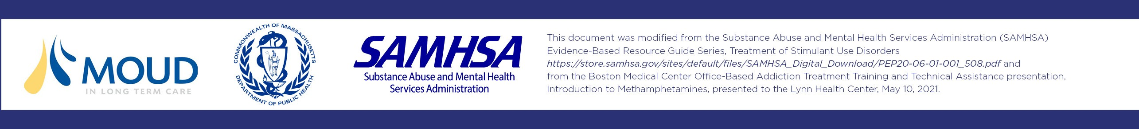
24 weeks.

This document was modifed from the Substance Abuse and Mental Health Services Administration (SAMHSA) Evidence Based Resource Guide Series, Treatment of Stimulant Use Disorders https://store.samhsa.gov/sites/default/fles/SAMHSA Digital Download/PEP20 06 01 001 508.pdf and from the Boston Medical Center Ofce Based Addiction Treatment Training and Technical Assistance presentation, Introduction to Methamphetamines, presented to the Lynn Health Center, May 10, 2021.
Cognitive Behavioral Therapy

Training Available
s

Treatment: Helping clients improve the quality of their lives not by changing their circumstances, but altering their perceptions of those circumstances.

Training Intensity and Duration: No prescribed intensity and duration; typically, 5 to 10 months.

