
Report

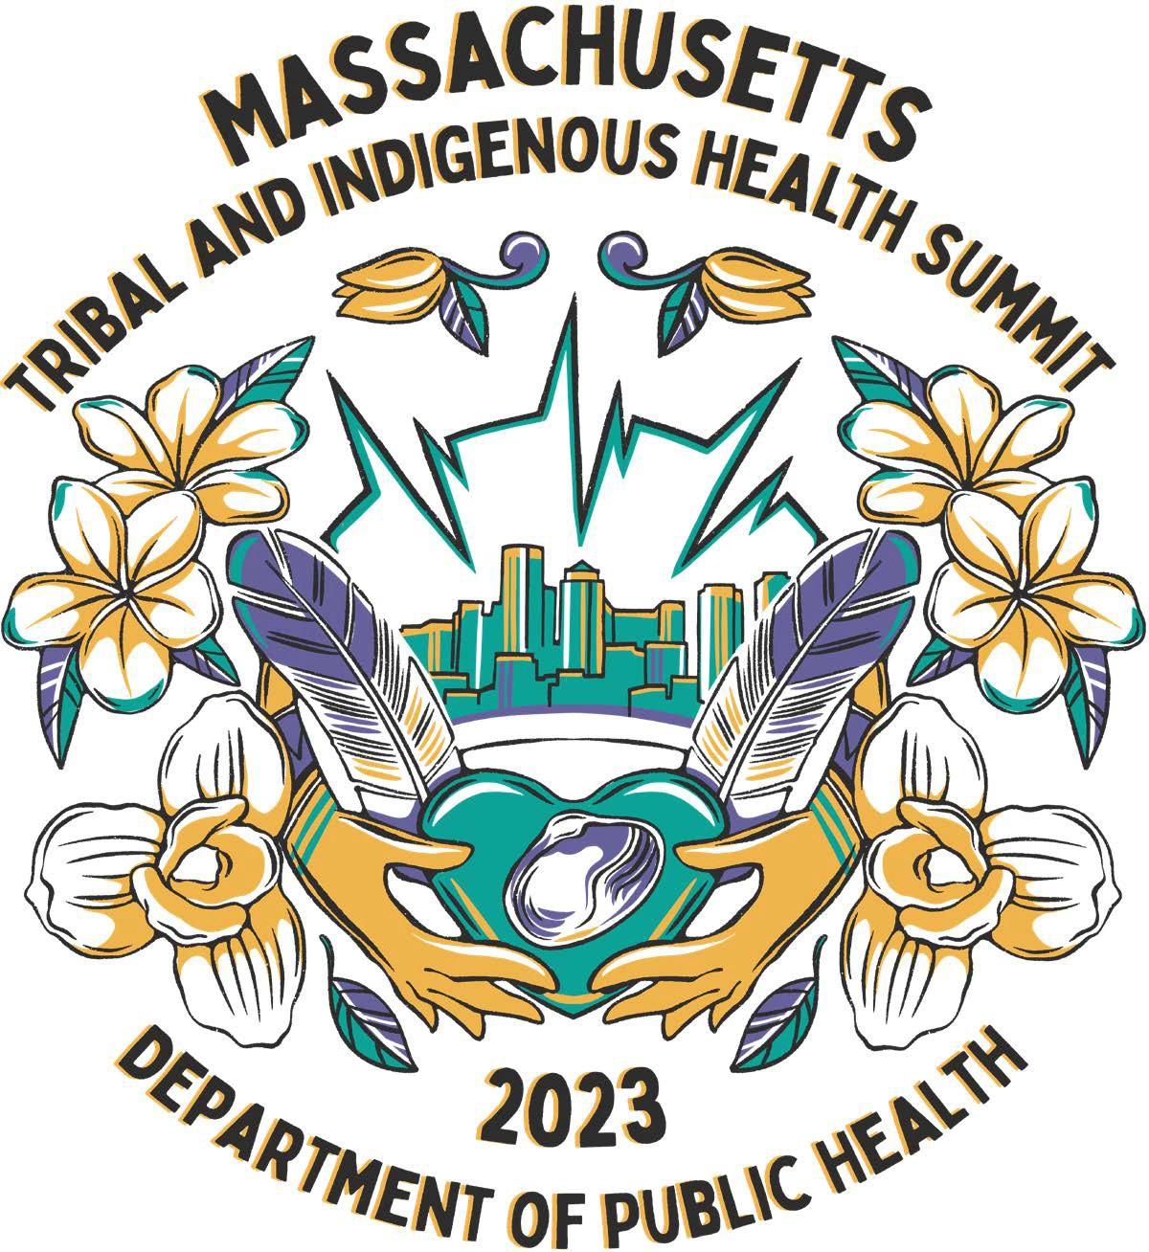

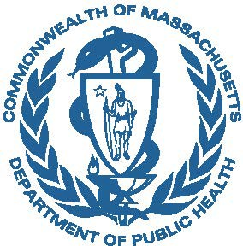

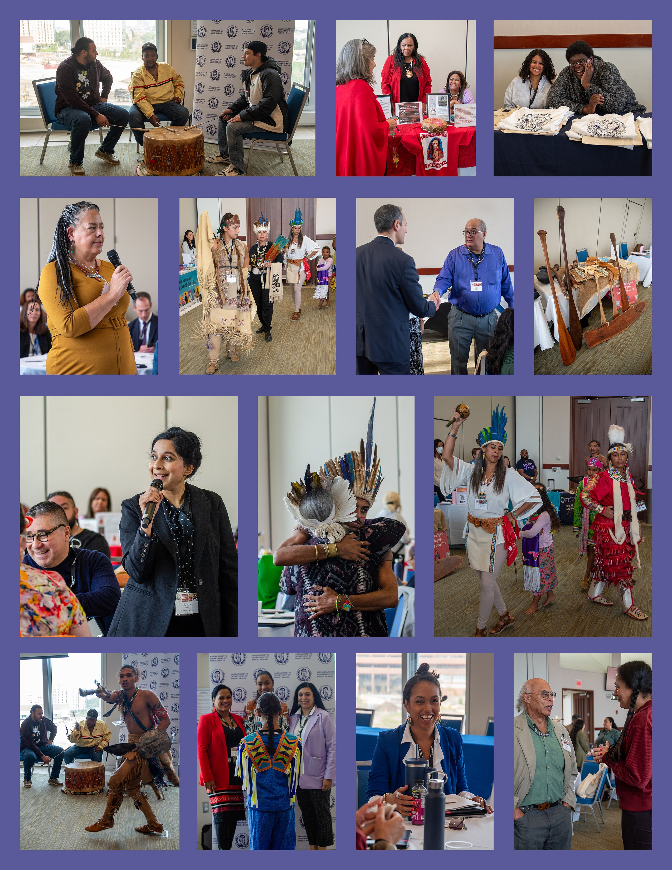

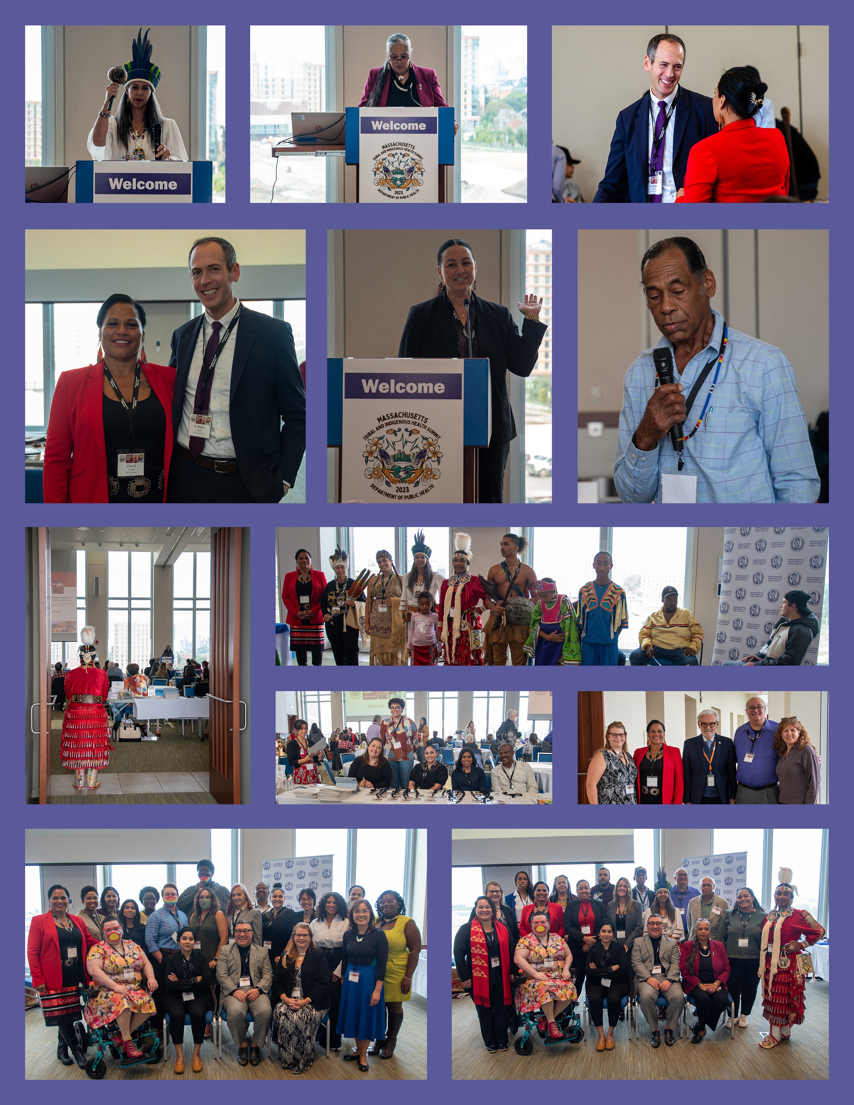

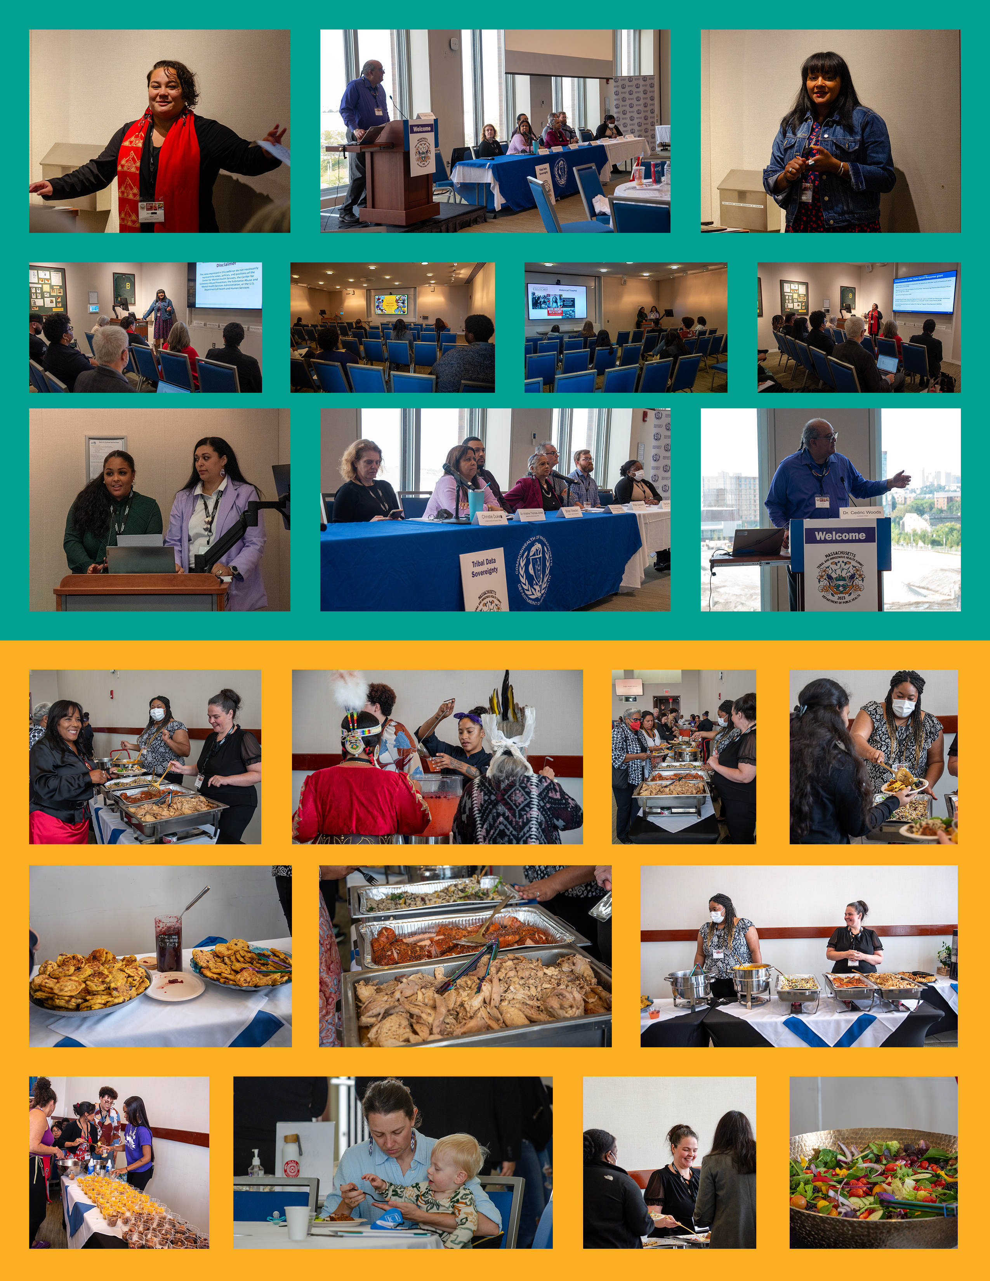

The Tribal Health Summit was the beginning of what I see as a way for all of us to continue learning, growing, networking, and collaborating. The energy and spirit in the room were contagious, and I left the forum encouraged and inspired to expand the collaboration and relationships between DPH and the Tribes and Tribal Serving Organizations.
— DPH Commissioner Dr. Robert Goldstein

EXECUTIVE SUMMARY
The Massachusetts Department of Public Health (DPH) and Tribal community partners convened the inaugural Massachusetts Tribal and Indigenous Health Summit at
the University of Massachusetts Boston on September 28, 2023. Over 150 people attended, representing Tribes, state government, federal government, Tribal and Indigenous Peoples Serving Organizations, and other organizations working on improving the health of Tribal and Indigenous people in Massachusetts.
The summit was conceived to gather a variety of interested parties to address key issues impacting the health of Tribal and Indigenous people in Massachusetts. These issues included improving the collection and analysis of Tribal health data, improving communication between government health agencies and Tribal Nations, and ensuring more efficient and effective funding mechanisms to improve funding to support Tribal and Indigenous health.

TABLE OF CONTENTS
LAND ACKNOWLEDGEMENT 1
OVERVIEW 1
KEYNOTE ADDRESS 2
SUMMIT GOALS AND OUTCOMES 3
NEXT STEPS 6
MAIN SESSION PRESENTATIONS 7
SMALL GROUP PRESENTATIONS 8
PARTICIPATING AGENCIES FOCUSED ON TRIBAL AND INDIGENOUS HEALTH 9
EXHIBITORS 10
ACKNOWLEDGEMENTS 13

LAND ACKNOWLEDGEMENT
The purpose of the Land Acknowledgement is to show respect for the local Indigenous peoples and recognize their enduring relationship to the land. It is a way of showing gratitude, honoring the truth, and resisting the erasure of Indigenous histories and cultures. It also helps to create awareness about history and establish relationships with Native communities that are often suppressed or forgotten.
Here at the Massachusetts Department of Public Health (DPH), we would like to acknowledge that the land where we live, work, learn, worship, grow, age, and farm, where we are today and where we are working from, are the original homelands of the Massachusetts Tribal nations. We need to protect and honor the history and people of these places because, despite centuries of colonial theft and violence, this is still Indigenous land and will aways be Indigenous land.

OVERVIEW
The inaugural Massachusetts Tribal and Indigenous Health Summit was held at the University of Massachusetts Boston on September 28, 2023. The Summit marked a new beginning in bringing people across the state’s public health and health care spectrum together for the betterment of Tribes, Indigenous people, and the organizations that serve Native American populations in Massachusetts.
Among the 150 attendees were Tribal leaders and community members from Tribes in Massachusetts, Rhode Island, and New York, as well as staff from Tribal and Indigenous People Serving Organizations (TIPSOs). Representatives from federal and
state agencies were present to learn and discuss Tribal and Indigenous culture, health priorities, and best practices from the COVID-19 pandemic.
The summit was conceived to gather together a variety of interested parties, including local, state, federal and Tribal governments, Tribal and Indigenous Serving Organizations, and Tribal Community partners to learn, grow, support, and connect. To
make this possible, a diverse group of people worked together to create an environment that was safe and inclusive, and that drew on the experiences of Massachusetts’ Tribal and Indigenous people.
The format and content of the summit centered Tribal and Indigenous experience and culture. A Tribal Land Acknowledgement by Elizabeth Solomon focused participants on the longstanding history that has brought them to reside on the land, allowing them to reflect on their own place within that history and the impact on health. Mashpee Wampanoag Chairman Brian Weeden offered a prayer in his traditional Algonquin language.

Drumming and dancing were incorporated throughout the day, transforming the conference room into a place of community. Tribal leaders were asked to stand and be recognized, honoring them while showing the diversity of Tribal and Indigenous leaders participating in the summit. Tribal Elders were also honored, acknowledging the deep knowledge and experience they brought to the day’s conversation. The food served at lunch was catered by Chef Sherry Pocknett, a member of the Mashpee Wampanoag Tribe and the first Indigenous woman to win a prestigious James Beard Award.
The summit fostered a common consensus of the inequities Tribal and Indigenous people in Massachusetts face by discussing Tribal and Indigenous communities’ battle with COVID-19 and other critical health concerns. The summit explored the critical impact of social determinants of health, including limited health care resources.
Participants engaged in sharing strategies and resources to culturally enhance and strengthen partnerships in the state. Specific breakout sessions on Tribal data sovereignty, substance use, and mental health allowed panelists and participants to discuss the issues and share potential resources and strategies to address these and other issues that critically impact Tribal and Indigenous communities.
A team comprised of DPH staff and Tribal members from various communities planned the event, led by Cheryl Cromwell, the Tribal and Indigenous Health Equity Strategist for DPH’s Community Engagement Unit who is an enrolled member of the Mashpee Wampanoag Tribe.

KEYNOTE ADDRESS
This is a summary of the Keynote Address given by Chairwoman Cheryl Andrew-Maltais of the Aquinnah Wampanoag Tribe of Gay Head.
The Tribal Health Summit offered an opportunity to bring together many different people, perspectives, and ideas. The summit also offered a space for the acknowledgement of the resilience of the Indigenous community to still be here, in our own homelands. It is no small feat that despite 400 years of genocide, the Tribes are still here, organized, and working together as a community. And while we recognize our ability to sustain ourselves, there are still longstanding disparities within these communities that
need to be acknowledged, which is a debt owed to us by the United States and the Commonwealth of Massachusetts, for which we paid it forward with the lives of our Ancestors, our lands, and our natural resources.
The summit offered a tangible sign that the Commonwealth recognizes its responsibility to engage with Tribes and Tribal communities — as well as other Indigenous communities. Prior to federal recognition, Tribal communities had a relationship with the state, but our health outcomes have never been very positive, and there have always been disparities between Tribal communities and others. The summit offered a space

for all of us to roll up our sleeves and work together to generate better outcomes for our people through opportunities for flexible funding, transparent data sharing, and equitable partnerships.
One of the most exciting aspects of the summit was that it seemed to put us — the state and the Tribes and Tribal communities — on a path forward to expand our relationship and engage in more equitable collaboration. Throughout the day, it was inspiring to hear about some of the community successes that were highlighted in the presentations. And while there is no cookie-cutter model, there are always elements of others’ successes that can be modified and implemented elsewhere.
As we look toward the future, it will be crucial to ensure ongoing opportunities for collaboration, respecting the rights and knowledge of each entity, in order for the Tribes to make their decisions based upon the knowledge and judgement which is in each of the Tribes’ best interest.
From a Tribal perspective, health exists in the totality of physical, spiritual, emotional, and social health. Through self-governance, our Tribe has been able to incorporate health care services that elevate overall health and that break down the silos that exist within Western health perspectives.
To support these outcomes, the role of access to resources cannot be underestimated; while it is all well and good to have and share great ideas, we must also have people
at the table who are the decision-makers with bureaucratic authority to make the necessary changes and who can provide access to the resources needed to make great ideas happen. Through the deliberate focus on equity and flexibility, the state can support opportunities for Tribal communities to develop programs and services that adapt to our communities’ specific and unique needs.
The summit offered an opportunity to discuss and consider what is possible in the future. We need to keep this dialogue and momentum going. More frequent
opportunities to communicate and collaborate with decision-makers will move us all toward understanding the true need for flexible funding, transparent data sharing, and equitable partnerships.

SUMMIT GOALS AND OUTCOMES
The summit was organized around several goals that, if achieved, would improve the systems impacting Tribal and Indigenous health in Massachusetts.

Goal: Establish and enhance federal, state, regional, local, and Tribal relationships/ partnerships.

Outcome: The Inaugural Tribal and Indigenous Health Summit fostered conversation between key members of local, state, and federal governments; Tribal leadership; and Tribal and Indigenous community members. The topics, format, and setting of the event brought people together in one authentic environment to begin and grow these engagements.
As a result of relationships that grew out of the summit, the Tribal Health Strategist has created and strengthened partnerships across the state. The growth of partnerships has started a process of increasing resource capacity in Tribes and Indigenous communities and as well as understanding on the part of state agencies and programs about the needs and strengths of Indigenous people in the Commonwealth.

Goal: Improve understanding of the history of Tribes and Indigenous people in Massachusetts, New England, and beyond.
Outcome: Presenting information on topics that are central to Tribes and Indigenous communities created a framework for the conversations during the summit. In her keynote speech, Chairwoman Cheryl Andrew-Maltais of the Aquinnah Wampanoag Tribe of Gay Head gave a history of the land and people and highlighted the importance of recognizing that the community and culture of Indigenous people in Massachusetts is still very much alive.
Dedicating time to listen to and acknowledge the history and generational trauma that Tribal and Indigenous people carry enabled summit participants to take a more informed perspective, shifting the way they approach their work. The resulting conversations were guided by a spirit of reciprocal teaching and learning.

Goal: Gain knowledge of Tribal sovereignty, consultation, meaningful engagement, and health systems that serve Tribal and Indigenous people.
Outcome: Summit participants learned about the complexity of health care systems serving Tribal and Indigenous people in Massachusetts and across the United States. Presenters highlighted gaps and the difficulty of navigating multiple systems with different requirements. Native American Lifelines, a federal Urban Indian Program located in Baltimore and Boston that serves all Native people regardless of
governmental status, gave an overview of where non-federally recognized Tribal citizens receive health care.

Goal: Learn about Tribal and Indigenous priorities and challenges before, during the height of, and in the current state of the COVID-19 pandemic, as well as social determinants of health disparities.
Outcome: Dr. Jill Jim presented information about the COVID-19 pandemic in Indian Country, sharing data that demonstrated inequities and loss of life that Tribes and

Indigenous communities experienced across the United States. The data showed underlying inequities and uneven government support that contributed to the health disparities, made more pronounced during the COVID-19 pandemic.
The questions and discussions following Dr. Jill’s presentation demonstrated a commitment by the participants to examine the solutions, best practices, and strategies to address these disparities, acknowledging that the issues were important enough
to continue the tough conversations that followed. Through conversation, summit participants demonstrated a greater understanding of how Tribes and Indigenous communities are not included equitably in the resource allocation of the state and local governments, impacting social determinants of health.

Goal: Strengthen, engage, and coordinate resources and best practices that will support Tribal and Indigenous communities.
Outcome: Summit participants consisted of Native and non-Native people who embraced the knowledge of Tribal and Indigenous people and wanted to learn how they could create strong relationships and partnerships for future collaborations. The focus on learning informed future support and ongoing engagement between Tribal leadership and local, state, and federal government. The next summit will continue to build on this foundational understanding, focusing on specific areas of best practice to enhance coordination and collaboration.

Goal: Discuss policy development to address effective access to resources for Tribal and Indigenous communities.
Outcome: The summit afforded a space where Tribal communities and federal, state, regional, and local governments were able to learn and discuss key issues impacting Tribal and Indigenous health, including underlying social determinants of health. Key discussions included potential opportunities for improving government support for and collaboration with Tribes, Indigenous, and Tribal and People Serving Organizations.
Among the topics discussed were:
Better data collection and analyses from Tribal and Indigenous populations, leading to better public health interventions and solutions that are evidence-based, community centered, and community led. DPH data groups are actively engaged in this effort and were part of the panel presentation on Tribal data sovereignty.
The need for a funding mechanism that would streamline contracting between the Tribes and DPH. DPH’s Community Engagement Unit staff conducted an analysis of how other state health departments contract with sovereign Tribal nations.
Individuals at DPH plan to use the results of this analysis to identify opportunities to change contracting language and/or procurement models to produce better

contracts between Tribal nations and the Department moving forward. The DPH Chief Legal Counsel and Comptroller’s Office have also expressed an interest in the results of this analysis, which could result in further-reaching positive impacts beyond DPH.
Educating interested parties about the need for policy and legislative change to allow for increased state and federal funding to Tribal and Indigenous populations, employing data collected and analyzed in collaboration with Tribal and Indigenous communities and Public Health Authorities.
Improved community-engaged consultations with Tribal and Indigenous leaders and members of Tribal and Indigenous populations. Specifically, engaging to collaboratively plan how to address emerging environmental and health threats, including social determinants of health and other underlying issues.

The collaborative efforts between the Department of Public Health and non-federally recognized tribes are essential for the survival

of tribes in Massachusetts. This partnership, rooted in mutual respect, understanding, and support for our unique health care needs, is the cornerstone for the enduring existence and thriving future of Indigenous peoples in the Commonwealth.
—Melissa Harding Ferretti, Chairperson, Herring Pond Wampanoag Tribe

NEXT STEPS
The summit provided a valuable forum for a variety of people focused on Tribal and Indigenous health, and the consensus was that a second summit should be held in 2024. DPH has allocated funding to enable this to happen, and the next Tribal and Indigenous Health Summit will take place in September 2024.
Throughout the year leading up to the second summit, partnerships will continue and DPH staff will ensure that movement occurs on the key topics outlined in the previous section of this report.
At the next summit, participants will dive deeper into the strategies of building lasting and meaningful partnerships between Tribal and Indigenous communities and local, regional, state, and federal governments. The summit will provide an opportunity
to measure progress in the areas of priorities identified at the first summit, and to continue to build capacity to improve the health of Tribal and Indigenous people in Massachusetts.

Having a space for Tribes and Indigenous communities to share their priorities and concerns was an opportunity that we don’t get these days. As a leader from a Tribe in another state, the experience had me thinking that we need to do this across the New England states, as we are intertribal in so many ways. I am looking forward to the next one and thankful for the time I had addressing some heath issues with Indian Health Service and other state and federal agencies with my own Tribe.
—Hiawatha Brown, Narragansett Indian Tribe Councilman for 35 years, Rhode Island

MAIN SESSION PRESENTATIONS

How Tribal and Indigenous Peoples Serving Organizations (TIPSOs) Promote Wellness through Culture and Partnership
In August 2020, as part of its Vaccine Equity Initiative, DPH launched the COVID Community Grants Program to rapidly invest funding and capacity building support to organizations in communities hardest hit by COVID-19, ensuring that several of those organizations were Tribal and Indigenous peoples serving organizations (TIPSOs).
Representatives from some of these TIPSOs shared their experiences at the summit, exploring the challenges they faced and the strategies they employed.

The Chappaquiddick Wampanoag Nation, Ohketeau Cultural Center, and the Herring Pond Wampanoag Tribe presented their experience in their responses to COVID-19 and the social determinants of health impacted by the pandemic. COVID-19 Pandemic in Indian Country

Panelists:
Shauntea Turner, Mashpee Wampanoag Tribe IPSO Lead, Health Resources in Action Melissa Ferretti, Chairwoman, Herring Pond Wampanoag Tribe
Shana Elana “Strong Doe” (Curtis) Simmons, Tribal Secretary and Director of Grants, Chappaquiddick Wampanoag Tribe
Tracy Ramos, Nipmuc Tribe, Program Director at Ohketeau Cultural Center

COVID Pandemic in Indian Country
Presentation by Jill Jim, PhD, MPH, MHA, Navajo Nation
Public Health Infrastructure & Accreditation Programs Director, National Indian Health Board

Dr. Jim spoke about Indian Country’s response to the COVID-19 pandemic, which she explained was a factor of Tribal cultural practices combined with Western medicine. Tribes exercised Tribal sovereignty, establishing public health orders to protect elders and those most at risk. They developed highly effective emergency response models that the U.S. can learn from. As a result, Tribes had higher vaccination rates than other racial/ethnic groups during the initial implementation of the COVID-19 vaccines.
Despite that success, there emerged a disparity in the decrease of life expectancy for the American Indian and Alaska Native populations compared to other groups during the height of the pandemic, a reminder of the underlying inequities and the work still to be done. Tribal Indigenous Health Summit TIPSO presentation

SMALL GROUP PRESENTATIONS

Tribal Data Sovereignty
The presentation and discussion focused on Tribal data and how to appropriately collect, analyze, and disseminate back to the Tribes and Tribal Public Health Authorities. Panelists discussed methodologies that are currently being used and explored innovative ways to achieve an accurate account of each person in the Tribal and Indigenous communities. Panelists discussed ways to restructure policies and support Tribal and Indigenous communities in obtaining equitable resources through data.
Participants learned about projects and efforts underway in identifying and addressing data inequities.

Panelists:
Chairwoman Cheryl Andrew-Maltais, Wampanoag Tribe of Gay Head Aquinnah Ryan Burke, DPH
Arielle Coq, DPH
Christy Duke, Tribal Epidemiology Center, United South and Eastern Tribes Phillip Granberry, Research Professor, UMass
Humberto Reynoso, DPH
Kristine Thomas, Narragansett Indian Tribe Chairman Brian Weeden, Mashpee Wampanoag Tribe Dr. Cedric Woods, Lumbee Tribe

Mental Health: Culturally Sustaining and Trauma Informed
Presentation and discussion provided the context of Indigenous trauma events and systemic racism that continues to impact Native people today. The panelists focused on ways Native peoples are surviving and thriving through culturally informed community building. Participants learned to recognize examples of mental health and prevention work that is strengths-based, trauma-informed, and culturally sustaining.

Panelists:
Michelle Napoli, Federated Indians of Graton Rancheria Tribe Leana Pilet, Mashpee Wampanoag Tribe
Jackie Vorpahl, Choctaw Nation of Oklahoma

Leading with Culture: The Integration of Substance Use Prevention, Treatment, Recovery, and Harm Reduction Practice
Presentation and discussion included the overview of the many aspects of substance use in Tribal and Indigenous communities. Panelists identified challenges and highlights of prevention, treatment, and recovery efforts underway between the Tribal and Indigenous communities and the state. There was a specific focus on how we can engage our youth and young adults while addressing the importance of family,
community, and partnerships with state and federal agencies to meet the needs of our most vulnerable population. Participants also heard a personal life experience from addiction to recovery.

Panelists:
Kathleen Herr-Zaya, DPH Daniel Howell, DPH
Seinna Hunter, Shinnecock Nation Jennifer Miller, DPH
Stephanie Roderick, Mashpee Wampanoag Sabrina Xaviar, DPH

Tribal Doctorate Students Paving the Way
Tribal students pursuing their doctorate degrees at University of Massachusetts Medical School presented on their pathways to deciding and becoming Tribal health professionals. They spoke about what their educational attainment will mean to the Tribal and Indigenous communities they represent. Participants learned about the projects the panelists are working on that will bring a major impact to their communities and beyond. The projects involve topics of violence against women as well as mental health and substance use within the youth and young adult population.

Panelists:
Terese Aronowitz, Hassanamisco Tribe
Chyla Hendricks, Mashpee Wampanoag Tribe
Autaquay Peters-Mosquera, Mashpee Wampanoag Tribe

PARTICIPATING AGENCIES FOCUSED ON TRIBAL AND INDIGENOUS HEALTH

Indian Health Service
The Indian Health Service (IHS) is an agency within the United States Department of Health and Human Services. It is the principal federal health care advocate and provider for American Indians and Alaska Natives. The IHS a comprehensive federal, tribal, and urban Indian health care system. Summit participants heard from Dr. Beverly Cotton, a citizen of the Mississippi Band of Choctaw Indians, who is the Director of the Nashville Area HIS, which covers a geographical area from Maine to Florida to east Texas, serving 36 Tribal nations and three Urban Indian Health Programs. ihs.gov/nashville

Native American LifeLines
Native American LifeLines, Inc., is a Title V Indian Health Services contracted Urban Indian Health Program that serves Urban American Indians and Alaska Natives in the Boston and Baltimore metropolitan areas. The mission of Native American LifeLines is to promote health and social resiliency within urban American Indian communities. The organization applies principles of trauma-informed care to provide culturally centered behavioral health, dental, outreach, and referral services. Native American LifeLines’ behavioral health program is accredited by the Commission on Accreditation of Rehabilitation Facilities (CARF). Summit participants heard from Nichol Brewer-Lowry, an enrolled member of the Lumbee Tribe of North Carolina who serves as the Boston Site Director, and Kerry Hawk Lessard, Native American LifeLines’ Executive Director, who is a descendant of the Fort Peck Assiniboine & Sioux Tribe. nativeamericanlifelines.org

The summit gave the Commission on Indian Affairs a platform to build stronger partnerships with federal, state, and local governments in addressing Native American issues.

—John “Jim” Peters, Jr, Executive Director, Massachusetts Commission on Indian Affairs

EXHIBITORS
A wide variety of government, nonprofit, and private sector organizations shared information at table exhibits during the summit. Exhibitors are listed below.

Community Engagement Unit: LGBTQ+
The DPH Community Engagement Unit’s LGBTQ+ health focus area highlights resources regarding LGBTQ+ health, sexual wellness, and addiction harm reduction resources.
Resources include Tribal LGBTQ+ identities, health resources, and information about health issues for LGBTQ+ communities. The Community Engagement Unit is part of the Office of Health Equity. mass.gov/OHE

Community Health Equity Initiative
DPH’s Community Health Equity Initiative (CHEI) collects data on the social and structural causes of health needs facing Massachusetts residents, specifically among communities who are disproportionately affected by health emergencies. Through
this data collection, CHEI strives to help communities, along with their state and local partners, prioritize changes to policy and how and where resources go. mass.gov/CHEI

Federation for Children with Special Needs
The Federation empowers families so that they have the information and resources they need for their children. The Federation works with families with children from birth to adulthood, providing individual assistance, training, leadership development, and support. fcsn.org

Harvard University Native American Program
The Harvard University Native American Program’s mission is to bring together Native American, Alaska Natives, and Native Hawaiian students and interested individuals from the Harvard community for the purpose of advancing the well-being of Indigenous peoples through self-determination, academic achievement, and community service. hunap.harvard.edu

Health and Disability Program
DPH’s Health and Disability Program within the Office of Health Equity provides information and tools to help people across the Commonwealth understand and act on health inequities affecting the disability community.
mass.gov/health-and-disability-program-hdp

Indian Child Welfare Act
The purpose of the Indian Child Welfare Act (ICWA) is “to protect the best interest of Indian Children and to promote the stability and security of Indian tribes and families by the establishment of minimum Federal standards for the removal of Indian children and placement of such children in homes which will reflect the unique values of Indian culture” (25 U.S. C. 1902). ICWA provides guidance to states regarding the handling of
child abuse and neglect and adoption cases involving Native children and sets minimum standards for the handling of these cases. bia.gov/bia/ois/dhs/icwa

Karaya Wellness Traditional Healing and Chiropractic Services
Karaya Wellness’ founder is Dr. Darlene Flores, a traditional Medicine Keeper for her Taino Higuayagua Caribbean Tribe who advocates for more holistic medicine to be taught and practiced in the Black, Indigenous, and people of color communities. karayawellness.com

Massachusetts Center of Native American Awareness
The Center’s mission is to preserve Native American cultural traditions, to assist Native American residents with basic needs and educational expenses, to advance public knowledge and understanding that helps dispel inaccurate information about Native Americans, and to work toward racial equality by addressing inequities across the region. mcnaa.org

Massachusetts Department of Public Health’s Bureau of Substance Addiction Services
DPH’s Bureau of Substance Addiction Services (BSAS) oversees the statewide system of prevention, intervention, treatment, and recovery support services for individuals, families, and communities affected by substance addiction. mass.gov/BSAS

Massachusetts Department of Public Health’s Office of Preparedness and Emergency Management
DPH’s Office of Preparedness and Emergency Management (OPEM) provides planning and preparedness resources for disasters, outbreaks, and other large-scale public health emergencies as well as volunteer opportunities. OPEM partnered with federally recognized Tribes in Massachusetts to use COVID-19 funding. mass.gov/OPEM

MassHealth and Health Connector Program
MassHealth and the Health Connector provide partial and full health benefits for qualifying children, families, seniors, and people with disabilities living in
Massachusetts. Members may have access to doctor visits, dental, prescription drugs, behavioral health services, and other important health care services. mass.gov/MassHealth and mahealthconnector.org

Missing and Murdered Indigenous Woman (MMIW)
For decades, Native American and Alaska Native communities have struggled with high rates of assault, abduction, and murder of Tribal members. Community advocates
describe the crisis as a legacy of generations of government policies of forced removal, land seizures, and violence inflicted on Native peoples. For more information on a local MMIW movement, contact Junise Bliss at northeastmmiw@gmail.com.

Ohketeau Cultural Center
Ohketeau allows for the opportunity for interdisciplinary education through cultural workshops, dance, music, art, and other indoor and outdoor activities that allow participants the opportunity to fully express their talents. The Center’s mission is to provide a safe, rewarding, and enriching experience for the Indigenous community of the region. ohketeau.org

No Loose Braids
A Nipmuc-led organization focused on continuing and reviving Eastern Woodlands traditions and cultural practices. No Loose Braids’ mission is to braid Eastern Woodland Tribal communities together in continuity and reciprocity through traditional practice, cultural revitalization, experiential learning, knowledge sharing, and art. noloosebraids.com

North American Indian Center
The North American Indian Center of Boston provides cultural and social services for the American Indian, Alaskan Native, First Nations, and Native Hawaiian urban communities across the Commonwealth. The Center is involved in municipal and statewide initiatives for environmental, racial, and social justice. naicob.org

ACKNOWLEDGEMENTS
We are grateful to the many experts involved in varied aspects of Tribal and Indigenous health who shared their knowledge and experience during the event. Bios and photos of the speakers can be found in the event’s program: Tribal Summit Program.

Thank you to each person who joined in the planning and implementation of the inaugural Tribal and Indigenous Health Summit.

Thanks also go to the organizations and the people within them who supported this effort, especially the Centers for Disease Control and Prevention (CDC), Native American Lifelines, the University of Massachusetts and its New England Institute for Native American Studies, UMass Medical School, and Tufts University.

Within the Massachusetts Department of Public Health, special thanks go to the Office of Health Equity and its Community Engagement Unit, to the Vaccine Equity Initiative, and to the Bureau of Substance Addiction Services for their commitment to the summit and to their ongoing support and efforts to increase the health and well-being of Tribal and Indigenous people.

It was truly an honor to participate in the inaugural Tribal and Indigenous Health Summit. I am especially thankful to all Tribal and Indigenous leaders and members who participated — DPH values and appreciates your attendance, participation, and thoughtful calls to action toward making critical programmatic and legislative changes to improve health access and outcomes for all Tribal and Indigenous residents across Massachusetts.
—Sujata Ghosh, MSW, M.Sc., Director, Office of Health Equity, Massachusetts Department of Public Health

