**Tribal and Indigenous Health Summit**

2023

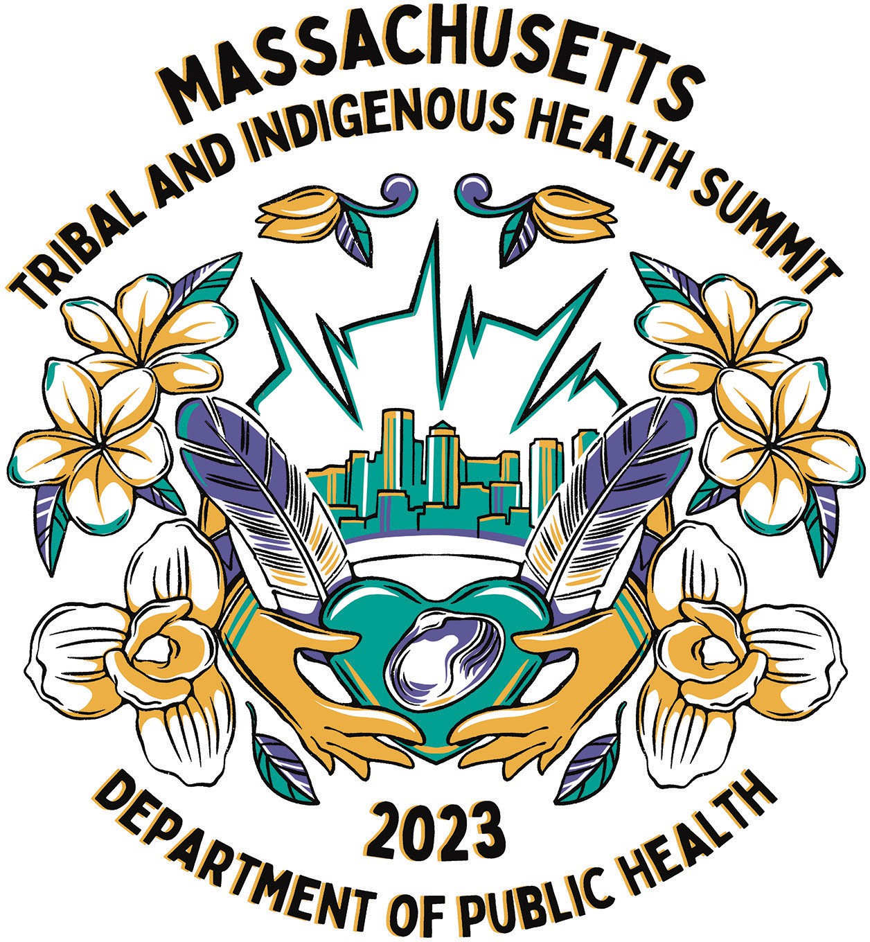

# inside front cover BLANK

**ACKNOWLEDGMENT**

### A special thanks to the following collaborators/sponsors and staff whose help made this event possible:

##### Planning committee members

* Cheryl Cromwell, DPH, Lead Planner, Community Engagement Unit
* Nichol Brewer-Lowry, Native American Lifelines
* Cedric Woods, Institute for New England Native American Studies–UMASS Boston
* Emelie Trayah, AdCare Educational Institute
* Jen Miller, DPH, Bureau of Substance Addiction Services
* Kathleen Herr-Zaya, DPH, Bureau of Substance Addiction Services
* ShwaiMay Lee, DPH Community Engagement Unit
* Qyunh Dang, DPH Community Engagement Unit
* Andrea Yesupatham, DPH Community Engagement Unit
* Lorraine Anyango, DPH Community Engagement Unit
* Melissa Charles, DPH Community Engagement Unit
* Perla Roberts, DPH Community Engagement
* Jocelyn Santos Long, DPH Community Engagement Unit
* Bianey Ramirez, DPH Health and Disability Unit
* Sreeja Katapurakkel, DPH, Office of Health Equity
* Antonia Blinn, DPH Acting Deputy Chief Operating Officer
* Gwendolyn Stewart, DPH, Communications Team Lead
* Zakea Boeger, DPH Communications Team

##### Sponsors

MA Department of Public Health, Bureau of Substance Addiction Services and Office of Health Equity, University of Massachusetts Boston,

University of Massachusetts Medical School, Tufts University, Native American Lifelines Inc., AdCare Educational Institute, Inc.

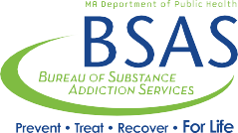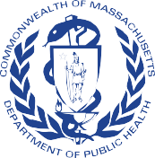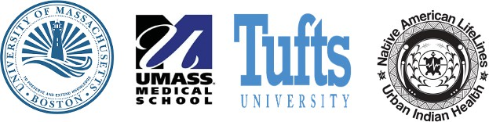

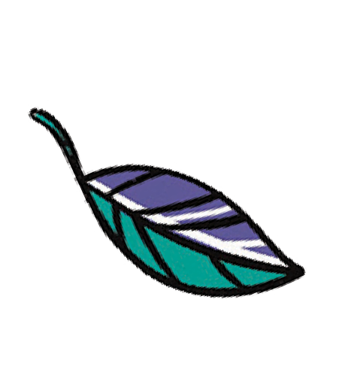

**ART**

##### Quincy Harding

Quincy is an POC artist and illustrator originally from Massachusetts and currently resides in southern California. She is a member of the Herring Pond Wampanoag Tribe of Plymouth Massachusetts and graduated with her Bachelors of Fine Arts from Rhode Island School of Design with a major in illustration. Her work ranges from fashion designs, funky drawings, textile designs and digital work as well. She also enjoys reworking and customizing thrifted clothing to bring them new life. With her love of fashion, beauty, and streetwear her work produces a unique style of glamorous new-age illustration that’s hi, sporty and chic. Check out her website *quincyharding.com.*



**AT A GLANCE**

The Department of Public Health will convene a gathering of Tribes and Indigenous Communities, Tribal and Indigenous People Serving Organizations, along with regional, state, and local representatives and organizations to discuss the common challenges, solutions to such challenges and best practices in responding to the COVID-19 pandemic.

The summit will focus on sharing of strategies and resources to culturally enhance and strengthen outreach, education, access to vaccines, integration of data collecting and reporting and other T/I health needs in these disproportionately impacted communities.

This platform will offer a critical opportunity to build stronger relationships and partnerships among State and Tribal stakeholders as well as effective on-going engagement between T/I communities and DPH.

##### Objectives

* Establish and enhance Federal, State, Local, Regional and Tribal relationships/partnerships.
* Improve understanding of the history of Tribes and Indigenous people in Massachusetts, New England, and beyond.
* Gain knowledge of Tribal sovereignty, consultation, meaningful engagement, and health systems that serve Tribal and Indigenous people.
* Learn about T/I pre, current and post COVID priorities and challenges, and Social Determinants of Health disparities.
* Strengthen, engage, and coordinate resources and best practices that will support T/I communities.
* Discuss policy development to address effective access to resources for T/I

**MISSION STATEMENTS**

## The Department of Public Health

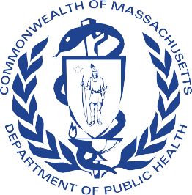

The mission of the Massachusetts Department of Public Health (DPH) is to prevent illness, injury, and premature death; to ensure access to high quality public health and health care services; and to promote wellness and health equity for all people in Massachusetts.

We envision a Commonwealth in which all people enjoy optimal health.

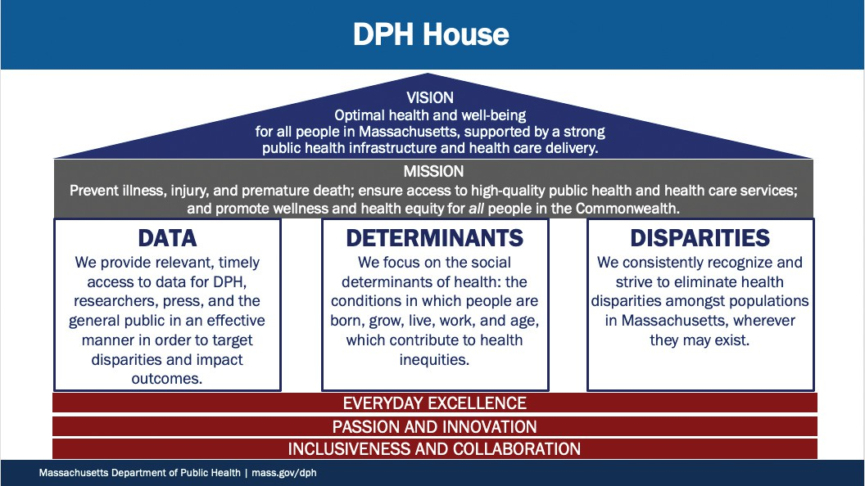

**MISSION STATEMENTS**

## Office of Health Equity

The Office of Health Equity (OHE) works to address social determinants so everyone can attain their full health potential. We promote principles and policies that inform the way health services are designed and delivered.

##### Sujata Ghosh

*Director for the Office of Health Equity*

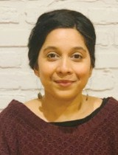Sujata Ghosh (she/her) is the Director for the Office of Health Equity at the Massachusetts Department of Public Health. Over the past fifteen years, Sujata’s career has spanned in different areas of public health, from working on maternal child health initiatives with UNICEF in India to early childhood policy development in child welfare at the Massachusetts Department of Children and Families. Her core work and leadership has always been towards advancing human rights and social justice efforts using the lens of racial and health equity. Born in Canada to immigrant, Indian-American parents, Sujata identifies being trilingual and tri- cultural. She earned a Master of Science degree in Social Work Policy and

Administration with a minor in Law at Columbia University. Sujata also holds a Master of Science in Human Rights Law and a Bachelor of Science in Geography, Economics and Political Science.

##### Eduardo Nettle

*Deputy Director of the Office of Health Equity*

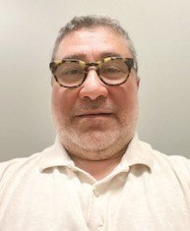Eduardo E. Nettle is the Deputy Director of the Office of Health Equity (OHE), directing the Community Engagement Unit (CEU); a new program at the Department of Public Health, aiming to strategically address community needs and social determinants of health by utilizing innovative best practices and evidence-based racial and health equity-focused approaches to achieve health equity for all Massachusetts residents. The CEU leads efforts supporting over 50 community-based, faith-based, and tribal and indigenous people serving organizations, through the Vaccine Equity Initiative (VEI) to increase awareness and promotion of COVID-19

vaccination, education around safety and efficacy of vaccines and to reduce barriers in access to vaccines in the endemic phase. While Eduardo has recently joined OHE, he is a 20-year veteran at the Department of Public Health, having worked in the field of HIV/AIDS, sexual health, sexually transmitted infections, and hepatitis C treatment access, as well as other infectious disease within the Bureau of Infectious Diseases Prevention and Laboratory Sciences, Office of HIV/AIDS. Most recently, Eduardo was part of several DPH employees supporting the VEI in the Community Liaison program supporting vaccine efforts in priority municipalities.

### Commonwealth of Massachusetts

**Tribal and Indigenous Health Summit** 2023

### Break Out Sessions and Open Forum

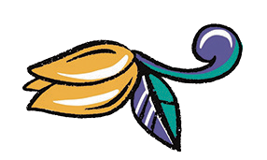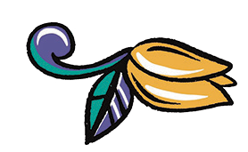

**AGENDA**

**Welcome**

Cheryl Cromwell

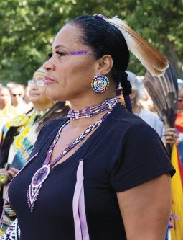

###### Cheryl Cromwell

Tribal and Indigenous Health Equity Strategist Department of Public Health

An enrolled member of the Mashpee Wampanoag Tribe. Cheryl comes to the Department of Public Health with over 19 years of Tribal Government Leadership. As a member of the Tribal Council Board Cheryl was appointed as the Tribe’s Health Liaison to lead the building of healthcare services to her nation. Cheryl provided strategic direction in collaboration with the Tribal Health Advisory Committee, Tribal Council and Indian Health Services on developing a sustainable plan to bring direct healthcare services to her community.

In 2011, the Tribe opened the first Federal Indian Health Service Clinic in 2013 and the Mashpee Wampanoag Dental Clinic in 2016. In addition to her contribution in the clinics success, she was the direct bridge in partnering with local, state, regional, federal governments, and agencies in creating the overall capacity development of the tribe’s Health and Human Services department.

Serving as one of the first members of the U.S. Health and Human Services Secretary Tribal Advisory Committee (STAC) implemented by Secretary Kathleen Sebelius in 2010, representing over 574 federally recognized Tribal nations became a paramount position in identifying resources, recreating policy and reviewing strategic plans to include tribal nations and Indigenous communities.

Cheryl served as Vice Chairwoman on the National Indian Health Service – Direct Service Tribe Advisory Committee, the Indian Health Service Budget Formulation Team and the Behavioral Health Advisory committee, just to name a few. She has received local and national recognition through awards in leadership, volunteerism, partnership and trailblazing in the work she has done throughout her career. Cheryl is a visionist that has the experience and expertise in working in Tribal Health and plans to bring her lived experience and results-oriented workflow to the table for the betterment of the people she serves, regardless of their governmental status. She is honored and humbled to have the opportunity to lead and organize the first ever Tribal and Indigenous Health Summit in Massachusetts, to bring people together and pave the way for a better and healthier future for all Tribal and Indigenous people here is Massachusetts.

###### Contact Us:

Cheryl L. Cromwell (Mashpee Wampanoag Tribe)

Tribal and Indigenous Health Equity Strategist Community Engagement Unit (CEU)

Office of Health Equity

Massachusetts Department of Public Health (MDPH) 250 Washington Street

Boston, MA 02111



Commonwealth of Massachusetts

**Tribal and Indigenous Health Summit** 2023 **AGENDA**

**Tribal Land Acknowledgement**

Elizabeth Solomon

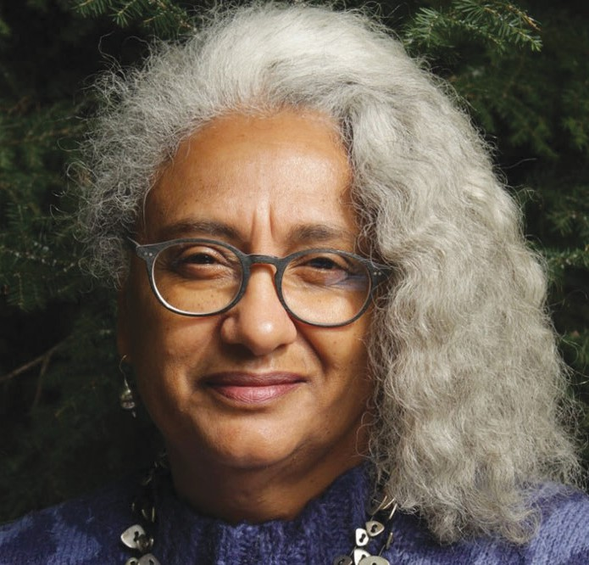

**Elizabeth Solomon** is an enrolled member of the Massachusetts Tribe at Ponkapoag. Ms. Solomon speaks frequently about local indigenous issues and has a long-standing commitment to human rights, diversity, inclusion, and community building that she brings to both her paid and volunteer work.

Ms. Solomon currently works as the Director of Administration in the Department of Social and Behavioral Sciences at the Harvard T.H. Chan School of Public Health and has over three decades of public health experience working in in both university and community-based settings. She also serves on multiple advisory and management boards.

Ms. Solomon recently completed a master’s degree in museum studies and she has a commitment to work with native communities and others that are currently underrepresented in museum exhibits and public history programs to assist them with bringing their voices and stories to the forefront.

##### Prayer

Chairman Brian Weeden

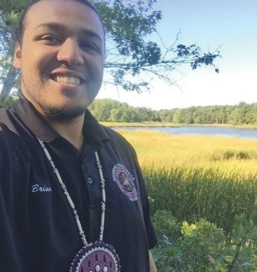**Brian Weeden**, at 28-years old, is the youngest person elected to Chairman of the Mashpee Wampanoag Tribe. He is from the Eel Clan. Chairman Weeden also serves on numerous boards and committees in the community, including the town of Mashpee School Committee and Historical Commission. Chairman Weeden is the Co-President/Trustee of the United National Indian Tribal Youth (UNITY) INC., National Congress of American Indians (NCAI) Youth Commission Co- Vice President. Chairman Weeden has and continues to be heavily involved in his Tribe serving on the Tribe’s Pow Wow Committee, Land Use and Planning Committee, Enrollment Committee and Youth Advisory Committee. As a certified

language teacher, Chairman Weeden is the Vice President of the WLRP Board of Directors.

##### Cultural Song and Dance

Tribal Drummers and Dancers

##### University of Massachusetts Boston Chancellor

Chancellor Marcelo Suárez-Orozco

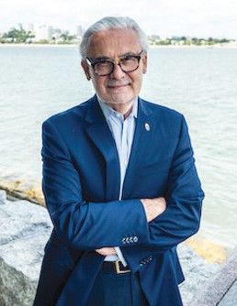**Chancellor Marcelo Suárez-Orozco** assumed the role of chancellor of the University of Massachusetts Boston on August 1, 2020. Prior to coming to UMass Boston Suárez-Orozco served as the inaugural UCLA Wasserman Dean, leading two academic departments, 16 nationally renowned research institutes, and two innovative demonstration schools at UCLA’s Graduate School of Education & Information Studies. His research focuses on cultural psychology and psychological anthropology, with an emphasis on education, globalization, and migration. His award-winning books and edited volumes have been published by Harvard University Press, Stanford University Press, University of California Press, Cambridge University Press, New York University Press, and others.



Commonwealth of Massachusetts

**Tribal and Indigenous Health Summit** 2023 **AGENDA**

**Massachusetts Department of Public Health Commissioner**

Robert H. Goldstein, MD, PhD

###### Robert H. Goldstein, MD, PhD

Commissioner Robbie Goldstein oversees a public health workforce of over 3,200 and an expansive department comprised of eight bureaus and several offices responsible for a range of programs, including environmental health, infectious diseases, injury prevention, and maternal and child health. In addition, the department licenses health professionals and facilities that impact public health and operates the state public health laboratory and four public health hospitals.

Goldstein was appointed Commissioner by Governor Maura Healey in April 2023. Previously, he served as Senior Policy Advisor at the Centers for Disease Control and Prevention (CDC), where he focused on public health emergency response, infectious diseases, and CDC’s strategic policy initiatives. Prior to his time at CDC, Goldstein was the Medical Director and founder of the Massachusetts General Hospital (MGH) Transgender Health Program, a multidisciplinary clinical program that created a safe and affirming environment for the transgender and nonbinary community of Massachusetts and New England. Trained in infectious diseases, with a specialty in HIV treatment and prevention, Goldstein has focused his clinical work on providing care to those living with and at risk for HIV. His experience caring for patients drives his academic and policy pursuits identifying and working to eliminate barriers to equitable access to care.

Goldstein holds a BS, MD, and PhD from Tufts University. He completed his residency training in internal medicine at MGH where he served as Chief Resident. He completed his infectious disease training in the MGH/Brigham and Women’s Hospital infectious disease program.

##### Massachusetts Commissioner on Indian Affairs

John Jim Peters

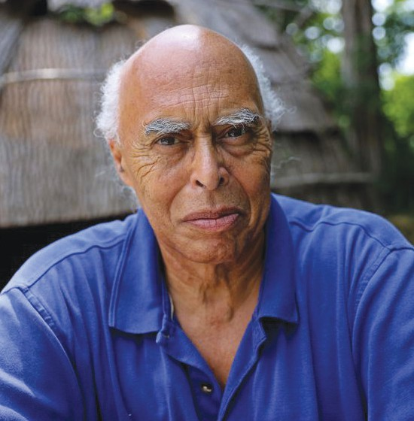**John (Jim) Peters** – Jim is a member of the Mashpee Wampanoag Tribe. Prior to joining the Mass Commission on Indian Affairs as the executive director in May 1999, Jim held a number of positions with New England Tribes. He served as a Career Development Counselor with the Mashantucket Pequot Tribe of Connecticut. He was the Executive Director for the Mashpee Wampanoag Indian Tribe on Cape Cod and earlier held the position of Tribal Planner and Tribal Programs Administrator for the Narragansett Tribe in RI. He also served as the Town Planner for the Town of North Kingstown in Rhode Island.

Jim earned a Bachelor’s Degree in Business Administration and a Master’s Degree in City Planning. Aside from his employment and educational background, he has participated in many cultural, social, and historic Native American events that have taken place in Southern New England over the past 50 years.

Jim looks forward to bridging the gaps in Tribal and State relationships and his continued leadership with the Commission



Commonwealth of Massachusetts

**Tribal and Indigenous Health Summit** 2023 **AGENDA**

**Keynote Speaker**

Chairwoman, Cheryl Andrews-Maltais, Aquinnah Wampanoag Tribe of Gay Head

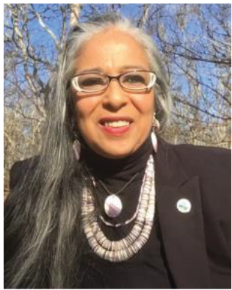**Cheryl Andrews-Maltais** is the Chairwoman of the Wampanoag Tribe of Gay Head Aquinnah. Recently elected to her 5th term as Chairwoman, she has served her Tribe in this role for over 12 years. She also served in the Obama Administration, appointed as a Senior Advisor to the Assistant Secretary-Indian Affairs, and was her Tribe’s first Historic Preservation Officer. She currently serves on several Secretarial Advisory Committees and Councils; from the Health and Human Services STAC, to Homeland Security, to the Tribal Interior Budget Council, to both the IHS and BIA Self Governance Advisory Councils, to the Government Accountability Office Tribal and Indigenous Advisory Council. She also serves as a Board Member of the United

South and Eastern Tribes, and she is the Chairwoman of the Tribe’s Gaming Corporation. She was honored as a 2019 National Indian Women Supporting Each Other “Woman of the Year” and inducted into the 2022 Women Empowering Women for Indigenous Nations “Warrior Women’s Circle”. The Aquinnah Wampanoag Tribe has been Federally Recognized for 36 years and has enjoyed BIA and IHS Self-Governance status for approximately 21 years. She has been married to her husband Daniel Maltais for 30 years and together they have a daughter, Samantha Maltais who is currently attending Harvard Law School. Samantha is the first member of her Tribe and of the Wampanoag Nation to attend Harvard Law School.

##### COVID in Indian Country

Dr. Jill Jim

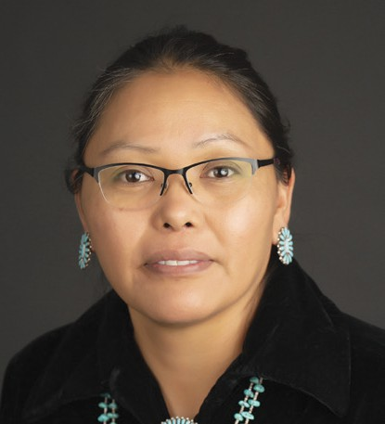**Dr. Jill Jim** is the Navajo Department of Health Executive Director and was a member of President Joe Biden’s COVID 19 Advisory Board. Dr. Jim’s educational background centers on community health promotion and health care administration. She earned a Doctorate in Public Health from the University of Utah in 2017. Dr. Jim is a member of the Navajo Nation and a fluent Navajo speaker.

Prior to becoming the Executive Director, Dr. Jim worked as a health care analyst for HealthInsight and a consultant for the Navajo Area Indian Health Service. She is also a trained epidemiologist and advised the Utah Department of Health. In January 2019, Dr. Jill Jim was appointed by President Jonathan Nez and Vice

President Myron Lizer of the Navajo Nation to their administration and she began to serve as the Executive Director of the Navajo Department of Health. When COVID-19 reached the Navajo Nation in March of 2020, Dr. Jim focused on responding to the public health emergency and teaching Navajo legislators about the role of public health. Education was a large part of Dr. Jim’s work and a key objective included translating information about the science of COVID-19 so that Navajo people could understand it. Dr. Jim was then appointed to the Biden-Harris COVID-19 Advisory Board given her public health expertise. Dr. Jim plans on continuing her job with the administration of President Nez and the Navajo Nation through the end of her term.



Commonwealth of Massachusetts

**Tribal and Indigenous Health Summit** 2023 **AGENDA**

**Indian Health Services**

Dr. Beverly Cotton

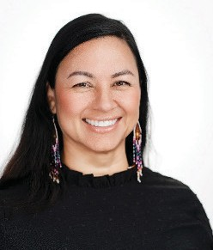

**Beverly Cotton**, a citizen of the Mississippi Band of Choctaw Indians, is the Director of the Nashville Area Indian Health Service (IHS). The IHS, an agency within the Department of Health and Human Services, is the principal federal health care advocate and provider for American Indians and Alaska Natives.

As Area Director, Dr. Cotton provides leadership in the administration of a comprehensive federal, tribal, and urban Indian health care system. The Nashville Area covers a geographical area from Maine to Florida and over to east Texas serving 36 tribal nations and three Urban Indian Health Programs.

Dr. Cotton joined IHS in 2011. She previously served as the acting director for the IHS Office of Clinical and Preventive Services. As acting director, she was the principal advisor to the Chief Medical Officer.

Dr. Cotton holds a Doctor of Nursing Practice degree from Vanderbilt University.

##### Native American Lifelines Urban Indian Health Overview

Nichol Brewer-Lowry Kerry Hawk Lessard

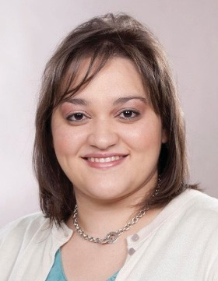**Nichol Brewer-Lowry** is an enrolled member of the Lumbee Tribe of North Carolina. Nichol currently serves as the Site Director for Native American LifeLines Boston, an Urban Indian Organization. She is a Park Scholar and Coca-Cola Scholar who received a Bachelor of Science in Biochemistry from NC State University. She continued her education at Chicago Medical School, where she earned a Master of Science in Biomedical Science and a Master of Science in Health Administration while completing coursework toward a Medical Doctor degree. Health issues prevented the completion of her M.D. degree, but she has recovered after spending more than two and a half years

bed bound. Nichol has worked as a professor at various colleges. During the pandemic, Nichol worked as a 7th and 8th grade science teacher at Magnolia Elementary School in her tribal community. Nichol enjoys being an aunt and loves spending time with her family.

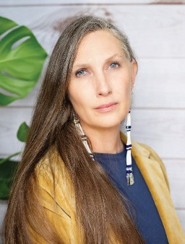**Kerry Hawk Lessard** is Executive Director of Native American LifeLines, an Urban Indian Health Program serving tribal communities in Baltimore and Boston. As an applied medical anthropologist, her area of expertise explores the impact of historical trauma and culture loss in the lives of Urban Indians. Kerry’s work focuses on the creation and implementation of culturally grounded health promotion/ disease prevention programs that support Indigenous identity and resilience as key aspects of physical, emotional, social, and spiritual wellness. Kerry is a descendant of the Fort Peck Assiniboine & Sioux Tribe, and her ancestor’s experience as a survivor of the

Carlisle Indian Boarding School informs and drives her work.

##### Tribal and Indigenous People Serving Organizations (TIPSO)

Shauntea Turner

Chairwoman Melissa Harding Ferretti Janelle Sack Pocowatchit

Shana Simmons Tracy Ramos

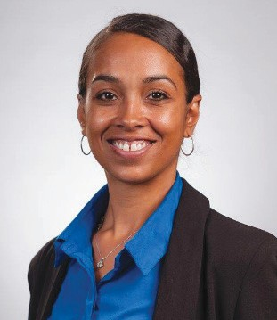

Commonwealth of Massachusetts

**Tribal and Indigenous Health Summit** 2023 **AGENDA**

**Shauntea Turner**, TIPSO Lead, a dedicated member of the Mashpee Wampanoag Tribe, is a seasoned professional in Human Resources, specializing in operational, fiscal, and strategic management. In addition to her exemplary work in HR, she has extended her expertise as a Technical Assistant, providing invaluable support to tribal and indigenous peoples’ serving organizations (TIPSOs). Shauntea plays a vital role in assisting TIPSOs in acquiring essential COVID-19 grants since November 2022 and continues to support them throughout the grant cycle.

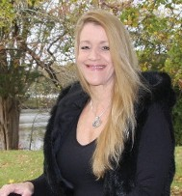**Melissa Ferretti**, Chairwoman of the Herring Pond Wampanoag Tribe, is a passionate advocate for tribal health, indigenous rights, and environmental justice. With a deep connection to her heritage and a career spanning real estate, tribal leadership, and environmental initiatives, Melissa is dedicated to community empowerment and progress. She is also the first Wampanoag woman to be elected as a Select Board Member in Bourne, MA.

Notable Involvements:

* Tribal Leadership: Dedicated to preserving sacred sites, tribal rights, and youth empowerment.
* Education: Co-taught Indigenous Women’s Leadership and Tribal Nation Self-Determination at UMass Boston.
* Environmental Engagement: Active member in various environmental associations and committees.
* Real Estate: Licensed Real Estate Sales Associate and Notary Public, affiliated with Jack Conway & Company.
* Melissa’s journey embodies resilience, advocacy, and a commitment to making a positive impact on her community and beyond.

###### Janelle Sack Pocowatchit

Janelle, a dedicated COVID-19 Program Manager at the North American Indian Center of Boston (NAICOB), is passionately committed to supporting Native American communities. With roots in the Mi’kmaq First Nations and the Comanche Nation of Oklahoma, Janelle brings a unique perspective and deep cultural understanding to her vital role in addressing public health challenges.

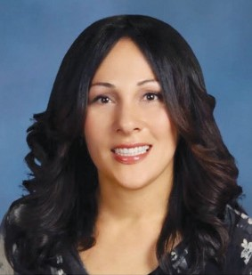**Shana Elana (Curtis) Simmons**, known as “Strong Doe,” is a distinguished individual deeply committed to advancing healthcare within indigenous communities.

Shana’s educational journey began at Northeastern University, where she graduated from the College of Criminal Justice. She furthered her studies at the Florida Institute of Technology, in Behavior Analysis Practice Master’s Program.

With a strong foundation in behavior analysis, Shana currently holds critical roles as the Tribal Secretary and Director of Grants for the Chappaquiddick Tribe of the Wampanoag Indian Nation. Additionally, she serves as a District Behavior

Specialist and is recognized as a Board-Certified Assistant Behavior Analyst.

Shana’s professional expertise stems from a diverse background, including work as a Gang Unit Investigator, Crime Scene Investigator, and Teacher specializing in students with emotional and behavioral disabilities. With over two decades of experience, she excels in conducting meetings, promoting effective communication, teaching, coaching, and crisis interventions.

Beyond her profession, Shana’s passion lies in preserving and sharing tribal history and traditions with younger generations, ensuring cultural continuity. She continuously seeks out information to support the physical and mental health of Tribal citizens and other underserved populations.

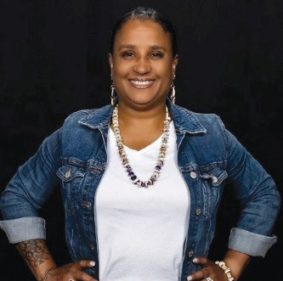

Commonwealth of Massachusetts

**Tribal and Indigenous Health Summit** 2023 **AGENDA**

**Tracy Ramos**, a Nipmuc Tribe member from Central Massachusetts, embodies a deep commitment to preserving Indigenous culture and enhancing well- being. Engaged in various community activities, from powwows to language preservation, she believes in the power of unity and culture preservation.

With a Master’s in Public Health, Tracy’s focus is on researching intergenerational trauma and health disparities within the Indigenous population. She utilizes her knowledge of bias, inequities, and racism to enhance health equity for Indigenous communities.

Tracy also serves as a Board Director at The Women of Color Health Equity Collective, advocating for systemic change and cultural humility. Committed to serving and supporting the Indigenous population, she applies a public health approach to her work.

**CATERING**

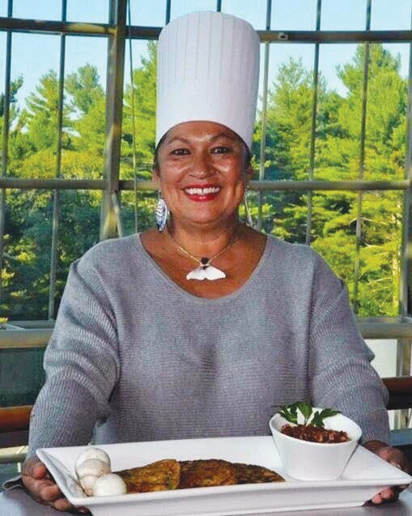

##### Chef Sherry Pocknett

The *James Beard Restaurant and Chef Awards* announced its 2023 winners, including some groundbreaking firsts for the annual ceremony, often called the Oscars of the food world. Since 1990, the James Beard Awards recognize “exceptional talent in the culinary and food media industries, as well as a demonstrated commitment to racial and gender equity, community, sustainability, and a culture where all can thrive.”

Sherry Pocknett became the first Indigenous woman to win a James Beard Award, triumphing in the Best Chef: Northeast category. Pocknett is from *Sly Fox Den Too*, a restaurant in Charlestown,

Rhode Island, specializing in Native American cuisine.

Sherry is a proud member of the Mashpee Wampanoag Tribe and comes from a long family lineage of cooks and chefs. she started cooking when she was about eight years old on an Easy-Bake Oven that she got for Christmas. She is an Indigenous woman living off the land and keeping the traditions alive.

**Indigenous Cuisine by Sly Fox Den**

**Salad**

Autumn salad with cranberry vinaigrette

Corn cakes with strawberry cranberry chutney

**Entree**

Roast Turkey with gravy

Black pepper smoked Salmon

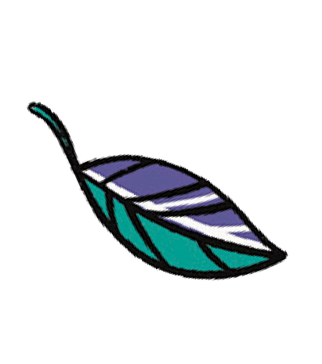

We are honored and blessed to experience her delicious and prestigious Indigenous Cuisine here at the Tribal and Indigenous Health Summit.

Three Sisters Rice

Mashed Butternut Squash or garlicky green beans

**Dessert**

Peach shortcake or cranberry pear crisp

Drinks

Commonwealth of Massachusetts

**Tribal and Indigenous Health Summit** 2023 **BREAKOUT SESSIONS**

#### Tribal Data Sovereignty

Presentation and discussion will be focused on Tribal Data and how to appropriately collect, analyze, and disseminate back to the Tribes and Tribal Public Health Authorities. Discuss methodologies that are currently being utilized and explore innovative ways to achieve an accurate account of each person in the Tribal and Indigenous communities. Restructure the policies and support T/I communities in obtaining equitable resources through Data. Learn about projects and efforts underway in identifying and addressing the data inequities.

***Panelist:***

Ryan Burke (DPH) Humberto Reynoso (DPH) Arielle Coq (DPH)

Dr. Cedric Woods (Lumbee Tribe)

Kristine Thomas (Narragansett Indian Tribe) Chairman Brian Weeden (Mashpee Wampanoag Tribe)

Chairwoman Cheryl Andrew-Maltais (Wampanoag Tribe of Gay Head Aquinnah) Phillip Granberry (Research Professor, UMass)

Christy Duke

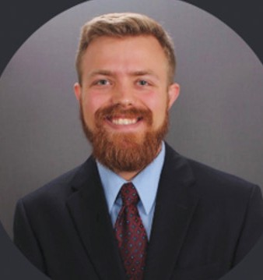**Ryan Burke** is a senior surveillance epidemiologist in the Division of Surveillance, Analytics & informatics in the Bureau of Infectious Disease and Laboratory Sciences (BIDLS). He has been at the Massachusetts Department of Public Health (MA DPH) for 5 years and in his current position is the Tribal Health Liaison. In his role he works to improve data sharing and data access for state and federally recognized tribes, as well as other Public Health Authorities representing Tribal and Indigenous communities. As an epidemiologist within BIDLS he focuses on infectious disease surveillance data from the Massachusetts Virtual Epidemiologic

Network (MAVEN). He also works with other groups within DPH focusing on data reporting for all DPH and how to improve current processes to support and Tribal and Indigenous communities. He received his Bachelor of Science from the University of Massachusetts – Amherst in Public Health and Master of Public Health degree from Rollins School of Public Health at Emory University.

**Humberto Reynoso**, PhD is affiliated with the Department of Public Health’s Office of Population Health. Dr. Reynoso conducts health services research from a multidisciplinary mixed-methods perspective. He received a Bachelors in Anthropology from Escuela Nacional de Antropología e Historia in Mexico, a Master’s degree in Social Work from Simmons College, and a Doctorate degree in Social Policy from the Heller School of Social Policy and Management, Brandeis University.

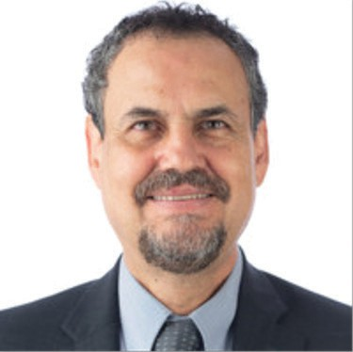

Commonwealth of Massachusetts



**Tribal and Indigenous Health Summit** 2023 **BREAKOUT SESSIONS**

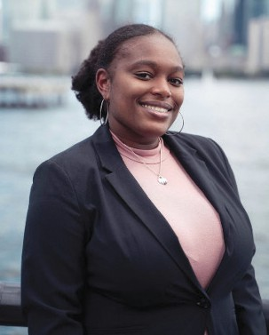**Arielle Coq**, MPH is an epidemiologist in the Office of Population Health under the Special Analytic Project Team. She has been at Massachusetts Department of Public Health for 2.5 years and has been focused on analyzing COVID-19 data. Arielle received her Bachelor of Science from University at Albany, SUNY in Public Health and Master of Public Health degree with a concentration in epidemiology from Columbia University Mailman School of Public Health. In her free time, Arielle enjoys traveling and staying current with soccer and basketball.

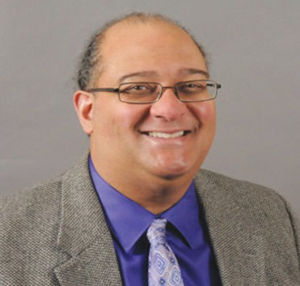**Dr. Cedric Woods** is a citizen of the Lumbee Tribe of North Carolina. He combines over a decade of tribal government experience with a research background and has served as the director of INENAS since 2009. Currently, Cedric is working on projects with tribes in the areas of tribal government capacity building, Indian education, economic development, and chronic disease prevention. Prior to arriving at UMass Boston, Cedric completed a study on the evolution of tribal government among the Mashpee Wampanoag Tribe and the Mashantucket Pequot Tribal Nation.

While pursuing his doctoral studies at the University of Connecticut, he served in a variety of capacities for the Mashantucket Pequot Tribal Nation. These positions included director of career development, research analyst, tribal government spokesman, and deputy chief operating officer. Cedric has served as a consultant for the National Museum of the American Indian, the Haliwa Saponi Indian Tribe of North Carolina, and the Mashantucket Pequot Museum and Research Center. He is a member of the Board of Trustees of Plymouth Plantation, a bicultural living history museum in Plymouth, Massachusetts.

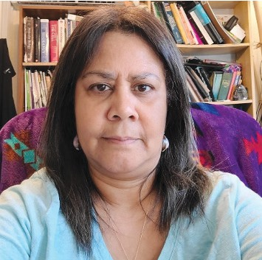**Dr. Kristine Thomas-Jones** is a Seaconke Wampanoag Tribal Member and has been in academia for over twenty years. Presently, she is a Clinical Faculty Member in MPH program at SNHU and a licensed Chiropractor who practiced for many years in Middletown, RI. Her research has included working with secondary datasets from governmental agencies and her research interest includes American Indians/ Alaskan Natives (AIs/ANs) access to healthcare, healthcare utilization, health outcomes, and their perspectives on the COVID vaccination. She has also published

an article in the International Public Health Journal, in 2022 titled “Healthcare Access and Utilization for Urban American Indians/Urban Alaskan Natives versus Urban Non-Hispanic Whites from the Northeast United States.” In her spare time, she also enjoys working with herbs to make medicinal herbal teas.

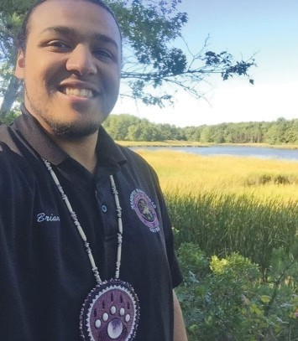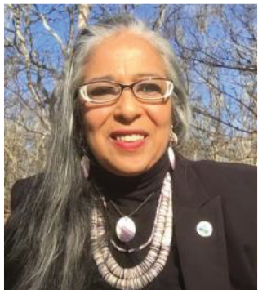

**Brian Weeden**, See Brian’s bio on page 9

**Cheryl Andrews-Maltais**, See Cheryl’s bio on page 11

Commonwealth of Massachusetts

**Tribal and Indigenous Health Summit** 2023 **BREAKOUT SESSIONS**

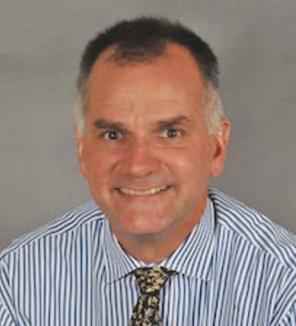**Phillip Granberry** is a social demographer specializing in immigration in the United States. He worked with various community-based organizations assisting recently arrived U.S. immigrants before earning a Ph.D. in Public Policy. His research focuses on the accumulation and use of social capital among Mexican migrants and the impact of welfare and immigration policy reform on Latinos in Massachusetts. He is currently a senior research associate or the Gastón Institute. He teaches in the Economics Department at the UMass Boston, where he teaches courses on international migration and metropolitan area economic development.

In addition, he is a Senior Researcher in Demography for the Boston Planning and Development Agency.

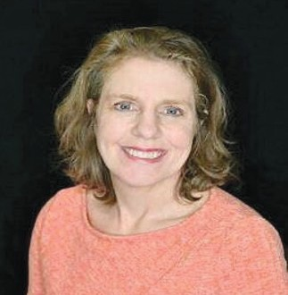**Christy Duke**, MPH, conducts project reviews and periodic update checks with various project staff members to ensure that TEC work is completed on schedule and within budget restraints. In consultation with USET member Tribal Nations, provides executive leadership, vision, and direction in planning, developing, implementing, and evaluating programs, services, functions, and activities. Serve as liaison to USET Health Committee and Board of Directors regarding public health emergencies. Serve as an advisor to federal, state, and Tribal workgroups related to public health and/or epidemiology. Work with Tribal, Inter-Tribal, and private,

academic, state, and federal agencies within the region and nation to advocate for equitable health and public health resources for members of Tribal Nations. Act as Subject Matter Expert regarding data and data quality issues affecting member Tribal Nations. Work collaboratively with Tribal, Inter-Tribal, and private, academic, state, and federal agencies within the region and nation to ensure that comprehensive, quality health data is available and accessible to the Native American population. Help guide the development and maintenance of an Area-wide system of population health-related data collection, analysis, and interpretation. Help guide epidemiological investigations. Serves as the Director of the Tribal Epidemiology Center Director on the Tribal Epidemiology Centers Consortium (TEC-C). Provides guidance and support to the USET Executive Director regarding the changing developments in health programs, policies, regulations, and legislation that may require USET attention and action. Act as a liaison to tribal, state, and federal agencies and assist Tribal Governments in negotiating with state agencies in areas such as data sharing and program requirements.

#### Mental Health: Culturally Sustaining and Trauma Informed.

Presentation and discussion will provide the context of Indigenous trauma events and systematic racism that continues to impact Native people today. We will focus on ways Native peoples are surviving and thriving through culturally informed community building. Learn to recognize examples of mental health and prevention work that is strengths-based, trauma-informed, and culturally sustaining.

***Panelist:***

Jackie Vorpahl (Choctaw Nation of Oklahoma)

Michelle Napoli (Federated Indians of Graton Rancheria Tribe) Leana Pilet (Mashpee Wampanoag Tribe)

Commonwealth of Massachusetts

**Tribal and Indigenous Health Summit** 2023 **BREAKOUT SESSIONS**

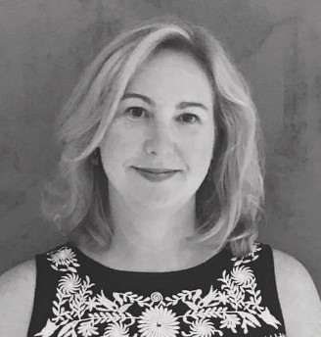**Jacqueline M Vorpahl**, Ph.D. – As a member of the Choctaw Nation of Oklahoma and a licensed clinical psychologist, Dr. V (as she is referred to by her clients) launched Behavioral Health Programs at the North American Indian Center of Boston, Native American Lifelines and at the Wampanoag Tribe of Gayhead. She served as a long- time member of the National Suicide Prevention Committee for Native Americans. She currently provides historical trauma & cultural humility training for mental health and other professionals across the US and runs sacred parent training programs for Massachusetts tribal communities. She has over 30 years’ of clinical mental health

experience working with individuals of different cultural and socio-economic backgrounds expressing depression, dissatisfaction, stress, anxiety, unhappiness, and a lack of meaning in their life. She has helped thousands of individuals and families to overcome their obstacles and develop internal resources that bring contentment. She is the creator of the award-winning Chill Outz® app which consists of five stories that lead the child and adult to use the various evidence-based practices of mindfulness, progressive relaxation, breathing, storytelling, cognitive behavioral therapy, movement and sensory stimulation.

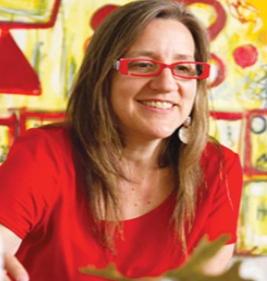**Michelle Napoli** (pronouns: ‘iti/’uh in Coast Miwok worldview/language ~ and ~ she/her/hers) has been a licensed mental health counselor and expressive therapist for 18 years. She is an assistant professor in art therapy at Lesley University in the Expressive Therapies Division in the Graduate School of Arts and Social Sciences. Michelle collaborates with faculty and students to integrate culturally responsive and anti-oppressive approaches in expressive therapies and counselor education pedagogy. Michelle’s community-based work focuses on authentic cultural continuity and identity formation as prevention and treatment. For example, she integrates the

arts as cultural resiliency and for language reacquisition in collaboration with her Native community, the Federated Indians of Graton Rancheria and collaborates with Native artists in a wellness initiative for the Institute for New England Native American Studies, which is sponsored by BSAS.

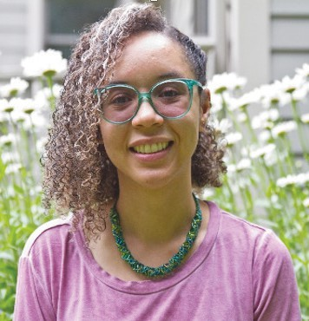**Leana Pilet**, a member of the Mashpee Wampanoag tribe, is a Licensed Mental Health Counselor with a background in expressive art therapy. She is the Director of Youth and Young Adult Services at the Institute for Health and Recovery (IHR) and an adjunct professor at Lesley University in the Expressive Therapies Division. Leana specializes in trauma informed care and her experience includes counseling, consulting, and training development for both inpatient and community-based settings. Through her work with people impacted by a substance use disorder, mental health disorder, trauma, and domestic violence, Leana has gained an acute

awareness of the systemic impacts on individuals. This has influenced her passion for systemic change and creating spaces that center healing, wellness, and empowering communities of care.

Commonwealth of Massachusetts

**Tribal and Indigenous Health Summit** 2023 **BREAKOUT SESSIONS**

#### Leading with Culture: The Integration of Substance Use Prevention, Treatment, Recovery, and Harm Reduction Practice.

Presentation and discussion will include the overview of the many aspects of Substance Use in Tribal and Indigenous communities. Identify challenges and highlights of prevention, treatment, and recovery efforts underway between the Tribal and Indigenous communities and the state. There will be a specific focus on how we can engage our youth and young adults while addressing the importance of family, community, and partnerships with state and federal agencies to meet the needs of our most vulnerable population. Hear a real-life experience from addiction to recovery.

***Panelist:***

Jennifer Miller (DPH) Kathleen Herr-Zaya (DPH) Sabrina Xaviar (DPH)

Stephanie Roderick (Mashpee Wampanoag) Seinna Hunter (Shinnecock Nation)

Daniel Howell

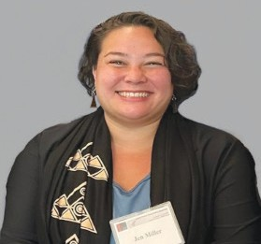**Jen Miller** is a Kanaka Maoli wahine (Native Hawaiian woman), is currently serving as the program manager for the State Opioid Response at the Bureau of Substance Addiction Services in the Massachusetts Department of Public Health. With over a decade of experience in substance use disorder treatment, mental health counseling, and harm reduction, she is an accomplished expert in her field. She received her Master’s degree in Mental Health Counseling and Behavioral Medicine from Boston University’s School of Medicine.

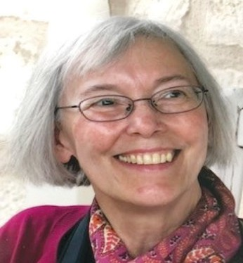**Kathleen Herr-Zaya**, PhD, has felt privileged to team up with the Institute for New England Native American Studies, UMASS Boston to help prevent substance misuse and promote healthy lives. Together with a DPH-led Work Group they support Native peoples to develop a Native American Community Advisory Board; parents’ groups; after-school “Circle Tied to Mother Earth Program” series; Young Adult Arts Program; consultation on grant writing; outreach; and books (see mass. gov/maclearinghouse/nativeamerican for Coming Home, etc.). Currently Kathleen is also Contract Manager for the MA Department of Public Health Bureau of

Substance Addiction Services, where she oversees diverse early childhood and youth programs. In the past, Kathleen was a Co- and Principal Investigator, Heller School, Brandeis University, Waltham, MA; Lecturer, Suffolk University; Lecturer, Northeastern University, and a psychiatric nurse.

Commonwealth of Massachusetts

**Tribal and Indigenous Health Summit** 2023 **BREAKOUT SESSIONS**

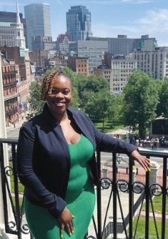**Sabrina Xavier** (she/hers) is the Acting Assistant Director of the Office of Youth and Young Adult Services within the Bureau of Substance Addiction Services at Massachusetts Department of Public Health. In her role, Sabrina is responsible for the ongoing development and coordination of statewide youth-focused substance use and co-occurring intervention and treatment services within the Office of Youth and Young Adult Services. In addition, she coordinates BSAS-funded projects to address early intervention of adolescent substance use, including school and community-based programs, workforce development trainings, and special initiatives across the Commonwealth. Sabrina has a Master of Public Health degree in Program Management and Maternal & Child Health from Boston University School of Public Health. She has been working with youth and young adults since her time served as a U.S. Peace Corps Health

Volunteer in South Africa, supporting communities to mitigate the impacts of the HIV epidemic. During her free time, Sabrina enjoys reading, spending time with family, and traveling around the globe trying different cuisines and treats.

###### Stephanie Roderick

“We’ll go to the park tomorrow,” she told my her four-year-old son every day. Something made her realize that tomorrow would never come because she was faced with an addiction problem mixing drugs and alcohol. That was 1989. Stephanie entered her first treatment facility so that she could become a responsible mom and for 13 years she remained sober!. In 2002 her son had graduated from high school and she thought she was ok, however, having to endure the fact that her father was facing the end of life in their family home, the pain began to seem unbearable and again Stephanie was back to numbing herself and suppressing her feelings with

drugs and alcohol. It only took one glass of wine and there she was caught in the vicious cycle, yet again. On May 7, 2010, Stephanie entered treatment with the support of her tribe’s Indian Health Service (IHS). This program was a Native American inpatient, 56-day treatment program that is run by natives for natives. During this time in the recovery process , she became deeply impacted by the work and support of her counselor. Having that counselor that understood her and the work that needed to happen impacted her in such a profound way that Stephanie decided that helping others in this area was her calling. In 2016 Stepahanie successfully acquired her Alcohol and Drug Substance Use License through the University of Massachusetts Boston and today I she remains sober and active in the work of helping others on their path. Stephanie is humbled and excited to share her experience from Addiction to Recovery. Stephanie is a proud member of the Mashpee Wampanoag Tribe.

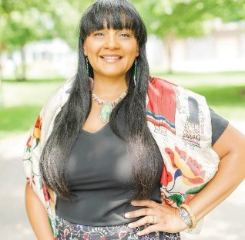**Sienna Hunter-Cuyjet** (she/her/ohke), LMSW, LCSW, LICSW, ACSW Sienna is an enrolled member of the Shinnecock Nation born and raised on the reservation located on Eastern Long Island, NY. She is eldest daughter of Roberta Hunter, Esq. (Shinnecock) and the late Glenn Cuyjet, psychotherapist (Lenape/Delaware/Nanticoke). Sienna served as a former Tribal Council member who chaired the governance and election committee that brought the Trustee elections back to the territory.

In 2017 she joined the team at the SAMHSA Tribal Training & Technical Assistance Center by way of Wopila Consulting LLC, a woman owned small business, as the Technical Assistant (TA) Coordinator. Sienna had the opportunity to work with Native Connections Grantees across the country who are working to combat suicide, substance mis/abuse and address mental health through

Commonwealth of Massachusetts

**Tribal and Indigenous Health Summit** 2023 **BREAKOUT SESSIONS**

prevention and intervention. Currently she works at Three Star Government still on the SAMHSA Tribal Training & Technical Assistance Center team as a Task Lead providing support to Tribal communities and Tribal Governments across the country in areas of mental health, substance mis/abuse, strategic planning, trauma, and crisis intervention. Sienna enjoys working closely with tribal communities and governments in their growth and development; the opportunity to travel and learn about each community; and the time spent with co-workers developing and delivering training modules.

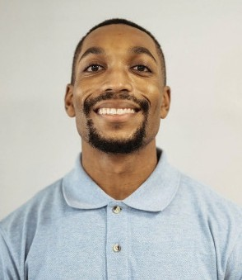**Daniel Howell**, MPH currently works at the Department of Public Health (DPH), Bureau of Substance Addiction Services (BSAS) in the Office of ‘Youth and Young Adult Services (OYYAS). In his current role he works as a project coordinator for several grants and initiatives, most of which focus on brief intervention strategies and programs for youth primarily between the age of 13-17. Prior to his work in the OYYAS department, Dan was a grant manager in an OBAT clinic. While working at Lowell Community Health Center, Dan worked alongside the nurse manager to help

run the day-to-day operations as well as collaborate with other departments to triage care and fulfill grant requirements. Community engagement was another focal point for Dan where he found himself collaborating with other agencies and programs within Lowell focused on opioid overdose response and treatment.

Dan’s passion to help others and giving a voice to marginalized communities is what pushes him to continue his work today. In his off-time Dan is a competitive powerlifter where he has seen success on a national stage, and he also coaches several athletes in the sport of powerlifting.”

#### Tribal Doctorate Students Paving the Way

Presentation from Tribal students pursuing their doctorate degrees at University of Massachusetts Medical School. Hear about their pathways to deciding and becoming a Tribal Health professional and what that will mean to the Tribal and Indigenous communities they represent. Learn about the projects they are working on that will bring a major impact to their communities and beyond. Violence against Women and Mental Health and Substance abuse within the youth and young adult population.

***Panelist:***

Terese Aronowitz (Hassanamisco Tribe)

Chyla Hendricks (Mashpee Wampanoag Tribe)

Autaquay Peters-Mosquera (Mashpee Wampanoag Tribe)

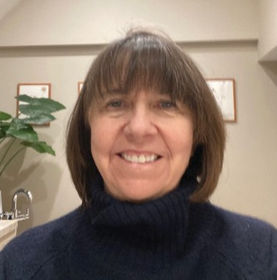**Teri Aronowitz** is a professor at the Tan Chingfen Graduate School of Nursing at UMass Chan Medical School and is mentoring Autaquay and Chyla. Her seminal contribution has been to advance the science of evidence-based care for healthy adolescent development. Dr. Aronowitz has completed over a dozen CBPR projects with African American, Asian American, and Native American families to promote resilience against risk behaviors. She is a Fellow of the American Academy of Nursing.

Tribal Summit Topic: The Social Determinants of Health that Affect the Intersectionality of Intimate Partner

Commonwealth of Massachusetts

**Tribal and Indigenous Health Summit** 2023 **BREAKOUT SESSIONS**

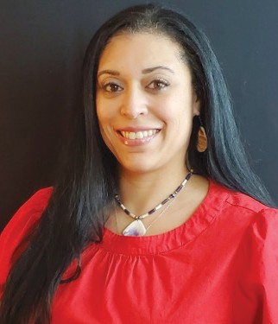**Autaquay Peters-Mosquera** is a PhD student here at Tan Chingfen GSN UMass Chan Medical School, Tan Chingfen Graduate School of Nursing. She earned a Bachelor of Science in Nursing and a holds a Master’s degree in Business Administration in Healthcare and was awarded a Tan Chingfen GSN Pre-Doctoral Diversity Fellowship. Her research focus is Missing and Murdered Indigenous Women and violence prevention.

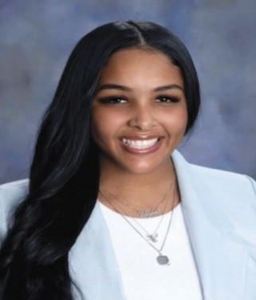**Chyla Bingham-Hendricks** graduated with a Bachelor of Science in Nursing from UMass Boston in May of 2022. She was admitted into the BS-PhD program in the Tan Chingfen Graduate School of Nursing at UMass Chan Medical School and was awarded a Tan Chingfen GSN Pre-Doctoral Diversity Fellowship. Her research focus is substance misuse and corresponding policies related to treatment focusing on the Native American population.

# inside back cover BLANK

**Thank you for participating in the First-ever Massachusetts Tribal and Indigenous Health Summit.**

## Please make sure you fill out the feedback forms to help guide us moving forward in bringing Equity and Inclusion to

Tribal and Indigenous Communities.

***THANK YOU***

