## BACKGROUND

**INDOOR AIR QUALITY**

**ASSESSMENT**

**Triton Regional High School**

**112 Elm Street**

**Newbury, Massachusetts**

Prepared by:

Massachusetts Department of Public Health

Bureau of Climate and Environmental Health

Indoor Air Quality Program

August 2023

|  |  |
| --- | --- |
| Building: | Triton Regional High School (TRHS) |
| Address: | 112 Elm Street, Newbury, MA |
| Assessment Requested by: | Brian L. Forget, Superintendent of Schools  Triton Regional School District |
| Reason for Assessment: | General Indoor Air Quality (IAQ) concerns |
| Date of Assessment: | April 6, April 20, and May 4, 2023 |
| Massachusetts Department of Public Health/Bureau of Climate and Environmental Health (MDPH/BCEH) Staff Conducting Assessment: | Michael Feeney, Director, Ruth Alfasso Environmental Analyst/Inspector, and Jennifer Lajoie, Environmental Analyst/Inspector, IAQ Program |
| Building Description: | The TRHS was built in 1971 and renovated in 2001. It is a multi-story brick building with a complex shape and multiple sections of flat roof. The building contains general classrooms, science classrooms, an auditorium, gymnasium, cafeteria, kitchen, library, computer room, art room, music room and office spaces. The building also houses the Triton Regional Middle School, and some facilities are shared between the two schools. |
| Windows: | Openable in most areas |

**METHODS**

Please refer to the IAQ Manual for methods, sampling procedures, and interpretation of results (MDPH, 2015).

As mentioned above, the building also houses the Triton Regional Middle School (TRMS), with some facilities shared between the two schools. A separate report on the assessment of the TRMS is also available.

**RESULTS AND DISCUSSION**

The following is a summary of testing results from the May 4, 2023 visit (Table 1):

* ***Carbon dioxide*** was above the MDPH guideline of 800 parts per million (ppm) in about one third of the areas visited, indicating that many classrooms need additional fresh air. Levels above 800 ppm were typically found in smaller classrooms and those with high occupancy.
* ***Temperature*** was within to slightly below the recommended comfort range of 70°F to 78°F.
* ***Relative humidity*** was within the recommended range of 40% to 60% in all areas assessed.
* ***Carbon monoxide*** levels were non-detectable (ND) in all areas assessed.
* ***Fine particulate matter (PM2.5)*** concentrations were below the National Ambient Air Quality Standard (NAAQS) level of 35 μg/m3 in all areas assessed.

## Ventilation

An HVAC system has several functions. First it provides heating and, if equipped, cooling. Second, it is a source of fresh air. Finally, an HVAC system will dilute and remove normally-occurring indoor environmental pollutants by not only introducing fresh air, but by filtering the airstream and ejecting stale air to the outdoors via exhaust ventilation. Even if an HVAC system is operating as designed, point sources of respiratory irritation may exist and cause symptoms in sensitive individuals.

Fresh air in the majority of classrooms is supplied by unit ventilators (univents) (Picture 1). Univents draw air from the outdoors through a fresh air intake located on the exterior wall of the building and return air through an air intake located at the base of the unit. Fresh and return air are mixed, filtered, heated, and provided to rooms through an air diffuser located in the top of the unit (Figure 1). In many classrooms, the univent was blocked by furniture or items (Table 1). In some cases, such as shown in Picture 1, this appeared to be deliberate, potentially to reduce drafts or noise. For fresh air exchange, univents need to be on and operating at all times the classroom is occupied. If univents are noisy or creating drafts, occupants should work with the facilities department and rearrange classrooms to mitigate issues.

A univent was opened and assessed in the TRMS, and similar issues are likely to be seen in the TRHS univents. Filters, while well fitted into the cabinet, appeared to be of a low filtration efficiency. Filters with a Minimum Efficiency Rating Value (MERV Rating) of 8 should be used, or higher if the equipment can handle them. Dust and debris were noted in TRMS univents; univent cabinets should be vacuumed to remove dust and debris during filter changes.

Mechanical exhaust ventilation in classrooms is provided by wall-mounted exhaust vents (Picture 2) connected to rooftop motors. Some of the vents accessed did not appear to be drawing any air, which may mean they are turned off, or that the fans are not functioning. Fresh air for some common areas is provided by air handling units (AHU) through ducted supply vents in ceilings (Picture 3).

TRHS has no means to provide chilled air/air conditioning from univents. Univents operating during warm weather directly introduce unconditioned outdoor air into classrooms. Some locations are equipped with window-mounted AC units, ductless wall-mounted AC units, or portable AC units (Picture 4; Table 1). This type of equipment may be susceptible to excessive condensation generation when operated during periods of hot, humid weather. In the experience of IAQ staff, the operation of any equipment designed to chill air can result in:

* building materials in the airstream being chilled below the dew point to gather condensation, or
* Exceeding the capacity of a unit to drain condensation is exceeded resulting in water pooling inside.

The impact of condensation is further discussed in the Microbial/Moisture Concerns section of this report. Note that AC units have filters that should be cleaned or replaced on a regular basis to remove debris.

Rooftop ductwork connecting the AHUs to the building ventilation system was examined. Insulation on the ductwork was found to be damaged or completely missing (Pictures 5 through 8). In this condition, maintaining temperature control in winter months would be difficult. In addition, ductwork is directly exposed to wind-driven rain, which may enter ducts through seams. IAQ staff did not examine the interior of ductwork with missing insulation to note any other conditions that could lead to poor temperature control or air quality.

The MDPH IAQ Program recommends that supply and exhaust ventilation operate continuously during occupied periods to provide air exchange and filtration. Without sufficient supply and exhaust ventilation, normally-occurring environmental pollutants can build up and lead to indoor air quality/comfort complaints.

It is also important to note that despite ongoing maintenance and replacement of parts/components by TRHS facilities staff, many of the univents throughout the TRHS are at the end of their life cycle. According to the American Society of Heating, Refrigeration, and Air-Conditioning Engineering (ASHRAE), the service life[1] of this type of unit is 15-20 years, assuming routine maintenance of the equipment (ASHRAE, 1991). Control systems such as thermostats may also be beyond their service life, making temperature control difficult.

To have proper ventilation with a mechanical ventilation system, the systems must be balanced after installation to provide an adequate amount of fresh air to the interior of a room while removing stale air from the room. It is recommended that HVAC systems be re-balanced every five years to ensure adequate air systems function (SMACNA, 1994). It is not known when the last balancing of the HVAC system at the TRHS was conducted.

The TRHS has openable windows in many classrooms and offices which can be an additional source of fresh air. Windows should not be opened during heavy rain, or when air conditioning is operating in the room to prevent water damage.

## Microbial/Moisture Concerns

All classrooms were assessed for the presence of visible water damage and mold odors. TRHS did not have any detectable mold odors or signs of mold growth in classrooms. Water-damaged ceiling tiles were noted in many areas (Picture 9; Table 1). These may result from roof leaks, or leaks from the plumbing, HVAC, or sprinkler system. Leaks should be repaired, and the water-damaged materials removed and replaced as soon as practical. During replacement of tiles, the area above the removed tiles should be checked for additional water damage and repairs made as needed.

Water-damaged carpeting was noted in several areas of the Library/Media Center (Picture 10). These areas did not have odors or other signs of mold growth. Porous materials such as carpeting or ceiling tiles should be dried with fans and heating within 24 to 48 hours of becoming wet (US EPA, 2008). If porous materials are not dried within this time frame, mold growth may occur. Water-damaged porous materials cannot be adequately cleaned to remove mold growth and should be discarded.

### Extreme weather conditions

It is important to note that Massachusetts experienced extended periods of high relative humidity during recent summers. July of 2021 was the wettest ever recorded in Massachusetts, and the three-month period from June through August 2021 (meteorological summer), was the fourth wettest on record, according to the National Oceanic and Atmospheric Administration’s Centers for Environmental Information. The three-month period also was the third warmest ever in the state and was tied for the warmest on record across the United States. (HG, 2021, NOAA, 2021). These conditions are challenging for buildings, particularly those without air conditioning.

Classrooms on the first and second floors had bowed ceiling tiles (Picture 11, Table 1). As ceiling tiles become moistened by high relative humidity, the wetting can cause ceiling tiles to distend (bow) while sitting in the suspended ceiling rails. One source of water vapor that can increase indoor relative is extended periods of hot, humid weather with heavy rains, as occurred during the summer of 2021. While unstained bowed tiles are not a source of mold, this is an indication that high relative humidity has occurred for a significant period. Therefore, other materials that remain in classrooms during hot humid weather, particularly when the school is unoccupied, may be subject to moistening and water damage. This includes carpeting/area rugs, furniture, and stored items such as boxes, paper and clothing. According to ASHRAE, if relative humidity exceeds 70% for long enough, mold growth may occur even in the absence of liquid water. (ASHRAE, 2019).

Stand-alone air conditioners, including window-mounted, ductless, or portable types, chill air and reduce humidity, which can increase comfort for occupants during hot, humid weather. However, during very humid weather, they have the potential to lead to condensation and water damage. Each type of air conditioner collects condensation during operation. If the unit is not designed and situated to properly remove the collected condensation (e.g. via an attached hose and pump, or outside the building for a window-mounted unit), leaks can occur which can moisten porous materials. The potential for leaks increases as the amount of condensation generated increases due to high temperatures and humidity. In addition, surfaces chilled by the cold outlet air of the air conditioner can generate condensation. To avoid water damage due to use of air conditioning, doors and windows should be closed when the air conditioning is in operation, chilled air outlets should be directed away from surfaces, and condensation drainage, including pumps and hoses, should be monitored for clogs and leaks.

### Roof conditions

The roof membrane has lost adherence to its substrate in several locations (Picture 12). An area of damaged roof membrane was noted (Picture 13). The roof also appears to have several issues with drainage, including areas with pooling water or where water had previously pooled and dried (Pictures 14 and 15). Pooling water can be attributed to settling of the roof membrane as well as blockage of roof drains by leaves and other debris from trees that overhang the roof (Picture 15). Without adequate drainage, pooling water on the roof can also freeze during cold weather to cause degradation of the roof membrane.

### Building envelope issues

IAQ staff examined the building envelope to identify possible sources of water outside, breaches, and/or other conditions that could provide a source of moisture that can adversely affect indoor air quality. The following outdoor conditions related to moisture were identified:

* Plants were observed in contact with and near the foundation (Picture 16). Plants near the building can cause water damage to brickwork and mortar. In addition, plants shading exterior walls can slow drying. Water can eventually penetrate the brick, subsequently freezing and thawing during the winter. This freezing/thawing action can weaken and damage bricks and mortar.
* Mulch was used near the building (Picture 16), which not only holds moisture against the building, but can also be a fire hazard. Current Massachusetts code (527 CMR 1.00, section 10.13.10.4.) prohibits the use of mulch within 18” of a flammable building exterior (MBFP, 2020). While brick exteriors are not subject to this regulation, mulch should be kept away from buildings. Mulch and plants can also be a source of food and harborage for pests.
* Some exterior doors had light visible beneath them indicating that the weatherstripping was missing or worn out (Picture 17). Doors to the exterior should be made weather-tight.

These conditions can undermine the integrity of the building envelope and provide a means for water entry into the building through exterior walls, foundation concrete, and masonry (Lstiburek & Brennan, 2001). In addition, these breaches in exterior areas can provide a means for drafts and pest entry into the building.

### Poor drainage in courtyards

The TRHS has several large interior courtyards that have poor water drainage. Accumulated rainwater pools against the building foundation around the perimeter of the courtyards. Over time, rainwater runoff from the exterior wall can compress soil to produce a furrow-like depression of ground adjacent to the building foundation, which, in turn, can result in puddling. Univents can draw water vapor from these pools, which can potentially: corrode the univent cabinet, moisten filters to cause mold growth, and increase relative humidity inside the building. Such pooling can also result in penetration of water into below grade space. One courtyard also appears to slope towards below-grade space, which can create conditions for water pooling and damage to exterior walls.

The presence of large trees (Picture 18) is likely enhancing water retention and affecting courtyard drainage; courtyard trees also overhang the roof. These trees pose several hazards to the TRHS:

* Leaves and other debris accumulate around roof drains, which inhibits rainwater drainage from the roof. Ineffective drains can lead to water running off the roof to moisten exterior walls.
* Trees prevent sunlight from drying courtyard walls and soil.
* The trees are a possible danger to the TRHS due to the distance from exterior walls:
  + The recommended safe distance that any tree should be planted is the minimum of the expected maximum growth height of the species from the exterior of a building (BI, 2015).
* Soil subsidence may also be caused by tree roots, which can undermine the structure of a building to cause wall and floor cracking and related damage. To prevent subsidence, a sufficient distance appropriate for the tree species is recommended (Williams, 2006).
* Severe weather may result in the tree falling onto the TRHS or the tree roots damaging the foundation. Due to the height of the trees, each is likely located closer than recommended distances.
* In general, a tree root system will spread out in all directions from its trunk. In some cases, tree roots can extend for over 100 feet from its trunk. Any structure disrupting the root structure may make the tree unstable if subjected to high winds from a certain direction. Based on the location, the foundation walls likely disrupt the roots of several trees.
* The Federal Emergency Management Agency (FEMA) provides several recommendations in order to prepare for severe thunderstorms. Of note FEMA recommends “Cut down or trim trees that may be in danger of falling on your [building]” (FEMA, 2018). Given the proximity to the TRHS exterior walls, removal of trees from the courtyard should be strongly considered.

### Other moisture issues

Sinks were noted in some classrooms (Table 1). Sinks should be well maintained to avoid leaks and odors. The area under sinks is a moist environment so porous items should not be stored there. In one area, a sink was located over a carpet, which can be damaged by leaks/condensation and become a source of mold. Unused sinks may be subject to dry drain traps. If the P-trap seals on plumbing become dry, sewer gases can enter occupied spaces. Unused sinks should be wetted periodically to prevent dry traps, or, if no longer needed, should be properly removed.

Aquariums were noted in some areas (Table 1). Aquariums, terrariums, and similar items should be kept clean to prevent odors and microbial growth. Plants were also noted in some classrooms and offices (Table 1). Indoor plants should be well maintained and not overwatered to prevent water damage and pests. This includes plants used for science experiments. Plants, aquariums, terrariums, and other sources of odors should be kept away from the airstream of univents and other ventilation equipment.

## Other Concerns

A number of other conditions that can potentially affect indoor air quality were also observed.

### Science Chemical Storage Room

The storage of chemicals in the science area poses a number of potential indoor air quality and safety hazards. A number of flammable and VOC-containing chemicals (e.g., methanol) are stored in a flame proof cabinet (Picture 19). While this cabinet appears to be designed to meet the requirements of the National Fire Prevention Association (NFPA) (NFPA, 2023), two open vents (Picture 20) were noted. The NFPA does not require venting in flammable storage cabinets, however, if venting is done, it must be vented directly outdoors in a manner not to compromise the specific performance of the cabinet (NFPA, 2023). In this configuration, it would not be expected that this cabinet would perform to prevent the spread of fire to stored chemicals.

A cabinet that contains chemistry materials appears to be connected by a duct to a non-motorized exhaust vent on the roof (Picture 21). Without a motorized roof vent, backdraft from this vent can introduce hot, humid air during heatwave conditions, which can cause condensation on the nearby floor (Picture 22) as well as corrosion of various metal hinges and fasteners (Picture 23). In addition, as air backdrafts, any evaporation from stored chemicals can be forced into occupied space through the vent in cabinet doors.

Acids were stored in a cabinet beneath the chemical hood (Picture 24). Plumbing pipes also exist in this cabinet. Acid containers are prone to leaking and should be stored in a cabinet constructed of acid-resistant materials. Pipes made of copper and steel are prone to corrosion when exposed to strong acidic materials, which may result in degradation of plumbing and lead to water leaks. In addition, items should not be stored in chemical fume hoods, the hoods are only for currently active experimentation.

### Workshop Equipment

There were several classrooms containing workshop equipment such as table saws and drills (Picture 25). Some of this equipment appeared to be connected to a centralized wood dust collection system, which removes dust from the source and contains it for later disposal (Picture 26). Dust collection systems need to be operated every time cutting/drilling occurs, and the collection vessel needs to be emptied regularly. Wood dust can be irritating to the skin, eyes, and respiratory tract, and collected wood dust or shavings can become mold colonized if moistened, or pest food/harborage if left unattended for long periods of time. Note that the univent in one of the woodshop areas was heavily coated with wood dust (Picture 27); operation of the univent can serve to aerosolize wood dust.

In classroom A105 (Metal Shop), students were conducting soldering activities. The process of soldering can release a variety of gases and fumes that can be irritating or hazardous including lead and rosin (MIT, 2020). Soldering should be conducted with task-based exhaust ventilation and sufficient fresh make-up air. Use of personal protective equipment including appropriate respiratory protection should also be considered when soldering.

The art room has an electric-fired kiln. This kiln has an exhaust vent to remove heat and odors/fumes from inside the equipment during operation, Occupants should be kept away from the kiln when it is in use, and the kiln exhaust vent should be used during all kiln operation. Only lead-free glazes should be used in the school; glaze containers examined were labelled lead-free.

### Volatile organic compounds

Exposure to low levels of total volatile organic compounds (TVOCs) may produce eye, nose, throat, and/or respiratory irritation in some sensitive individuals. MDPH IAQ staff noted hand sanitizers, cleaning products, and dry erase materials in some areas (Table 1). All of these products have the potential to be irritants to the eyes, nose, throat, and respiratory system of sensitive individuals. Scented products such as air fresheners should not be used in schools, as many people are sensitive to the chemical compounds used in them. While hand sanitizers may be necessary, these should be used in areas with good ventilation, with the containers kept closed when not in use.

In one classroom tennis balls were found sliced open and placed on chair legs to reduce noise (Table 1). Tennis balls are made of a number of materials that are a source of respiratory irritants. Constant wearing of tennis balls can produce fibers and off-gas VOCs. Tennis balls are made with a natural rubber latex bladder, which becomes abraded when used as a chair leg pad. Use of tennis balls in this manner may introduce latex dust into the school environment. Some individuals are highly allergic to latex (e.g., spina bifida patients) (SBAA, 2001). It is recommended that the use of materials containing latex be limited to reduce the potential for symptoms in sensitive individuals (NIOSH, 1997). Latex-free glides should be used for this purpose.

### Window Caulking

Window caulking was found in poor condition in many areas, including peeling from windows on the exterior of the building (Picture 28). Given the age of the building , it is possible that window caulking contains PCBs (polychlorinated biphenyls). Polychlorinated biphenyls or PCBs were used in a wide variety of building materials in structures constructed before the late 1970s, including sealants for windows such as caulking If window caulking has the potential to contain PCBs, it should be managed in accordance with EPA recommendations found in “Practical Actions for Reducing Exposure to PCBs in Schools and Other Buildings Guidance for school administrators and other building owners and managers”. This document can be found at <https://www.epa.gov/sites/default/files/2016-03/documents/practical_actions_for_reducing_exposure_to_pcbs_in_schools_and_other_buildings.pdf>. In this document, the US EPA makes the following recommendations regarding window caulking:

* Clean inside schools and other buildings frequently to reduce dust and residue.
* Encapsulate the caulking.
* Ensure that ventilation systems are operating. (US EPA, 2015).

### Other issues

Food and food preparation equipment were found in many classrooms and breakrooms. Some of the equipment had spills or crumbs (Picture 29) which can lead to smoke or odors and be attractive to pests.

Items were found hanging from the ceiling in some areas (Picture 30). Hanging items can collect dust and are difficult to clean. In addition, the process of hanging items from the ceiling can expose occupants to dust and debris from above the ceiling tile system.

Some offices and other areas were carpeted. Area rugs were also found in some classrooms (Picture 31, Table 1). Carpets should be vacuumed regularly using a high-efficiency particulate arrestance (HEPA)-equipped vacuum cleaner to prevent aerosolization of dusts. Area rugs should also be cleaned regularly and should be stored off the floor during the summer months to prevent water damage. Used area rugs should not be brought into the school from outside, as these may be contaminated with allergens such as pet dander. Upholstered furniture was also noted in some areas. These should also be regularly cleaned to remove dust and debris.

Air purifying units were noted a few areas. Air purifiers with ionizing settings that produce ozone should not be used in occupied areas (US EPA, 2003). Air purifiers using high-efficiency particulate arrestance (HEPA) filters are a good choice to remove suspended particles in the air. They should be used and maintained, including filter changes, in accordance with manufacturer's instructions.

Items were noted on surfaces in classrooms, including floors and univents. Items stored in classrooms, offices and storerooms provide a source for dusts to accumulate and make it difficult for custodial staff to clean. Items should be stored neatly and sorted frequently to remove items that are no longer needed.

### Radon

The Environmental Protection Agency (EPA) conducted a National School Radon Survey in which it discovered nearly one in five schools had “…at least one frequently occupied ground contact room with short-term radon levels above 4 [picocuries per liter] pCi/L” (US EPA, 1993). The BCEH/IAQ Program therefore recommends that every school be tested for radon, and that this testing be conducted during the heating season while school is in session in a manner consistent with USEPA radon testing guidelines. Radon measurement specialists and other information can be found at [www.nrsb.org](http://www.nrsb.org) and <http://aarst-nrpp.com/wp>, with additional information at:  [https://www.mass.gov/radon](%20https://www.mass.gov/radon).

# CONCLUSIONS AND RECOMMENDATIONS

In view of the findings at the time of the visit, the following recommendations are made these recommendations are separated into **short-term** recommendations, and **long-term** recommendations that may require planning and capital funds to achieve.

Management of a building without air conditioning can be challenging. The following documents can provide guidance that can be used to reduce the impact of hot, humid weather in buildings:

* Preventing mold growth in Massachusetts schools during hot, humid weather: <https://www.mass.gov/service-details/preventing-mold-growth-in-massachusetts-schools-during-hot-humid-weather>
* Remediation and prevention of mold growth and water damage in public schools and buildings to maintain air quality: <https://www.mass.gov/service-details/remediation-and-prevention-of-mold-growth-and-water-damage-in-public-schools-and-buildings-to-maintain-air-quality>
* Methods for increasing comfort in non-air-conditioned schools: <https://www.mass.gov/doc/methods-for-increasing-comfort-in-non-air-conditioned-schools/download>

## Short-term Recommendations

### Ventilation Recommendations

1. Run supply and exhaust systems continuously when the school is occupied.
2. Ensure univents and exhaust vents are not blocked by furniture and items. Work with building maintenance staff to resolve issues with drafts or noise.
3. Restart or repair exhaust fans to ensure exhaust flow.
4. Consider size and ventilation of classrooms when scheduling large groups of students.
5. Continue with regular filter changes for HVAC equipment using the best quality/highest minimum efficiency rating value (MERV) that can be used. During filter changes, vacuum debris from univents and AHU cabinets.
6. Maintain window, ductless, and portable air conditioners in accordance with manufacturer's instructions including cleaning and filter changes.
7. Use openable windows for additional fresh air during temperate weather. Tightly close windows at the end of the day and avoid opening windows when air conditioning is in use.
8. Consider having the HVAC system balanced if it has been more than 5 years since the last balancing.

### Water Damage Recommendations

1. Replace water-damaged ceiling tiles once leaks from plumbing, HVAC or building envelope have been resolved.
2. Remove water-damaged and mold-colonized materials using practices outlined in the US EPA Mold Remediation in Schools and Commercial Buildings <http://www.epa.gov/mold/mold-remediation-schools-and-commercial-buildings-guide>.
3. Avoid storing porous items on the floors of classrooms over the summer months and store particularly water-sensitive materials (e.g., costumes, musical instrument cases) in climate-controlled areas.
4. Monitor air conditioning units for condensation and leaks. Avoid directing chilled air at surfaces to prevent surface moistening.
5. Have the roof membrane repaired to ensure continuous integrity and reduce pooling.
6. Trim trees that overhang the roof.
7. Regularly clean debris such as leaves from the roof.
8. Have the roof and building joints inspected and repaired to fix leaking. Once leaks have been resolved, repair water-damaged materials.
9. Trim plants at least 5 feet away from the building including in the courtyard.
10. Avoid the use of mulch next to the building.
11. Replace worn weatherstripping on exterior doors.
12. Maintain sinks to avoid plumbing leaks. Moisten drain traps of seldom-used sinks to prevent sewer gas from entering occupied spaces. Where sinks are not needed, consider having them properly removed.
13. Keep aquariums and terrariums clean.
14. Ensure that indoor plants are well maintained and kept away from the airstream of ventilation equipment.

### Other Recommendations

1. Consider permanently sealing vent to wood cabinet in Picture 21.
2. Seal vent in the flameproof cabinet to maintain its fire integrity.
3. Remove acids from cabinet underneath the chemical hood to prevent degradation of plumbing pipes.
4. Use local/direct exhaust ventilation and dust collection systems for workshop equipment and ensure the dust collection system is regularly emptied.
5. Perform soldering operation with good task-based exhaust ventilation and make-up air. Consider using appropriate personal protective equipment for respiratory protection during soldering activities.
6. Clean the ventilation equipment in workshop areas regularly to remove dust and debris that can become aerosolized.
7. Use the exhaust vent for the kiln every time the kiln is used and until it has cooled down. Keep the kiln area free of items.
8. Avoid bringing in scented products (e.g., air fresheners, candles). Use only school-provided cleaning materials to avoid potential product interactions.
9. Avoid using latex-containing tennis balls as chair or table glides. Replace with latex-free glides or other materials.
10. Keep food in tightly closed pest-proof containers and keep food preparation equipment clean and free of spills and crumbs.
11. Avoid hanging items from the ceiling.
12. Clean area rugs and carpets in accordance with IIRC recommendations. Store area rugs rolled up and off the floor in a dry area during summer break.
13. Keep air purifiers clean and change the filters in accordance with manufacturer's instructions. Avoid using any air purifier that may produce ozone.
14. Reduce clutter and store items neatly to make it easier to clean.
15. Repair/replace the window caulking in the areas noted in a manner consistent with US EPA recommendations.
    1. Examine sealant throughout the building and repair and replace as needed in a manner consistent with US EPA recommendations in [Practical Actions for Reducing Exposure to PCBs in Schools and Other Buildings (epa.gov)](https://www.epa.gov/sites/default/files/2016-03/documents/practical_actions_for_reducing_exposure_to_pcbs_in_schools_and_other_buildings.pdf)).
    2. Inspect the condition of window sealant on a quarterly basis and make repairs as needed.
16. The school should be tested for radon by a certified radon measurement specialist during the heating season when school is in session. Radon measurement specialists and other information can be found at: [www.nrsb.org](http://www.nrsb.org), and <http://aarst-nrpp.com/wp>.
17. To learn more about radon, review the MDPH’s Radon in Schools and Child Care Programs factsheet, with additional information at: <https://www.mass.gov/radon>.
18. Consider including an IAQ component in the school’s Wellness Advisory Committee. An IAQ plan should have an IAQ liaison/teacher representative, a member of maintenance/facilities and administration that conduct regular walk-throughs to identify on-going and/or potential environmental issues.
19. Consider adopting the US EPA (2000) document, “Tools for Schools,” as an instrument for maintaining a good IAQ environment in the building available at: <http://www.epa.gov/iaq/schools/index.html>.
20. For guidance on maintaining an asthma-friendly healthy school environment, please consult the MDPH Asthma Prevention and Control Program’s [Clearing the Air: An Asthma Toolkit for Healthy Schools](https://www.maasthma.org/schooltoolkit).
21. Refer to the resource manual and other related indoor air quality documents located on the MDPH’s website for further building-wide evaluations and advice on maintaining public buildings. These documents are available at <http://mass.gov/dph/iaq>.

## Long Term Recommendations

1. Consider removing all trees from the courtyard.
2. Consider regrading the courtyard to reduce water flow towards the building.
3. Consider other activities to improve water drainage from courtyards.
4. Determine if the roof is still under warranty by the manufacturer. If not, consideration should be given to replace the roof.
5. Since the HVAC system is likely beyond its service life contact a building engineering firm for advice regarding conditions noted at the TRHS, including a building-wide HVAC equipment assessment to determine:
   1. Whether the existing HVAC system can be balanced as recommended.
   2. The operability and feasibility repairing the existing equipment.
   3. If the equipment should be replaced due to age, physical deterioration and availability of parts for ventilation components.

# REFERENCES

ASHRAE. 1991. ASHRAE Applications Handbook, Chapter 33 “Owning and Operating Costs”. American Society of Heating, Refrigeration and Air Conditioning Engineers, Atlanta, GA.

ASHRAE, 2019. American Society of Heating, Refrigeration and Air Conditioning Engineers (ASHRAE) Ventilation for Acceptable Indoor Air Quality. ANSI/ASHRAE Standard 62.1-2019. Atlanta, GA.

BI. 2015. A List of Trees and the Recommended Safe Distance from Buildings. Bickers Insurance, Littlehampton, West Sussex, UK. <https://www.bickersinsurance.co.uk/about-us/latest-news/property-owners-news/a-list-of-trees-and-the-recommended-safe-distance-from-buildings/>

FEMA. 2018. How to Stay Safe When a Thunderstorm Threatens. Federal Emergency Management Agency, Washington, DC. FEMA V-1009/May 2018. <https://www.ready.gov/sites/default/files/2020-03/thunderstorm-information-sheet.pdf>

HG. 2021. Mold keeps South Hadley High School shuttered. Hampshire Gazette. <https://www.gazettenet.com/South-Hadley-High-School-still-closed-amid-mold-remediation-42413519>.

Lstiburek, J. & Brennan, T. 2001. Read This Before You Design, Build or Renovate. Building Science Corporation, Westford, MA. U.S. Department of Housing and Urban Development, Region I, Boston, MA.

MBFP. 2020. Massachusetts Comprehensive Fire Safety Code. 527 CMR 1.00: Board Of Fire Prevention Regulations. October 2, 2020.

MDPH. 2015. Massachusetts Department of Public Health. “Indoor Air Quality Manual: Chapters I-III”. Available at: <https://www.mass.gov/lists/indoor-air-quality-manual-and-appendices>.

MIT. 2020. Soldering Safety and Health Guidelines. MIT EHS. Last reviewed September 28, 2020. <https://ehs.mit.edu/wp-content/uploads/EHS-0167.pdf>

NFPA. 2023. Flammable and Combustible Liquids Code. NFPA 30. 2024 edition. National Fire Prevention Association.

NOAA. 2021. Summer 2021 neck and neck with Dust Bowl summer for hottest on record. National Oceanic and Atmospheric Administration, 1401 Constitution Avenue NW, Room 5128, Washington, DC 20230 <https://www.noaa.gov/news/summer-2021-neck-and-neck-with-dust-bowl-summer-for-hottest-on-record>

NIOSH. 1997. NIOSH Alert Preventing Allergic Reactions to Natural Rubber latex in the Workplace. National Institute for Occupational Safety and Health, Atlanta, GA.

SBAA. 2001. Latex In the Home And Community Updated Spring 2001. Spina Bifida Association of America, Washington, DC.

SMACNA. 1994. HVAC Systems Commissioning Manual. 1st ed. Sheet Metal and Air Conditioning Contractors’ National Association, Inc., Chantilly, VA.

US EPA. 1993. Radon Measurement in Schools, Revised Edition. Office of Air and Radiation, Office of Radiation and Indoor Air, Indoor Environments Division (6609J). EPA 402-R-92-014

US EPA. 2000. Tools for Schools. United States Environmental Protection Agency, Office of Air and Radiation, Office of Radiation and Indoor Air, Indoor Environments Division (6609J). EPA 402-K-95-001, Second Edition. <https://www.epa.gov/iaq-schools/indoor-air-quality-tools-schools-action-kit> last changed December 30, 2021

US EPA. 2003. “Ozone Generators that are Sold as Air Cleaners: An Assessment of Effectiveness and Health Consequences”. United States Environmental Protection Agency, Office of Air and Radiation, Indoor Environments Division, Washington, DC. Last updated September, 2018. <https://www.epa.gov/indoor-air-quality-iaq/ozone-generators-are-sold-air-cleaners>

US EPA. 2008. “Mold Remediation in Schools and Commercial Buildings”. Office of Air and Radiation, Indoor Environments Division, Washington, DC. EPA 402-K-01-001. September 2008. Available at: <http://www.epa.gov/mold/mold-remediation-schools-and-commercial-buildings-guide>

US EPA. 2015. Practical Actions for Reducing Exposure to PCBs in Schools and Other Buildings Guidance for school administrators and other building owners and managers July 28, 2015. Available at: <https://www.epa.gov/sites/production/files/2016-03/documents/practical_actions_for_reducing_exposure_to_pcbs_in_schools_and_other_buildings.pdf>.

Williams, A. 2006. The Distance at Which Trees Can Affect a Building is Quite Significant. The Architects’ Journal. <https://www.architectsjournal.co.uk/home/the-distance-at-which-trees-can-affect-a-building-is-quite-significant/130858.article>

**Figure 1**

**Unit Ventilator (Univent)**

Mixed Air

Air Diffuser

**Outdoors Indoors**

Fan

Heating/Cooling Coil

Air Mixing Plenum

Filter

Outdoor Return

Air Air

Air

Flow

Control

Louvers

**Air Flow**

= Fresh Air/Return Air

= Mixed Air

**Picture 1**

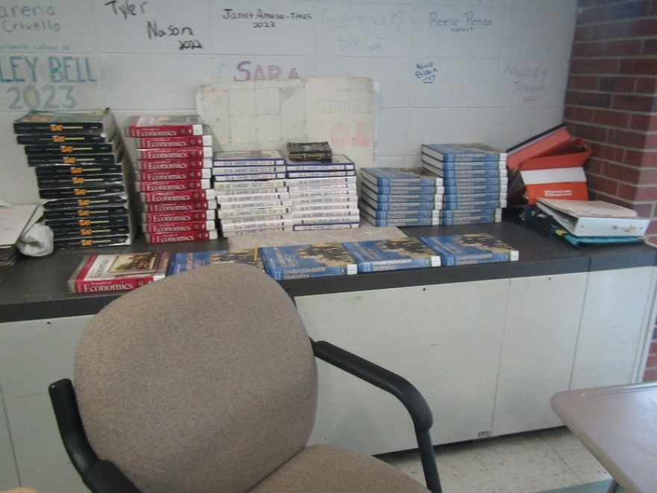

**Univent (blocked by books)**

**Picture 2**

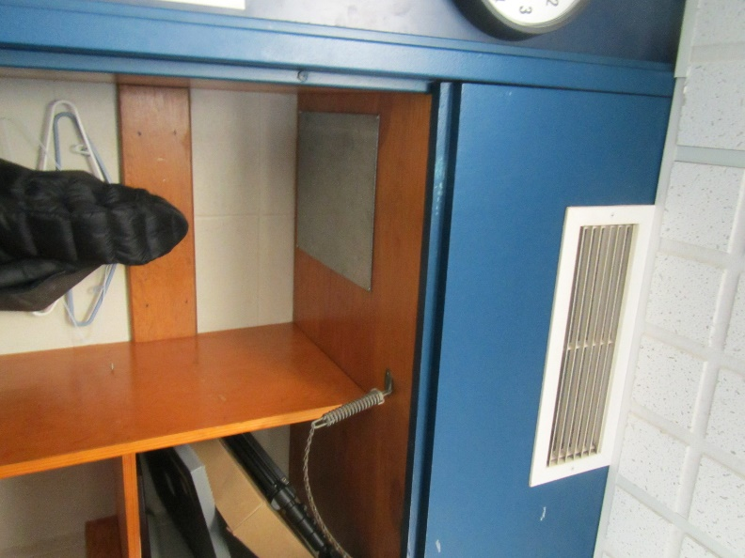

**Classroom exhaust vent**

**Picture 3**

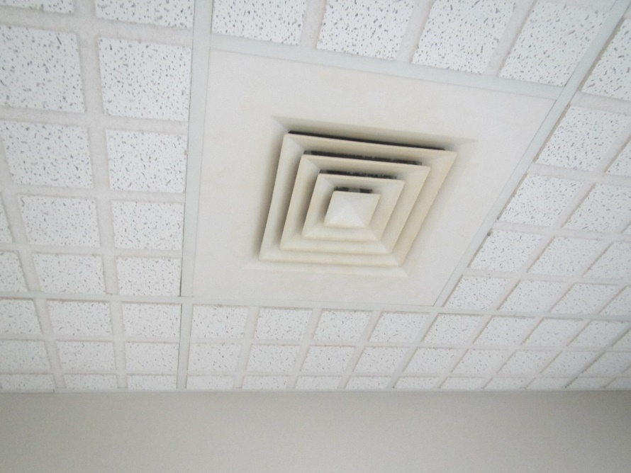

**Supply vent**

**Picture 4**

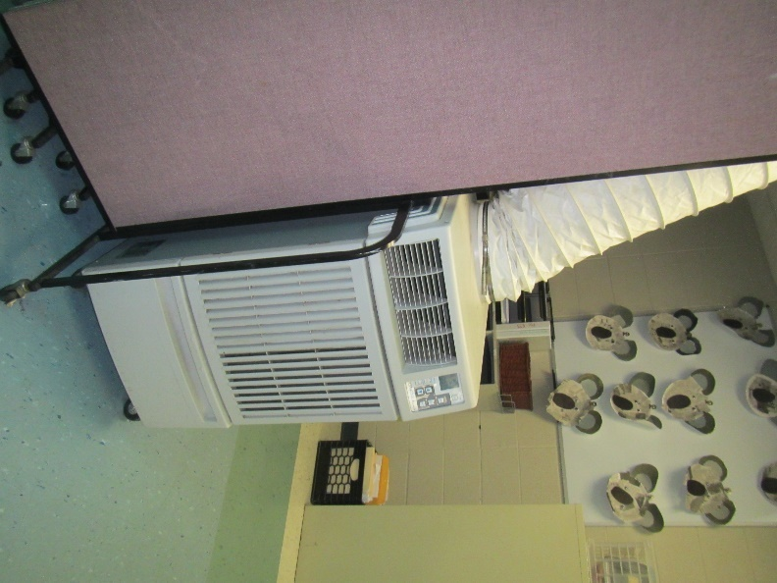

**Portable air conditioner**

**Picture 5**

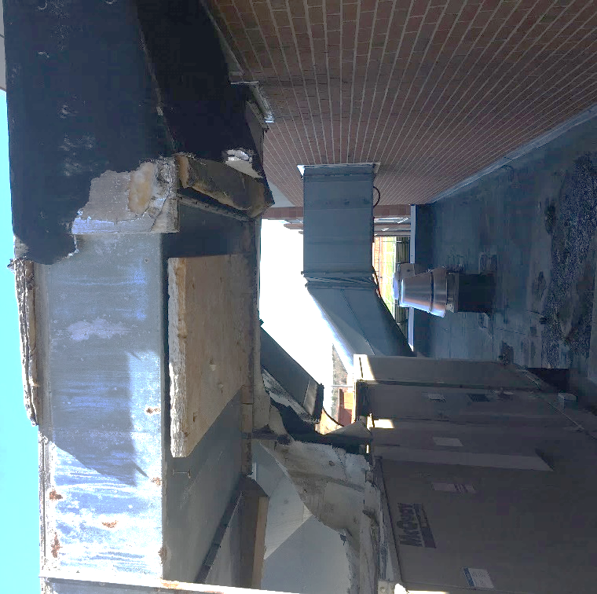

**Damaged insulation on rooftop ducts**

**Picture 6**

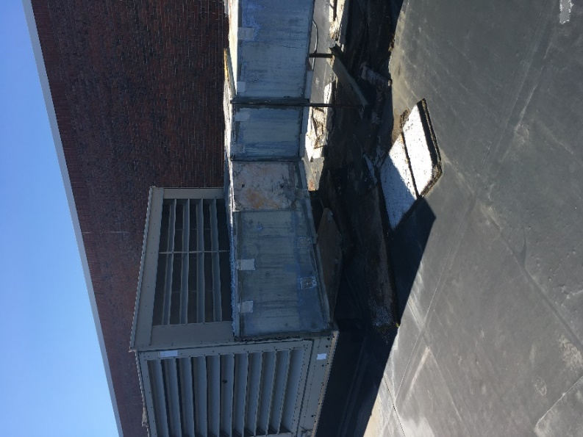

**Exposed ducts with missing and damaged insulation**

**Picture 7**

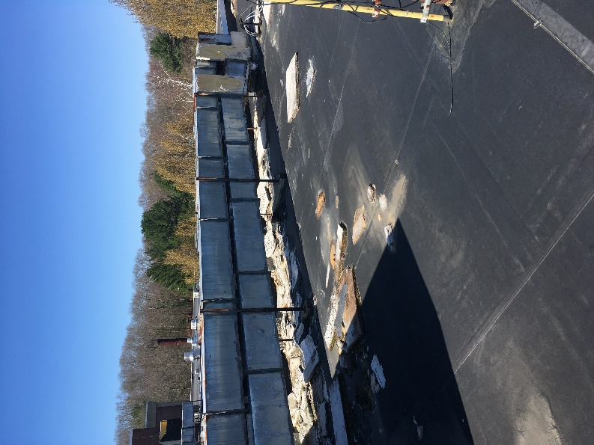

**Exposed ducts with missing damage insulation, note insulation on roof**

**Picture 8**

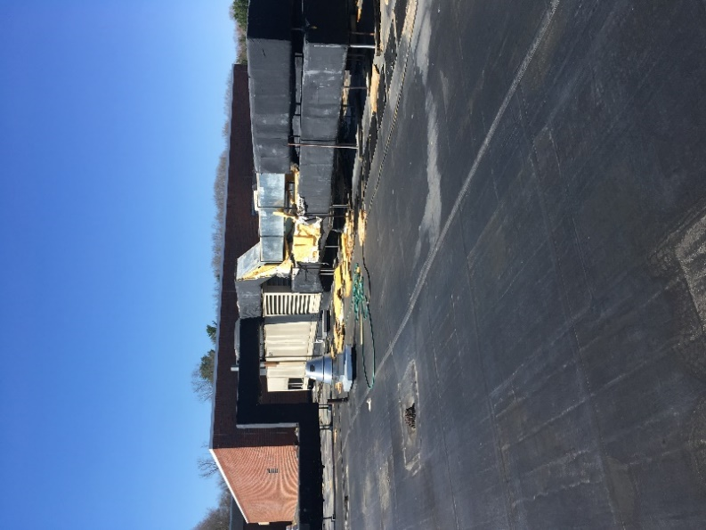

**Exposed ducts with missing and damaged insulation; note insulation fallen on roof**

**Picture 9**

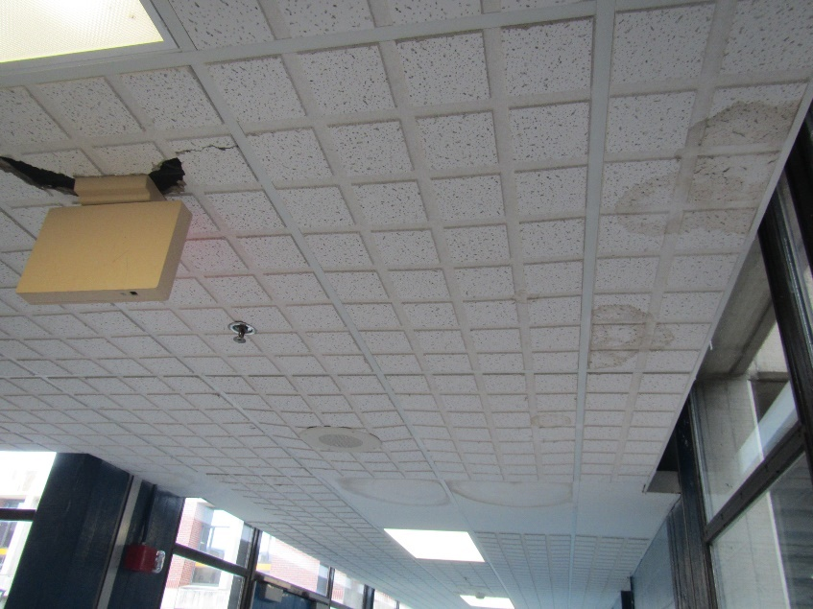

**Water-damaged ceiling tiles**

**Picture 10**

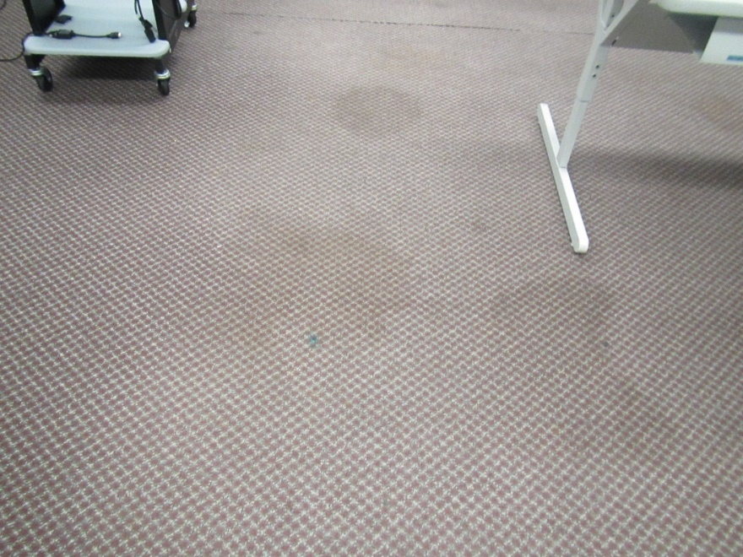

**Water-damaged/stained carpet**

**Picture 11**

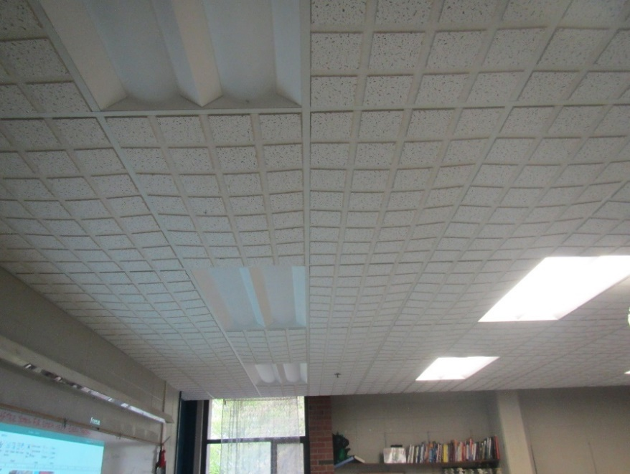

**Bowed ceiling tiles**

**Picture 12**

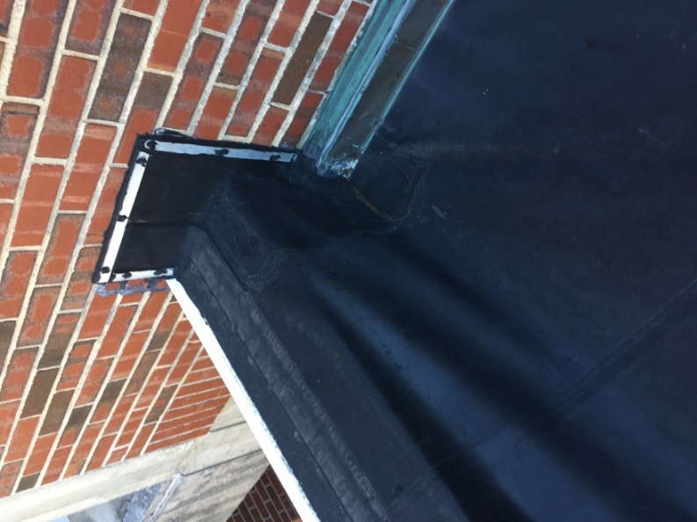

**Roof membrane detached from decking**

**Picture 13**

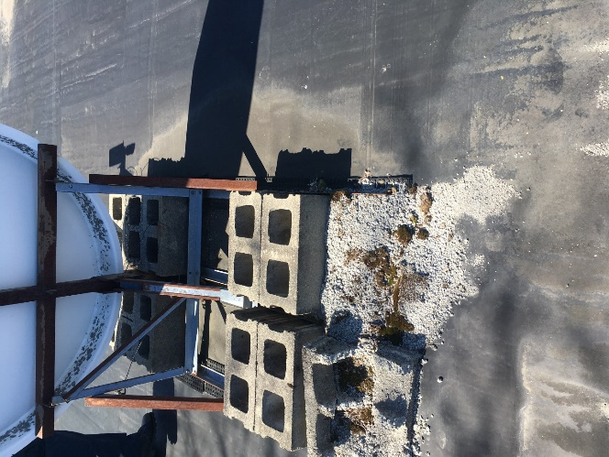

**Damage to roof membrane**

**Picture 14**

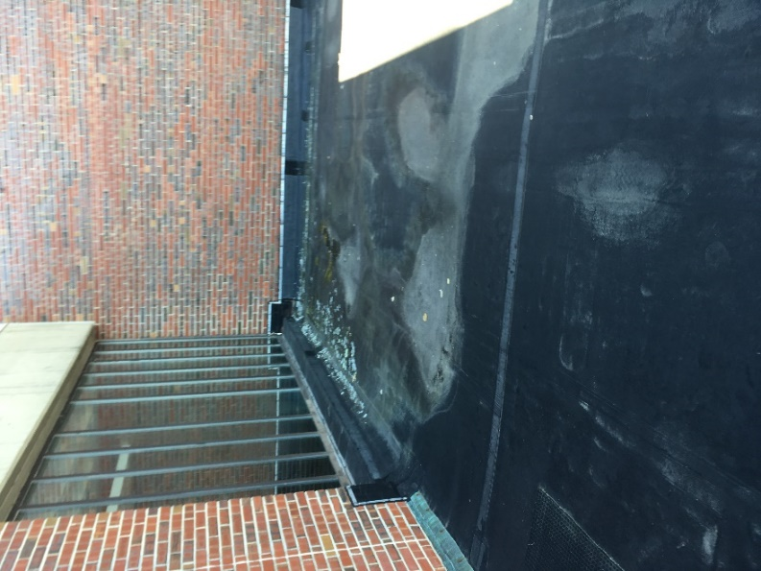

**Dried pools of water on the roof**

**Picture 15**

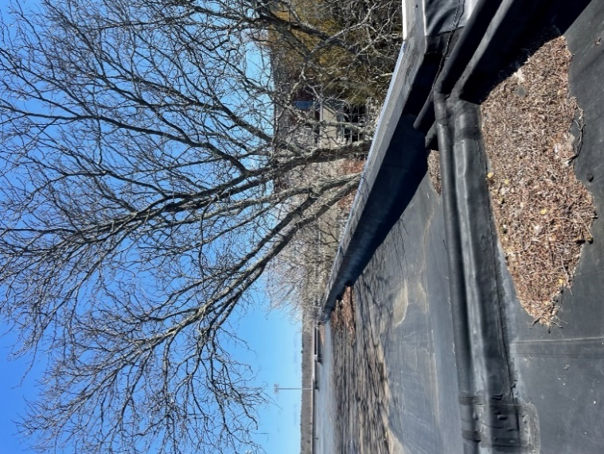

**Courtyard trees overhanging roof and debris on roof from trees**

**Picture 16**

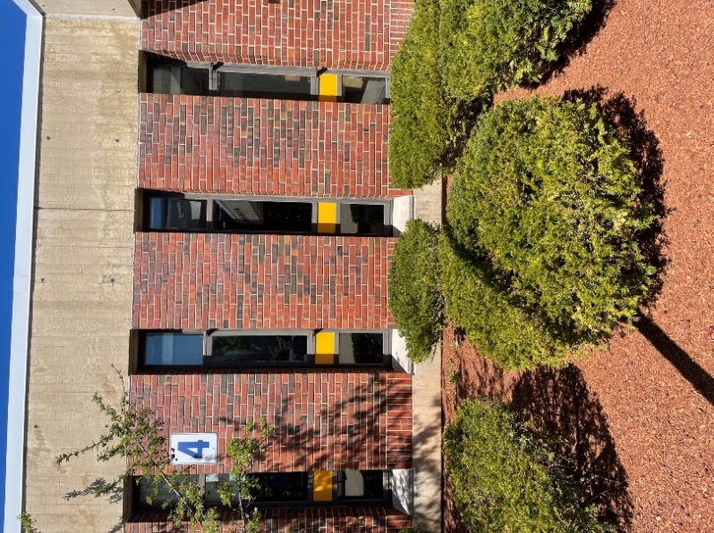

**Bushes and mulch close to building**

**Picture 17**

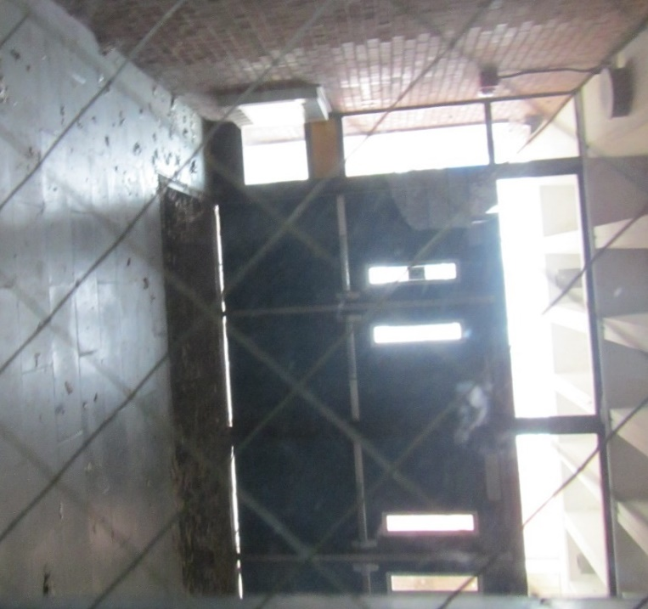

**Light visible underneath exterior doors**

**Picture 18**

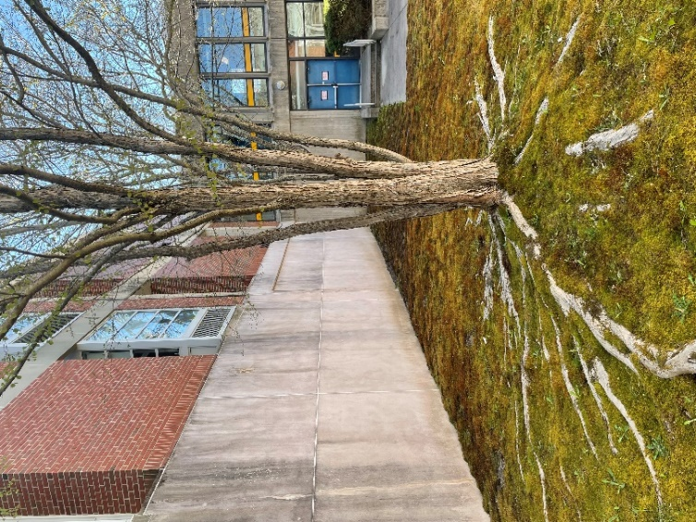

**Full-grown tree in courtyard**

**Picture 19**

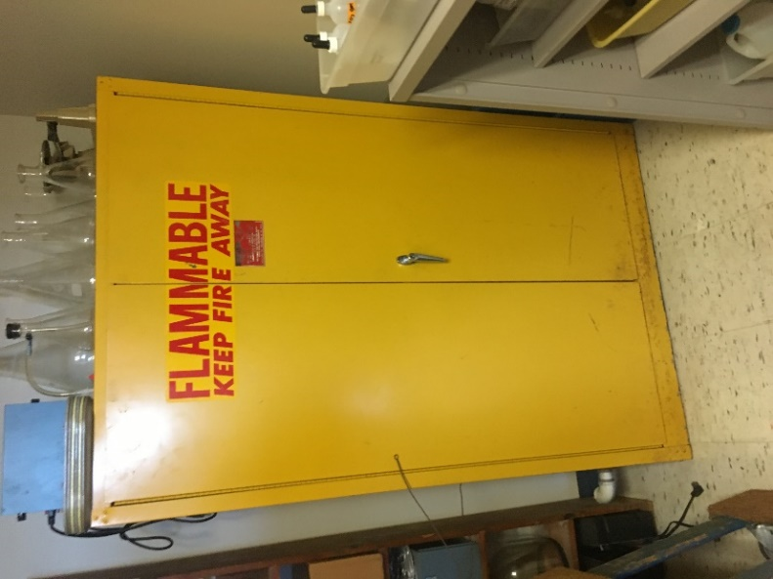

**Flameproof cabinet**

**Picture 20**

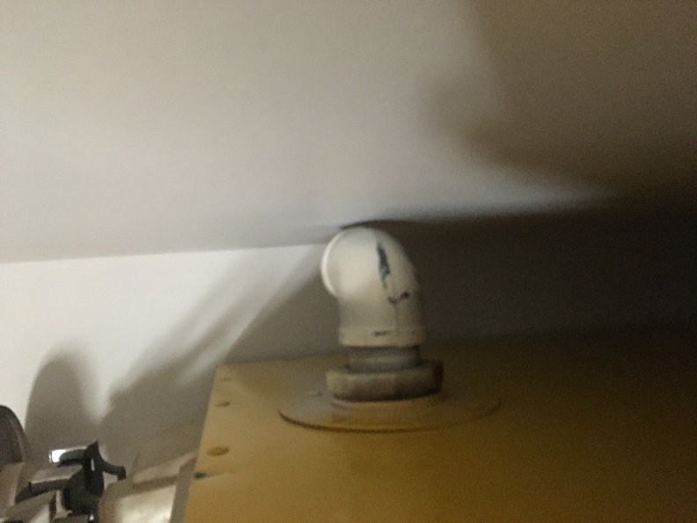

**Unnecessary vent from flameproof cabinet**

**Picture 21**

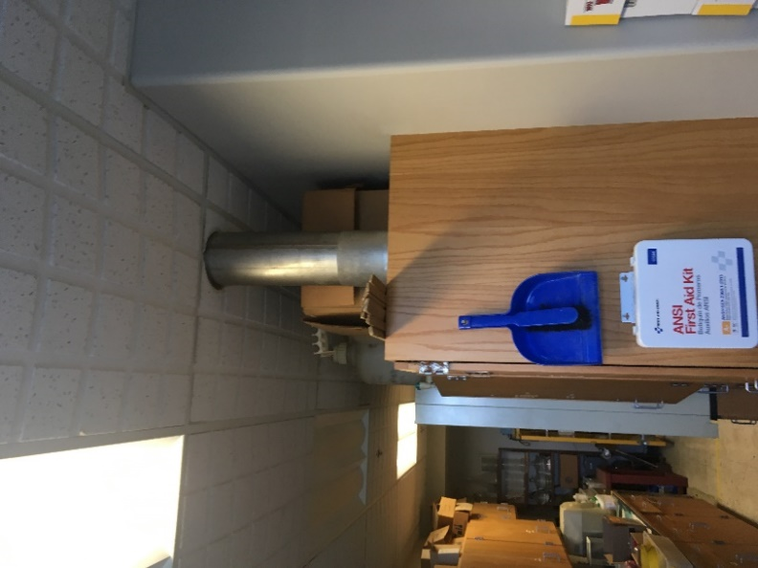

**Cabinet with non-motorized vent**

**Picture 22**

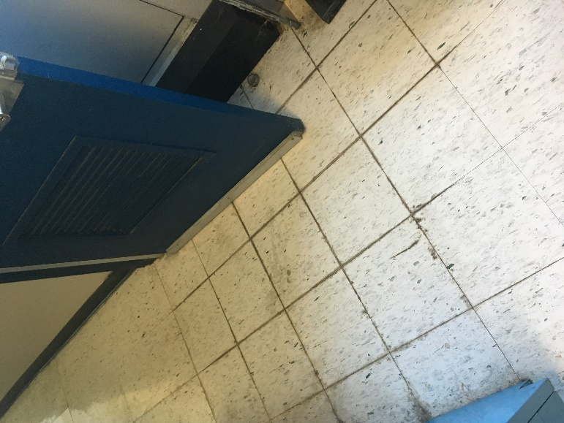

**Floor tiles damaged by frequent condensation accumulation**

**Picture 23**

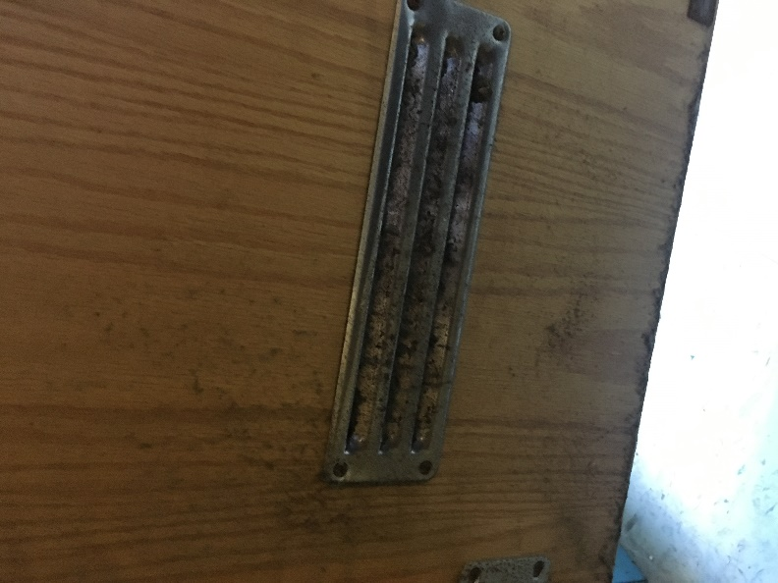

**Corrosion on the cabinet vent door of Picture 21**

**Picture 24**

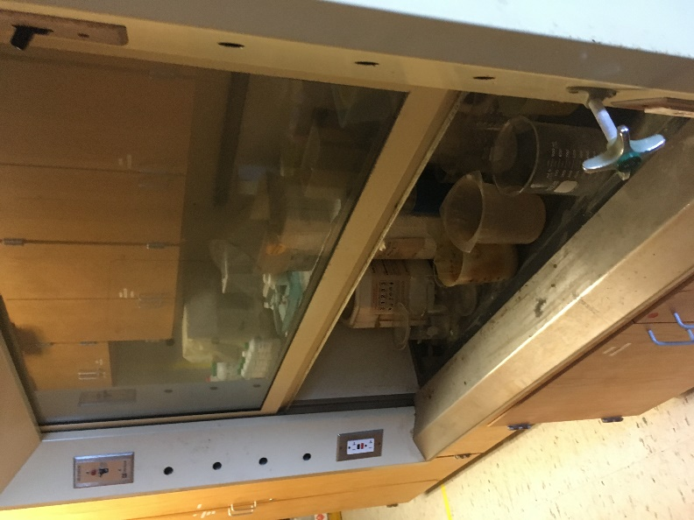

**Chemicals stored in and below chemical fume hood**

**Picture 25**

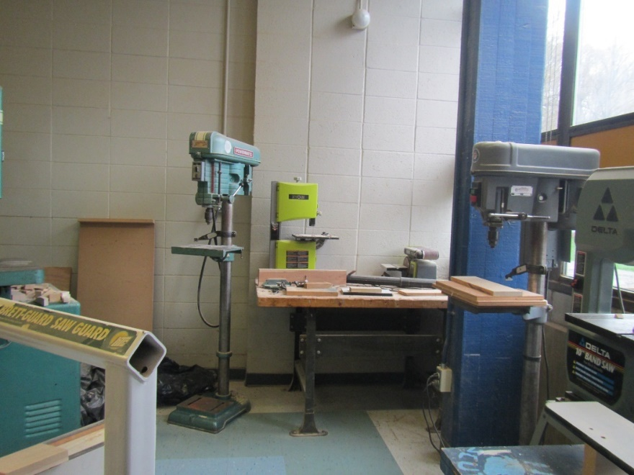

**Wood shop equipment**

**Picture 26**

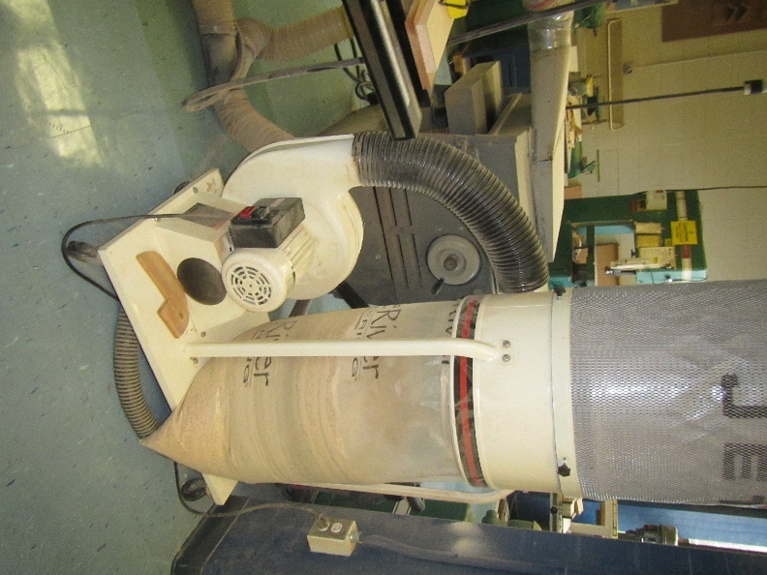

**Wood dust collection equipment**

**Picture 27**

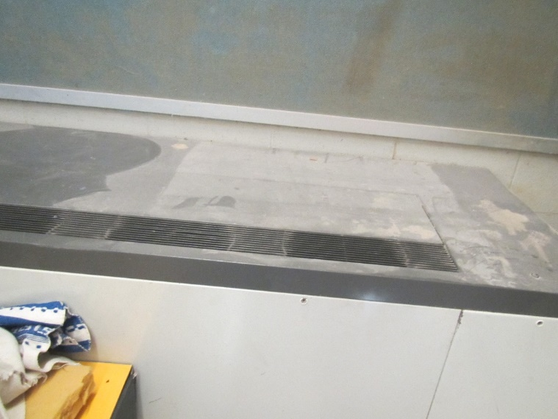

**Heavy coating of wood dust on a univent.**

**Picture 28**

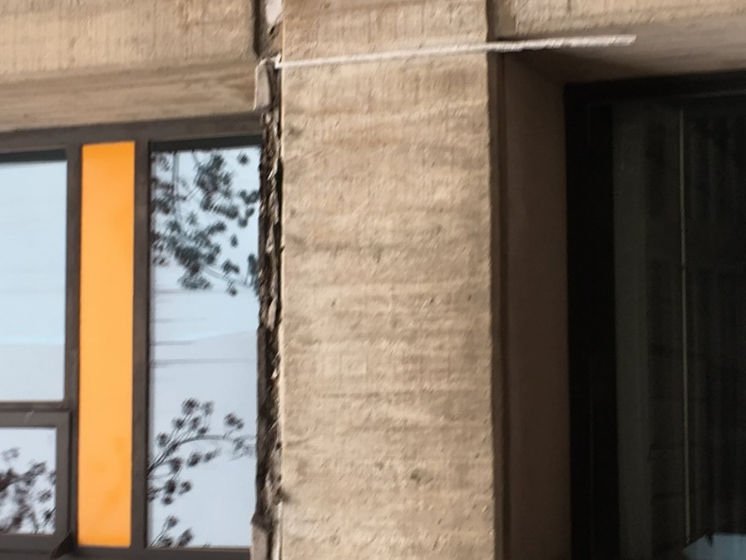

**Peeling window caulking on exterior of building**

**Picture 29**

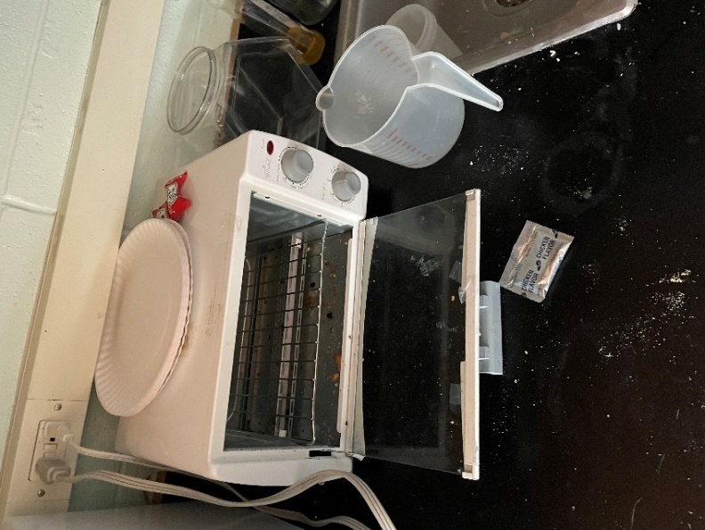

**Food debris in toaster oven**

**Picture 30**

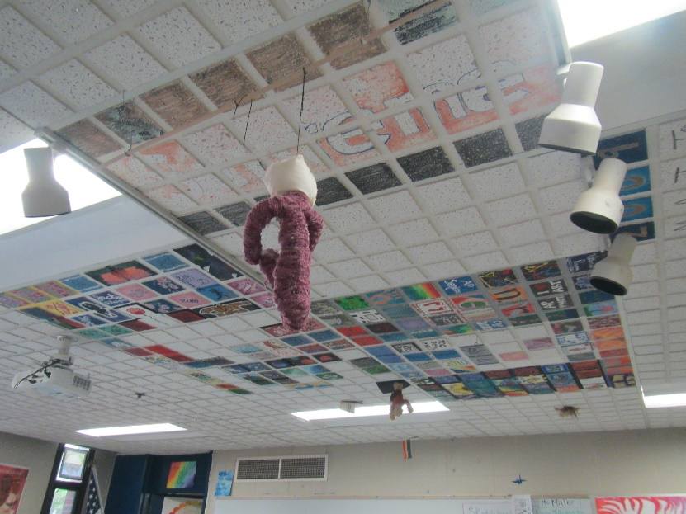

**Items hanging from the ceiling**

**Picture 31**

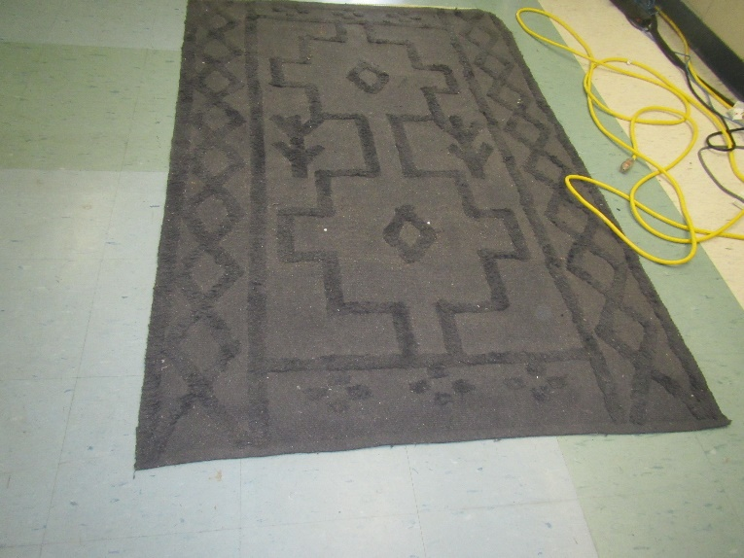

**Area rug**

| **Location/ Room** | **Carbon**  **Dioxide**  **(ppm)** | **Carbon Monoxide**  **(ppm)** | **Temp**  **(°F)** | **Relative**  **Humidity**  **(%)** | **PM2.5**  **(µg/m3)** | **Occupants**  **in Room** | **Windows**  **Openable** | **Ventilation** | | **Remarks** |
| --- | --- | --- | --- | --- | --- | --- | --- | --- | --- | --- |
| **Supply** | **Exhaust** |
| Background (outside) | 378 | ND | 53 | 54 |  |  |  |  |  |  |
| Second Floor, H series rooms | | | | | | | | | | |
| H201 | 775 | ND | 68 | 47 | ND | 9 | Y | Y on | Y | DEM |
| H202 | 1064 | ND | 69 | 48 | ND | 12 | Y | Y on | Y | Bowed CT, WD CT |
| H203 | 822 | ND | 69 | 47 | ND | 3 | Y | Y off |  | Bowed CT, chalk, DEM, plush couches |
| H204 |  |  |  |  |  | 13 | Y | Y | Y | Bowed CT, WD CT |
| H205 | 1739 | ND | 69 | 57 | ND | 19 | Y | Y | Y | Couches |
| H206 | 1190 | ND | 68 | 51 | ND | 15 | N | Y | Y | Bowed CT, 3 WD CT |
| H215 | 810 | ND | 68 | 47 | ND | 3 | Y | Y |  | ND, plant, DEM, microwave |
| H216 | 940 | ND | 70 | 45 | ND | class left recently | Y | Y blocked |  | DEM, tennis balls, dust, WD near window |
| H217 | 994 | ND | 68 | 52 | ND | 13 | Y | Y | Y |  |
| H218 | 988 | ND | 71 | 48 | ND | 13 | N | Y |  | Air purifier, DEM |
| H219 | 1043 | ND | 68 | 53 | ND | 14 | Y | Y | Y | Plants |
| H220 | 1344 | ND | 70 | 49 | ND | 3 | N | Y |  |  |
| H223 | 854 | ND | 70 | 44 | ND | 0 | Y | Y | Y | Microwave, PC, DO, HS, fridge |
| H224 | 1657 | ND | 69 | 56 | ND | 9 | Y | Y | Y |  |
| H225 | 1662 | ND | 69 | 52 | ND | 15 | Y | Y | Y | DEM |
| H226 | 1928 | ND | 70 | 57 | ND | 15 | Y | Y | Y |  |
| H227 | 1078 | ND | 69 | 49 | ND | 8 | Y | Y | Y | DEM, HS, pencil shavings |
| H229 | 1462 | ND | 68 | 53 | ND | 19 | Y | Y | Y | Univent on and partially blocked, chalk, HS, DEM, NC |
| First floor, H series rooms | | | | | | | | | | |
| H101 | 1904 | ND | 67 | 50 | ND | 10 | Y | Y | Y | Books, WD CT |
| H102 | 1446 | ND | 68 | 55 | ND | 9 | Y | Y | Y | Bowed CTs |
| H103 | 749 | ND | 68 | 48 | ND | 9 plus some leaving/  entering | Y | Y |  | DEM |
| H103 | 496 | ND | 66 | 57 | ND | 4 | Y | Y | Y | WAC |
| H104 | 996 | ND | 68 | 53 | ND | 0 | Y | Y | Y | Bowed CTs |
| H105 | 686 | ND | 68 | 47 | ND | 3 | Y | Y | y | DEM, heater, bowed CT, HS |
| H106 | 1430 | ND | 69 | 51 | ND | 7 | N | Y |  |  |
| H106 | 1079 | ND | 64 | 49 | ND | 14 | Y | Y | Y | Bowed CT, computers |
| H107 copy/workroom | 717 | ND | 68 | 47 | ND | 0 | N | Y |  | DEM, PC, microwave, fridge |
| H112 | 832 | ND | 68 | 48 | ND | 16 | Y | Y |  | Bowed CT, DEM, HS |
| H113 | 736 | ND | 67 | 58 | ND | 0 | Y | Y | Y | Sinks, Bowed CTs, aquarium with turtle |
| H115 | 1211 | ND | 68 | 62 | ND | 7 | Y | Y | Y |  |
| H117 | 1337 | ND | 68 | 64 | ND | 12 | Y | Y | Y | Bowed CT, plants |
| H118 | 1125 | ND | 67 | 55 | ND | 14 | Y | Y | Y |  |
| H119 | 1263 | ND | 67 | 57 | ND | 15 | Y | Y | Y | WD CTs, sinks, missing CTs |
| H121 | 798 | ND | 68 | 47 | ND | 0 | Y | Y blocked |  | MT, PC |
| H123 | 930 | ND | 68 | 49 | ND | 14 | Y | Y | Y | Area rug-dusty, DEM, overflowing recycling |
| H125 | 1160 | ND | 68 | 51 | ND | 11 | Y | Y | Y | DEM, clutter |
| H129 | 1746 | ND | 67 | 58 | ND | 4 | Y | Y | Y | WD CTs |
| H132 | 775 | ND | 71 | 49 | ND | 2 | N/A | Y | Y | WD CTs, bowed CTs |
| Library/Media Center | | | | | | | | | | |
| L100 Main library | 742 | ND | 70 | 51 | ND | 20 | N | Y | N | Carpet, sanitizer, disinfectant spray |
| Library left side | 582 | ND | 71 | 43 | ND | 4 | Y | Y |  | Stained carpet |
| REACH | 681 | ND | 68 | 48 | ND | 2 | N | Y |  | Plants |
| REACH inside | 652 | ND | 68 | 47 | ND | 1 | N | Y |  | Area rug and upholstered furniture, DEM, CP |
| Media center meeting room | 671 | ND | 71 | 45 | ND | 8 | N | Y |  | Stained carpet, DEM |
| Tech office | 600 | ND | 71 | 44 | ND | 0 | N | Y |  | DEM, equipment |
| Cafeteria | | | | | | | | | | |
| Cafeteria | 710 | ND | 70 | 48 | ND | 0 | N | Y | Y | WD CTs |
| Cafeteria, near food service | 473 | ND | 69 | 44 | ND | 0 | Doors to outside | Y | Y on | WD floor near doors to outside |
| A series rooms | | | | | | | | | | |
| A104 Wood Shop | 488 | ND | 64 | 48 | 2 | 0 | Y | Y dusty |  | Wood dust collection system, shop equipment, old smoke filter, DEM |
| A105 Metal Shop | 643 | ND | 64 | 53 | ND | 15 | Y |  |  | Soldering in progress |
| A104A | 641 | ND | 66 | 52 | ND | 0 | N/A | Y | N | Wood storage for woodshop |
| A213 | 964 | ND | 66 | 55 | ND | 10 | Y | Y | Y | Microwave, crumbs in toaster, plants, dirty sink |
| A208 | 673 | ND | 66 | 51 | ND | 3 | Y | Y | Y | Bowed CTs |
| A205 | 623 | ND | 67 | 50 | ND | 0 | Y | Y | Y | Carpet, sink over carpet |
| A205B | 605 | ND | 69 | 48 | ND | 0 | N/A | Y | Y | MTs, WD CTs |
| A202 | 634 | ND | 69 | 49 | ND | 0 | Y | Y | Y | Art room, WD CTs, bowed CTs |
| Resource room | 657 | ND | 65 | 50 | ND | 0 | N | Y | Y | Ductless AC, WD CT |
| A209 | 777 | ND | 67 | 48 | ND | 1 | N | Y | Y | SPED room, portable AC, fridge, microwave, oven |
| A209 rear | 833 | ND | 68 | 48 | ND | 0 | Y | Y | Y | WAC, DEM, AP |
| A200 auditorium | 453 | ND | 69 | 44 | ND | 15 | N | Y | Y | Carpeted |
| Stage | 422 | ND | 70 | 43 | ND | 0 | N |  |  |  |
| Music keyboards room | 455 | ND | 70 | 42 | ND | 0 | N |  |  | Carpet, bag of discarded batteries, ductless AC, 2 MT |
| Music podcast room | 486 | ND | 70 | 43 | ND | 0 | N | N | Y | WD CT, MT, ductless AC, carpet |
| A201 art | 499 | ND | 67 | 46 | ND | 0 | Y | Y | Y | DEM, hanging items, art supplies |
| A201 Kiln room |  |  |  |  |  | 0 | N | Y | Y | Ceiling-mounted univents, exhaust hood |
| A201 Art rooms office |  |  |  |  |  | 0 | N | Y | Y | Clutter |
| Gymnasiums | | | | | | | | | | |
| Middle School Gym | 529 | ND | 66 | 47 |  | 0 | Y | Y | Y | WD wall, possibly from roof |
| High School Gym | 539 | ND | 67 | 45 |  | 13 | Y | Y | Y | Bowed CT |
| Main office area rooms | | | | | | | | | | |
| Cubes outside food & nutrition | 824 | ND | 71 | 50 | ND | 0 | N/A | Y | Y | Carpet |
| Main office | 640 | ND | 69 | 46 | ND | 3 | Y | Y | Y | Carpet, plants |
| O254 | 610 | ND | 70 | 44 | ND | 3 | N | Y | Y | 3 WD CT |
| O255 | 503 | ND | 66 | 48 | ND | 0 | Y | Y |  | Carpet, plants |
| O256 | 541 | ND | 67 | 50 | ND | 0 | Y | Y |  | Carpet |
| O257 | 579 | ND | 68 | 47 | ND | 0 | Y | Y |  | Carpet, plants |
| O271 | 865 | ND | 70 | 51 | ND | 0 | N/A | Y | Y | Conference room, carpet |
| O275 | 719 | ND | 70 | 49 | ND | 0 | Y | Y | Y | Carpet |
| O279 | 732 | ND | 71 | 48 | ND | 0 | N/A | Y | Y | Carpet |
| O282 | 802 | ND | 71 | 48 | ND | 2 | N/A | Y | Y | Carpet |
| O287 breakroom | 768 | ND | 72 | 51 | ND | 0 | N/A | Y | N | Carpet, fridge on carpet, microwave |
| Superintendent’s office suite | | | | | | | | | | |
| Account payable | 618 | ND | 69 | 45 | ND | 0 | N | Y | Y | Carpet, PC |
| Conference | 599 | ND | 71 | 43 | ND | 0 | N | Y | Y | Carpet, DEM |
| Executive assistant | 572 | ND | 70 | 45 | ND | 1 | N | Y | Y | Carpet |
| O274 workroom | 559 | ND | 71 | 44 | ND | 1 | N | Y | Y | NC |
| O279 | 572 | ND | 70 | 44 | ND | 0 | N | Y | Y | Carpet, fake plant |
| O282 | 689 | ND | 71 | 44 | ND | 3 | N | Y | Y | Carpet |
| O286 | 623 | ND | 72 | 43 | ND | 0 | N | Y | Y | Carpet |
| O288 | 601 | ND | 72 | 43 | ND | 0 | N | Y | Y | WD CT, carpet |
| Office | 562 | ND | 70 | 45 | ND | 0 | N | Y | Y | Carpet, DEM, pillows |

1. The service life is the median time during which a particular system or component of …[an HVAC]… system remains in its original service application and then is replaced. Replacement may occur for any reason, including, but not limited to, failure, general obsolescence, reduced reliability, excessive maintenance cost, and changed system requirements due to such influences as building characteristics or energy prices (ASHRAE, 1991).