# BACKGROUND

**INDOOR AIR QUALITY**

**ASSESSMENT**

**Triton Regional Middle School**

**112 Elm Street**

**Byfield, Massachusetts**

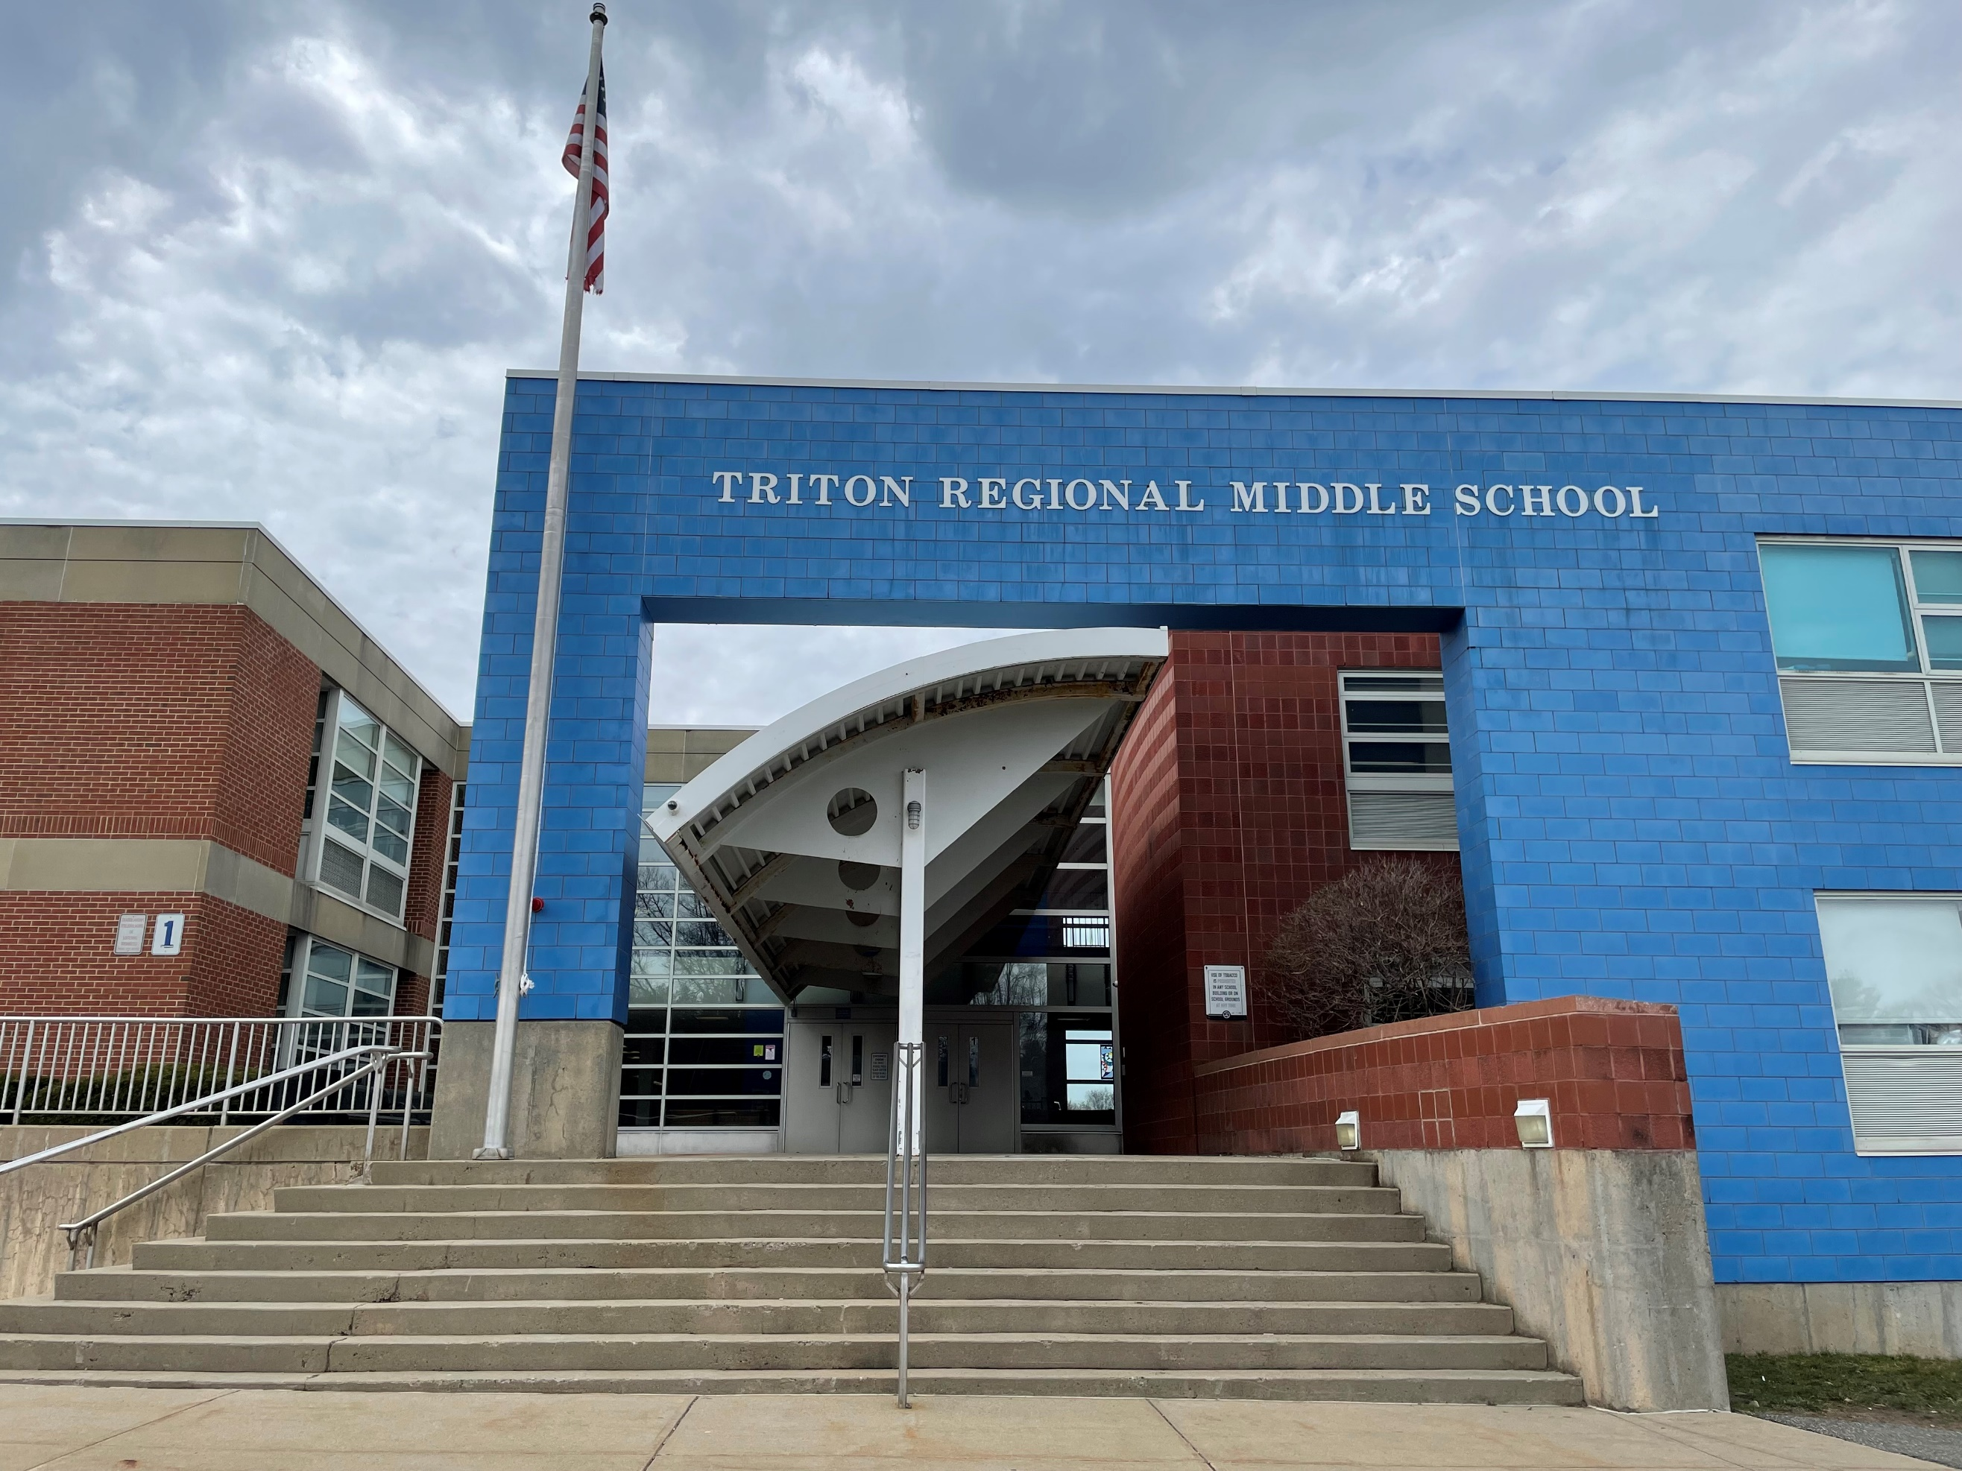

Prepared by:

Massachusetts Department of Public Health

Bureau of Climate and Environmental Health

Indoor Air Quality Program

July 2023

|  |  |
| --- | --- |
| Building: | Triton Regional Middle School (TRMS) |
| Address: | 112 Elm Street, Byfield, MA |
| Assessment Requested by: | Brian L. Forget, Superintendent of Schools Triton Regional School District after the Massachusetts Department of Public Health (MDPH) was contacted by a parent. |
| Reason for Assessment: | Concerns about mold and other general Indoor Air Quality (IAQ) concerns |
| Date of Assessment: | April 6, 2023, April 20, 2023 |
| Massachusetts Department of Public Health/ Bureau of Climate and Environmental Health (MDPH/BCEH) Staff Conducting Assessment: | Michael Feeney, Director, IAQ Program, and Jennifer Lajoie, Environmental Analyst/Inspector, IAQ Program |
| Building Description: | The TRMS was built in 1971 and renovated in 2001. It is a multi-story brick building with a complex shape and multiple sections of flat roof. The building contains general classrooms, science classrooms, an auditorium, gymnasium, cafeteria, kitchen, library, computer room, art room, music room and office spaces and is combined with the Triton Regional High School (TRHS). |
| Windows: | Openable in most areas |

**METHODS**

Please refer to the IAQ Manual for methods, sampling procedures, and interpretation of results (MDPH, 2015). As mentioned above, the building also houses the TRHS, with some facilities shared between the two schools. A separate report on the assessment of the TRHS will also be available.

**RESULTS AND DISCUSSION**

The following is a summary of testing results (Table 1):

* ***Carbon dioxide*** was below the MDPH guideline of 800 parts per million (ppm) in most areas visited indicating adequate fresh air in most classrooms and other spaces. Levels above 800 ppm were found in some smaller classrooms with high occupancy.
* ***Temperature*** was within or close to the recommended comfort range of 70°F to 78°F in areas tested.
* ***Relative humidity*** was within or slightly below the recommended range of 40% to 60% in areas assessed.
* ***Carbon monoxide*** levels were non-detectable (ND) in all areas assessed.
* ***Fine particulate matter (PM2.5)*** concentrations were below the National Ambient Air Quality Standard (NAAQS) level of 35 μg/m3.

## Ventilation

A Heating, Ventilating, and Air Conditioning (HVAC) system has several functions. First it provides heating and, if equipped, cooling. Second, it is a source of fresh air. Finally, an HVAC system will dilute and remove normally-occurring indoor environmental pollutants by not only introducing fresh air, but by filtering the airstream and ejecting stale air to the outdoors via exhaust ventilation. Even if an HVAC system is operating as designed, point sources of respiratory irritation may exist and cause symptoms in sensitive individuals.

Fresh air in the majority of classrooms is supplied by unit ventilators (univents). (Picture 1). Univents draw air from the outdoors through a fresh air intake located on the exterior wall of the building and return air through an air intake located at the base of the unit. Fresh and return air are mixed, filtered, heated or cooled and provided to rooms through an air diffuser located in the top of the unit (Figure 1).

A univent was opened and assessed. Filters, while well-fitted into the cabinet, appeared to be of a low filtration efficiency. Filters with a Minimum Efficiency Rating Value (MERV) rating of 8 should be used, or higher if the equipment can handle them. Dust and debris was noted in the univent; univent cabinets should be vacuumed clean during filter changes.

Mechanical exhaust ventilation in classrooms is provided by wall-mounted exhaust vents connected to rooftop motors. The MDPH IAQ Program recommends that supply and exhaust ventilation operate continuously during occupied periods to provide air exchange and filtration. Without sufficient supply and exhaust ventilation, normally occurring environmental pollutants can build up and lead to indoor air quality/comfort complaints.

It is also important to note that despite ongoing maintenance and replacement of parts/components by facilities staff, many of the HVAC units throughout the building are at the end of their life cycle. According to the American Society of Heating, Refrigeration, an1d Air-Conditioning Engineering (ASHRAE), the service life[1] of this type of unit is 15-20 years, assuming routine maintenance of the equipment (ASHRAE, 1991).

Fresh air for some common areas is provided by air handling units (AHU) through ducted supply vents in ceilings. Air handling unit examination was conducted as a part of assessing the TRHS and will be included in that report.

To maximize air exchange, the IAQ program recommends that both supply and exhaust ventilation operate continuously during periods of occupancy. To have proper ventilation with a mechanical ventilation system, the systems must be balanced after installation to provide an adequate amount of fresh air to the interior of a room while removing stale air from the room. It is recommended that HVAC systems be re-balanced every five years to ensure adequate air systems function (SMACNA, 1994). Based on the age and condition of the univents, balancing of the HVAC system may not be possible.

TRMS has no means to provide chilled air/air conditioning from univents. Univents operating during warm weather directly introduce unconditioned outdoor air into the classroom.

Some locations have window-mounted AC units (Table 1). This type of equipment may be susceptible to excessive condensation generation when operated during periods of hot, humid weather, which is described further below in the Microbial/Moisture Concerns section of this report. AC units have filters that should be cleaned or replaced on a regular basis to remove debris.

The TRMS has openable windows in many classrooms and offices which can be an additional source of fresh air. Windows should not be opened during heavy rain, when air conditioning is operating, or during freezing temperatures in the wintertime to prevent water damage from condensation or freezing pipes.

## Microbial/Moisture Concerns

All classrooms were assessed for the presence of visible water damage. Water-damaged ceiling tiles were noted in many areas (Picture 2; Table 1). These may be from roof or plumbing leaks. Leaks should be repaired, and the water-damaged materials removed and replaced as soon as practical. During replacement of tiles, the area above the removed tiles should be checked for additional water damage and repairs made as needed.

The roof, including flashing between different sections, and the rest of the building envelope should be examined and repaired. Once the leaks are repaired, water-damaged materials should be repaired, and any removed ceiling tiles replaced.

The TRMS did not have any detectable mold odors and did not appear to have significant water damage to interior spaces throughout the building. Porous materials such as carpeting or ceiling tiles should be dried with fans and heating within 24 to 48 hours of becoming wet (US EPA, 2008). If porous materials are not dried within this time frame, mold growth may occur. Water-damaged porous materials cannot be adequately cleaned to remove mold growth and should be discarded.

### Extreme weather conditions

It is important to note that Massachusetts experienced extended periods of high relative humidity during recent summers. July of 2021 was the wettest ever recorded in Massachusetts, and the three-month period from June through August 2021 (meteorological summer), was the fourth wettest on record, according to the National Oceanic and Atmospheric Administration’s (NOAA) Centers for Environmental Information. The three-month period also was the third warmest ever in the state and was tied for the warmest on record across the United States (HG, 2021, NOAA, 2021). These conditions are challenging for buildings, particularly those without air conditioning.

Such conditions have occurred in New England prior to Summer 2021. During the summer of 2018, the Boston area also experienced an unprecedented period of extended hot, humid weather. According to the Washington Post, “[d]ata…show[s]…cities in the Northeast have witnessed such humidity levels for record-challenging duration...[i]ncluding Albany, Boston, Burlington, Portland, and Providence” during the summer of 2018 (WP, 2018). “Boston and nearby locations… [saw]…historic numbers of those warm nights with low temperatures at or above 70 degrees…Providence and Blue Hill Observatory have already broken their annual records” (WP, 2018).

During both summer 2018 and 2021, extended periods of outdoor relative humidity above 70% occurred. Under these excessively moist weather periods, public buildings experienced extended periods of water vapor exposure from high relative humidity. When exposed to these conditions, porous materials such as gypsum wallboard, cardboard, and other materials may become prone to developing mold colonization, particularly if located in areas that are prone to developing condensation on floors and walls (e.g., below grade space). According to the American Society of Heating, Refrigerating and Air-Conditioning Engineers (ASHRAE); if relative humidity exceeds 70%, mold growth may occur due to wetting of building materials (ASHRAE, 2019) even in the absence of liquid water.

### Building materials subject to excess humidity

Classrooms on the first and second floors had bowed ceiling tiles (Picture 3; Table 1). As ceiling tiles become moistened by high relative humidity, the wetting can cause ceiling tiles to distend (bow) while sitting in the suspended ceiling rails. One source of water vapor that can increase indoor relative is extended periods of hot, humid weather with heavy rains, as described above. While unstained bowed tiles are not a source of mold, this is an indication that high relative humidity has occurred for a significant period. Therefore, other materials that remain in classrooms during hot humid weather, particularly when the school is unoccupied, may be subject to moistening and water damage. This includes carpeting/area rugs, furniture, and stored items such as boxes, paper, and clothing.

The lowest floor of the former TRMS has floors that are in direct contact with soil. Floor tiles appear to have water damage (Picture 4) that is typical of having temperatures significantly (> 5°F) below air temperature. Given this, it is likely that the lowest levels of the building have both floors and walls that are prone to condensation during hot, humid weather.

The key to managing condensation is understanding dew point. The dew point is the temperature that air must reach for saturation to occur. When warm, moist air passes over a cooler surface, condensation can form. If a building material/component has a temperature below the dew point, condensation will accumulate on that material. Porous materials can be moistened by condensation or by droplets resulting from condensation on nearby surfaces, which creates conditions where mold may grow. Porous building materials such as gypsum wallboard, and stored materials such as cardboard, cloth, paper, and soft wood can all become water-damaged and mold-colonized.

Stand-alone air conditioners, including window-mounted, ductless, or portable types (Table 1), chill air and reduce humidity, which can increase comfort for occupants during hot, humid weather. However, during very humid weather, they have the potential to lead to condensation and water damage. Each type of air conditioner collects condensation during operation. If the unit is not designed and situated to properly remove the collected condensation (e.g., via an attached hose and pump, or outside the building for a window-mounted unit), leaks can occur which can moisten porous materials. The potential for leaks increases as the amount of condensation generated increases due to high temperatures and humidity. In addition, surfaces chilled by the cold outlet air of the air conditioner can generate condensation. To avoid water damage due to use of air conditioning, doors and windows should be closed when the air conditioning is in operation, chilled air outlets should be directed away from surfaces, and condensation drainage, including pumps and hoses, should be monitored for clogs and leaks.

### Roof conditions

The roof appears to have several issues with drainage. Areas where pooled water had occurred and then dried were noted (Picture 5). Pooling water can be attributed to settling of the roof membrane as well as blockage of roof drains by leaves and other debris from trees that overhang the roof (Pictures 6 and 7). Without adequate drainage, pooling water on the roof can also freeze during cold weather to cause degradation of the roof membrane.

### Building envelope issues

IAQ staff examined the building envelope to identify possible sources of water outside, breaches, and/or other conditions that could provide a source of moisture that can adversely affect indoor air quality. The following outdoor conditions related to moisture were identified:

* Plants were observed in contact with and near the foundation. Plants near the building can cause water damage to brickwork and mortar. In addition, plants shading exterior walls can slow drying. Water can eventually penetrate the brick, subsequently freezing and thawing during the winter. This freezing/thawing action can weaken and damage bricks and mortar.
* Mulch was used near the building (Picture 8), which not only holds moisture against the building, but can also be a fire hazard. Current Massachusetts code (527 CMR 1.00, section 10.13.10.4.) prohibits the use of mulch within 18″ of a flammable building exterior (MBFP, 2020). While brick exteriors are not subject to this regulation, mulch should be kept away from buildings. Mulch and plants can also be a source of food and harborage for pests.
* Some exterior doors had light visible beneath them indicating that the weatherstripping was missing or worn out (Picture 9). Doors to the exterior should be made weather-tight.

These conditions can undermine the integrity of the building envelope and provide a means for water entry into the building through exterior walls, foundation concrete, and masonry (Lstiburek & Brennan, 2001). In addition, these breaches in exterior areas can provide a means for drafts and pest entry into the building.

### Poor drainage in courtyards

The building has several large interior courtyards that have poor water drainage. Accumulated rainwater pools against the building foundation around the perimeter of the courtyards. Over time, rainwater runoff from the exterior wall can compress soil to produce a furrow-like depression of ground adjacent to the building foundation, which, in turn, can result in puddling (Picture 10). Univents can draw water vapor from these pools, which can potentially: corrode the univent cabinet, moisten filters to cause mold growth, and increase relative humidity inside the building. Such pooling can also result in penetration of water into below grade space. One courtyard also appears to slope towards below-grade space, which can create conditions for water pooling and damage to exterior walls.

The presence of large trees is likely enhancing water retention and affecting courtyard drainage as well as overhanging the roof. These trees pose several hazards:

* Leaves and other debris accumulate around roof drains (Picture 6), which inhibits rainwater drainage from the roof. Ineffective drains can lead to water running off the roof to moisten exterior walls.
* Trees prevent sunlight from drying courtyard walls and soil (e.g., Picture 11).
* The trees are a possible danger due to the distance from exterior walls:
  + The recommended safe distance that any tree should be planted is the minimum of the expected maximum growth height of the species from the exterior of a building (BI, 2015).
* Soil subsidence may also be caused by tree roots (Picture 12), which can undermine the structure of a building to cause wall and floor cracking and related damage. To prevent subsidence, a sufficient distance appropriate for the tree species is recommended (Williams, 2006).
* Severe weather may result in the tree falling onto the building or the tree roots damaging the foundation. Due to the height of the trees, each is likely located closer than recommended distances.
* In general, a tree root system will spread out in all directions from its trunk (Picture 12). In some cases, tree roots can extend for over 100 feet from its trunk. Any structure disrupting the root structure may make the tree unstable if subjected to high winds from a certain direction. Based on the location, the foundation walls likely disrupt the roots of several trees.
* The Federal Emergency Management Agency (FEMA) provides several recommendations in order to prepare for severe thunderstorms. Of note FEMA recommends “Cut down or trim trees that may be in danger of falling on your [building]” (FEMA, 2018). Given the proximity to exterior walls, removal of trees from the courtyard should be strongly considered.

### Other moisture issues

Sinks were noted in some classrooms (Table 1). Sinks should be well maintained to avoid leaks and odors. The area under sinks is a moist environment so porous items should not be stored there. Unused sinks and other fixtures (Picture 13) may be subject to dry drain traps. If the U- or P-trap seals on plumbing become dry, sewer gases can enter occupied spaces. Unused sinks and other plumbing fixtures should be wetted periodically to prevent dry traps, or, if no longer needed, should be properly removed.

Aquariums were noted in some areas (Table 1). Aquariums, terrariums, and similar items should be kept clean to prevent odors and microbial growth. Plants were also noted in some classrooms and offices (Picture 1; Table 1). Indoor plants should be well maintained and not overwatered to prevent water damage and pests. This includes plants used for science experiments. Plants, aquariums, terrariums, and other sources of odors should be kept away from the airstream of univents and other ventilation equipment.

## Other issues

One classroom had sliced open tennis balls on chair legs to reduce noise (Table 1). Tennis balls are made of materials that may be a source of respiratory irritants. Constant wearing of tennis balls can produce fibers and off-gas VOCs. Tennis balls are made with a natural rubber latex bladder, which becomes abraded when used as a chair leg pad. Use of tennis balls in this manner may introduce latex dust into the school environment. Some individuals are highly allergic to latex (e.g., spina bifida patients) (SBAA, 2001). It is recommended that the use of materials containing latex be limited to reduce the potential for symptoms in sensitive individuals (NIOSH, 1997). Latex-free glides should be used for this purpose.

A wood shop with saws and drills was noted (Pictures 14 and 15). The shop drills do not appear to be connected to a centralized wood dust collection system, which removes dust from the source and contains it for later disposal. Dust collection systems need to be operated every time cutting/drilling occurs, and the collection vessel needs to be emptied regularly. Wood dust can be irritating to the skin, eyes, and respiratory tract, and collected wood dust or shavings can become mold colonized if moistened, or pest food/harborage if left unattended for long periods of time.

Food and food preparation equipment were found in many classrooms and breakrooms. Some of the equipment had spills or crumbs which can lead to smoke or odors and be attractive to pests.

Items were found hanging from the ceiling in some areas. Hanging items can collect dust. In addition, the process of hanging items from the ceiling can expose occupants to dust and debris from above the ceiling tile system.

Some offices and other areas were carpeted. Area rugs were also found in some classrooms (Table 1). Carpets should be cleaned annually (or semi-annually in soiled/high traffic areas) in accordance with Institute of Inspection, Cleaning and Restoration Certification (IICRC) recommendations (IICRC, 2012). Carpets should be vacuumed regularly using a high-efficiency particulate arrestance (HEPA)-equipped vacuum cleaner to prevent aerosolization of dusts. Area rugs should also be cleaned regularly and should be stored off the floor during the summer months to prevent water damage. Used area rugs should not be brought into the school from outside, as these may be contaminated with allergens such as pet dander.

## Radon

The Environmental Protection Agency (EPA) conducted a National School Radon Survey in which it discovered nearly one in five schools had “…at least one frequently occupied ground contact room with short-term radon levels above 4 [picocuries per liter] pCi/L” (US EPA, 1993). The BCEH/IAQ Program therefore recommends that every school be tested for radon, and that this testing be conducted during the heating season while school is in session in a manner consistent with US EPA radon testing guidelines. Radon measurement specialists and other information can be found at [www.nrsb.org](http://www.nrsb.org) and <http://aarst-nrpp.com/wp>, with additional information at: <http://www.mass.gov/eohhs/gov/departments/dph/programs/environmental-health/exposure-topics/iaq/radon>.

# CONCLUSIONS AND RECOMMENDATIONS

The following documents can provide guidance that can be used to reduce the impact of hot, humid weather in buildings.

* Mold Growth Prevention During Hot, Humid Weather <https://www.mass.gov/service-details/preventing-mold-growth-in-massachusetts-schools-during-hot-humid-weather>
* Remediation and Prevention of Mold Growth and Water Damage in Public Schools <https://www.mass.gov/service-details/remediation-and-prevention-of-mold-growth-and-water-damage-in-public-schools-and>
* Methods for Increasing Comfort in Non-air-conditioned Schools <https://www.mass.gov/doc/methods-for-increasing-comfort-in-non-air-conditioned-schools/download>

To remedy building problems, two sets of recommendations are made: short-term measures that may be implemented as soon as practicable and long-term measures that will require planning and resources to address overall IAQ concerns:

## Short-term recommendations

### Ventilation Recommendations

1. Run supply and exhaust systems continuously when the school is occupied.
2. Consider size and ventilation of classrooms when scheduling large groups of students.
3. Continue with regular filter changes for HVAC equipment using the best quality/highest minimum efficiency rating value (MERV) that can be used. During filter changes, vacuum debris from univent and AHU cabinets.
4. Maintain window air conditioners in accordance with manufacturer's instructions including cleaning and filter changes.
5. Use openable windows for additional fresh air during temperate weather. Tightly close windows at the end of the day and avoid opening windows when air conditioning is in use (or during freezing temperatures in wintertime).
6. For best functioning of the exhaust system, keep classrooms doors closed.
7. Have the HVAC system balanced every 5 years in accordance with SMACNA recommendations (SMACNA, 1994).

### Water damage recommendations

1. Replace water-damaged ceiling tiles once leaks from plumbing, HVAC or building envelope have been resolved.
2. Given the conditions noted in the lowest level of the TRMS, do not store materials there that are susceptible to mold growth if moistened by condensation. Such materials include paper, cardboard, cloth, books, leather, engineered woods such as particle board or chipboard, and gypsum wallboard.
3. It is recommended that porous material be dried with fans and heating within 24 to 48 hours of becoming wet (US EPA, 2008, ACGIH, 1989). If porous materials are not dried within this time frame, mold growth may occur. Water-damaged porous materials cannot be adequately cleaned to remove mold growth. If porous materials are not dried within this time frame, they should be removed and discarded.
4. Ensure that condensation can drain from air conditioning equipment and that chilled air does not lead to condensation on adjacent materials.
5. Have the roof and building joints inspected and repaired to fix leaking. Once leaks have been resolved, repair water-damaged materials.
6. Regularly remove debris from in and around roof drains and inspect the condition of the roof. Repair roof membrane as needed.
7. Trim plants at least 5 feet away from the building.
8. Avoid the use of mulch next to the building.
9. Add or repair weatherstripping on exterior doors to maintain weathertightness.
10. Take steps to address drainage in courtyards to address water puddling.
11. Consider removing trees from the courtyard and trim them away from the outside of the building.
12. Ensure that all sink and floor drains have sufficiently wetted traps. Pour water into each drain a minimum of once a week to maintain trap integrity. Consider sealing or properly abandoning any sinks and drains that are no longer needed.
13. Keep aquariums and terrariums clean to prevent odors.
14. Keep indoor plants in good condition, avoid overwatering, and keep them away from univents and other sources of airflow.

### Other recommendations

1. Avoid using latex-containing tennis balls as chair or table glides. Replace with latex-free glides or other materials.
2. Use local/direct exhaust ventilation and dust collection systems for workshop equipment and ensure the dust collection system is regularly emptied.
3. Keep food in tightly closed pest-proof containers and keep food preparation equipment clean and free of spills and crumbs.
4. Clean area rugs and carpets in accordance with IICRC recommendations. Store area rugs rolled up and off the floor in a dry area during summer break.
5. The school should be tested for radon by a certified radon measurement specialist during the heating season when school is in session. Radon measurement specialists and other information can be found at: [www.nrsb.org](http://www.nrsb.org/), and <http://aarst-nrpp.com/wp>.
6. To learn more about radon, review the MDPH’s [Radon in Schools and Child Care Programs](https://www.mass.gov/info-details/radon-in-schools-and-child-care-programs?utm_source=IAQP&utm_medium=reports) factsheet, with additional information at: <https://www.mass.gov/radon>.
7. Consider including an IAQ component in the school’s Wellness Advisory Committee program. An IAQ plan should have an IAQ liaison/teacher representative, a member of maintenance/facilities and administration that conduct regular walk-throughs to identify on-going and/or potential environmental issues.
8. Utilize the US EPA’s (2000), “Tools for Schools”, as an instrument for maintaining a good IAQ environment in the building available at: <https://www.epa.gov/iaq-schools>.
9. For guidance on maintaining an asthma-friendly healthy school environment, please consult the MDPH Asthma Prevention and Control Program’s [Clearing the Air: An Asthma Toolkit for Healthy Schools](https://www.maasthma.org/schooltoolkit).
10. Refer to resource manual and other related IAQ documents located on the MDPH’s website for further building-wide evaluations and advice on maintaining public buildings. These documents are available at: <http://mass.gov/dph/iaq>.
11. Refer to the resource manual and other related indoor air quality documents located on the MDPH’s website for further building-wide evaluations and advice on maintaining public buildings. These documents are available at <http://mass.gov/dph/iaq>.

## Long Term Recommendations

1. Consider removing all trees from the courtyard.
2. Consider regrading the courtyard to reduce water flow towards the building.
3. Consider other activities to improve water drainage from courtyards.
4. Since the HVAC system is likely beyond its service life contact a building engineering firm for advice regarding conditions noted at the TRMS, including a building-wide HVAC equipment assessment to determine:
   1. Whether the existing HVAC system can be balanced as recommended.
   2. The operability and feasibility repairing the existing equipment.
   3. If the equipment should be replaced due to age, physical deterioration and availability of parts for ventilation components.

# REFERENCES

ACGIH. 1989. Guidelines for the Assessment of Bioaerosols in the Indoor Environment. American Conference of Governmental Industrial Hygienists, Cincinnati, OH.

BI. 2015. A List of Trees and the Recommended Safe Distance from Buildings. Bickers Insurance, Littlehampton, West Sussex, UK. <https://www.bickersinsurance.co.uk/about-us/latest-news/property-owners-news/a-list-of-trees-and-the-recommended-safe-distance-from-buildings/>

FEMA. 2018. How to Stay Safe When a Thunderstorm Threatens. Federal Emergency Management Agency, Washington, DC. FEMA V-1009/May 2018.

HG. 2021. Mold keeps South Hadley High School shuttered. Hampshire Gazette. https://www.gazettenet.com/South-Hadley-High-School-still-closed-amid-mold-remediation-42413519.

IICRC. 2012. Institute of Inspection, Cleaning and Restoration Certification. Carpet Cleaning: FAQ.

Lstiburek, J. & Brennan, T. 2001. Read This Before You Design, Build or Renovate. Building Science Corporation, Westford, MA. U.S. Department of Housing and Urban Development, Region I, Boston, MA.

MBFP. 2020. Massachusetts Comprehensive Fire Safety Code. 527 CMR 1.00: Board Of Fire Prevention Regulations. October 2, 2020.

MDPH. 2015. Massachusetts Department of Public Health. “Indoor Air Quality Manual: Chapters I-III”. Available at: <https://www.mass.gov/lists/indoor-air-quality-manual-and-appendices>.

NOAA. 2021. Summer 2021 neck and neck with Dust Bowl summer for hottest on record. National Oceanic and Atmospheric Administration, 1401 Constitution Avenue NW, Room 5128, Washington, DC 20230 <https://www.noaa.gov/news/summer-2021-neck-and-neck-with-dust-bowl-summer-for-hottest-on-record>

NIOSH. 1997. NIOSH Alert Preventing Allergic Reactions to Natural Rubber latex in the Workplace. National Institute for Occupational Safety and Health, Atlanta, GA.

SBAA. 2001. Latex In the Home And Community Updated Spring 2001. Spina Bifida Association of America, Washington, DC.

SMACNA. 1994. HVAC Systems Commissioning Manual. 1st ed. Sheet Metal and Air Conditioning Contractors’ National Association, Inc., Chantilly, VA.

US EPA. 1993. Radon Measurement in Schools, Revised Edition. Office of Air and Radiation, Office of Radiation and Indoor Air, Indoor Environments Division (6609J). EPA 402-R-92-014

US EPA. 2000. Tools for Schools. Office of Air and Radiation, Office of Radiation and Indoor Air, Indoor Environments Division (6609J). EPA 402-K-95-001, Second Edition. <http://www.epa.gov/iaq/schools/index.html>.

US EPA. 2008. “Mold Remediation in Schools and Commercial Buildings”. Office of Air and Radiation, Indoor Environments Division, Washington, DC. EPA 402-K-01-001. September 2008. Available at: <http://www.epa.gov/mold/mold-remediation-schools-and-commercial-buildings-guide>

Williams. 2006. The Distance at Which Trees Can Affect a Building is Quite Significant. The Architects’ Journal. <https://www.architectsjournal.co.uk/home/the-distance-at-which-trees-can-affect-a-building-is-quite-significant/130858.article>

WP. 2018. ‘It’s been relentless’: Smothering summer humidity in the Northeast has crushed records. Washington Post, Washington, DC. <https://www.washingtonpost.com/news/capital-weather-gang/wp/2018/08/30/its-been-relentless-smothering-summer-humidity-in-the-northeast-has-crushed-records/>

**Figure 1**

**Unit Ventilator (Univent)**

Mixed Air

Air Diffuser

**Outdoors Indoors**

Fan

Heating/Cooling Coil

Air Mixing Plenum

Filter

Outdoor Return

Air Air

Air

Flow

Control

Louvers

**Air Flow**

= Fresh Air/Return Air

= Mixed Air

**Picture 1**

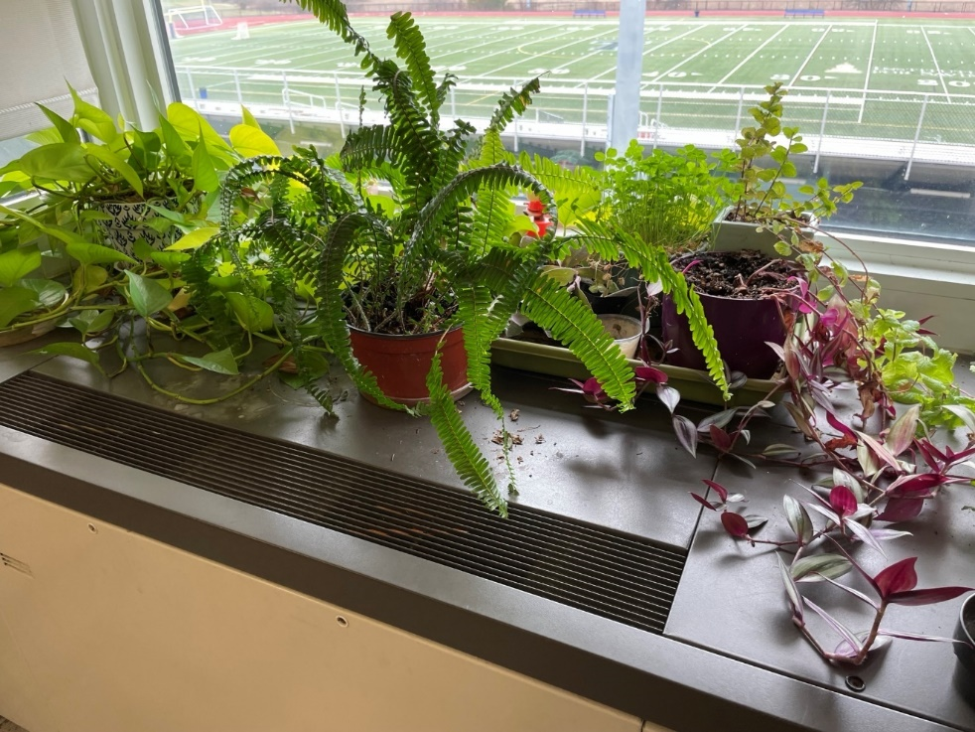

**Univent, note plants on top**

**Picture 2**

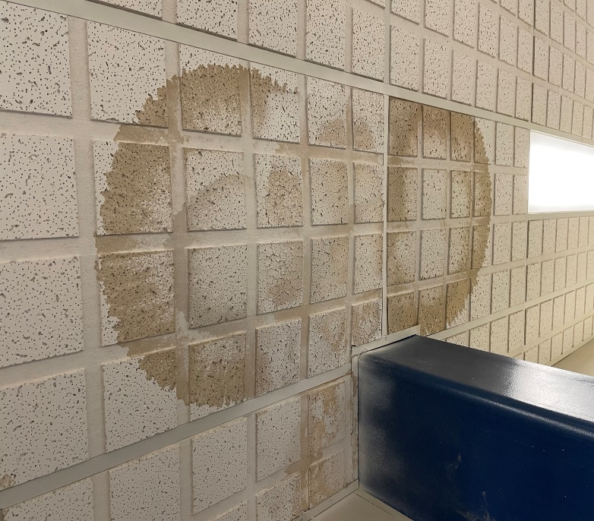

**Water-damaged ceiling tiles**

**Picture 3**

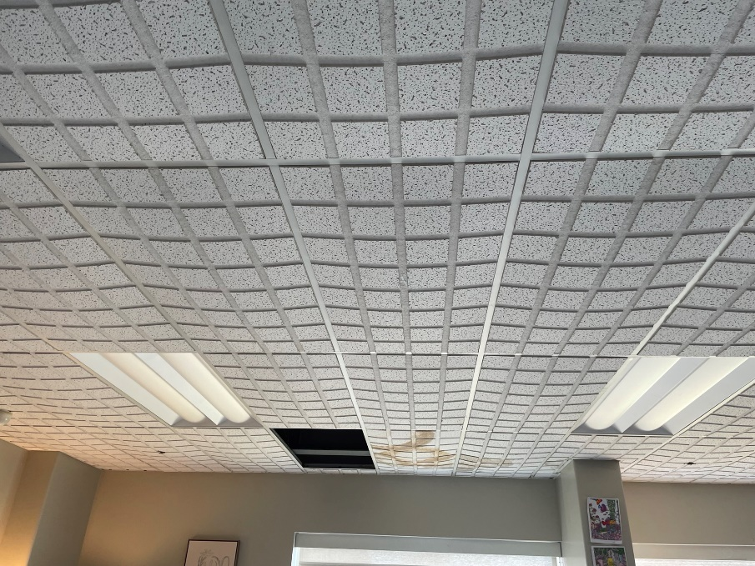

**Bowed ceiling tiles**

**Picture 4**

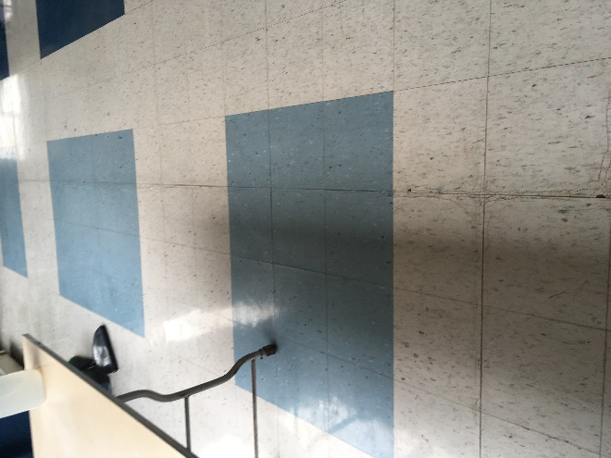

**Water-damaged floor tiles**

**Picture 5**

**Roof section of TRMS, Note discoloration of roof membrane due to standing water
Note branches of courtyard trees overhanging roof
**

**Roof section of TRMS, Note discoloration of roof membrane due to standing water**

**Note branches of courtyard trees overhanging roof**

**Picture 6**

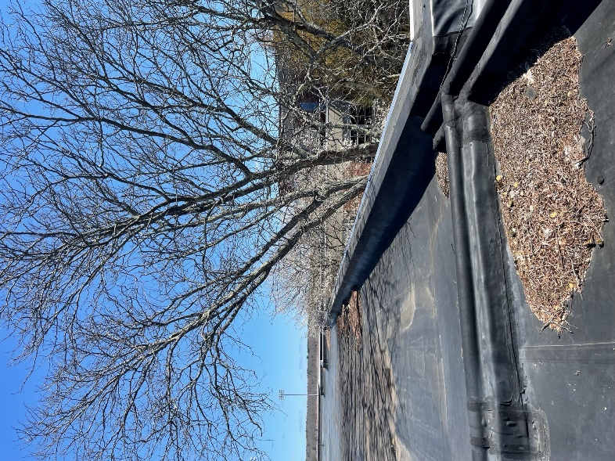

**Leaves and other debris on roof and trees overhanging roof**

**Picture 7**

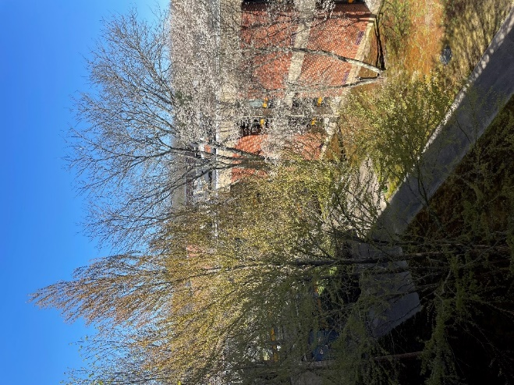

**Courtyard trees overhanging roof**

**Picture 8**

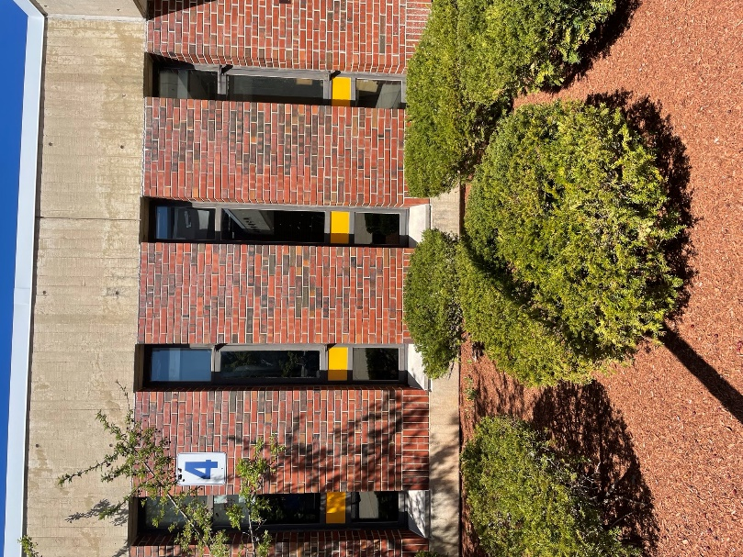

**Bushes and mulch close to building**

**Picture 9**

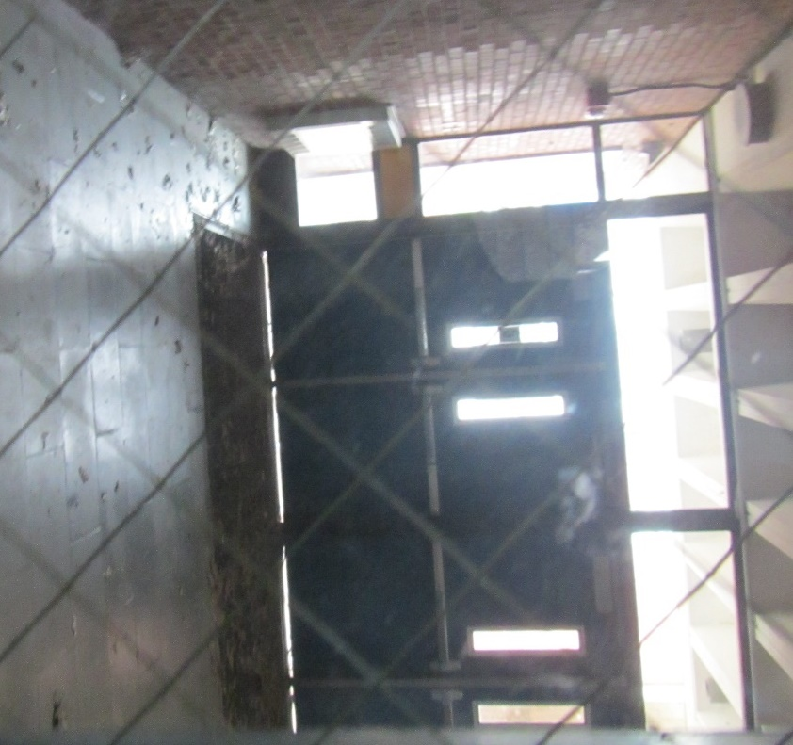

**Light visible underneath exterior doors**

**Picture 10**

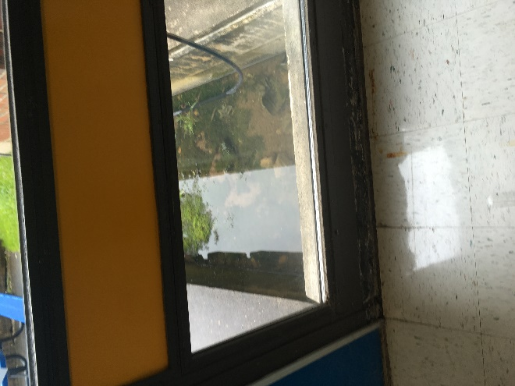

**Water puddling against slab in courtyard**

**Picture 11**

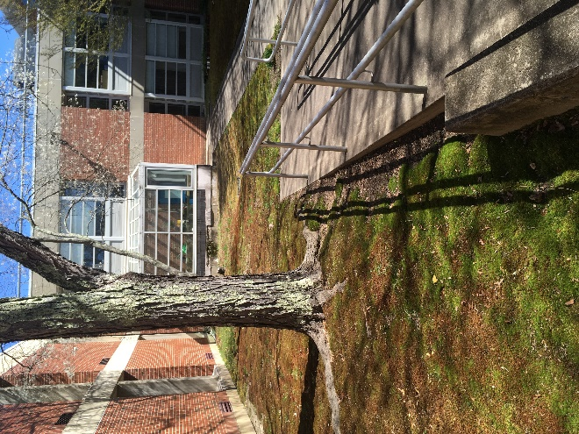

**Courtyard with moss, indicating poor drainage**

**Picture 12**

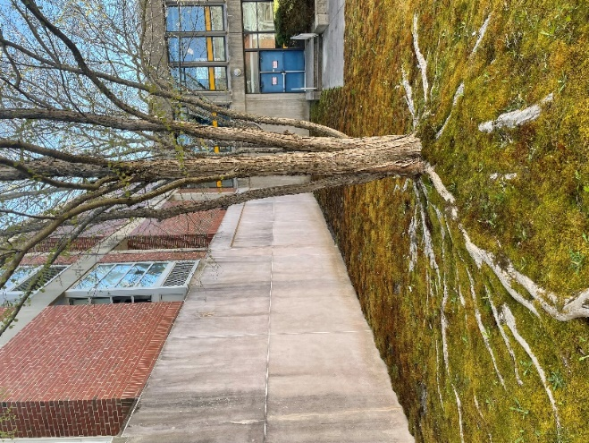

**Tree with roots extending towards exterior wall**

**Picture 13**

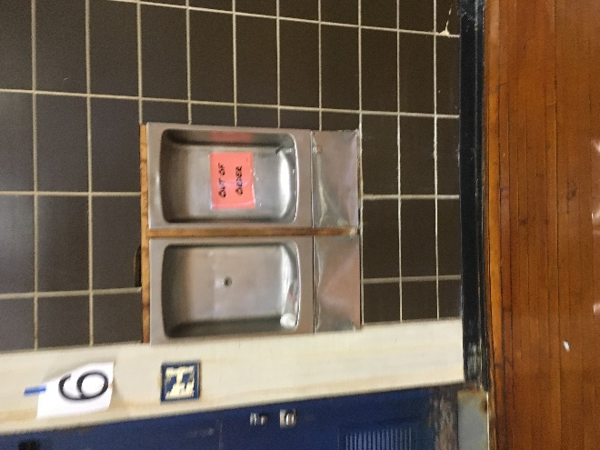

**Unused water fountain**

**Picture 14**

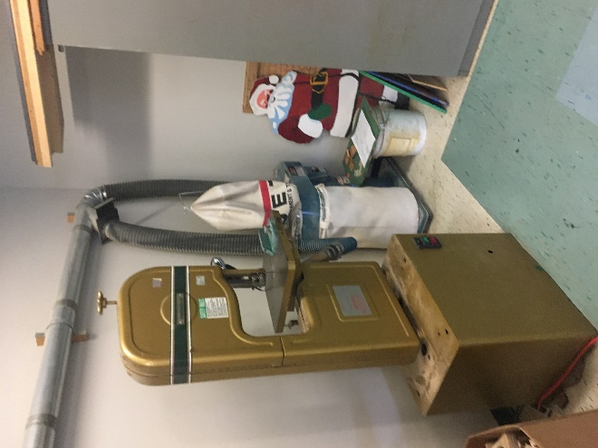

**Wood dust collector and band saw in wood shop**

**Picture 15**

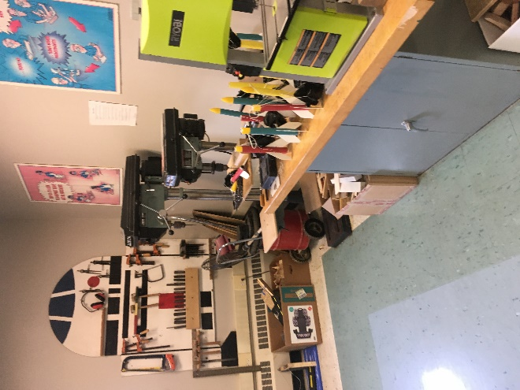

**Table drills with no exhaust vents**

| **Location/ Room** | **Carbon**  **Dioxide**  **(ppm)** | **Carbon Monoxide**  **(ppm)** | **Temp**  **(°F)** | **Relative**  **Humidity**  **(%)** | **PM2.5**  **(µg/m3)** | **Occupants**  **in Room** | **Windows**  **Openable** | **Ventilation** | | **Remarks** |
| --- | --- | --- | --- | --- | --- | --- | --- | --- | --- | --- |
| **Supply** | **Exhaust** |
| Background (outside) | 378 | ND | 53 | 54 |  |  |  |  |  | Clear |
| First Floor | | | | | | | | | | |
| M100 | 1083 | ND | 74 | 41 | ND | 6 | Y | Y | Y | Woodshop, wood dust collector not vented outdoors |
| M100 Computer | 1459 | ND | 74 | 40 | ND | 19 | Y | Y | Y | CT |
| M100 Office | 1053 | ND | 74 | 38 | ND | 1 | Y | Y | Y |  |
| M103 | 665 | ND | 73 | 44 | ND | 3 | Y | Y | Y | Bowed CTs |
| M105 | 445 | ND | 73 | 43 | ND | 1 | Y | Y | Y | Bowed CTs, WD CTS, missing CTs  Window AC |
| Second Floor | | | | | | | | | | |
| M200 breakroom | 682 | ND | 75 | 41 | ND | 0 | Y | Y | Y | Photocopier, microwaves, toaster oven, fridge |
| M201 | 488 | ND | 75 | 35 | ND | 1 | Y | Y | Y | Blocked CT |
| M202 | 723 | ND | 74 | 41 | ND | 0 | Y | Y | Y |  |
| M203 | 658 | ND | 74 | 37 | ND | 0 | Y | Y | Y |  |
| M204 | 625 | ND | 73 | 41 | ND | 1 | Y | Y | Y |  |
| M206 | 654 | ND | 73 | 40 | ND | 0 | N/A | Y | N |  |
| M207 | 650 | ND | 73 | 36 | ND | 1 | Y | Y | Y |  |
| M208 | 563 | ND | 73 | 40 | ND | 0 | Y | Y | Y | Towels tucked under uninvent |
| M210 | 510 | ND | 71 | 43 | ND | 1 | Y | Y | Y | Aquarium, hanging items from ceiling |
| M210 breakroom | 499 | ND | 71 | 44 | ND | 0 | N/A | Y | N | Fridge and watercooler on carpet, food |
| M210B | 513 | ND | 71 | 44 | ND | 2 | Y | Y | Y | carpet |
| M216 | 472 | ND | 71 | 43 | ND | 0 | Y | Y | Y | Missing CT  Sink |
| M217 | 486 | ND | 75 | 35 | ND | 1 | Y | Y | Y |  |
| M219 | 523 | ND | 77 | 33 | ND | 1 | Y | Y | Y | carpet |
| M219D | 523 | ND | 77 | 33 | ND | 1 | Y | Y | Y | carpet |
| M219C | 525 | ND | 70 | 33 | ND | 0 | Y | Y | Y | carpet |
| M219B | 523 | ND | 77 | 33 | ND | 1 | Y | Y | Y | carpet |
| M219E | 526 | ND | 77 | 32 | ND | 0 | Y | Y | Y | Carpet |
| M219A | 548 | ND | 77 | 33 | ND | 0 | Y | Y | Y | Carpet, WD CT |
| M220 | 560 | ND | 71 | 44 | ND | 0 | Y | Y | Y | Photocopier  Sink |
| M222 | 548 | ND | 72 | 43 | ND | 0 | Y | Y | Y | WD CT, bowed CTs, window AC |
| M226 | 513 | ND | 71 | 42 | ND | 0 | Y | Y | Y | Sinks, science prep room |
| M228 | 507 | ND | 71 | 43 | ND | 0 | Y | Y | Y | Univent blocked |
| M230 | 435 | ND | 70 | 44 | ND | 1 | Y | Y | Y | Microwaves, hot plate, sink |
| M232 Chorus Rm | 484 | ND | 72 | 43 | ND | 0 | Y | Y | Y |  |
| M229 | 486 | ND | 72 | 41 | ND | 0 | Y | Y | Y |  |
| M227 | 448 | ND | 70 | 44 | ND | 0 | Y | Y | Y | Area rugs, microwave, coffee pot, hanging items from ceiling |
| M225 | 421 | ND | 70 | 45 | ND | 0 | Y | Y | Y | Bowed CTs |
| M223 | 461 | ND | 71 | 44 | ND | 0 | Y | Y | Y | Debris on classroom floor |
| M221 | 603 | ND | 71 | 43 | ND | 0 | Y | Y | Y |  |
| Third Floor | | | | | | | | | | |
| M328 | 709 | ND | 74 | 35 | ND | 1 | N | Y | Y | Toaster |
| M327 | 465 | ND | 73 | 34 | ND | 0 | Y | Y | Y |  |
| M326 | 595 | ND | 72 | 42 | ND | 0 | Y | Y | Y | Plants, area carpet, aquarium, items on univent |
| M325 | 439 | ND | 73 | 36 | ND | 0 | Y | Y | Y |  |
| M324 | 565 | ND | 71 | 42 | ND | 0 | Y | Y | Y | Uninvent blocked, plants |
| M323 | 599 | ND | 75 | 35 | ND | 1 | Y | Y | Y | Tennis balls |
| M322 | 1148 | ND | 73 | 47 | ND | 19 | Y | Y | Y |  |
| M321 | 513 | ND | 75 | 33 | ND | 0 | Y | Y | Y |  |
| M320 | 622 | ND | 74 | 40 | ND | 0 | Y | Y | Y | Sinks, hanging items from ceiling |
| M319 | 556 | ND | 75 | 33 | ND | 2 | Y | Y | Y |  |
| M316 | 644 | ND | 75 | 41 | ND | 2 | Y | Y | Y | Sink |
| M312 | 437 | ND | 74 | 40 | ND | 0 | Y | Y | Y | Sink, window AC, fridge |
| M310 | 921 | ND | 73 | 44 | ND | 23 | Y | Y | Y | Stained CTs, missing CT, sinks |
| M308 | 508 | ND | 68 | 44 | ND | 1 | Y | Y | Y | WD CTs |
| M306 | 805 | ND | 71 | 45 | ND | 1 | Y | Y | Y | Missing CTs |
| M307 | 1242 | ND | 74 | 41 | ND | 25 | Y | Y | Y |  |
| M304 breakroom | 797 | ND | 72 | 44 | ND | 0 | Y | Y | Y | Photocopier, fridge, sink, microwave, toaster with food debris |
| M303 | 1285 | ND | 74 | 41 | ND | 21 | Y | Y | Y |  |

1. The service life is the median time during which a particular system or component of …[an HVAC]… system remains in its original service application and then is replaced. Replacement may occur for any reason, including, but not limited to, failure, general obsolescence, reduced reliability, excessive maintenance cost, and changed system requirements due to such influences as building characteristics or energy prices (ASHRAE, 1991).