
MA FACE
Occupational Fatality Report

Truck Driver Dies while Rotating Tires Mounted on Demountable Multi-piece Rim Wheels - Massachusetts

Release Date: March 1, 2013 Massachusetts Department of Public Health
Investigation: # 11-MA-044-01 Occupational Health Surveillance Program

______________________________________________________________________________
SUMMARY

On October 19, 2011 a 39-year-old male truck driver (victim) was fatally injured while rotating the tires on a rear tandem axle dual wheel truck. Although the incident was not witnessed, it appears that the victim was struck in the head by a wedge clamp from the multi-piece demountable rim wheel when a rim released. A co-worker found the victim on the ground in the company’s garage and placed a call for emergency medical services (EMS). Personnel from the local and state police departments, fire department and EMS all arrived within minutes of the call. The victim was pronounced dead at the incident location. The Massachusetts FACE Program concluded that to prevent similar occurrences in the future, employers should:
- Ensure that all multi-piece rim wheel tires are deflated prior to removing them from a vehicle’s axle;
- Ensure that when tires mounted on demountable rims are being removed from a vehicle, all of the rim’s wedge clamps are loose before entirely removing any of the lug nuts;
- Ensure that employees never position themselves in the trajectory of (in front of or over) inflated tires mounted on multi-piece rims while servicing any wheel or tire component; and
- Develop standard operating procedures (SOP) for servicing multi-piece rims and provide training on these procedures.

INTRODUCTION

On October 19, 2011, the Massachusetts FACE Program was alerted by the local media that earlier that same day a male truck driver was fatally injured while rotating tires on a truck. An investigation was initiated. On December 13, 2011, the Massachusetts FACE Program Director traveled to the company’s office location and met with the company owner to discuss the incident. The police department report, death certificate, company information, and the OSHA fatality and catastrophe report were reviewed during the course of the investigation. The incident location and the truck involved in the incident were observed and photographs were taken.

The employer is a septic company that primarily installs and provides septic pumping services. The company has been in business for 35 years and has three pump trucks, two dump trucks, a backhoe and a front end loader. The company had four employees, including the victim at the time of the incident. The victim had been employed with the company for 16 years at the time of the incident. Employees worked five days per week, Monday through Friday. A typical work day would start around 6:30 a.m. at the location where the company parked the trucks and the work day ended at 4:00 p.m.

The company did not have a comprehensive written health and safety program but did hold two safety meetings each year. The company provided new employees with in-house, on-the-job training. The victim had a valid Massachusetts Commercial Drivers License. The company had workers’ compensation insurance as required by law in Massachusetts (G.L. c. 152, Sec. 25A). There was no union representation at the company.

INVESTIGATION

The truck involved in the incident is a 10-wheel septic system pump truck. Both the truck chassis and tank were manufactured in 2001 (Figure #1). The truck has a diesel engine and rear tandem axle dual wheels with demountable rims and tubeless 1100 R24 tires. The tires were reported to be approximately one year old at the time of the incident. The truck’s rear wheels are three-piece demountable rims. The three pieces are a rim base, a split locking ring, and a continuous side ring. The rim parts are designed so the locking ring fits into a gutter on the base rim, locking the continuous side ring in place on the rim when the tire is inflated. These demountable rims also have a cast spoke hub, a component of the axle, to which the demountable rim is clamped. In this case, the spoke hub consisted of six spokes (six bolt pattern) and six clamps to hold the rim in place on the spokes. Since the spoke hub is attached to the truck’s axle, when the rims are removed from the truck the spoke hub section remains attached to the truck (Figure #2).

When placing tires mounted on demountable rims onto a truck, the rim is positioned onto the spoke hub and then wedge clamps are used to hold the rim in place on the spokes. The wedge clamps prevent the rim from spinning on the spokes and are positioned onto the studs. Lug nuts fasten the wedge clamps onto the spoke’s studs and secure the wheel in place (Figure #3). For dual wheel setups, the outer tire and rim mounts onto the same spoke hub as the inner rim, and the rims are separated by a spacer.

On the day of the incident, all of the company employees were off-site performing their assigned tasks. The victim’s assigned task was to perform a septic system pumping job, but the job had been cancelled earlier that day. After the job was cancelled, it appears that the victim then started to rotate the septic truck’s rear tires. Vehicle maintenance is mostly performed in-house by company employees. It was reported that a few days before the incident, the company owner and the victim were discussing that it was time to rotate the tires on that truck and that they would perform this task later that same week. It was also reported that the task of rotating tires was usually performed with two employees.

To begin the task, the victim backed the truck into one of the company’s garage bays. The garage door was left open and the truck was positioned so the truck’s cab remained outdoors. It appears that prior to starting the task of rotating the tires, all of the truck’s tires remained fully inflated on their rims. A hydraulic floor jack was positioned under the left rear axle to raise the truck’s left rear tires off the ground. Once the left rear tires were lifted off the ground, the victim removed both the outer and inner wheels on the forward rear axle.

Since the victim was working alone and the incident was un-witnessed it is difficult to know exactly what happened and what the victim was doing when the incident occurred. It appears that the victim had just removed the outer rear wheel on the rear most axle by loosening and removing most of the six lug nuts and wedges (Figure #2). The victim then moved this wheel away from his immediate work area. Evidence suggests that the victim was standing in front of the inner left rear wheel and was starting to remove the wheel from the axle when its rim suddenly released. It would appear that when the rim released, this caused the victim to be blown back. Both the split locking ring and continuous side ring and at least one of the wedges were propelled out from the wheel with great force. The victim was struck in the forehead by one of the wedges.

At about 8:40 a.m. a co-worker arrived at the company garage to drop off a trailer. The co-worker found the victim lying next to the truck. The co-worker immediately placed a call for emergency medical services (EMS) and was assisting the victim. Personnel from the local and state police departments, fire department and EMS all arrived within minutes of the call. The victim was pronounced dead at the incident location.

CAUSE OF DEATH

The medical examiner listed the cause of death as blunt force head injuries.

RECOMMENDATIONS/DISCUSSION

Recommendation #1: Employers should ensure that all multi-piece rim wheel tires are deflated prior to removing them from a vehicle’s axle.

Discussion: When multi-piece rim wheels are inflated, they are under great air pressure. It is this air pressure that holds the multiple components of the multi-piece rim wheel together. When there is an uncontrolled release of the air pressure from the tire, this causes the rim wheel components to separate. When the rim wheel components separate, they are usually dislodged causing them to be thrown at extreme speeds and violent force (Figure # 4).

In this incident, the wheels that were being rotated reportedly appeared to be in good condition with no noticeable damage. Therefore, this case underscores the importance of always deflating multi-piece rim wheels, releasing the air pressure in a controlled fashion, prior to maintenance or removal from a vehicle. Deflating multi-piece rim wheel tires can be accomplished by removing the wheel’s core valve.

Recommendation #2: Employers should ensure that when tires mounted on demountable rims are being removed from a vehicle, all of the rim’s wedge clamps are loose before entirely removing any of the lug nuts.

Discussion: In this case it appears that most of the lug nuts may have been completely removed prior to ensuring that all of the rim’s wedge clamps were loose. This possibly contributed to the incident. Demountable rim wheel wedge clamps are likely to be under pressure when in place. When the lug nuts have been completely removed from the studs and the pressure releases, the wedges can be forcefully release through the air.

To prevent the wedges from releasing into the air, first loosen all of the lug nuts leaving them threaded on the wheel studs a few turns; do not totally remove the lug nuts from the studs. Next use a hammer to loosen the wedges by tapping on them. When the wedges become loose they may move away from the rim with a “pop”. Leaving the lug nuts threaded multiple turns on the wheel studs will stop the movement of the wedges and prevent their release into the air. Once all of the wedges are loose, the lug nuts and wedges can be totally removed from the wheel’s studs.

Recommendation #3: Employers should ensure that employees never position themselves in the trajectory of (in front of or over) inflated tires mounted on multi-piece rims while servicing any wheel or tire component.

Discussion: OSHA's definition of trajectory is any potential path or route that a rim wheel component may travel during an explosive separation or sudden release of the pressurized air (Figure #4). When a rim wheel with an inflated tire is mounted on a vehicle, the hazard of being struck by a wheel component during an explosive separation or sudden release when working on the wheel exists. Therefore, to minimize this hazard it is extremely important for employees to always stay outside of the trajectory by never positioning themselves in front of or over inflated tires.

Recommendation #4: Employers should develop standard operating procedures (SOP) for servicing multi-piece rims and provide training on these procedures.

Discussion: Employers should develop standard operating procedures (SOP) for servicing multi-piece rims and should train employees who will service multi-piece rims in these procedures.¹ Only employees who are assigned to service multi-piece rim wheels and have been trained on the proper servicing of these rim wheels, including demounting, inspecting, inflating and mounting procedures, should be allowed to service them. The SOP should also include both the multi-piece rim manufacturer's and the tire manufacturer's instructions and recommendations and applicable OSHA standards.

OSHA has outlined safe operating procedures for multi-piece rim wheels in their standard, Servicing multi-piece and single piece rim wheels.² In addition to the above two recommendations, other required procedures for servicing multi-piece rim wheels are listed below. The full text of this standard can be found at www.osha.gov.
- Use a restraining device (cage or barrier) when inflating tires.
- Ensure employees do not rest or lean any part of their body or equipment on or against a restraining device being used when inflating tires.
- No attempt shall be made to correct the seating of side and lock rings by hammering, striking or forcing the components while the tire is pressurized.
- Cracked, broken, bent or otherwise damaged rim components shall not be reworked, welded, brazed, or otherwise heated.
- No heat shall be applied to a multi-piece wheel or wheel component.

The employer should routinely provide employees training on the SOP. Even employees who are not assigned to service multi-piece rims should be provided the training so they will be aware of the potential hazards of these wheels, including never attempting to inflate flat tires.

REFERENCES

1. Code of Federal Regulations, 29 CFR 1910.177, Servicing multi-piece and single piece rim wheels, Motor vehicles, U.S. Government Printing Office.

2. Servicing Single-Piece and Multi-Piece Rim Wheels (booklet). U.S. Department of Labor, Occupational Safety and Health Administration,1998, http://www.osha.gov/Publications/wheel/wheel-chart-booklet.pdf

3. Massachusetts FACE project, FACE Facts, Worker Killed While Inflating a Tire Multi-Piece Rim – Massachusetts, Vol. 7, No. 2, August 2004, http://www.mass.gov/eohhs/docs/dph/occupational-health/face-facts/face-fact-rim.pdf

Figure 1 – Truck involved in the incident

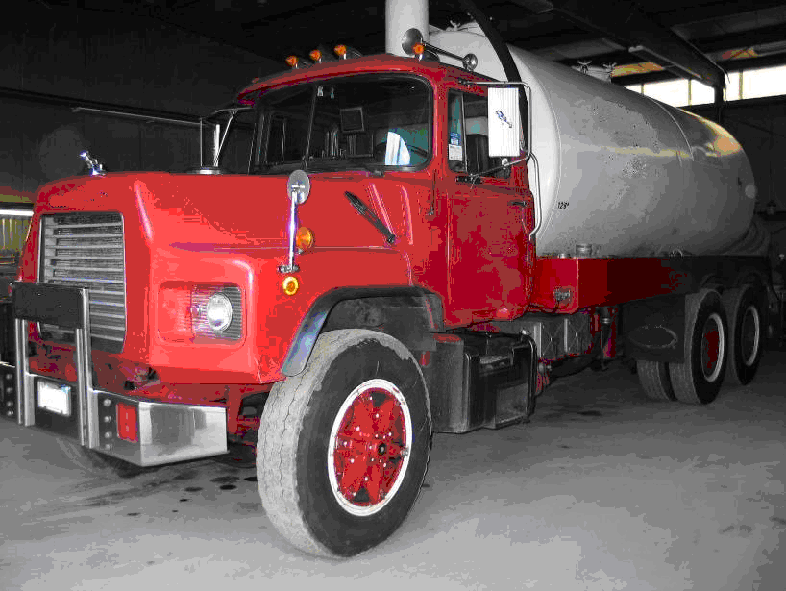

Figure 2 – Truck involved in the incident with three of the four driver’s side
rear wheels removed

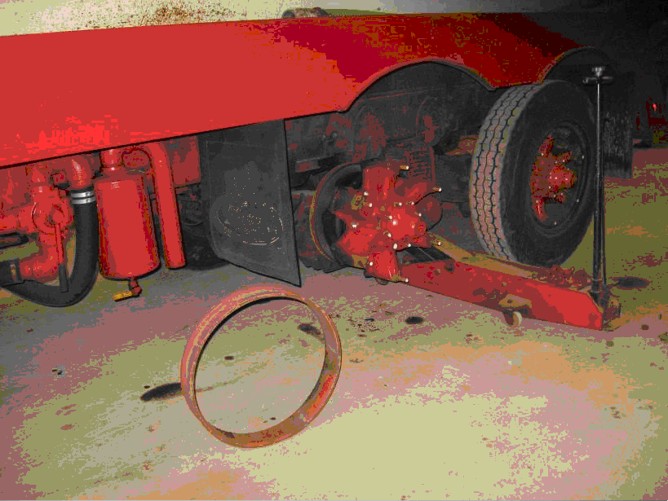
Spoke hub
Dual wheel spacer

Figure 3 – Demountable rim wheel with wedge clamp

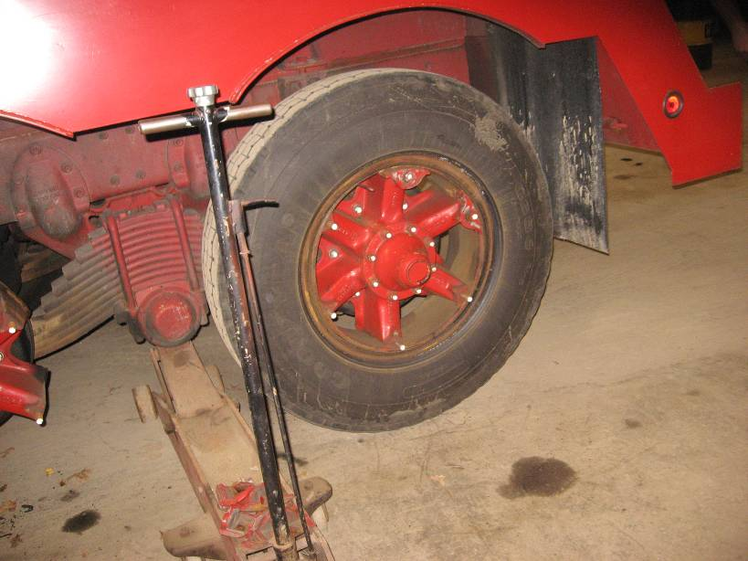
Wedge clamps

Figure 4 - Trajectory of multi-piece rim parts in different scenarios.

Michael A. Fiore, MS, Director | Letitia Davis, Sc.D., Ed.M., Director
Massachusetts FACE Program | Occupational Health Surveillance Program
Occupational Health Surveillance Program | Massachusetts Department of Public Health
Massachusetts Department of Public Health

******************************************************************************

FATALITY ASSESSMENT AND CONTROL EVALUATION PROGRAM

The Massachusetts Department of Public Health, in cooperation with the National Institute for Occupational Safety and Health (NIOSH), conducts investigations on the causes of work-related fatalities. The goal of this program, known as Massachusetts Fatality Assessment and Control Evaluation (Massachusetts FACE) is to prevent future fatal workplace injuries. Massachusetts FACE aims to achieve this goal by identifying and studying the risk factors that contribute to workplace fatalities, by recommending intervention strategies, and by disseminating prevention information to employers and employees.

Massachusetts FACE also collaborates with engineering and work environment faculty at the University of Massachusetts at Lowell to identify technological solutions to the hazards associated with workplace fatalities.

NIOSH funded state-based FACE Programs currently include: California, Iowa, Kentucky, Massachusetts, Michigan, New Jersey, New York, Oregon, and Washington.

**********************************************************************************

Additional information regarding this report is available from:

Occupational Health Surveillance Program
Massachusetts Department of Public Health
250 Washington Street, 6th floor
Boston, Massachusetts 02108-4619
(617) 624-5627

Evaluate this report

We would appreciate your feedback on these reports so we may continue to improve the MA FACE project and our investigation reports. A feedback form can be found at: www.mass.gov/eohhs/docs/dph/occupational-health/report-evaluation.doc
The completed form may be returned by fax to (617) 624-5676, by mail to FACE, 250 Washington Street, 6th Floor, Boston, MA 02108, or by email to ma.face@state.ma.us.

