

Massachusetts Department of Public Health
Bureau of Infectious Disease and Laboratory Sciences
Disease Status Report
Reportable Disease: Active Tuberculosis

Tuberculosis (TB) is caused by the bacterium Mycobacterium tuberculosis (M. tuberculosis) and usually affects the lungs. TB is spread through the air when an infected person coughs, sings, or speaks.
- In 2015, 192 cases of active Tuberculosis were reported to the Massachusetts Department of Public Health or 2.8 cases for every 100,000 residents.
- Eighty-seven percent of these cases were in persons born outside the United States (n=167), largely from Asia (51%), Africa (18%), the Caribbean (13%), and Latin America (13%).
- Suffolk County had the highest incidence rate at 6.4 cases per 100,000 residents, followed by Worcester County at 3.4 and Middlesex County at 3.2 cases per 100,000 residents.
- In 2015, Massachusetts had 30 cases (21%) that were resistance to one or more TB drugs, and seven cases resistant to INH and RIF (5%), or multi-drug resistance TB (MDR-TB).
More Information
Case Definition
Fact Sheet
TB Annual Report

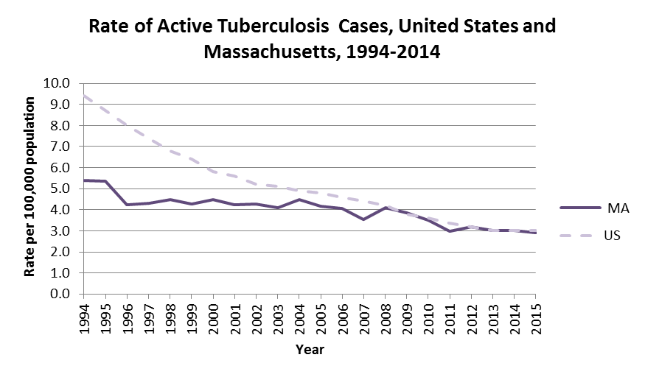

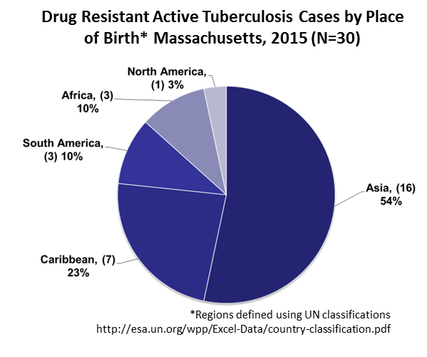
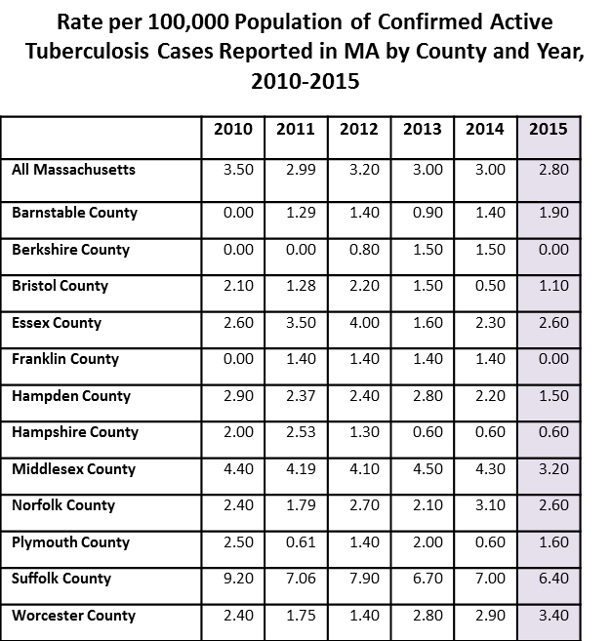
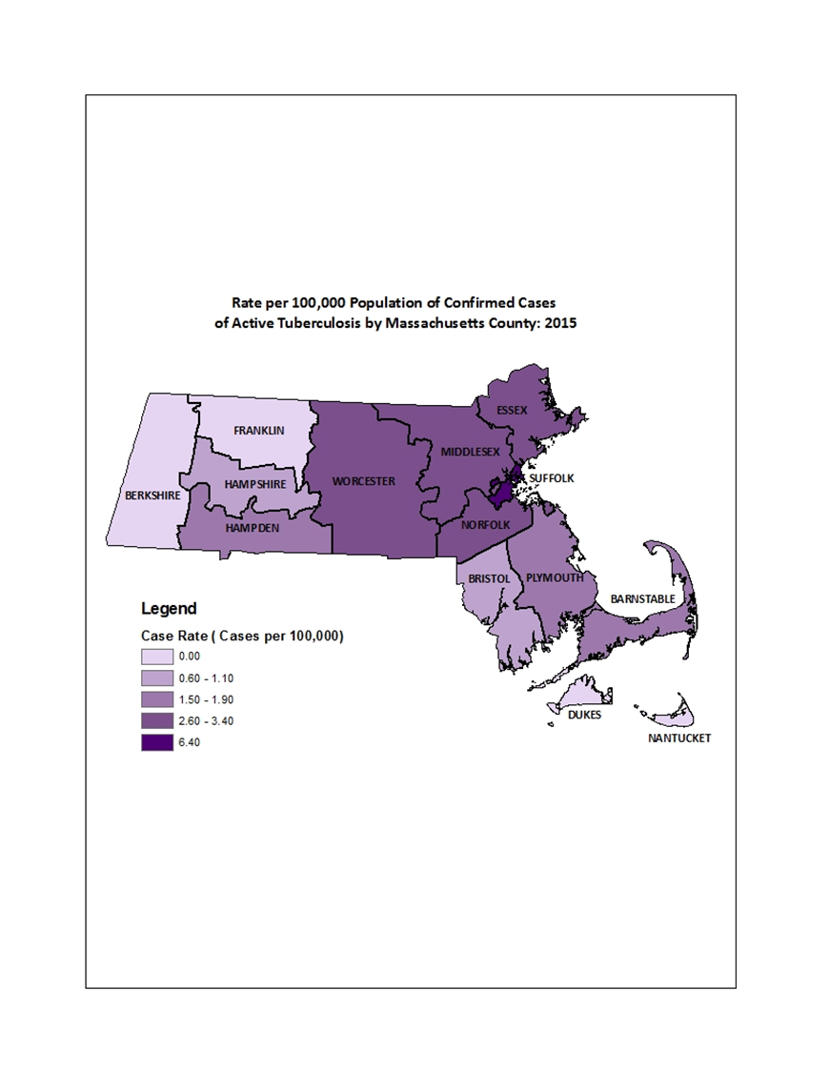
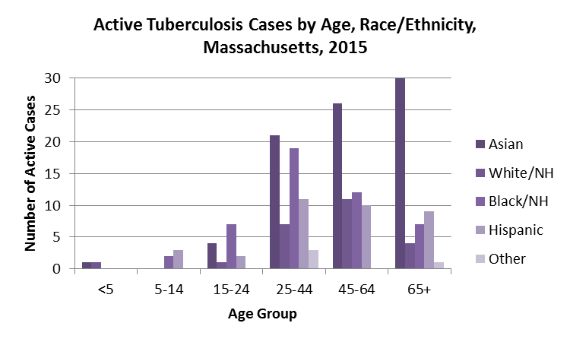
Data are current as of 2/2016 and may be subject to change

