Two Massachusetts News Carriers Killed
Struck by Cars While Delivering from Bicycles
Background
During a six month period, two Massachusetts news carriers, employed by different newspapers, were killed by motor vehicles while delivering their papers from bicycles. Neither child was wearing a helmet, even though the 1994 Massachusetts Bicycle Helmet Law applied to one of the victims.
Neither employer had a comprehensive safety program for the carriers. However, safety materials were handed out during the news carriers' orientation. One employer also provided a reflective vest and arm band; however, according to several news carriers' families, the equipment was not provided consistently.
Both carriers worked as independent contractors. Independent contractor status excludes workers from protection under Occupational Safety and Health Administration (OSHA) standards, as well as from receiving workers' compensation benefits.
Federal child labor law, which limits the hours and conditions of youth employment, do not apply to news carriers. Massachusetts news carriers, unlike other working minors, are not required to obtain work permits before they begin employment. Instead, a written statement of permission to sell or deliver newspapers from a parent or guardian is necessary. Only one of the two employers required parental permission and actively involved the parents in the child's employment.
Investigation #1
The victim was a fourteen-year-old male who had delivered papers for approximately 15 months. The newspaper distribution vehicle's drop-off point was less than one block from a busy, suburban street. The victim crossed this street each day to pick up his papers.
The boy was en route to the drop-off point, and was about to cross the street on his bicycle, when he was hit by a van. He was wearing a "stadium jacket" with a large, thick hood which may have blocked his peripheral vision; he was not wearing a helmet. Apparently, the side mirror
of the van struck the child in the back of the neck, and the impact threw him from the bike. The driver was not cited for speeding since there was no physical evidence to indicate the speed of the van. The victim suffered two head injuries: one from the impact of the mirror, the other from his fall to the ground. He died of a severe brain injury two days later.
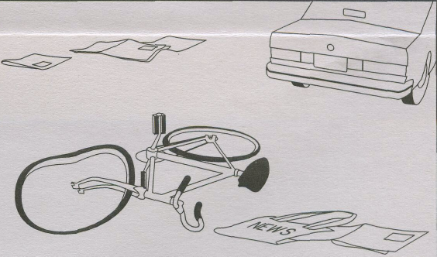
Investigation #2
The victim was a twelve-year-old female who had delivered papers for approximately six months. Her route consisted of 29 customers on two streets. The girl had just made a delivery and was coming out of a customer's driveway when she was struck by a Jeep. She was wearing a reflective vest and white jacket, but not a helmet. The driveway was steep and lined with a row of five tall pine trees which obstructed the view from the street. The only individuals who witnessed the incident were the Jeep driver and his son. The youth died from blunt head trauma one hour after being hit.
The incident occurred on an undivided two-lane road, approximately 25 feet wide. The road was slightly wet from previous rain, and traffic was heavy at the time. Speeding was reportedly a problem on the road.
The driver, who was unable to estimate his speed, stated that he saw the bicycle emerge suddenly from the driveway, but was unable to avoid the collision. The driver continued for 90 feet after the impact.
Recommendations
In order to prevent future bicycle-related injuries, the Massachusetts FACE Program recommends that employers
* require all carriers delivering from a bicycle to wear approved bicycle helmets and prohibit carriers from using hoods while riding bicycles;
locate their newspaper drop-off points away from busy intersections or streets and give serious consideration to the safety of news carriers by taking traffic patterns and the age of carriers into account when making route assignments;
• hold periodic (monthly or quarterly) safety meetings for news carriers at the district or community level and provide a safety training program for the personnel who manage news carriers.

Fatality Assessment and Control Evaluation (FACE) Project • 617-624-5627

