WATER DAMAGE ASSESSMENT

Tyngsborough Historical Society
(former Littlefield Public Library)
Middlesex Road
Tyngsborough, MA

Prepared by:
Massachusetts Department of Public Health
Bureau of Climate and Environmental Health
Indoor Air Quality Program
August 2023

BACKGROUND
Building: | Tyngsborough Historical Society (THS)  (former Littlefield Public Library)
Address: | Middlesex Road  Tyngsborough, MA
Reason for Request: | Ventilation and water damage issues
Date of Assessment: | June 9, 2023
Massachusetts Department of Public Health/Bureau of Environmental Health (MDPH/BEH) Staff Conducting Assessment: | Michael Feeney, Director, Indoor Air Quality  (IAQ) Program
Building Description: | The THS was originally built as a public library in 1904. The THS is a single-story brick building with a recently repaired tile roof. The building was renovated to install an HVAC system and create occupied space in the basement. A mechanical room containing the furnace and HVAC system is located in the basement adjacent to the occupied areas.
Building Population: | At the time of the assessment, the building was used to house Tyngsborough historical objects and materials. THS staff access the building on a regular basis. No building occupants were present during this visit.
Windows: | Openable

METHODS
Please refer to the IAQ Manual for methods, sampling procedures, and interpretation of results (MDPH, 2015). No IAQ testing was conducted during this assessment. The assessment consisted of visual inspection for water-damaged materials and conditions that could contribute to water damage and other IAQ issues.

Ventilation
The THS has a centralized HVAC system with a supply and return installed in the basement furnace room. The air handling unit (AHU) is installed in a mechanical room that is shared by the building furnace. Air is supplied to occupied areas through floor and wall-mounted supply vents mounted connected to the AHU via ductwork. Air mixes in the main room and is drawn to a return vent (Picture 1) located at the bottom of the first floor-to-basement stairwell as well as located in the wall shared by the basement room (Picture 2). In essence, the stairwell serves as the pathway for air to be returned to the AHU.
No fresh air intake could be located for the AHU. The HVAC system recirculates air without a fresh air supply. The sole supply of fresh air is opening windows. The restroom does not appear to have a mechanical exhaust vent and relies on opening windows for exhaust ventilation. Without an exhaust vent, pollutants generated in the restroom, including odors and moisture, cannot be effectively removed and may become entrained in the building ventilation system.

Microbial/Moisture Concerns
It is important to note that Massachusetts experienced extended periods of high relative humidity during the summers of 2018, 2021, and 2023. July of 2021 was the wettest ever recorded in Massachusetts, and the three-month period from June through August, known as the meteorological summer, was the fourth wettest on record, according to the National Oceanic and Atmospheric Administration’s (NOAA) Centers for Environmental Information. The three-month period also was the third warmest ever in the state and was tied for the warmest on record across the United States (HG, 2021, NOAA, 2021). During the summer of 2018, the Boston area also experienced an unprecedented period of extended hot, humid weather. According to the Washington Post, “[d]ata…show[s]…cities in the Northeast have witnessed such humidity levels for record-challenging duration...[i]ncluding Albany, Boston, Burlington, Portland, and Providence” during the summer of 2018 (WP, 2018). “Boston and nearby locations… [saw]…historic numbers of those warm nights with low temperatures at or above 70 degrees…Providence and Blue Hill Observatory have already broken their annual records” (WP, 2018).

Under these weather conditions, public buildings experienced extended periods of water vapor exposure from high relative humidity. When exposed to these conditions, porous materials such as gypsum wallboard, cardboard, and other materials may become moistened and colonized with mold, particularly if located in areas that are prone to developing condensation, such as floors and walls in contact with the ground (e.g., below grade space). According to the American Society of Heating, Refrigerating and Air-Conditioning Engineers (ASHRAE); if relative humidity exceeds 70%, mold growth may occur due to wetting of building materials (ASHRAE, 2022) even in the absence of liquid water.

Water Damage in the Basement
A visual inspection for signs of water damage and microbial growth was conducted on both floors. Gypsum wallboard adjacent to the return vent in the basement shows signs of repeated water damage (Picture 1). The vent louvers on both return vents have rust and other signs of water exposure. This type of water damage occurs when air with high relative humidity is drawn to the return vent.
Shelving in the basement room has been water damaged (Pictures 3 to 5). In addition, the basement floor is covered with wall-to-wall carpeting which shows signs of chronic water damage (Picture 6). This is likely the result of moisture exposure from a combination of hot, humid weather, lack of exhaust ventilation, and water leaks through the foundation walls.
In addition, the lowest floor of the THS has floors and walls that are in direct contact with soil. It is likely that both the floor and walls in the basement are prone to condensation during hot, humid weather.
The key to managing condensation is understanding dew point. The dew point is the temperature that air must reach for saturation to occur. When warm, moist air passes over a cooler surface that is below the dew point, condensation can form. If a building material/component has a temperature below the dew point, condensation will accumulate on that material. Porous materials can be moistened by condensation or by droplets resulting from condensation on nearby surfaces. Porous building materials such as gypsum wallboard, and stored materials such as cardboard, cloth, paper, and soft wood can all become water-damaged. If porous materials are exposed to water for longer than 24 to 48 hours, mold colonization can occur.
The United States Environmental Protection Agency (US EPA) and the American Conference of Governmental Industrial Hygienists (ACGIH) recommend that porous materials be dried with fans and heating within 24 to 48 hours of becoming wet (US EPA, 2008). If porous materials are not dried within this time frame, mold growth may occur. Once mold has colonized porous materials, they are difficult to clean and should be removed and discarded.

Sources of Moisture

The HVAC system
To reduce condensation, it is important to control introduction of moisture into the HVAC system and the rest of the building when the HVAC system is operating in chilling mode. Sources of uncontrolled moisture draw in the HVAC system includes:
- spaces around the basement exterior exit door located near to the basement room return vent.
- a missing pane in basement window (Picture 7).
- air leakage/use of open windows on first floor when HVAC in chilling mode.
- open chimney flue (if not permanently sealed).

Lack of roof gutter/downspout
One significant condition contributing to possible moisture exposure to below grade space is that roof edges do not have a gutter/downspout system to capture rainwater. Rainwater flows off the roof edge to impact on the base of exterior walls (Pictures 8). In addition, the construction of a cement access ramp on the north wall of the building created a seam that allows water to accumulate against the foundation (Picture 9).
As rain falls from the roof edge and impacts the ground with force, soil becomes compressed, which creates furrows, allowing water to puddle at the base and splash against exterior walls. The repeated wetting, and lack of drying, likely provides the condition that results in moss growth on walls, which can accelerate weathering/damage to brick and mortar. Splashing from rainwater moistens exterior wall stone which requires a drain system to allow water to drain from the wall system.

CONCLUSIONS/RECOMMENDATIONS
The THS has a number of issues likely related to the water damage to stored and building materials in the basement. To remedy building problems, the following recommendations are made:

Water Damage Recommendations
- During extended periods of hot, humid weather, consider using a dehumidifier in the basement. Dehumidifiers should be used to reduce indoor relative humidity below 70% if possible. If humidity drops below 40%, discontinue use of the dehumidifier until the next period of humid weather.
- Please note that dehumidifiers should be configured to drain condensation from the unit away from the building interior. If the dehumidifiers are purchased, ensure it is properly maintained, including cleaning and drainage.
- Ensure that all windows are closed when the HVAC system is operating in chilling mode, particularly during periods of hot, humid weather.
- Management of buildings in extreme relative humidity and rain can be challenging. The following documents can provide guidance that can be used to reduce the impact of hot, humid weather in buildings; Mold Growth Prevention during Hot, Humid Weather https://www.mass.gov/service-details/preventing-mold-growth-in-massachusetts-schools-during-hot-humid-weather and Remediation and Prevention of Mold Growth and Water Damage in Public Schools https://www.mass.gov/service-details/remediation-and-prevention-of-mold-growth-and-water-damage-in-public-schools-and
- Water-damaged carpeting, shelves and gypsum wallboard should be removed from the basement level in a manner consistent with the US EPA’s “Mold Remediation in Schools and Commercial Buildings”. Available at: http://www.epa.gov/mold/mold-remediation-schools-and-commercial-buildings-guide.
- Prior to carpet removal, determine if asbestos-containing floor tile is present beneath carpeting. If found, carpet removal will likely require compliance with asbestos removal and disposal laws.
- Consider replacing gypsum wallboard exhibiting water damage (e.g., Pictures 1 and 6) with a material not prone to mold growth when wet, such as cement board.
- Avoid storing porous materials in contact with the floor or exterior walls in the basement.
- Render the basement door as airtight as possible to prevent air from drawing to the HVAC return vent by installing weather stripping and a door sweep.
- Repair broken window shown in Picture 7.
- Consider installing a gutter/downspout on the roof edges.
- Examine the sealant in the access ramp exterior junction (Picture 9) and repair as needed.

Other Recommendations
- Refer to resource manual and other related IAQ documents located on the MDPH’s website for further building-wide evaluations and advice on maintaining public buildings. These documents are available at: http://mass.gov/dph/iaq.

REFERENCES
ASHRAE, 2022. American Society of Heating, Refrigeration and Air Conditioning Engineers (ASHRAE) Ventilation for Acceptable Indoor Air Quality. ANSI/ASHRAE Standard 62.1-2022. Atlanta, GA.
HG. 2021. Mold keeps South Hadley High School shuttered. Hampshire Gazette. https://www.gazettenet.com/South-Hadley-High-School-still-closed-amid-mold-remediation-42413519.
MDPH. 2015. Massachusetts Department of Public Health. Indoor Air Quality Manual: Chapters I-III. Available at: https://www.mass.gov/lists/indoor-air-quality-manual-and-appendices#indoor-air-quality-manual-.
NOAA. 2021. Summer 2021 neck and neck with Dust Bowl summer for hottest on record. National Oceanic and Atmospheric Administration, 1401 Constitution Avenue NW, Room 5128, Washington, DC 20230 https://www.noaa.gov/news/summer-2021-neck-and-neck-with-dust-bowl-summer-for-hottest-on-record.

US EPA. 2008. “Mold Remediation in Schools and Commercial Buildings”. Office of Air and Radiation, Indoor Environments Division, Washington, DC. EPA 402-K-01-001. September 2008. Available at: http://www.epa.gov/mold/mold-remediation-schools-and-commercial-buildings-guide.
WP. 2018. ‘It’s been relentless’: Smothering summer humidity in the Northeast has crushed records. Washington Post, Washington, DC. https://www.washingtonpost.com/news/capital-weather-gang/wp/2018/08/30/its-been-relentless-smothering-summer-humidity-in-the-northeast-has-crushed-records/

Picture 1
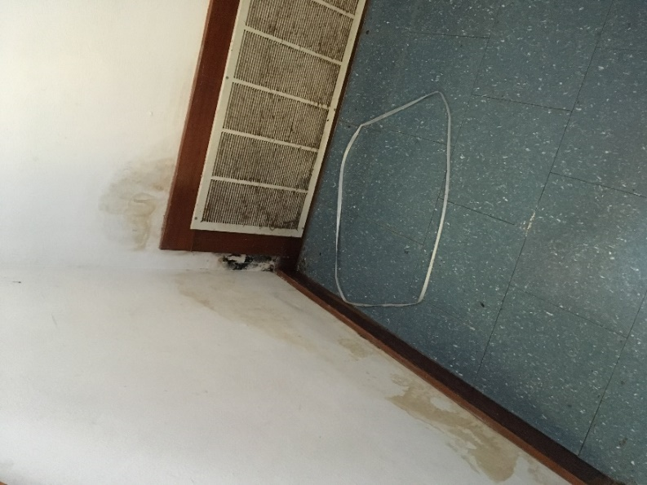
HVAC return vent at base of stairwell; note water damage to gypsum wallboard
Picture 2
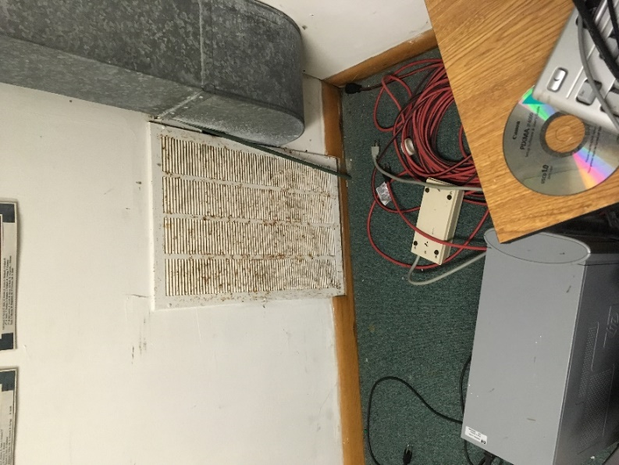
Basement room return vent, note rust on louvers

Picture 3
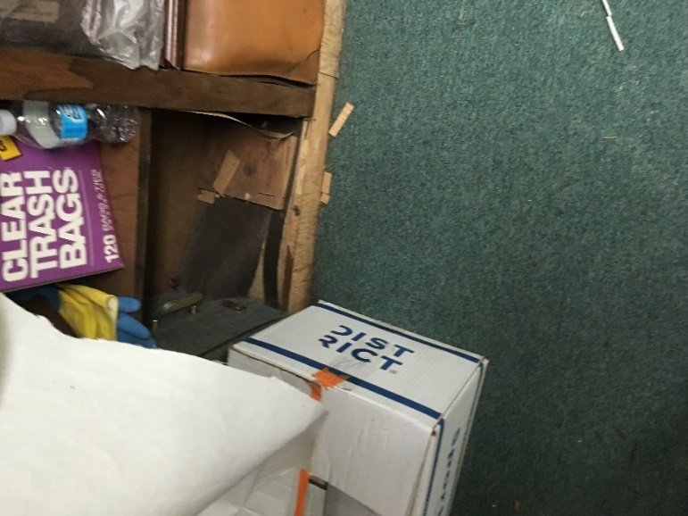
Water-damaged shelves with carboard, paper and other porous materials adjacent to water-damaged materials
Picture 4
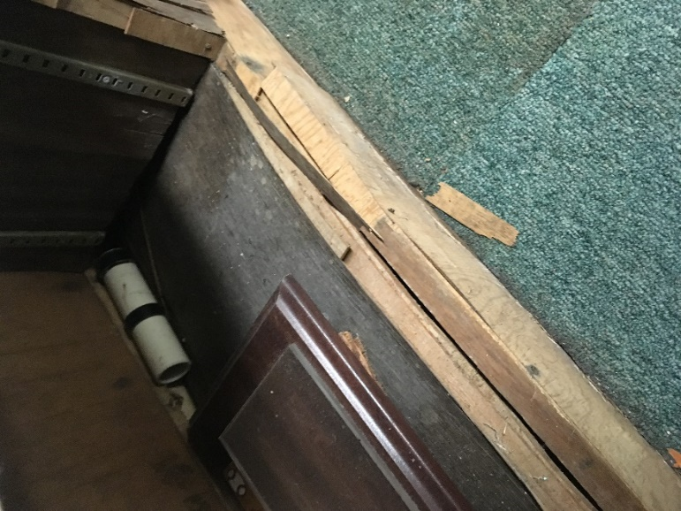
Water-damaged shelves

Picture 5
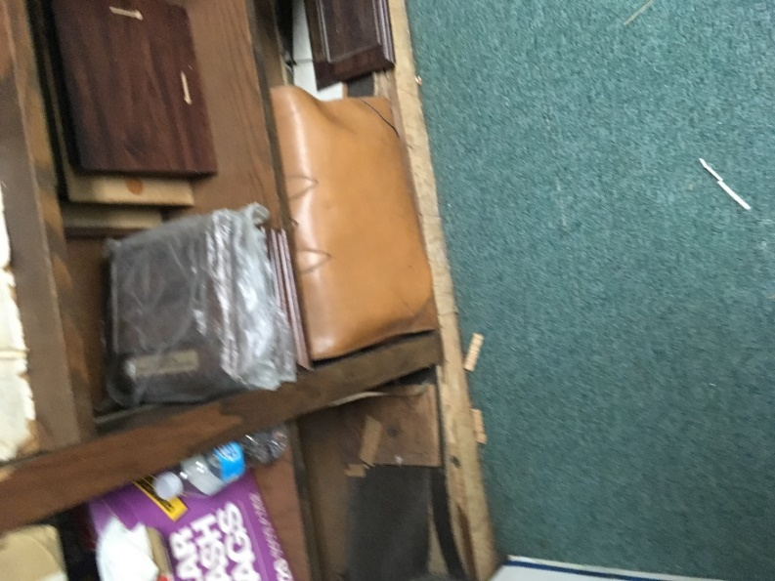
Water-damaged shelves with leather case on lower shelf
Picture 6
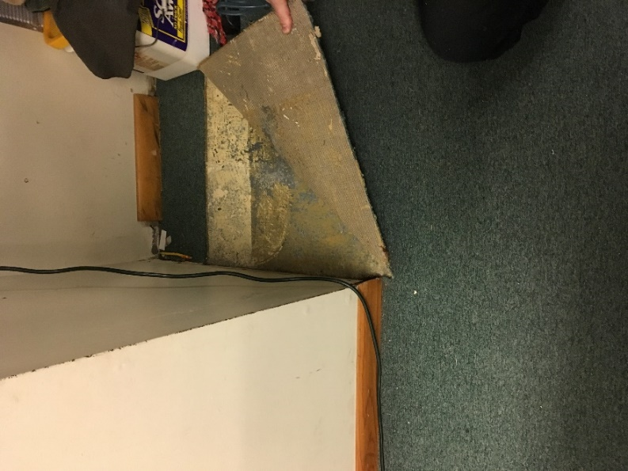
Water-damaged carpeting and gypsum wallboard

Picture 7
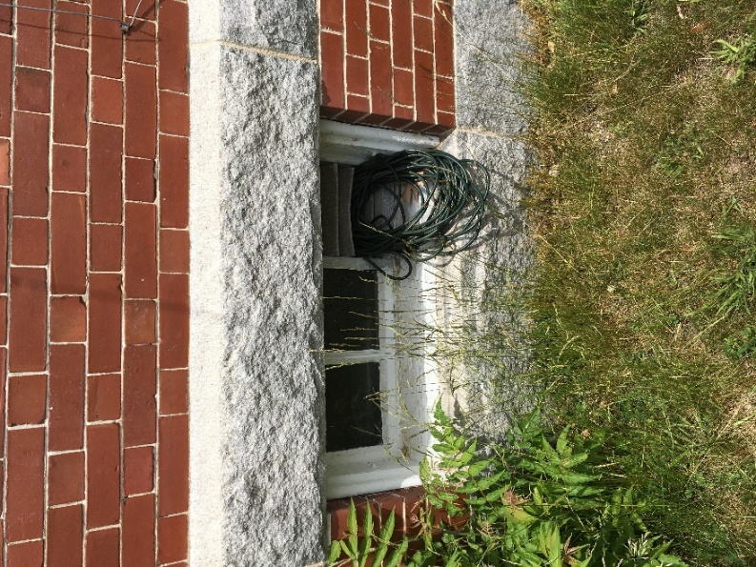
Missing pane in basement window
Picture 8
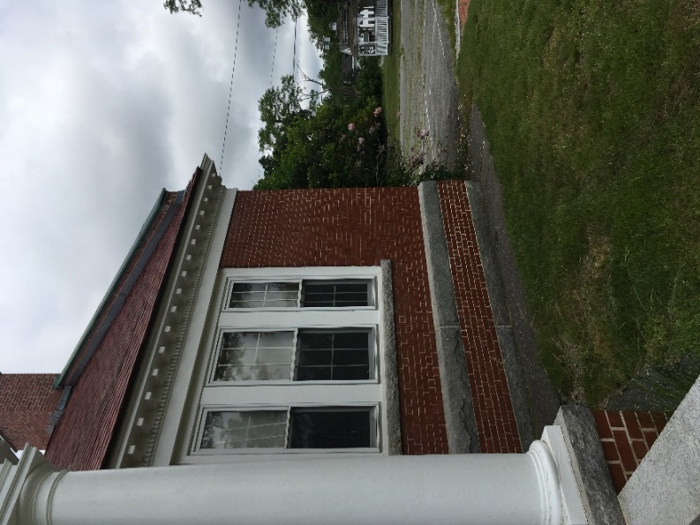
Roof edge without gutter/downspout

Picture 9
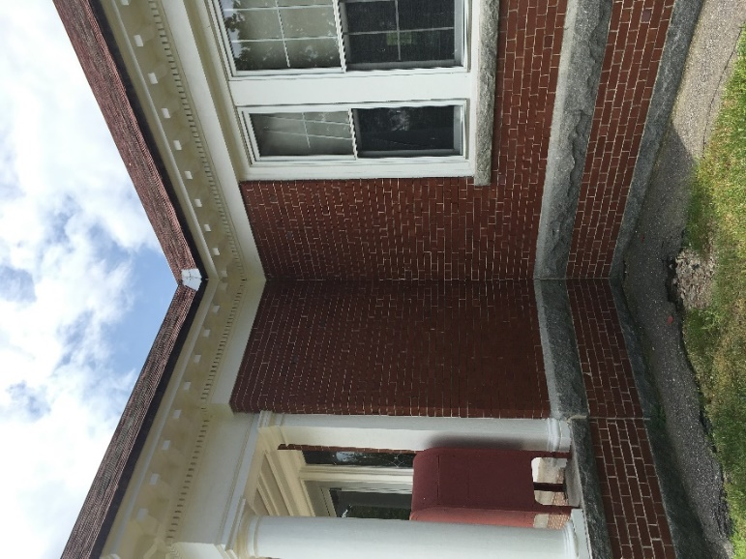
Access ramp/wall joint sealant; note eroded soil below roof valley where water can accumulate to drain toward the foundation walls beneath the tarmac apron

