INDOOR AIR QUALITY ASSESSMENT

Tyringham Town Offices
2 Church Street
Tyringham, Massachusetts



Prepared by:
Massachusetts Department of Public Health
Bureau of Environmental Health
Indoor Air Quality Program
March 2015

Background/Introduction
At the request of Molly Curtin-Schaefer, Tyringham Town Administrator, the Massachusetts Department of Public Health (MDPH), Bureau of Environmental Health (BEH) provided assistance and consultation at the Tyringham Town Offices (TTO), 2 Church Street, Tyringham, Massachusetts. On January 30, 2015, a visit to conduct an assessment was made to the TTO by Michael Feeney, Director of BEH’s Indoor Air Quality (IAQ) Program. Reports of a mold odor in the Assessor’s Office prompted this assessment.
The TTO is a one-story, two room wood schoolhouse built in 1792. A two story addition to the rear of building was made during the 1960’s (Picture 1). A cement block structure was also added to the rear of the building, which contains an air handling unit (AHU) (Picture 2). The building has a fieldstone foundation with a shallow crawlspace.
The building houses the Assessor’s Office, a historic room and a foyer with kitchen and restroom on the first floor. The second floor of the building has an office and an access door leading to the attic of the original building. Windows are openable.

Methods
Air tests for carbon dioxide, carbon monoxide, temperature, and relative humidity were taken with the TSI, Q-Trak, IAQ Monitor 7565. Air tests for airborne particle matter with a diameter less than 2.5 micrometers were taken with the TSI, DUSTTRAK™ Aerosol Monitor Model 8520. BEH/IAQ staff also performed a visual inspection of building materials for water damage and/or microbial growth.

Results
The TTO has 2 full time employees who typically serve several visitors on a daily basis. Tests were taken during normal operations. Results appear in Table 1.

Discussion

Ventilation
Carbon dioxide levels were below 800 parts per million (ppm) in all areas, indicating adequate air exchange in the majority of areas surveyed at the time of the assessment (Table 1). It should be noted, however, that many areas were sparsely populated at the time of the assessment. With increased occupancy, carbon dioxide levels would be expected to be higher.
The TTO is heated by a gas-fired forced hot air (FHA) furnace unit. The FHA unit is located in a cement block room. This unit provides heating but does not introduce fresh air. Air from the Assessor’s Office is drawn into a large return vent (Picture 3). A suspended ceiling was installed above the assessor’s office and historic room. The suspended ceiling in both rooms has a plastic “egg crate” vent (Picture 4). It appears that the vent in the Assessor’s Office is designed to draw air from the historic room via the egg crate in the suspended ceiling and an opening in the wall between the rooms in the ceiling plenum.
Minimum design ventilation rates are mandated by the Massachusetts State Building Code (MSBC). Until 2011, the minimum ventilation rate in Massachusetts was higher for occupied office spaces, with similar requirements for other occupied spaces (BOCA, 1993). The current version of the MSBC, promulgated in 2011 by the State Board of Building Regulations and Standards (SBBRS), adopted the 2009 International Mechanical Code (IMC) to set minimum ventilation rates. Please note that the MSBC is a minimum standard that is not health-based. At lower rates of cubic feet per minute (cfm) per occupant of fresh air, carbon dioxide levels would be expected to rise significantly. A ventilation rate of 20 cfm per occupant of fresh air provides optimal air exchange resulting in carbon dioxide levels at or below 800 ppm in the indoor environment in each area measured. MDPH recommends that carbon dioxide levels be maintained at 800 ppm or below. This is because most environmental and occupational health scientists involved with research on IAQ and health effects have documented significant increases in indoor air quality complaints and/or health effects when carbon dioxide levels rise above the MDPH guidelines of 800 ppm for schools, office buildings and other occupied spaces (Sundell et al., 2011). The ventilation must be on at all times that the room is occupied. Providing adequate fresh air ventilation with open windows and maintaining the temperature in the comfort range during the cold weather season is impractical. Mechanical ventilation is usually required to provide adequate fresh air ventilation.
Carbon dioxide is not a problem in and of itself. It is used as an indicator of the adequacy of the fresh air ventilation. As carbon dioxide levels rise, it indicates that the ventilating system is malfunctioning or the design occupancy of the room is being exceeded. When this happens, a buildup of common indoor air pollutants can occur, leading to discomfort or health complaints. The Occupational Safety and Health Administration (OSHA) standard for carbon dioxide is 5,000 parts per million parts of air (ppm). Workers may be exposed to this level for 40 hours/week, based on a time-weighted average (OSHA, 1997).
The MDPH uses a guideline of 800 ppm for publicly occupied buildings. A guideline of 600 ppm or less is preferred in schools due to the fact that the majority of occupants are young and considered to be a more sensitive population in the evaluation of environmental health status. Inadequate ventilation and/or elevated temperatures are major causes of complaints such as respiratory, eye, nose and throat irritation, lethargy and headaches. For more information concerning carbon dioxide, please see Appendix A.
Indoor temperature measurements at the time of the assessment were 70°F (Table 1) in occupied rooms which was within the MDPH recommended comfort range. Unoccupied space in the TTO had a temperature range of 57°F to 58°F (Table 1). The MDPH recommends that indoor air temperatures be maintained in a range of 70°F to 78°F in order to provide for the comfort of building occupants. In many cases concerning indoor air quality, fluctuations of temperature in occupied spaces are typically experienced, even in a building with an adequate fresh air supply.
Indoor relative humidity measurements at the time of the assessment ranged from 19 to 26 percent (Table 1), which were below the MDPH recommended comfort range. The MDPH recommends a comfort range of 40 to 60 percent for indoor air relative humidity. Humidity levels in the building would be expected to drop during the heating season. The sensation of dryness and irritation is common in a low relative humidity environment. Low relative humidity is a very common problem during the heating season in the northeast part of the United States.

Microbial/Moisture Concerns
A significant mold/musty odor was noticeable upon entering the Assessor’s Office from the rear foyer/kitchen area. This odor was traced to the east corner of the Assessor’s Office (Picture 5). The odor lessened and appeared to be confined to the east corner of the Assessor’s Office. The odor appeared to lessen when the FHA unit was deactivated. It is likely that an opening in the floor or walls exists in and around the east corner of the Assessor’s Office; this would allow air to enter from the crawlspace. Rotted wood also exists at the base of the exterior east corner of the TTO (Picture 6) which can also provide a pathway for odors from the crawlspace. It appeared that the lower section of the southeastern exterior wall was more recently replaced (Picture 7). There are three possible sources of water to enter the crawlspace and produce a musty odor that is penetrating into the Assessor’s Office.
- The east corner downspout has come away from the gutter, which can directly moisten the wood at the foundation. In addition, the downspout empties at the base of the building. Downspouts should be directed to empty at least five feet away from a building to prevent water penetration through the foundation.
- Rainwater can penetrate through clapboard above the repaired southeast exterior section. Water can accumulate behind the new clapboard, wetting materials and possibly penetrating through the sill/foundation junction.
- Water from driving rain may accumulate along the foundation from the driveway.
If these sources of water intrusion are not addressed, wood rot and related odors may occur. Repeated moistening of crawlspace soil may also result in microbial growth and associated moldy odors. Unfortunately, IAQ staff could not identify any means to create cross ventilation for the crawlspace. Absence of passive crawlspace vents can result in a buildup of water vapor which can lead to mold growth.
Another possible source of a moldy odor is the wall-to-wall carpet installed in the Assessor’s Office. Moisture is introduced into the interior of the crawlspace via the means previously described. As relative humidity levels increase indoors, porous building materials, such a wood and carpeting, can absorb moisture. The moisture content of wood and carpeting can fluctuate with increases/decreases in indoor relative humidity. The installation of the carpet creates a vapor barrier which prevents air and water vapor movement though the wood floor from the crawlspace. Without air and water vapor movement, the floor slats cannot dry since moisture is trapped between the carpet and underlying floor. The American Conference of Governmental Industrial Hygienists (ACGIH) and the US Environmental Protection Agency (US EPA) recommend that porous materials be dried with fans and heating within 24 to 48 hours of becoming wet (ACGIH, 1989; US EPA, 2001). If porous materials are not dried within this time frame, mold growth may occur. Water-damaged porous materials cannot be adequately cleaned to remove mold growth. The application of a mildewcide to porous materials is not recommended.
A factor increasing the odor penetration into the Assessor’s Office is the configuration of the ductwork and operation of the FHA unit. The velocity of air drawn by the return vent of the FHA depressurizes the Assessor’s Office, which in turn will draw air from cracks/crevices and other openings in walls and floors. This draw of air will also draw crawlspace odors and water vapor into the Assessor’s Office, which can then moisten carpet, building materials and other materials which can lead to mold growth and musty odors.

Other IAQ Evaluations
Indoor air quality can be negatively influenced by the presence of respiratory irritants, such as products of combustion. The process of combustion produces a number of pollutants. Common combustion emissions include carbon monoxide, carbon dioxide, water vapor, and smoke (fine airborne particle material). Of these materials, exposure to carbon monoxide and particulate matter with a diameter of 2.5 micrometers (μm) or less (PM2.5) can produce immediate, acute health effects upon exposure. To determine whether combustion products were present in the indoor environment, BEH/IAQ staff obtained measurements for carbon monoxide and PM2.5.

Carbon Monoxide
Carbon monoxide is a by-product of incomplete combustion of organic matter (e.g., gasoline, wood and tobacco). Exposure to carbon monoxide can produce immediate and acute health effects. Several air quality standards have been established to address carbon monoxide and prevent symptoms from exposure to these substances. The MDPH established a corrective action level concerning carbon monoxide in ice skating rinks that use fossil-fueled ice resurfacing equipment. If an operator of an indoor ice rink measures a carbon monoxide level over 30 ppm, taken 20 minutes after resurfacing within a rink, that operator must take actions to reduce carbon monoxide levels (MDPH, 1997).
The American Society of Heating Refrigeration and Air-Conditioning Engineers (ASHRAE) has adopted the National Ambient Air Quality Standards (NAAQS) as one set of criteria for assessing indoor air quality and monitoring of fresh air introduced by HVAC systems (ASHRAE, 1989). The NAAQS are standards established by the US EPA to protect the public health from six criteria pollutants, including carbon monoxide and particulate matter (US EPA, 2006). As recommended by ASHRAE, pollutant levels of fresh air introduced to a building should not exceed the NAAQS levels (ASHRAE, 1989). The NAAQS were adopted by reference in the Building Officials and Code Administrators (BOCA) National Mechanical Code of 1993 (BOCA, 1993), which is now an HVAC standard included in the Massachusetts State Building Code (SBBRS, 2011). According to the NAAQS, carbon monoxide levels in outdoor air should not exceed 9 ppm in an eight-hour average (US EPA, 2006).
Carbon monoxide should not be present in a typical, indoor environment. If it is present, indoor carbon monoxide levels should be less than or equal to outdoor levels. On the day of the assessment, outdoor carbon monoxide concentrations were non-detect (ND) (Table 1). No measurable levels of carbon monoxide were detected inside the building (Table 1).
It is important to note that the cement block room does not appear to provide a source of combustion air for the FHA gas burner. This means that air is drawn from the TTO interior to combust gas. Due to the configuration of the FHA return vent, if the door to the room housing the unit and the rear door of the Assessor’s Office are both open, products of combustion (e.g., carbon monoxide, etc.) may be drawn into the occupied space, despite the presence of a power vent within the FHA unit.

Particulate Matter
The US EPA has established NAAQS limits for exposure to particulate matter. Particulate matter is airborne solids that can be irritating to the eyes, nose and throat. The NAAQS originally established exposure limits to particulate matter with a diameter of 10 μm or less (PM10). According to the NAAQS, PM10 levels should not exceed 150 microgram per cubic meter (μg/m³) in a 24-hour average (US EPA, 2006). These standards were adopted by both ASHRAE and BOCA. Since the issuance of the ASHRAE standard and BOCA Code, US EPA established a more protective standard for fine airborne particles. This more stringent PM2.5 standard requires outdoor air particle levels be maintained below 35 μg/m³ over a 24-hour average (US EPA, 2006). Although both the ASHRAE standard and BOCA Code adopted the PM10 standard for evaluating air quality, MDPH uses the more protective PM2.5 standard for evaluating airborne particulate matter concentrations in the indoor environment.
Outdoor PM2.5 was measured at 1 μg/m³ (Table 1). PM2.5 levels measured indoors ranged from 1 to 2 μg/m³ (Table 1), which were below the NAAQS PM2.5 level of 35 μg/m³. Frequently, indoor air levels of particulate matter (including PM2.5) can be at higher levels than those measured outdoors. A number of mechanical devices and/or activities that occur in buildings can generate particulate matter during normal operations. Sources of indoor airborne particulate matter may include but are not limited to particles generated during the operation of fan belts in the HVAC system, use of stoves and/or microwave ovens in kitchen areas; use of photocopiers, fax machines and computer printing devices; operation of an ordinary vacuum cleaner and heavy foot traffic indoors.

Other Conditions
The FHA unit contains a filter that is not flush with the opening (Picture 8), which can allow for particles to bypass the filter and be distributed by the FHA unit as it operates. In addition, the filter is of a type that will provide minimal filtration of particulate matter from air. The dust spot efficiency is the ability of a filter to remove particulate matter of a certain diameter from air passing through the filter. Filters that have been determined by ASHRAE to meet its standard for a dust spot efficiency of a minimum of 40 percent would be sufficient to reduce many airborne particulates (Thornburg, 2000; MEHRC, 1997; ASHRAE, 1992). Pleated filters with a Minimum Efficiency Reporting Value (MERV) of 9 would normally be recommended, since this type of filter would remove common air particles such as pollen. Note that increasing filtration can reduce airflow (called pressure drop), which can subsequently reduce the efficiency of the unit due to increased resistance. Prior to any increase of filtration, the FHA unit should be evaluated by a ventilation engineer to ascertain whether it can maintain function with a more efficient filter.
Signs of rodent infestation were observed throughout the TTO. Traps were noted in the Assessor’s Office. There were many holes/gaps around the foundation which allow for rodents to easily enter the building. It was reported to BEH/IAQ staff that a pest control company makes a visit once per month. MDPH typically recommends adopting a more comprehensive integrated pest management (IPM) plan to more effectively control rodents and other pests.

Conclusions/Recommendations
The conditions found within the TTO raise a number of indoor air quality issues. The penetration of storm/rainwater into the building envelope combined with the chronically moist conditions in the crawl space create conditions that likely allow moist air, odors and other pollutants into occupied areas of the TTO. In view of the findings at the time of the visit, the following recommendations are made:
- Consider installing a combustion air vent for the FHA unit to draw air from outdoors.
- Examine the east corner of the Assessor’s Offices for holes/cracks, crevices or other openings through the floor and exterior wall and seal with an appropriate material. This examination should include moving the bookshelf installed along the southeast wall in the east corner.
- Consider removing the wall-to-wall carpet from the Assessor’s Office.
- Reconnect/install the gutter and downspout system to capture water and direct it away from the foundation.
- Consult with a water intrusion contractor to take necessary actions to prevent storm water, groundwater, and associated moisture from entering the crawlspace. This may include:
  - sealing gaps in foundations;
  - installing perimeter drains;
  - providing vapor barrier to the underside of the floor and;
  - installing a sloped, water impermeable surface barrier (clay cap);
- Consult with a building engineer/contractor to evaluate strategies to stop water/moisture from penetrating the building envelope along the southeast wall, which may include addressing storm water runoff from the driveway.
- Ensure that the filters have the recommended minimum 40% dust spot efficiency accounting for manufacturer limitations with pressure drop. Ensure they are installed correctly and changed on a regular schedule in accordance with manufacturer’s recommendations.
- For buildings in New England, periods of low relative humidity during the winter are often unavoidable. Therefore, scrupulous cleaning practices should be adopted to minimize common indoor air contaminants whose irritant effects can be enhanced when the relative humidity is low. To control dusts, a high efficiency particulate arrestance (HEPA) filter equipped vacuum cleaner in conjunction with wet wiping of all surfaces is recommended. Avoid the use of feather dusters. Drinking water during the day can help ease some symptoms associated with a dry environment (throat and sinus irritations).
- Examine the feasibility of installing passive vents to aid in drying the crawlspace.
- Use the principles of integrated pest management (IPM) to rid this building of pests. Activities that can be used to eliminate pest infestation may include the following:
  - Keep list/inventory of location of all rodent bait/sticky traps, monitor on a regular basis and replace as needed to prevent odors from rodent die off. Do not place rodent traps in the airstream of ventilation equipment;
  - Do not use recycled food containers for other purposes. Seal containers to be recycled in a container with a tight fitting lid to prevent rodent access;
  - Remove non-food items that rodents are consuming or using as bedding;
  - Store foods in tight-fitting containers;
  - Avoid eating at workstations. In areas were food is consumed, vacuum periodically to remove crumbs;
  - Regularly clean crumbs and other food residues from toasters, toaster ovens, microwave ovens coffee pots and other food preparation equipment;
  - Examine each room and the exterior walls of the building for means of rodent egress and seal appropriately. Holes as small as ¼” is enough space for rodents to enter an area. If doors do not seal at the bottom, install a weather strip as a barrier to rodents;
  - Reduce harborages (cardboard boxes, paper) where rodents may reside; and
- Refer to the IPM Guide, which can be obtained at the following Internet address: http://www.mass.gov/eea/docs/agr/pesticides/publications/ipm-kit-for-bldg-mgrs.pdf.

References
ACGIH. 1989. Guidelines for the Assessment of Bioaerosols in the Indoor Environment. American Conference of Governmental Industrial Hygienists, Cincinnati, OH.
ASHRAE. 1989. Ventilation for Acceptable Indoor Air Quality. American Society of Heating, Refrigeration and Air Conditioning Engineers. ANSI/ASHRAE 62-1989.
ASHRAE. 1992. Gravimetric and Dust-Spot Procedures for Testing Air-Cleaning Devices Used in General Ventilation for Removing Particulate Matter. American Society of Heating, Refrigeration and Air Conditioning Engineers. ANSI/ASHRAE 52.1-1992.
BOCA. 1993. The BOCA National Mechanical Code/1993. 8th ed. Building Officials and Code Administrators International, Inc., Country Club Hill, IL.
MDPH. 1997. Requirements to Maintain Air Quality in Indoor Skating Rinks (State Sanitary Code, Chapter XI). 105 CMR 675.000. Massachusetts Department of Public Health, Boston, MA.
MEHRC. 1997. Indoor Air Quality for HVAC Operators and Contractors Workbook. MidAtlantic Environmental Hygiene Resource Center, Philadelphia, PA.
OSHA. 1997. Limits for Air Contaminants. Occupational Safety and Health Administration. Code of Federal Regulations. 29 C.F.R 1910.1000 Table Z-1-A.
SBBRS. 2011. Mechanical Ventilation. State Board of Building Regulations and Standards. Code of Massachusetts Regulations, 8th edition. 780 CMR 1209.0
Sundell. 2011. Sundell, J., H. Levin, W. W. Nazaroff, W. S. Cain, W. J. Fisk, D. T. Grimsrud, F. Gyntelberg, Y. Li, A. K. Persily, A. C. Pickering, J. M. Samet, J. D. Spengler, S. T. Taylor, and C. J. Weschler. 2011. Ventilation rates and health: multidisciplinary review of the scientific literature. Indoor Air, Volume 21: pp 191–204.
Thornburg, D. 2000. Filter Selection: a Standard Solution. Engineering Systems 17:6 pp. 74-80.
US EPA. 2001. Mold Remediation in Schools and Commercial Buildings. US Environmental Protection Agency, Office of Air and Radiation, Indoor Environments Division, Washington, D.C. EPA 402-K-01-001. March 2001.
US EPA. 2006. National Ambient Air Quality Standards (NAAQS). US Environmental Protection Agency, Office of Air Quality Planning and Standards, Washington, DC. http://www.epa.gov/air/criteria.html.
Picture 1
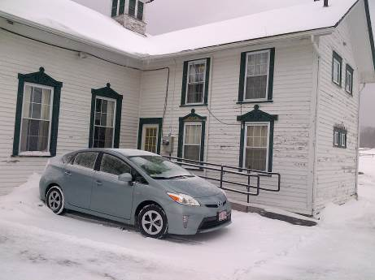
Two story addition at rear of original building
Picture 2
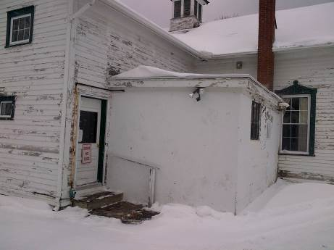
Cement block addition
Picture 3
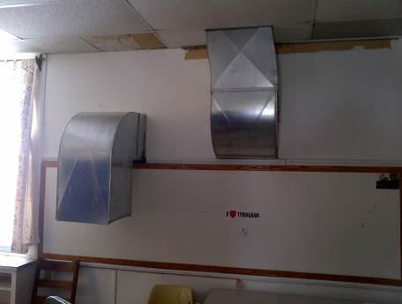
Return vent in Assessor’s Office
Picture 4
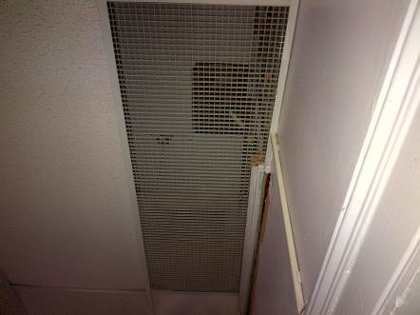
“Egg crate” in suspended ceiling serving as return vent for the Historical Room
Picture 5
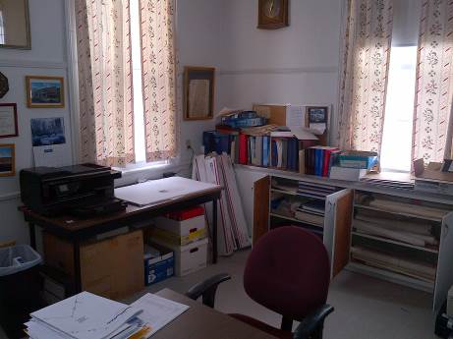
East corner of Assessor’s Office
Picture 6
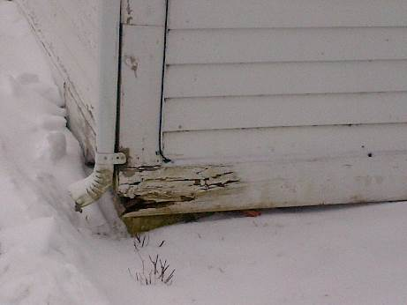
Rotted wood at base of the east exterior corner of TTO
Picture 7
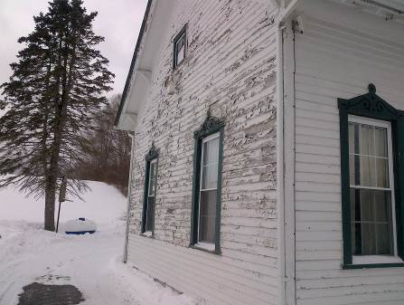
Southeast exterior wall outside Assessor’s Office
(Note lack of peeling paint on clapboard at the bottom of the wall)

Picture 8

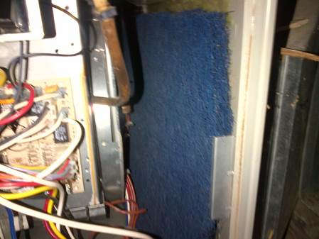

Loose filter in FHA
Location | Carbon  Dioxide  (ppm) | Carbon Monoxide  (ppm) | Temp  (°F) | Relative  Humidity  (%) | PM2.5  (µg/m³) | Occupants  in Room | Windows  Openable | Ventilation |  | Remarks
 |  |  |  |  |  |  |  | Supply | Exhaust | Remarks
Outdoors (Background) | 399 | ND | 32 | 34 | 1
Assessors | 481 | ND | 70 | 19 | 1 | 0 | Y | Y | Y | Musty odor, wall crack, mouse trap
2nd floor office | 626 | ND | 70 | 21 | 2 | 1 | Y | Y | N
Historical room | 463 | ND | 58 | 22 | ND | 0 | Y | Y | Y
Restroom | 461 | ND | 58 | 24 | ND | 0 | Y | N | Y
FHA room | 473 | ND | 57 | 26 | ND | 0 | N | N | N

