 | Massachusetts Department of Environmental Protection  Bureau of Resource Protection – Drinking Water Program  UIC Class V Well  Completion of Construction Notification Form
 | Enter UIC Registration Number (required): |  | UIC Registration Number
 | A. Residential/Facility Information
Important: When filling out forms on the computer, use only the tab key to move your cursor - do not use the return key.  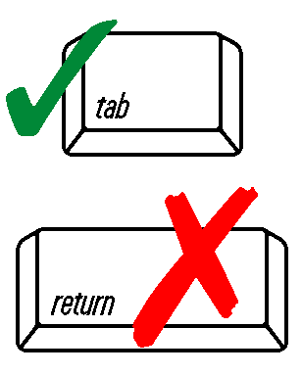 | Facility/Residential Property Name
 | Facility/Residential Property Street Address
 | City/Town |  | State | Zip Code
 | B. Preparer Information
 | Preparer Name |  | Preparer Address (if different from facility)
 | City/Town |  | State | Zip Code
 | Zip |  | Telephone Number
 | Preparer’s Email |  | Preparer’s Phone #
 | C. Well Information
 | Date well construction completed |  | Date well(s) put into use
 | Was there any information that was unavailable or missing in the original UIC application (i.e. well depth, depth to water table/bedrock)?
 | Yes No
 | Has any of the information that was submitted with the original UIC application (including any previously submitted UIC registration modification forms) changed, or have any of the UIC well and discharge system conditions that MassDEP placed on the UIC registration approval not been met (excluding any post start-up sampling requirements)? This would include, but not be limited to, the following: well dimensions, well seal materials, piping/tubing materials, well(s) location(s), number of wells, number of entry points to the system, types of discharges, types of additives, and any of the attachments previously submitted.
 | Yes No
 | If you answered “Yes” to either of the previous questions, you must complete the BRP WS06 UIC Registration form that is applicable to the well type associated with the UIC Registration Number that you entered at the top of this form. You shall complete only the UIC Registration Number, facility name and address and those portions of the form that are changed, including data not supplied with the original application, and resubmit only those attachments that were modified.
 | For drilled wells, attach the well driller’s Well Completion Report.
 | Attach laboratory analytical results for raw water samples and post treatment/process/heat pump bacteria samples as required for your well type or per MassDEP conditions stipulated in the UIC Registration approval-to-install letter.
 | C. Well Information (cont.)
 | Attachments
 | Applicable BRP WS06 Registration form (including any revised plans or attachments)
 | Well Completion Report (for drilled wells only) Analytical Data
 | Other (describe):
 | D. Certifications
 | Operator
 | I certify under pains and penalties of law that I have personally examined and am familiar with the information submitted in this document and all attachments and based on my personal knowledge or inquiry of those agents immediately responsible for obtaining the information on my behalf, I believe the information is true, accurate, and complete. I am aware that there are significant penalties for submitting false information, including possible fines and imprisonment.
 | Signature of Operator |  | Date
 | Printed Name of Operator |  | Position/Title
 | Owner (must be completed if owner has not signed above as operator)
 | I certify that I have personally examined and am familiar with the information submitted in this document.
 | Signature of Owner |  | Date
 | Printed Name of Owner |  | Position/Title
Submit a signed and complete application package to:

MassDEP
Bureau of Resource Protection - UIC Program
One Winter Street, 5th Floor
Boston, MA 02108

Send duplicate copies of this form to:
Local Board of Health

