WATER DAMAGE ASSESSMENT

UMass Dartmouth
Cedar Dell Village
Units 511, 512, 513, 514, 515 & 516
285 Old Westport Road
Dartmouth, MA

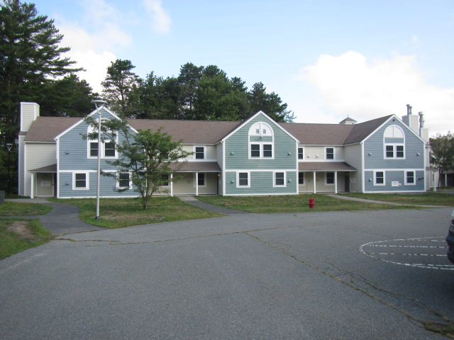

Prepared by:
Massachusetts Department of Public Health
Bureau of Environmental Health
Indoor Air Quality Program
September 2022

BACKGROUND
Building: | Cedar Dell Village, Units 511, 512, 513, 514, 515 & 516, UMass Dartmouth (UMD) campus
Address: | 285 Old Westport Road, Dartmouth, MA
Assessment Requested by: | Massachusetts Division of Labor Standards
Reason for Request: | Water damage/mold concerns
Date of Assessment: | September 9, 2022
Massachusetts Department of Public Health/Bureau of Environmental Health (MDPH/BEH) Staff Conducting Assessment: | Cory Holmes, Assistant Director, Indoor Air Quality (IAQ) Program
Date of Building Construction: | The housing units were constructed in the 1970s and renovated in 2006-2007.
Building/Area Description: | Former dormitory buildings, vacant since March 2020, slated to be used as UMD Police annex space. Building materials consist of gypsum wallboard (GW) ceilings and walls with carpet tiles on concrete floors.
Windows: | Windows are openable

METHODS
A visual assessment was performed, and moisture testing of porous building materials (i.e., GW) was conducted with a Delmhorst, BD-2000 Model, Moisture Detector equipped with a Delmhorst Standard Probe. Please refer to the IAQ Manual and appendices for additional information on methods, sampling procedures, and interpretation of results (MDPH, 2015).

RESULTS AND DISCUSSION
The following is a summary of indoor air testing results (Table 1).
- Temperature was within or close to the recommended range of 70°F to 78°F in areas assessed.
- Relative humidity was above the recommended range of 40% to 60% in the majority of areas assessed, indicating a source of water vapor in the building.
- Moisture Testing GW was slightly moistened throughout the units most likely due to elevated relative humidity conditions. GW was found wet on the west wall of 513B due to a condensate leak from the portable air conditioner (AC) in the area above.

Microbial/Moisture Concerns
At the time of assessment, musty odors and small areas of mold growth were observed in many areas throughout units 511-516. A likely source of musty odors was carpet squares on floors and wall-to-wall carpeting on stairs (Pictures 1 and 2). UMD Facilities staff were planning on having all carpet removed, which should be helpful in reducing moisture and associated odors. In general, the service life of carpeting is approximately 10-11 years (IICRC, 2002).
As reported by UMD staff, the buildings were unoccupied during the summer months of 2022. And it is important to note that the buildings have no mechanical heating, ventilation, and air conditioning (HVAC) systems. As originally designed, the building uses openable windows to provide fresh air. There is no mechanical ventilation, apart from bathroom exhaust vents which are not in use when the building is vacant. In addition, the building was renovated in 2006-2007, which included the installation of energy efficient windows and other features to increase the airtightness of the building. With this configuration, humid air can accumulate inside the building during hot, humid weather.
To reduce indoor relative humidity in the building, dehumidifiers were installed in several locations (Table 1). A dehumidifier is designed to draw air over a coil that is at a temperature at or below the dew point to have water vapor condense on the coil, which then collects in a vessel. Water is removed from the vessel either manually, or through a drain directly into a sink, floor drain, or other plumbing location. For cooling and additional humidity reduction, portable ACs were installed (Picture 3). To provide exhaust for the portable ACs, holes were made in exterior walls and flexible ducts were connected to vents on the outside of the building (Pictures 3 and 4). The ACs are set by temperature only (no relative humidity setting option), however, they have a “dry” setting designed to dehumidify air. At the time of assessment, a number of the ACs were set to the “dry” setting.

Despite the operation of air conditioners and dehumidifiers, relative humidity was elevated in the building at the time of the assessment. These measurements indicate that a water vapor source exists inside the building which is not being sufficiently reduced by the use of dehumidifiers/air conditioners. These relative humidity measurements may indicate that the dehumidifiers are drawing outdoor air into the building through spaces in the building envelope (e.g., gaps in or around walls, windows, doors) and/or is reevaporating collected condensation.
It appears that the operation of the portable ACs, which ejects hot air from the building through the flexible ducts without any conditioned make-up air, is depressurizing the building (i.e., pulling air into rooms where portable ACs are operating) to draw moisture from wall cavities, which would in turn increase indoor relative humidity. Relative humidity measurements in the building were in a range of 58% to 83%, with an outdoor measurement of 76%. In this configuration, moisture is likely being drawn from outdoors. This was demonstrated by the consistent presence of dust/debris and mold growth around wall and ceiling utilities (e.g., switch plates, outlets, smoke detectors) throughout the units (Pictures 5 through 9). Dust/debris deposition and mold growth were also observed around window and door frames (Pictures 9 and 10), further indicating depressurization. These deposits are the result of the following conditions:
- As the portable ACs exhaust air to the outside they draw moist/unconditioned make-up air from the wall cavities.
- This flow of air deposits dust and debris (including naturally occurring mold spores) around these utility openings.
- Elevated relative humidity moistens the wallboard and debris, which can serve as mold growth mediums.
Water damage on the GW ceiling was observed in unit 512 (Picture 11) which was reported to be from an AC condensate leak in the room directly above. This leak also resulted in moistening GW in the west wall of 513B, which had elevated moisture measurements at the time of assessment.
Visible mold growth was also observed on bathtub caulking in several bathrooms and on a number of stored items throughout the space (Pictures 12 through 14). Some of these items can be cleaned, or, if not needed, they should be discarded.
In order for building materials to support mold growth, a source of water exposure is necessary. The US Environmental Protection Agency (US EPA) and the American Conference of Governmental Industrial Hygienists (ACGIH) recommends that porous materials (e.g., wallboard, carpeting) be dried with fans and heating within 24 to 48 hours of becoming wet (US EPA, 2008; ACGIH, 1989). If porous materials are not dried within this time frame, mold growth may occur.
Gutters and downspouts around the units were in disrepair (Pictures 15 through 17). Without proper drainage, rainwater can pool around the building creating chronic dampness conditions and contribute to elevated relative humidity levels within the building.
Finally, open utility holes in walls, ceilings and ductwork were observed (Pictures 18 through 20). These breaches can provide a pathway for dust/debris in wall cavities and the ceiling plenum to migrate into occupied areas.

CONCLUSIONS/RECOMMENDATIONS
The conditions observed at the Cedar Dell Village are complex. The units were built and used as dormitory space and are being repurposed and converted into police offices and storage. The storage areas are of primary concern for preventing exposure to extreme temperatures and humidity.
The initial recommendation is to eject water vapor from the building interior using the following suggested procedure:
During a time period where outdoor relative humidity is predicted to stay below 60% for at least 48 hours,
- Open all windows on the north side of the building.
- Place a fan in a window or exterior door to direct indoor air directly outdoors. Use either a smoke ejector fan or an industrial fan of sufficient capacity to achieve at least two air exchanges for the volume of the building.
- Have all interior doors, including closet and cabinet doors, open during this venting.
- Do not do this activity if either rain or high outdoor humidity is predicted for 48 hours during this venting procedure.
- Measure relative humidity indoors to establish a baseline. Then measure relative humidity during the procedure to monitor if relative humidity drops below outdoor measurements.

Using drier weather conditions and fans placed to purge air from the building, water vapor inside the building should be reduced. Once relative humidity is reduced, resume use of dehumidifiers as needed. If relative humidity increases after dehumidifiers are activated, that may indicate that this equipment is drawing moist outdoor air from spaces in the building envelope. In addition, it is advised that all dehumidifiers are equipped with a means to directly drain accumulated water into a plumbing drainage system to reduce potential re-evaporation of water vapor.
The following additional recommendations are made:
- All mold-colonized materials should be cleaned/removed in accordance with the US EPA’s “Mold Remediation in Schools and Commercial Buildings” published by the US Environmental Protection Agency (US EPA, 2008). (http://www.epa.gov/mold/mold-remediation-schools-and-commercial-buildings-guide
- Continue with plans to remove carpeting. Removal of carpeting may generate airborne dust/debris, so once cut/removed place in trash bags for transport out of building and use stand up fans in exterior doors or near windows to exhaust airborne particulates.
- Consider contracting with a professional flooding and restoration firm to perform remediation throughout the units.
- Remove and replace water-damaged GW moistened for longer than 48 hours (e.g., west wall 513B).
- Remove all switches/wall plates, smoke detectors, etc. to clean surfaces of dust/debris/mold. Use an insulation material on the back of wall plates etc. to make utility holes as airtight as possible to prevent draw of air from the wall cavities and ceiling plenums.
- Replace tub caulking. If tubs/showers are not to be used, they should be professionally sealed/capped to prevent sewer gas odors from entering the building via dry traps.
- Consider installing humidistats in the air conditioning units that can be monitored at a central location or app via phone/laptop.
- Consider contacting the manufacturer for advice on adjusting the portable ACs for maximum efficiency for reducing relative humidity while maintaining thermal comfort.
- Consider working with an HVAC engineering firm to:
- Evaluate the space and its needs for recommendations for installing HVAC equipment to maintain temperature and relative humidity. Particular attention should be made for specialty storage areas that are temperature and humidity sensitive.
- Determine if currently used ACs can be adjusted to properly maintain temperature and relative humidity.
- If these portable ACs cannot provide adequate temperature and relative humidity levels to prevent further mold growth, consider replacing with devices that can be set for relative humidity (%) or replace with window mounted ACs and stand-alone dehumidifiers.
- Ensure porous items such as paper and cardboard boxes are elevated off the floor and stored on shelves.
- Make repairs to gutters and downspouts to drain water away from the building.
- Seal any/all open utility holes/breaches in walls, ceilings, and floors.
- Ensure file cabinets and other furniture have airspace (1-2 inches) between them and walls to prevent the trapping of moisture that can lead to mold growth.
- Once remediation activities are completed, clean all items and surfaces with a high efficiency particulate arrestance (HEPA) filter equipped vacuum cleaner combined with wet wiping.
- Refer to resource manual and other related IAQ documents located on the MDPH’s website for further building-wide evaluations and advice on maintaining public buildings. These documents are available at: http://mass.gov/dph/iaq.

REFERENCES
ACGIH. 1989. Guidelines for the Assessment of Bioaerosols in the Indoor Environment. American Conference of Governmental Industrial Hygienists, Cincinnati, OH.
IICRC. 2002. Institute of Inspection, Cleaning and Restoration Certification. A Life-Cycle Cost Analysis for Floor Coverings in School Facilities.
MDPH. 2015. Massachusetts Department of Public Health. Indoor Air Quality Manual: Chapters I-III. Available at: Indoor air quality - manual and appendices | Mass.gov
US EPA. 2008. Mold Remediation in Schools and Commercial Buildings. US Environmental Protection Agency, Office of Air and Radiation, Indoor Environments Division, Washington, D.C. EPA 402-K-01-001. http://www.epa.gov/mold/mold-remediation-schools-and-commercial-buildings-guide.
Picture 1
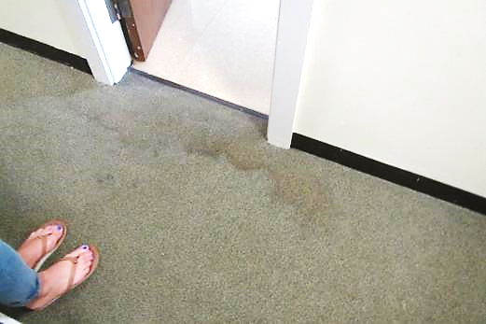
Water-damaged carpet squares on floor
Picture 2
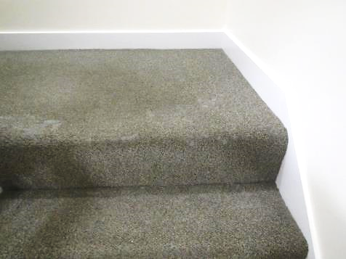
Water damage/mold growth (white staining) on stairwell carpeting
Picture 3
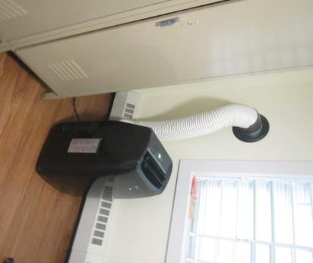
Portable AC unit ducted through exterior wall
Picture 4
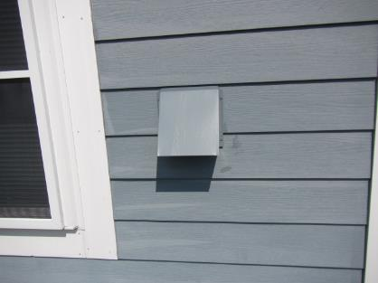
Exterior vent connected to portable AC unit exhaust
Picture 5
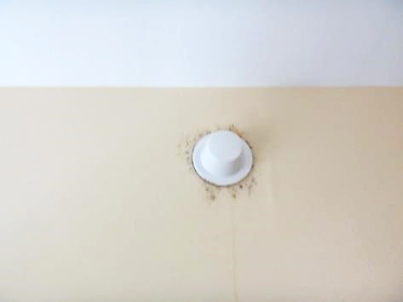
Dust/debris and visible mold growth around sprinkler cap
Picture 6
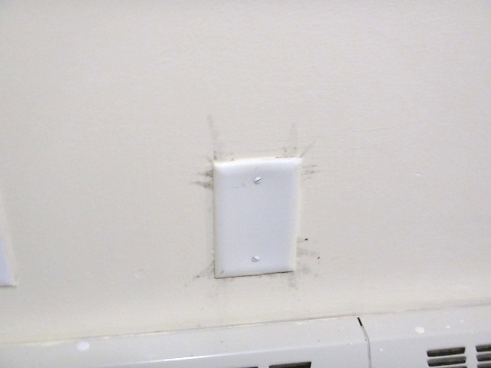
Dust/debris and visible mold growth around wall plate
Picture 7
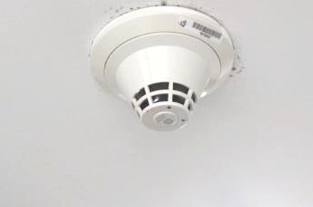
Dust/debris and visible mold growth around smoke detector
Picture 8
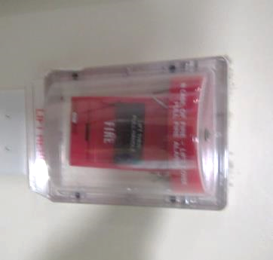
Dust/debris and visible mold growth around (and inside) fire alarm
Picture 9
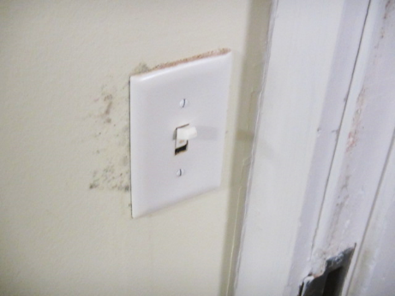
Dust/debris and visible mold growth around light switch and door jamb
Picture 10
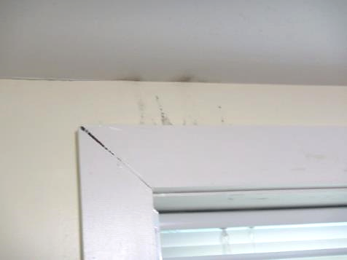
Dust/debris and visible mold growth around window frame
Picture 11
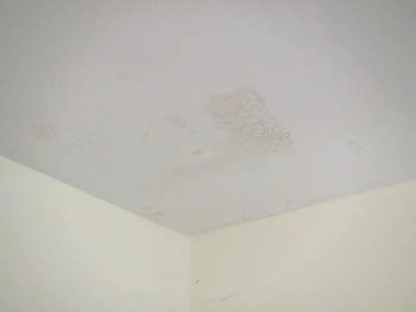
Water-damaged GW ceiling in unit 512
Picture 12
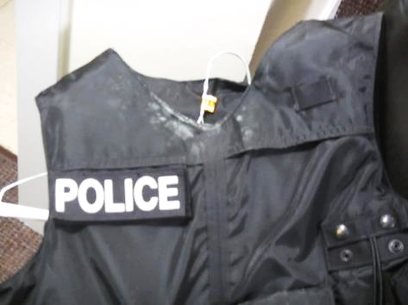
Visible mold growth (white staining) on police vest
Picture 13
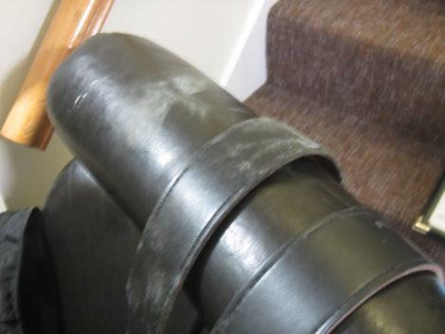
Visible mold growth (white staining) on leather items
Picture 14
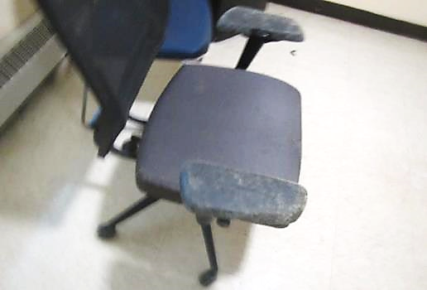
Visible mold growth (white staining) on upholstered chair
Picture 15
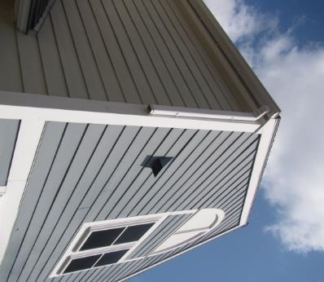
Missing downspout (arrow)
Picture 16
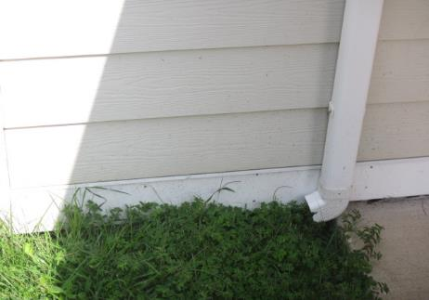
Downspout emptying against the building
Picture 17
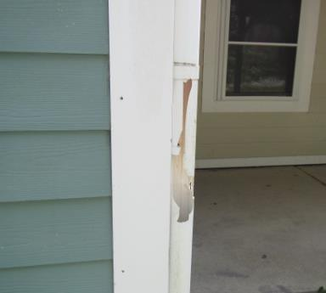
Damaged downspout (bracket)
Picture 18
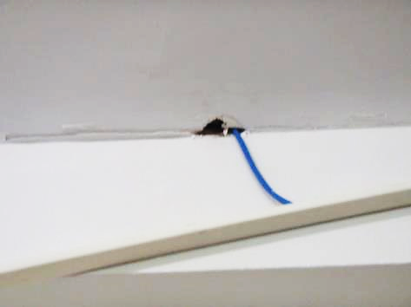
Open utility hole in ceiling
Picture 19
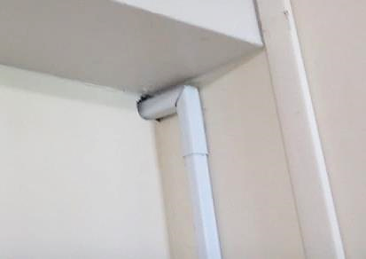
Open utility hole in wall
Picture 20
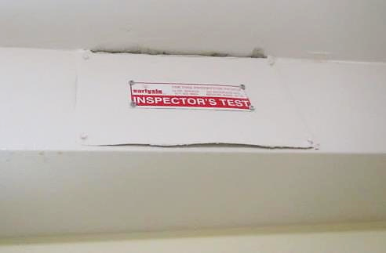
Open utility hole in wall/ceiling, note accumulated dust/debris and visible mold growth indicating airflow
Location | Air Temp  (ºF) | Relative Humidity  (%) | Comments
Background (outdoors) | 74 | 76 | Mostly sunny, warm/humid, 100% relative humidity overnight https://www.wunderground.com/history/daily/us/ma/new-bedford/KEWB/date/2022-9-9
Unit 511
Quarter Master | 71 | 74 | GW low moisture reading, dust/debris and visible mold growth around utility plates (e.g., switch/wall plates, outlets, smoke detectors)
Quarter Master Storage | 77 | 83 | GW low moisture reading, dust/debris and visible mold growth around door jamb, window frame and utility plates (e.g., switch/wall plates, outlets, smoke detectors)
LT. Office | 71 | 75
C | 76 | 75 | GW low moisture reading, dust/debris and visible mold growth around utility plates (e.g., switch/wall plates, outlets, smoke detectors)
D | 69 | 69
E | 72 | 71 | Gypsum wallboard - low moisture reading, dust/debris and visible mold growth around utility plates (e.g., switch/wall plates, outlets, smoke detectors)
F | 73 | 72
Bathroom |  |  | Mold growth on tub caulking
2nd Floor Hallway |  |  | Space under door to adjacent unit, rec. installing weather-stripping
Unit 512
Front Room | 72 | 67 | Water-damaged gypsum wallboard ceiling (condensate leak) dry to low moisture reading, dust/debris and visible mold growth around utility plates (e.g., switch/wall plates, outlets, smoke detectors)
C | 73 | 68 | Dust/debris and visible mold growth around utility plates (e.g., switch/wall plates, outlets, smoke detectors)
Main Room | 72 | 61 | Accumulated water in ceiling light, dust/debris and visible mold growth around utility plates (e.g., switch/wall plates, outlets, smoke detectors)
E | 73 | 68
F | 74 | 65 | Dust/debris and visible mold growth around utility plates (e.g., switch/wall plates, outlets, smoke detectors)
513
A | 78 | 60 | Dehumidifier
B | 74 | 61 | West wall gypsum wallboard – wet/elevated moisture reading, dust/debris and visible mold growth around utility plates (e.g., switch/wall plates, outlets, smoke detectors)
Main Room/Kitchen | 73 | 60 | Dust/debris and visible mold growth around utility plates (e.g., switch/wall plates, outlets, smoke detectors)
D | 76 | 59 | Dust/debris and visible mold growth around utility plates (e.g., switch/wall plates, outlets, smoke detectors), dead insects/sticky traps
E | 75 | 58 | Dust/debris and visible mold growth around utility plates (e.g., switch/wall plates, outlets, smoke detectors)
F | 75 | 66 | Dust/debris and visible mold growth around utility plates (e.g., switch/wall plates, outlets, smoke detectors)
514
A | 72 | 52 | Dust/debris and visible mold growth around utility plates (e.g., switch/wall plates, outlets, smoke detectors), dehumidifier full
B | 72 | 61 | Dust/debris and visible mold growth around utility plates (e.g., switch/wall plates, outlets, smoke detectors)
Main Room/UMDPD Storage | 73 | 58
C | 69 | 67 | Dust/debris and visible mold growth around utility plates (e.g., switch/wall plates, outlets, smoke detectors)
D | 65 | 66 | Dust/debris and visible mold growth around utility plates (e.g., switch/wall plates, outlets, smoke detectors)
E | 66 | 64
F | 70 | 70 | Dust/debris and visible mold growth around utility plates (e.g., switch/wall plates, outlets, smoke detectors)
515 |  |  | White staining/visible mold growth on stairs/carpet
A | 78 | 61 | Dust/debris and visible mold growth around utility plates (e.g., switch/wall plates, outlets, smoke detectors)
B | 74 | 65 | Boxes on floor, moldy chair
C | 73 | 72
D | 74 | 70 | Dust/debris and visible mold growth around utility plates (e.g., switch/wall plates, outlets, smoke detectors)
E | 70 | 63 | Dust/debris and visible mold growth around utility plates (e.g., switch/wall plates, outlets, smoke detectors)
F | 72 | 72 | AC unit off
Main Room/Kitchen | 74 | 67 | Main Room/Kitchen
516
Main Room/Kitchen | 71 | 62
Armory | 72 | 70
B | 71 | 68
C | 68 | 65 | Dust/debris and visible mold growth around utility plates (e.g., switch/wall plates, outlets, smoke detectors)
D | 69 | 76 | Dust/debris and visible mold growth around ceiling light
E | 66 | 71 | Dust/debris and visible mold growth around utility plates (e.g., switch/wall plates, outlets, smoke detectors)
F | 65 | 68

