UMASS MEMORIAL HEALTH CARE, INC. DETERMINATION OF NEED APPLICATION #20121712-TO
Applicant’s Responses of March 8, 2021 to Questions dated February 17, 2021

- Provide the APM contract percentages for UMass Memorial Health Care, Inc. and Harrington Memorial Hospital using the table provided below. Provide a year for the data.

APM Contract Percentages  UMass Memorial Health Care 2021 | % | Harrington 2020 | %
ACO and APM Contracts | 42.00% |  | 52.50%
Medicare MSSP  Medicare BPCI- Advanced  THP risk- commercial products HPHC risk- commercial products | BACO  Medicare MSSP  THP risk- commercial products HPHC risk- commercial products BCBS  Fallon Medicare Advantage
Non ACO and Non APM Contracts | 58% |  | 47.50%

Factor 1a. Patient Panel Need
- UMMHC sees approximately 8.9% of patients in HMH’s primary and secondary service areas (pg.2).
  - Provide data on the types of UMMHC services these patients utilize.

UMMHC had the following inpatient and outpatient volumes by service for patients residing in HMH’s primary and secondary towns (includes MA and CT residents). Please note FY20 volumes were down due to the impact of COVID19.

 | UMMHC Hospitals |  |  |  | % of Total
Inpatient | 2018 | 2019 | 2020 |  | 2018 | 2019 | 2020
Cardiac/Thoracic/Vascular Services | 716 | 697 | 641 |  | 13.6% | 13.2% | 12.9%
General Medicine | 1,389 | 1,426 | 1,363 |  | 26.4% | 26.9% | 27.5%
General Surgery | 489 | 498 | 435 |  | 9.3% | 9.4% | 8.8%
Neurology & Neurosurgery | 290 | 335 | 293 |  | 5.5% | 6.3% | 5.9%
OB/GYN/Neonatology | 1,568 | 1,518 | 1,458 |  | 29.8% | 28.7% | 29.4%
Oncology | 157 | 139 | 143 |  | 3.0% | 2.6% | 2.9%
Orthopedics | 266 | 314 | 250 |  | 5.1% | 5.9% | 5.0%
Other | 155 | 133 | 153 |  | 2.9% | 2.5% | 3.1%
Psychiatry | 102 | 116 | 87 |  | 1.9% | 2.2% | 1.8%
Spine | 135 | 121 | 132 |  | 2.6% | 2.3% | 2.7%
Inpatient Total | 5,267 | 5,297 | 4,955 | 100.0% 100.0% 100.0%

UMMHC Hospitals |  |  |  | % of Total
 | 2018 | 2019 | 2020 |  | 2018 | 2019 | 2020
Outpatient
ED | 8,116 | 8,362 | 6,719 |  | 6.3% | 6.2% | 5.8%
Endo and Surgical Svc | 5,166 | 5,385 | 3,516 |  | 4.0% | 4.0% | 3.1%
Infusions | 2,553 | 2,953 | 3,024 |  | 2.0% | 2.2% | 2.6%
Labs | 5,258 | 5,810 | 10,236 |  | 4.1% | 4.3% | 8.9%
Observation | 1,407 | 1,525 | 1,198 |  | 1.1% | 1.1% | 1.0%
Other | 103 | 163 | 83 |  | 0.1% | 0.1% | 0.1%
Primary Care | 15,114 | 14,902 | 12,389 |  | 11.7% | 11.1% | 10.7%
Rad Onc | 3,411 | 4,117 | 2,564 |  | 2.6% | 3.1% | 2.2%
Radiology | 14,075 | 14,585 | 12,718 |  | 10.9% | 10.8% | 11.0%
Rehab Service | 1,643 | 1,840 | 1,230 |  | 1.3% | 1.4% | 1.1%
Subspecialist: Pediatric Care | 10,829 | 10,756 | 8,934 |  | 8.4% | 8.0% | 7.8%
Subspecialist: Behavioral Health | 2,473 | 1,014 | 48 |  | 1.9% | 0.8% | 0.0%
Subspecialist: Cancer | 4,235 | 4,911 | 4,955 |  | 3.3% | 3.6% | 4.3%
Subspecialist: Cardiology/Vascular | 10,308 | 10,111 | 8,649 |  | 8.0% | 7.5% | 7.5%
Subspecialist: Dermatology | 3,417 | 3,773 | 2,848 |  | 2.6% | 2.8% | 2.5%
Subspecialist: Diabetes and Endocrine | 3,744 | 3,783 | 3,061 |  | 2.9% | 2.8% | 2.7%
Subspecialist: ENT | 1,983 | 2,278 | 1,636 |  | 1.5% | 1.7% | 1.4%
Subspecialist: General Surgery | 3,025 | 2,834 | 2,304 |  | 2.3% | 2.1% | 2.0%
Subspecialist: Neurosciences | 2,528 | 2,739 | 2,481 |  | 2.0% | 2.0% | 2.2%
Subspecialist: OB/GYN | 4,259 | 4,622 | 3,897 |  | 3.3% | 3.4% | 3.4%
Subspecialist: Ophthalmology | 1,611 | 2,278 | 1,996 |  | 1.2% | 1.7% | 1.7%
Subspecialist: Ortho/Podiatry | 12,451 | 13,133 | 10,668 |  | 9.6% | 9.8% | 9.3%
Subspecialist: Other | 6,921 | 7,055 | 5,539 |  | 5.4% | 5.2% | 4.8%
Subspecialist: Pulmonary | 2,033 | 2,299 | 1,719 |  | 1.6% | 1.7% | 1.5%
Subspecialist: Transplant | 556 | 707 | 652 |  | 0.4% | 0.5% | 0.6%
Subspecialist: Urology | 1,563 | 2,236 | 1,845 |  | 1.2% | 1.7% | 1.6%
Urgent Care | 505 | 477 | 352 |  | 0.4% | 0.4% | 0.3%
Outpatient Total | 129,287 | 134,648 | 115,261 |  | 100% | 100% | 100%

    - Are they able to access these services at HMH?

UMMHC hospitals and HMH offer many similar services at each respective entity such as low acuity inpatient care, behavioral health, emergency department, radiology, labs, and rehab services. Patient choice plays an important role in where care is received, with many patients deciding between getting their care where they live or where they work. Over time, UMMHC will need to better understand HMH’s patient choices about where they seek to get care to identify areas of opportunity for greater support and collaboration, with particular focus on encouraging patients to obtain care locally rather than at UMass Memorial Medical Center (the “Medical Center”) when clinically appropriate. UMMHC will work with HMH leadership to better understand the needs of the community to access specialty care in HMH’s service area to determine how to best meet those needs. One

example of how UMMHC and HMH leadership have already worked together to keep care local is by providing pre- and post-delivery OB/GYN care at HMH even when the deliveries are occurring at the Medical Center.

- The application states the proposed transaction will provide greater access by the Harrington community to the specialists and specialty care provided by UMMHC (pg.4).
  - Describe HMH’s current level of access to and utilization of UMMHC specialty care by service line.

Southern Worcester County patients currently have access to UMMHC specialty service lines primarily through the Medical Center or UMass Memorial Medical Group’s off-campus physician office practices (Please refer to question 2 for patient utilization by service). UMMHC does not currently have a significant number of specialists in HMH’s service area, but it is expected that HMH physicians will be integrated into the UMass Memorial Medical Group and, as provided for in the Affiliation Agreement, UMMHC will assist in the recruitment of the following physicians to the HMH service area: (i) three net new full-time primary care physicians; (ii) one net new full-time psychiatrist; and (iii) one net new full-time gastroenterologist. Over time, UMMHC anticipates that specialist care will be adjusted to meet the needs of the community that include the HMH service area.
High acuity tertiary and quaternary care will most likely continue to be provided at the Medical Center because the infrastructure to support such care is more cost-effective when it is centralized in the region.

The attached charts at Exhibit 3.a Spec Svs describe the UMMHC specialty services currently accessed by the Harrington managed care network patients.

    - Can HMH patients access UMMHC providers locally or do they need to travel to UMMHC to access specialty care?

Over the years, UMMHC has provided access to virtually every UMMHC specialty directly in the local Harrington community, with additional support from the Medical Center when there was a need for faster access or there were complex cases that required highly specialized services. Currently, three UMMHC specialists provide services in the HMH service area:

- Dr. Cynthia Ennis -clinic / electrophysiology procedures
- Dr. Douglas Jones and a nurse practitioner - vascular clinic
- Dr. Thomas Fitzgerald provides the radiation oncology service in the HMH Cancer Center

The Medical Center also provides HMH with eICU and teleneurology/telestroke services. As referenced above, the Affiliation Agreement also commits UMMHC to use diligent efforts to recruit a full-time gastroenterologist and a full-time psychiatrist to the HHCS service area.

  - Explain how the proposed transaction will lead to stronger and more closely aligned provision of specialty care (pg.3).

Improving access to ambulatory services for patients and referring providers is one of UMMHC’s top priorities across the system. Once HMH is part of UMMHC, this strategic focus will extend to include the HMH service area. UMMHC is investing in Ambulatory Care Transformation to allow patients faster access to primary and specialty care across UMMHC. Ambulatory Transformation looks to better utilize Advanced Practice Providers

for routine care visits to permit physicians to have more time in their schedules for new patient visits and patients with higher acuity conditions. Ambulatory Transformation also looks to find the best mix of support staff to provider ratio to maximize clinic productivity that will allow for faster access to high quality specialty care by patients in the community. HMH will be incorporated into this system-wide strategic and operational work which will strengthen access to care in the HMH local service area.

- The application states the addition of HHCS to UMMHC will enable more ambulatory access and allow the combined organization to retain care at the local level. (pg.5)
  - Describe how the proposed transaction will enable more ambulatory access for patients and referring providers?

The addition of HHCS to UMMHC will enable continued and increased access to ambulatory care by members of all the communities currently served by HHCS. UMMHC will bring the resources of a large centralized physician recruitment infrastructure and medical group management team to the challenge of increasing local access. In addition, UMMHC will offer the financial stability and access to state-of-the-art electronic health record systems necessary to retain high quality providers. While UMMHC and HHCS share a commitment to ensuring patients will have the ability to receive the bulk of their care locally, the full resources of the UMMHC system also will be available for HHCS patients. The extension of the UMMHC Epic electronic health record system to HHCS will further facilitate access and intra-system referrals.

Moreover, HHCS has developed a large continuum of behavioral health services, with seven outpatient clinic sites treating patients across the lifespan, as well as several structured outpatient programs such as Partial Hospitalization and Intensive Outpatient Treatment, and a new urgent care service (Addiction Immediate Care) for patients with substance use disorders. These services, in addition to the planned addition of 10 new adult psychiatric inpatient beds (for a total of 40) and UMMHC’s commitment to recruit a new psychiatrist, will not only continue to provide all levels of care to the local community, but will bring more integrated resources to which UMMHC and CommunityHealth Link can refer to meet the needs of patients in the HMH service area and assist in the transition of patients from the HMH Emergency Department. Finally, the Affiliation Agreement requires UMMHC to recruit three additional primary care physicians (“PCPs”).

- The Patient Panel includes the entire UMMHC and the HMH patients.
  - What are the benefits of this proposed merger to UMMHC patients and how will they be measured?

Most community hospitals such as HMH focus on providing lower acuity specialized care to patients in the community, while more acute specialized care is typically provided in a tertiary or specialized hospital such as the Medical Center. UMMHC does not anticipate that this structure will materially change because of the proposed project, but does believe that the UMass Memorial Medical Group can better assist in physician recruitment and retention of both PCPs and specialists in HMH’s service area.

UMMHC and HMH have a long history of working collaboratively to care for patients in southern Worcester County. UMMHC anticipates that this will continue once HMH becomes a member hospital of UMMHC and HMH physicians are employed by the Medical Group. The eICU and telestroke services are two examples where

UMMHC and HMH have collaborated to provide care to southern Worcester County residents. These two programs have allowed HMH patients access to high acuity care while remaining local, except in cases where more advanced treatment is needed in a tertiary hospital.

A telestroke service at a community hospital enables the ambulance to bring the patient with suspected stoke to the local hospital and have a time-sensitive evaluation for administration of tPA, which generally must be administered within a 3 to 4.5 hour window (“Time = Brain”). Without such a program, local patients with suspected stroke would bypass the local community hospital and be diverted directly to a tertiary hospital with full stroke infrastructure, even though they may not actually be experiencing a stroke. This allows a community hospital to rule out stroke and care for suspected stroke in the community. Telemedicine programs such as this enable a community hospital to stabilize and treat patients in the closest, most appropriate setting, and only transfer the patient to a tertiary facility if needed.

UMMHC anticipates that once HMH is integrated with EPIC, there will be greater alignment of care between HMH and the entire UMMHC system. Integration is expected to help improve overall quality of care as well as reduce the need for redundant testing that often can occur when patients receive care at multiple entities.

UMMHC will monitor overall inpatient volume trends to ensure patient needs are being met, both from a community and tertiary hospital perspective. UMMHC will also work with HMH management and local community leaders to better understand the needs of the community from an ambulatory perspective to determine the best way to meet patient needs.

Factor 1b. Public Health Value, Improved Health Outcomes and Quality of Life. Assurances of Health Equity
- The application has cited investing in community hospitals such as UMass Memorial Health Alliance-Clinton Hospital, Leominster campus and Marlborough (pg.6).
  - How do you plan to invest in HMH to ensure access to services for the local community?

UMMHC has invested in its community hospitals for the benefit of its patients, with an emphasis on providing local access to care. At UMass Memorial Health Alliance-Clinton Hospital, UMMHC recently completely redesigned and renovated a crowded emergency department, in addition to other renovations and enhancements elsewhere at the hospital. At Marlborough Hospital, UMMHC has developed a comprehensive Cancer Center that is convenient for patients in the community, as well as for patients seeking care in a less crowded campus than the Medical Center. This is particularly important to patients whose care requires multiple visits.

UMMHC will support HMH with best practices, including ensuring that a robust Community Health Needs Assessment (CHA) is completed that engages the area’s Latino/Hispanic community and other minority and vulnerable populations. The CHA process includes the incorporation of focus groups, key stakeholder interviews, community health surveys and community forums. Additionally, from the findings and identified priorities of the CHA, UMMHC will provide shared learning for the development and implementation of a Community Health Improvement Plan (CHIP).

In collaboration with community stakeholders, UMMHC will strengthen HMH’s local CHNA (Community Health Network Area) infrastructure to develop the strategies necessary to implement the CHIP, which will enhance shared ownership with community partners and stakeholders towards achieving health improvement outcomes for vulnerable and under-resourced populations. UMMHC will share best practices with HMH to develop a strategy for conducting outreach that engages multi-sectoral representation among community partners in the local CHNA. UMMHC will work with HMH to seek opportunities to partner and leverage funding to address the priorities identified in the CHA and the CHIP. UMMHC will work with HMH to forge strong linkages with the local public health sector in HMH’s service area.

The transaction will also enable UMMHC to work closely with HMH on its community health improvement efforts to identify interventions based on specific community needs and how UMMHC might apply its existing, developed interventions to the area. If funding and capacity are available, some interventions could include community health worker Interventions focused on priority issues such as pediatric asthma. UMMHC will work collaboratively with Harrington in the development of a robust Community Health Needs Assessment and Community Health Improvement Plan that will identify community health needs specific to their area and outline strategies to addressing them considering their existing level of work with public health and other community stakeholders in the Harrington area. UMMHC will help in expanding those areas and building additional community/clinical linkages.

UMMHC will also work with Harrington and its local community to expand CommunityHELP – an electronic database of community organizations and resources for assistance in addressing social determinants of health – to include the Harrington service area. Once HMH is integrated into the UMMHC Epic electronic record, the fully integrated version of CommunityHELP will be available to HMH and its providers.

  - How will these investments improve health outcomes and quality of care for HMH patients?
    - Provide metrics that will be used to track progress.

Given the importance of Social Determinants of Health, it is critical to develop community/clinical linkages to address community health needs. As such, UMMHC:
- Will incorporate a community/clinical linkage approach to develop an intervention(s) to address identified needs.
- Will utilize data to identify the population, looking at Social Determinants of Health and adopt evidence- based models that support community/clinical linkages to improve health outcomes among vulnerable populations.
- Will track the zip code activity in the Harrington region within CommunityHELP and add Southbridge to the monthly score card (usage data tracking) to track most prevalent Social Determinants of Health searches.

Measurements and metrics would include:
  - Identification of data indicators such as food insecurity, housing, transportation and access to care and social supports and services.
  - Utilization of data to identify the need and root cause of a disparity among vulnerable populations

  - Development of clinical/community linkage intervention(s)
  - Number of patients impacted
  - Evidence of utilization of culturally competent Community Health Workers
  - Evidence of engagement of the public health sector to develop a population-based perspective
  - Evidence of engagement of community organizations/resources that can support the intervention(s) such as: barber shops, faith-based groups, local employers, YMCA/YWCAs and others
  - Evidence of engagement with other health care providers such as: community health centers, local providers, and VNAs
  - Evidence of addressing language and cultural barriers within the intervention(s)
  - Evidence of successful adoption of evidence-based models
  - Evidence of creating a data collection methodology that tracks outcomes and improvement
  - Evidence of utilization of performance monitoring e.g.; ongoing quality improvement Lean methodology (Plan Do Study Act) to make necessary changes
  - Evidence of implementing an evaluation plan for the intervention(s)
  - Evidence of incorporation of a sustainability plan for intervention(s)
  - Evidence of shared outcomes with the community

- The application states UMMHC and HHCS both participate in the UMass Memorial Managed Care Network and UMass Memorial Accountable Care Organization (MSSP) (pg.4). Both organizations have collaborated to improve quality and patient outcomes and reduce total medical expenses (TME) through performance improvement initiatives, post-acute networks, and aligned care management strategies.
  - Explain the performance improvement initiatives, post-acute networks, and aligned care management strategies undertaken.

The attached pdfs (7.a H Quality 2020; 7.a H AWV 2021; 7.a H PHO 2021; 7.a H PHO newsletter) demonstrate the performance improvement initiatives taken by HHCS in 2019, 2020 and into 2021. The UMass Memorial Office of Clinical Integration (OCI) is responsible for managing the performance of the system’s value-based contracts. Because HHCS participates in the managed care network and the Medicare ACO, performance improvements and care management strategies are developed in coordination with OCI. The initiatives described in the attachment were developed through collaboration by the UMass Memorial Office of Clinical Integration’s Chief Medical Officer and Senior Director of Performance Improvement, and the Harrington PHO leadership under the structure of the UMM ACO and Managed Care Network.

  - Demonstrate how the collaborations have resulted in improved quality and patient outcomes.

Please see attached performance report (7.b perf Rpt).

- The application states HMH’s service area includes a significant Hispanic/Latino population and that UMMHC will ensure targeted outreach to the Hispanic/Latino and other ethnic groups in the area to improve access to care and health disparities (pg.16).
  - Provide examples of specific outreach strategies that UMMHC has used to improve access to and quality of services for these groups.
    - Describe any benchmarks and metrics that were used to track progress.

UMMHC has used the following outreach strategies to improve access to the quality of services for the foregoing groups:

Development and implementation of a multi-sectoral, community-wide Pediatric Asthma Intervention

i. | Number of referrals
ii. | Number of home visits conducted by Community Health Workers
iii. | Funding leveraged for home remediation
iv. | Improved school attendance
v. | Medication adherence
vi. | Tracking of hospitalizations and ED use

- Organizing and supporting the Coalition for a Healthy Greater Worcester (a Healthy Communities Coalition) that coordinates progress of the Greater Worcester Community Health Improvement Plan (CHIP)
- Evidence of successful tracking of CHIP priorities
- Evidence of a successful infrastructure that supports the CHIP
- Evidence of successful tracking of CHIP indicators

- Development of an ACE (Adverse Childhood Experience) Program in collaboration with the Worcester Youth Violence Task Force that addresses trauma in children under ten years of age
- Number of children served
- Number of home visits conducted by Community Health Workers
- Evidence of tracking of social determinants of health impacting families and children
- Evidence of connectivity to social supports

- Development of Community Gardens in collaboration with neighborhood residents to address food insecurity in food desert areas
- Number of neighborhood youth workers employed in the Worcester Regional Environmental Council’s (REC) YouthGrow program
- Pounds of fresh produce grown at the community garden and distributed to food insecure areas across the City of Worcester through REC’s Veggie Mobile and Mobile Markets
- Number of community gardeners from the neighborhood in which the garden is located

- Improve access to medical and preventive dental care for vulnerable populations through the UMass Memorial Ronald McDonald Care Mobile at ten neighborhood sites and in 20 elementary schools serving low income populations
- Number of patients served
- Number of schools served
- Number of sealants, fluoride varnish, dental screenings provided
- Number of patients diverted from unnecessary ED use

- In collaboration with the Worcester Division of Public Health and representatives of the Latino community, UMMHC provides COVID-19 Testing in multiple neighborhoods in which data have indicated a high COVID positivity prevalence
i. | Number of people tested
ii. | Patient zip code neighborhood data
iii. | Positivity rates
iv. | Successful functionality of a Community Advisory Board

- UMMHC developed a mobile COVID-19 vaccination program that partners with community-based organizations to educate and provide vaccines in the neighborhood while also providing vaccines to individuals who are homebound. The intervention collaborates with a range of community-based organizations including faith-based groups, community development corporations and the Worcester Boys & Girls Club.
- Number of people vaccinated onsite at neighborhood locations
- Number of people vaccinated in the home
- Evidence of partnerships with neighborhood/community-based organizations
- Tracking of racial/ethnic data to ensure targeting populations of color with high COVID-19 positivity rates

- The application states UMMHC has an explicit system-wide focus on addressing health disparities based on race and ethnicity. UMMHC’s approach is data driven and focused on measurable progress (pg.8).
  - Describe UMMHC’s specific plans for addressing health disparities.
    - What other outcome metrics do you track in addition to reducing disparities in well child visits for Black/African American and Hispanic/Latino patients (FY2021)?

Exhibit 9.a RE Quality describes the ambulatory measures tracked by race and ethnicity. While reduction of racial/ethnic disparities in well child visits is a strategic system goal (and included in the system annual performance incentive program), all measures are part of our performance improvement work.

    - How does UMMHC plan to include HHCS in its efforts to address health inequities and reduce health disparities?

Health equity and reducing health disparities is a UMMHC “True North” goal and each member entity is required to set downstream goals to achieve improvement for the system. Like the other entity presidents, the HMH president will be evaluated and incentivized based on System performance on these goals. As part of the UMMHC system, HHCS will be included in all system-led performance improvement initiatives and held accountable to meet these goals. The UMMHC Office of Clinical Integration will continue to collaborate with the HHCS population health department to set and assist it to achieve similar goals, including providing sophisticated data reporting and best practice support.

- Describe the structure of UMMHC’s current SDoH screening and referral processes for UMMHC hospital patients including when screening occurs, domains covered, and the referral process.
  - The application mentions partnerships with CBOs and a web-based platform (CommunityHELP) to link patients to resources.
    - Does UMMHC have a mechanism to track or follow-up with patients referred to these resources?

The UMMHC SDoH screening process is anchored in UMMHC’s primary care practices. By September 30, 2021, 75% of UMMHC primary care practices will be conducting universal SDoH screening for their patients annually. The SDoH screening tool identifies needs within 14 domains, is available in 4 languages and will shortly become a component of UMMHC’s patient portal pre-visit check-in process. UMMHC is working with community organizations to explore direct web linkage through the CommunityHELP platform to provide immediate linkage from SDoH screening to referrals to appropriate community-based resources (such as community legal aid, housing or food resources). UMMHC’s social work team also can access the SDoH screening information.

Once an SDoH screening has been completed, the workflow tasks the patient’s primary care with following up to rescreen the patient and evaluate whether identified resources have addressed the need. Social workers can escalate for emergent needs and for those patients who require support accessing community resources.

- Language Access and other CLAS measures:
  - Describe the structure of the UMMHC interpreter services (IS) program for UMMHC hospital patients including staffing, hours of operations, and service delivery modalities.

UMMHC has a long standing, robust Interpreter Services department which serves the UMMHC community in a variety of ways, including assisting both inpatient and ambulatory patients, and providing access to telephonic capabilities in over 100 languages. Attached (Exhibit 11.a UM IS SOS) is the Medical Center’s Interpreter Services Scope of Services. To varying degrees, these services are provided at the UMMHC member hospitals as deemed necessary.

    - Describe any anticipated operational changes to the IS Program as a result of the proposed transaction?
UMMHC anticipates increased sharing of best practices and procedures.

    - What are the Applicant’s plans for integrating HHCS into its IS program.

UMMHC’s plans to integrate HHCS into the IS program are as follows:
- Conduct a Language Needs Assessment that identifies the need; will incorporate feedback from patients in multiple departments, provider and community feedback
- Share IS assessment findings with leadership and community
- Develop a plan to address language needs that includes hiring and training of Medical Interpreters as well as provider training on cross cultural competency/ communication with a focus on how to effectively utilize interpreters
- Conduct on-going tracking of language needs and report to leadership
- According to the identified language needs, will utilize the different methods of interpretation to meet patients’ language proficiency as well as hard of hearing needs

Currently, HHCS interpreter services is a 24/7 service with two full-time employees who work Monday – Friday, along with Stratus Video for 240+ languages that can be accessed by staff immediately and round the clock.

  - Describe what else the Applicant is doing around CLAS to ensure that services delivered to the patient panel are effective and equitable. Refer to the guide on CLAS https://www.mass.gov/lists/making-clas-happen-six-areas-for-action - if needed.

The responsibility to integrate the CLAS six domains listed below in the organization activities is not centralized and falls under the responsibilities of various departments as described below.

- Foster cultural competence
- Build community partnerships
- Collect and share diversity data
- Benchmark: plan and evaluate
- Reflect and respect diversity
- Ensure language access

UMMHC is committed to ensuring that equitable health care access, and culturally and linguistically appropriate care and services are available to all of its patients. Therefore, as the COVID19 pandemic and the current public health crisis disproportionately affected the Latino/Hispanic and Limited English Proficiency (LEP) communities in the region and exposed significant health inequities, UMMHC has adopted a Health Equity strategic priority that is driven by data, community and hospital leadership engagement, and input from the affected communities. While addressing health equity issues is always a leading priority for UMMHC’s work, the Health Equity Task Force solidifies this targeted approach through various efforts such as making access to linguistic and culturally appropriate services one of the top priorities of the organization's strategy to ensure equitable health care access to patients.

The IS department at the Medical Center is one of most comprehensive hospital-based programs in the country. The main goal of the IS department is to deliver high quality language services to ensure that the LEP patient population at the Medical Center have access to care that is safe, effective, patient-centered, timely, efficient, and equitable.

IS evaluates language services data that include the ratio of languages to overall population, ratio of diverse population language needs by admission and requests for interpreters. Hospital demographic data, quality performance by interpreter modalities, staffing levels, wait times for service delivery and other factors are reviewed on an ongoing basis with senior leadership to examine current conditions, identify areas of improvement, and strategically improve quality and accessibility of language services.

Ongoing training and educational sessions are provided to ensure caregivers understand cultural competence and the importance of using qualified interpreters to provide the highest quality and safest care, in a manner compatible with our patients’ preferred language to receive health information.

Community Partnership: The Community Benefits Department is responsible for conducting Community Education and Outreach. Community input for program and policy development is developed through the Community Health Needs Assessment; input is gathered through the following initiatives listed below. The data and input gathered through efforts such as working with the limited English-speaking population and other racial, ethnic and linguistic groups through the UMass Memorial Care Mobile program provide deeper understanding of the critical linguistic and cultural barriers that impact health and one’s ability to be healthy.
This data and feedback will continue to be pursued and utilized to provide better advocacy for policy change and funding opportunities for interventions that target and more effectively address these barriers.

The Community Health Needs Assessment process includes the following methods of input:

- focus groups
- community surveys
- participates in community activities
- community outreach programs
- Other: conducts community stakeholder interviews and Community Forums in collaboration with its partners (Worcester Division of Public Health, Fallon Health, Coalition for a Healthy Greater Worcester)

Factor 1c Efficiency, Continuity of Care, Coordination of Care
The application states UMMHC is taking a multi-pronged approach to reducing out migration, including strengthening care coordination and addressing the barriers to timely access to care. (pg.5)
  - Describe UMMHC’s multi-pronged approach to reducing outmigration.

Improving access to the ambulatory services for patients and referring providers is one of UMMHC’s top priorities. The addition of HMH to UMMHC will enable more ambulatory access and allow the combined organization to retain care at the local level. The goal of UMMHC’s Ambulatory Transformation is to open providers’ schedules to allow patients faster access to specialty care and primary care across the health system. Ambulatory Transformation looks to better utilize Advanced Practice Providers for routine care visits so that physicians have more time in their schedules for new patient visits and those patients with higher acuity conditions. Ambulatory Transformation also looks to find the best ratio of support staff to providers to maximize clinic productivity that will allow for faster access to quality by patients in the community.

UMMHC is pursuing this strategy to improve timely access to care as UMMHC believes that this is a key element to stemming outmigration. If patients in our service area are unable to access care locally and timely, that increases the likelihood they seek care elsewhere, especially for more acute, time-sensitive, suspected conditions. This generally results in higher cost care if patients go to Boston, or even greater Boston, and reduces the coordination of care as the patients’ care is fragmented across unaffiliated providers.

UMMHC has also started utilizing Sg2 Data Analytics to better understand the details of outpatient outmigration. Previously, outmigration data was more limited to inpatient analyses. Physician liaisons use this data to help educate referring physicians about the breadth and quality of services available locally and the impact on coordination of care for the benefit of their patients.

- The application states the proposed transaction will keep appropriate care local. (pg.5)
  - How does UMMHC’s expertise in its own community hospitals to date demonstrate its ability to
keep care local?

UMMHC is focused on offering patients a choice about where to receive care by providing a wide range of services at its community hospitals, including inpatient, surgical, diagnostic radiology, and ambulatory care. UMMHC encourages patients to remain local, especially when UMMHC community hospitals can provide a similar level of services as the Medical Center. The Medical Center and the UMMHC community hospitals regularly work together in conjunction with physicians to identify patients that can remain local for their care. The Medical Center looks to identify strategies to keep appropriate inpatients at the community hospitals so that it is better able to serve those requiring high tertiary level care, rather than having to transfer or redirect them to Boston for care. It is estimated that about 1,000 patients requiring tertiary level care are redirected annually to other facilities because of bed capacity issues at the Medical Center.

UMMHC has made investments in its community hospitals’ subspecialty and emergency department care to enable patients to remain local for care including: replacement of a linear accelerator at UMass Memorial HealthAlliance-Clinton; the development of a cancer program at Marlborough Hospital; the renovations to UMass Memorial HealthAlliance-Clinton’s Leominster Campus emergency department; and the continued investment in a highly functioning eICU program used by the community hospitals and the Medical Center’s Memorial campus to keep ICU level of care patients local.

    - What types of metrics is UMMHC using to track progress?

On a monthly basis, UMMHC monitors cost center volumes at the department level in relation to budget and budget initiatives that are put in place at the beginning of every fiscal year. These budgets and budget initiatives are put in place with leadership at the Medical Center, UMass Memorial Medical Group, and the community hospitals to better manage service line care across all entities. Please also see the response below in subsection
(ii) and the metrics in the UMass Memorial Health Alliance–Clinton Tracker.

    - Provide evidence to show improvements over time.

The following areas are UMMHC’s areas of focus as it relates to keeping care local:

- Physician Recruitment: UMMHC has a large physician recruitment practice that allows us to recruit to local markets.
- Physician Recruitment: UMMHC is able to send specialists to its community hospitals to provide part- time support.
- Telemedicine/TeleHealth: UMMHC is able to provide tele-consults that allow community hospitals in our network to keep higher acuity patients instead of transferring them. Many of the high acuity patients do not require procedures and can stay in community, but community hospitals historically have been resistant to doing this due to the chance of a patient needing an immediate procedure that they could not provide. If a procedure that cannot be provided locally is required, community hospitals can transfer the patient to the Medical Center for care.
- TRAC Center: UMMHC has a patient Transfer Center that monitors referrals to Worcester and seeks to divert care to our community hospitals if they can provide the right level of care for these patients.

UMMHC tracks patient transfers. Below is a snapshot of the UMass Memorial HealthAlliance-Clinton Tracker. Historically patients seen at UMass Memorial HealthAlliance-Clinton Hospital’s Clinton campus were transferred to the Medical Center when more advance care was needed that couldn’t be provided at Clinton. UMass

Memorial HealthAlliance-Clinton Hospital’s leadership has developed a process by which patients are first evaluated to see if its Leominster campus can meet patient needs before they are considered for transfer to the Medical Center. This has allowed more patients to remain in a community hospital setting when clinically appropriate.
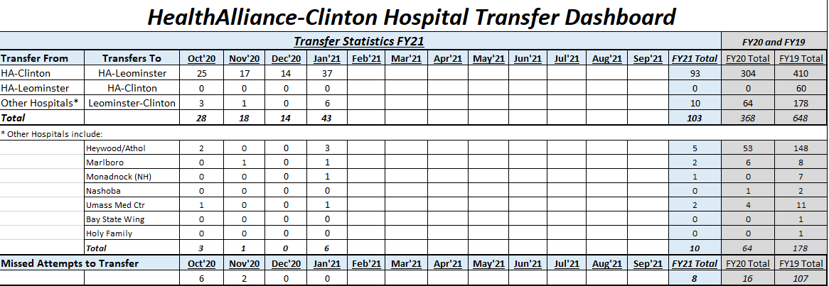
- How will the proposed transaction allow for better communication and more coordinated care? (pg.5)
  - Provide details on UMMHC’s coordinated plan and clinical pathways.

    - How will HHCS be incorporated into this infrastructure?
    - What metrics will you use to track improvements?

Attached (13.a Pop Hlth) is an extensive overview of the UMMHC population health quality and performance program. This includes the structure, major strategies and performance monitoring thru metrics. HHCS is already incorporated into this program through its participation in our Medicare ACO and as part of our Managed Care Network. As mentioned previously in the response to Question 7, the UMass Memorial Office of Clinical Integration currently works closely with the HHCS population health team on shared value-based contracts to monitor and improve performance in quality and reducing total medical expense. The transaction will strengthen that relationship and allow for increased partnership and sharing of best practices on all value- based contracts at HHCS. Improvement is expected as a result of this increase in partnership and expansion of shared value-based contracts.

- Demonstrate how EPIC has been beneficial for UMMHC hospitals and campuses (e.g., how it has brought efficiencies, consistency).

UMMHC achieved HIMSS Stage 7 recognition – a distinction shared by a very small percentage of health care organizations. UMMHC is the largest health care system in Central Massachusetts and has the region’s only Level 1 Trauma Center. The HIMSS Analytics Electronic Medical Record Adoption Model (EMRAM) for hospitals and O-EMRAM for outpatient, incorporates methodology and algorithms to automatically score hospitals and ambulatory sites around the world relative to their electronic medical records (EMR) capabilities. This eight- stage (0 to 7) model measures the adoption and utilization of EMR functions. Currently, UMass Memorial Hospitals make up three of only seven hospitals in Massachusetts that have achieved HIMSS Stage 7.

The implementation of Epic has provided UMMHC with a single patient record for care of all 1.2 million of its patients, regardless of location. As patients move between care settings within UMMHC, information about their care is readily available. Providers can see everything that has occurred with their patient, including up-to- date diagnostic results. UMMHC uses Epic as both its EHR and a Practice Management (PM) solution, eliminating the need for integration technologies to share patient centric information.

Hundreds of physicians and staff from across UMMHC helped design and tailor the version of Epic that UMMHC adopted to capture a patient’s entire care experience – from scheduling an appointment to receiving a bill for services. The following is an overview of what Epic provides to UMMHC:

- Easy to use documentation tools – tools that have been built for dozens of specialties and physicians.
- Private secure data – securely share clinical data via Epic, since end user access by role (e.g. nurse, medical assistant, physician, etc.) is managed by security policies and procedures. Advanced security functions are in place to protect sensitive information and to comply with HIPAA regulations.
- Quick access to data – Epic enables access whether caregivers are in the office, home or working in the hospital, thereby saving time, increasing productivity, and facilitating physician efficiency.
- Patient safety – UMMHC takes advantage of Epic drug-drug and drug-allergy interaction checking at the time of medication ordering, as well as electronic medication prescribing directly to pharmacies, thereby reducing medication errors.
- Meaningful Use™ – UMMHC utilizes Epic to satisfy Meaningful Use requirements qualifying UMMHC to attest for those regulatory initiatives.
- Lab and Imaging Results – Epic interfaces with lab and imaging results from many service providers through existing interfaces.
- myChart – UMMHC offers a new, system-wide patient website that allows patients to request prescription refills and appointments, view their health information and communicate with UMMHC staff electronically. There are currently over 215,000 patients sharing and accessing information through myChart with UMMHC.

UMMHC has used Epic to document care associated with:
- Over 221,000 emergency department visits
- Over 1.5 million ambulatory visits
- Over 4,500 births
- Over 49,000 discharges

HHCS currently uses two separate electronic medical records with limited integration. Physicians and others providing care for patients often must look in multiple systems to gain a full picture of what is happening with their patients. When HHCS caregivers move to Epic, they will have access to a single patient record that includes all information about the patient. Additionally, information from other health care providers who use Epic will be easily available. Epic’s “Care Everywhere” system has allowed UMMHC to exchange patient information for:
- 9 million patients
- with over 2,000 hospitals
- with over 1,700 emergency departments
- with 43,000 ambulatory clinics/practices
- from all 50 states

While the migration plans have not been solidified, the current plan to move HHCS caregivers from their current Allscripts and Meditech systems is expected to be completed in a single move from their legacy systems to Epic. Little downtime and disruption is expected to occur during this migration. Until the migration to Epic, HHCS caregivers have access to UMMHC’s “Epic CareLink” portal which allows UMMHC to extend patient information to external facilities and affiliated providers, helping improve continuity of care in our community. EpicCare Link is secure, real-time, and easy to roll out to users who need remote access to UMMHC’s clinical data.

  - As implementing EPIC at HMH is a multi-year effort, what are the interim plans to ensure continuity and coordination of care between UMMHC hospitals and HMH?

UMMHC is in the pilot phase of an EMR integration project which will enable HHCS EMR data to be brought into the Epic system for purposes of care coordination, performance reporting and analysis. UMMHC expects this project to go live in the spring 2021 if all regulatory approvals have been received. Attached (14.a EMR Int) is the most recent project plan update.

Factor 1e. Evidence of Sound Community Engagement through the Patient Panel
Factor 1e. Requires us to consider “evidence of sound community engagement and consultation throughout the development of the Proposed Project, including documentation of the Applicant's efforts to ensure engagement of community coalitions statistically representative of the Applicant’s Patient Panel.”

- To date, what community engagement efforts have UMMHC undertaken during the development of the proposed transaction including types of activities, level of participation, and feedback received.

UMMHC wants to be formally engaged with the greater community of Southbridge and surrounding area. In light of the pandemic, UMMHC will adapt to the circumstances utilizing technology (i.e. Zoom, Webex) and small group interviews and gatherings throughout the geographical area, while adhering to safety protocols.
Interpreting for linguistic minorities and deaf/hard of hearing will be provided whenever necessary. UMMHC is looking forward to establishing dialogue and developing solid linkages with the area’s most vulnerable and under-resourced populations as we strive to have a healthier community. UMMHC considers the CHI Guidelines indispensable in working with HHCS. As such, the following actions will ensure that there is appropriate engagement that incorporates planning, evaluation and implementation, accountability that has engaged diversified community members, with transparency and reporting on interventions and outcomes to ensure having an impact on community health improvement related to identified needs.

UMMHC recognizes that building a healthy community requires a long-term effort. The following are part of a road map for long-term planning and strategies to build the pieces needed to make the south Worcester County healthier. These actions and shared learned opportunities would begin as part of our Community Benefits approach once the transaction completing the acquisition of HMH is complete and continue thereafter.

The following actions are anticipated to occur over time:
- Community Benefits: Develop a robust Community Benefits Advisory Committee that is ethnically diverse and representative of underserved populations residing in the area, as well as inclusion of representatives of different sectors. UMMHC will foster and sustain an on-going communication strategy to foster transparency and accountability.
- Developing Trust and Identifying Needs-Listening Strategies: A. Forums: UMMHC anticipates conducting a minimum of 3 forums with community stakeholders such as neighborhood leaders and personnel from local banks, police departments, public schools, academia, philanthropy, Quinisagmond

Community College, Family Health Center, social support organizations, public schools, the Renaissance Medical Group, local government, community/neighborhood leaders and grass roots groups; and B. Conduct One-on-One Interviews and Small Groups: UMMHC will provide interpreters to facilitate communication with Limited English speaking populations and hard of hearing.
- Neighborhood Outreach: Weather permitting, UMMHC will conduct a walk around the neighborhood or key locations as a strategy to outreach where vulnerable populations reside or engage/congregate.
- Engage Local Public Health: UMMHC will conduct outreach to the local departments of Public Health (i.e. Webster and Southbridge) as a strategy to develop trust and gain knowledge about the community. In Worcester, the Worcester Division of Public Health (WDPH) has been a partner in the development of the Community Health Assessment since 2008. In 2013-14, UMMHC’s partnership with the WDPH resulted in the WDPH earning national accreditation and recognition as the first health department in the Commonwealth of Massachusetts to earn federal accreditation.
- Community Health Needs Assessment Review and Update: A. UMMHC will review with community representatives the 2019 Community Health Needs Assessment findings and identify current community needs; B. UMMHC will develop partnerships/collaborative efforts that will result in the development of a Community Health Improvement Plan.
- Community Benefits Annual Report and Community Benefits Strategic Implementation Plan: UMMHC will update the HMH Community Benefits Strategic Implementation Plan and ensure completion of a Community Benefits Annual Report in compliance with regulatory requirements.
- Community Benefits Reporting and Regulatory Requirements: UMMHC will ensure compliance of all reporting and regulatory requirements.
- Integration of a Health Equity Lens: A. Given that UMMHC has adopted a system-wide Health Equity agenda that is addressing inequalities in care, UMMHC would replicate this for HMH.

Factor 1f. Competition on Price, Total Medical Expenses (TME), Costs and Other Measures of Health Care Spending
- The application states the transaction is not expected to have an adverse impact on competition, and other measures of healthcare spending. (pg.4-5)
  - How does UMMHC plan to maintain the financial viability of HMH without impacting payment rates?
  - Research has shown that hospital mergers can impact prices¹. What are your plans to ensure that prices don’t increase?

HMH will have access to the financial stability and resources of the UMMHC system. In addition, UMMHC will bring its proven Lean management system and centralized administrative support structure to maximize efficiencies. The Project presents a significant opportunity for UMMHC to reduce total medical expense by keeping care local within the UMMHC system, the third lowest cost system in the State, and to prevent outmigration to the higher cost facilities in Eastern Massachusetts. UMMHC is taking a multi-pronged approach to reducing outmigration, including strengthening care coordination and addressing the barriers to timely access to care. Preventing out-migration and keeping care local in Central Massachusetts will help maintain the financial viability of HMH.

1 Schwartz et al. (2020). What We Know About Provider Consolidation (Issue Brief – 9510-2).KFF. Available: https://www.kff.org/health-costs/issue- brief/what-we-know-about-provider- consolidation/#:~:text=Even%20when%20a%20hospital%20merges,unacquired%2C%20stand%E2%80%90alone%20hospitals

As a safety net system with a significant public payor – and specifically MassHealth - patient population, UMMHC is reliant on reasonable commercial rates to remain financially viable. Nonetheless, UMMHC consistently remains one of the lowest cost systems in Massachusetts. As HHCS physicians already contract through the UMMHC Managed Care Network for the three major commercial payor contracts (Tufts, HPHC and BCBSMA), the transaction is unlikely to have a material impact on pricing.

Factor 2 Cost containment, Improved Public Health Outcomes and Delivery System Transformation
- The application states the proposed transaction will improve HMH’s performance in value-based contracts. (pg.9)
  - Describe HMH’s current participation in value-based contracts and intended changes you plan to make to improve HMH’s performance.

HMH currently participates in 6 value-based contracts:

- Medicare ACO with UMMHC
- Blue Cross - internal Managed Care Network with UMMHC
- TUFTS- Managed Care Network with UMMHC
- HPHC - Managed Care Network with UMMHC
- Fallon Medicare Advantage
- Boston ACO with BMC

The various EHRs in the Harrington system, the EPIC system at the Medical Center, and independent provider reporting platforms hinder the aggregation of patient quality data that might lead to improved patient outcomes and contract performance. Many of the data are derived from the processing of billing data, which has a six-week lag. With the acquisition and the implementation of Epic at HHCS, HMH will be able to improve patient outcomes and contract performance by having more real-time information upon which to act. HHCS also will be fully integrated into UMMHC’s overall robust quality infrastructure focused on improving quality and safety of care and patient experience.

- The application states the transaction will improve the status of the combined communities through local hiring, local purchasing, and community-based investments. (pg.7)
  - UMMHC plans to track and improve the status of the combined communities.
    - What key outcome metrics will be tracked? Why have these metrics been chosen?
    - How will you ensure local hiring and community-based investments?

Community-based Investments: All investments address a Social Determinant of Health that has been identified in the CHA or CHIP reports of UMMHC’s member hospitals (the Medical Center, UMass Memorial HealthAlliance-Clinton Hospital, and Marlborough Hospital). All investments are reviewed and approved by UMMHC’s Community Benefit Committee. UMMHC has committed to increasing the existing Anchor Mission investments by $1 million to a total of $3.1 million by September 30, 2021. Specific community-based investments already deployed ($2.4 million) include:
- Finally, Home Loan Fund ($500,000): to support housing for chronically homeless in Worcester.
- Creative Hub Community Arts Center ($500,000) to create community and economic hub in under- resourced neighborhood in Worcester.
- Fitchburg Arts Community ($750,000): pre-development financing for mix of 43 affordable and 19 market-rate apartments that will be preferentially available to local artists.

- Worcester Common Ground ($400,000): quick-turnaround financing to support purchase of affordable properties by first-time homeowners.
- Tiny Home Village ($300,000): predevelopment costs for the $4.6M joint venture by East Side CDC and Civico to create village of 16 tiny homes for chronically homeless

Local Hiring: UMMHC has been working with community-based partners to identify and better understand the barriers that exist in recruiting and hiring local applicants for positions available at UMMHC, with the goal of overcoming these barriers, where feasible, to achieve specific hiring goals. The work includes:
- Initial identification of five entry-level positions that have minimal education and experience requirements, which align with the client base of our community-based partners.
- Coaching both potential candidates and potential hiring managers on meeting each other in an interview setting.
- Arranging interviews with candidates proposed by our community-based partners
- Tracking candidates and outcomes, and follow the post-hire results
- Expanding to additional job categories, beyond the initial five, to leverage the relationships that have been built
- Year one (FY20) resulted in 4 hires. Year two (FY21, still in process) has totaled 13 hires
- Working on greater community outreach regarding work at UMMHC, targeting high schools
- Exploring opportunities for training and coop programs

Local partners currently include:
- MassHire
- Worcester Adult Learning Center
- Worcester Community Action Council
- Ascentria Care Alliance and Ascentria Community Services
UMMHC would seek to work with community agencies in the Harrington service area. Initial entry level jobs identified:
- Houseworker
- PCA I-Inpatient
- Catering Associate
- Patient and Equipment Transporter
- Driver/Material Handler

Local Purchasing: The UMMHC Purchasing Sub-Committee has been working with both internal stakeholders and external community organizations to develop an actionable strategy to increase local purchasing. Its initial efforts are focused on identifying the barriers that exist with finding, developing, and building local spend. It is now working with the Healthcare Anchor Network (HAN) and collaborating with other hospitals that have adopted the HAN Impact Purchasing Commitment. A summary of the actions taken to support efforts to increase UMMHC’s local, diverse and sustainable purchasing include:

- Attributed spend data to identify purchases from certificated diversity suppliers (MWBE), disadvantaged businesses, and local businesses (defined as residing within UMMHC’s service areas)
- Joining other HAN members and adopted the Impact Purchasing Commitment. This commitment establishes five-year defined growth goals for the following purchasing functions:

  - Increase diverse spending
  - Promote sustainable spending
  - Build community wealth
- Creating dashboard reporting and Key Performance Indicators that will allow UMMHC to track and monitor progress against goal
- UMMHC is in the process of amending policies, contracting processes, and purchasing workflows to support diverse, local, and sustainable purchasing
- Creating internal processes designed to support/drive purchases to diverse and local vendors, when possible

- Harrington currently participates in the MassHealth ACO program through the Boston Accountable Care Organization (BACO)?
  - Are there any planned changes to Harrington’s participation in BACO as a result of the proposed transaction? No
  - Are there any plans for UMMHC to participate in the MassHealth ACO program? Not at this time.

Exhibits

Spec Svs

    - In the past 2 years, 21% of Harrington patients have received care from a UMMHC specialist
Harrington Patients Receiving Care from UMMHC Specialists between 03/01/2019-03/01/2020
Patients in MCN Value Based Care Programs as of January 2021

10,000
9,000
8,000
7,000
6,000
5,000
4,000
3,000
2,000
1,000
-

8,631
1,837 (21.3%)
1,242 (14.4%)

Total Harrington Patients in an MCN Value Based Care Program as of January 2021
Patients with a Visit to a UMMHC Speciality in the Past 2 Years (03/01/2019-03/01/2021)
Patients with a Visit to a UMMHC Speciality in the Past Year (03/01/2020-03/01/2021)

3

    - In the past 2 years, radiology is the UMMHC specialty most utilized by Harrington patients, both in number of visits and in unique patients utilizing.
    - Most frequent specialties:

- Radiology | - Oncology / Oncology Infusion | - Neurology
- Cardiology / Heart and Vascular | - Dermatology

5000
4500
4000
3500
3000
2500
2000
1500
1000
500
0
Most Frequent UMMHC Specialties Utilized by Harrington Patients between 03/01/2019-03/01/2021
Patients in Value Based Care Programs as of January 2021
4517
2206
263
495
368
204372
603
294
876
428
647
281
144

Visits in Past Year
Unique Patients in Last Year Visits in Last 2 Years
Unique Patients in Last 2 Years

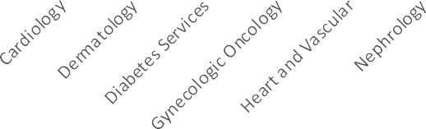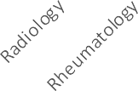

4

PHO AWV

Harrington PHO
Annual Wellness Visit (AWV) Focus 2021

    - Give providers their patient panel with 2020 AWV date early in 2021

    - Review components of the AWV along with billing codes at our Q1 meetings

    - Encourage outreach to those without an appointment in 2021

    - Schedule the following year AWV upon patient checkout

    - Hired 2 patient outreach coordinators to assist in scheduling
appointments

      - Patients not understanding the AWV vs a physical exam

      - Providers performing and billing a physical exam on Medicare patients

      - Receptionist or scheduler not noting the correct visit type on providers schedules

      - Patient refusal

H PHO Newsletter

lk 1□b I' 3□. 211'8 !H a r r i n g t o n
HEALTl ICARE SYSl E \·1
Compassionate Qudity Care

GOJ:'JG ON :'-lO\V:
\\:c, a. k t.k,l ""d' office ,chcduk" ,•isit h,at'or the nd r>f the -,.e.ar fer,- ,,,..
µalicJJl wk, hn 11-:,: y<:l li<ot,ii s1een iri 2ll1 a i ·icludi11;1!;:
>f' liCJllS wilh:,, d"m1ic i,ease wh,i m:,y not h:<ve lwen se<'n this c,l,m,br re:<r.
:,[' cie,its cu may LUJl iclc,r l1 >1lLh ,. liuL ,·,ho kw-:, J10L l,"""·"""' in 1H c l,·nJ:,,r
year.

&!ginr1iug 12 / 11:1 we will offer rnvnlhl Onbm1rdin1( - Getting to know
the Pim. We, will r<.1ttch <mt to ea,;;b pruvideC"/Joc11tion tu schedule the e
mee tin gs. They will he hr-1d at th Pll O omcc du rl n_g I u nch h 0111-:,;:,
Depression Screening
l'a tients aged 12. yc,a ,· .'l"d,,1d"r ·11,i,;J LD bo, c:rc,c 11,,,J f": ,r· cl i r: i::.JI d(: pr·,, iorl (In the dace Dftl10 \ it u fng an 8Q; ]l(lrnpr18, ,.ind rdJzM d rr .1i011 ,nc:,(!nhg tool l,J\ U it p ri itiv0, a fo11 rm - up rkrn is ,fo,:urnr. ru:,d on th c d le::: nf th c, po. [tivc
screen, Acc p ll l)!c Ln<1 I ,m, I '11, PH Q2 "" d PH Q9. Tl",
p tie:it' fil must r.:,tkct:
l)at :1nd typ or c:ree;ning lrn,I, : rrn<:ad if ;w ibl;,,
    - f't'C't'id Ct'', cgn lll ro.::
•rmvtd(!r· iril srpr<:al;•liun uf n:>stilts- pu [tiv '-H" ne>p, liv>:>
•1r pnsiLi·,,e, .- fol10w- up phn b required.

I\.. Wno are we, 1
Coding Corner
Ucp,·,:,ssi un ....-c,rn yu u l,c mun· SJJcL"i [_c tban F32.9
t i,,..1m,•.5.si<1n L )".'

[.i:-.. (";1:-,.;1:-..111L;: l-...- •.-·.11;1.· • I l11-.:•n1..-

UM
F32.1
.,..,ju, .t.p diS<>nfo,, w>glc cpiSOD<k_ mid
MaJw depressive dls(,fller, l!JPl,!;,od,,,. IOOde,,.,r..
Ma,.,. .....- ""'°"" ...........
<115<Jrd . Sfflll.., .... wMllout
l'-"f'd"lulii:;1.: lu-
- .. jo, <l""'nl . ,.;,,gleq.,;......,_ """""'...u,
psy,ch<,,licfl:.lu=
M;q,QJ .r,li-;;icul :°5iD51lc: ,r:pi:-.ndir.,.. in p."ll'finl n::mmif1111

Ph:,- = 'iJl 11 11 ·1 11". •., 1111 111 IL' I 1,)n nr r, 11: 111 IL'I 11:i
[;,z.:j lo!ai(H d-epr"05151ve-dl!ioHMJ, ,;l1111loi ill hi. f"1"1'1"""""1
D.2.ll1 <1y,poor1co1sar<1...-
Cl2.II!! oo- "IJ'l!"God dep,essl.,.. ep1. i..,.

I 1)LY"-:,i ;"i:;- - i ":-:1LTiL l.l.1;.uLdL1) 1Ji L )l.11(..,: DI ;J(: -;r_;,_ - Llj: _1

  - H PHO 2021

Year Ahead
PHO Focus for 2021

Immunizations
Transitional Care Management (TCM) visits
Colorectal Cancer Screening
Diabetic Measures (HgbA1c, Retinal Eye, Pneumonia Vaccine, Microalbumin)
Depression screening
Tobacco screening and cessation

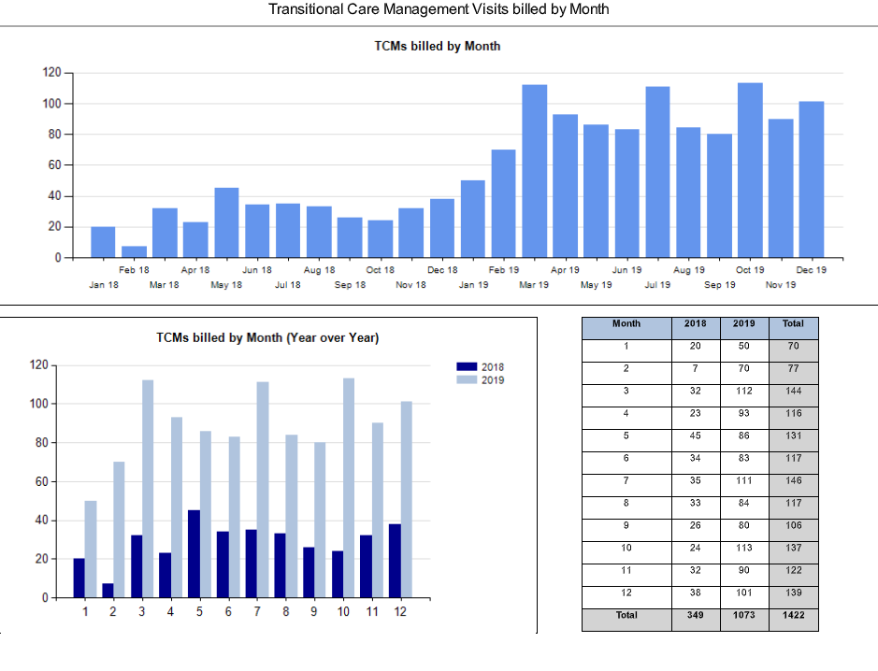

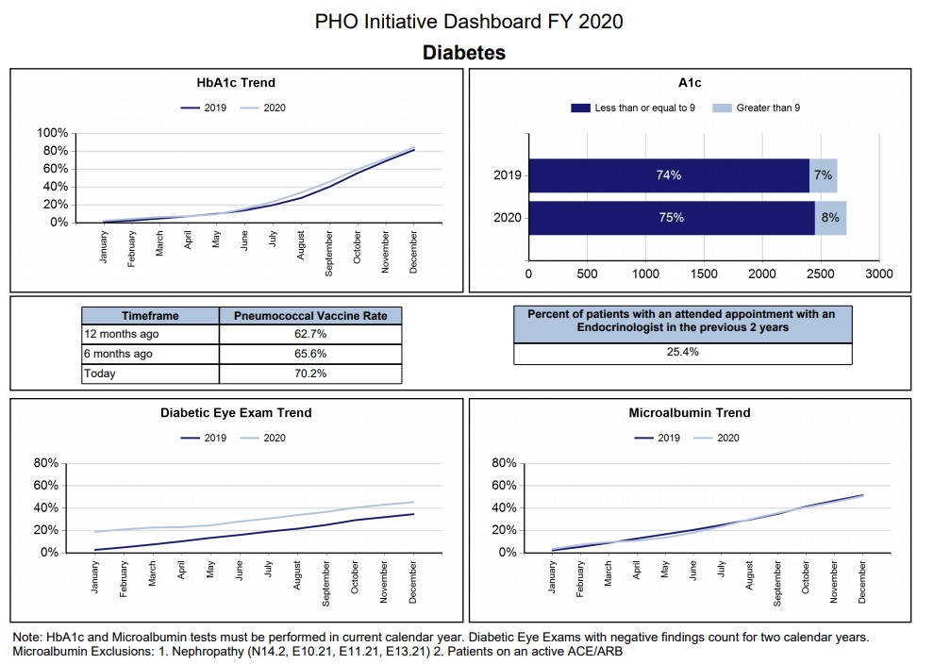

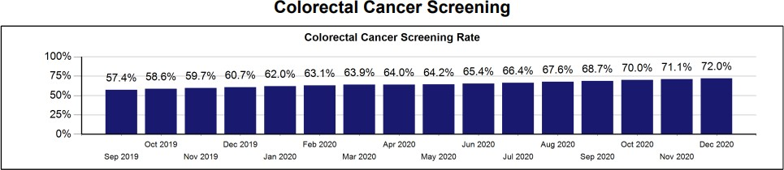

    - Colorectal CA screener will continue to be a focus for the PHO in 2021
    - Continue to utilize our Wellness Nurse Navigator to support providers
    - New chart prep forms and process will help bring attention to patients who are non-compliant
    - We are measuring the data a little differently
      - Data will be by provider rather than by patient
      - Focus will be on Primary Care Providers

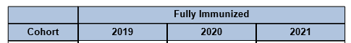

Childhood Immunizations

Adolescent Immunizations

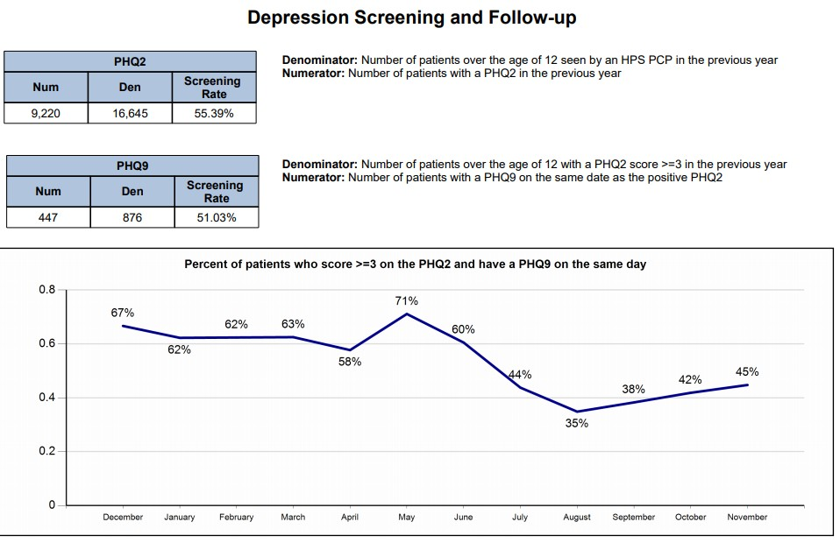

H Quality 2020

We specifically targeted two quality areas:

    - CRC screening
    - Diabetic measures

For the end of year we are focusing on:

    - TCM visits
    - HCC coding

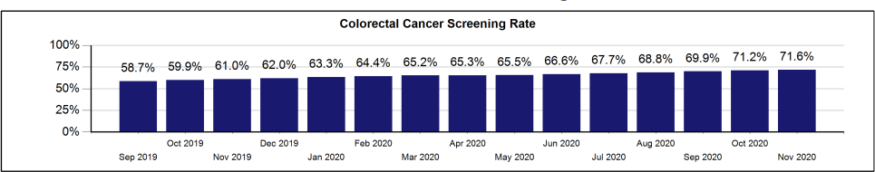

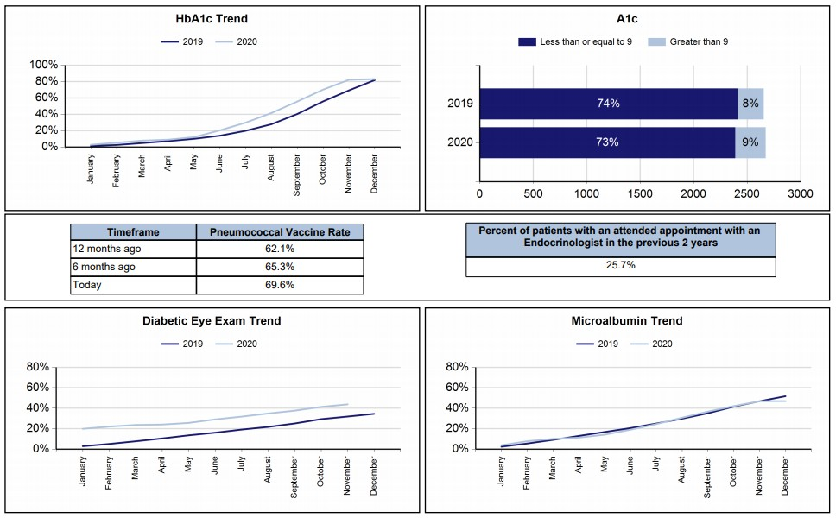Diabetic Focus

Transitional Care Management (TCM)
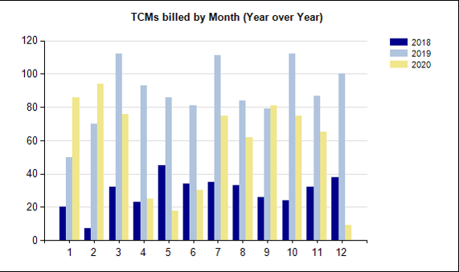

HMH discharges:
June: TCM visits 44%, total office visits 80% July: TCM visits 45%, total OV 86% September: TCM visits 48%, total OV 89% October: TCM visits 46%, total OV 80%

H Perf Rpts

HARR Quality Measure Performance
High Performing Measures; Full Points Earned

PROCESS MEASURES | HARR Measure  Performance-- Exceeding National 90th Percentile (Full Point Earned)
Breast Cancer Screening | YES
Colorectal Cancer Screening | YES
Well Child Visit 3to6 | YES
Well Child Visit 12TO21 | YES
Well Infant Visit | YES
Diabetes BP Control | YES
HTN BP Control | YES

HARR Quality Measure Performance
Opportunities for Quality Improvement- No points earned

PROCESS MEASURES
Depression Acute Treatment
Diabetes A1c Screening
Diabetes Eye Exam
Diabetes Statin Adherence*
Adolescents Immunization
* Measure NOT included in CY2020 Measure Set

UM IS SOS

UMassMemorial
Health Care
Interpreter Serv·c:es Department
UMass Memorial M edical Center

FY20 Scope of Services

UMass Medical Center (UMMMC, provides access to care ill a manner compatible witl:t our patients-' preferred language to :receive healtl:t
informa tion an d/ or comm um cation :needs, health belie,fa and cultural practices. 1he Inter pretre Services Department uses a comprehensive
quality improvement proc.esses to ensure that patien ts-w itl:t L imi ted English Proficiency (LEP) have timely access to qualified inte1preter servioes ill over 100 fangua s and to auxiliary services and aocommodations needed for the Deaf an d Har d of Hearing (DHH ) patients. Servioes are available 24 hot:U's a day, sev en da y s a weenk. to ensure tl:tat tl:te patient's inability to comnu:mica te in English does not interfere with the
provision of me dical care. Comprehensive data collection and da ta analysis, monitoring systems, and :interpreter services educational
:requirements trainings are in place to ensure the quality of su ch s e:rvioes.

Population Served
- A highly diverse patient population speaking over 100 languages. 29% of Mass refu gee groups settled ill W01Ce ste r Area..
- 24,511 tmique Limi ted English Proficiency (LEP) and Deaf and Har d of hearing (DHH) patients. (20.6% in crease over 5 yrs )
Services Availabilitv
  - Qualified mterp1:eters are available 24/ 7 v:ia Video Remote hlierpreting (VR,I) Face ,to Face (F2F) Over the phone interp reting (OPI)
  - Hospital interpr-ete rs : 28.3 . FfEs
UMMMC Interpreter Encounters by Language

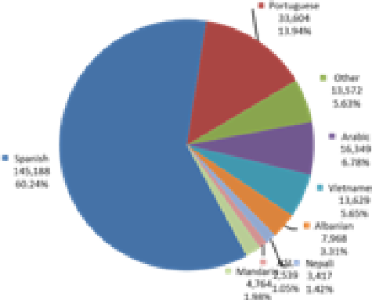
FY20Total lnierprefation fut <:ou n rl:e r s

277 ,3 54

Mission

Deliver high qualify" Lan gu age Serv ices to ensure that the non-English speaking, and Limited English Proficient patien t pop ulation at lJMass

have access to care that is Safe, Effe ctive , Patien t Cen tered , Time,l
Efficient, and E uitabllie.

One o f ,th e largest and moci;;t comprehensiYe hospital-bas ed p1'0gt a:ms in the coun try . Sh ow cased by the AHCRQ. Selected as an exemp1a:ry program in the
N atio nal Heaith caise Q uali ty Report (NHQR)- a tiona1 leader in education and ,t:rai ni n
- Uses comprehensi Ye q uali ty im pro vem en t JJ10' cesses, LEAN me tho dology, and NQPM, while maintaining th.e org anization' s fmanc ial h eal th an d compliance with Langu age Access federa] an d state regulatio ns.
- Integrated solid da ta collection and optimized reporting systems to build operation al efficiencies, reduce v.,ras ,te, de crease wait time, increase productivity
with focus on value to the patient =d d inica ] areas .
- Red es ign ed operational mode] to adopt to the COVID 19 pan demic wruch has p11esented un expec ted challenge s to deli ver in terpre ter services across clin ical are as. Accele.ra te-d the expans ion of Video Remote In te:rpi·etin g (VRI) and in tegr ated an-site hospital interpreters in the VRI call center and Teleheal,th pla t fo rm s.

 | Visits/Admissions | Admissions
Inpatient | 38,918 | 4,839 | 12%
Emergency | 110,665 | 12,551 | 11%
Outpatient | 966,687 | 111,564 | 12%
Grand Total | 1,116,270 | 128,954 | 12%

Quality Goals
  - Eliminate 1.angua:ge barriern fo provide Limited English Proficien.cy (LEP) patients, and th.ose who rure Deaf ill' hard of hearing
v.rith timely and effective culturally competent acoess t.o the highest quruity , safest cal'e and exceptional experience.
  - Mammin. a highly qualified Language Services wruk force, including .onsite conltractors and :remote vendrus.
  - De1livery of high-value language services to p a tie n t-p ro vider within.< 15 min from request.

Quality Performance Metrics

Adopting core measures is cri.tical t.o set ta:rgets of inl.p:rovem enrt deli.verv .of languag;e Services...
Total Hospital
LEPVisits/
LEP % of Hospital
identify gaps, monifor performance and strategically improve the

STI: Percent of patients scre ened for their preferr,e d
spoken language

Pat ie nt 's prefe n ed la ng ua ge f:or care is a re q Li ire d fie lld in the
patiie nt 's IEIM R de mog raphic tab .. Syst e ms are in place t o mo niit o r accuracy... TMs data is used to
me as u re the act ua ll dem and for iinte rpret e r se rvi c es based on patiie nt viis iit s and admiss iio ns .,
ST4: Percent of interprete r' s total wmk ti.me spent providing medical interpre ta ti o n
Tota l time prov idi ng product ive se rviices iis
me as ured by oom bi nii ng i nd ivid ual i nte rpre te r
en oount e r dat a with time she ets..,
Waiit t iime data is co lll e ct e d aoross mod a,lit ies and
a ggregated iint o a cent ra !l
database system for re po rt ing a nd mo nit o ri n g processes.
ST 3: P ercent of encounters in w hi ch patients waite d less than fifteen minutes for a
qualified medical interpre ter
ST2.: P e rcen t of p ati e n ts rec eiv ing langu ages erv ices
from those qualified to
prov ide them

Syste ma t ic process meas u res utiHza t io n of qu alliifie d
i nte rp ret e rs or qual ifie d bii liingua ll pro vi de rs across allll d i n ical areas..,
Report is gene rat ed to id e nt ify uniq ue LE P pat ie nts w:itlf-i a
docu me nted int e rp ret e r e nco unt e r dmiing theiir
admiss io n o r out pat ie nt vis it .

ST1, ST;2 ST3 are part of the fiue standardized measw :es developed by the Robe-rt Wood Johnson's;; S peaking Together: National Language Seruices
Net work" and of which UMass Memorial Medical Center In terpreter Services Departme nt was a collaborating grantee.
Strategic Plan

1) Expand aooess to qualified interpreter services at all  points of care 24:./ 7. | 4) Streamline inte:r eter rounding process to positively impact patient experience. Increase access to intel:preters and its- utilization by medical staff.
2) Syste:mwide ed-wc a t:i.o n al plan to engage merural providers regarding availability and nnpo:rtanae of using qualified in te:rp re,ltei's n-om a quality, safety and regclatory standpoint | 5) Quality nnprovement lllitiati.ve to make a meanmgfol rnduction in  preventable 30-day :readmis sio ns of LEP patients with HF

UMassMemorial
Ii
Health Care
Interpreter Serv·ces Department
UMass Memorial Medical Center

6) Instituting systennvide policy and work pl'Ocess to have hi.llingual providers tested and vetted in language proficiency to provide patient earn in a language other than English.

3) Implement a standardized EP]C JJ1'0Cess to docrunent interpreter utilization at pomt of care, monitor provider's adherence, and strategically set in:tp:rovement targets.

References: State and Federal Regulations

    - Title VI of the Civil Rights Act of 1964; Po1iicyGuidance on ,the Prohibition against National Ori:gm Discrimination as It Affects Persons with Limited English Proficiency..
- National Standards for Culturally and Linguistically Apjpropriare Sel:vioes in Health Ca.re (CLAS StandMd s)
- M .G.L. c. Ill§, 2:S J
  - State Law: ERIL (Cha,pter 66 of ,!the Acts of 2000, EHecbve July 200][)
  - The Americans wifh Disabilli ties Act of 1990 (ADA)

Pop Hlth

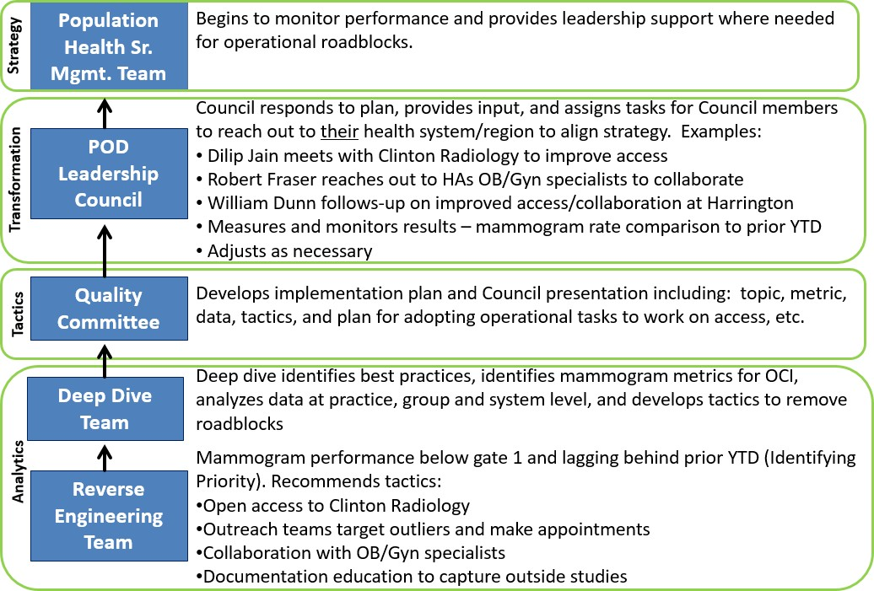Population Health – Quality Best Practice

Recommend Tactics

Practice Improvement Facilitation Model – Provides Account Management Services to Primary Care Physicians & Clinical Teams
Quality
Improvement
Communicate
Train
Practice
Improvement Facilitators
Support
Consult
Monitor
- Report Review
- Progress to Goals
- Liaison with System (e.g. Epic)
- Connection to Resources
- HCC Coding Audits
- Patient Experience Survey Process
- Meet every 4-6 wks.
- Email
- Phone
- Reports
- One-pagers
- Webinars
- Skill Development
- Quality Program Initiatives

- Report access/usage
- Quality Metrics
- Population Health Initiatives

- Best Practices
- Standard Work
- Lean Process Redesign

Physician Engagement & POD Structure

How do we get physicians involved?
      - Chief Medical Officer for Population Health maintains street credibility as a practicing physician
      - Concentrate on improving care at patient level
      - Help them with practice redesign for population health work
to translate into extra “time” with patients
      - Stick to the “common ground” on metrics
      - Give them a voice!!! & Best Practice sharing with colleagues

38 PODS with designated physician POD leaders
          - PODs are practice type specific (IM, FM, Peds)
          - POD Leaders meet quarterly and a subset, the POD Council, meets for 2 months/quarter to provide input and guidance into pop health initiatives (many opportunities for providers to get involved)
          - Physician leaders and physician involvement in Amb. Quality,
Utilization Mgmt., and Behavioral Health Integration Committees
          - Practice Improvement Facilitator assigned to each pod as “single point of contact”

Quality Measurement
*the ambulatory quality measures we manage
            - Commercial Programs (BCBS, HPHC, Tufts)
              - Internal Rewards Program
            - Governmental Programs
              - MIPS / MACRA
              - Overall ACO Quality
              - GPRO
            - UMMHC Self-insured
              - Diabetes focus

36

Ambulatory Quality Metrics

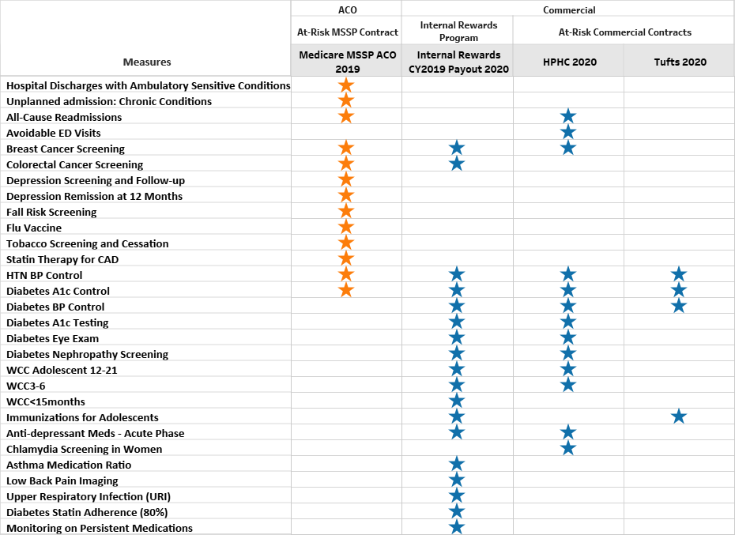

37

23 Quality Measures in 2019 / 10 GPRO Quality Measures

These measures are separated into four key domains that are the basis for assessing, benchmarking, rewarding, & improving ACO quality  performance. |  | Data Source |  |  |  | Who is responsible?
 |  | Patient  Survey | Claims | EHR Incentive Program | GPRO Web Interface | CMS - Approved survey vendor selected by the ACO to administer the survey
Patient/Care Giver Experience | ACO – 1 Getting timely care, appointments, and information ACO – 2 How well your providers communicate  ACO – 3 Patients’ rating of provider | X  X X
 | ACO – 4 Access to specialists  ACO – 5 Health promotion and education ACO – 6 Shared decision making  ACO – 7 Health status/functional status ACO – 34 Stewardship of patient resources ACO – 45 Courteous helpful office staff ACO – 46 Care Coordination | X X X X X X X
Care Coordination  and Patient | ACO – 8 Risk-standardized all condition readmission |  | X |  |  | CMS - Claims data files, information from PECOS and NPPES, and National Level  Repository
 | ACO – 38 All-cause unplanned admissions for patients with multiple |  | X
Safety
 | ACO – 43 Ambulatory sensitive condition acute composite |  | X
 | ACO – 13 Screening for future fall risk |  |  |  | X | ACO – Via GPRO (Group Practice Reporting Option)  - CMS will provide list for sampling of patient records  - ACO must submit data for sample patients via GPRO Web Interface  10 GPRO Quality Measures
Preventative | ACO – 14 Influenza immunization |  |  |  | X
Health
 | ACO – 17 Tobacco use: screening and cessation intervention  ACO – 18 Screening for clinical depression and follow- up plan ACO – 19 Colorectal cancer screening  ACO – 20 Breast cancer screening  ACO – 42 Statin therapy for the prevention & treatment of cardiovascular disease |  |  |  | X  X X X X
Clinical Care  for At-Risk Population | ACO – 40 Depression remission at 12 months (Depression) |  |  |  | X
 | ACO – 27 Diabetes mellitus: HbA1c poor control (Diabetes) |  |  |  | X
 | ACO – 28 Controlling high blood pressure (Hypertension) |  |  |  | X

Quality Performance Reporting & Tools

- Provider / Group Level
  - Action items via PIF team
- Auditing Capabilities
  - Conduct direct chart review and feedback
- OCI Dashboards
  - Align strategy, tactics, and interventions
  - Reverse engineer
- Leverage Epic, other EHRs

39

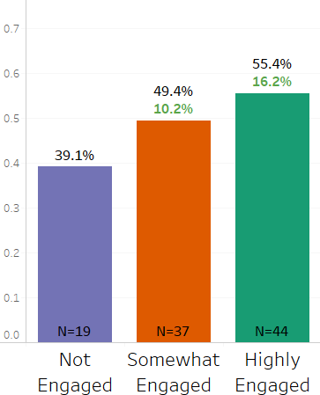
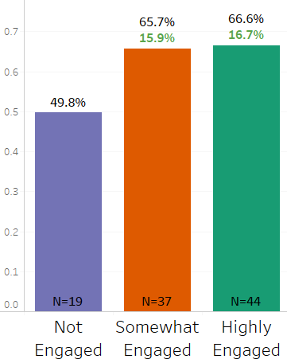Improved engagement (citizenship) leads to improved quality
End of year

Mid-year

Highly Engaged: Had both PIF meeting and Tableau report usage in 2018.
Somewhat Engaged: Had PIF Meeting or Tableau report usage in 2018.
Not Engaged: No PIF meeting and no Tableau report usage in 2018.

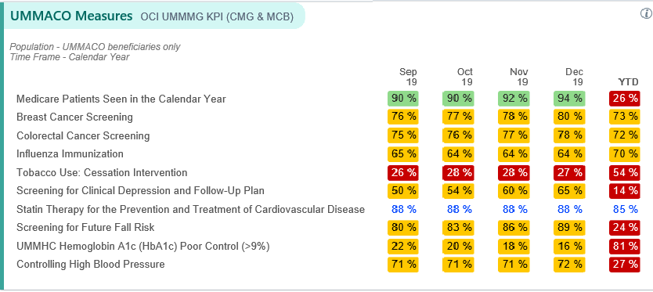UMMACO Epic Dashboard Review
- as of 1.21.20
2019 goals based on 90th percentile performance by measure for all MSSPs

41

Overview of GPRO audit performance - as of 1.20.20

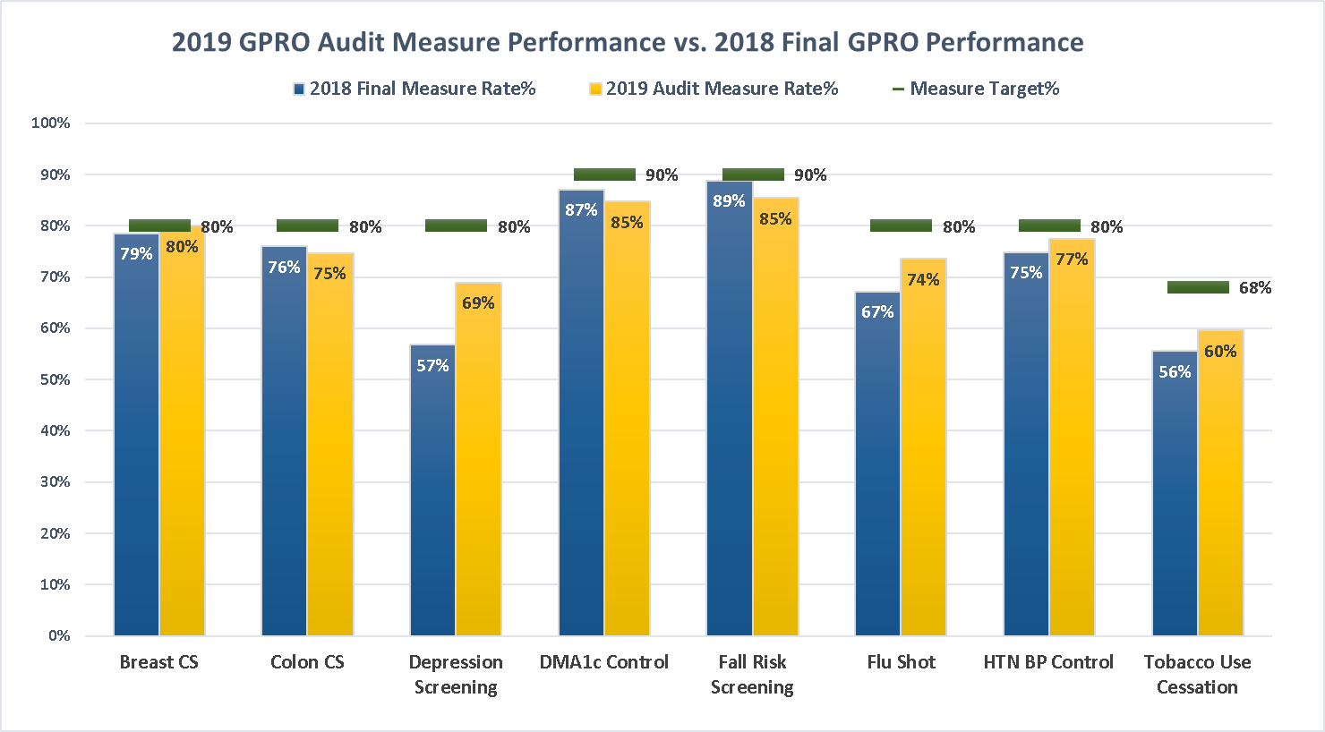

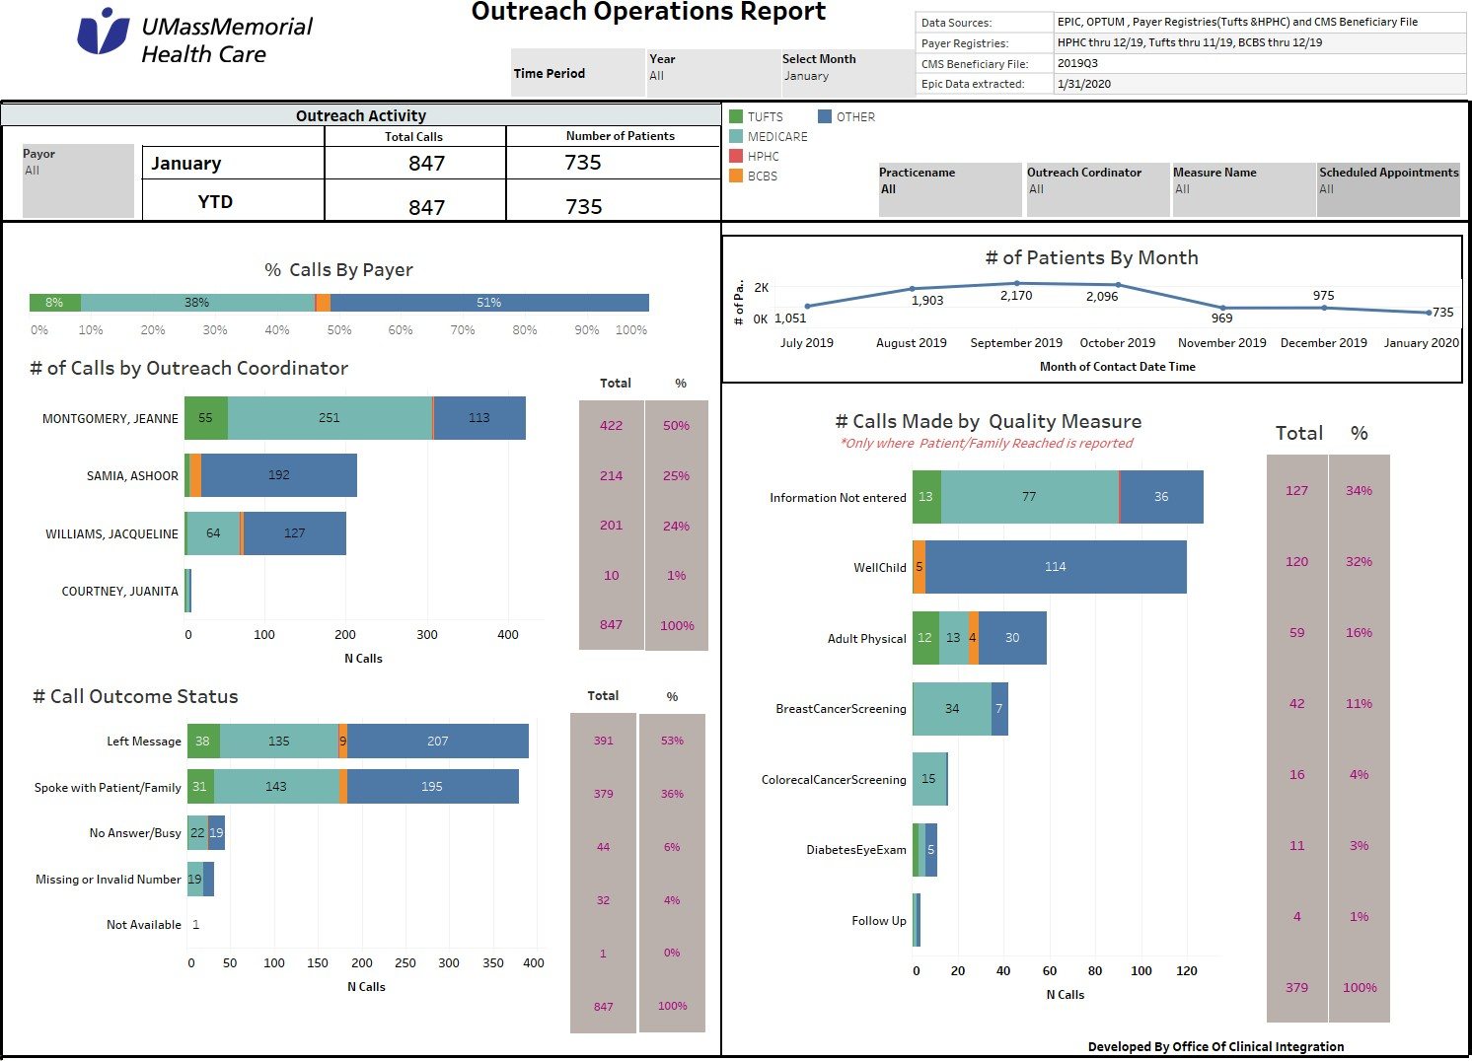

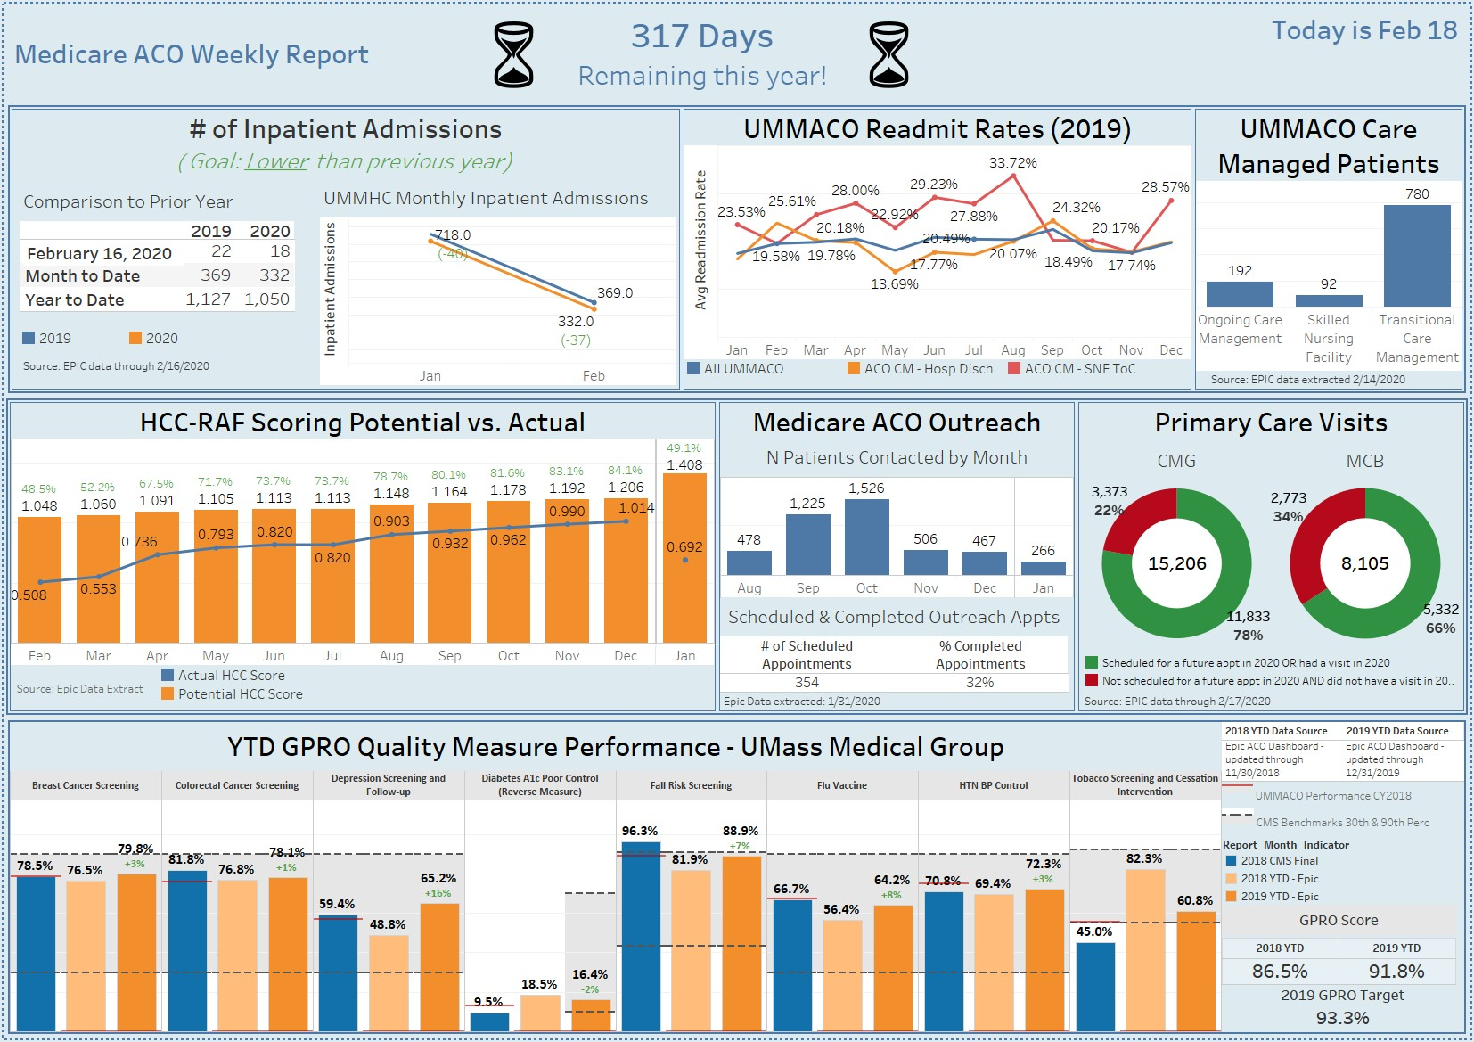

Performance / Incentives

- Commercial Programs (BCBS, HPHC, Tufts)
  - Internal Rewards
- Governmental Program
  - MIPS / MACRA
  - Overall ACO Quality
  - GPRO
- Self-insured (e-ACO)
  - Diabetic outcomes

45

MCN Ambulatory Quality Measure Performance
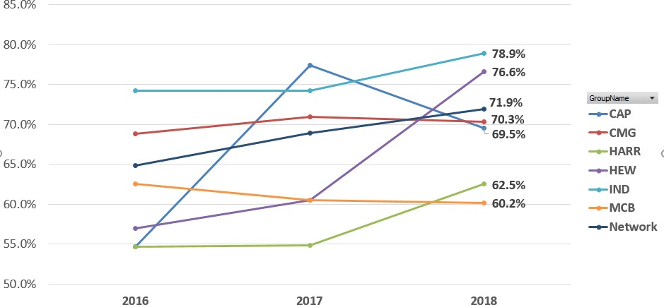Group Comparisons, 2016-2018
MCN Network Target Score for CY2018:
>68.9%
Goal achieved

46

- MCN Independents continue to have highest quality scores
- CAP decrease in 2018 but continues to be above target
- Heywood group had biggest increase
- Medical Center Based practices continue to see lower overall quality scores compared to network

MCN Ambulatory Quality Score
Process Measures ONLY- 2018, 2019 YTD

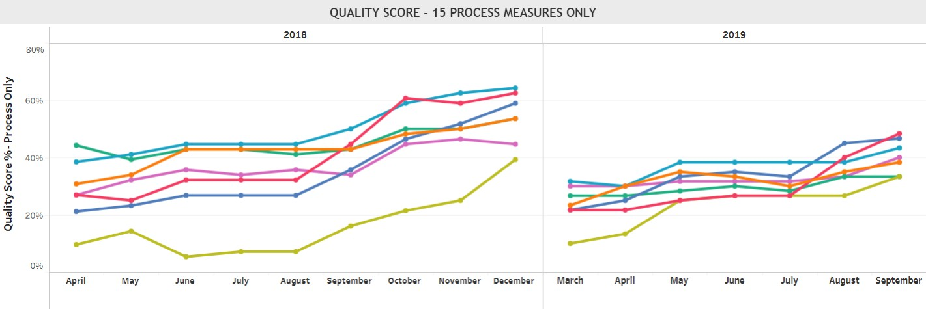
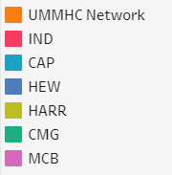

The benchmarks will continue to rise as the nation focuses on quality improvement.

Standing still is not an option!!!

47

Examples of measures where we are losing ground in 2019
NCQA 90th Benchmark YOY Change by Measure vs. MCN Network Performance (Practices above & below peer average)

Diabetes Blood Pressure Control

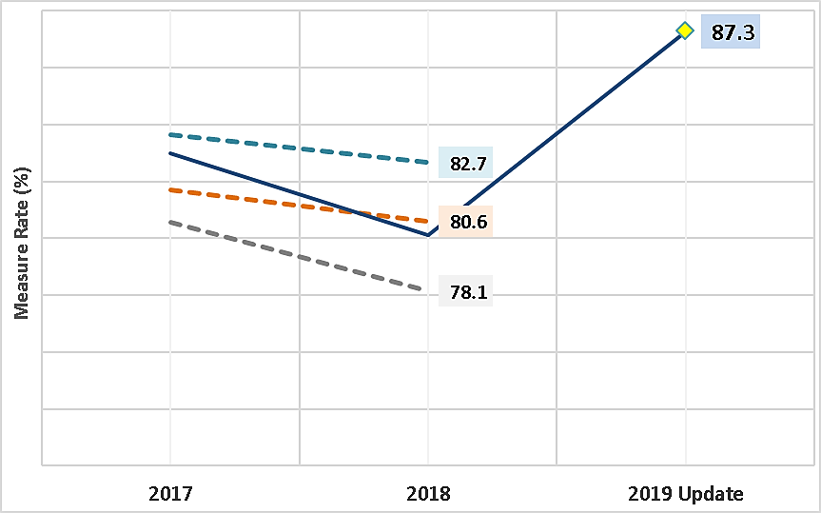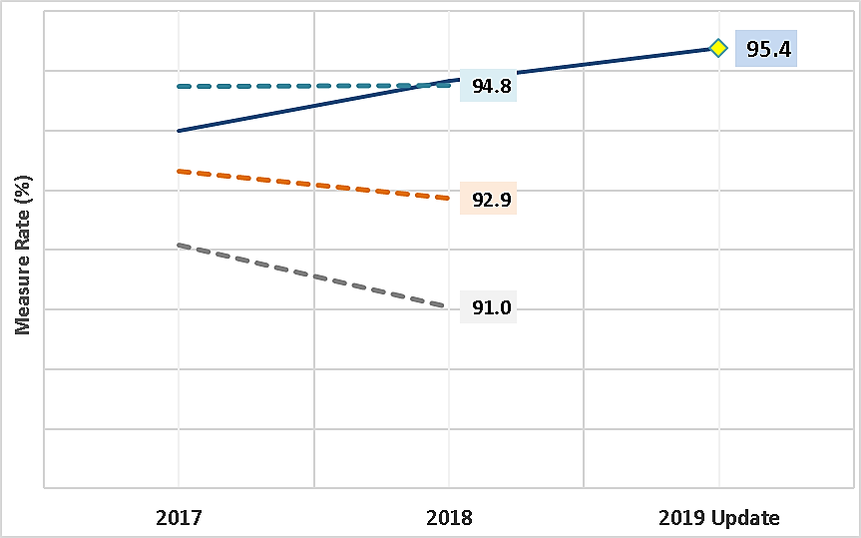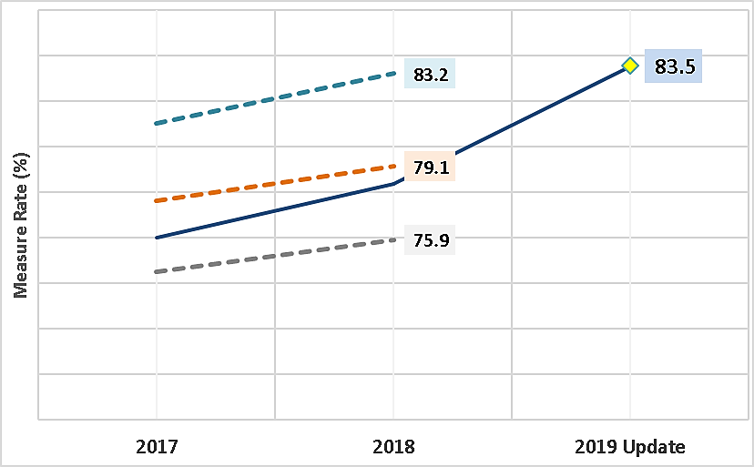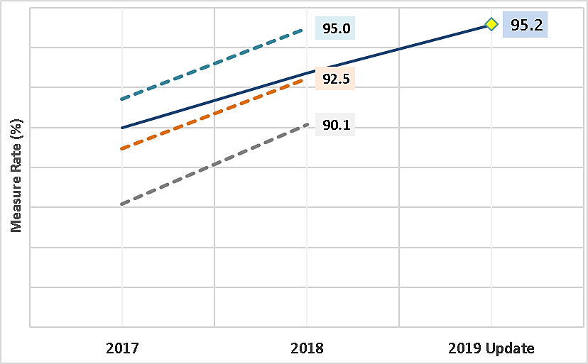Diabetes Nephropathy Screening

Low Back Pain
Diabetes A1c Screening

MCN Quality Measure Performance
Measures in CY2018 program and comparison to upper thresholds
PROCESS MEASURES | Measure Performance Exceeding National 90th Percentile (Full points earned where YES)
Asthma Medication Ratio
Breast Cancer Screening | YES
Colorectal Cancer Screening | YES
Depression Medication Management (Acute Phase)
Diabetes Care: HbA1c Testing (1 test per year)
Diabetes Care: Eye Exam
Diabetes Care: Nephropathy Screening
Diabetes Care: Adherence to Statins
Low Back Pain Imaging | YES
Appropriate Treatment of Upper Respiratory Infection (URI) | YES
Well Child Visits - Ages 3-6 | YES
Well Child Visits - Ages 12 to 21 | YES
Well Child Visits - Age < 15 Months | YES
BMI Percentile Documentation for Children and Adolescents | YES
Annual Monitoring for Patients on Persistent Medications
OUTCOMES MEASURES
Diabetic HbA1c in Poor Control (>9.0%) | YES
Diabetes Blood Pressure Control | YES
Hypertension Blood Pressure Control | YES
PATIENT EXPERIENCE MEASURES | MHQP Top Decile
Adult Access to Care
Adult Communication
Adult Integration of Care
Adult Knowledge of the Patient
Pediatric Access to Care | YES
Pediatric Communication
Pediatric Integration of Care
Pediatric Knowledge of the Patient

Exceeding National 90TH Percentile: 46%
(12 of 26 measures)

49

UMMACO CAHPS 2018 – 8 Measures 2018 vs. 2017
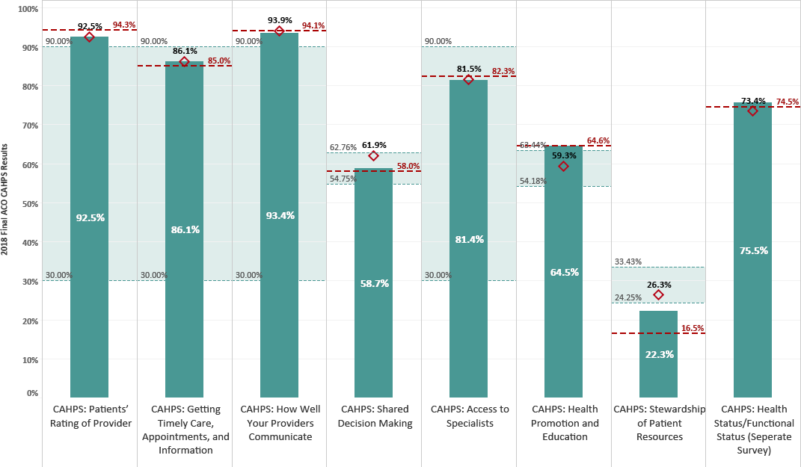Patient Experience
2017 CMS results are recalibrated based on survey question changes in 2018.
CMS has adjusted benchmarks for 2018 based on the new survey.

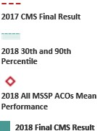Data Source: Final CMS & Press Ganey Results

Quality Measures YTD comparison

Epic practices only

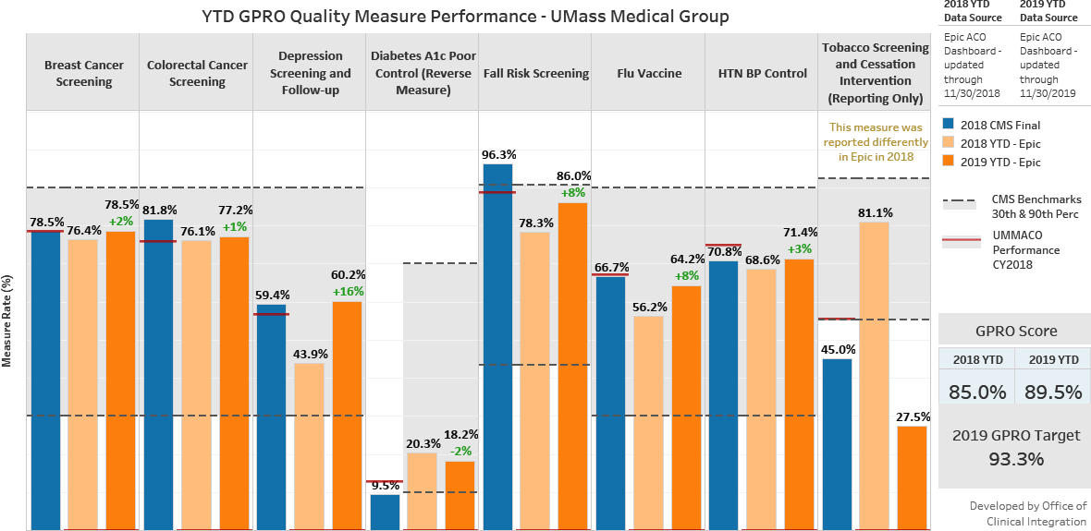

51

How does UMMACO quality stack up?

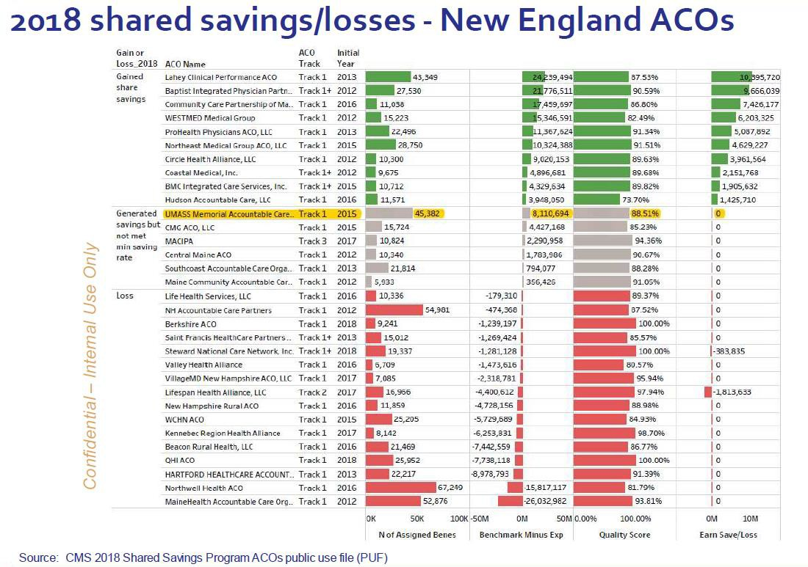

52

A laser focus on quality in 2020
- Identifying opportunities
- Developing QI approach
- Prioritizing expectations
- Leveraging internal tools
- Guiding providers
- Evaluating impact

53

Population Health Strategic Approach

 | Primary Care Providers | Specialists | Office of Clinical Integration
Quality | - Prevention  - Screening  - Chronic disease metrics  - Annual wellness visits | - tobacco screening  - fall risk  - flu vax  - Refer patients back to PCP for annual exams | - Monitoring  - Feedback  - Outreach
HCC | - Chronic HCC dx (such as DM)  - Chronic HCC conditions (such as ostomy status)  - Acute HCC that can be managed in ambulatory setting (such as pneumonia) | - Acute HCC dx that result in  hospitalization  - Chronic HCC dx that require specialist mgmt (such as CHF)  - Refer patients back to PCP for annual exams | - Provider  education/resources  - Monitoring  - Feedback  - Identification of HCC opportunities
TME | - Reduce readmissions – timely hospital f/u visits (TCM)  - ED avoidance  - Ambulatory mgmt of some acute dx (such as acute DVT)  - Advance care planning | - Reduce readmissions – timely hospital f/u visits  - Reduce LOS  - ED avoidance  - Ambulatory surgery center  - Advance care planning | - TME monitoring/feedback  - Care management  - SNF and hosp f/u phone calls  - Specialty pharmacy  - Hospice/palliative care  - Post-acute preferred SNF

Groups
Provider/Practice

- ED
- Hospital
Inpatient World
Post Acute

HCC

Quality

TME

  - Educate providers
  - Develop EMR tools locally
  - Optimize Code Capture
    - Suspect diagnosis
    - Dropped codes
    - Green sheets

  - Leverage GPRO Audits
    - Target 2nd rounders
  - Engage low citizens
  - Develop AWV strategy

  - Use HCC/TME goal to target
practice intervention
    - Identify areas of focus for each practice <goal
  - Use HCC cohort report to collaborate with hospital/ED for potential specialist opportunites

    - Understand HCC concept
      - Demonstrate burden of illness in practice
    - Pre-visit plan
      - Dropped codes
    - Reach out to unscheduled
patients
    - Use audits to find suspect
diagnosis

    - Schedule AWVs or ROV
      - Address care gaps
and prevention
      - Manage chronic
diagnosis outcomes
    - Use GPRO audits to find
areas to improve

    - Schedule TCM visits
      - Decreases
readmission
    - Use clinical resources
      - Shield’s Care
Management
      - DVT/PE
      - Behavioral Health
      - CKD
      - ACP
    - Create urgent slots to
decrease ED visits
- Ambulatory Specialty
- Dialysis
  - Understand HCC concept
    - Precise diagnoses since increase in complexity
  - Identify opportunities with
CBO & Fran

Top 2 priorities for Chairs/Chiefs
- Mortality
- PSI-90

  - New payment reform will help with documenting acuity

  - Quality improvement
    - Learn from
collaboratives
    - Rona shares data
  - GPRO documentation
    - Flu documentation
    - Fall risk
documentation
- Improve care coordination
  - Leverage inpatient Care Management teams
- Bundled payment programs
- Care plans in “Eddie” for ED
- ASC usage & Other Specialist collaboration opportunities (FRAN)

- Preferred SNF network
- Preferred HHA network
- Palliative care consults &
Advanced Care Planning

Focus | Strategy | Key Tactics
Quality  Performance | - 10 GPRO Measures | - Educate providers regarding FY 19 GPRO measures  - Implementation of continuous auditing of GPRO measures throughout FY19
 | - Quality Improvement  Target (QIT) | - Leverage data and performance analytics to establish a quality improvement (QIT) target per practice  - Integrate QIT planning into quarterly Performance  Practice Package visit agenda and monthly PIF visits
HCC Coding (hierarchical condition category) | - HCC Interventions | - OCI outreach to practices via multiple modalities led by Dr. Trudy Manchester (practice meetings, PH WINS webinars, POD meeting presentations, HCC Tips, Group Talk, etc.)
 | - Epic-compatible Applications | - Further investigation into potential Epic-compatible applications

Focus | Strategy | Key Tactics
Care Management | - Post-Acute | - Expansion of preferred post-acute network – evaluate additional SNFs and home health agencies
 | - Transitions of Care | - Conduct follow-up phone calls to ACO patients discharged from the Med Center/Marlborough/HealthAlliance hospitals  - Conduct TCM (transitional care management) pilot  - Escalation of appropriate patients to RN or SW
 | - Palliative Care | - Expand tools and resources promoting provider  education on palliative care
Specialist Engagement | - GPRO (the Group Practice Reporting Option for quality performance reporting) | - Two (2) specialist deep dive meetings held to date to provide an update and leverage their contribution to GPRO quality measures  - Recruited 3 specialists as POD leaders
 | - ESRD (End Stage Renal Disease) | - Full multi-specialty meeting at HealthAlliance to evaluate ESRD care across the continuum to develop a pathway

Best Place To Give Care – Best Place to Get Care

58

14.a EMR Int

RqeclstliE - Rqecl stliE

Project Sfa hJs Oi erview - 202:1---0Q:-1 9

Current Sfat.us G Green

m21 Project Status Report - Project Status
Working with the Bl t eam t o un ders t and t he scope and t he t imeli ne to mo ve t he cont en t fr om Cl arit y to Cab oodle. OCI team to execu t e the val idat ion on the cont en t m oved from the Pro vide rs t o Cl arity.

Pro j ed: Project: Mna ager
m Exit:omalEM R Dam Eu e Jo lll!!i
lnb;gr.oti o n

Portfolio App lic:atiOfils

ro gram

Cu r r ent St at us St at us Comment s

st ate
Work ilil !Progress Budget Code
MClOIO!iO | Olpita l | Thom.,. Smm avacca 67. 24
PIB11n ed sta rt Date | l't arm ,ed End Date | PIB11n ed Cost
2020--04--fil | 202.1-0G-ZB, | $14.,2'1-9,ZB
Adu al. sta rt Date  2020-06-08 | Act ua l End Date | Ad:ual. Cost  $13,364.11

l't,as.e

Exeam ng Cost ty pe
On hold
No

E><emtii.re ons o r
Prn ject !:ipal'>S-Or
J eai11it.e Shirshac:

% Complete

Overall

Sch edul e

Cost

Resources

Desc riptio n
m Emamal.EMRDam lnteg;;aliOfil ll'hase 2(Fl/'2.0 ) - lncema,Ho stedl Ath e na , e-d in i"""-1 intelifaces
(00 1>'!) to E;pic fo rdata, gat:ion ilil th e m <HI .S uite

Scope

Key Milest ones

s mm.ary

Execuwe Summa,-y
Last week th e imeg,,tion was ap,pm v ed by ,m a nge <lDnt rol a n d th e q 1J1e ries wen, exewt.edl lih e pm j edt tea m was .ti le to see d at.:a mo v e from tlie in dividual group prad ioesto i• in the fonn, of dowments.. lihe IS te a m is now wmking witl, the 00 team to fl!'lliew th e oontent and worfi through a val:oda tion strategy. In addition, tJ,e l,S teamh asst arted working with the Ill te am to determ.-ie1!1,,a wo rk invotved to move l!he, data fro m Clarity to Caboodle_

Last: Weelo:'s AA:lh i evemenls

d ha n ge oonu ol spp FOVed tihe di a nge, a nd th e qu e ry hBll been exewted ilglfflst 3 pro vider group s will, llO
patient.st. Content is avsi1aible ., Ep.ic.

Key Activiities l/llanned

tiips,_ ,.,,,,_ _ _1o.m • 'll;2!' ..._lb%Jl' _11 ;J _JJ"<ijl

Pending Compl et ed

Short Descr iption | Planned Star t Date | Planned End Date | State | Status
Go-Liv e Readine ss As sessment Appro ved | 2021-05-25 08:00:00 | 2021-05-25 08:00:00 | Pending | Gree n
Go Live 2 of 2 (Cl arit y to Ca boo dle) | 2021-05-26 08:00:00 | 2021-05-26 08:00:00 | Pending | Gr een
Execu t e G at e Co mplet e | 2021-05-26 08:00:00 | 2021-05-2 6 08:00:00 | Pending | Green
Pro jec t Acce pt an ce App r oved | 2021-06-25 08:00:00 | 2021-06-25 08:00:00 | Pending | Green
Cl ose / Pro jec t Complet e  . 114 | 2021-06-28 08:00:00 | 2021-06-28 08:00:00 | Pending | Green

- The Application states that race/ethnicity are self-reported (pg.1), and that in FY20, 14.2% of UMMHC patients and 9.6% of HMH patients chose not to report or reported a category other than those reported.
  - Can you provide a breakdown of the category Other/Unknown into those choosing not to report
and those reporting another category? At UMMHC, less than 1% of the patients chose not to
report or were unable to provide a response. The remaining self-reported Other for their race.
HMH’s response is included in b.
  - Describe the steps for collecting race/ethnicity data from patients at UMMHC facilities and HMH, including when the information is collected, how it is collected, and how often it is collected. For
UMMHC, Race, Ethnic background, Hispanic indicator and Language are all captured via registration. The questions are asked during the registration process generally during an initial visit. Depending on the workflow, it is either a hard stop or a soft stop, meaning the fields must be completed or they can be skipped. For example, in our outpatient ambulatory clinics the fields area a hard stop, where in the ED the fields can be skipped because we may not always be able to ask the patient for the information. Patients also have the ability via myChart to complete/update the questions themselves. We also use the attached .pdf to educate users (attachment 1.b).

For HMH, both Meditech and Allscripts require an entry in a demographics field on the registration page. HMH asks each patient the following race-ethnicity question to complete that field: “For race and ethnicity you consider yourself to be…?” Based on the patient’s response, HMH and HPS enter one of the following in the demographics field:

African American Asian
Caucasian Hispanic
Native American/Alaska Native Native Hawaiian/ Pacific Island Other
Unknown

A patient that does not respond to the question, or any patients that are entered into the HMH system for reference laboratory services, is listed as “Unknown”.
- The Application states that while HHCS experiences annual financial losses overall and its average operating loss margin of approximately 5% is below rating agencies median. Please provide data used to make this comparison.
  - Are there any other indicators of HHCS’ financial challenges?
In responding to this question, it is noteworthy that in its 2016 Report, Community Hospitals at a Crossroads, the Massachusetts Health Policy Commission (“HPC”) examined the many substantial challenges facing community hospitals in the Commonwealth and HPC concluded “the variety of challenges – driven both by changes to care delivery and payment models and by market dysfunction – make traditional community hospital operating and business models unsustainable.”

The HPC 2016 Report identifies several characteristics of community hospitals facing this uncertain future. Among these are:
- High public payer mix
- Low payment rates
- Low case mix
- Declining volume (from outmigration of patients to teaching hospitals and competition from non- hospital providers)
- Significant mix of low margin service lines such as Emergency and Behavioral Health services
- Aging facilities
- Difficulty recruiting physicians
- Lack of resources to invest in health delivery transformation (e.g., population health data and analytics, integrated health records)
5 years after this HPC report, these uncertainties and substantial challenges to the remaining Massachusetts community hospitals, including HMH, have grown even more acute.

For HHCS, this is evidenced by the chart attached that shows certain financial ratios and other data over the past 5 years, including results of operations, debt service coverage, and day’s cash on hand and average age of plant relative price and payor mix trends. The financial ratios are compared to S&P ratios (August 19, 2020).
HHCS ratios have been less than the S&P published medium.

HHCS has experienced challenging operations over the past 5 years. It has generally operated at a loss. When investment activity is included, HHCS has been operating at near breakeven.

HHCS’s ability to meet its debt service covenant over the past 5 years has been consistent. This calculation includes investment activity.

Day’s cash on hand has been declining over time. During the last 5 years, Days Cash on Hand was 129 days. Days have declined 13 days since then to 116 days (adjusted for Medicare/Medicaid Advance Funding).

During the last 5 years, HMH’s physical plant has further aged and now the average age has increased from 15 years to almost 20 years.

The chart attached reports data for HHCS, representing consolidated operations of HMH and HPS (attachment 2.b).

The chart’s data demonstrate that HHCS has many of the community hospital/health system warning signs cited by HPC in its 2016 Report, Community Hospitals at a Crossroads.

Recently, HHCS has been fortunate that the stock market has been at an all-time high. The favorable stock market condition has made it possible for greater subsidization of HHCS operations from its investment activities, and allowed HHCS to have overall break even on operations which has supported HHCS’s ability to meet its debt service covenant. Unfortunately, supporting operations has resulted in a decline in investments in HHCS PP&E as evidenced by the increasing age of the plant and declining days cash on hand. It has also

hampered HHCS’s ability to build the infrastructure needed to support health delivery transformation for the HHCS community.

HHCS cannot expect the stock market conditions to continue to be as favorable, and in the event of a future stock market decline, HHCS will experience what at worst could be a devastating financial event and at best will continue to degrade the ability of HHCS to reinvest in the necessary resources it needs to continue to provide hospital and medical services to the south Worcester County community while maintaining adequate quality of care.

In addition, the impact of COVID has had negative impact on HHCS operation as evidenced in the 2020 ratios. The rebound from COVID has not met HHCS management’s expectations.
- In the responses to DoN follow-up questions (pg.3) the Applicant states UMMHC will assist in the recruitment of physicians to the HMH service area. Are there any plans for recruiting gerontologists?

Under the Affiliation Agreement, UMMHC has agreed to assist HHCS with the recruitment of physicians into the HHCS service area. While HHCS, through HPS, has enjoyed some success with physician recruitment, there continues to be several long-standing and remaining gaps in certain specialties for the HHCS community that need to be addressed. Currently, as a pre-closing effort, HHCS is discussing with UMMHC a plan to address current gaps in the following medical specialties at HMH, and within the HPS medical offices: cardiology, oncology, endocrinology, ophthalmology, and primary care.

While these current discussions have not yet focused specifically on the recruitment of a gerontologist for HMH/HPS, HHCS and UMMHC leadership plan to undergo a more thorough and detailed physician staffing needs study. Through this study, both entities will obtain a greater understanding of what the short and long term needs are for provider recruitment to the HHCS service area and, after the transaction is consummated, the two Systems will be able to engage in a larger collaborative study, established strategy and implementation plan for physician recruitment. Should the recruitment of a gerontologist for the HHCS service area emerge as a priority through this study, or through various other UMMHC community system efforts, HHCS leadership would support the recruitment and hiring of a gerontologist into the HHCS service area.

- The Application states that improving ambulatory services for patients and referring providers is one of UMMHC’s top priorities across the system (pg.5). Describe plans for improving ambulatory services for referring providers. UMMHC has been working diligently with many referring providers to understand
and redefine processes when it comes to how patient referrals and care is provided throughout UMMHC’s system. UMMHC is utilizing lean management principles to improve clinical and non-clinical pathways to enable an easier process for referring physicians and patients to be seen by the most appropriate physician in a timely manner. These efforts have focused on many different touch points that is involved with ambulatory patient care areas such as: central scheduling, physician templates, clinic staffing needs, and physician recruitment.
- The Application states that UMMHC is taking a multi-pronged approach to reducing outmigration (pg.5).
  - Provide a definition of outmigration. Outmigration is defined as patients residing in UMMHC’s
service area who receive healthcare outside of UMMHC’s service area.

  - Based on this definition, provide a description of the major contributors to outmigration. There
are a number of contributing factors that influence where a patient seeks care. Some of the
major contributing factors to outmigration are the following: inpatient bed capacity at the Medical Center has been at high levels limiting tertiary patients access to care thus requiring patients to be transported to Boston area hospitals; patients choosing Boston area hospitals because of the branding efforts they have undertaken to attract commercial patients with the idea that their patient safety and quality is superior to local community hospitals in Central Massachusetts; and a certain level of outmigration to Boston area hospitals that occurs because some patients require more specialized care than UMMHC can provide such as: heart transplants, high acuity children’s care, and high acuity cancer care.
- Define the specific measures you will use to assess the impact of the Proposed Project.
A primary outcome of the proposed project is the maintenance of high quality care for the
Harrington community. UMMHC and HHCS will specifically track and monitor:
- the level of care being provided to the community as evidenced by hospital discharges, emergency department visits, primary care visits and ancillary services provided by HHCS caregivers.
- HHCS quality measures as described in the Exhibits to the previous response.
- Specific population health initiatives identified prior to the start of each calendar year and revised as necessary during the year. These measures include but are not limited to annual well visits, telehealth visits, potentially avoidable emergency department visits, transition of care visits and advanced care planning visits.

- In the responses to DoN follow-up questions, the Applicant states that Interpreter Services (IS) are provided at UMMHC member hospitals to varying degrees, as deemed necessary.
  - Describe how IS services vary between member hospitals and the reasons for the variation. Full IS
services are provided at each facility through multiple platforms with varying utilization. Each
facility has a specific focus of in-person interpreters based on the needs of that community. Aside from the in-person IS each facility utilizes the system agreements for both virtual IS and phone IS. UMMHC is able to access a myriad of services and is able to do so on every unit in its hospital. UMMHC has virtual systems and phone equipment that is available and can be operational within a few minutes.
  - How are member hospitals ensuring appropriate and timely access to IS? On a monthly basis,
UMMHC monitors the utilization between in-person, virtual, and phone IS services. If there are
changes in service requirement over a period of time – UMMHC makes adjustments to the mix of offerings by time of day based on the trended needs (including language options for in- person). UMMHC is also in the process of reviewing its IS services to determine how best to provide service across entities – increasing access to in-person services for a wider array of needs. UMMHC also continues to monitor the virtual IS world as technology is continuing to change and looks to make adjustments in real time.

- In the responses to DoN questions, the Applicant states that the SDoH screening tool identifies needs in 14 domains

  - What are the 14 domains? Food, Housing, Utilities, Transportation, Employment, Budget Strain,
Education, Childcare, Social Support, Legal Assistance, Health Insurance, Dental Health,
Material Needs (clothing, furniture, diapers, etc.), and Stress
  - List the measures used to track progress and assess performance.
    - Distinct patients screened
      - Overall and by primary care practice
      - Percent of primary care practice attributed patients screened in the past year (12 rolling calendar months)
      - For screened patients:
        - Percentage with identified needs
        - Percentage with no identified needs
        - Percentage declined or unable to complete survey
    - CommunityHELP resource database:
      - Resource searches per month
      - Top 3 areas of need searched within CommunityHELP
        - Overall
        - By central MA municipality (Clinton, Fitchburg, Leominster, Marlborough, Worcester; Southbridge addition in progress)
      - Top 3 search terms within each of the 3 top need categories
        - Overall
        - By central MA municipality (Clinton, Fitchburg, Leominster, Marlborough, Worcester; Southbridge addition in progress)

- In the responses to DoN questions, the Applicant states UMMHC is in the pilot phase of an EMR integration project that will enable HHCS EMR data to be brought into the Epic system and that UMMHC expects this project to go live in the spring 2021 (pg. 16).
  - Are you still on track to complete migration by Spring 2021? For clarification, the integration
that was previously mentioned refers to an effort by which certain quality and population
health information will be transmitted from Harrington’s EMR to the UMMHC EMR via an Information Exchange system. This integration does not create a UMMHC medical record for each Harrington patient and bringing HHCS onto the Epic system will take several years. The timeline for go live for this exchange is summer 2021. While the migration plans have not been solidified, the current plan to move HHCS caregivers from their current Allscripts and Meditech systems is expected to be completed in a single move from their legacy systems to Epic. Little downtime and disruption is expected to occur during this migration. Until the migration to Epic, HHCS caregivers have access to UMMHC’s “Epic CareLink” portal which allows UMMHC to extend patient information to external facilities and affiliated providers, helping improve continuity of care in our community. EpicCare Link is secure, real-time, and easy to roll out to users who need remote access to UMMHC’s clinical data.
  - Are there any plans to provide Epic training to clinical and support staff? There are no plans to
provide Epic training to clinical and support staff as a result of this integration effort.

- The Application and responses to DoN questions state that HHCS has developed a large continuum of behavioral health services in its service area and that the Proposed Project will allow HHCS to continue to

provide and further develop these services. Describe how the transaction is expected to sustain and improve HHCS’ behavioral health services.

Through the integration of the UMMHC and HHCS behavioral health programs, the Proposed Project will allow the affiliated health systems to be more able to develop a full continuum of care using complementary services from each system to treat a wider scope of patients. UMMHC has an established interventional psychiatry service employing ECT and other treatments that would become more accessible to patients in the HHCS area, and potentially develop satellite clinics in the HHCS service area. Likewise, HHCS has recently created an Addiction Immediate Care center which would integrate into the larger UMMHC system allowing patients throughout central Massachusetts in need of urgent assessment and treatment to have better access to such behavioral health services. Because of the expected future capital commitments from UMMHC, HHCS was able to respond to the Commonwealth’s request (via DMH/BSAS/MassHealth) for additional psychiatric beds and is in the process of constructing a new 24-bed inpatient unit on its Webster campus. These additional psychiatric beds will help address the large number of behavioral health patients boarding in the emergency departments in all UMMHC, HMH and other area hospitals. If the Proposed project is approved, UMMHC and HHCS as affiliates will establish a coordinated daily “bed huddle” effort to address the on- going crisis in the delay for inpatient psychiatric placement. Through the development of such a regional coordinated effort with HHCS becoming an affiliate of UMMHC, the focus will remain on filling service gaps rather than unnecessary duplication, and patients will have more treatment options available in the central Massachusetts region without the difficulty and cost of needing to seek services in the Boston area.

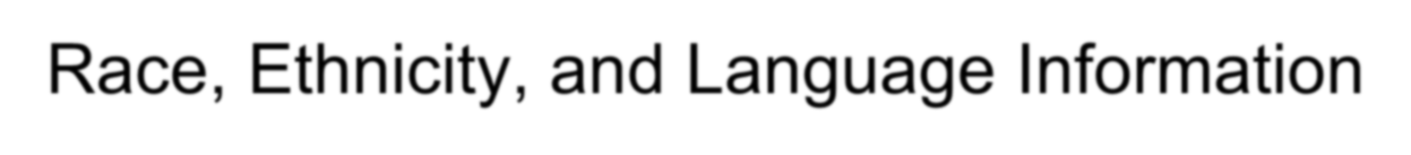
Collecting Patient
Race, Ethnicity, and Language Information

Training Tutorial

Our Patient Population

- Our UMass Memorial Healthcare patient population is highly
diverse.

- They speak over 100 different languages and come from over 70
different ethnic and racial backgrounds

- Our ability to communication may be inhibited by language and cultural differences

Objectives

  - To define Race and Ethnicity

  - Review the importance of accurate collection of race/ethnicity/language data

  - Learn best practices to collect the data and to respond to patient questions & concerns

Race vs. Ethnicity (Ethnic Background)

RACE: A person’s self-identification with one or more social groups which may be based on shared physical, social and/or biological characteristics and geographic origins; the US Government identifies the following race categories:
- Race Categories: American Indian or Alaska Native, Asian, Black or African American, Native Hawaiian or Pacific Islander, White, Other
Hispanic Indicator: Combination of Origin (ancestry, nationality, lineage or country) reflecting ancestry or origin in Spain, Mexico or any of the Spanish speaking countries of the Caribbean or Central or South America
- Indicators: Hispanic or Latino or Not Hispanic or Latino
Ethnicity or Ethnic Background: An individual’s background, heritage, culture, ancestry, or sometimes the country where there were born.
- Examples of Ethnic Background: African, African American, American, Brazilian, Chinese, Mexican/Mex Amer/Chicano, Puerto Rican, Russian, South African, Thai, Swedish, Vietnamese

Race vs. Ethnicity (Ethnic Background)

- A person can identify as being of more than one race and Epic can capture that information
– For example, a person can identify as both Asian and Black or African American
- A person who identifies as Hispanic can be of any race

What Does this Information Have to Do With Health?
There are disparities in access to health care treatment and in the quality
of care and health care outcomes between racial, ethnic, and language groups in the US.

To eliminate these disparities:
1. We need to identify them
If we find these disparities:
- We will work to reduce those gaps
- We will work to improve quality of care for all patients

This means we need complete and accurate data about all of the patient
we serve.

Why do We Need to Collect this Information?
Language information is essential to provide safe and quality care to our patients

Errors in Language information impact multiple points of the organization including patient care.

We are required by :
  - Federal Government (CMS) for meaningful use incentives
  - Joint Commission standards to improve patient provider communication
  - Department of Public Health for hospital licensure

Key Points of Data Collection
- All patients must be asked for their Primary Language,
Race, Ethnicity, and Ethnic Background

- Patients must self identify these items. Do not guess for them

- Patients can have more then one Race or Ethnicity

Why Every Patient Needs to Be Asked?
Below are some images from a recent New York Times article about ethnicity and race in the U.S. Could you have guessed each individual’s ethnic/racial background?

Japanese/Spanish Black/White
Source: “Black? White? Asian? More Young Americans Choose All of the Above” New York Times, Susan Saulny, January 29, 2011. Photo credit: Stephen Crowley, The New York Times Company.

Making a Brief Introduction:

“Now I’m going to ask a few questions about your racial and ethnic background, as well as your language preferences.

“We collect this information from all of our patients and use it to make
sure that we are providing high quality and personalized care to
everyone.”

“The information collected is for hospital use only and not shared with immigration “

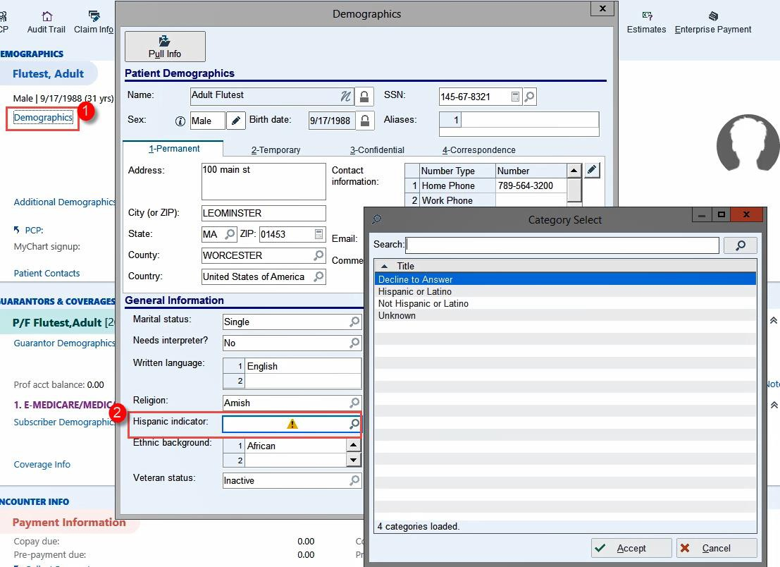
Asking About Hispanic Indicator
“ Would you describe yourself as Hispanic or Latino?”
“If response is some, partly, a little, or half, please enter Yes”

Defined as someone who comes from (or whose family comes from) a country in Latin America
or another Spanish-speaking Country

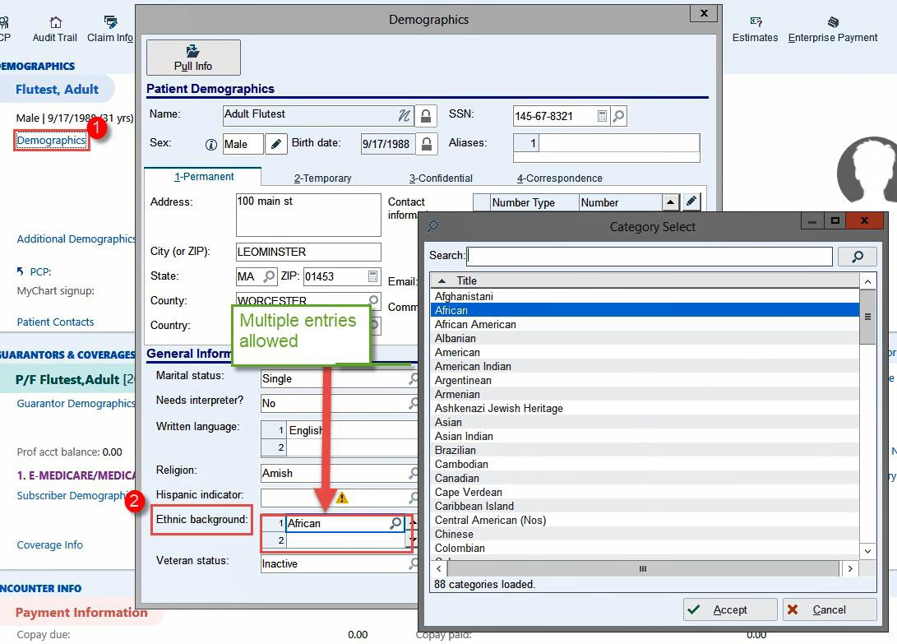

Asking About Ethnic Background
“How would you describe your ethnicity, or cultural
background?
You can choose more than one option.”

Asking About Race
“How would you describe your racial background?
You can choose more than one option.”
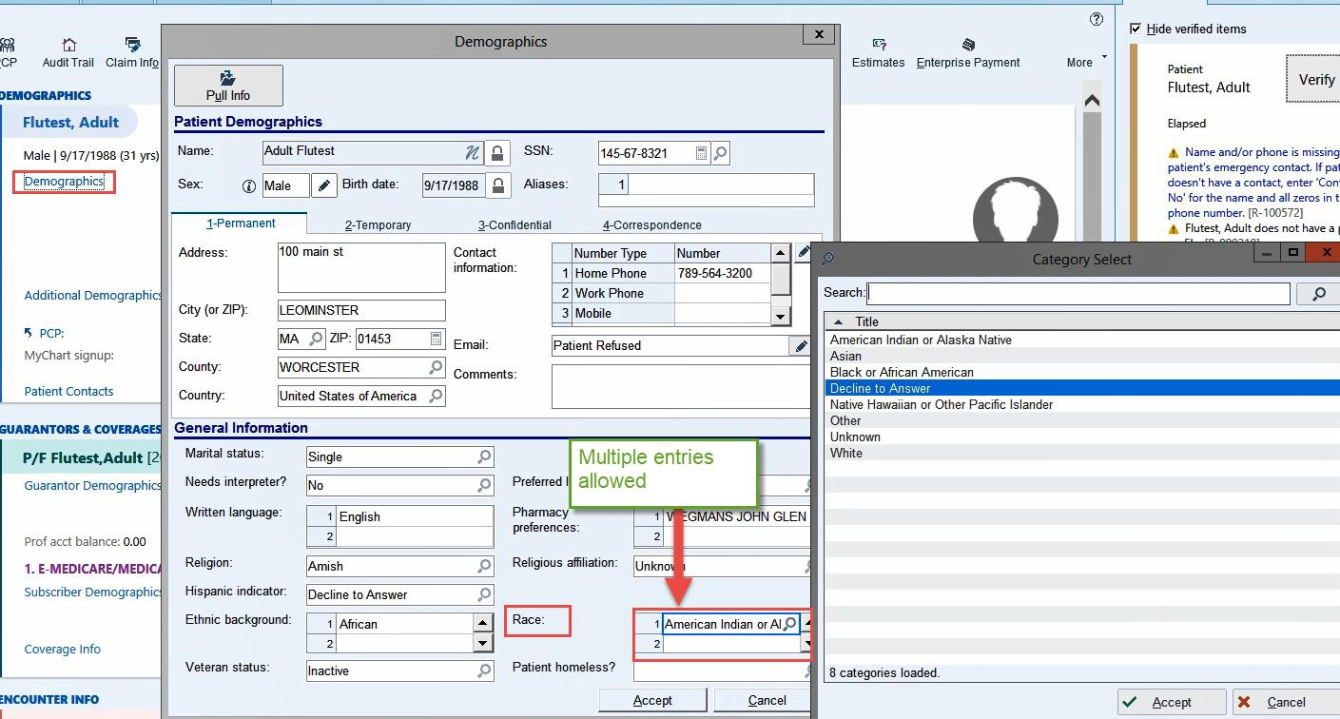

Tips:

Asking About Language
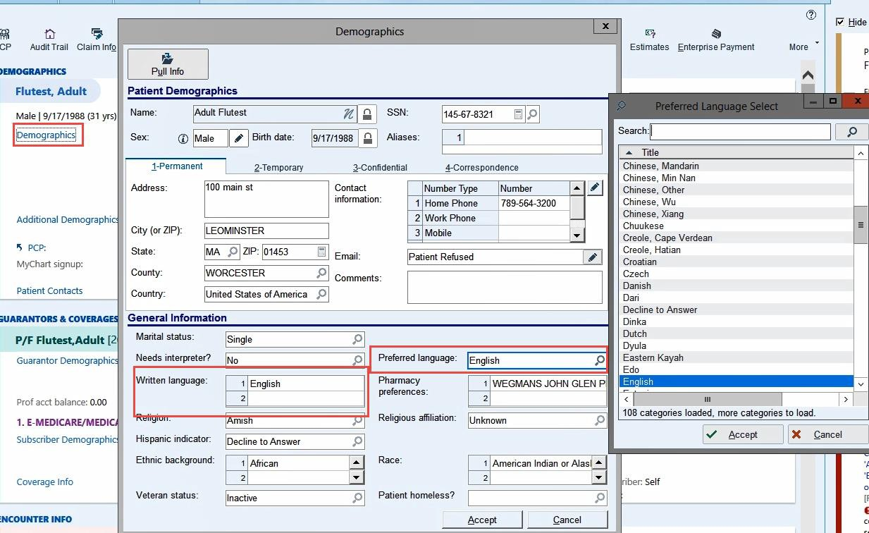
“ In what language would you prefer to receive your health information?”

- Preferred language may be different than the language the patient speaks at home.

- Don’t confuse the patient’s social fluency in English with their ability to understand medical information.

- Don’t make assumptions based on the patient’s appearance, name, nationality or language similarities.

Don’t ask “Do you speak Spanish?” or Do you speak X language?”
Patients may answer yes even if that is not their preferred language.

Frequently Asked Questions

If a patient asks “Why are you collecting this information?”

  - We are Collecting this information from All of our patients.

  - This information helps us to learn more about the communities we
serve, which helps us better meet everyone’s needs.

  - This information will only be used to make sure that we are giving all patients the best care possible.

If a patient says “I don’t know my race/ethnicity”
  - Explain what race/ethnicity means.

  - Explain that patients can select more than one option.

  - Provide examples (use Ethnicity Tool if possible).

  - If still unable to identify race/ethnicity, let patient know that they can select “Other.”

  - Do not select "Unknown."

If a patient says “Can’t you tell just by looking at me?”

“I understand that you think the answers are obvious, but I do have to ask every patient. And since I can’t always be sure of the answers, we think it is better to let people
tell us. It is important that we record your response.”

If a patient says “I’m American”

“Are there any other options you would like to select, in addition to American?”

If a patient says “How is my
information kept private?”
“Your privacy is protected. The users of this information have very strict rules about how the
data are reported. We will protect this information like we protect your health."

If a patient says “Can I still receive services if I don’t give you this information?”

"Yes, you can still receive services even if you choose not to answer these questions. Answering these questions is voluntary. However,
the more complete the data we collect, the better we are able to
serve you and our entire patient population."

If a patient declines to answer

  - Do not force an answer—answering these questions is voluntary.
  - Select 'Declined to Answer.' Do not select 'Unknown.'
  - It is important to record a "Declined to Answer" response because
that means we should NOT ask the patient for this information again.

When should I mark “Unknown”?
This is to be used only when the patient is unable to directly communicate to staff for some reason. (In the Emergency Department this field can be left blank for any visit that a patient is unable to communicate)

Entries of “Unknown” will prompt a user via the side bar checklist to update the value on the patient’s next visit.
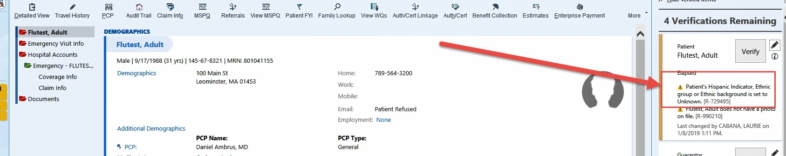

If a patient refuses to answer, select “Declined to Answer.”

Please keep in mind…

  - Your work is incredibly important for ensuring that we have accurate and complete information about our patients.
  - Data quality is in your hands!
  - For questions contact the interpreter services department in your hospital.
:

UMass Memorial Health Care, Inc. DoN #20121712-TO – Answer to Question 2. b. Attachment

Adjusted for Pension
 |  |  |  |  |  | Termination
 | 2016 | 2017 | 2018 | 2019 | 2020 | 2020 | (1)
Operating Margin % | -1.8% | -5.0% | -2.9% | 0.5% | -12.8% | -5.9%
S&P Ratio | 2.4% | 2.2% | 2.3% | 2.7%
Excess Margin% (includes investment activity) | -0.2% | -1.2% | 0.0% | 1.6% | -5.6% | 1.3%
S&P Ratio | 3.7% | 4.5% | 3.9% | 4.3%
Debt Service Ratio | 3.9 | 2.4 | 3.5 | 4.2 | (0.8) | 4.1 | (2)
S&P Ratio | 4.3 | 4.5 | 4.4 | 4.4
Days Cash | 127 | 129 | 120 | 114 | 143 | 116
S&P Ratio | 197 | 205 | 213 | 218
Average Age of Plant | 14.71 | 15.27 | 16.67 | 17.53 | 19.95 | 19.95
S&P Ratio | 10.6 | 10.8 | 10.6 | 11.0
Relative Price | 0.90 | 0.90 | 0.85 |  |  |  | (3)
Medicare Payor Mix |  | 40.02% | 40.90% | 42.32% | 43.74% |  | (4)
Medicaid Payor Mix |  | 25.28% | 25.62% | 24.68% | 23.80%
Governmental Payor Mix |  | 65.30% | 66.52% | 66.99% | 67.54%
Commercial Payor Mix |  | 34.70% | 33.48% | 33.01% | 32.46%
Total |  | 100.00% | 100.00% | 100.00% | 100.00%
- HHCS incurred a one time pension termination expense of $11,041,000
- HHCS received $9.3m is Federal and State COVID Grants
- CHIA Realtive Price Report 2018
- Internal Data
S&P report August 19,2020

