EXHIBITS
Exhibit 1 MGB’s 2014 Presentation to J.P. Morgan Exhibit 2 Statement of Work
Exhibit 3 ICA’s Deficient Response to Statement of Work Exhibit 4 Recently Implemented DoNs
Exhibit 5 Health Policy Commission’s October 2021 Slides: Provider Price Variation Exhibit 6 Aerial Map
Exhibit 7 CHIA Analysis – Community Hospital Reliance on Outpatient Revenue

EXHIBIT 1
MGB’s 2014 Presentation to J.P. Morgan

Partners HealthCare System
Gary L. Gottlieb, M.D.
President and Chief Executive Officer
Peter K. Markell
Executive Vice President for Administration and Finance, Chief Financial Officer and Treasurer
J.P. Morgan Healthcare Conference January 13, 2014

 | Disclaimer
2 | The presentation you are about to view is provided as of January 13, 2014. If you are viewing this presentation after that date, there may have been events that occurred subsequent to such date that would have a material adverse effect on the information that was presented.  This presentation contains certain “forward-looking statements” concerning financial and operating plans and results which involve known and unknown risks and uncertainties. In particular, statements preceded or followed by, or that include the words, “believes,” “expects,” “estimates,” “anticipates,” “plans,” “intends,” “scheduled,” or similar expressions are forward-looking statements. Various factors could cause Partners’ actual results to differ materially including, but not limited to, federal and state regulation of healthcare providers, changes in reimbursement policies of state and federal government and managed care organizations, competition in the healthcare industry in our market, general economic and capital market conditions, and changes in our labor and supply costs and in our ability to retain personnel. For more information on these and other risk factors, please refer to our most recent bond official statement or annual disclosure statement filed on the Electronic Municipal Market Access (EMMA) website maintained by the Municipal Securities Rulemaking Board.  Partners does not undertake any responsibility to update any such forward-looking statements except as expressly required by law.

Partners HealthCare Overview

Brigham and Women’s Hospital Massachusetts General Hospital
Founded 1832 Founded 1811

Key Statistics FYE September 30, 2013

- Total Operating Revenue
- Patient Service | 66%
- Research & Academic | 15%
- Insurance Premium | 13%
- Other | 6%

- Inpatient Discharges
- Lives Under Management
$10.3 Billion

165,800
760,000
- Licensed Beds
- Physicians
- Employees (FTEs)
- Clinical Trials
- Clinical & Research Fellows and Residents
4,050
6,660
43,300
1,650
4,300

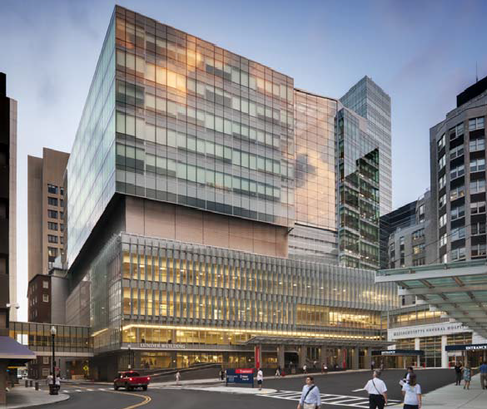
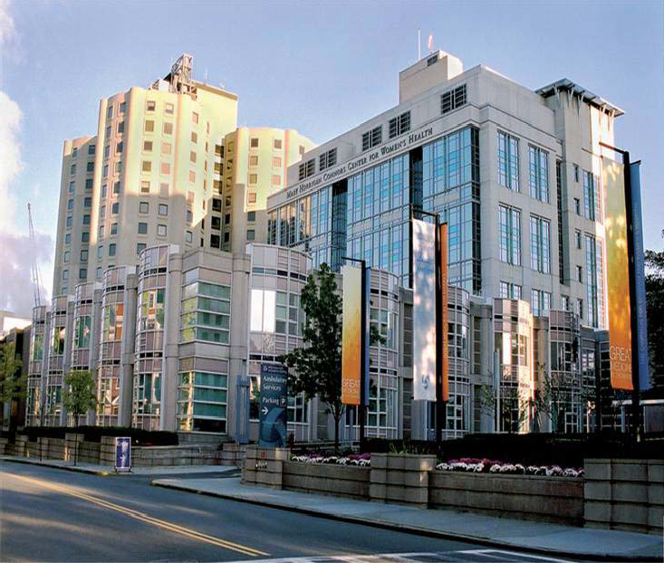
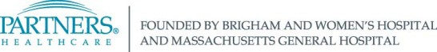

3

 | Partners’ Full Continuum of Care
4 | Acute Care Post Acute Care  - 2 Academic Medical Centers ■ 4 Rehabilitation Hospitals  - 3,800 Tertiary Specialists ■ 2 Skilled Nursing Facilities  - 7 Community Hospitals ■ Home Health Agency  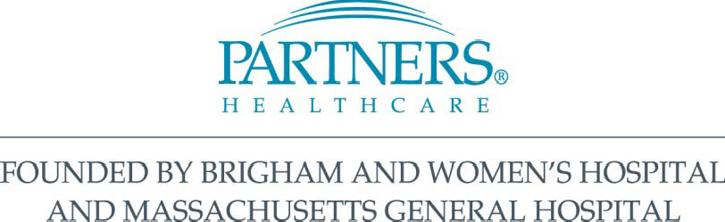  Primary Care Specialty Care  - 6 Multi-Specialty Ambulatory Care Centers ■ Psychiatric Hospital  - 2,900 Community-Affiliated Physicians ■ Pediatrics  - 6 Community Health Centers ■ Cancer Centers

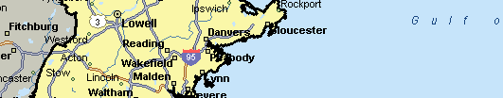
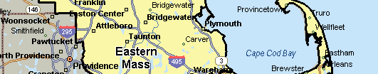
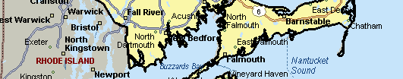
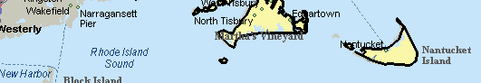
Partners Eastern Massachusetts network is comprised of hospitals, physician groups and clinical affiliates

Owned Hospitals and PCHI Members Clinical Affiliates

Hospital
Ambulatory care center (ACC) Primary care practice (PCP)

Notes:
Hospitals include rehabilitation and psychiatric sites
ACC sites include primary care, specialty services, outpatient rehabilitation and mental health services
Only large adult PCP group locations are shown

5

 | Market pressures continue to intensify, requiring system approach to compete successfully
6 | Cost pressure, impetus to prove value Increased accountability: rewards  for longitudinal solutions (value) vs. rewards for “clicks” (volume)  Increased competition: ACOs, rationalization  Health systems competing directly to sell value to employers & consumers

 | The Strategic Path
7 | We need to control our destiny to make our institutions stronger and to preserve our mission  - We must own financial responsibility for our patients  - Price linked to Quality – in the marketplace  - Right Care, Right Place, Coordination

Partners HealthCare’s strategy

Four Pillars of Mission:
Patient Care, Discovery, Teaching and Community

Effective, Efficient, Accessible patient-family centered care

Invest in improving community
Continue to build world class training program
Translate research into clinical care
health

8

 | Build Upon Clinical Strengths To Redesign Care Delivery and Make Care More Affordable
9 | Deliver more integrated, Increase patient affordability patient-centered care while protecting mission  Translate Invest in Continue to research into improving build world class clinical care community training program  health  Develop and track performance metrics to demonstrate unparalleled patient experience, outcomes and value

Partners Strategy: Care Redesign

Deliver more integrated, patient-centered care

  - Investment in Care Redesign
− Population Health Management
− Specialty conditions / episodes
  - Partners eCare (IT)
10

 | Three Phases of Work for Improving Population Health
11 | Phase 3  Phase 2  Phase 1  4 Disease Prevention  Specialty care:  2 Where a large fraction of costs  are incurred, especially in 5 Wellness Promotion  Primary care/high risk: commercial and employee  1 Where the majority of our populations  contractual population is  managed 3 Patient engagement: Involving patients in better  self-management of care  Ongoing: Central Information Systems and Infrastructure

Partners Strategy: Patient Affordability

Increase patient affordability while protecting mission

- Cost reduction across system (Exceeded three year $300M goal)
- Create efficiencies while maintaining quality
- Share targets and best practices across the system
- Determine benchmarks

12

 | Unifying Partners missions
13 | Research Continuous Learning  Community  Practice  - New research models to foster innovation in translational research and commercialization in a time of wide-spread cuts in research funding  - Bridging research, clinical and community missions  - Integrated model of continuing professional development

Partners has pursued strategies to diversify and grow
research funding and innovation

$1.6
Partners Total Research Revenue

$1.4

$1.2

$1.0
($ in billions)

$0.8

$0.6

$0.4

$0.2

57%

50%

All Other Sponsors Industry/Corporate Foundations
Non-Profit Other Federal ARRA
NIH
DHHS

$0.0
2007 2013

Note: Revenue includes Research Activity, Other Science; excludes accruals and P&L adjustments.
14

New grants to support translation of early stage discoveries into commercially viable products
The NIH Centers for Accelerated Innovations: Trans- Partners NIH Grant - NHLBI U54
Drug Discovery

Devices Diagnostics

Research IT

15

PHS Population Management Network
- Providers tightly integrated
  - Hospitals - mergers, joint ventures
  - MDs - employed, leased
  - Take risk for total medical expense
- Development Goals:
  - Manage Eastern Mass lives
  - PCP investment
Clinical Collaborations
- Range from Specialty Clinics to Joint Ventures
Highly Effective Population Management Network
Vendor Relationship
- Referral contracts
- Excellent service

Partners MA and NE Network Strategy

16

 | Network strategy: Expand population served and make appropriate care more accessible and affordable
17 | Pending affiliations to expand population served, enable redesign of episodic care and facilitate site of care rationalization  South Shore Hospital Hallmark Health System  - Acquisition of strong regional ■ Acquisition of long-term contracting community hospital following affiliate within Partners primary service long-term clinical affiliation area  - Goals: ■ Goal: achieve site of care  - Build primary care presence rationalization by transitioning 4 acute  - Support population health community hospitals located north of  management Boston:  - Develop information ■ 2 “right-sized” acute hospitals technology infrastructure ■ 1 short stay outpatient center  - 1 psychiatric center of excellence

 | Network strategy: Establish ambulatory care centers to support primary care growth in Eastern Massachusetts
18 | Ambulatory Urgent Care, Other  Care Center Primary Care Key PHM Mental Specialty Ancillaries Services(1) Health,  Services Rehab Services  Partners HealthCare Lives  Population  Served Referral Population  Strategy  - Add new primary care providers in key strategic geographies to grow covered lives in Eastern Massachusetts  - Develop community-based ambulatory care and urgent care centers in strategic geographies  - Incorporate core medical village services at each ambulatory care center to support population health management while creating capacity and flexibility to include additional services based on market specific needs and innovative care models (e.g. telehealth)  (1) Includes services needed to better deliver care in the community including cardiology, dermatology, endocrinology, pain medicine, musculoskeletal, etc.

Evolving contracting strategy and insurance models to keep pace with changing market

Collaborate with insurers to align incentives through shared risk contracts and implement joint medical management programs
Contract

Commercial
Medicare ACO
Neighborhood
Health Plan1
■

    - Evaluating increasing risk to optimize return on population health management investment
Expertise in managing financial risk
Opportunities for integrated medical management
■

■
Pioneer Accountable Care Organization
Medicare Advantage (limited participation via Tufts plan)
■

■
Risk sharing for covered services for members with Partners primary care providers (PCPs)
Strategy
- Capitalize on population health management efforts for primary care population
- Expand PCPs in contract
- Develop insurance product for commercial markets
- Integrate medical management with Partners providers to achieve more cost effective care

1NHP, a managed care organization with approximately 264,400 members, joined Partners on October 1, 2012.

19

Partners HealthCare and Neighborhood Health Plan share a unified objective to better integrate medical management

NHP will offer a continuum of insurance products
that integrate care for its members, optimize provider relationships, and differentiate product offerings and customer service

Medicaid
Commercial
Medicare

- Diversify product offerings
- Expand government advocacy
- Increase commercial lives in targeted markets
- Target small to mid- sized employers
- Implement Medicare products for individual and group retirees
- Retain members who currently ‘age out’ at 65+

1Neighborhood Health Plan, a managed care organization with approximately 264,400 members, joined Partners on October 1, 2012.

20

Partners share of Eastern Massachusetts inpatient discharges has been relatively stable over the past five years

Market Share: Inpatient discharges

25.0%

20.0%

22.0% 22.0%

21.5% 21.6% 21.5%

Partners

15.0%

10.0%

5.0%

0.0%
10.8% 10.8% 10.5% 10.7% 10.7%

9.3% 9.6% 9.4% 9.6% 9.4%
6.0% 5.9%
4.8% 4.8% 4.6%
2.9% 3.1% 3.1% 3.1% 3.1%
2.6% 2.6% 2.9% 3.2% 3.2%
2007 2008 2009 2010 2011

Steward CareGroup

Boston Medical Center
Lahey Tufts

Source: Inpatient Case Mix Database (Massachusetts Center for Health Information and Analysis) excludes normal newborns. Partners includes all acute care hospitals and Dana Farber Cancer Institute.
Steward includes Carney, Good Samaritan, Holy Family, Merrimack Valley, Nashoba, Norwood, St. Anne’s and St. Elizabeth’s. CareGroup includes BIDMC, BIDMC Needham, Mount Auburn and Baptist.

21

Regional and national referrals are a growing source of higher acuity volume

  - Clinical affiliations throughout New England, nationally and internationally draw higher acuity cases to Brigham and Women’s Hospital and Massachusetts General Hospital
Case Mix Index: Q4FY10 - FY13 Annualized % Change
CMI 4.5

4.0

3.5
Other New England
11%

5%

3.0
Other US

2.5
4%
MA
2.0
FY10Q4 FY11Q4 FY12Q4 FY13TD

Case Mix Index is a measure of acuity.
22 22

Care efficiency drives decline in acuity-adjusted Length of Stay

- Since FY04, acuity, as measured by Case Mix Index (CMI), has increased 18.0% and 11.6%, for the academic medical centers and community hospitals, respectively
- Adjusting for this rise in CMI, practice changes effecting greater throughput have lowered Case Mix Adjusted Length of Stay over the same period by (10.4%) and (13.5%) for the academic medical centers and community hospitals, respectively

Academic Medical Centers (1)
Community Hospitals (1)(2)

6.5
6.0
5.5
5.0
.
4.0
3.5
3.0
2.5
2.0
1.5
LOS

CMI Adj ALOS ALOS CMI
3.5

3.0

.

2.0

1.5

1.0
CMI
6.5
6.0
5.5
5.0
4.5
4.0
3.5
3.0
2.5
2.0
1.5
LOS

CMI Adj ALOS ALOS CMI
3.5

3.0

2.5

2.0

1.5

1.0
CMI

(1 ) Academic medical centers = Brigham and Women’s Hospital and Massachusetts General Hospital. CMI Adj. ALOS: Discharge days divided by Case Mix Adjusted Discharges (CMI * discharges)
(2) Community Hospitals = Faulkner, North Shore and Newton-Wellesley hospitals
23

Bending the cost curve at Partners acute care hospitals

$7,200

FY13 vs. FY12: $90 million improvement over recent trend

$7,038
3.9%

Lower unit of cost : $132

$6,450

$6,519

$6,774
$6,906

$6,274

$5,700
$5,916
FY09 FY10 FY11 FY12 FY13
Actual Cost/adj CMAD FY10-FY12 trend

Lower unit cost trend in FY13 $132 x Acute Hospital Adjusted CMADS x .685k
FY13 Improvement over trend $ 90 million

24

Key financial performance indicators

Operating Cash Flow (EBIDA) & Operating Cash Flow Margin

$900
$800
$700
Operating Cash Flow Operating Cash Flow Margin (R)

$712.2
$827.0

$788.1
10.0%
9.0%
8.0%

$600
$500
$400
$300
$200
$100
$0
$569.6
$627.2
7.0%
6.0%
5.0%
4.0%
3.0%
2.0%
1.0%
0.0%

FY09 FY10 FY11 FY12 FY13
$8,000
$7,000
Unrestricted Cash
Days Cash on Hand
270
$6,896.9
260
$6,000
$5,000
$4,000
$3,000
$2,000
$1,000
$0
$5,942.9
$4,962.6
$5,203.4
250
$4,349.0
240

230

220

210

200
FY09
FY10
FY11
FY12
FY13

Unrestricted Cash and Days Cash on Hand

$ in millions. FY12 excludes asset impairment charge of $114M. FY13 excludes Medicare clawback charge of $79M. Unrestricted Cash includes unrestricted portion of unrealized gains on investments carried at cost.
25

FY14-FY18 Capital Spending Capacity

$1,800

$1,600

Uncommitted Capital Requests Committed Capital
Capital Capacity @ 2.5% Margin
FY14-FY18
- Committed Capital Requests: $4.5B*
- Uncommitted Capital Requests: $2.3B

$1,400

$1,200

$1,000
($ in millions)

$800

$600

$400

$200

$0
FY11 FY12 FY13 FY14 FY15 FY16 FY17 FY18
ACTUAL SPENDING
PROJECTED SPENDING

Capital spending is subject to maintenance of key financial performance targets

26

Partners Capital Investments FY14-FY18: $6.8 Billion

Data Center, Enterprise Data Warehouse

Partners eCare (integrated revenue and clinical management system); Network Investments: Hallmark/NSMC, South Shore, Ambulatory Care Strategy

Strategic Initiatives
$1,544M 23%

IT
$406M 6%

Infrastructure/ Renovations/ Equipment
$3,047M 45

Routine maintenance, Partners administrative space consolidation, North Shore

Brigham and Women’s Hospital new research & clinical building and various other facility investments
Clinical/ Research Investments
$1,763M 26%
Medical Center Facility Investment

27

EXHIBIT 2
Statement of Work

Mass General Brigham Independent Cost Analysis for Determination of Need Proposed Projects

DRAFT 6-15-2021

Background
Mass General Brigham (MGB) has filed 3 Determination of Need (DoN) applications for which a separate Independent Cost Analysis (ICA) is being required for each of the projects to assess whether the projects will be consistent with the health care cost containment goals of Massachusetts.
The three projects are:

Project Number | Description | Net New Capacity | Proposed  Expenditure
MGB-20121716- HE  (Faulkner Project) | 5-story addition to BWFH's existing hospital facility that will contain 78 new M/S beds; an 8 - bed observation unit; relocated and expanded endoscopy services; an MRI; and shell space and other renovations. | 78 medical/surgical beds; 8- bed observation unit; expanded endoscopy services, including one additional procedure room; 1 new  imaging unit. | $150,098,582
MGB-20121612- HE  (Tower Project) | New building containing 482 M/S and ICU beds w/corresponding closure of 388 existing semi- private beds (94 net new); relocated and expanded cardiology and oncology services; new imaging (CT, MRI, PET/CT and PET/MRI); and  other renovations | net 94 new inpatient beds, 24 new ORs, 7 new imaging units on the MGH campus in Boston. | $1,880,774,238
21012113-AS  (Clinic Project) | 3 new ambulatory sites that will be located in Westborough, Westwood, and Woburn. Each site will include an ASC with 4 operating rooms, Physician Services, and Imaging Services (CTs  and MRIs) | Three clinic locations - Woburn, Westwood, Westborough with a total of 12 new ORs, 10 new imaging  units, outpatient services | $223,724,658

The ICA is being conducted to provide an independent analysis at the direction of the Determination of Need (DoN) program. The Applicant is paying for the analyst’s service, but the analyst does not represent the Applicant.
This analysis will be done at the statewide health care system level with conclusions made about both short and long term (5-10 years) impacts.
As part of the ICA, the Department of Public Health (DPH) expects that the analyst will evaluate the Application closely and solicit data from the Applicant as necessary and should identify any data gaps or inconsistencies in the data or in the Applications, to be addressed as they arise throughout the analytic process.
In the final ICA report, the analyst should clearly identify where any assumptions were made. Where the Applicant is making any claims in the Application that are necessary for the analyst’s work, the analyst should seek to verify that such claims are reasonable (e.g., based on research or past performance by the

1

Applicant). The report should be certified by the analyst in their professional capacity. The analyst will include as appendices the data sources and methodologies used in the ICA.
Below are delineated the larger issues to be addressed for each of the projects through the ICA, followed by issues specific to each project that will inform the analysis of these issues.
Elements of the ICA

Below is a minimum of what each ICA should include. The analyst may include additional analysis to document the potential impact on health care spending and market functioning in Massachusetts. Before finalizing the questions, DPH staff will meet with the selected analyst to ensure the questions meet the primary goals of each ICA. These questions are aligned with the state cost containment goals and elements/factors reviewed by HPC and CHIA related to cost containment.
The main elements to be considered by this analysis for each of the projects are:
- Price/Competition
- Utilization/Capacity Price /Competition (P)
Data show price is the major driver of health care costs and health care cost growth. MGB providers currently command some of the highest prices in the Commonwealth and have the highest market share overall.
Issues/Questions to be Addressed:

P1) How will each Project change utilization at higher versus lower priced providers, and what will be the subsequent impact on health care price/spending for commercial and public payers?
P2) How will each Project change price levels for the Applicant’s relevant services, and what will be the subsequent impact on health care price/spending for commercial and public payers?
P3) How will each Project impact the Applicant’s relevant market share for services and its negotiating leverage, and what will be the subsequent impact on health care price/spending for commercial and public payers?
- For the two projects addressing inpatient capacity (Faulkner and Tower projects), the Applicant asserts that the MGB currently accounts for 19% of discharges (market share) in the Commonwealth
  - Conduct analyses of market share in relevant markets
  - Project changes to market share as result of the project and potential impact to prices and health care spending
- Evaluate any other impacts on price and competition, including the impact of any clinician/staffing recruitment plans, as available.

2

Utilization/Capacity (U)

Each of the projects adds net new capacity, which can impact cost. Areas for analysis include:

U1) Test utilization vs potential cost - for basis of cost impact of utilization, evaluate the Applicant’s calculation for need (inpatient beds/imaging units/ORs) in the region of proposed project, including:
- Documenting current service availability in the project region
- Current population/demographics in the region
- Expected changes in the populations/demographics
Specifically, independent analysis of current and potential utilization of the services and shifts from existing providers (Applicant and competing) and subsequent cost impacts, addressing:
- Patient Profile indices including:
  - Demographics (race, ethnicity, region, SES)
  - Commercial vs Public payer
  - Current MGB patients vs patients of other providers
  - Acuity levels of patients
- How does above compare to the broader populations of the region
- Demographics (race, ethnicity, region, SES)
- Commercial vs Public payer

U2) Evaluate potential shifts in utilization of services by the patient population, including addressing specifically changes from lower cost to higher cost services/providers/provider systems or vice versa.
U3) Evaluate access to the project services by MassHealth ACO participants and individuals in subsidized insurance products through the Health Connector Authority (“ConnectorCare products”).
U4) Evaluate the potential for supply-driven demand versus existing demand Overarching questions to be addressed (O)
O1) If cost increases, who bears the change in cost – payers, patients, employers? O2) If savings realized, who benefits from savings – payers, patients, employers?

3

Project-specific questions
Below are examples of additional specific areas of inquiry for each project that will generally inform the high-level questions above. The anticipated impacts of these projects will be addressed using available data sources, including past performance.
Project-specific questions for Faulkner Project

- Analyze the price impact of net new Faulkner (BWFH) inpatient beds and associated staffing
  - Delineate differential impact if physicians receive academic or community rates.
- For each of the following service lines, to what extent will volume at BWFH represent new volume, volume shifting from current MGB facilities, versus a shift in volume from other providers, taking into account expected demographic changes and existing service capacity at MGB and other regional providers? What is the projected impact on cost?
  - Endoscopy
  - Inpatient
- Payer mix and the impact on cost to the system
  - What is the current distribution of Commercial (distinguishing ConnectorCare from unsubsidized)/Medicaid/Medicare mix for the Applicant as a whole for the new volume that is expected?
  - What is the projected future distribution of Commercial/Medicaid/Medicare mix?
  - Project changes to market share as a result of the project and potential impact to prices and health care spending
Project-specific questions for MGH Tower Project

- What will the cost impact be from changes in price e.g., addition of net new private rooms?
- Payer mix
  - What is the current distribution of Commercial (distinguishing ConnectorCare from unsubsidized)/Medicaid/Medicare mix for the Applicant as a whole, and for the new volume that is expected?
  - What is the projected future distribution of Commercial/Medicaid/Medicare mix?
- For each of the following service lines / areas, to what extent will volume generated at MGH be new volume, a shift from current MGB facilities, versus a shift in volume from other providers, taking into account expected demographic changes and existing service capacity at MGB and other regional providers?
  - Surgery
  - Inpatient
  - Imaging
- Assess the impact on utilization of the project’s increased imaging capacity including specifically:
  - Do the projections take into account MGB’s presently operational imaging capacity?

4

  - Do the volume projections for need include MGB’s projected shifts in care from inpatient to ASC/outpatient as stated in DoN applications for which the holder has approval that are not fully implemented yet?
  - What is the estimated downstream impact of proposed project’s new imaging volume on surgery and inpatient volume?
Project-specific questions for Clinics Project

- The application states the Ambulatory Surgical Center (ASC) rates at these locations will be 25% less than MGB’s community hospital facility rates for comparable procedures. The analysis will test this assertion, taking into consideration:
  - Contract rate for a free-standing ASC
  - Differential between potential physician rates to be used for the ASCphysicians
- To what extent does projected volume at the clinics represent new volume,, volume shifting from current MGB providers, versus a shift in volume from other providers, taking into account expected demographic changes and existing service capacity at MGB and other regional providers?
- The Applicant asserts that with the new availability of services at outpatient clinics, utilization will shift from inpatient or hospital-based to outpatient facilities. Analyze the following:
  - How much care is shifting from MGB inpatient sites to MGB clinics
  - Shift from non-MGB hospital-based providers to MGB clinics
  - Shift from other outpatient sites to MGB clinics
  - What are the cost implications of all shifts (short term and long term)?
- How will the overall price of these ASCs compare with existing providers in the region and how would any change in price be anticipated to impact Massachusetts health care cost containment goals (factoring in potential shifts identified in questions 2 and 3)?
- The Applicant asserts that the current Patient Panel of MGB in the Proposed Project communities (market share) is 50%
  - Conduct analyses of market share in relevant markets
  - Project changes to market share as result of the projects and potential impact to prices and health care spending.
- Payer mix
  - What is the current distribution of Commercial (distinguishing ConnectorCare from unsubsidized)/Medicaid/Medicare mix for the Applicant as a whole, and for the new volume that is expected?
  - What is the projected future distribution of Commercial/Medicaid/Medicare mix?
- Analyze net impact of the Proposed Project on the region’s current labor market pool, particularly the cost of labor, a contributor to overall healthcare costs.
  - Physicians
  - Mid-level
  - Nurses
  - Technologists and other professionals (e.g., Radiology, PT)
3782\0001\797465.v1

5

EXHIBIT 3
ICA’s Deficient Response to Statement of Work

Examples of Procedural & Substantive Deficiencies in ICA’s Response to DPH’S Multi-Site SOW

    - Duty to Analyze: DPH instructed CRA that it “may include additional analysis to document the potential impact on health care spending and market functioning in Massachusetts”.
      - An independent consultant has a duty to examine relevant information, including reliable information in the public domain and as provided by parties of record. This duty is heightened when contradictory information is well documented, as was here, and particularly where such contradictions have the Applicant as its main source and where they have been reported by the AGO (as well as parties of record).
      - The three MBG ICAs share one SOW containing both common components as well as unique questions specific to each application, evidence of the inherent interconnectedness of MGB’s three pending DoN applications, as recognized in the AGO report and the HPC’s comments on the ICA released on January 25, 2022. ICAs conducted by the Consultant unfortunately are not considered in tandem.

    - Duty to Consider Research and Past Performance: Per DPH, where the Applicant is making any claims in the Application that are necessary for the analyst’s work, “the analyst should seek to verify that such claims are reasonable (e.g., based on research or past performance”).
      - Past performance: This was not analyzed in the ICA in even though comparable examples and other highly relevant information was available for analysist:
        - MGB’s continued expansion of Foxborough ACC¹, and MGB’s many recent imaging projects at their Newton Wellesley Hospital, MGPO Waltham, and MGPO Somerville locations were not considered².
        - By using 2018 APCD data without adjustment, the Consultant’s analysis excludes the addition of a Shield MRI at University campus in 2019, the Surgery Center of Shrewsbury being fully operational with 9 licensed ORs in August 2020, the licensing of 3 ORs at the Natick Surgery Center in September 2020, and UMMH’s increased market share in many service lines.
      - Research:
        - The Consultant applied antitrust economic theory to evaluate what it deemed to be a mere local market entry situation. The Consultant did not

¹ See UMMH Comments Note [36])
² See UMMH Comments Note 14; Exhibit 4.

1

clarify that health care economists, as well as some government regulators, would review this differently. The limited antitrust analysis is particularly concerning in light of MGB’s own use of the broadly defined Eastern Massachusetts to describe its activities, the use of the AGO of that same market measure and MGB’s well-documented dominant market power and thus its capacity to influence payers across markets³.
        - Research reviewed by the Consultant is sometimes not presented in a balanced way with the intent to support the Consultant’s assumptions and conclusions; research that would support the opposite or different conclusions often is not cited or is discounted out of hand even if it appears to prove an important point. Research is sometimes reviewed with no conclusions drawn and is sometimes stale⁴.
    - Physician Data:
      - The Consultant was supposed to consider the: “Differential between potential physician rates to be used for the ASC physicians”. Per CHIA healthcare, cost for physicians went up by 4.3% between 2018 and 2019, exceeding the cost benchmark by 1.2% percentage points. Physician services/rates are an essential part of any DoN review of any clinic application regardless of whether it is also a categorical DoN for ASC and/or imaging.⁵ Thus, DPH is required to review physician service impacts, including the impacts of community physicians who contract with Payers with MGB. Although it did so for the Faulkner ICA, the Consultant did not here.
    - Patient Panel Need:

      - CRA was instructed by DPH to “evaluate the Applicant’s calculation for need (… imaging units/ORs)” in the region of the Proposed Project, “including: Documenting current service availability in the project region”. In other words, to analyze capacity constraints generally and at MGB. Despite DPH’s request and MGB’s admission (“as we pointed out in the Application, Mass General Brigham’s decision to include these imaging modalities at the Project Sites was not based primarily on a system-wide capacity analysis”⁶), CRA did not examine Applicant’s specific need for the Proposed Project based on the Application and

3 As discussed in the UMass TTG April 14 public comments, MGB can leverage its market dominance to cross traditional geographic boundaries in a predatory manner that will destabilize safety net and community providers, e.g. by tying its new facilities to its must-have Boston hospitals The Proposed Project may lead to cross market price effects due to MGB’s increased leverage in statewide payer contracts.
⁴ See UMMH Comments, Note 44.
5 The DPH capital expenditure threshold for clinics provides for 2022: “For all other expenditures and acquisitions by or for health care facilities, other than hospitals - $2,084,490”
⁶ See MGB response to DPH Question 10(a).

2

based on MGB’s vast new stable of implemented and in process⁷ DoN approvals for imaging equipment and ORs.⁸

- DPH requested of Consultant: “To what extent does projected volume at the clinics represent new volume, volume shifting from current MGB providers, versus a shift in volume from other providers, taking into account expected demographic changes and existing service capacity at MGB and other regional providers?” (emphasis added). As described in the UMMH Comments, the Consultant accepted MGB assumptions as provided, including inflated patient panel assumptions not grounded in reality, and also adopted additional questionable assumptions, without the proper vetting and analysis it was charged by DPH and the AGO to undertake.

- The Consultant also ignored the recent community health needs assessment undertaken by MGB which information showed residents of the Westborough service area are largely satisfied with their access to care, making clear that MGB’s decision to build a clinic centered in the midst of some of the wealthiest towns in Central Mass was not due to compelling community need⁹.

3782\0001\799286.3

⁷ The Consultant reviewed 2018 CHIA data. The Application uses 2019 scans, and equipment was put into use in 2020, so the data analyzed does not account for all of the new equipment located nearby the ACCs. The Consultant could have could have asked for selective reporting or recent data.
⁸ See [Note 43, Exhibit 4].
⁹ MGB’s survey gave respondents 17 options to choose from as Strengths of their Community, and the number 2 most cited strength was “Accessible Medical Services” – which was selected by almost 70% of this group of community-representative respondents, ranking it as the region’s number 2 asset. And in MGB’s response to DPH Question 27(c), MGB includes a chart demonstrating that Westborough CHNA did not identify a need for access to services or care in contract to the other two proposed sites.

3

EXHIBIT 4
Recently Implemented DoNs

MGB's Listed Approved and Pending DoN Projects
Table represents the number of incremental new services and the volume anticipated by MGB
DoN pending projects and applications | Mass.gov

 | # of MRIs, CTs, OR Rooms, OBS Beds
Projects | MRI Units | CT Units | # Operating Rooms | IP Med/Surg Beds | Observation Beds | Endoscopy Rooms/Suites | DoN Application  Year

Newton Wellesley Hospital |  | 1 |  |  | 8 | 1 | 2020
MGPO Somerville | 3 |  |  |  |  |  | 2020
MGPO Waltham | 2 | 1 |  |  |  |  | 2019
MGH | 1 |  |  |  |  | 3 | 2019
Brigham & Women's Foxborough | 1 | 1 |  |  |  |  | 2019
Brigham & Women's Faulkner |  | 1 |  |  |  |  | 2019
MGH Waltham |  |  | 6 |  |  |  | 2018
Brigham Women's Hospital | 1 |  |  |  |  |  | 2018
Subtotal for Approved Projects | 8 | 4 | 6 | 0 | 8 | 4
Westborough | 1 | 1 | 4 |  |  |  | 2021
Westwood | 2 | 2 | 4 |  |  |  | 2021
Woburn | 2 | 2 | 4 |  |  |  | 2021
Subtotal for Ambulatory Projects | 5 | 5 | 12 | 0 | 0 | 0
MGH* | 3 | 4 | 7 | 94 |  |  | 2021
Brigham & Women's Faulkner | 1 |  |  | 78 | 8 | 1 | 2021
Subtotal for MGB Hospital Facilities | 4 | 4 | 7 | 172 | 8 | 1
Grand Total | 17 | 13 | 25 | 172 | 16 | 5
Endoscopy Rooms/Suites
Observation Visits
Inpatient Discharges

OR Cases

CT Scans

MRI Scans

Projects
Increased Volumes per MGB's DoN Applications

Newton Wellesley Hospital  MGPO Somerville | 26,208 | 1,000 |  |  | 1,410 | 734
MGPO Waltham | 15,147 | 12,780
MGH | 462 |  |  |  |  | 8,015
Brigham & Women's Foxborough | 5,861 | 6,139
Brigham & Women's Faulkner MGH Waltham  Brigham & Women's Hospital | 1,500 | 1,100 | 7,200
Subtotal for Approved Projects | 49,178 | 21,019 | 7,200 | 0 | 1,410 | 8,749
Westborough | 3,054 | 3,963 | 3,201
Westwood | 6,963 | 10,598 | 5,387
Woburn | 5,944 | 9,701 | 5,937
Subtotal for Ambulatory Projects | 15,961 | 24,262 | 14,525 | 0 | 0 | 0
MGH* | 3,778 | 46,523 | 1,103 | (376)
Brigham & Women's Faulkner | 551 |  |  | 1,991 | 124 | 694
Subtotal for MGB Hospital Facilities | 4,329 | 46,523 | 1,103 | 1,615 | 124 | 694
Grand Total | 69,468 | 91,804 | 22,828 | 1,615 | 1,534 | 9,443
*This DoN application includes 1 PET/MRI units and 2 PET/CT units; for illustration purposes they have been combined with MRIs and CTs

3782\0001\799235.1

EXHIBIT 5
Health Policy Commission’s October 2021 Slides: Provider Price Variation

Plenty of price variation in Massachusetts too (1/2)

I Outpatient prices relative to Medicare, by provider I
300%

250%

DOUBUMliDICAA£"S W.YMOfT

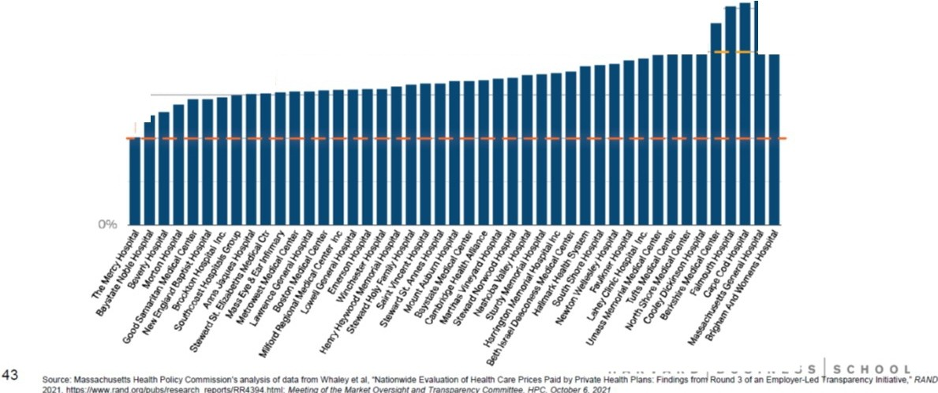
200% ---( ----------=-= . -
150% rEQ.UIVALENT TO MEDICARE
100%

50%

Plenty of price variation in Massachusetts too (1/2)

IInpatient prices relative to Medicare, by provider I
300o/o

250%

EQUIVALENT TO MEDICARE

DOUBLC MEDtCAAE 6 ,,.YMCNT

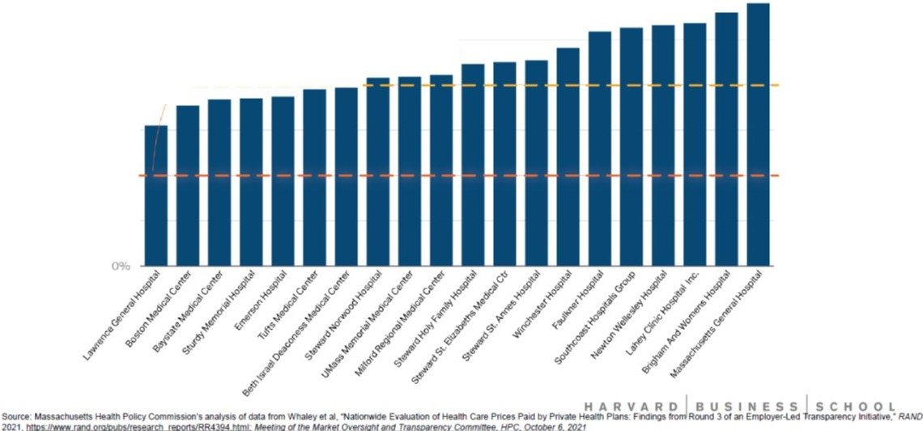
200% --/r------- -

150%

100%

50%

44

EXHIBIT 6
Aerial Map

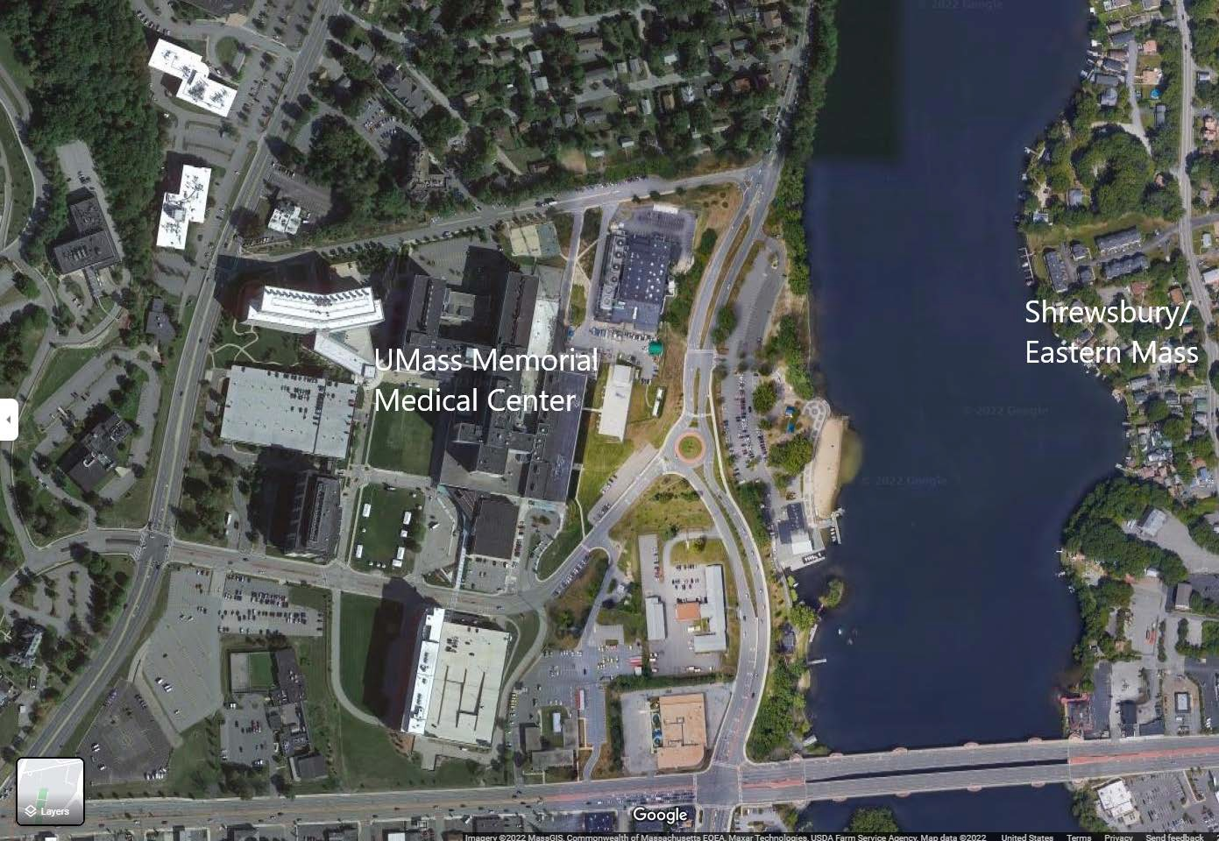

EXHIBIT 7
CHIA Analysis – Community Hospital Reliance on Outpatient Revenue

CHIA FY19 Hospital Profile Results
FY19-Massachusetts-Hospital-Profiles-Compendium.pdf (chiamass.gov)
MGB Facilities

AMCs:
IP NPSR per CMAD |  |  | OP Revenue
FY19  Inpatient Discharges | FY19 IP NPSR  per CMAD | % Changes  from FY18- FY19 | % OP  Revenue | FY19 Outpatient Revenue | % Changes  from FY18- FY19 | Total  Surplus(Deficit) in FY19
47,838 | 18,028 | 3.6% | 42.0% | 937,155,561 | 13.0% | 229,133,000
54,158 | 16,967 | 5.0% | 57.0% | 1,518,801,470 | 7.1% | 431,072,000
17,367 | 15,436 | 8.9% | 52.0% | 259,858,224 | 3.9% | 33,948,000
25,815 | 14,234 | 3.5% | 73.0% | 832,048,920 | 6.5% | 36,720,000
40,393 | 13,644 | -1.7% | 61.0% | 637,224,152 | 8.4% | 24,618,000
42,229 | 13,432 | 8.1% | 57.0% | 747,352,834 | 3.8% | 48,258,000
23,936 | 12,559 | 4.1% | 68.0% | 652,368,000 | 8.3% | 74,693,000
19,209 | 10,850 | -2.1% | 63.0% | 271,156,883 | 18.0% | 73,709,075
19,509 | 13,092 | 0.4% | 68.0% | 281,084,693 | 12.8% | (43,970,000)
9,817 | 12,250 | -6.3% | 63.0% | 161,618,126 | 12.6% | 23,631,000
14,215 | 11,160 | 3.1% | 69.0% | 148,201,952 | 2.7% | 8,774,000
11,390 | 10,478 | 3.6% | 66.0% | 131,610,993 | 2.4% | 7,002,145
7,833 | 9,301 | 1.9% | 73.0% | 136,384,289 | 7.8% | 26,448,113
9,861 | 8,434 | -2.0% | 73.0% | 141,936,702 | 5.4% | 13,865,242
7,857 | 8,157 | -12.4% | 69.0% | 104,511,688 | 9.7% | (8,211,000)
4,469 | 7,879 | 5.9% | 82.0% | 104,176,161 | -0.2% | 13,625,962
3,360 | 5,525 | -23.0% | 72.0% | 51,764,198 | 17.2% | 263,000

Brigham Womens Mass General Tufts Medical Boston Medical
Beth Israel Deconess Medical UMass Medical Center
Key Teaching Hosptials:
Lahey Hospital Saint Vincent
Key Community Hospitals:
Newton Wellesley
Brigham Women's Faulkner Winchester Hospital
MetroWest *
Sturdy *
Milford
HealthAlliance *
Harrington *
Marlborough Hospital *

* Community - High Public Payor Hospital

