Understanding and Responding to Opioid and Simulant Overdoses

1600
1400
Number of Deaths
1200
1000
800
600
400
200
0

Opioid and Stimulant-Related Deaths in MA

*

2009 2010 2011 2012 2013 2014 2015 2016 2017 2018 2019

Opioids Only Stimulants Only Opioids with Stimulants
* Deaths involving both opioids and stimulants have increased steadily from 125 in 2013 to 734 in 2019.

Source: Centers for Disease Control and Prevention, National Center for Health Statistics. Multiple Cause of Death 1999-2019 on CDC WONDER Online Database, released in 2020. Data are from the Multiple Cause of Death Files, 1999-2019, as compiled from data provided by the 57 vital statistics jurisdictions through the Vital Statistics Cooperative Program. Accessed at http://wonder.cdc.gov/mcd-icd10.html on Jul 9, 2021

Recognizing a Suspected Overdose
Opioid
- Blue lips and fingertips for light skin, gray or ashen for darker skin
- Pinpoint pupils
- Breathing slow, irregular, or stopped
- Pulse slow, erratic, or absent
- Nonresponsive to voice or sternal rub
Stimulant
- Hyperthermia (resident may be very hot)
- Mental distress (anxiety, paranoia, panic, hypervigilance, hallucinations)
- Dilated pupils
- Rapid breathing
- Rapid or irregular pulse
- Teeth grinding or erratic movements
- Hypertension, chest pain, tremors

Opioids

Responding to a Suspected Overdose
If non-responsive after 3 minutes, give another dose of Narcan
or CPR, if trained

Check for signs of an overdose
Call 9ll Give Narcan Begin rescue breaths
Stay with the person until help arrives

Stimulants

Attempt to de-escalate

Narcan only works on opioids;
however, if suspected exposure to opioids, administer Narcan

If suspected exposure to opioids and
non-responsive after 3 minutes, administer another dose of Narcan

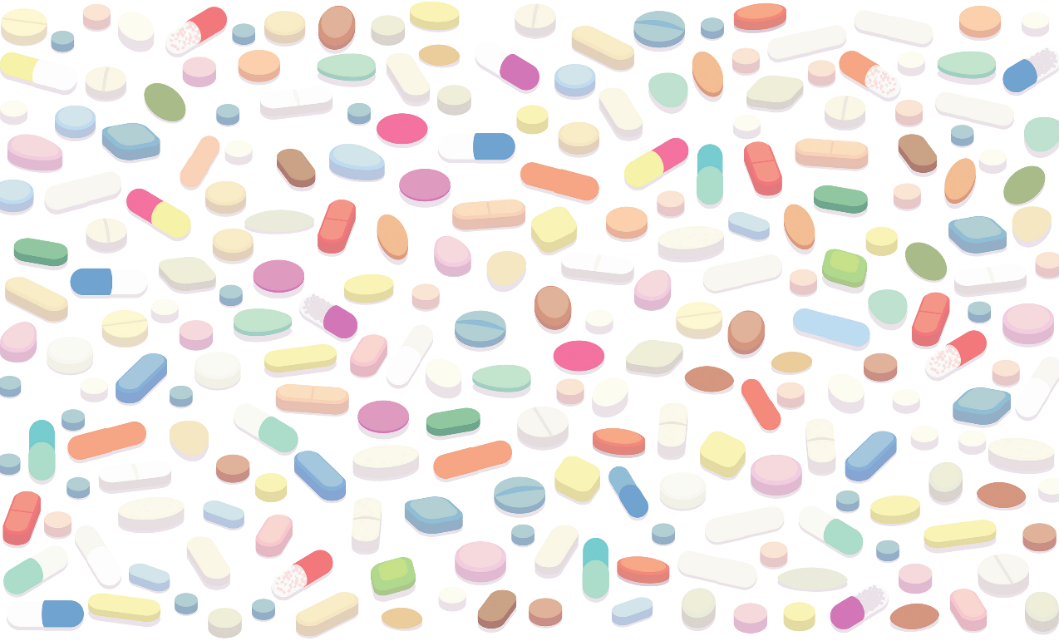
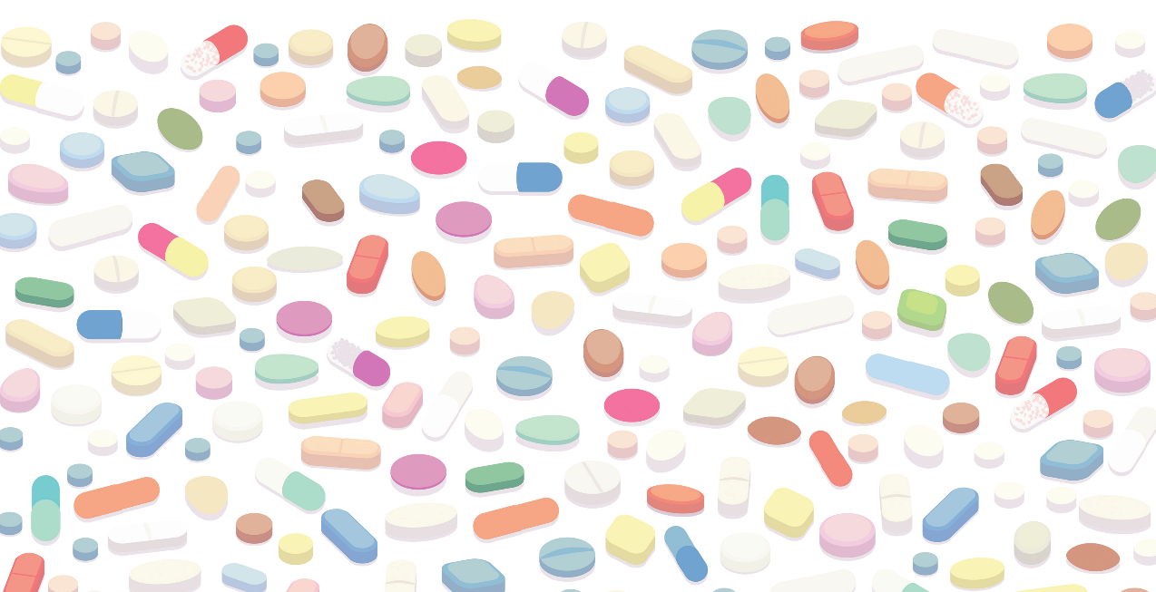
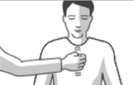
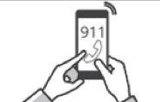
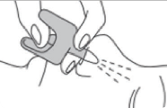
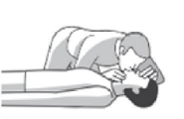
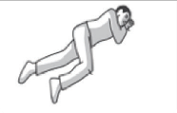
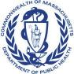
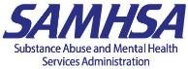
Source: www.mass.gov/narcan, visit for Spanish version

This document was modified from the Substance Abuse and Mental Health Services Administration (SAMHSA) Evidence-Based Resource Guide Series, Treatment of Stimulant Use Disorders https://store.samhsa.gov/sites/default/files/SAMHSA_Digital_Download/PEP20-06-01-001_508.pdf and
from the Boston Medical Center Office-Based Addiction Treatment Training and Technical Assistance presentation, Introduction to Methamphetamines, presented to the Lynn Health Center, May 10, 2021.

