Preliminary Report in Response to RFR BD-20-1065-MCB1-1-50101
Understanding the Delta Between Legal Blindness and Visual Impairments

Date of Report: October 15, 2020

Study Team Members:
Nicole C. Ross, OD, MS, Associate Professor New England College of Optometry
Tiffany Arango, MS, PhD Candidate 2021, Northeastern University
Kamila Osypiuk BS, OD Candidate 2023, New England College of Optometry
Cecilia Idman-Rait, MPH, Research Coordinator,New England College of Optometry
Nathan W. Skrocki, Program Officer, Massachusetts Commission for the Blind
Alexis G. Malkin, OD, Associate Professor, New England College of Optometry

ORIGINAL RFP EXCERPT:
“The Massachusetts Commission for the Blind’s Central Registry contains ~26,000 Consumers who are Blind. The American Community Survey indicates that Massachusetts contains ~125,477 individuals who have a vision disability. So, there are ~100,000 individuals in Massachusetts that may be or could be current and/or future consumers of our agency. MCB seeks an understanding and be provided a report that includes spreadsheets that has an analysis of best estimates in the amounts of individuals that we could potentially serve would inform us about coming trends in our programs and services.”

INTRODUCTION:

Most irreversible low vision conditions in the United States are caused by age-related eye diseases. These include age-related macular degeneration, diabetic retinopathy, and glaucoma as the most common (1). Eighty percent of Americans with low vision are over age 65 (2). Although the annual death rate in the elderly low vision population slows the rate of growth in prevalence, the aging of the U.S. population is accelerating as the generation known as the “baby boomers” move into their older years. Thus, the number of people with low vision is expected to double over the next two decades (1). We have previously conducted a meta-analysis using prevalence and incidence findings based on age and race, from major epidemiological studies, described by Massof et al.,(2) to predict the prevalence and incidence of visual impairment (i.e. low vision, with a visual acuity of 20/70 or worse) in older adults in Massachusetts. This was presented to the Massachusetts Commission for the Blind (MCB) in 2014. This model was constructed based on large population-based vision screening studies of the prevalence rate of low vision and blindness in the U.S. including: Baltimore Eye Survey, Framingham Eye Study, Beaver Dam Eye Study, Mud Creek Valley Study and the Salisbury Eye Study. This model does consider race, as conditions such as glaucoma and macular degeneration are more prevalent among certain groups. A limitation of this previous work was the lack of epidemiological studies specific to the Latinx population.

Our previously presented analysis revealed that, based on 2010 U.S. census data (3), the prevalence of visual impairment in Massachusetts in 2010 was 55,866 with an annual incidence rate of 10,204. Using U.S. census models for predicting population growth (3), (refer to Appendix 3 in US 2010 census), the prevalence of low vision in Massachusetts is expected to have grown to 62,722 with an increasing annual incidence of 11,370. Prevalence and incidence rates are also shown by county (Table 1) and by the MCB region (Table 2). The county with the highest prevalence and incidence rates is Middlesex county, representing the “Greater Boston MCB region.”

County | Total Prevalence  of Low Vision 2010 | Estimated Total  Prevalence of Low Vision 2020 | Annual Incidence  of Low Vision 2010 | Estimated Annual  Incidence of Low Vision 2020
Suffolk | 4,850 | 5,543 | 825 | 934
Middlesex | 12,008 | 13,466 | 2,185 | 2,435
Essex | 6,587 | 7,373 | 1,212 | 1,347
Norfolk | 6,160 | 6,896 | 1,136 | 1,263
Worcester | 6,441 | 7,192 | 1,175 | 1,305
Bristol | 4,830 | 5,398 | 896 | 995
Plymouth | 4,001 | 4,528 | 702 | 789
Barnstable | 3,054 | 3,441 | 595 | 661
Berkshire | 1,512 | 1,690 | 291 | 322
Dukes | 155 | 174 | 28 | 32
Franklin | 655 | 732 | 122 | 135
Hampden | 4,291 | 4,813 | 791 | 879
Hampshire | 1,251 | 1,396 | 233 | 258
Nantucket | 70 | 80 | 12 | 14
Boston City (part of Suffolk county) | 3,377 | 3,887 | 560 | 637
TOTAL | 55,866 | 62,722 | 10,204 | 11,370
Table 1. Prevalence and Incidence of Age Related Visual Impairment by County

Table 2 describes the incidence and prevalence of low vision by MCB region and the number of legally blind individuals in those regions, according to the 2012 registry report. In this earlier analysis, legally blind individuals represented less than 50% of the total population of individuals with vision impairment and annual incidence based on the figures posted in Table 2.

MCB Region | Total  Predicted  Low Vision  Prevalence 2010 | Prevalence of  Legal  Blindness per  2012 MCB  Registry | Estimated  Prevalence  of Low  Vision 2020 | Total  Annual  Incidence  of Low Vision 2010 | Total  Incidence  of Legal  Blindness per MCB 2012  Report | Estimated  Annual  Incidence  of Low Vision 2020
Western MA | 7,709 | 4073 | 8,631 | 1,437 | 333 | 1,594
Central MA | 6,441 | 3856 | 7,192 | 1,175 | 264 | 1,305
Northeastern MA | 6,587 | 5322 | 7,373 | 1,212 | 403 | 1,347
Greater Boston | 18,168 | 5673 | 20,362 | 3,321 | 407 | 3,698
Southeastern MA  and Islands | 12,111 | 5539 | 13,621 | 2,233 | 444 | 2,490
Boston | 4,850 | 3598 | 5,543 | 825 | 225 | 934
Total | 55,866 | 28,061 | 62,722 | 10,204 | 2,076 | 11,370
Table 2. Prevalence and Incidence of Low Vision and Legal Blindness by MCB region

The present analysis will help to identify the current number of people with vision impairment, and the expected increase in cases as this population ages. By identifying the number of people with low vision, the Massachusetts Commission for the Blind can more adequately prepare for low vision rehabilitation in the near future. Low vision rehabilitation can be highly effective in restoring the ability of visually impaired and blind people of all ages to function in everyday life (4), but the availability of low vision rehabilitation services is inadequate to meet the current need, and no national plan exists to address the growing demand for services that is nation-wide. Plans must be made to increase providers, clinicians and services available to suit the growing demands.

A recently published epidemiological survey by David B. Rein, et al. (5) has included cross-sectional analyses of major national surveys of vision impairment. The range of those with vision impairment varies depending on the study and the methodology but there is a clear increase after the age of 65. For those under 65, the prevalence of blindness ranges from 0.1-5.6% and increases to up to 16.6% after age 65. Visual impairment ranges from 1.6-24.8% in those under 65 and 2.2% to 26.6% over age 65. The NHANES (6) study found that in the US, approximately 7% of the total population is visually impaired or blind (worse than 20/40) and this matched very closely with self-report in the same population. This is similar to the prevalence numbers as reported by Chan, et al in 2018 (7) and Swenor, et al in 2019 (8). Our model and analysis of Massachusetts data has been informed by the major epidemiological studies available on US populations with vision impairment.

The Massachusetts Commission for the Blind (MCB) has a large database of registered individuals who have been identified as legally blind by a healthcare provider. These individuals are categorized as either vocational (typically under age 55 but includes anyone with a work-related goal) or social rehabilitation (typically over age 55). All individuals in the Massachusetts registry must meet legal blindness standards as delineated by the Social Security Administration. This means that they must have best corrected visual acuity of less than 20/200 (or worse than 20/100 if measured on an ETDRS or electronic eye chart) in the better seeing eye, visual field of less than 20 degrees in the better seeing eye, or be declared legally blind based on the following statement “standard acuity testing is impossible or unreliable, and in my medical opinion, the functional vision is at the level of legal blindness as defined above.”

METHODS:
The MCB Project Manager directed a search of the files in MCB’s central database and case management system, called AWARE (Accessible Web-Based Activity and Reporting Environment). AWARE holds a total of seven years of data. Cases registered with MCB up to September 4, 2020 were included in the analysis. Variables extracted from AWARE include:program (Social Rehabilitation-SR or Vocational Rehabilitation-VR), county, age, diagnosis, gender, etiology, SSD/SSI status, and case closure outcome. It is important to note, that due to limitations in the AWARE system, not all data could be extracted at a given time, and thus MATLAB and additional coding strategies were utilized to link de-identified data sets.
Gap Analysis:
Utilizing data from the US 2010 Census and the predictions therein for the 2020 US Census for the state of Massachusetts, we were able to tabulate the number of older individuals in the following age categories by gender and race: 40-44, 45-49, 50-54, 55-59, 60-64, 65-69, 70-74, 75-79, 80-84 and 85+ years. A model to predict age related vision loss by age group, race and gender described by Massof et al. (2) was applied. This data was then compared to the age-related cases of legal blindness in the MCB aware system. Members of the study team also contacted the authors of the Latino Eye Study to better estimate the prevalence of vision impairment among this group. This analysis is ongoing and is not included in this preliminary report. Figures 1 and 2 illustrate the model for predicted prevalence and incidence of visual impairment by age and race as described by Massof et al.(2)

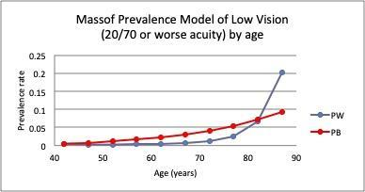
Figure 1. Predicted prevalence rate by age and race (PW = Caucasian, PB= African American) for permanent visual impairment, defined as a visual acuity worse than 20/70 in the better seeing eye, as described by Massof et al. (2)

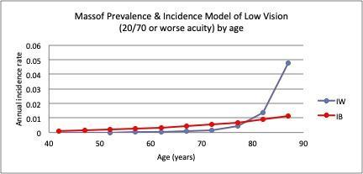
Figure 2. Predicted incidence rate by age and race (PW = Caucasian, PB= African American) for permanent visual impairment, defined as a visual acuity worse than 20/70 in the better seeing eye, as described by Massof et al. (2)

Exploring Risk Factors of Legal Blindness:
Case diagnoses and etiologies from the MCB AWARE dataset were then interpreted clinically by study team members and classified utilizing a data dictionary. Subsequently a MATLAB code was constructed to uniformly apply this clinical decision making into one of the following categories: age related, hereditary, infectious, neoplasm, systemic disease, toxicity, trauma or unspecified. Type of vision impairments by their categorical etiology were then compared by county. Additionally, type of vision loss was considered, cases were classified as the following types: congenital, acquired or unspecified by a similar approach. A multinomial logistic regression was performed to explore the potential predictors of legal blindness. Potential predictors considered in the analysis included: program type (VR or SR), age, race and gender. County was also considered as a predictor in a subset of the analysis. We intend to explore this further, pending access to additional data by the MCB Program Officer.

Exploring Risk Predictors of Rehabilitation Success:
A logistic regression was performed to explore the potential predictors of rehabilitation success in VR cases. Outcome variables for the analysis included a closure status as “closed” with details in the closure reason indicating a successful case closure (yes/no binary outcome). It is worth noting, that many of the cases in the current de-identified dataset had missing data in regards to case closure, and thus we are awaiting further datasets from the Program Officer in hopes to reduce the instances of missing data. In this preliminary analysis, potential predictors considered included: county age, race, etiology, gender and whether it was a progressive or non-progressive condition. We intend to explore this further, pending access to additional data by the Program Officer.

PRELIMINARY RESULTS:
Updated Gap Analysis:
In exploring the potential gap between visual impairment and legal blindness, the comparison of our model of visual impairment to MCB AWARE case data continues to illustrate that legal blindness represents 50% of all visual impairment cases. The difference in this gap is largest in the highest age category of individuals 85 and older. However, this analysis assumes all providers successfully report 100% of all cases of legal blindness, which may not be true. Figures 3 through 7, illustrate the predicted prevalence of vision impairment in 2010, the predicted prevalence of vision impairment in 2020, and the number of cases of legal blindness by age category for the five most populous counties in Massachusetts.
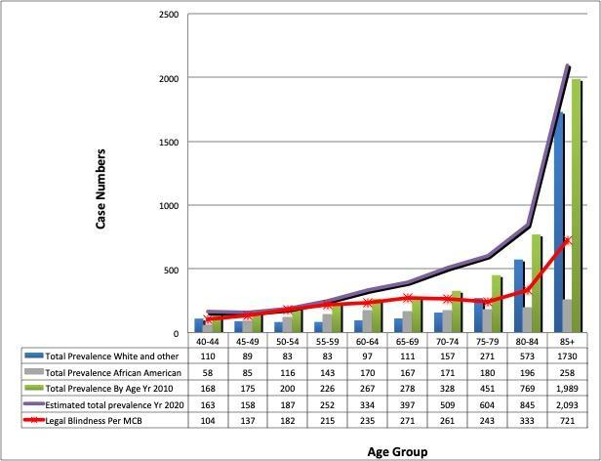
Figure 3. Prevalence Suffolk County. Predicted prevalence rate by age and race for permanent visual impairment (2020 prevalence = purple line), defined as a visual acuity worse than 20/70 in the better seeing eye, as described by Massof et al. (2) plotted on the same graph as the reported legal blindness cases for Suffolk county (red line).

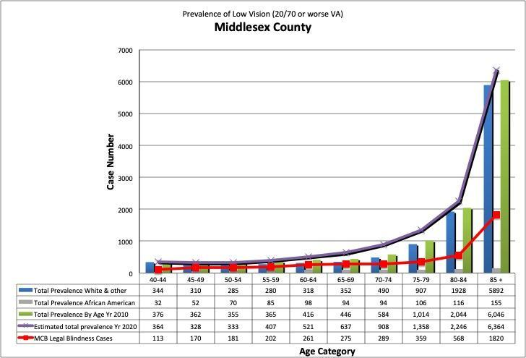
Figure 4. Prevalence Middlesex County. Predicted prevalence rate by age and race for permanent visual impairment (2020 prevalence = purple line), defined as a visual acuity worse than 20/70 in the better seeing eye, as described by Massof et al. (2) plotted on the same graph as the reported legal blindness cases for Middlesex county (red line).
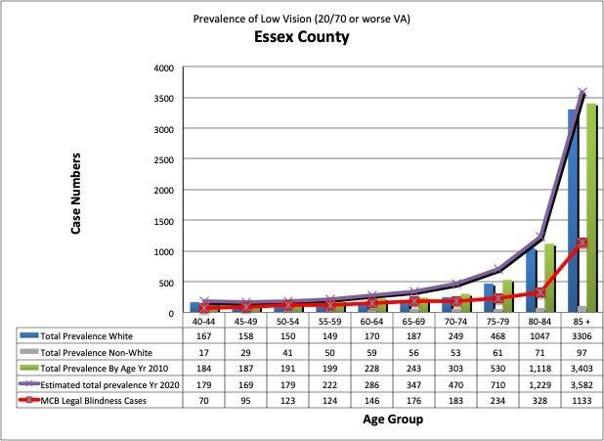
Figure 5. Prevalence Essex County. Predicted prevalence rate by age and race for permanent visual impairment (2020 prevalence = purple line), defined as a visual acuity worse than 20/70 in the better seeing eye, as described by Massof et al. (2) plotted on the same graph as the reported legal blindness cases for Essex county (red line).
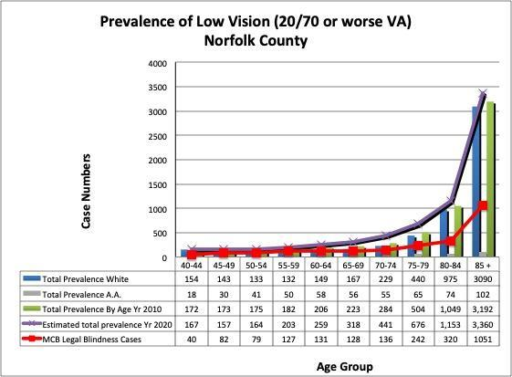
Figure 6. Prevalence Norfolk County. Predicted prevalence rate by age and race for permanent visual impairment (2020 prevalence = purple line), defined as a visual acuity worse than 20/70 in the better seeing eye, as described by Massof et al. (2) plotted on the same graph as the reported legal blindness cases for Norfolk county (red line).

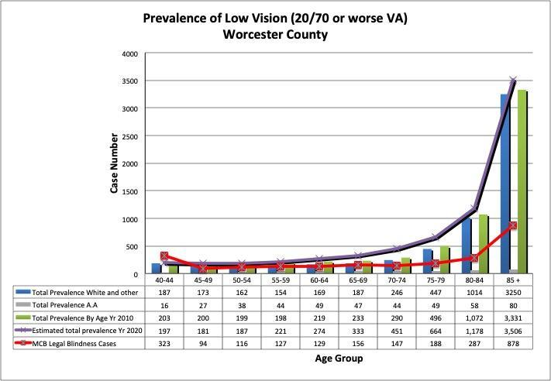
Figure 7. Prevalence Worcester County. Predicted prevalence rate by age and race for permanent visual impairment (2020 prevalence = purple line), defined as a visual acuity worse than 20/70 in the better seeing eye, as described by Massof et al. (2) plotted on the same graph as the reported legal blindness cases for Worcester county (red line).

Understanding Cases of Legal Blindness in Massachusetts:
In exploring the number of persons with legal blindness in Massachusetts, Table 4 details the percent of cases by county and program (VR or SR) with a progressive ocular diagnosis and/or etiology. On average 7% of persons with legal blindness have a progressive condition, and this is also true when looking at individuals in the VR or SR programs. Figure 8 illustrates these percentages by county as a heat map; Middlesex county far exceeds the others with 19% of cases having progressive vision loss. In exploring the etiologies associated with progressive vision loss, the most common cause was age-related eye disease accounting for 65% of cases, followed by systemic etiologies (13.5% of cases), and hereditary etiologies (also 13.5% of cases). Middlesex county also has a significantly older population than the other counties according to 2010 census data.
% Progressive Legal Blindness by County and Case Type
County | Total Cases | SR Cases | VR Cases
Barnstable | 4.7 | 5 | 2.4
Berkshire | 2.3 | 2.4 | 1.6
Bristol | 9 | 9.2 | 7.6
Dukes | 0.1 | 0.2 | 0.1
Hampden | 8.9 | 9.1 | 7.3
Hampshire | 2.2 | 2.2 | 2.3
Franklin | 1 | 1 | 1.3
Plymouth | 7.7 | 8.1 | 5.5
Norfolk | 10.3 | 10.5 | 8.6
Nantucket | 0 | 0 | 0.1
Middlesex | 19 | 18.5 | 22.6
Suffolk | 12.4 | 12 | 14.9
Worcester | 10.1 | 9.9 | 12.2
Essex | 12 | 11.8 | 13.6
Table 4. Percent of cases by county and program (VR or SR) with a progressive ocular diagnosis and/or etiology.
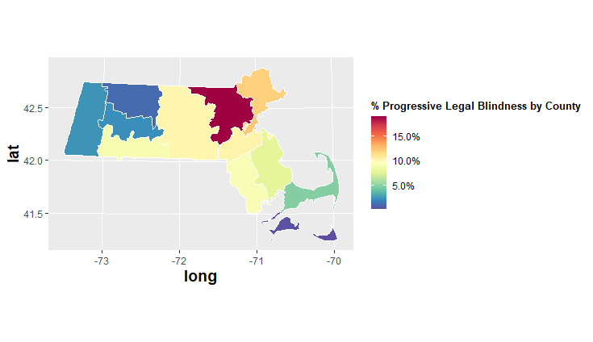
Figure 8. Percent of progressive vision loss cases of legal blindness. Heat map illustrating the percent of individuals with a progressive ocular condition by county. Middlesex county far exceeds the others in the number of cases of progressive vision loss.

Similar to the predicted models for the prevalence of vision impairment, exploration of legal blindness cases by age (Figure 9) reveals increasing prevalence with age, with a significantly large increase in the 85 and older group.

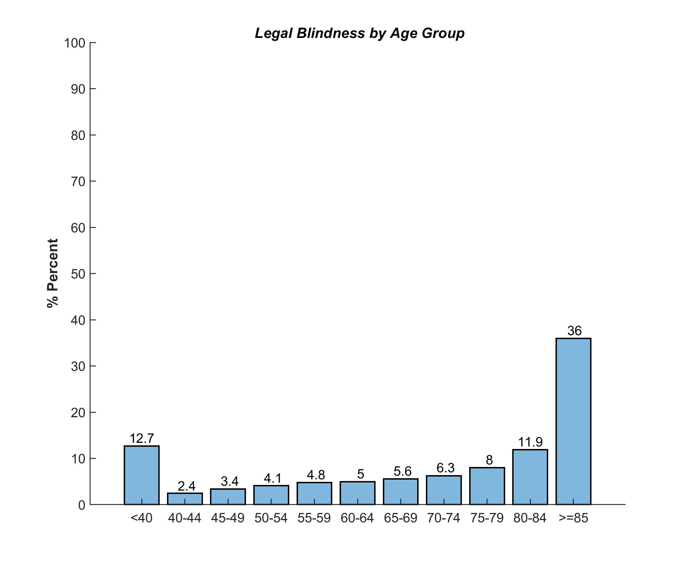
Figure 9. Cases of legal blindness by age. Prevalence of legal blindness increases with advanced age, with individuals 85 and older representing the highest number of cases.

However, when comparing those in the VR vs. SR programs (Figure 10), the populations are quite different, with most of the cases in the VR program occurring in individuals 40 and younger.
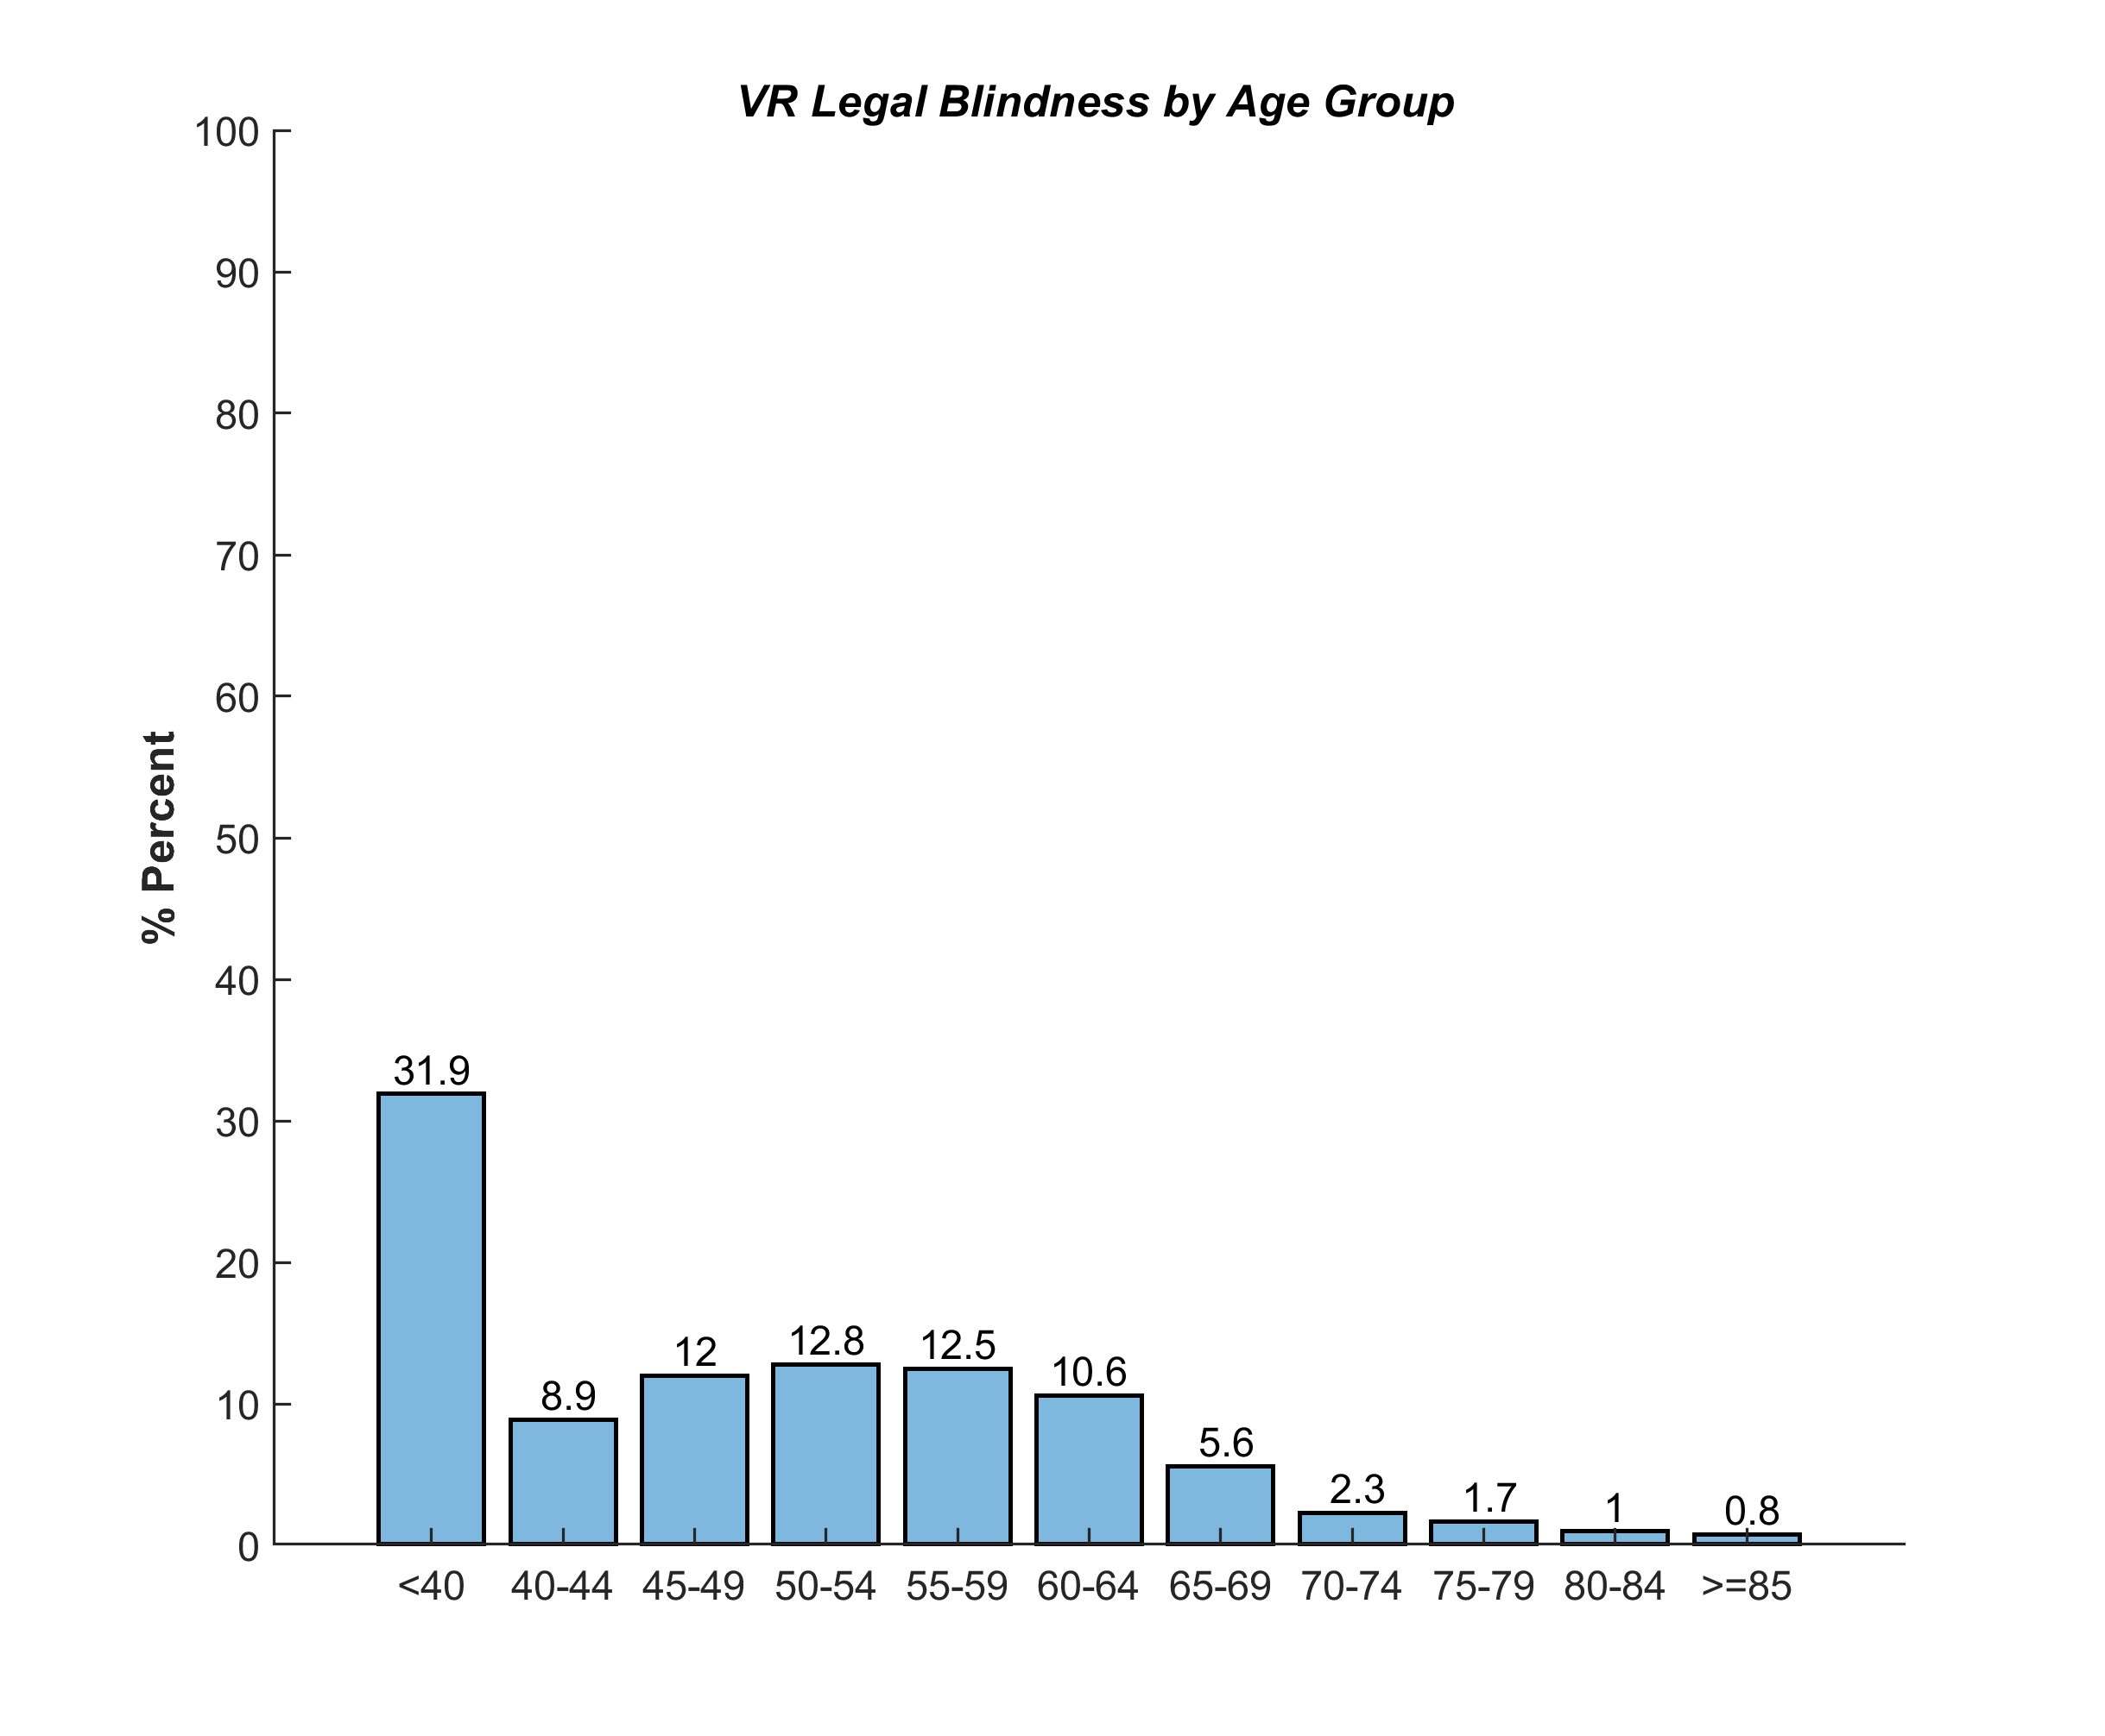 | 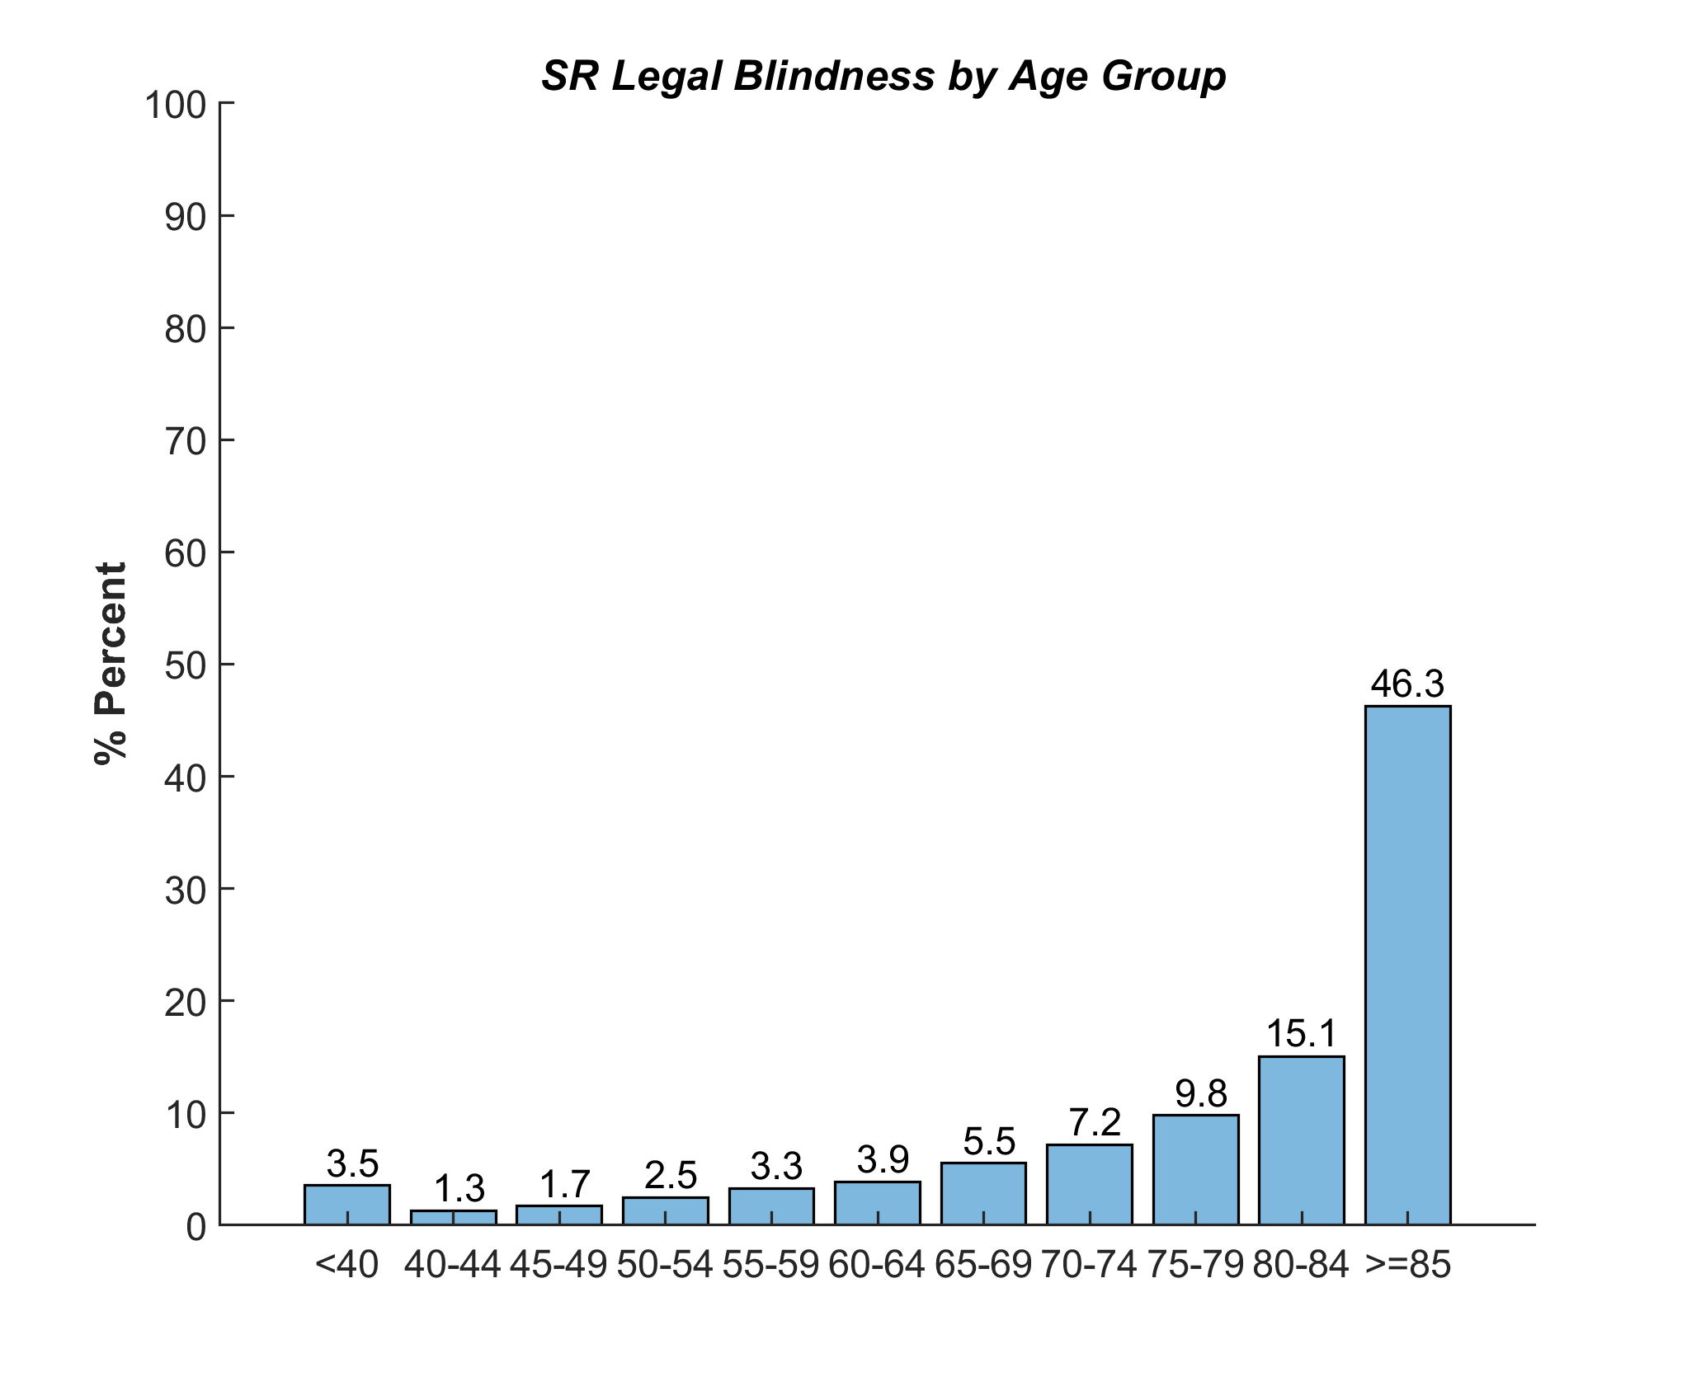
(A) (B)
Figure 10. Cases of legal blindness by age and program (A) Individuals in the Vocational Rehabilitation Program (VR),(B) Individuals in the Social Rehabilitation Program (SR). Prevalence of legal blindness increases with increasing age in SR, where most cases in VR age occur under 40 years of age.

In exploring the overall etiologies of vision loss by county, delineated in Table 5 and Figure 11, age related vision impairment exceeds any other etiology in every county in Massachusetts.

Legal Blindness by County and Etiology Type (Total Population from 2019 estimated Census Data)
County | Total Population | Acquired | Age-related | Congenital | Toxicity | Trauma | Hereditary | Unspecified | Systemic Disease | Neoplasm | Infectious
Barnstable | 212,990 | 4 | 93 | 0 | 0 | 2 | 7 | 6 | 18 | 0 | 1
Berkshire | 124,944 | 3 | 59 | 0 | 0 | 1 | 9 | 7 | 2 | 0 | 1
Bristol | 565,217 | 5 | 125 | 0 | 1 | 1 | 27 | 36 | 33 | 2 | 1
Dukes | 17,332 | 1 | 1 | 0 | 0 | 0 | 0 | 0 | 0 | 0 | 0
Hampden | 466,372 | 8 | 127 |  | 3 | 4 | 32 | 22 | 33 | 4 | 1
Hampshire | 160,830 | 3 | 48 | 0 | 0 | 0 | 13 | 4 | 5 | 2 | 0
Franklin | 70,180 | 0 | 22 | 0 | 0 | 0 | 11 | 5 | 5 | 0 | 0
Plymouth | 521,202 | 7 | 139 | 0 | 0 | 1 | 35 | 23 | 33 | 4 | 0
Norfolk | 706,775 | 11 | 151 | 0 | 0 | 0 | 53 | 38 | 31 | 2 | 3
Nantucket | 11,399 | 1 | 2 | 0 | 0 | 0 | 0 | 0 | 0 | 0 | 0
Middlesex | 1,611,699 | 13 | 302 | 1 | 2 | 2 | 101 | 63 | 65 | 7 | 2
Suffolk | 803,907 | 11 | 139 | 0 | 0 | 1 | 61 | 41 | 65 | 5 | 3
Worcester | 830,622 | 10 | 133 | 0 | 1 | 2 | 35 | 27 | 41 | 5 | 1
Essex | 789,034 | 10 | 196 | 0 | 0 | 2 | 5523 | 0 | 32 | 0 | 2
Table 5. Cases of legal blindness by etiology and county. Age related vision impairment accounts for the majority of legal blindness in every county.

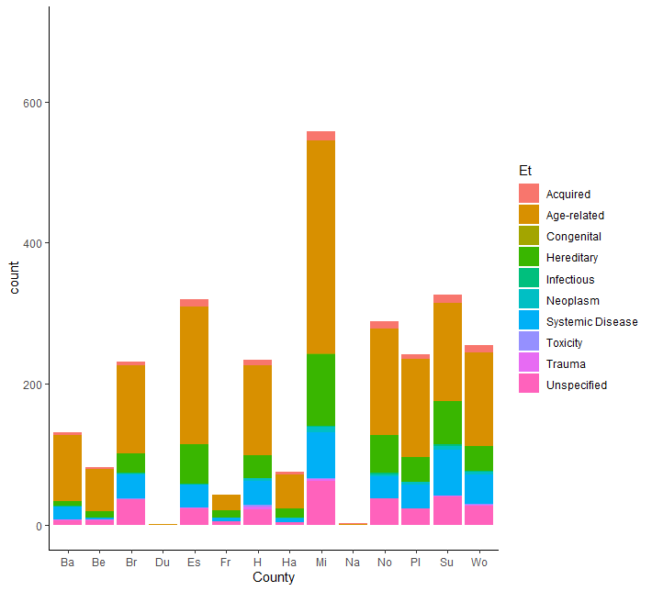
Figure 11. Cases of legal blindness by etiology (Et). Age related causes of legal blindness account for the majority of cases.

Risk Factors of Legal Blindness:
In exploring predictors associated with cases of legal blindness, results from a multinomial logistic regression indicated that case type, age, race and gender were significant predictors of legal blindness. Table 6 reports the relative risk of legal blindness in comparison to the reference group. Relative risk ratios greater than one indicate elevated risk, and relative risk ratios less than one indicate reduced risk (i.e. protective). As indicated by the relative risk ratios, younger individuals had a lower risk of having an acquired cause of visual impairment. Asian individuals were less likely to have congenital compared to acquired causes of visual impairment. African Americans and Hispanic or Latinx individuals were less likely to have a congenital compared to acquired cause of visual impairment in comparison to white individuals. Surprisingly, males were more likely to have legal blindness than females, and this is also illustrated by Figure 12. This result was not expected as it is known that females are more likely to report to low vision rehabilitation clinics(1). Thus males with legal blindness and vocational goals may represent an underserved population.
Multinomial Logistic Regression-Relative risk ratio* for p < 0.05
Outcome variable | Congenital vs Acquired | Unspecified vs Acquired
Age | 0.93* | 0.96*
VR vs SR | 0.68* | 0.96
Asian vs White | 0.56* | 1.05
Black/AA vs White | 0.64* | 0.87
Hispanic/Latino vs White | 0.41* | 0.86
Multiple vs White | 0.61* | 0.83
Other vs White | 1.12 | 0.91
Male vs Female | 1.07 | 1.34*
Table 6. Relative Risk ratios for predictors of legal blindness, * indicates a significant predictor.

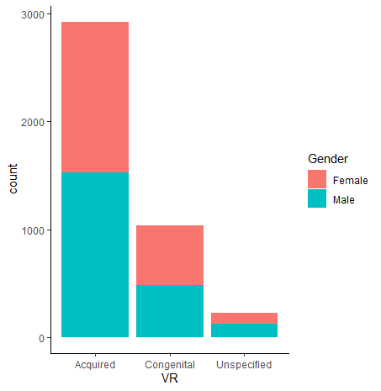
Figure 12. Cases of legal blindness by gender in VR Program. Males (males n=2140, female n= 2048) account for the majority of legal blindness cases, most having acquired causes of vision loss.
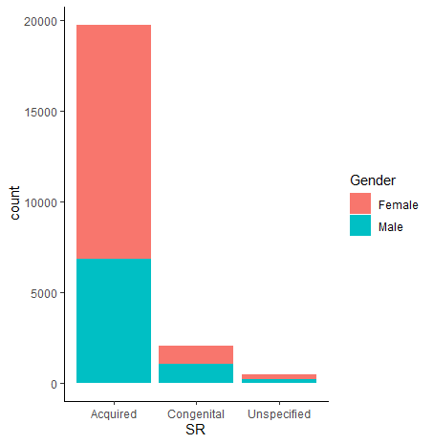
Figure 13. Cases of legal blindness by gender in SR Program. Females (females n=14,136, males n= 8,160) account for the majority of legal blindness cases, most having acquired causes of vision loss. Females have a slightly higher incidence of congenital vision impairment.

In further exploring the causes of visual impairment, relative to people in Suffolk county, those living in Duke county had an increased relative risk (9.43) of having a congenital rather than an acquired visual impairment.. Residents of Hampden and Hampshire counties also had a relative risk ratio >1, indicating more likelihood of a congenital vision impairment (Hampden 1.21, Hampshire 1.20). This is further delineated in Table 7.

Multinomial Logistic Regression-Relative risk ratio* for p < 0.05
Outcome variable | Congenital vs Acquired | Unspecified vs Acquired
Age | 0.96* | 0.98*
Barnstable vs Suffolk | 0.67 | 0.83
Bristol vs Suffolk | 0.90 | 1.25
Berkshire vs Suffolk | 0.60 | 1.09
Franklin vs Suffolk | 0.67 | 3.30*
Dukes vs Suffolk | 9.43* | 0.0002*
Essex vs Suffolk | 0.71* | 1.23
Middlesex vs Suffolk | 0.98 | 1.13
Hampden vs Suffolk | 1.21* | 1.57*
Hampshire vs Suffolk | 1.20 | 2.10
Norfolk vs Suffolk | 0.97 | 1.90*
Nantucket vs Suffolk | 0* | 0*
Plymouth vs Suffolk | 0.90 | 1.07
Worcester vs Suffolk | 0.60* | 1.64
Table 7. Relative risk of legal blindness in VR cases by type (acquired, congenital, unspecified) and by county in reference to Suffolk county.

Predictors of Rehabilitation Success:
Here we report the risk factors associated with rehabilitation success. It is important to note that the following analysis is very much preliminary, as many of the cases received from the AWARE export display missing data. This was especially true for cases in the SR program. We are continuing to work with the Program Officer to reduce the instances of missing data where possible.

The following analysis was completed with VR cases (as this dataset was mostly complete) to explore predictors of rehabilitation success. A logistic regression exploring predictors of county, age, race, and progressive vs. non-progressive etiology was performed. Results from the regression indicate that the odds of men having success in the vocational rehabilitation program were 20% less than for women (OR=0.79, p<0.05). Additionally, older age was associated with increased odds of successful rehabilitation (each one unit change in age has an 0.03 increase in log odds, p<0.0001). However, while significant, the log odds are small with each increasing unit of age, and thus additional analyses exploring the age categories will be performed and discussed in a future progress report.

Interestingly, those with hereditary eye disease had the most success in the vocational rehabilitation program, and those in Hampshire county were 80% more likely to have success in the VR program compared to Suffolk county residents (OR= 1.80). Those in Hampden county were also 21% less likely to be progressively legally blind than those residents of Suffolk county. This effect of county of residence needs to be further explored in larger data sets with reduced instances of missing data.

SUMMARY AND RECOMMENDATIONS:
While this initial report revealed some interesting findings, further data analysis is currently being conducted to draw appropriate conclusions. While the gap between visual impairment and legal blindness continues to be around 50%, there continues to be a potential underreporting bias in legal blindness cases. With further support and funding, the study team suggests that additional analysis be conducted to explore those eye care providers who consistently register individuals with MCB, by specialty (retina, glaucoma, anterior segment, etc). This can then be compared with the current analysis of cases of legal blindness by diagnosis and categorical etiology to determine if a specific group of eye care providers might benefit from further awareness and continuing education programs regarding low vision rehabilitation services. A targeted effort can then be made to present at upcoming continuing education events that those providers might attend.

With respect to the potential predictors of legal blindness in Massachusetts, our preliminary analysis is consistent with previous reports that age related vision loss is the primary cause of vision impairment and increases most sharply in prevalence in individuals 85 years and older. Race was also a significant predictor for progressive and etiology of vision loss.

For those in the vocational rehabilitation program we were able to explore factors associated with rehabilitation success. While there are more men registered in the vocational rehabilitation program, they are less likely to be successful in vocational rehabilitation. This may represent an opportunity for future targeted interventions. However, the current dataset was missing rehabilitation case closure reason for more male individuals than female. Additionally, patients who reside in Hampshire county were most likely to be successful in the program (p=0.05).

References:
- Goldstein JE, Massof RW, Deremeik JT, Braudway S, Jackson ML, Kehler B, et al. Baseline traits of low vision patients served by private outpatient clinical centers in the United States. Archives of Ophthalmology. 2012;130(8):1028-37.
- Massof RW. A model of the prevalence and incidence of low vision and blindness among adults in the U.S. Optometry and Vision Science. 2002 Jan;79(1):31-8.
- 2010 United States Census [September 2014]. Available from: http://quickfacts.census.gov/qfd/states/25/25019.html.
4. Stelmack JA, Szlyk JP, Stelmack TR, Demers-Turco P, Williams RT, Moran DA, et al. Measuring outcomes of vision rehabilitation with the veterans affairs low vision visual functioning questionnaire Investigative Ophthalmological & Visual Science. 2006;August;47(8):3253-61.
- Rein DB, Lamuda PA, Wittenborn JS, Okeke N, Davidson CE, Swenor BK, Saaddine J, Lundeen EA. Vision Impairment and Blindness Prevalence in the United States: Variability of Vision Health Responses across Multiple National Surveys. Ophthalmology. 2020 Jul 11:S0161-6420(20)30673-4.
6. National Health and Nutrition Examination Survey. Centers for Disease Control and Prevention: Vision and Eye Surveillance System. (2009)
7. Chan T, Friedman DS, Bradley C, Massof R. Estimates of Incidence and Prevalence of Visual Impairment, Low Vision, and Blindness in the United States. JAMA Ophthalmol. 2018;136(1):12-19. doi:10.1001/jamaophthalmol.2017.4655
8. Swenor BK, Wang J, Varadaraj V, et al. Vision Impairment and Cognitive Outcomes in Older Adults: The Health ABC Study [published correction appears in J Gerontol A Biol Sci Med Sci. 2019 Jan 14;:]. J Gerontol A Biol Sci Med Sci. 2019;74(9):1454-1460. doi:10.1093/gerona/gly244

