COMMONWEALTH OF MASSACHUSETTS

AND

LOCAL S-28 & S-29 OF THE

INTERNATIONAL ASSOCIATION OF FIRE FIGHTERS

COLLECTIVE BARGAINING AGREEMENT

January 1, 2015 –December 31, 2017
TABLE OF CONTENTS

SUBJECT PAGE

PREAMBLE 3

ARTICLE 1 RECOGNITION 4
ARTICLE 2 MANAGERIAL RIGHTS/PRODUCTIVITY 4
ARTICLE 2A RULES AND REGULATIONS 5
ARTICLE 3 UNION SECURITY 5
ARTICLE 4 AGENCY FEE 7
ARTICLE 5 UNION BUSINESS 8
ARTICLE 6 ANTI-DISCRIMINATION/AFFIRM. ACTION 11
ARTICLE 7 WORKWEEK AND WORK SCHEDULES 12
ARTICLE 8 LEAVE 15
ARTICLE 9 VACATIONS 30
ARTICLE 10 HOLIDAYS 33
ARTICLE 11 EMPLOYEE EXPENSES 35
ARTICLE 12 SALARY RATES 35
ARTICLE 13 GROUP HEALTH INSURANCE CONTRIBUTIONS 37
ARTICLE 13A HEALTH AND WELFARE 37
ARTICLE 13B TUITION REMISSION 38
ARTICLE 14 PROMOTIONS 39
ARTICLE 15 CONTRACTING OUT 41
ARTICLE 16 OUT OF TITLE WORK 42
ARTICLE 17 CLASSIFICATION/RE-CLASSIFICATION 43
ARTICLE 17A TECHNOLOGICAL CHANGE 44
ARTICLE 18 LAY-OFF PROCEDURE 47
ARTICLE 19 SAFETY AND HEALTH 49
ARTICLE 20 MANAGEMENT DIRECTIVES 50
ARTICLE 21 TRAINING AND CAREER LADDERS 50
ARTICLE 22 CREDIT UNION DEDUCTION 51
ARTICLE 23 ARBITRATION OF DISCIPLINARY ACTION 52
ARTICLE 23A GRIEVANCE PROCEDURE 53
ARTICLE 24 PERSONNEL RECORDS 56
ARTICLE 24A PERFORMANCE EVALUATION 57
ARTICLE 25 LABOR/MANAGEMENT COMMITTEE 60
ARTICLE 26 NO STRIKES 60
ARTICLE 27 SAVINGS CLAUSE 60
ARTICLE 28 DURATION 61
ARTICLE 29 APPROPRIATION BY THE GENERAL COURT 61
ARTICLE 30 DRUG FREE WORKPLACE PROGRAM 61
ARTICLE 31 PHYSICAL FITNESS STANDARDS 65

SUBJECT PAGE

APPENDIX A SALARY RATES 68
APPENDIX B GRIEVANCE REPORT 72

M.O.U. 104th Fighter Wing Fire Department 74
M.O.U./Appendix Local S29 Recognition 79
M.O.U. Employer’s Adoption Assistance Program 81
M.O.U. Uniforms and Appearance 82
M.O.U. Uniforms Allowance, S-28 83
M.O.U. Uniforms Allowance, S-29 84

PREAMBLE

This Collective Bargaining Agreement entered into this 22nd day of December, 2015 by the Commonwealth of Massachusetts acting through the Commissioner of Administration and Finance and his/her Human Resources Division, hereinafter referred to as the “Employer”, or the “Commonwealth”; and by Local S-28 and S-29, International Association of Fire Fighters, hereinafter referred to as the “Union” or “Local S28” or “Local S29”; and has as its purpose the promotion of harmonious relations between the Union and the Employer. To this end, the parties recognize the importance of dealing with one another with mutual respect and dignity.

ARTICLE 1
RECOGNITION

Section 1
The Commonwealth recognizes the Union as the exclusive collective bargaining representative of employees of the Commonwealth as certified by the Division of Labor Relations.

In order to establish and maintain clear and concise employee/labor relations policy, the parties agree that the Human Resources Division, on behalf of the Secretary for Administration and Finance, is solely responsible for the development and implementation of all employee relations policies. Only the Human Resources Division has the authority to make commitments or agreements with respect to wages, hours, standards of productivity, performance and any other terms and conditions of employment, with the Union as the exclusive union representative.

Section 2
A. As used in this contract the term "employee" or "employees" shall include:

full-time persons employed by the Commonwealth.

B. Exclusion: all managerial and confidential employees;

C. A full-time employee is defined as an employee who normally works a full
workweek and whose employment is expected to continue for twelve (12) months or more, or an employee who normally works a full workweek and has been employed for twelve (12) consecutive months or more.

ARTICLE 2
MANAGERIAL RIGHTS/PRODUCTIVITY

Section 1
Except as otherwise limited by an express provision of this Agreement, the Employer shall have the right to exercise complete control and discretion over its organization and technology including but not limited to the determination of the standards of services to be provided and standards of productivity and performance of its employees; establish and/or revise personnel evaluation programs; the determination of the methods, means and personnel by which its operations are to be conducted; the determination of the content of job classifications; the appointment, promotion, assignment, direction and transfer of personnel; the suspension, demotion, discharge or any other appropriate action against its employees; the relief from duty of its employees because of lack of work or for other legitimate reasons; the establishment of reasonable work rules; and the taking of all necessary actions to carry out its mission in emergencies.

Section 2
Delivery of services to the public in the most efficient, effective, and productive manner is of paramount importance to the Department and the Union. Such achievement is recognized to be a goal of both parties as they perform their respective roles and meet their responsibilities.

Section 3
It is acknowledged that during the negotiations which resulted in this Agreement, the Union had the unlimited right and opportunity to make demands and proposals with respect to all proper subjects of collective bargaining. Therefore, for the life of this Agreement, this Agreement shall constitute the total agreement between the parties, and the Union agrees that the Employer shall not be obligated to any additional collective bargaining.

Section 4
Any prior agreement covering employees in this bargaining unit shall be terminated upon the effective date of this Agreement and shall be superseded by this Agreement.

ARTICLE 2A
RULES AND REGULATIONS

The Rules and Regulations governing Vacation Leave, Sick Leave, Travel, Overtime, Military Leave, Court Leave, Other Leave, Charges and State Personnel, Accident Prevention, as authorized by Section 28 of Chapter 7 of the General Laws (Red Book) and those Rules and Regulations governing Classifications, Salaries, Allocations, Individual Reallocations, Salary Increments as authorized by Section 45 (5) and Section 53 of Chapter 30 of the General Laws (Gray Book) shall not apply to employees covered by this Agreement.

If a conflict exists between the Collective Bargaining Agreement and the rules and regulations of the Department, the Collective Bargaining Agreement shall prevail.

ARTICLE 3
UNION SECURITY

Section l
The Union shall have the exclusive right to the check-off and transmittal of Union dues on behalf of each employee.

Section 2
An employee may consent in writing to the authorization of the deduction of Union dues from his/her wages and to the designation of the Union as the recipient thereof. Such consent shall be in a form acceptable to the Employer, and shall bear the signature of the employee. An employee may withdraw his/her Union dues check-off authorization by giving at least sixty (60) days notice in writing to his/her Department Head.

Section 3
An employee may consent in writing to the authorization of the deductions of an agency fee from his/her wages and to the designation of the Union as the recipient thereof. Such consent shall be in a form, acceptable to the Employer, and shall bear the signature of the employee. An employee may withdraw his/her agency fee authorization by giving at least sixty (60) days notice in writing to his/her Department Head.

Section 4
The Employer shall deduct dues or an agency fee from the pay of employees who request such deduction in accordance with this Article and transmit such funds in accordance with departmental policy as of July 1, 1976 to the comptroller of the Union together with a list of employees whose dues or agency fees are transmitted provided that the State Treasurer is satisfied by such evidence that he may require that the comptroller of the Union has given to the Union a bond, in a form approved by the Commissioner of the Department of Revenue, for the faithful performance of his/her duties, in a sum and with such surety or securities as are satisfactory to the State Treasurer.

Section 5
When a Bargaining Unit employee is promoted or changes job titles within the Unit or is recalled, or returns from an authorized leave of absence without pay, the employee shall continue with his/her dues deduction and no new dues deduction authorization card will be requested, if at the time of his/her change of status there is in effect a current dues deduction card authorizing dues to be deducted and paid to the Union. Notification of any cancellation of dues deduction will be sent to the Union. In any event, there shall be no liability on the part of the Employer under this section.

Section 6
The parties agree that it is the sole responsibility of an employee who promotes to a management position title, or out of the Bargaining Unit, to notify the Department’s payroll office to cease any/all union dues deductions.

Section 7 Political Education Fund
A. An employee may consent in writing to the authorization of the deduction of a political education fund fee from his/her wages and to the designation of the union as the recipient thereof. Such consent shall be in a form acceptable to the Employer and shall bear the signature of the employee. An employee may withdraw his/her political education fund fee authorization by giving at least sixty (60) days notice in writing to his/her Department Head.

B. The Employer shall deduct such political education fund fee from the pay of employees who request such deduction and shall transmit deductions to the treasurer of the Union together with a list of employees whose political education fund fees are transmitted provided that the Union is in conformity with the requirements of Section 4 of this Article.

ARTICLE 4
AGENCY FEE

Section 1
Each employee who elects not to join or maintain membership in the Union shall be required to pay as a condition of employment, beginning thirty (30) days following the commencement of his/her employment or the date of the signing of this Agreement, whichever is later, a service fee to the Union in any amount that is proportionally commensurate with the cost of collective bargaining and contract administration, but not to exceed the amount of periodic dues paid by employees who are members of the Union.

Any agency service fee shall be calculated in accordance with the provisions of Chapter 150E and regulations adopted there under and shall not include costs for the following activities:

- contributions to political candidates or political committees formed for a candidate or political party;

- publicizing of an organizational preference for a candidate for political office;

- efforts to enact, defeat, repeal or amend legislation unrelated to the wages, hours, standards of productivity and performance, and other terms and conditions of employment, and the welfare or the working environment of employees represented by the exclusive bargaining agent or its affiliates;

- contributions to charitable, religious or ideological causes not germane to its duties as the exclusive bargaining agent;

- benefits, which are not germane to the governance or duties as bargaining agent, of the exclusive bargaining agent or its affiliates and available only to the members of the employee organization.

Section 2
This Article shall not become operative as to employees in the Bargaining Unit certified to the Union until this Agreement has been formally executed, pursuant to a vote of a majority of all employees in the Bargaining Unit present and voting.

Section 3
The Union shall reimburse the Employer for any expenses incurred as a result of being ordered to reinstate an employee terminated at the request of the Union for not paying the agency fee. The Union will intervene in and defend any administrative or court litigation concerning the propriety of such termination for failure to pay the agency fee. In such litigation the Employer shall have no obligation to defend the termination.

Section 4
Disputes between the parties concerning this Article shall be resolved in accordance with the grievance procedure contained in this Agreement.
In the event such a dispute is submitted to arbitration, the arbitrator shall have no power or authority to order the Employer to pay such service fee on behalf of any employee. If the arbitrator decides that an employee has failed to pay or authorize the payment of the service fee in accordance with this Article, the only remedy shall be the termination of the employment of such employee if the employee continues to refuse to pay or authorize payment of the required service fee after sufficient time to do so.

Section 5
All members of the bargaining unit shall be entitled to representation and to all the rights and benefits provided under this agreement without regard to their membership, non-membership, or agency fee status within the Union or its affiliates.

ARTICLE 5

UNION BUSINESS

Section 1 Union Representation
Union staff representatives shall be permitted to have access to the premises of the Employer for the performance of official Union business, provided that there is no disruption of operations. Requests for such access will be made in advance and will not be unreasonably denied. The Union will furnish the Employer with a list of staff representatives and their areas of jurisdiction.

Section 2 Grievance Processing
Union stewards or Union officials shall be permitted to have time off without loss of pay for the investigation and processing of grievances and arbitrations. Requests for such time off shall be made in advance and shall not be unreasonably denied. The Union will furnish the Employer with a list of Union stewards and their jurisdictions. The Union shall delineate the jurisdiction of Union stewards so that no steward need travel between work locations or sub-divisions thereof while investigating grievances.

Grievant shall be permitted to have time off without loss of pay for processing their grievances through the contractual grievance procedure, except that for class action grievances no more than three (3) grievant shall be granted such leave.

Section 3 Paid Leave of Absence For Union Business
Leave of absence without loss of wages, benefits or other privileges may be granted to elected delegates of the Union to attend PFFM and/or IAFF conventions. Persons designated as alternate delegates shall not be granted paid leaves of absence to attend such conventions. Such paid leave shall not exceed a total of five (5) days per year.

Time off without loss of wages, benefits, or other privileges may be granted to Union negotiating committee members for attendance at negotiating sessions.

Time off without loss of wages, benefits, or other privileges may be granted to representatives and officers of the Union to attend joint labor/management meetings.

All leave under this section shall require prior approval of the Appointing Authority and shall be in writing. The Union agrees to provide seven calendar (7) days advance notice.

Section 4 Unpaid Union Leave of Absence
Representatives and officers of the Union may be granted leaves of absence without loss of benefits or other privileges (not including wages) to attend hearings before the Legislature and State agencies concerning matters of importance to the Union.

Witnesses called by the Union to testify at a Step III Conference or in an arbitration proceeding (Step IV) may be granted time off without loss of benefits or other privileges (not including wages).

All leave under this section shall require prior approval of the Human Resources Division and shall be in writing. The Union agrees to provide seven (7) days advance notice.

Section 5 Union Use of Premises
The Union shall be permitted to use facilities of the Department for the transaction of Union business during working hours and to have reasonable use of the Department's facilities during off duty hours for Union meetings subject to appropriate compensation if required by law. This section shall not be interpreted to grant an employee the right to carry on Union business during his/her own working hours, not granted elsewhere in the contract.

The Union shall be permitted one-half (1/2) hour per year to address its members regarding various union issues.

Section 6 Bulletin Boards
The Union may post notices on bulletin boards or on an adequate part thereof in places and locations where notices usually are posted by the Employer for employees to read. All notices shall be on Union stationery, signed by an official of the Union, and shall only be used to notify employees of matters pertaining to Union affairs. The notices may remain posted for a reasonable period of time. No material shall be posted which is inflammatory, profane or obscene, or defamatory of the Commonwealth or its representatives, or which constitutes election campaign material for or against any person, organization or faction thereof.

Section 7 Employer Provision of Information
The Employer shall be required to provide the Union with the following information:

A. The Union and/or the employee shall furnish to the Department/Agency, a signed copy of the Union dues/agency fees deduction card that contains a waiver authorizing the use of his/her Social Security Number for the purposes of conducting business between the Union and the Commonwealth. The Union and the Commonwealth agree that employee social security numbers will not be released to any third party outside of the business relationship existing between the Union and the Commonwealth, unless directed in writing, by the employee.

The Union further agrees that should it improperly disclose, release or distribute the social security numbers of employees in the bargaining unit, it will indemnify the Commonwealth for any and all damages resulting from such improper disclosure by the Association.

B. Concurrent with the issuance of bi-weekly wages to workers in the bargaining unit
represented by the Association, the Employer will electronically forward a data file (MVEN005) to the Union for all employees for whom dues or agency fees have been deducted.

C. Upon the issuance of bi-weekly wages to workers in the bargaining units represented by the Association, the Employer will electronically forward a data file (MVEN002) to the Union for all employees whose job title is represented by the Association and for whom the Employer is providing contributions to the Health and Welfare Fund. This file shall contain:

- Agency/Departmental Code
- Social Security Number
- Employee ID
- Last Name
- First Name
- Middle Initial
- Home Address
- Date of Birth
- Marital Status
- Gender
- State Service Date
- Date Employee Started in Bargaining Unit
- Bargaining Unit
- Pay Title Code
- Authorized Hours
- Information Date
- Action Date
- Employee Status
- Status Description
- Confidential Code
- Termination Date
- Action Code
- Action Reason Code
- Account Number
- Location Code
- Division Number/Mail Drop
- Calculated FTE
- Grade
- Step
- Biweekly Salary-Comp rate
- Civil Service Seniority Date
- Owned Job Code
- Dept Entry Date
- Effective Date
- Step Entry Date
- MA Dept Service Date
- Hire Date
- Rehire Date
- MA State Service Date

D. Upon the request of the Union, the Employer may electronically forward employee data file(s)/extracts, using tools (such as MS Access and the Commonwealth’s Information Warehouse)
that are commonly used by the Employer. These files may contain data, which describes the
employee, their job, or personnel actions performed. The request for this data will not be
unreasonably denied.

Section 8 Orientation
When the Department provides an orientation program for new employees, one (1) hour shall be allotted to the Union and to the new employees during which time a Union representative may discuss the Union with the employees.

The Union and Management agree that a Firefighter will be present at the Union orientation provided that said Firefighter is a member in good standing in the Union. At no time will the hour afforded the Union be observed by non-Union employees.

ARTICLE 6

ANTI-DISCRIMINATION AND AFFIRMATIVE ACTION

Section 1
The Employer and the Union agree not to discriminate in any way against employees covered by this Agreement on account of race, religion, creed, color, national origin, sex, sexual orientation, age, ethnicity, mental or physical disability, union activity, gender identity, gender expression, military or veteran status.

Section 2
The Union and the Employer agree that when the effects of employment practices, regardless of their intent, discriminate against any group of people on the basis of race, religion, creed, color, age, sex, national origin, or mental or physical disability, or being a Vietnam Era Veteran, specific positive and aggressive measures must be taken to redress the effects of past discrimination, to eliminate present and future discrimination, and to ensure equal opportunity in the areas of hiring, upgrading, demotion or transfer, recruitment, layoff or termination, rate of compensation and in-service or apprenticeship training programs. Therefore the parties acknowledge the need for positive and aggressive affirmative action.

Section 3
The Statewide Labor/Management Committee established pursuant to ARTICLE 25 shall give priority to the area of affirmative action. The Committee shall review affirmative action programs and shall devote its best efforts to alleviating any obstacles that are found to exist to the implementation of the policy and commitments contained in the Governor's Executive Order No. 116 dated May 1, 1975 or as subsequently amended or in Governor's Executive Order #253 (1988) or as subsequently amended.

Section 4
The provisions contained in Article 14 and Article 18 shall not be construed to impede the implementation of affirmative action programs developed by the Department in accordance with goals set forth in this Article.

Section 5
The Employer and the Union acknowledge that sexual harassment is a form of unlawful sex discrimination, and the parties mutually agree that no employee should be subjected to such harassment. The term sexual harassment as used herein is conduct such as unwelcome sexual advances, requests for sexual favors and other verbal or physical conduct of a sexual nature which constitutes sexual harassment when:

A. Submission to such conduct is made either explicitly or implicitly a term or condition of an individual's employment;
B. Submission to or rejection of such conduct by an individual is used as the basis for employment decisions affecting such individual; or
C. Such conduct has the purpose or effect of unreasonably interfering with an individual's work performance or creating an intimidating, hostile or offensive working environment.

Section 6
A grievance alleging a violation of Section 5 of this Article shall be filed initially at Step II of the grievance procedure. Such action must be brought within twenty-one (21) days from the alleged act or occurrence. However, an employee who has filed a complaint alleging sexual harassment under the Commonwealth's Statewide Sexual Harassment Policy may not file a grievance regarding those same allegations under this Section.

ARTICLE 7
WORKWEEK AND WORK SCHEDULES

Effective on or about November 1, 2015, the Commonwealth will transition from monthly accruals for sick and vacation benefits to bi-weekly accruals. All paid leave time shall be prorated for regular and part time employees.

Section l Scheduled Hours, Workweek, Workday
A. The regular work week will be forty-two (42) hours, averaged over an eight (8) week cycle as follows: One twenty-four hour shift on, followed by two (2) twenty-four hour shifts off, followed by one (1) twenty-four hour shift on, followed by four (4) twenty-four hour shifts off.
With respect to the Local S-29 of the IAFF, the regular work week will be fifty-three (53) hours for shift members and forty-nine (49) for the Training Lieutenant. The two week shift cycle contains: Four (4) twenty-four (24) hour shifts and one (1) ten-hour shift on.

B. The work schedule, both starting times and quitting times, of employees shall be posted on a bulletin board at each work location or otherwise made available to employees and Union stewards.

C. The employer shall, whenever practicable, give any affected employee whose schedule is being involuntarily changed ten (10) days written notice of such contemplated change. The provisions of this subsection shall not be used for the purpose of avoiding the payment of overtime, nor shall it be used for the purpose of harassing employees.

D. To the extent practicable, the normal work day shall be 7:30 am to 7:30 am the next workday. With respect to Local S-29, the normal work day shall be 7:00 am to 7:00 am the next workday, to the extent practicable.

Section 2 Overtime
A. An employee shall be compensated at the rate of time and one half his/her regular rate of pay for authorized overtime work performed in excess of forty-two (42) hours (averaged over an eight week period). For the purpose of this article, regular overtime rate shall be defined as : straight the for all hours compensated up to and including 42 hours. Premium rate for all hours compensated over 42 hours. With respect to the Local S-29 of the IAFF, an employee shall be compensated at the rate of time and one half his/her regular rate of pay for authorized overtime work performed in excess of one-hundred six (106) hours averaged over a two (2) week period. Overtime for the Training Lieutenant will be based upon the forty-nine (49) hour schedule.

B. The Employer shall not, for the purpose of avoiding the payment of overtime, curtail the scheduled hours of an employee during the remainder of a workweek in which the employee has previously worked hours beyond his/her normally scheduled workday.

- All time for which an employee is on full pay status such as paid sick leave, paid
vacation leave, and paid union leave shall be considered time worked for the purpose of calculating overtime compensation.

D. There shall be no duplication or pyramiding of the premium pay for overtime work provided for in this Agreement.

E. Employees who are engaged in special kinds of activities where scheduling of such work during regularly scheduled hours is not feasible, shall not be paid overtime on a weekly basis but may be given compensatory time off for such overtime work.

F. The Employer shall make every effort to compensate employees for overtime no later than the second payroll period following the payroll period of the overtime worked.

G. Upon the request of an employee, an Appointing Authority shall grant compensatory time in lieu of payment for overtime at the rate of not less than one and a half hours for each hour of employment for which overtime compensation would be required under this Article. This shall be designated on the overtime form supplied by the Employer.

Such compensatory time shall not be accumulated in excess of one hundred twenty six (126) hours and may be utilized in half hour increments.

An Appointing Authority shall permit the use of compensatory time at the employee’s request, provided the use of compensatory time does not unduly disrupt the operation of the Department. Upon termination, an employee shall be paid for all unused compensatory time at the final regular rate of pay.

H. Should an employee on stand-by duty be required to report to work, such employee shall receive, in addition to his/her stand-by pay, additional pay for all hours worked on an overtime basis in accordance with Section 2 (overtime) and Section 5 (call back) of this Article and all other relevant provisions of this Agreement. When the practice has been for the Employer to provide the employees on stand-by with an electronic paging device, this practice shall continue.

Section 3 Call Back Pay
A. An employee who has left his/her work place of employment after having completed work on his/her regular shift, and who is called back to his/her work place prior to the commencement of his/her scheduled shift shall receive a minimum of four (4) hours pay at his/her regular hourly overtime rate. This Section shall not apply to an employee who is called in to start his/her shift early and who continues to work that shift.

B. An employee who is called back to work as outlined above but is not called back to a work place shall receive a minimum of two (2) hours pay at his/her regular overtime rate. This shall include situations where an employee fulfills his/her call back assignment through the use of an electronic communication device such as a telephone or “networked” computer.

For the purpose of this article, an employee whose regular workweek is forty-two (42) hours “regular overtime” shall only mean premium pay if the employee has exceeded forty-two (42) hours of work or paid benefit time for the week. An employee whose regular workweek is fifty-three (53) hours “regular overtime” shall only mean premium pay if the employee has exceeded fifty-three (53) hours of work or paid benefit time for the week.

Section 4 Stand-by Duty
A. An employee who is required by the Department Head to be available on a stand-by basis to report to duty when necessary shall be reimbursed at a rate not to exceed ten dollars ($10.00) for such stand-by period.

- The stand-by period shall be fifteen (15) hours in duration for any night stand-by duty, and shall be nine (9) hours in duration for any day stand-by duty.

C. Stand-by duty shall mean that a Department Head has ordered any employee to be immediately available for duty upon receipt of a message to report to work. If any employee assigned to stand-by duty is not available to report to duty when contacted, no stand-by pay shall be paid to the employee for the period.

D. An employee who is required by the Department Head as a condition of employment to be available by electronic pager to report to duty immediately upon being paged shall be reimbursed at a rate not to exceed ten dollars ($10.00) for such stand-by period.

ARTICLE 8
LEAVE

For the purpose of ARTICLE 8 – LEAVE all paid leave time shall be prorated for regular part-time employees.

As soon as administratively feasible, the Commonwealth will transition from monthly to biweekly accrual for sick leave benefits.

In accordance with this Article leave benefits/limitations for the Training Lieutenant will be based upon the forty-nine (49) hour schedule.

Section 8.1 Sick Leave
A. A full-time employee shall accumulate sick leave with pay credits at the following
rate for each bi-weekly pay period of employment:

Average Scheduled Hours per Bi-Week Sick Leave Accrued
84 hours bi-weekly 4.846153 hours

An employee on any leave with pay or industrial accident leave (c. 41, s. 111F) shall accumulate sick leave credits. There shall be no limit to the number of unused sick leave credits which an employee may accumulate.

This Article as applied to the Local S-29 of the IAFF:

A full-time employee shall accumulate sick leave with pay credits at the following rate for each bi-weekly pay period of employment:

Average Scheduled Hours per Bi-Week Sick Leave Accrued
98 hours bi-weekly 5.653846 hours
106 hours bi-weekly 6.115384 hours

- Sick leave shall be granted, at the discretion of the Appointing Authority, to an employee only under the following conditions:

- When an employee cannot perform his/her duties because he or she is
incapacitated by personal illness or injury.

- An employee may use up to a maximum of five hundred and four (504) hours per calendar year for the purpose of:

- caring for the spouse, child, foster child, step child, parent, step parent, brother, sister, grandparent, grandchild, parent or child of spouse, person for whom the employee is legal guardian, or a relative living in the household who is seriously ill; or

b. Parental leave due to the birth or adoption of a child, to be concluded within twelve (12) months of the date of the birth or adoption. Eligible employees utilizing sick leave under this section shall not be required to submit a medical certification, unless the appointing authority has reason to believe that the birth or adoption claim was not genuine. This leave benefit shall be in addition to eighty four (84) hours of paid leave set forth in Section 8.7.1 below.

This Article as applied to Local S-29 of the IAFF:

An employee may use up to a maximum of six hundred thirty-six (636) hours per calendar year for the purpose of:

(a) caring for the spouse, child, foster child, step child, parent, step parent, brother, sister grandparent, grandchild, parent or child of spouse, person for whom the employee is legal guardian, or a relative living in the same household who is seriously ill; or

(b) Parental leave due to the birth or adoption of a child, to be concluded within twelve (12) months of the date of the birth or adoption. Eligible employees utilizing sick leave under this section shall not be required to submit a medical certification, unless the Appointing Authority has reason to believe that the birth or adoption claim was not genuine. This leave benefit shall be in addition to one hundred six (106) hours of paid leave set forth in Section 8.7.1 below.

- An employee may use up to a maximum of eighty four (84) hours of accrued sick leave in a calendar year in order to attend to necessary preparations and legal requirements related to the employee’s adoption of a child, except that in no event may an employee charge more than a total of five hundred and four (504) hours of accrued sick leave in a calendar year for adoption related purposes. With respect to Local S-29 of the IAFF, an employee may use up to a maximum of one hundred six (106) hours of accrued sick leave in a calendar year in order to attend to necessary preparations and legal requirements related to the employee’s adoption of a child, except that in no event may an employee charge more than a total of six hundred thirty-six (636) hours of accrued sick leave in a calendar year for adoption related purposes.

- When through exposure to contagious disease, the presence of the employee at his/her work location would jeopardize the health of others.

- When appointments with licensed medical or dental professionals cannot reasonably be scheduled outside of normal working hours for purposes of medical treatment or diagnosis of an existing medical or dental condition.

- When an employee is absent due to the excessive use of alcohol or narcotics, becomes and continues to be an active participant in an approved counseling service program.

- An employee shall be entitled to use up to eighty four (84) hours of accrued sick leave per calendar year for necessary preparations and/or legal proceedings related to foster care of DCF children, such as foster care reviews, court hearings and MAPS training for pre-adoptive parents. HRD may approve a waiver of the eighty four (84) hours limit if needed for difficult placements. In addition, an employee may use the one day per month of paid leave available to employees for volunteer work under the Commonwealth’s SERV volunteer programs for the above cited foster care activities. With respect to Local S-29 of the IAFF, an employee shall be entitled to use up to one hundred six (106) hours of accrued six leave per calendar year for necessary preparations and/or legal proceedings related to foster care of DCF children, such as foster care reviews, court hearings and MAPS training for pre-adoptive parents. HRD may approve a waiver of the one hundred six (106) hours limit if needed for difficult placements. In addition, an employee may use the one day per month of paid leave available to employees for volunteer work under the Commonwealth’s SERV volunteer programs for the above cited foster care activities.

- A full-time employee shall not accrue full sick leave credit for any bi-weekly pay period in which he/she was on leave without pay or absent without pay. Instead the employee shall earn sick leave credits based on the hours paid within the bi-weekly pay period.

- Upon return to work following a sick leave in excess of five (5) consecutive work
days, or when the Appointing Authority has reason to suspect that an employee is unfit for duty, an employee may be required to undergo a medical examination by an Employer appointed physician to determine his/her fitness for work. If the examination by the Physician reveals that the employee is fit for duty, the employee will immediately return to duty without loss of wages or leave. If the examination by the Physician reveals that the employee is unfit for duty, the employee's own leave time will run from the time the employee left the work location. The employee, if found unfit for duty and if he/she desires, may then receive an examination by a physician of his/her own choice. The employer will bear the costs of the employee's initial examinations under this paragraph E.

Sick leave must be charged against unused sick leave credits in units of fifteen minutes, but in no event may the sick leave credits used be less than the actual time off.

- An employee having no sick leave credits, who is absent due to illness may, at the
employee's discretion, be placed on available vacation leave under Article 9. Additionally, the Appointing Authority may grant such employee a leave of absence without pay or an extension of a leave of absence without pay only upon the written request of the employee.

Such written request shall include a detailed statement of the reason for the requested leave and shall be accompanied by substantiating proof of such an illness. No leave of absence granted pursuant to this paragraph shall be for a period longer than three (3) months.

- An employee who is reinstated or reemployed after an absence of less than three (3)
years shall be credited with his/her sick leave credits at the termination of his/her prior employment. An employee who is reinstated or reemployed after a period of three (3) years or more shall receive prior sick leave credits, if approved by the Personnel Administrator, where such absence was caused by:

1. Illness of said employee;
2. Dismissal through no fault or delinquency attributable solely to said employee; or
3. Injury while in the employment of the Commonwealth in the line of duty, and for which said employee would be entitled to receive Workers' Compensation benefits.

- Employees requesting sick leave under this Article must notify the designated
representative of the Appointing Authority at least one (1) hour before the start of his/her work shift on each day of absence. Repeated violations of this notification procedure may result in the denial of sick leave. Such notice must include the general nature of the illness or injury and the estimated period of time for which the employee will be absent. Where circumstances warrant, the Appointing Authority or designee shall reasonably excuse the employee from such daily notification.

H. 1. Where the Appointing Authority has reason to believe that sick leave is being abused, the Appointing Authority may require satisfactory medical evidence from the employee. This request shall be reduced to writing and shall cite specific reasons for the request. When medical evidence is requested, such request shall be made as promptly as possible. To the extent practicable, the employee shall receive prior notice that the Appointing Authority believes he/she is abusing sick leave and that he/she may be required to produce medical evidence for future use of sick leave.

- Satisfactory medical evidence shall consist of a signed statement by a licensed
Physician, Physician's Assistant, Nurse Practitioner, Chiropractor or Dentist that he/she has personally examined the employee and shall contain the nature of the illness or injury; a statement that the employee was unable to perform his or her duties due to the specific illness or injury (diagnosis not required) on the days in question; and the prognosis for employee's return to work. In cases where the employee is absent due to a family or household illness or injury, as defined in Section 1.C.2 of this Article, satisfactory medical evidence shall consist of a signed statement by medical personnel mentioned above indicating that the person in question has been determined to be seriously ill and needing care on the days in question.

A medical statement provided pursuant to this Article shall be on the letterhead of the attending physician or medical provider as mentioned above, and shall list an address and telephone number. Failure to produce such evidence within seven (7) calendar days of its request may result, at the discretion of the Appointing Authority, in denial of sick leave for the period of absence.

- Any inappropriate use of sick leave shall be recorded as unauthorized leave
without pay and (may) result in discipline.

4. Employees who are believed, by the employer, to have a serious medical condition qualifying for FMLA leave will obtain from their Healthcare Provider a completed “Certification of Healthcare Provider for Employees of Serious Health Condition” form (G1). The employee will return this form within 15 days of receipt.

I. In extraordinary circumstances, where the Appointing Authority, or the designated
person in charge if the Appointing Authority is unavailable, has sufficient reason to believe that an employee has a mental or physical incapacity rendering him/her unfit to perform his/her job or which jeopardizes workplace safety or stability, the Appointing Authority or the designated person in charge may authorize the removal of such employee from the workplace. It is understood that the employee might not recognize or acknowledge such unfitness. Notification shall be made to the Union Representative as soon as possible, by the Appointing Authority or his/her designee when an employee is removed from the workplace in accordance with this paragraph.

The employee shall be required to undergo a medical examination to determine his/her fitness for work. The employee, if he/she so desires, may be represented by a physician of his or her own choice, in which case such verification and cost shall be the responsibility of the employee. However, the Appointing Authority shall reserve the right to obtain a second opinion from a Commonwealth designated physician to determine fitness for work. Such cost shall be borne by the Appointing Authority.

J. No employee shall be entitled to a leave under the provisions of this Article in
excess of the accumulated sick leave credits due such employee.

K. Employees whose service with the Commonwealth is terminated shall not be entitled
to any compensation in lieu of accumulated sick leave credits. Employees who retire shall be paid twenty percent (20%) of the value of their unused accrued sick leave at the time of their retirement. Upon the death of an employee who dies while in the employ of the Commonwealth, twenty percent (20%) of the value of the unused sick leave which the employee had personally earned and accrued as of the time of death shall be paid in the following order of precedence, as authorized by the Chief Human Resources Officer upon request of the Appointing Authority of the deceased employee:

First: to the surviving beneficiary or beneficiaries, if any, lawfully designated by the employee under the state employees' retirement system; and
Second: if there be no such designated beneficiary, to the estate of the deceased. It is understood that any such payment will not change the employee's pension benefit.

L. Sick leave credits earned by an employee following a return to duty after a leave
without pay or absence without pay shall not be applied to such period of time.

M. The parties recognize that absenteeism and overutilization of sick leave by employees are, where they occur, problems of mutual concern. The parties therefore agree that a Labor/Management Committee shall be formed which shall meet regularly during the life of the Agreement to develop methods of reducing overutilization of sick leave and absenteeism. All medical information submitted or gathered under this Section shall be kept in a secure and confidential manner so as to respect employees' rights to privacy.

Section 2 Paid Personal Leave
A. During the first full pay period in each January, full-time employees on the payroll as of September 1, 2012 will be credited annually with paid personal leave credits at the following rate:

Scheduled Hours per Week Personal Leave Credits

84.0 hours biweekly 42.00 hours
106.0 hours biweekly 53.00 hours

During the first full pay period in each January, full-time employees hired after September 1, 2012 will be credited annually with paid personal leave credits at the following rate:

Scheduled Hours per Week Personal Leave Credits

84.0 hours biweekly 25.200 hours
106.0 hours biweekly 31.800 hours

Such personal leave may be taken during the following twelve (12) months at a time or times requested by the employee and approved by the Department. Full-time employees hired or promoted into the bargaining unit after the first full pay period in January of each year will be credited with personal leave days in accordance with the following schedule:

Date of Hire or Scheduled Personal Leave
Promotion Hours per Week Credited

January 1 – March 31 42.0 25.200 hours
April l – June 30 42.0 16.800 hours
July l – September 31 42.0 8.400 hours
October 1 – December 31 42.0 0 hours

Except as provided for herein, any personal leave not taken by the last Saturday prior to the first full pay period in January will be forfeited by the employee. Employees' personal leave balances shall be charged for time used on an hour-for-hour basis, e.g. one hour charged for one hour used and may be used in conjunction with vacation leave. An employee who cannot utilize his/her personal leave in the months of November and December, due to the operational needs of the Department shall be permitted to carry-over eight (8) hours of personal leave credit not utilized, to the next calendar year.

This Article and Section as applied to Local S-29 of the IAFF:
A. During the first full pay period in each January, full-time employees on the payroll as of that date will be credited annually with paid personal leave credits at the following rate:

Scheduled Hours per Week Personal Leave Credits

49.0 hours per week 29.400 hours
53.0 hours per week 31.800 hours

Such personal leave may be taken during the following twelve (12) months at a time or times requested by the employee and approved by the Department. Full-time employees or promoted into the bargaining unit after the first full pay period in January of each year will be credited with personal leave days in accordance with the following schedule:

Date of Hire or Scheduled Personal Leave
Promotion Hours per Week Credited

January 1 – March 31 49.0 29.400 hours
April l – June 30 49.0 19.600 hours
July l – September 31 49.0 9.800 hours
October 1 – December 31 49.0 0 hours

Date of Hire or Scheduled Personal Leave
Promotion Hours per Week Credited

January 1 – March 31 53.0 31.800 hours
April l – June 30 53.0 21.200 hours
July l – September 31 53.0 10.600 hours
October 1 – December 31 53.0 0 hours

Except as provided for herein, any personal leave not taken by the last Saturday prior to the first full pay period in January will be forfeited by the employee. Employees' personal leave balances shall be charged for time used on an hour-for-hour basis, e.g. one hour charged for one hour used and may be used in conjunction with vacation leave. An employee who cannot utilize his/her personal leave in the months of November and December, due to the operational needs of the Department shall be permitted to carry-over eight (8) hours of personal leave credit not utilized, to the next calendar year.

- Nothing in this Section shall be construed as giving more than three (3) personal days (to employees hired after September 1, 2012) in a given year, or more than five (5) personal days (to employees on the payroll as of September 1, 2012) in a given year, except in the following instance: any employee covered by this Agreement, who has been prevented from utilizing any of the allowable 25.2 hours of personal leave per year due to the operational needs of the Department and where such personal leave time was denied by an authorized agent of the Department after October 1st of the year in question but before December 31st shall be allowed to either cash in the personal leave hours not taken during the current year or carry them into the next calendar year. Under no circumstances may more than twenty four (24) personal hours be carried over in a given calendar year and any personal leave carried over must be used during the calendar year into which it is carried over or it will be forfeited.

With respect to Local S-29 of the IAFF, nothing in this Section shall be construed as giving more than three (3) personal days (to employees hired after September 1, 2012) in a given year, or more than five (5) personal days (to employees on the payroll as of September 1, 2012) in a given year, except in the following instance: any employee covered by this Agreement, who has been prevented from utilizing any of the allowable 31.8 hours of personal leave per year due to the operational needs of the Department and where such personal leave time was denied by an authorized agent of the Department after October 1st of the year in question but before December 31st shall be allowed to either cash in the personal leave hours not taken during the current year or carry them into the next calendar year. Under no circumstances may more than twenty four (24) personal hours be carried over in a given calendar year and any personal leave carried over must be used during the calendar year into which it is carried over or it will be forfeited.

Section 3 Bereavement Leave
A. Upon evidence satisfactory to the Appointing Authority of the death of a spouse or child, an employee shall be entitled to a maximum of 58.8 hours of leave without loss of pay to be used at the option of the employee within thirty (30) calendar days from the date of said death and within ninety (90) calendar days from the date of the death of the employee’s spouse. With respect to Local S-29 of the IAFF, upon evidence satisfactory to the Appointing Authority of the death of a spouse or child, an employee shall be entitled to a maximum of 74.2 hours of leave without loss of pay to be used at the option of the employee within (30) calendar days from the date of said death and within ninety (90) calendar days from the date of the death of the employee’s spouse.

B. Upon evidence satisfactory to the Appointing Authority of the death of a parent, step parent, brother, sister, grandparent, grandchild, person for whom the employee is legal guardian, parent or child of spouse or person living in household, an employee shall be entitled to a maximum of 33.6 hours of leave without loss of pay to be used at the option of the employee within thirty (30) calendar days from the date of said death. With respect to Local S-29 of the IAFF, upon evidence satisfactory to the Appointing Authority of the death of a parent, step parent, brother, sister, grandparent, grandchild, person for whom the employee is legal guardian, parent or child of spouse or person living in household, an employee shall be entitled to a maximum of 42.4 hours of leave without loss of pay to be used at the option of the employee within (30) calendar days from the date of said death.

Section 4 Voting Leave
An employee whose hours of work preclude him/her from voting in a town, city, state, or national election shall upon application be granted a voting leave with pay, not to exceed two hours, for the sole purpose of voting in the election.

Section 5 Civic Duty Leave
A. Employees summoned for jury duty will be granted a leave of absence with pay for time lost from their regular work schedule while on said jury duty upon presentation of the appropriate summons to the Appointing Authority by the employee.

- An employee who receives jury fees for jury service upon presentation of the appropriate court certificate of service, shall either:

- Retain such jury fees in lieu of pay for the period of jury service if the jury fees exceed his/her regular rate of compensation for the period involved; or
- Remit to the Appointing Authority the jury fees if less than his/her regular rate of compensation for the period involved.

C. Jury fees for the purpose of this Article shall be the per diem rate paid for jury duty by the court not including the expenses reimbursed for travel, meals, rooms or incidentals.

D. An employee summoned as a witness in court on behalf of the Commonwealth or any town, city or county of the Commonwealth or on behalf of the Federal Government shall be granted court leave with pay upon filing of the appropriate notice of service with his/her department head except that this Section shall not apply to an employee who is also in the employ of any town, city or county of the Commonwealth or in the employ of the Federal Government or any private employer and who is summoned on a matter arising from that employment.

E. All fees for court service except jury fees paid for service rendered during office hours must be paid to the Commonwealth. Any fees paid to an employee for court service performed during a vacation period may be retained by the employee. The employee shall retain expenses for travel, meals, rooms, etc.

F. An employee on court leave who has been excused by the proper court authority shall report to his/her official duty station if such interruption in court service will permit four or more consecutive hours of employment. Court leave shall not affect any employment rights of the individual.

G. No court leave shall be granted when the employee is the defendant or is engaged in personal litigation.

Section 6 Military Leave
A. An employee shall be entitled during the time of his/her service in the armed forces of the Commonwealth, and as a member of a reserve component of the armed forces of the United States, under Sections 38, 40, 41, 42, 59 or 60 of Chapter 33 of the General Laws, to receive pay therefore, without loss of his/her ordinary remuneration as an employee.

B. An employee shall be entitled, during his/her annual tour of duty of not exceeding thirty-four (34) days (285.60 hours) in any state fiscal year and not exceeding seventeen (17) days (142.8 hours) in any federal fiscal year, as a member of a reserve component of the armed forces of the United States, to receive pay therefor, without loss of his/her ordinary remuneration as an employee under Section 59 of Chapter 33 of the General Laws as amended.

C. An employee who is a member of a reserve component of the armed forces of the United States and who is called for duty other than the annual tour of duty of not exceeding thirty-four (34) days (285.60 hours) in any state fiscal year and not exceeding seventeen (17) days (142.8 hours) in any federal fiscal year, shall be subject to the provisions of Chapter 708 of the Acts of 1941 as amended, or of Chapter 805 of the Acts of 1950 as amended, or Chapter 671 of the Acts of 1966, and amendments thereto.

D. In accordance with Chapter 708 of the Acts of 1941, as amended, an employee who, on or after January 1, 1940, shall have tendered his/her resignation or otherwise terminated his/her service for the purpose of serving in the military or naval forces of the United States who does serve or was or shall be rejected for such service shall, except as otherwise provided by Chapter 708 of the Acts of 1941, as amended, be deemed to be or to have been on military leave, and no such person shall be deemed to have resigned from the service of the Commonwealth or to have terminated such service until the expiration of two years from the termination of said military or naval service by him/her.

E. An employee who is a member of the armed forces of the Commonwealth or who is a member of a reserve component of the armed forces of the United States, and whose service requires attendance at regularly scheduled drills may upon his/her request and with reasonable advance notice to his/her Appointing Authority request his/her work schedule to be adjusted to accommodate such military obligation or may be granted use of available personal leave or vacation leave. All such schedule changes and/or leave time granted shall be in accordance with the operational needs of the Department.

F. This Section shall be construed in conjunction with applicable law.

Section 7.1 Family Leave
During family leave taken in conjunction with the birth, adoption or placement of a child, an employee shall receive his/her salary for eighty four (84) hours of said leave, at the option of the employee. The eighty four (84) hours of paid family leave granted under this Section may be used on an intermittent basis over the twelve (12) months following the birth or adoption, except that this leave may not be charged in increments of less than 8.4 hours. For cases of foster placement, if the placement is less than eighty four (84) hours, the number of paid hours shall equal the number of work hours that fall within the placement time period. In addition, if the employee has accrued sick leave, vacation leave or personal leave credits available, the employee may use such credits for which he/she may otherwise be eligible under the sick leave, personal leave, or vacation leave provisions of this Agreement. The eighty four (84) hours of paid leave granted under this Section shall be prorated for regular part-time employees.

Section 7.2 Family and Medical Leave

A. Family Leave
- An Appointing Authority shall grant to a full-time employee who has completed her/his probationary period, or if there is no such probationary period, has been employed for at least three consecutive months, an unpaid leave of absence for up to twenty-six (26) weeks in conjunction with the birth, adoption or placement of a child as long as the leave concludes within twelve (12) months following the birth or placement. The ability to take leave ceases when a foster placement ceases unless the need for additional leave is directly connected to the previous placement.

2. At least thirty (30) days in advance, the employee shall submit to the Appointing Authority a written notice of his/her intent to take such leave and the dates and expected duration of such leave. If thirty (30) days notice is not possible, the employee shall give notice as soon as practicable. The employee shall provide upon request by the Appointing Authority proof of the birth or placement or adoption of a child.

- If an employee has accrued sick leave, personal leave, compensatory leave, or vacation credits at the commencement of her/his family leave, the employee may use such leave credits for which he/she may be eligible under the sick leave, personal leave or vacation provisions of this Agreement. The Appointing Authority may, in his/her discretion, assign an employee to temporarily backfill for an employee who is on family leave. Such assignment may not be subject to the grievance procedure.

4. At the expiration of the family leave, the employee shall be returned to the same or equivalent position with the same status, pay and length of service credit as of the date of her/his leave. If during the period of the leave, employees in an equivalent position have been laid off through no fault of their own, the employee will be extended the same rights or benefits, if any, extended to employees of equal length of service in the equivalent position in the Department.

5. Employees taking an unpaid leave of absence under this provision will accrue sick and vacation leave benefits only for the first eight (8) weeks of such unpaid leave. Notwithstanding any other provision of the Agreement to the contrary, the family leave granted under this Article shall not affect the employee's right to receive any contractual benefits for which he/she was eligible at the time of his/her leave.

6. During the time an employee is on family leave, the employee shall be entitled to group health insurance coverage benefits on the same terms and conditions in effect at the time the leave began, provided the employee continues to pay the required employee share of premium while on leave. If the employee fails to return from leave, the Commonwealth may recover, as provided under FMLA, the cost it incurred in maintaining insurance coverage under its group health plan for the duration of the employee's leave.

B. Medical Leave
- An Appointing Authority shall grant to any employee who has completed his/her probationary period or, if there is no probationary period, who has been employed at least three (3) consecutive months, an unpaid leave of absence for up to twenty-six (26) weeks to care for a spouse, child or parent who has a serious health condition or for a serious health condition which prevents the employee from being able to perform the functions of her/his position. For this leave, under the Family and Medical Leave Act, 29 U.S.C. 26111 et seq., and accompanying regulations, 29 C.F.R. Part 825, the Employer will request medical certification at the time the employee gives notice of the need for the leave or within five business days thereafter, or in the case of the unforeseen leave, within five business days after the leave commences.

2. At least thirty (30) days in advance, the employee shall submit a written notice of his/her intent to take such leave and the dates and expected duration of such leave. If thirty (30) days notice is not possible, the employee shall give notice as soon as practicable. The employee shall provide, upon request by the Appointing Authority, satisfactory medical evidence. An employee requesting a medical leave shall complete the Department’s FMLA form and submit it to the Appointing Authority. Under FMLA law, the Appointing Authority it may obtain a second opinion at its own expense.

In the event there is a conflict between the second opinion and the original medical opinion, the Appointing Authority and the employee may resolve the conflict by obtaining the opinion of a third medical provider, who is approved jointly by the Appointing Authority and the employee, at the Appointing Authority's expense.

3. Intermittent leave usage and modified work schedules may be granted where a spouse, child or parent has a serious health condition and is dependent upon the employee for care, or for a serious health condition which prevents the employee from being able to perform the functions of his/her position.

Effective January 1, 2016 employees who are on intermittent FMLA, or for a new requests, must provide satisfactory medical documentation to support an intermittent FMLA and may utilize up to sixty (60) days of their FMLA allotment provided in Section 8 (B) (1) for intermittent absences.

Where intermittent or a modified work schedule is medically necessary, the employee and Appointing Authority shall attempt to work out a schedule which meets the employee’s needs without unduly disrupting the operations of the workplace.

Such modified work schedules may include full time continuous leave, a change in job responsibilities, an alternative work option or a continuation of the intermittent leave beyond the sixty (60) days if operations allow provided the employee has not exhausted the 26 weeks of FMLA leave allowed within the previous fifty two (52) week period.

At the expiration of the intermittent medical leave, modified work schedule, or job assignment that was agreed upon, the employee shall be returned to the same or equivalent position with the same status, pay and length of service credit as of the date of his/her leave.

In the event that no alternative is agreed upon and if the employer believes that operations are being unduly disrupted, the employer will give written notice to the Union and employee of the intent to terminate the intermittent leave.

In such an event, no employee who then requests full time continuous leave and who is otherwise eligible shall be denied such leave as long as they provide medical documentation supporting an FMLA qualifying illness. Such leaves will be limited to the remainder of the twenty six (26) weeks of available FMLA leave and based upon their intermittent determination shall not be eligible for the Catastrophic leave extension.

The Appointing Authority shall maintain the ability to transfer an employee to an alternative position with no reduction of pay or benefits in order to avoid disruption of operations so as long as the transfer is reasonable and not meant to discourage the use of intermittent leave. Wherever practicable an employee who transfers pursuant to this paragraph shall be given ten (10) days’ notice of such transfer.

In the event that the employer gives notice of its intent to terminate the intermittent leave, and the affected employee does not wish to access any remaining full-time leave benefits as described above, the Union may request expedited impartial review by an arbitrator to determine whether the Agency has made a reasonable attempt to accommodate the need of the employee’s intermittent leave beyond the sixty (60) days and whether or not the leave unduly disrupts operations. Said review must be requested within ten (10) calendar days of the notification that the leave will be terminated. The status quo ante shall be preserved pending the decision of the arbitrator, unless the proceedings are unreasonably delayed due to the part of the Union or Employee.

The parties shall meet upon execution of the agreement to establish the review/arbitration process noted above. Such proceedings shall be informal in accordance with the rules to be agreed upon by the parties. The parties shall develop a form to be used as notice to the Union and employee of the intent to terminate the intermittent leave.

4. If the employee has accrued sick leave, personal leave, compensatory leave, or vacation leave credits at the commencement of his/her medical leave, that employee may use such leave credits for which he/she may be eligible under the sick leave, personal leave or vacation leave provisions of this Agreement.

5. At the expiration of the medical leave, the employee shall be returned to the same or equivalent position with the same status, pay and length of service credit as of the date of her/his leave. If during the period of the leave, employees in an equivalent position have been laid off through no fault of their own, the Employer will extend the same rights or benefits, if any, extended to employees of equal length of service in the equivalent position in the department.

6. Between periods of unpaid medical leave, where an employee returns to the payroll for a period of less than two (2) weeks, when a holiday falls during that time, no holiday pay or compensatory time shall be granted for such holiday.

7. During the time an employee is on medical leave, the employee shall be entitled to group health insurance coverage benefits on the same terms and conditions in effect at the time the leave began, provided the employee continues to pay the required employee share of premium while on leave. If the employee fails to return from leave, the Commonwealth may recover the cost it incurred in maintaining insurance coverage under its group health plan for the duration of the employee's leave, in compliance with the requirements set forth under the FMLA and regulations thereunder.

Section 8 Non-FMLA Family Leave
A. Upon written application to the Appointing Authority, including a statement of any reasons, any employee who has completed his/her probationary period, or if there is no probationary period who has been employed at least three (3) consecutive months who has given at least two (2) weeks prior notice of his/her anticipated date of departure and who has given notice of his/her intention to return, may be granted non-FMLA family leave for a period not exceeding ten (10) weeks. Such leave shall be without pay or benefits for such period. The Appointing Authority may, in his/her discretion, assign an employee to backfill for an employee who is on non-FMLA family leave. Such assignment may not be subject to the grievance procedure.

The purpose for which an employee may submit his/her application for such unpaid leave shall be limited to the need to care for, or to make arrangements for care of grandparent, grandchild, sister or brother living in the same household, or child - whether or not the child (or children) is the natural, adoptive, foster, stepchild or child under legal guardianship of the employee.

B. Ten (10) days of non-FMLA family leave may be taken in not less than one-day increments. However, such leave requires the prior approval of the Appointing Authority or his/her designee.

C. If an employee has accrued sick leave, personal leave, compensatory leave, or vacation leave credits at the commencement of her/his non-FMLA family leave, that employee may use such leave credits for which he/she may be eligible under the sick leave, personal leave, or vacation leave provisions of this Agreement.

D. Between periods of non-FMLA family leave, where an employee returns to the payroll for a period of less than two weeks, when a holiday falls during that time, no holiday pay or compensatory time shall be granted for such holiday.

Section 9
For the purposes of ARTICLE 8 LEAVE, ARTICLE 9 VACATIONS, and ARTICLE 10_ HOLIDAYS, the term "day" with respect to employees who work an irregular workday or whose regular workday is longer than the normal eight hour workday shall mean 8.4 hours, and for the purpose of ARTICLE 9 VACATIONS, the term "week" with respect to such employees shall mean forty-two (42) hours.

Section 10 Educational Leave
Employees may be granted a paid leave of absence in accordance with the policies of the Employer for educational purposes to attend conferences, seminars, briefing sessions or other functions of a similar nature that are intended to improve or upgrade the individual's skill or professional ability. The employee shall not suffer any loss of seniority or benefits as a result of such leave.

Section 11 Authorized Leave of Absence Without Pay
The Appointing Authority or his/her designee, may grant an employee a leave of absence or an extension of a leave of absence upon written request filed by the employee. The written request shall include a detailed statement of the reason for the requested leave and if the absence is caused by illness, shall be accompanied by substantiating proof of such illness. A copy of the approved written request shall be placed into the employee's personnel file.

No leave of absence for a period longer than three (3) months, except one granted because of illness as evidenced by the certificate of a physician and approved by the Appointing Authority, shall be granted pursuant to this Section without the prior approval of the Appointing Authority.

If an employee shall fail to return to his/her position upon completion of the period for which a leave of absence has been granted, the Appointing Authority shall, within fourteen (14) days after the completion of such period, give notice that his/her employment is considered to be terminated.

Section 12 Domestic Violence / Sexual Assault or Stalking Leave
An employee may use up to a maximum of one hundred twenty six (126) paid hours per calendar year for the purpose of arranging for the care of him/herself or his/her child(ren) or for attending to necessary legal proceedings or activities in instances where the employee or his/her child(ren) is a victim of domestic abuse, domestic violence, sexual assault or stalking and where the employee is not the perpetrator. Said one hundred twenty six (126) hours are in addition to any other paid leave which the employee may accrue under the provisions of this Agreement.

If the employee has accrued sick leave, personal leave, compensatory leave or vacation leave credits at the completion of his/her domestic violence leave, that employee may use such leave credits for which he/she may be eligible under the sick leave, personal leave or vacation leave provisions of this Agreement.

ARTICLE 9
VACATIONS

For the purpose of ARTICLE 9 – VACATIONS all paid leave time shall be prorated for regular part-time employees.

As soon as administratively feasible, the Commonwealth will transition from monthly to biweekly accrual for vacation benefits.

In accordance with this Article leave benefits/limitations for the Training Lieutenant will be based upon the forty-nine (49) hour schedule.

Section l
The vacation year shall be the first full pay period in January through the last full pay period inclusive of December 31st of the same calendar year.

Section 2
- Vacation leave with pay shall be credited to full-time employees employed by the Commonwealth at the end of each pay period as follows:

Length of Continuous Full Time Creditable Service | Avg. Scheduled Hours Per Bi-Week | Vacation Credit Accrued
Less than 4.5 years | 84.0 | 3.2307692 hours
4.5 years but less  than 9.5 years | 84.0 | 4.6153846 hours
9.5 years but less than 19.5 years | 84.0 | 6.4615384 hours
19.5 years or more | 84.0 | 8.076923 hours
This Article and Section as applied to Local S-29 of the IAFF:

Vacation leave with pay shall be credited to full-time employees employed by the Commonwealth at the end of each pay period as follows:

Length of Continuous Full Time Creditable Service | Avg. Scheduled Hours Per Bi-Week | Vacation Credit Accrued
Less than 4.5 years | 98.0  106.0 | 3.769384 hours  4.076769 hours
4.5 years but less  than 9.5 years | 98.0  106.0 | 5.653846 hours  6.115384 hours
9.5 years but less than 19.5 years | 98.0  106.0 | 7.538307 hours  8.154 hours
19.5 years or more | 98.0  106.0 | 9.42323 hours  10.19215 hours

B. For determining vacation status under this Article, total years of "creditable service" shall be used. All service beginning on the first working day at the beginning of a pay period in the state agency where rendered, and all service thereafter becomes "creditable service" provided there has not been any break of three years or more in such service as referred to in Section 12 of this Article. Employees whose services commences during the middle of a mid bi-weekly pay period shall have vacation credits prorated accordingly.

Section 3
Employees will be credited with the next higher level accrual status during the pay period that includes July 1 of the fiscal year that the employee reaches the higher accrual status.

Section 4
An employee who is reinstated or re-employed after less than three years shall have his/her prior service included in determining his/her continuous service for vacation purposes.

Section 5
The Appointing Authority shall grant vacation leave in the vacation year in which it becomes available, unless in his/her opinion it is impossible or impracticable to do so because of work schedules or emergencies. In cases where the vacation requests by employees in the same title conflict, preference, subject to the operational needs of the Department, shall be given to employees on the basis of years of employment with the Commonwealth in that job title.
Unused vacation leave earned during the previous two (2) vacation years can be carried to the new calendar year beginning with the first full pay period in January for use during the following vacation year. Annual earned vacation leave credit not used by the last full pay period inclusive of December 31st of the second year it was earned will be forfeited.

The Appointing Authority is charged with the responsibility of seeing that vacation is taken in order that the employee does not lose vacation credits. Each employee shall receive annually, on or before October 1st, as of September 1st, a preliminary statement of the available vacation credits from the local office. A central office statement shall be forthcoming to each work location by October 31st for dissemination to each employee.

The parties recognize the need to ensure the granting of personal leave, vacation, holiday and compensatory time when it is requested and as it becomes available. Towards this end the Appointing Authority and Union representatives shall work out procedures for implementing this policy of granting time off.

Section 6
Absences on account of sickness in excess of the authorized sick leave provided in the Agreement (or for personal reasons not provided for under said sick leave provisions), may be charged to vacation leave upon request of the employee and subsequent approval by the Appointing Authority.

Section 7
Charges to vacation leave may be allowed in units of not less than fifteen minute increments.

Section 8
Employees who are eligible for vacation under this Article whose services are terminated shall be paid an amount equal to the vacation leave which has been credited but not used by the employee up to the time of separation, provided that no monetary or other allowance has already been made therefor.

Upon the death of an employee who is eligible for vacation credit under this Agreement, the Personnel Administrator may, upon request of the Department of the deceased person, authorize the payment of such compensation in the following order of precedence:

First: To the surviving beneficiary or beneficiaries, if any, lawfully designated by the employee under the state employees' retirement system, and

Second: If there be no such designated beneficiary, to the estate of the deceased.

Section 9
Employees who are reinstated or who are re-employed shall be entitled to their vacation status at the termination of their previous service and allowed such proportion of their vacation under Section 2 of this Article. No credit for previous service may be allowed where reinstatement occurs after an absence of three years unless approval of the Personnel Administrator is secured for any of the following reasons:

1. Illness of the employee;
2. Dismissal through no fault or delinquency attributable solely to the employee; or
3. Injury while in the service of the Commonwealth in line of his/her duties and for
which the employee would be entitled to receive Workers' Compensation benefits (c. 41, s. 111F).

Section 10
Vacation credits shall accrue to an employee while on a leave with pay status or on industrial accident leave (c. 41, s. 111F).

Section 11
Vacation leave earned following a return to duty after leave without pay or absence without pay shall not be applied against such leave or absence.

Section 12
If an employee is on industrial accident leave (c. 41, s. 111F) and has available vacation credits which have not been used, and who, because of the provision of Section 8 of this Article would lose such vacation credits, the Appointing Authority of such employee shall convert such vacation credits to sick leave credits on December 31st of the year in which such vacation credits would be lost if not taken.

ARTICLE 10
HOLIDAYS

For the purpose of ARTICLE 10 – HOLIDAYS all paid leave time shall be prorated for regular part-time employees.

In accordance with this Article leave benefits/limitations for the Training Lieutenant will be based upon the forty-nine (49) hour schedule.

Section 1
The following days shall be holidays for employees all paid leave time shall be prorated for regular part-time employees:

New Year's Day
Martin Luther King Day
Washington's Birthday
Patriot's Day
Memorial Day
Independence Day
Labor Day
Columbus Day
Veteran's Day
Thanksgiving Day
Christmas Day

Section 2
All holidays shall be observed on the Commonwealth's legal holiday unless an alternative day is designated by the Department.

Section 3
When a holiday occurs on the regular scheduled workday of a full-time employee, he/she, if not required to work that day, shall be entitled to receive 8.4 hours of pay at his/her regular rate for such holiday. With respect to Local S-29 from the IAFF, when a holiday occurs on a day that is not an employee’s regular workday, he/she, at the option of the Employer shall receive comp time for 10.6 hours at his/her regular rate or 10.6 hours of compensatory day off with pay within sixty days following the holiday to be taken at a time approved by the Appointing Authority.

Section 4
When a holiday occurs on a day that is not an employee's regular workday, he/she, at the option of the Employer shall receive pay for 8.4 hours at his/her regular rate or 8.4 hours of compensatory day off with pay within sixty days following the holiday to be taken at a time approved by the Appointing Authority.

Section 5
An employee required to work on a holiday shall receive 8.4 hours of compensatory time within sixty days following the holiday to be taken at a time approved by the Department Head or if a compensatory day cannot be granted by the Department because of a shortage of personnel or other reasons, then he/she shall be entitled to 8.4 hours of pay at his/her regular rate of pay in addition to pay for the holiday worked. With respect to Local S-29 from the IAFF, an employee required to work on a holiday shall receive 10.6 hours of compensatory time within sixty (60) days following the holiday to be taken at a time approved by the Department Head or if a compensatory day cannot be granted by the Department because of a shortage of personnel or other reasons, then he/she shall be entitled to 10.6 hours of comp time at his/her regular rate of pay in addition to pay for the holiday worked.

Section 6
An employee who is on leave without pay or absent without pay for that part of his/her scheduled workday immediately preceding or immediately following a holiday that occurs on a regularly scheduled workday for which the employee is not required to work shall not receive holiday pay for that holiday.

Section 7
An employee who is granted sick leave for a holiday or part of a holiday on which he/she is scheduled to work shall not receive holiday pay or a compensatory day off for that portion of the holiday not worked.

ARTICLE 11
EMPLOYEE EXPENSES

Section 1
A. When an employee is authorized to use his/her personal automobile for travel related to his/her employment he/she shall be reimbursed at the rate of forty ($0.40) cents per mile.

Mileage shall be determined by the odometer reading of the motor vehicle, but may be subject to review for reasonableness by the Appointing Authority who shall use a Web-based service as a guide.

Employees shall be reimbursed for reasonable associated costs for parking and tolls for authorized travel.

Evert effort will be made to reimburse employees as soon as administratively possible provided that all requests for reimbursements are submitted to the employee’s Appointing Authority within sixty (60) days from which the employee incurred such expense (follow agency policy for reimbursement at the end of the fiscal year). The parties understand that late submissions of expenses of more than sixty (60) days can cause delays in reimbursement and have a negative impact on the agency budget; therefore the parties agree to encourage employees to submit the reimbursement within sixty (60) days.

ARTICLE 12

SALARY RATES

Section 1
The following shall apply to full-time employees:

A. Effective the first pay period in January 2015, employees who meet the eligibility criteria provided in Section 2 of the Article shall receive a two percent (2%) across-the-board increase.

B. Effective the first pay period in January 2016, employees who meet the eligibility criteria provided in Section 2 of this Article shall receive a three-and-a-half percent (3.5%) across-the-board increase.

C. Effective the first pay period in January 2017, employees who meet the eligibility criteria provided in Section 2 of this Article shall receive a three-and-a-half percent (3.5%) across-the-board increase.

Section 2
Employees who receive a "Below" rating on their annual EPRS evaluation shall not be eligible to receive the salary increases provided in Section 1 of this Article, nor any step increases. Employees who receive a "Below" rating will have their performance reviewed on a monthly basis in accordance with Article 24A of this Agreement and will become eligible for the salary and step rate increase previously denied effective upon the date of receiving a "Meets" or "Exceeds" rating.

Section 3
The salary rate for employees hired, reinstated or reemployed on or after January 1, 2010 shall be Step 1 for the job group of his/her position except in cases where a new employee is hired by the Department at a salary rate, approved by the Chief Human Resources Officer, above Step 1.

Section 4
A. Under the terms of this Agreement, an employee shall advance to the next higher
salary step in his/her job group until the maximum salary rate is reached, unless he/she is denied such step rate by his/her Appointing Authority. An employee shall progress from one step to the next higher step after each fifty-two (52) weeks of creditable service in a step commencing from the first day of the payroll period immediately following his/her anniversary date.

- In the event an employee is denied a step rate increase by his/her Appointing
Authority, he/she shall be given a written statement of reasons therefore not later than five (5) days preceding the date when the increase would otherwise have taken effect. Time off the payroll is not creditable service for the purpose of step rate increases.

Section 5
A. The salary rates set forth in the Salary Schedules above shall remain in effect during the term of this agreement. Salary rates shall not be increased or decreased except in accordance with the provisions of this Agreement.

B. Employees shall be compensated on the basis of the salary rate for their official job classification.

Section 6
Effective January 1, 2010, or on such a later date as may be determined by the Employer,
all employees covered by the terms and conditions of this Collective Bargaining Agreement shall be paid on a bi-weekly basis.

Effective January 1, 2010, or on such a later date as may be determined by the Employer,
salary payments shall be electronically forwarded by the Employer directly to a bank account or accounts selected by the employee for receipt.

Section 7
Whenever an employee is promoted into a position covered by this Agreement, the employee's new salary rate shall be calculated as follows:

- For employees who are below the maximum step within their current job:
- Determine the employee’s current salary rate and step within his/her current job group; then
- Find the salary rate of the next higher step within the employee’s current job group; and
- Multiply the employee’s current salary rate by one and three one-hundredths (1.03); then
- Compare the higher of the resultant amounts from b) or c) above to the salary rates for the higher job group into which the employee is being promoted.
- The employee’s salary rate shall be the first rate in the higher job group that at least equals the higher of the resultant amounts from d) above.

- For employees who are at the maximum step within their current job:
- Determine the employee’s current salary rate and step within his/her current job group; then,
- Multiply the employee’s current salary rate by one and three one-hundredths (1.03); then,
- Compare the resultant amount from b) above to the salary rates for the higher job group into which the employee is being promoted.

The employee’s salary rate shall be the first rate in the higher job group that at least equals the resultant amount from c) above.

ARTICLE 13
GROUP HEALTH INSURANCE CONTRIBUTIONS

The Commonwealth and each covered employee shall pay the monthly premium rate for the Group Health Insurance Plan in a percentage amount determined by the General Court for the type of coverage that is provided for him/her and his/her dependents under the Plan.

ARTICLE 13A
HEALTH AND WELFARE

Section 1 Creation of Trust Agreement
The parties have agreed to establish (or to join) a Health and Welfare Fund under an Agreement and Declaration of Trust drafted by the Employer and executed by the Union and the Employer. Such Agreement and Declaration of Trust (hereinafter referred to as the "trust agreement") provides for a Board of Trustees composed of an equal number of representatives of the Employer and the Union.

The Board of Trustees of the Health and Welfare Fund shall determine, in their discretion
and within the terms of this Agreement and the Agreement and Declaration of Trust, such health and welfare benefits to be extended by the Health and Welfare Fund to employees and/or their dependents.

Section 2 Funding
A. Effective the first pay period in July of 2011, the Employer agrees to contribute on behalf of each full-time employee equivalent the sum of $13.50 per calendar week. Effective the first pay period in July of 2012, the Employer agrees to contribute on behalf of each full-time employee equivalent the sum of $14.00 per calendar week. Effective the first pay period in July 2014, the Employer agrees to contribute on behalf of each full-time employee equivalent the sum of $14.50 per calendar week. Effective the first full pay period in December 2014, the employer agrees to contribute on behalf of each full-time employee equivalent the sum of $15.00 per calendar week.

B. The contributions made by the Employer to the Health and Welfare Fund shall not
be used for any purpose other than to provide health and welfare benefits and to pay the operating and administrative expenses of the Fund. The contributions shall be made by the Employer in an aggregate sum within forty-five (45) days following the end of the calendar month during which contributions were collected.

Section 3 Non-grievable
No dispute over a claim for any benefits extended by this Health and Welfare Fund shall be subject to the grievance procedure established in any Collective Bargaining Agreement between the Employer and the Union.

Section 4 Employer's Liability
It is expressly agreed and understood that the Employer does not accept, nor is the
Employer to be charged hereby with, any responsibility in any manner connected with the determination of liability to any employee claiming under any of the benefits extended by the Health and Welfare Fund. The Employer's liability shall be limited to the contributions indicated under Section 2 above.

ARTICLE 13B
TUITION REMISSION

Full-time employees shall be eligible for tuition remission as follows:

- For enrollment in any state-supported course or program at the undergraduate or
graduate level at any Community College, State College or State University excluding the M. D. Program at the University of Massachusetts Medical School, full tuition remission shall apply;

B. For enrollment in any non-state supported course or program offered through
continuing education at any Community College, State College or State University, excluding the M. D. Program at the University of Massachusetts Medical School, fifty percent (50%) tuition remission shall apply;

C. Remission benefit is subject to space available and usual and ordinary admission
policies. It is also subject to the approval of the Board of Higher Education and the policies and procedures of same.

D. A committee shall be established to evaluate the experience of this program and
to consider possible extension of the program and to make recommendations concerning both.

E. Spouses of full-time employees shall be eligible for the remission benefits
contained in this Article and subject to the other provisions of this Article. It is understood that any program of spousal eligibility developed by the Board of Higher Education in conjunction with the Employer (HRD) will require the subordination of spousal eligibility rights to those remission benefit rights extended to full-time state employees in different bargaining units as well as full-time employees covered by the provisions of this Agreement.

ARTICLE 14
PROMOTIONS

Section 14.1
A promotion shall mean an advancement to a higher salary grade within the jurisdiction of the employee's Department/Agency except where there is more than one appointing authority in the Department/Agency a promotion shall mean an advancement to a higher salary grade within the jurisdiction of the employee's appointing authority. This Article is applicable to all promotions except those reasonably anticipated to be for less than one year and its application in all cases is restricted to employees who possess the educational, training, and/or experience requirements established by the Personnel Administrator for appointment to the relevant position.

All vacancies, excluding those reasonably anticipated to be for less than one (1) year, shall be posted but will not limit the Employer from hiring from outside the Department/Agency after all applicants within the Appointing Authority have been considered. The Department/Agency may receive applications from persons outside the Department/Agency or bargaining unit. In the event a person is hired from outside the Department/Agency, or bargaining unit such action shall be subject to the grievance procedure through Step III as provided by Article 23 of the Agreement if the Union alleges such employee does not meet the minimum requirements for the vacancy as determined by the Chief Human Resources Officer.

A. The following factors in priority order shall be used by the Appointing Authority or his designee in selecting the employee for a promotion:

1. Ability to do the job as determined by, but not limited to:

a. Experience and competence (job performance) in the same or related work

b. Education and training related to the vacant position

2. Seniority, as measured by length of service within the Appointing Authority

- Work history

B. For promotions made pursuant to this article, the Appointing Authority shall consider applicants and post promotional opportunities, within the Appointing Authority's jurisdiction. The Employer shall notify all applicants in writing on the non-selection form provided herein and shall post the name of the person selected to fill the position.

C. The provisions of Section B and Section 2 of this Article shall apply to all Bargaining Unit positions except approved managerial and confidential exclusions, disputed managerial and confidential exclusions and positions covered by the provisions of Chapter 14, Section 4 of the General Laws.

D. Where the Union files a grievance over the non-selection of an employee(s), the Union shall be limited to advancing to arbitration the grievance of one (1) non-selected employee per vacancy or file a Class Action. The Union shall specify such grievant in writing at the time of filing its demand for arbitration.

E. The Arbitrator shall not have the ability to select the successful candidate for the position. The limit on the remedial jurisdiction of the arbitrator shall not apply if the Appointing Authority re-selects the original successful candidate following an order to repost the position and the arbitrator finds a new violation of Article 14. If a redetermination of the selection process is ordered, it shall be limited to the original pool of applicants.

Section 14.2
A. Positions to be filled under the provisions of this Article shall be posted throughout the appropriate work unit(s) for ten (10) calendar days. In like manner the Employer shall post the name of the person selected to fill the position. The Union shall be furnished copies of all such positions. The Appointing Authority may reasonably determine the positions in which employees must be employed and/or the requisite experience the employees must possess in order to be eligible to apply for a given promotion. Employees on sick leave, vacation leave or authorized leave of absence for periods in excess of ten (10) calendar days, shall be mailed copies of those postings for which they are determined eligible to apply, provided the employee has requested in writing, for each period of absence in excess of ten (10) calendar days, that the Appointing Authority so furnish these postings.

Employees normally assigned to the field for periods in excess of ten (10) calendar days, who would therefore not have an opportunity to otherwise view a posting, shall also be mailed copies of those postings for which they are determined eligible to apply for provided the employee has requested in writing that the Appointing Authority so furnish those postings. The job postings shall include the job title, salary grade, eligibility requirements and other pertinent information.

B. An employee promoted in accordance with this Article whose performance is unsatisfactory may be returned to his/her previous job title under the jurisdiction of the Appointing Authority. If an employee's performance is determined to be unsatisfactory at any time during a probationary period of nine (9) months such determination shall not be subject to the grievance procedure.

C. If the employee so requests within two (2) weeks prior to the mid-point of the above designated probationary periods, his/her supervisor shall meet with the employee and a union representative to discuss the employee's performance in the position.

D. At any time prior to the mid-point of the above designated probationary periods, an employee may request to return to his/her former job title under the jurisdiction of the Appointing Authority and such request will be granted.

E. In the event an employee is returned to his/her former job title, the employee displaced by such return shall be returned to his/her former job title. Where more than one position in the back filled job title was filled pursuant to this Article, the employee last selected shall be the one displaced.

F. If an employee is returned to his/her former job title pursuant to the provision of Paragraph B of this Section, said employee will not be eligible for promotion pursuant to this Article for a period of one (1) year.

G. Notwithstanding the above paragraphs, employees may return to their former job titles under these provisions provided there is a position available under the jurisdiction of the Appointing Authority. In the event a position is not available under the jurisdiction of the Appointing Authority said employee shall be covered by the layoff and recall Articles of the Agreement.

H. All promotions made pursuant to this Article shall be temporary or provisional appointments at least until the completion of the probationary period. All vacancies resulting from an employee's promotion pursuant to this Article shall be filled temporarily or provisionally at least until the promoted employee has completed his/her probationary period.

I. It is not the intent of the Employer that the new salary plan specified in Article 12 discourage promotions from within the bargaining unit.

ARTICLE 15
CONTRACTING OUT

Section 1
Should it become necessary, a Special Labor Management Committee may be formed to advise the Secretary of A & F on contracting out of personnel services. The Committee shall consist of two persons designated by the Union and two persons designated by the Chief Human Resources Officer. Said Committee shall develop and recommend to the Secretary of A & F procedures and criteria governing the purchase of contracted services by the Commonwealth where such services are of a type traditionally performed by bargaining unit employees.

Section 2
In the event that the Union desires to discuss the purchase of services which are the type currently being provided by employees within the Department covered by this agreement, the Union shall request in writing a meeting of the Special Labor Management Committee established in Section 1.

The Committee shall examine both the cost effectiveness of such contracts and their
impact on the career development of Union members. In the event that the parties fail to reach an agreement in the Committee, the parties agree to submit the matter to an expedited fact-finding process.

Section 3
When the Department contracts out work which will result in the layoff of an employee
who performs the function that is contracted out, the Union shall be notified and the Employer and the Union shall discuss the availability of similar positions within the Department for which the laid-off employee is determined to be qualified and the availability of any training programs which may be applicable to the employee. In reviewing these placement possibilities, every effort will be made to seek matches of worker skills and qualifications with available, comparable positions.

Section 4
In the case of 03 contracts with individuals, the Committee shall review them to determine whether the work to be performed is long-term in nature, and whether it should more appropriately be performed by regular employees provided nothing in this Article shall limit the authority of the Secretary of A & F to promulgate rules and regulations covering contracting out of services pursuant to Chapter 29, Section 29A.

ARTICLE 16
OUT OF TITLE WORK

Section 1 Work in a Lower Classification
While an employee is performing the duties of a position classified in a grade lower than that in which the employee performs his/her regular duties, he/she will be compensated at his/her regular rate of pay as if performing his/her regular duties. Such employee will be returned to his/her regular duties at the earliest possible date.

Section 2 Work in a Higher Classification
Any employee who is assigned by his/her supervisor to a vacant position in a higher grade for a period of more than thirty (30) days shall receive the salary rate for the higher position from the first day of the appointment, provided such assignment has the prior approval in writing of the Appointing Authority or his/her designee. The approval of the Appointing Authority or his/her designee shall take effect as of the first day of the assignment. Any assignment to a vacant position in a higher grade must be in writing to be valid.

Section 3 Overtime Compensation
A. An employee who performs work in a higher classification shall have overtime compensation computed at the first step rate of the higher classification, unless the employee's regular rate of compensation is higher, in which case the overtime compensation shall be computed at the employee's regular rate of compensation.

B. An employee who performs overtime work in a lower classification shall have overtime compensation computed at the employee's regular rate of compensation unless it is higher than the maximum of the grade in which overtime is rendered, in which case he/she shall be paid at the maximum rate for the grade in which service is rendered.

ARTICLE 17

CLASSIFICATION AND RE-CLASSIFICATION

Section 1 Class Specifications
The Human Resources Division shall determine:

A. job titles;
B. relationship of one classification to the others; and
C. job specifications.

The Employer shall provide the Union with a copy of the class specification of each title covered by the Agreement for which such a specification exists.

Section 2 Employee Access
Each employee in the bargaining unit shall be provided with a copy of his/her class specification.

Section 3 Individual Appeal of Classification
Individual employees shall continue to have the same right to appeal the propriety of the classification of his/her position through the Chief Human Resources Officer or the Civil Service System which the individual employee enjoyed on June 30, 1976, and such appeal may not be the subject of a grievance or arbitration under Article 23A herein.

Section 4 Class Reallocations
Class reallocations may be requested by the Union whenever it believes a reallocation is
justified. If the Employer agrees that such an inequity exists, the Employer and the Union agree to jointly petition the General Court to provide the necessary funding for such class reallocation. If, however, the parties are unable to reach agreement the matter shall not be subject to the grievance procedure.

Section 5
The Employer and the Union agree that the procedure provided in Section 17.4 shall be
the sole procedure for class reallocations for all classes covered by this Agreement. No other class reallocations shall be granted under any other provisions of this Agreement.

Section 6
The Commonwealth and the Union agree that during the term of this agreement, January 1, 2015 through December 31, 2017, the Commonwealth shall retain the unreserved right to implement revised job specifications for job titles certified to bargaining unit 11 expect when:

The revised job specification will require a change in minimum entrance requirements that would adversely affect promotional opportunities for employees in bargaining unit 11.

OR

The revised job specification contains level distinguishing characteristics that are more restrictive than current and prevailing employment practices.

In the event the union believes either of the above are true, the matter shall be submitted to expedited arbitration in a forum agreed to by the parties. The issue(s) to be reviewed by the neutral shall be limited to an affirmative or negative assessment of the union’s claim under the above standards. Should the arbitrator agree with the union’s position, the parties acknowledge the implementation of the specification shall be subject to ordinary bargaining obligations.

ARTICLE 17A
TECHNOLOGICAL CHANGE

Section 1 Introduction
A. The Commonwealth and the Union recognize that automation and technological change are fast becoming an integral part of work in many of the departments/agencies in the state. Both parties are aware of the enormous impact these changes will have and are having on employees and the way in which they perform work. The Employer and the Union are committed to making this transition to automation in as responsive a way as possible to both the human issues and the provision of services to the public.

The Commonwealth and the Union are committed to the concepts that technology was not intended to replace state employees: that the transition be orderly and comfortable to agencies and employees; that the Union provide input in developing implementation, health and safety guidelines; and that adequate and appropriate training be available to employees to provide for job protection and advancement or retraining.

B. The Employer will notify the Union at least ten (10) working days in advance of any proposed technological change, including the introduction of VDT's in the work place.

- The Commonwealth and the Union further recognize that automation and technological
change are integral components of the way all departments and agencies better meet the challenges of effectuating business practices which ensure that they more effectively and efficiently attain their missions.

The Commonwealth and the Union recognize that the Commonwealth's Human Resources/Compensation Management System (HR/CMS) is the most comprehensive review of business processes regarding payroll, personnel and other processes ever undertaken by the Commonwealth, replacing such current systems such as PMIS and CAPS.

Therefore, the Commonwealth and the Union agree that HR/CMS shall become the cornerstone of the Commonwealth's payroll and personnel system.

To ensure that any of the changes required by HR/CMS are introduced and implemented in the most effective manner, the Union agrees to support the Commonwealth's implementation and accepts such changes to business practices, procedures and functions as are necessary to achieve such implementation (e.g. the change from a weekly to bi-weekly payroll system). The Commonwealth and the Union will establish a Special Labor-Management Committee made up of an equal number of Union representatives and Management representatives. This committee shall be the sole forum for the parties to discuss any issues of impact to the bargaining unit arising from the implementation of HR/CMS.

Section 2 Joint Committee on Technological Change and Automation
To ensure that the introduction and implementation of technological changes in the workplace occur in the most effective manner, a Joint Committee with equal representation from HRD and the Union be established. The purposes of the Joint Committee will include:

- To review the impact of technological changes as soon as possible after the
development of the implementation plan,
- To meet and discuss the impact of the implementation plan on such issues as
wage and classification changes; career ladder realignment; methods of introduction of new equipment and operating procedures; ergonomic specification; health and safety issues; training and job redesign.
- To develop and recommend specific training programs and/or procedures regarding use and operation of computer equipment.
4. To review specific problems as they arise.

Section 3 Ergonomic Guidelines
A. The State guidelines on visual display terminals, CRT's and printers, originally issued in 1984 and periodically amended, shall be used as a reference for this Agreement, to be applied where practicable.

B. The Union will be notified in advance of any proposed changes in these guidelines.

Grievances alleging a violation of this section may be grieved through step III of the grievance procedures of Article 23A Section 2.

Section 4 Classification
The parties agree that where jobs are significantly impacted by the introduction of technology/automation, these jobs will be subject to the appropriate review through the class reallocation appeals process designated in Article 17A, Section 4 of this Agreement. Where possible, new job classifications will be included in the bargaining unit.

Section 5 Health and Safety
A subcommittee of the Joint Committee will be established to review and discuss health and safety guidelines.

A. Pregnant employees who work on VDT systems may request temporary reassignment within their job description or a comparable position, and be reassigned within two (2) weeks of notification, for the duration of the pregnancy. Such work assignment shall be determined by the Appointing Authority or his/her designee. This request must be made in writing to the Appointing Authority with verification from the employee's physician. While in such alternative assignments, the employee shall be paid at his/her regular rate of pay.

B. VDT operators shall not be required to perform continuous duties at the work screen for periods in excess of two (2) hours at a time. For each consecutive two (2) hour period worked at his/her station, the employee shall be entitled to be away from the screen for a continuous period of fifteen (15) minutes. Such period may consist of an alternative job assignment or any break or lunch period otherwise authorized by this Agreement.

C. Agencies will provide safety training on all equipment for all operators. Wherever, possible, VDT's will be fitted with proper equipment to prevent possible radiation hazards.

D. Agencies will make every effort to ensure safe equipment through regular monitoring and maintenance of equipment and will provide necessary materials for routine maintenance by operators.

Section 6 Training
The Commonwealth and the Union recognize that the introduction of technological changes will require the need for employees to develop many different or new skills. To ensure that employees are adequately prepared to retain their current positions or to move into newly automated positions, the State is committed to providing training programs in the use of computer equipment as well as generic training for specific programs.

Section 7 Technology Resources
The parties specifically agree that all hardware, software, databases, communication networks, peripherals, and all other electronic technology, whether networked or free-standing, is the property of the Commonwealth and is expected to be used only as it has in the past for official Commonwealth business. Use by employees of the Commonwealth’s technological resources constitutes express consent for the Commonwealth and its Department/Agencies to monitor and/or inspect any data, any electronic mail messages, and any web sites that they may access. The Commonwealth retains, and through its Departments/Agencies, may exercise the right to inspect any user’s computer, any data contained in it, and any data sent or received by that computer.

Notwithstanding the above, under no circumstances will the following be considered valid business uses of the Commonwealth’s technology:

- In furtherance of any illegal act, including violation of any criminal or civil laws or regulations, whether state or federal;
- For any political purpose;
- For any commercial purpose;
- To send threatening or harassing messages, whether sexual or otherwise;
- To access or share sexually explicit, obscene, or otherwise inappropriate materials;
- To infringe any intellectual property rights;
- To gain, or attempt to gain unauthorized access to any computer or network;
- For any use that causes interference with or disruption of network users and resources, including propagation of computer viruses or other harmful programs;
- To intercept communications intended for other persons;
- To distribute chain letters; or
- To access online gambling sites.

The parties agree that the foregoing list and policy is not all-inclusive and will meet as needed to make appropriate modifications thereto.

The Department will disseminate this Section to its employees on an annual basis as part of the employee’s performance evaluation and afford said employees the opportunity to request clarification should it be necessary. The employee shall then sign an acknowledgment that he/she has received, read and understands this Section within ten (10) working days of receipt.

ARTICLE 18
LAYOFF PROCEDURE

Employees must be qualified for the position to be considered for transfers, bumping reassignments and recall under this Article.

The provisions of this Article shall apply to all employees unless superseded by civil service law. The provisions of this Article shall be applicable to all department/agencies.

Section 1 Layoff/Notice to Union/Notice to Employee
In the event that Management becomes aware of an impending reduction in workforce it
will make every effort to notify the Union at least ten (10) calendar days prior to the layoff. Management will notify the affected employees in writing not less than five (5) working days in advance of the layoff date. In the event there is a reduction in work force within the Department, the Human Resources Division will encourage the Department to develop a Voluntary Layoff Incentive program for affected employees. However, nothing contained in this Article shall preclude the Department from rejecting a volunteer based on the operational needs of the Department.

Section 2 Displacement-Bumping Procedure
A. In the event there is a reduction in work force within the department/agency which will result in bumping and layoff, the Human Resources Division will encourage the department/agency to develop a Voluntary Layoff Incentive program for affected employees.

B. An employee whose position is being eliminated shall have the right to exercise his/her seniority by accepting a reassignment within the Department/Agency, to the position of the least senior employee in his/her job title for which the employee is qualified, in the same region or to any other region statewide, provided that the affected employee is less senior than the employee whose position is eliminated.

C. Alternatively, an employee whose position is being eliminated may elect to bump to a lower title in his/her job series, or to a title outside of the employee’s job series in the next lower salary grade to the employee’s current salary grade, for which the employee is qualified, within his/her region, provided that there are persons with less seniority in the lower title(s). This option is limited to the least senior employee in the affected title.

D. An employee electing to reassign/bump as set forth above, must upon request provide to the Appointing Authority an updated resume at the time of his/her notification of his/her intention to reassign/bump. For purposes of this article, an employee shall be considered “qualified” if he/she has the education and experience to permit him/her to satisfactorily perform the essential functions of the job with 90 days or less of training, to be provided by the employer. Employees recalled to employment shall not be subject to a new probationary period.

E. For the purpose of this Article the geographic regions shall be defined and agreed to by HRD, the Union and the appropriate representative of the Department/Agency.

F. Employees who physically work in a particular region will be included in that region for bumping, layoff and recall regardless of the office to which their position is posted.

G. A full-time employee whose position has been eliminated has a right to be reassigned to the position of the least senior employee in the appropriate departmental unit, region, appointing authority or statewide.

H. The least senior full-time employee who is displaced as a result of the operation of Section G.2 above may: 1 be laid off, or 2 exercise bumping rights.

I. In all of the aforementioned personnel transactions in this Article, any employee who has been notified that he/she will actually be laid off shall file with his/her Appointing Authority, within four (4) working days of receipt of such notice, a written request to reassign in title, or bump down to displace other positions occupied by employees based upon their seniority and qualifications. As used in this Article, qualifications shall mean objectively demonstrable knowledge, skills, and/or abilities. Appeals of employees denied the opportunity to reassign/bump due to qualifications as defined herein shall be processed in accordance with provisions outlined in the parties’ memorandum of understanding regarding expedited arbitration as set forth in Appendix D.

J. It is agreed that the provisions of this Article do not preclude an employee from requesting and the Appointing Authority from granting, a voluntary layoff regardless of the employee's seniority in the Department. It is understood that this option of voluntary layoff shall include, but is not limited to recall rights, and payment for all accrued vacation time.

Section 3

Employees who are separated from employment as the result of a layoff and who are subsequently recalled to employment shall for purposes of determining their salary upon recall under Article 12, be credited with their prior service and shall not upon recall be considered to be "hired, reinstated or reemployed" notwithstanding the provisions of Article 12 to the contrary.

Section 4
The Department shall appoint employees on the recall roster, prior to the appointment of any other applicant, to fillable vacant bargaining unit positions for which the laid off employee is determined qualified by the Department.

Section 5
A laid off employee will remain on the recall roster for three (3) years except an employee who is offered recall to a position in the same job grade as the position from which he/she was laid off, and refuses such offer shall be removed from the recall list and his/her rights shall terminate at that time.

Section 6
The parties may, by agreement in writing, alter the implementation of this Article to meet the varying needs of the Department.

ARTICLE 19
SAFETY AND HEALTH

Section 1
A. The Employer agrees to provide a safe, clean wholesome surrounding in all places
of employment.

- Each Department Head shall issue instructions to all supervisory personnel to
carry out the provisions of this Article.

- When an employee reports any condition which he/she believes to be injurious to
his/her health to the administrative head of a work location, the administrative head shall correct the situation if within his/her authority, or shall report said complaint to his/her supervisor.

- A copy of the provisions of this Article shall be conspicuously posted in each
work location.

- In all new places of employment, where the Union alleges that the air quality is
inferior, the person in charge of the location will make reasonable efforts to have air quality checked. If the air quality is found to be sub-standard, the person in charge of the location shall make reasonable efforts to improve it.

- Whenever temperature inside any work location is unusually hot or cold, the
person in charge of such work location shall immediately contact the person responsible for the building to determine the cause and probable length of time necessary to correct the problem.

- The Employer will make every reasonable effort to abate asbestos containing
materials as recommended by the Division of Occupational Hygiene. Where such clean-up is not possible, the Employer will make every effort to avoid making work assignments which will unduly expose employees to known hazardous materials.

- Pregnant employees who work in conditions/situations deemed hazardous or
dangerous to the pregnancy by the attending physician may request a temporary reassignment within their job description or a comparable position, and may be reassigned within two (2) weeks of notification for the duration of the pregnancy. Upon request by management, the employee will provide medical evidence. Such work assignments shall be determined by the Appointing Authority or her/his designee. This request must be made in writing to the Department.

I. Grievances involving the interpretation or application of the provisions of this Article may be processed through Step III of the grievance procedure set forth in Article 23, but may not be the subject of arbitration.

ARTICLE 20
MANAGEMENT DIRECTIVES

It is understood and agreed that formal policy changes affecting working conditions of employees in the bargaining unit, will be forwarded to the Union in order for the Union to have the opportunity to meet and confer with management upon the impact of the directive.

ARTICLE 21
TRAINING AND CAREER LADDERS

Section 1 General
The Employer and the Union recognize the importance of training programs, the
development of career ladders and of equitable employment opportunity structures and seek here to establish a process for generating such program recommendations and their implementation.

Section 2 Committee
Toward these ends, the Employer and the Union agree to establish a Statewide Training
and Career Ladders Committee consisting of two (2) persons appointed by the Union and two (2) persons appointed by the Personnel Administrator. Such committee shall function continuously throughout the life of this Agreement.

Section 3 Union Access To Training
All training bulletins pertinent to this Article shall be sent to the Training and Career Ladders Committee and shall be posted by the Employer in appropriate work locations.

Section 4 Training Programs for Non-Civil Service and Civil Service Status
Employees
Training programs which may be recommended and initiated for job titles, classes, functions and so on which include personnel in both Civil-Service and non-civil service status shall be available to all such qualified personnel regardless of Civil Service or non-civil service status.

Section 5 Currently Available Educational Opportunities
Nothing in this Article shall be interpreted to suggest that the Training and Career Ladders Committee may not recommend the continuation or improvement of training and educational opportunities currently available to employees of the Commonwealth.

Section 6 Voluntary Attendance
Attendance at all courses/programs offered by the Training and Career Ladders program shall be voluntary and in accordance with the training and career ladder policies.

Section 7 Job Enrichment
The Department shall utilize existing resources to assist employees who request career development guidance. The Department/Agency shall notify the Union of the individual(s) who will assume this career guidance responsibility.

Section 8 EMT Continuing Education:
The employer agrees to provide EMT certification classes through in-house training and an EMT refresher course every year at times agreeable to the Union and management.

ARTICLE 22
CREDIT UNION DEDUCTION

The Commonwealth agrees to deduct from the regular salary payments (not a draw) of employees an amount of money, upon receipt of the employee's written authorization for the deduction for the purchase of shares in, making deposits to, or repaying a loan to a credit union organized under appropriate provisions of the Massachusetts General Laws. Any written authorization may be withdrawn by the employee by submitting a written notice of withdrawal to the Commonwealth and the treasurer of the credit union thirty (30) days in advance of the desired cessation of payroll deduction.

ARTICLE 23
ARBITRATION OF DISCIPLINARY ACTION

Section l
No employee who has been employed in the bargaining unit described in Article 1 of this Agreement for twelve (12) consecutive months or more shall be discharged, suspended, or demoted for disciplinary reasons without just cause. An employee who severs his/her employment with an Agency must serve an additional probationary period upon re-employment whether in the same or a different job title or the same or different agency.

Section 2
In the event that an employee is not given a departmental hearing prior to the imposition of discipline or discharge, a grievance alleging a violation of Section 1 of this Article shall be submitted in writing by the aggrieved employee to his/her agency head within ten (10) working days of the date such action was taken.

Section 3
In the event that an employee is given a departmental hearing prior to the imposition of discipline or discharge, a grievance alleging a violation of Section 1 of this Article shall be submitted in writing by the aggrieved employee to his/her agency head within ten (10) working days of the date such action was taken. Upon receipt of the grievance at Step II, the Appointing Authority shall review the actions taken at the lower level and shall either:

1. Hold a full conference at Step II and the provisions of "Article 23A - Grievance Procedure" shall apply, or,
2. Issue a written decision to waive the grievance to Step III and the provisions of "Article 23A - Grievance Procedure" shall apply.

Section 4
If an employee files a charge of discrimination covered by Article 6 with a state or federal agency or state or federal court arising from termination of employment, the Commonwealth and the Union agree that the union waives its right to arbitrate any grievance based on a claim of a violation of Article 6 relating to the same claim of discrimination. If the employee withdraws his or her charge with prejudice, other than in the case of a mutually agreeable settlement, the grievance shall be arbitrable if otherwise timely and appropriate. This waiver provision shall not apply to claims filed pursuant to MGL c. 150E or claims relating to the FMLA.

As a condition precedent to submitting a grievance alleging a violation of Section 1 of Article 22, the Union and the employee involved shall sign and give to the Employer, on a form agreed and incorporated as Appendix B, a waiver of any and all rights to appeal the disciplinary action to the Civil Service Commission. The waiver shall include a declaration that no disciplinary review has been commenced at the Civil Service Commission.

Section 5
A. Should the Union submit a grievance alleging a violation of Section 1 to arbitration pursuant to Article 23A the arbitration shall be conducted on an expedited basis.

B. An employee and/or the Union shall not have the right to grieve, pursuant to Articles 23 or 23A, disciplinary action taken as a result of the employee engaging in a strike, work stoppage, slowdown or withholding of services unless the Union alleges that the employee did not engage in such conduct.

ARTICLE 23A
GRIEVANCE PROCEDURE

Section 1
The term "grievance" shall mean any dispute concerning the application or interpretation of the terms of this collective bargaining Agreement.

Section 2
The grievance procedure shall be as follows:

Step I An employee and/or the Union shall submit a grievance in writing, on the grievance form prepared by the Employer (Appendix B) to the person designated by the agency head for such purpose not later than twenty-one (21) calendar days after the date on which the alleged act or omission giving rise to the grievance occurred or after the date on which there was a reasonable basis for knowledge of the occurrence. Such grievance shall identify the Article(s) believed to have been violated, state how and when the Article(s) was violated and state the remedy sought. The person so designated by the agency head shall reply by the end of seven (7) calendar days following the date of submission, or if a meeting is held to review the grievance by the end of twenty-one (21) calendar days following the date of the submission.

Step II In the event the employee or the Union wishes to appeal an unsatisfactory decision at Step I, the appeal shall be presented in writing, on the grievance form prepared by the Employer to the person designated by the agency head for such purpose within ten (10) calendar days following the Step I decision. Such grievance shall identify the Article(s) believed to have been violated, state how and when the Article(s) was violated and state the remedy sought. The agency head or his/her designee may meet with the employee and/or the Union for review of the grievance and shall issue a decision to the employee and/or the Union within fourteen (14) calendar days following the day the grievance is filed.

Disciplinary grievances filed at Step II or Step III of the grievance procedure, must also contain the "Waiver of Right to Appeal Disciplinary Action" form (as outlined in Article 23). Grievances not containing the signed waiver by the date of the scheduled conference or the rendering of a decision shall be considered denied.

In disciplinary matters for which the agency head or his/her designee issues a decision to waive the grievance to Step III as described in Article 23, Section 3, such written decision shall be issued within ten (10) calendar days following the day on which the appeal is filed at Step II. In such instances, the agency head or his/her designee shall forward a copy of the decision to waive the grievance to Step III, along with a copy of the disciplinary notice and the documentation presented by both parties at the pre-disciplinary hearing, to the Human Resources Division.

Step III In the event the employee or the Union wishes to appeal an unsatisfactory decision at Step II, the appeal must be presented, on the grievance form included in Appendix B of this Agreement, to HRD within ten (10) calendar days of the receipt of the unsatisfactory decision at Step II and notice shall be given to the agency involved. Such grievance shall identify the Article(s) believed to have been violated, state how and when the Article(s) was violated and state the remedy sought. HRD shall issue a written reply by the end of the thirty (30) calendar days following the day on which the appeal was filed or if a conference is held by the end of the twenty-one (21) calendar days following the close of the conference. HRD, at Step III, shall have the authority to sustain, vacate or modify a decision or action taken at the lower level.

Step IV Grievances unresolved at Step III may be brought to arbitration solely by the Union by filing a completed Request for Arbitration form with the Human Resources Division. Such form must be filed within thirty (30) calendar days of the receipt of an unsatisfactory Step III response. Simultaneous notice shall be given to the agency involved.

Section 3
The parties agree to explore Alternative Dispute Resolution options throughout the grievance procedure to the extent outlined in Section 15 of this Article.

Section 4
Once arbitration has been requested by the Union a hearing shall be held no later than twelve (12) months from such request. If a hearing is not held within the twelve (12) month period due to inaction of the Union, the grievance is thereby withdrawn with prejudice but without precedence.

Section 5
The parties will attempt to agree on an Arbitrator on a case-by-case basis. Failing such agreement within thirty (30) days of HRD's receipt of the Request for Arbitration, if HRD has not proposed to the Union a list of arbitrators acceptable to HRD or if there has been no agreement on an arbitrator the Employer or the Union may file said Request for Arbitration with the American Arbitration Association under its Voluntary Labor Arbitration Rules.

Section 6
The arbitrator shall have no power to add to, subtract from or modify any provision of this Agreement or to issue any decision or award inconsistent with applicable law. The decision or award of the arbitrator shall be final and binding in accordance with Massachusetts General Laws, Chapter l50C. Arbitrators will issue a decision within 30 days of receipt of the parties post-hearing brief of oral argument.

Section 7
All fees and expenses of the arbitrator, if any, which may be involved in the arbitration proceeding shall be divided equally between the Union and HRD. Each party shall bear the cost of preparing and presenting its own case except in the case of an untimely cancellation by either of the parties; then such expense shall be borne solely by the party at fault.

Section 8
If a decision satisfactory to the Union at any level of the grievance procedure other than Step IV is not implemented within a reasonable time, the Union may re-institute the original grievance at the next step of the grievance procedure. A resolution of a grievance at either Step I or II shall not constitute a precedent.

Section 9
If the Employer exceeds any time limit prescribed at any step in the grievance procedure, the grievant and/or the Union may assume that the grievance is denied and invoke the next step of the procedure, except, however, that only the Union may request impartial arbitration under Step IV. However, no deadline shall be binding on the grievant and/or the Union until a required response is given.

Section 10
In any disciplinary matter, once a conference has been held at either Steps II or III, or in any non-disciplinary matter, once a conference has been held at Steps I, II or III, neither party shall substantively change, modify or expand the charges, arguments, witness list or written documentation presented at that previous conference at the next step of the grievance procedure without endeavoring to give notification to the other party prior to the next scheduled conference or arbitration.

Section 11
Any step or steps in the grievance procedure, as well as time limits prescribed at each step of this grievance procedure, may be waived by mutual agreement of the parties in writing.

Section 12
The Department shall designate a person(s) to whom grievances may be submitted at Step I and/or Step II.

Section 13
The Union Steward at Step I and the Union Representative at Step II, whichever is appropriate, shall be notified of grievances filed by an employee on his/her own behalf and shall have the opportunity to be present at grievance meetings between the employee and the Employer held in accordance with the grievance procedure.

Section 14
It is agreed that grievances will not be filed by the Union, nor accepted by the Commonwealth, by facsimile. Any grievances received by facsimile will be denied as not properly filed.

Section 15
A. A sub-committee of the Commonwealth's Joint Labor-Management Committee, consisting of two (2) people designated by the Union and two (2) people designated by the Commonwealth, may meet and develop mutually agreed upon policies and implementation procedures for an Alternative Dispute Resolution Program which may include an option for mediation or a binding tri-partite panel at the Step III grievance level.

B. Furthermore, the committee may meet bi-monthly to review the Commonwealth's grievance procedure, review training needs related to the grievance procedure and to review individual labor-management proposals jointly submitted by the Department and Union representatives regarding alternative dispute resolution pilot programs, training needs and possible improvements to the efficiency of the grievance procedure.

C At, or following, the Step III stage of the grievance procedure an Alternative Dispute Resolution (ADR) pilot program may be developed with a goal for initial implementation within six (6) months from the signing of the Agreement. ADR programs may include, but shall not be limited to, mediation, an oral Step I grievance and review conferences.

Section 16 Alternative Dispute Resolution (ADR) Funding
Subject to funding, the Commonwealth shall pay for all costs incurred in compensating neutrals under the alternative dispute resolution obligations of this Article and the side-letter between the parties dated September 25, 2001. The parties agree that this obligation shall extend to an average of one day per month for the life of this agreement.

Section 17
Unless mutually agreed to before the hearing date, the parties agree that in disciplinary cases prior to settlement agreements and underlying discipline will not be disclosed or introduced to the arbitrator as evidence of disparate treatment.

ARTICLE 24
PERSONNEL RECORDS

Section 1
Each employee shall have the right, upon request, to examine and copy any and all material, including any and all evaluations, contained in any personnel records concerning such employee. The Union shall have access to an employee's records upon written authorization by the employee involved.

Section 2
Whenever any material, including evaluations, is to be inserted into the official personnel file or record of an employee, the employee shall be given a copy of such material upon its insertion. Whenever any material, including evaluations, is inserted into the personnel file or record of an employee, such material shall be date stamped before its insertion.

Section 3
A. The Union or any employee may challenge the accuracy or propriety of any material and/or evaluations in their personnel file or record by filing a written statement of the challenge in the official personnel file or record.

B. The Union or any employee may file a grievance based on a performance evaluation or on any material either of which results in a negative action. Upon a determination at any step of the grievance procedure that such performance evaluation, any other material or portion thereof, is either inaccurate or improperly placed in such employee's personnel record, such inaccurate evaluation, material, or portion thereof, shall be removed from the file together with any of the employee's statement or statements thereto.

C. Notwithstanding the provisions of Paragraph B above, an employee may file a grievance challenging any written memorandum which reprimands the employee for prior conduct or omissions and which warns the employee that further transgressions may result in suspension, demotion or discharge. Said memorandum will be found to violate this Agreement only if it is arbitrary, discriminatory or if it contains allegations which are erroneous. Said grievances shall be grievable to Step II.

D. The parties agree that reprimands that have been placed into the personnel record of an employee which are more than two and a half years old from the date of the issuance of the reprimand, provided there has been no subsequent discipline imposed, shall be removed from the personnel record.

E There shall be only one (1) official personnel file or record maintained by the
Employer. Information not included in the official personnel file or record shall
not be considered valid information and shall be purged.

ARTICLE 24A
PERFORMANCE EVALUATION

Section 1
There shall be no variation in format within the Department for the same job title. Any format must meet the following criteria (subject to formal promulgation under M.G.L. c. 31, s. 4 and 6A):

A. All employee evaluations shall be in writing and shall be included in the employee's official personnel file. The Union shall be notified should the employee lack English proficiency to understand the evaluation and its process. All EPRS evaluations shall be based on a "Meets" expectations, "Exceeds" expectations, or "Below" expectations standard.

B. Evaluations shall be completed by the employee's immediate state supervisor and be approved by a state supervisor of a higher grade designated by the Appointing Authority (except in cases of potential conflict of interest or other legitimate reasons).

C. A Final Formal EPRS evaluation shall be completed once per year for each member of the Bargaining Unit. Probationary employees shall be evaluated by the mid-point of their probationary period. However, the standard EPRS program shall commence no later than the first July 1st of their employment.

D. Prior to each evaluation period the supervisor shall meet with the employee and shall inform the employee of the general performance dimensions and procedures to be utilized in evaluating the employee's performance.

E. The performance dimensions shall be objective and job-related.

F. At least once during the evaluation period, at or near its mid-point, the supervisor shall meet with the employee to review the employee's progress. The employee shall have two (2) work days to review the evaluation prior to signing it. A remedial development plan shall be formulated jointly if the mid-term review results in a rating of "Below".

G. At or near the end of the evaluation period, the supervisor shall meet with the employee and inform the employee of the results of the evaluation. Following the employee’s review, the form shall be submitted to the higher level supervisor for final determination of ratings. The employee shall have two (2) work days to review the evaluation prior to signing and shall be given a copy of the completed form. The employee shall sign the evaluation and indicate whether he/she agrees or disagrees with the content thereof.

Section 2
There shall be established within each agency a Labor/Management Committee, consisting of not more than two (2) representatives of each party, which shall meet at reasonable times to discuss any problems or issues surrounding the Performance Evaluation System.

Section 3
A. Any employee who has received a rating of "Below" will have his/her evaluation reviewed monthly by the Appointing Authority or his/her designee, who shall review all the circumstances of the rating. The Appointing Authority or his/her designee may redetermine the rating after reviewing the circumstances of the initial evaluation. If the Appointing Authority or his/her designee re-determines the rating, the employee will receive the increase retroactive to the date of original step increase due, or Article 12 increase, whichever is appropriate. If the Appointing Authority or his/her designee does not redetermine the rating the employee may file, through the Union within fourteen (14) days with the Human Resources Division, a request for a review of the Appointing Authority's or his/her designee's determination by a tripartite panel consisting of one person designated by the Union, one person designated by the Personnel Administrator and one person designated by the Division of Labor Relations who shall be assigned on a rotating basis. The standard of review to be applied by the panel shall be solely limited to whether or not the final performance rating of "Below" was justified. The decision of the tripartite shall be final and binding and any employee having a "Below" rating overturned shall be made whole in as prompt a manner as possible. Any costs associated with this process will be borne equally by the parties.

B. The Department shall develop a remedial plan for an employee receiving any "Below" rating. Employees that may be nearing a "Below" rating shall be counseled by his/her supervisor as soon as possible, in advance of their final stage of the evaluation as to the specific areas that must be improved and what they must do to attain a "Meets" rating.

C. All performance merit ratings shall be based upon the EPRS system as found in this Article of the Local S28 / Local S29 Agreement and all payment of salary and/or step increases shall be based upon current language found in Article 12 related to pay for performance.

D. All financial considerations (i.e. merit increases, step rate increases) shall be based on the employee's most recent, final annual evaluation.

Section 4
Nothing in this Agreement shall be construed as limiting in any way any other appeal rights provided by law, except that the appeal procedures provided in this Agreement shall not be available to any employee who elects to appeal his/her evaluation rating under the provisions of G.L. c. 31, section 6C.

Section 5
The Parties agree to establish a Labor/Management Committee consisting of two representatives selected by the Union and two representatives selected by HRD. The Committee shall meet bi-monthly and shall review and make recommendations concerning the Commonwealth's policies and practices regarding the review and maintenance of Personnel Records. The Committee shall also discuss problems involving the Performance Evaluation System which are unrelated to the Labor Management Committees established above.

Section 6
The Parties agree to establish a Labor/Management Committee to review and make recommendations to revise the Performance Evaluation Guidelines/Form. Said Committee shall consist of two (2) representatives selected by the Union and two (2) representatives selected by HRD. The Committee shall convene and shall continue to meet upon request by either party.

ARTICLE 25
LABOR/MANAGEMENT COMMITTEE

Section 1
In order to provide a means for continuing communications between the parties and for promoting a climate of constructive employee relations, a Labor/Management Committee shall be established which shall consist of up to two (2) representatives designated by the Employer and up to two (2) representatives designated by the Union.

Section 2
The Committee shall meet at least twice each year. Such meeting shall not be for the purpose of discussing pending grievances or for the purpose of conducting negotiations on any subject. The topics discussed shall relate to the general application of the Agreement and to other matters of mutual concern including improvement of employer/employee relations and improvement of productivity.

ARTICLE 26
NO STRIKES

Section 1
Neither the Union nor any employee shall engage in, induce, support, encourage or condone a
strike, work stoppage, slowdown or withholding of services by employees.

Section 2
The Union shall exert its best efforts to prevent any violation of Section 1 of this Article, and if such action does occur, to exert its best efforts to terminate it.

ARTICLE 27
SAVING CLAUSE

In the event that any Article, Section or portion of this Agreement is found to be invalid or shall have the effect of loss to the Commonwealth of funds made available through federal law, rule or regulation, then such specific Article, Section or portion shall be amended to the extent necessary to conform with such law, rule or regulation, but the remainder of this Agreement shall continue in full force and effect. Disputes arising under this Article shall be discussed with the Human Resources Division and may be submitted by the Union to expedited arbitration.

ARTICLE 28
DURATION

This Agreement shall be for the three year period from January 1, 2015 to December 31, 2017 and terms contained herein shall become effective upon execution unless otherwise specified. It is expressly understood and agreed that it is subject to ratification by the membership. Should a successor Agreement not be executed by December 31, 2017, this Agreement shall remain in full force and effect until a successor Agreement is executed or an impasse in negotiations is reached. At the written request of either party, negotiations for a subsequent Agreement will be commenced on or after July 1, 2017.

ARTICLE 29
APPROPRIATION BY THE GENERAL COURT

The cost items contained in this Agreement shall not become effective unless appropriations necessary to fully fund such cost items have been enacted by the General Court in accordance with M.G.L. c.150E, section 7, in which case, the cost items shall be effective on the date provided in the Agreement. The Employer shall make such request of the General Court. If the General Court rejects the request to fund the Agreement, the cost items shall be returned to the parties for further bargaining.

ARTICLE 30
DRUG FREE WORKPLACE PROGRAM

Section 1
The Employer and the Union recognize that illegal drug use is a threat to the public’s welfare
and the bargaining unit employees. Thus, the Employer shall take necessary steps, including drug testing, to eliminate illegal drug usage. It is the goal of this Article and the Drug Free Workplace Program to prevent illegal drug use in the workplace. The Drug Free Workplace Program is solely initiated at the request of the Employer.

Section 2
In order to eliminate the safety risks which result from being under the influence of illegal drug usage, the parties agree that the establishment and administration of the Drug Free Workplace Program shall be accomplished in compliance with applicable laws, rules and regulations. The Employer agrees that the Union will be notified, in writing, of any changes to existing laws, rules, and regulations, prior to implementation for the purpose of negotiating the impact and implementation of the proposed changes.

Section 3
Under no circumstances will an employee be subjected to the urinalysis testing as a punitive measure.

Section 4
Bargaining unit employees will be entitled to Union Representation when ordered to cooperate and/or participate in any form of the Drug Free Workplace Program, including any formal discussion with the Employer and/or the Medical Review Officer (MRO), if the MRO contacts the employee regarding the test.

Section 5
The Union shall have knowledge of the method by which random testing selection is made. The Union shall also be notified and be provided the opportunity for I & I bargaining prior to a change in that method.

Section 6
When ordering bargaining unit employees to cooperate and/or participate in any form of the Drug Free Workplace Program, the employee’s supervisor must tell the employee that he/she has the right to Union Representation during any formal discussions with the Employer and/or the Medical Review Officer (MRO), if the MRO contacts the employee regarding the test.

Section 7
No test result will be considered positive unless both initial and confirmatory tests have been conducted in accordance with the HHS Guidelines and the employee has been given an opportunity to have a discussion with the Medical Review Officer.

Section 8
During all phases of specimen collection and whenever special or emergency collection procedures are necessary, a trained Collection Site Coordinator will use an approved specimen bottle for such collection and after collection is completed the Chain of Custody provisions shall be implemented.

Section 9
If a test is not confirmed as positive by the Medical Review Officer, no adverse action may be taken against an employee. No disciplinary records may be maintained in such cases.

Section 10
Employees shall be on official duty during all phases of testing.

Section 11
When available, the Union will be provided with a copy of the results of Blind Performance Test Specimens that is conducted to test the quality control of the drug testing facility that is being sued by the Employer.

Section 12
The Employer shall insure that urinalysis testing quality control conforms to the procedures and practices as defined by the Department of Health and Human Services (DHHS) Guidelines.

Section 13
Employees will not be directly observed while they are providing a sample unless there is reasonable suspicion that the employee has tampered, adulterated, or otherwise attempted to affect the test result.

Section 14
Any employee who has a confirmed positive drug test shall be referred and encouraged to enroll in the Employee Assistance Program (EAP). Continued participation in the EAP may be considered by the supervisor in determining any appropriate disciplinary action.

Section 15
The Employer shall provide to the Union any regulations, directives, or procedures pertaining to the drug testing program upon the publication of any such documents and provide for I & I bargaining for these regulations, directives or procedures as is provided for in the Statute.

Section 16
The Employer agrees to provide facilities at the installation drug testing and collection site. At a minimum, the collection site will be a building that is properly secured, that has sinks and other cleaning devices, that has separate storage for specimen supplies, that has temporary storage facilities for urine specimens, that has a rest room adjacent to the collection site and that has facilities for proper shipping and transportation of urine specimens to a certified drug testing laboratory. In the exceptional event that the installation collection site is not accessible and there is an immediate requirement for specimen collection (e.g., an accident investigation), a public rest room may be used in accordance with HHS guidelines.

Section 17
The Employer agrees that the system for selection of employees for drug testing shall be random and shall be set up in such a way as to eliminate any preferential treatment of any employee that is to be tested in accordance with appropriate regulations.

Section 18
When the Employer sets the quota for drug testing, the Union will receive the same notice of the quota that the management of the Fire Department receives.

Section 19
When Management requires a sample be provided under observation, the Union may have an observer present, if the employee so requests. The Union observer will be on official time for such periods of observation.

Section 20
In order to allow the Union to become familiar with the testing procedure and facilities of the Drug Testing Laboratory, the Employer agrees to provide all information to the Union that the Employer has available. This may include, but not limited to, any printed material or video tapes.

Section 21
The Employer agrees to notify the Union any time the Drug Testing Laboratory that conducts the testing of specimens is changed.

Section 22
The Employer agrees to provide to the Union a list of drugs to be tested for and samples of custody and control documents.

Section 23
The Employer agrees that the President of the Union (or his designee) will be allowed to attend any training on the Drug Testing Program that is provided to all supervisors and managers.

Section 24
All employees of the bargaining unit shall be provided periodic training on drug education as deemed necessary by the Employer.

Section 25
All members of the bargaining unit are to be given a copy of the provisions for “Safe Harbor” and a pamphlet that describes the Employee Assistance Program (EAP). The Union shall have access to the EAP regulations and guidelines.

Section 26
The Union will be advised of who the Medical Urine Testing Program Monitor (MUTPM)/Collection Site Coordinator is for the Massachusetts Military Reservation.

Section 27
Management retains the sole authority to grant deferrals in writing. Any employee selected for random drug testing (random and follow-up) may be given a deferral from testing if the employee:

  - Is in a non-duty status (annual leave, sick leave, suspension, continuation of pay, etc.);
  - Is on official travel away from the test site or is about to embark on official travel scheduled prior to testing notification;
  - Working on a different shift
  - Performing a task that requires the employee’s presence at the work site during the time the test is scheduled. The supervisor will inform the MUTPM of the deferral and attempt to reschedule for the same day at a different time.

Section 28
All employees of the unit that have been tested for drugs (random or initial) will be advised of the test results as soon as practicable thereafter.

Section 29
Employees of the unit may be tested for drug use (other than random or initial) when the Employer has a reasonable suspicion that the employee is using drugs illegally. This belief must be based on specific observable events and reasonable inferences drawn from these events. Mere “hunches” are not sufficient to meet this standard.

Section 30
Employees of the unit that are participating in a drug counseling or rehabilitation program may be deferred from the random drug testing designated position pool. Such employees will be tested at a frequency determined by the local activity’s Program Coordinator or as stipulated in the abeyance contract or last chance agreement.

Section 31
All records and test results relating to the Drug Testing Plan and the Employee Assistance Program shall be in accordance with the Privacy Act of 1974.

ARTICLE 31
PHYSICAL FITNESS STANDARDS

Section 1 Intent of Fitness Standards
The Employer and the Union agree that it is mutually beneficial to ensure that each employee is physically capable of performing the essential functions, as defined in the Americans with Disabilities Act, necessary for his/her service in a position covered by this Agreement. The Employer and the Union further agree that the development of valid, job-related medical and physical fitness standards, and the establishment of a program of regular medical and physical fitness examinations to determine compliance with said standards, is the best means of ensuring the physical capabilities of its employees as stated above.

Section 2 Initial Fitness Standards
The Union shall provide its full support and cooperation to the Human Resources Division (HRD) and/or HRD’s designee in the development of initial medical and physical fitness standards. Successful completion of said initial medical and physical standards shall become a component of the selection process for the initial appointment of persons to positions covered by this Agreement. Said support and cooperation shall include assisting HRD in the identification of employees to serve as subject matter experts, as well as encouraging the full support and cooperation of said subject matter experts and other employees during job analysis testing necessary to establish baseline fitness data.

Section 3 In-Service Fitness Standards
Upon establishment of initial medical and physical fitness standards as described in Section 2 of this Article, the Union agrees to provide its full support and cooperation to HRD and/or HRD’s designee in developing and implementing in-service medical and physical fitness standards for a program of regular medical and physical fitness testing for employees hired pursuant to the initial medical and physical fitness standards referenced in Section 2 of this Article. Such in-service medical testing shall not include the extraction of bodily fluids for the purpose of drug or HIV testing of an employee.

In the event that the Union does not agree with the test events and scores established pursuant to this Section, it may submit the dispute to a binding resolution by a neutral. The neutral shall be mutually selected by HRD and the Union and shall be a recognized expert in such matters, recognized by the American Psychological Association or a similar organization. In the event the parties are unable to agree on the neutral, the neutral shall be selected by the American Arbitration Association (AAA). The AAA shall select a neutral possessing the required expertise and shall not be limited to selection from the Labor panel. The arbitration proceeding shall be commenced within thirty (30) days of the date of submission, concluded within sixty (60) days, and a decision rendered within ninety (90) days of the original submission. The Employer and the Union shall pay equal shares of the fees and expenses of the neutral. Test events on passing scores which have been challenged by the Union shall not be implemented until a decision has been rendered by the neutral.

Section 4 Labor-Management Committee on Fitness Standards
There is hereby established a Fitness Standards Committee, comprised of two (2) representatives from HRD and two (2) representatives from the Union. The purpose of said Committee shall be to address any and all issues which pertain to the following:

- the development and implementation of in-service medical and physical fitness standards as indicated in Section 3 of this Article; and

- the implementation of an in-service medical and physical fitness testing program as indicated in Section 3 of this Article.

Section 5 Grievances Arising Under This Article
The Union may process to grievance and to arbitration any issue as to the interpretation or application of this Article, except disciplinary issues. In any grievance or arbitration involving this Article, the Union and the Employer agree to solicit from the American Arbitration Association panels of prospective neutrals possessing the following credentials: experience in labor relations and labor agreement interpretations; and, experience in physical fitness standards, physical training standards, and in physical testing standards. The Union and the Employer agree to use an arbitrator from such listing or any other mutually agreeable arbitrator in any such arbitration.

Labor Management Committees

- The parties shall establish a Labor Management Committee to discuss ongoing training opportunities.
- The parties will meet to ensure a complete integration of Local S-29 into the collective bargaining agreement.
For the COMMONWEALTH OF MASSACHUSETTS:

Kristen Lepore, Secretary for Administration and Finance

For the PROFESSIONAL FIREFIGHTERS OF MASSACHUSETTS:

__________
Date

APPENDIX A

Biweekly Salary Rate

Firefighters Salary Plans effective 7/13/2014 with an increase of: |  |  |  |  |  |  | 1.50%
 | Otis
Title | Grade | Step 1 | Step 2 | Step 3 | Step 4 | Step 5 | Step 6 | Step 7
Firefighter | 7A | $1,844.91 | $1,970.50 | $2,100.42 | $2,187.04 | $2,276.25 | $2,362.87 | $2,446.89
Firefighter/EMT | 7B | $1,940.19 | $2,065.78 | $2,195.70 | $2,282.32 | $2,371.53 | $2,458.15 | $2,542.16
Lieutenant | 8A | $2,667.11 | $2,753.72
Lieutenant/EMT | 8B | $2,762.38 | $2,849.00
Captain | 9 | $ 3,148.95
 | Barnes
Title | Grade | Step 1 | Step 2 | Step 3 | Step 4 | Step 5 | Step 6 | Step 7 | Step 8 | Step 9 | Step 10
Firefighter | 7A | $1,603.77 | $1,651.29 | $1,701.11 | $1,752.10 | $1,804.25 | $1,877.25 | $1,932.87 | $2,126.39 | $2,360.47 | $2,573.69
Firefighter/EMT | 7B | $1,693.78 | $1,741.29 | $1,791.12 | $1,842.10 | $1,894.25 | $1,967.25 | $2,022.88 | $2,216.40 | $2,450.47 | $2,663.69
Lieutenant | 8A | $2,857.59 | $2,943.32
Lieutenant/EMT | 8B | $2,947.60 | $3,033.32

Firefighters Salary Plans effective 1/11/2015 with an increase of: |  |  |  |  |  |  | 2.00%
 | Otis
Title | Grade | Step 1 | Step 2 | Step 3 | Step 4 | Step 5 | Step 6 | Step 7
Firefighter | 7A | $1,881.81 | $2,009.91 | $2,142.43 | $2,230.78 | $2,321.78 | $2,410.13 | $2,495.82
Firefighter/EMT | 7B | $1,978.99 | $2,107.09 | $2,239.62 | $2,327.96 | $2,418.96 | $2,507.31 | $2,593.01
Lieutenant | 8A | $2,720.45 | $2,808.80
Lieutenant/EMT | 8B | $2,817.63 | $2,905.98
Captain | 9 | $ 3,211.93
 | Barnes
Title | Grade | Step 1 | Step 2 | Step 3 | Step 4 | Step 5 | Step 6 | Step 7 | Step 8 | Step 9 | Step 10
Firefighter | 7A | $1,635.85 | $1,684.31 | $1,735.14 | $1,787.14 | $1,840.33 | $1,914.80 | $1,971.53 | $2,168.92 | $2,407.68 | $2,625.16
Firefighter/EMT | 7B | $1,727.65 | $1,776.11 | $1,826.94 | $1,878.95 | $1,932.14 | $2,006.60 | $2,063.33 | $2,260.72 | $2,499.48 | $2,716.96
Lieutenant | 8A | $2,857.59 | $2,943.32
Lieutenant/EMT | 8B | $2,947.60 | $3,033.32

Firefighters Salary Plans effective 1/10/2016 with an increase of: |  |  |  |  |  |  | 3.50%
 | Otis
Title | Grade | Step 1 | Step 2 | Step 3 | Step 4 | Step 5 | Step 6 | Step 7
Firefighter | 7A | $1,947.67 | $2,080.26 | $2,217.42 | $2,308.86 | $2,403.04 | $2,494.48 | $2,583.18
Firefighter/EMT | 7B | $2,048.25 | $2,180.84 | $2,318.00 | $2,409.44 | $2,503.62 | $2,595.06 | $2,683.76
Lieutenant | 8A | $2,815.66 | $2,907.10
Lieutenant/EMT | 8B | $2,916.25 | $3,007.69
Captain | 9 | $ 3,324.35
 | Barnes
Title | Grade | Step 1 | Step 2 | Step 3 | Step 4 | Step 5 | Step 6 | Step 7 | Step 8 | Step 9 | Step 10
Firefighter | 7A | $1,693.10 | $1,743.26 | $1,795.87 | $1,849.69 | $1,904.74 | $1,981.81 | $2,040.53 | $2,244.83 | $2,491.95 | $2,717.04
Firefighter/EMT | 7B | $1,788.12 | $1,838.28 | $1,890.88 | $1,944.71 | $1,999.76 | $2,076.83 | $2,135.55 | $2,339.85 | $2,586.96 | $2,812.06
Lieutenant | 8A | $2,957.61 | $3,046.34
Lieutenant/EMT | 8B | $3,050.76 | $3,139.49

Firefighters Salary Plans effective 1/8/2017 with an increase of: |  |  |  |  |  |  | 3.50%
 | Otis
Title | Grade | Step 1 | Step 2 | Step 3 | Step 4 | Step 5 | Step 6 | Step 7
Firefighter | 7A | $2,015.84 | $2,153.07 | $2,295.03 | $2,389.67 | $2,487.15 | $2,581.79 | $2,673.59
Firefighter/EMT | 7B | $2,119.94 | $2,257.17 | $2,399.13 | $2,493.77 | $2,591.25 | $2,685.89 | $2,777.69
Lieutenant | 8A | $2,914.21 | $3,008.85
Lieutenant/EMT | 8B | $3,018.32 | $3,112.96
Captain | 9 | $ 3,440.70
 | Barnes
Title | Grade | Step 1 | Step 2 | Step 3 | Step 4 | Step 5 | Step 6 | Step 7 | Step 8 | Step 9 | Step 10
Firefighter | 7A | $1,752.36 | $1,804.28 | $1,858.72 | $1,914.43 | $1,971.41 | $2,051.18 | $2,111.95 | $2,323.40 | $2,579.17 | $2,812.14
Firefighter/EMT | 7B | $1,850.71 | $1,902.62 | $1,957.06 | $2,012.77 | $2,069.75 | $2,149.52 | $2,210.30 | $2,421.74 | $2,677.51 | $2,910.48
Lieutenant | 8A | $3,061.12 | $3,152.96
Lieutenant/EMT | 8B | $3,157.54 | $3,249.37

APPENDIX B

Step # _______ Union & Local # _______________________________ Bargaining Unit # ___

GRIEVANCE REPORT
Grievant(s): ________________________________________ EE id #: _________________
Job Title: __________________________________________ Agency: ____________________
Institution: ________________________Work Location:________________________________
Agency Start Date (if known): _______________ Manager: _____________________________
Telephone Number_________________________________
Employer is in violation of Article(s) _______________________________________________
and other relevant provisions of the Agreement.

STATEMENT BY GRIEVANT OR UNION

The "statement" should include: (1) nature of the contract violation; i.e., what action did the employer take, or fail to take, which violated the Contract; (2) the date(s) of the violation and, where appropriate as in promotions, demotions, transfers, reassignments, etc., the relevant title(s) and work location(s). (Use additional sheets of paper, if necessary.)
______________________________________________________________________________________________________________________________________________________________________________________________________________________________________________________________________________________________________________________________________________________________________________________________________

RELIEF OR REMEDY SOUGHT
__________________________________________________________________________________________________________________________________________________________________________________________________________________________________________

_____________________ ________ ______________________________________ ______

Grievant's Signature Date Steward/Union Representative Signature Date

In accordance with Articles __ and __, all disciplinary grievances must also include the following completed form.

WAIVER OF RIGHT TO APPEAL DISCIPLINARY ACTION

I wish to submit the attached grievance under Article 23A, Grievance Procedure and Article 23, Arbitration of Disciplinary Action, appealing my demotion, suspension or discharge effective on __________________________ and pursuant to Article 23, Section 4 of the Agreement between Local S28 and the Commonwealth of Massachusetts dated _________________________ I hereby waive any and all rights to appeal this disciplinary action to any other forum including the Civil Service Commission. I have not initiated any other appeal of this disciplinary action.
_______________________________ ____________________________________
DATE EMPLOYEE SIGNATURE UNION REPRESENTATIVE SIGNATURE

AppA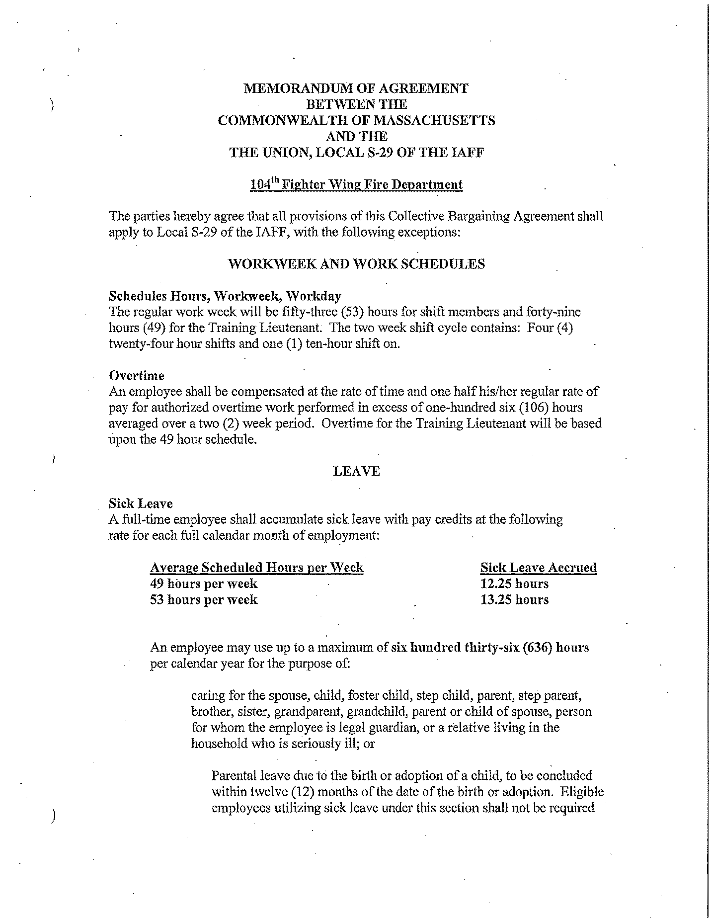

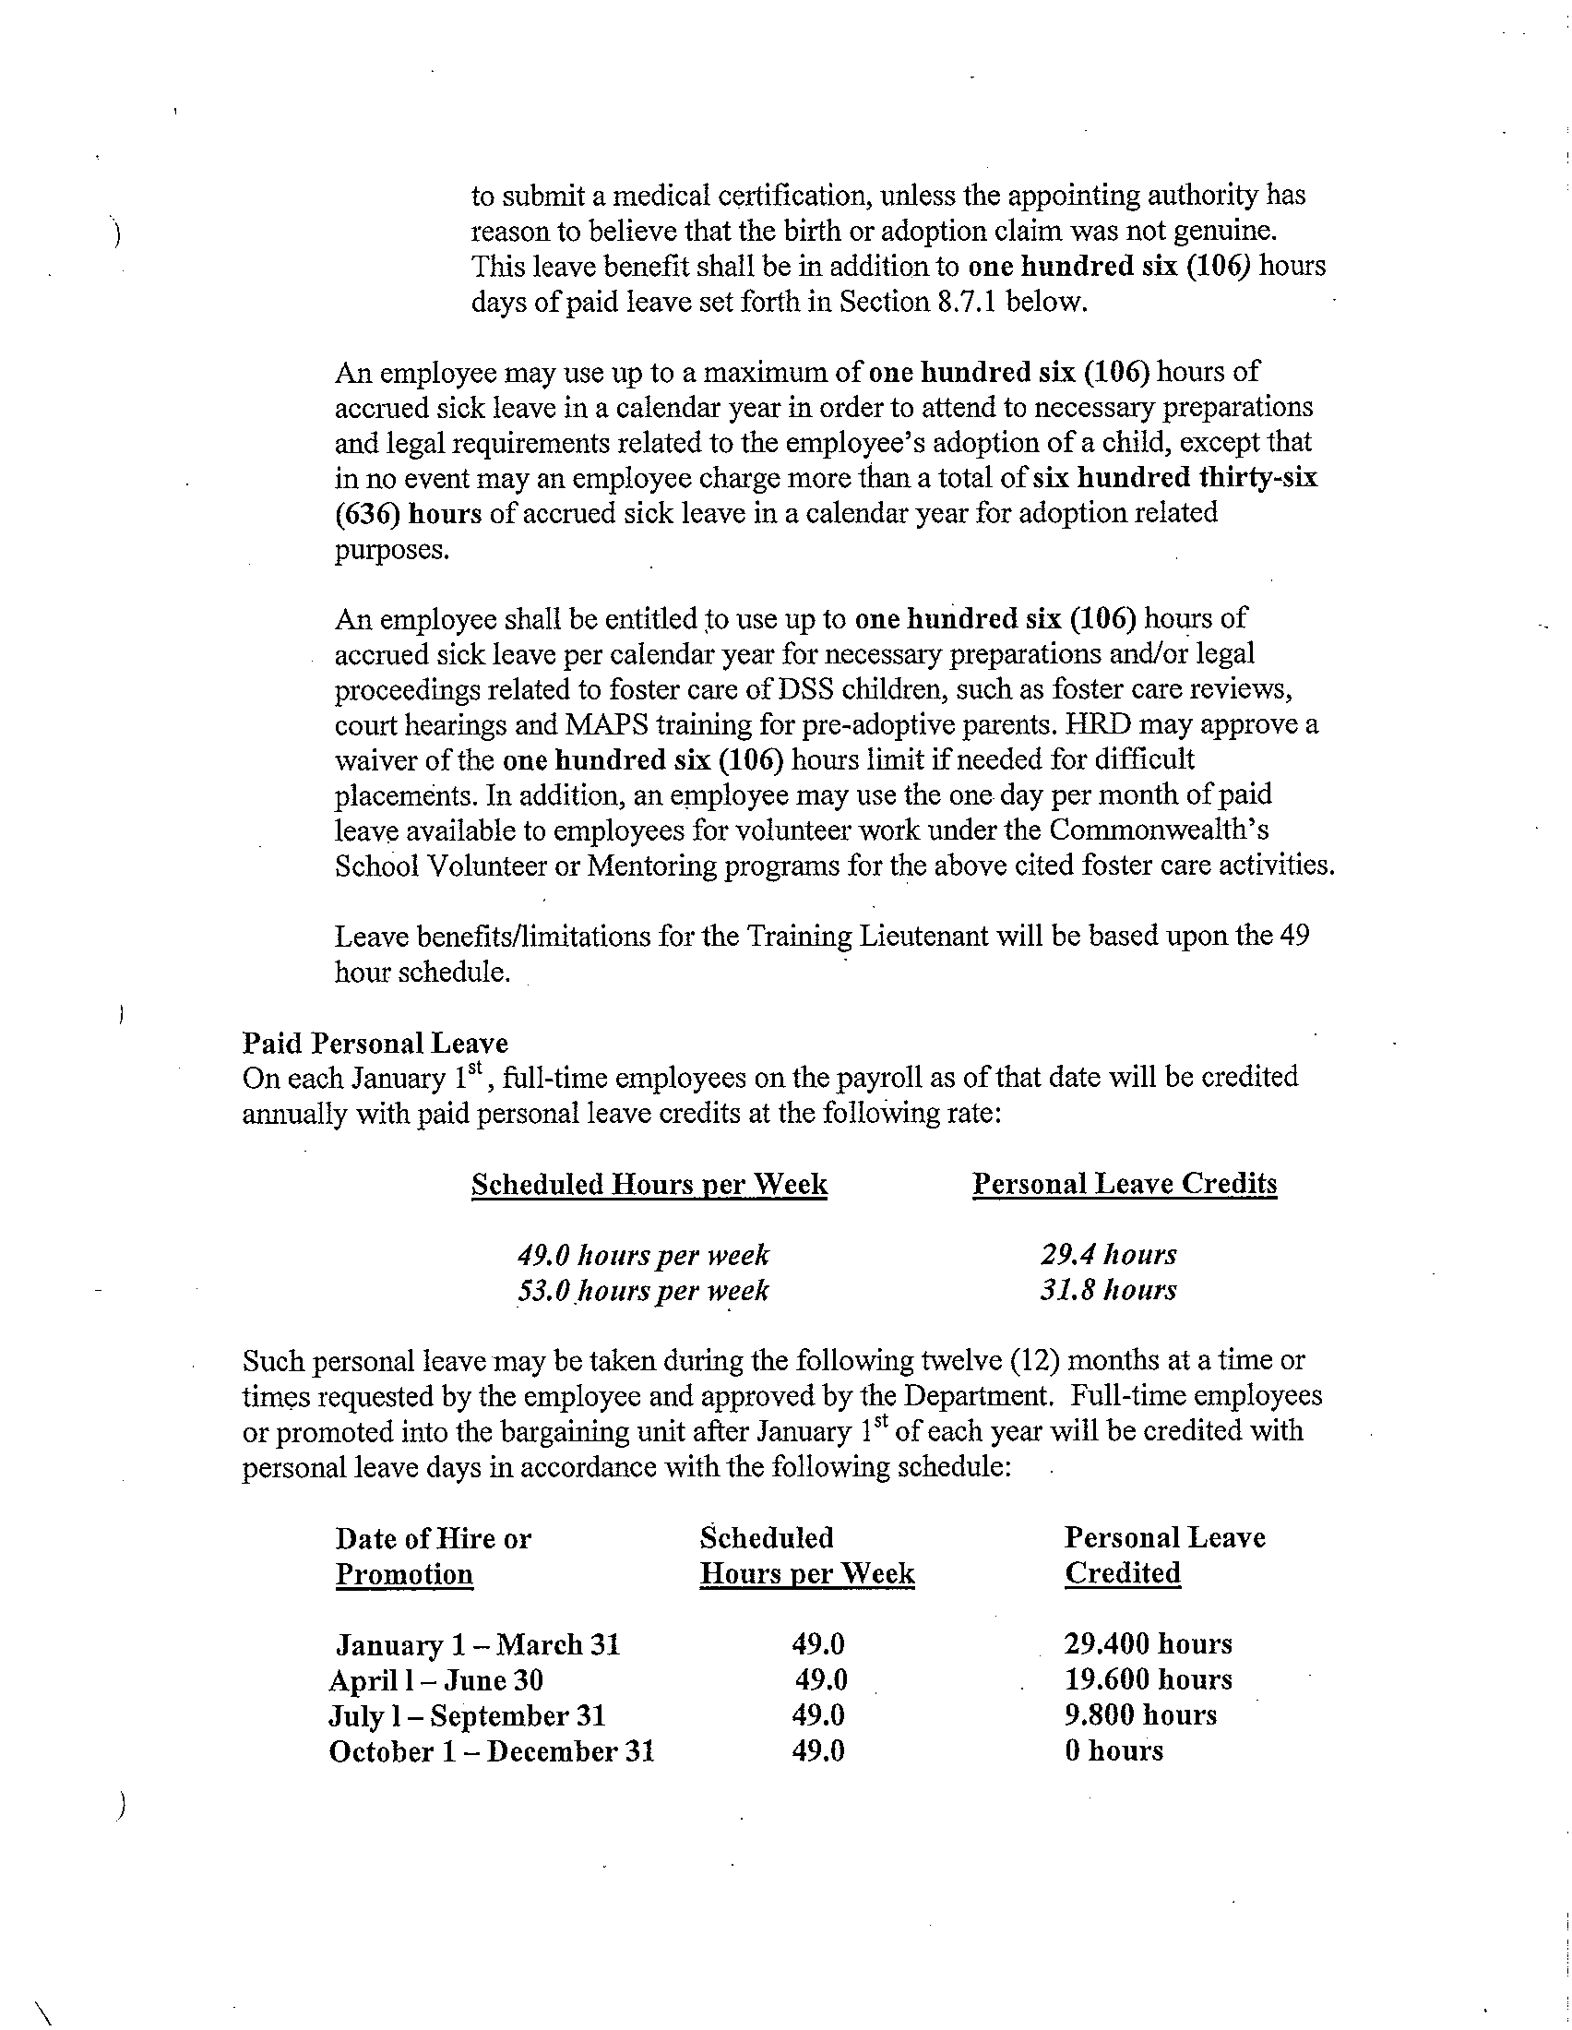

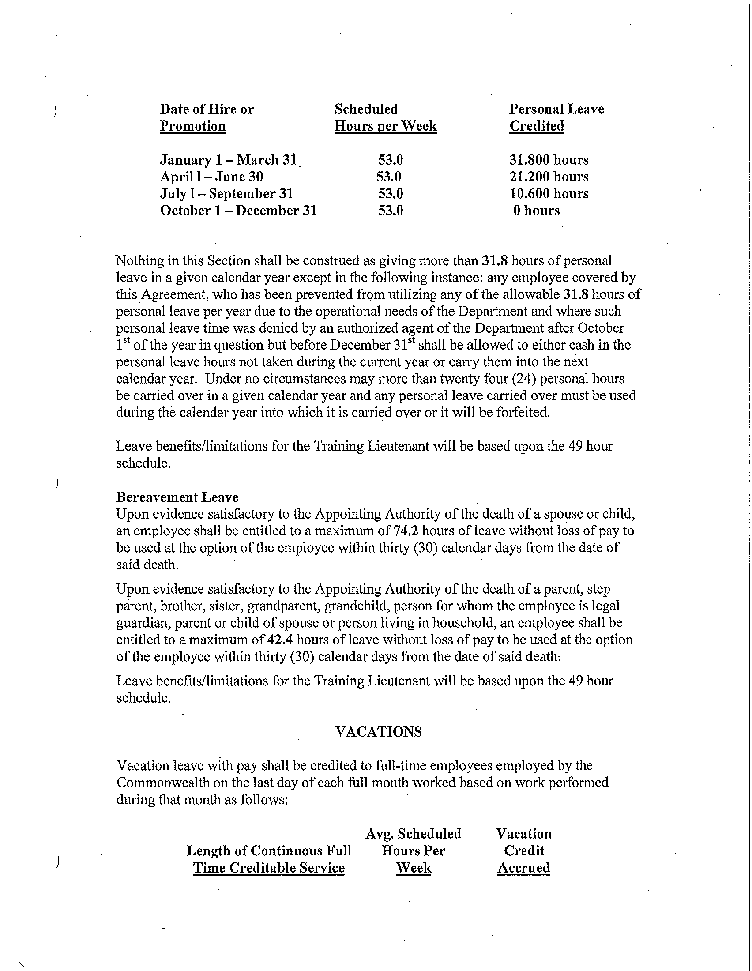

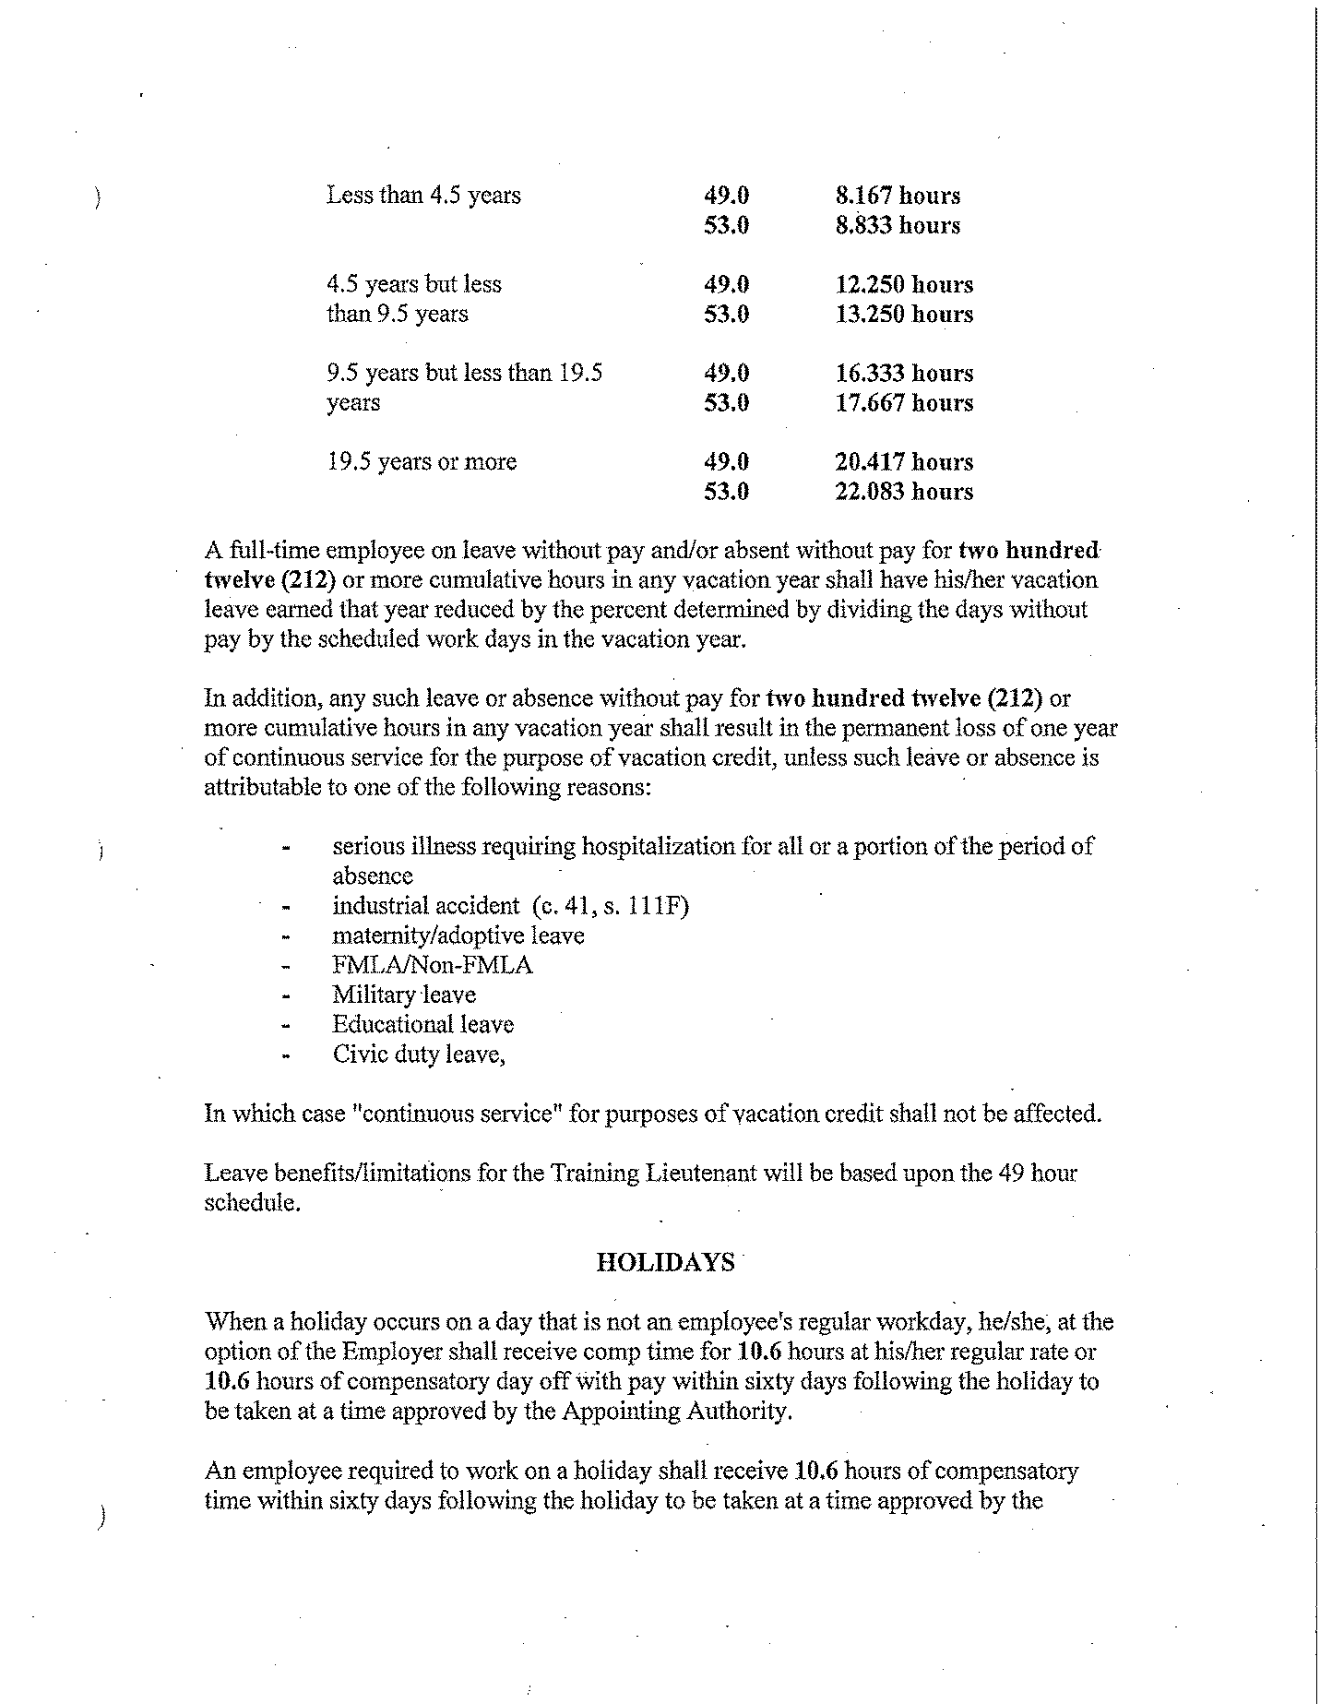

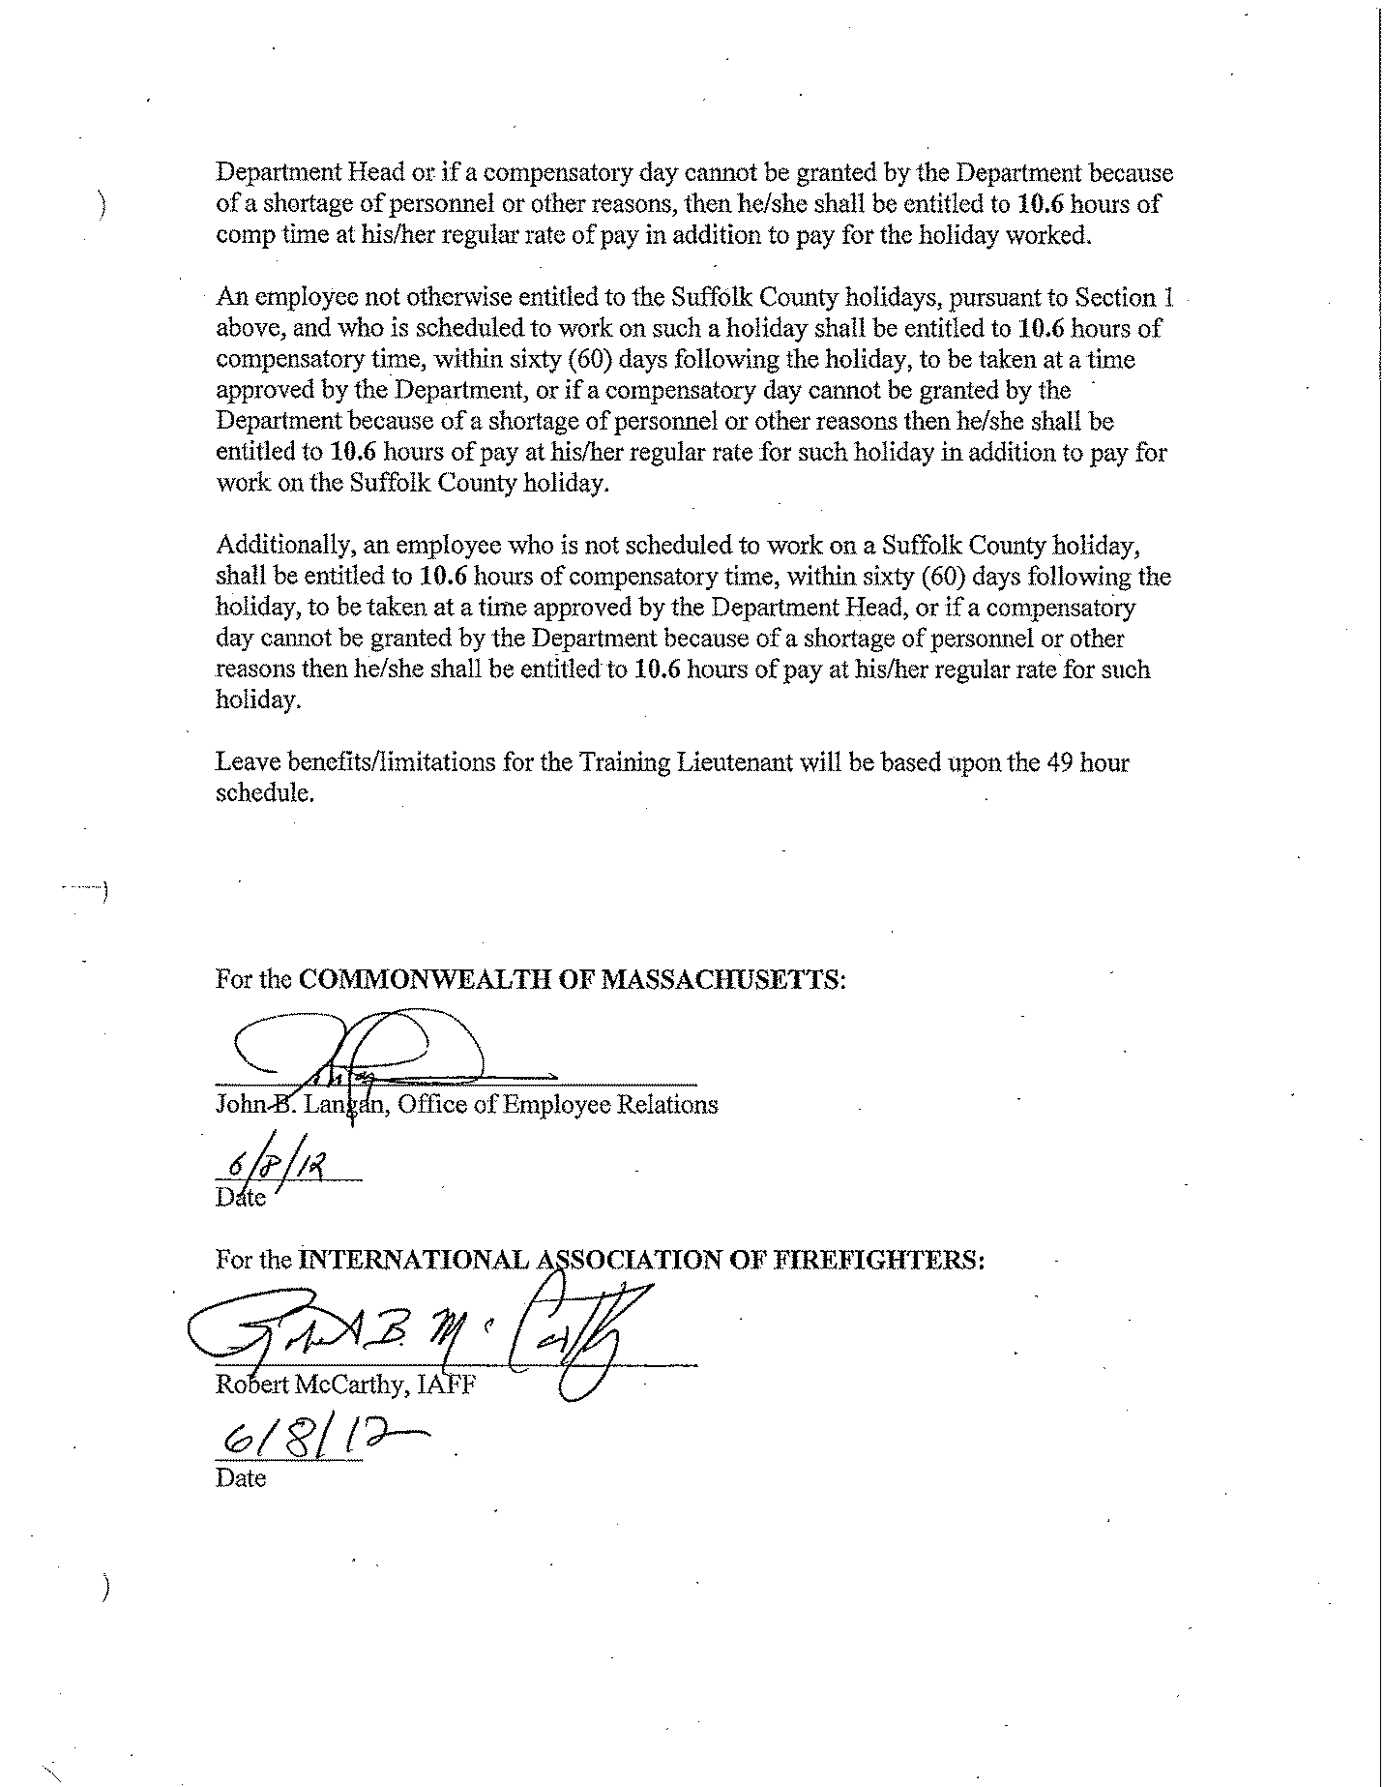
APPENDIX D
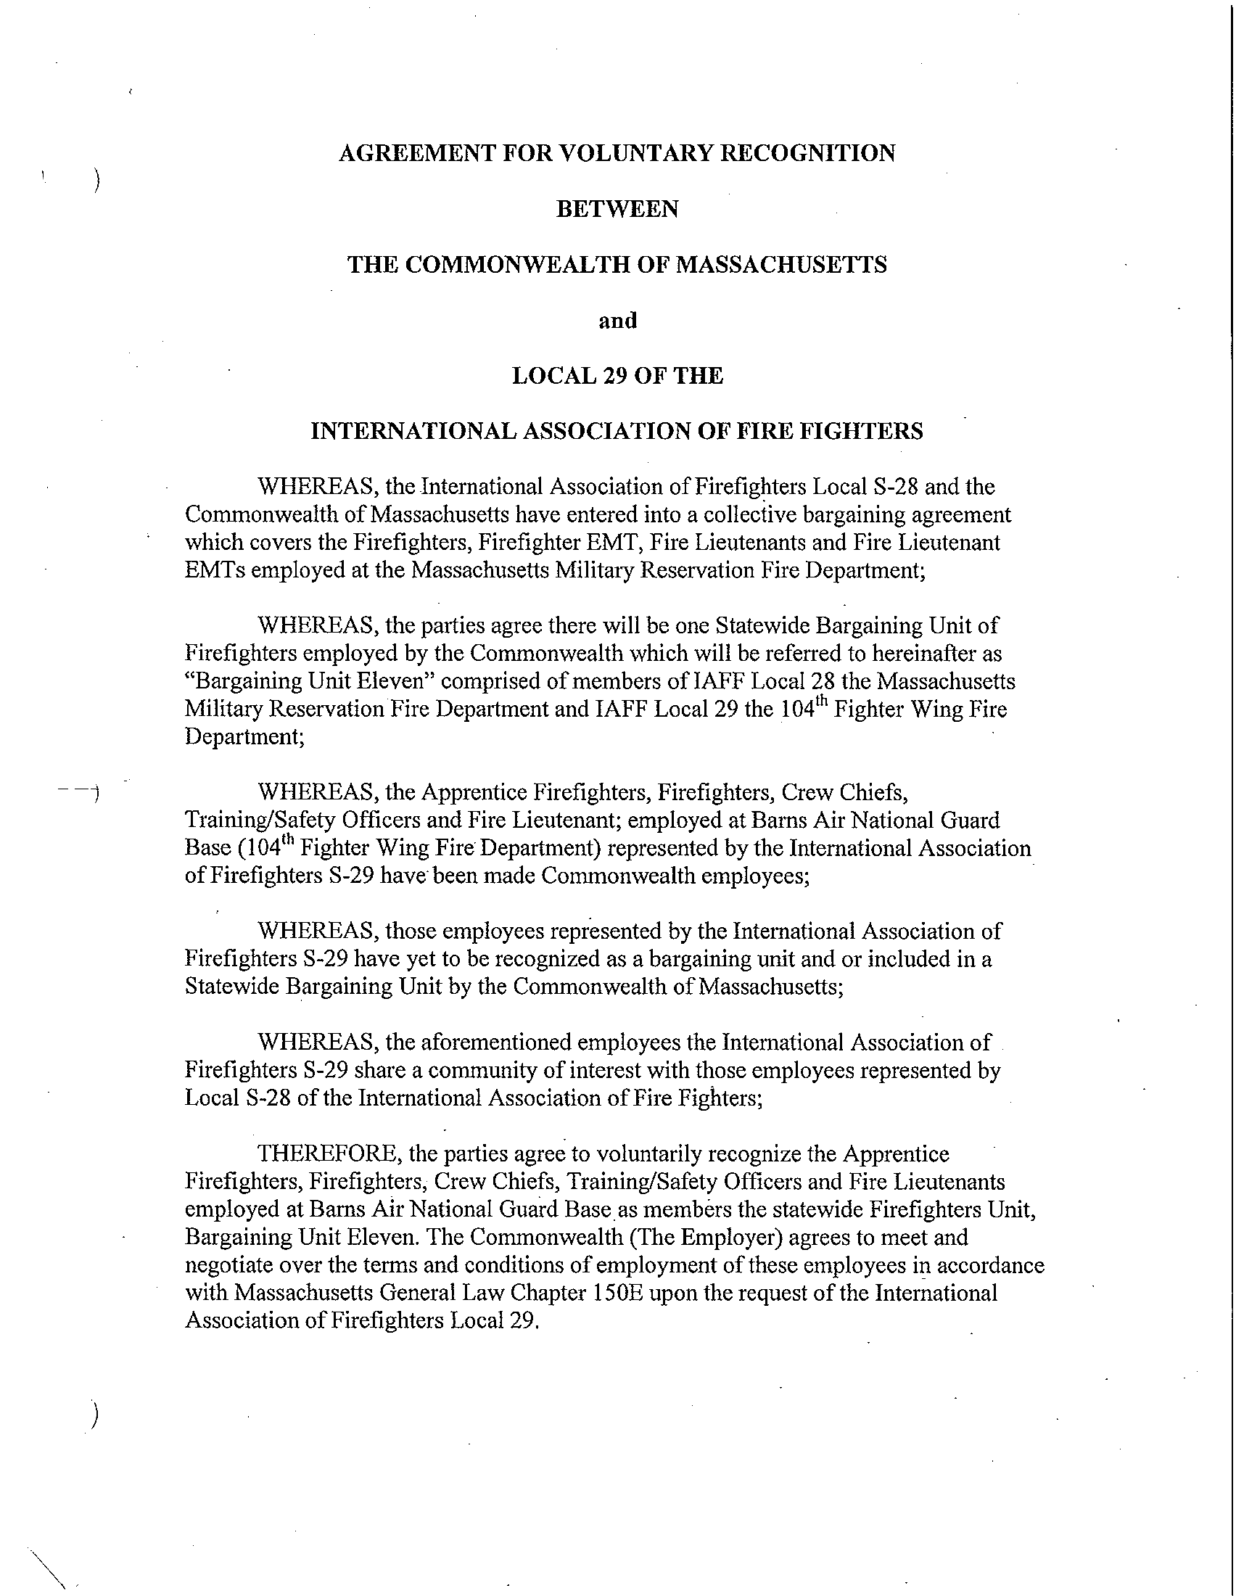

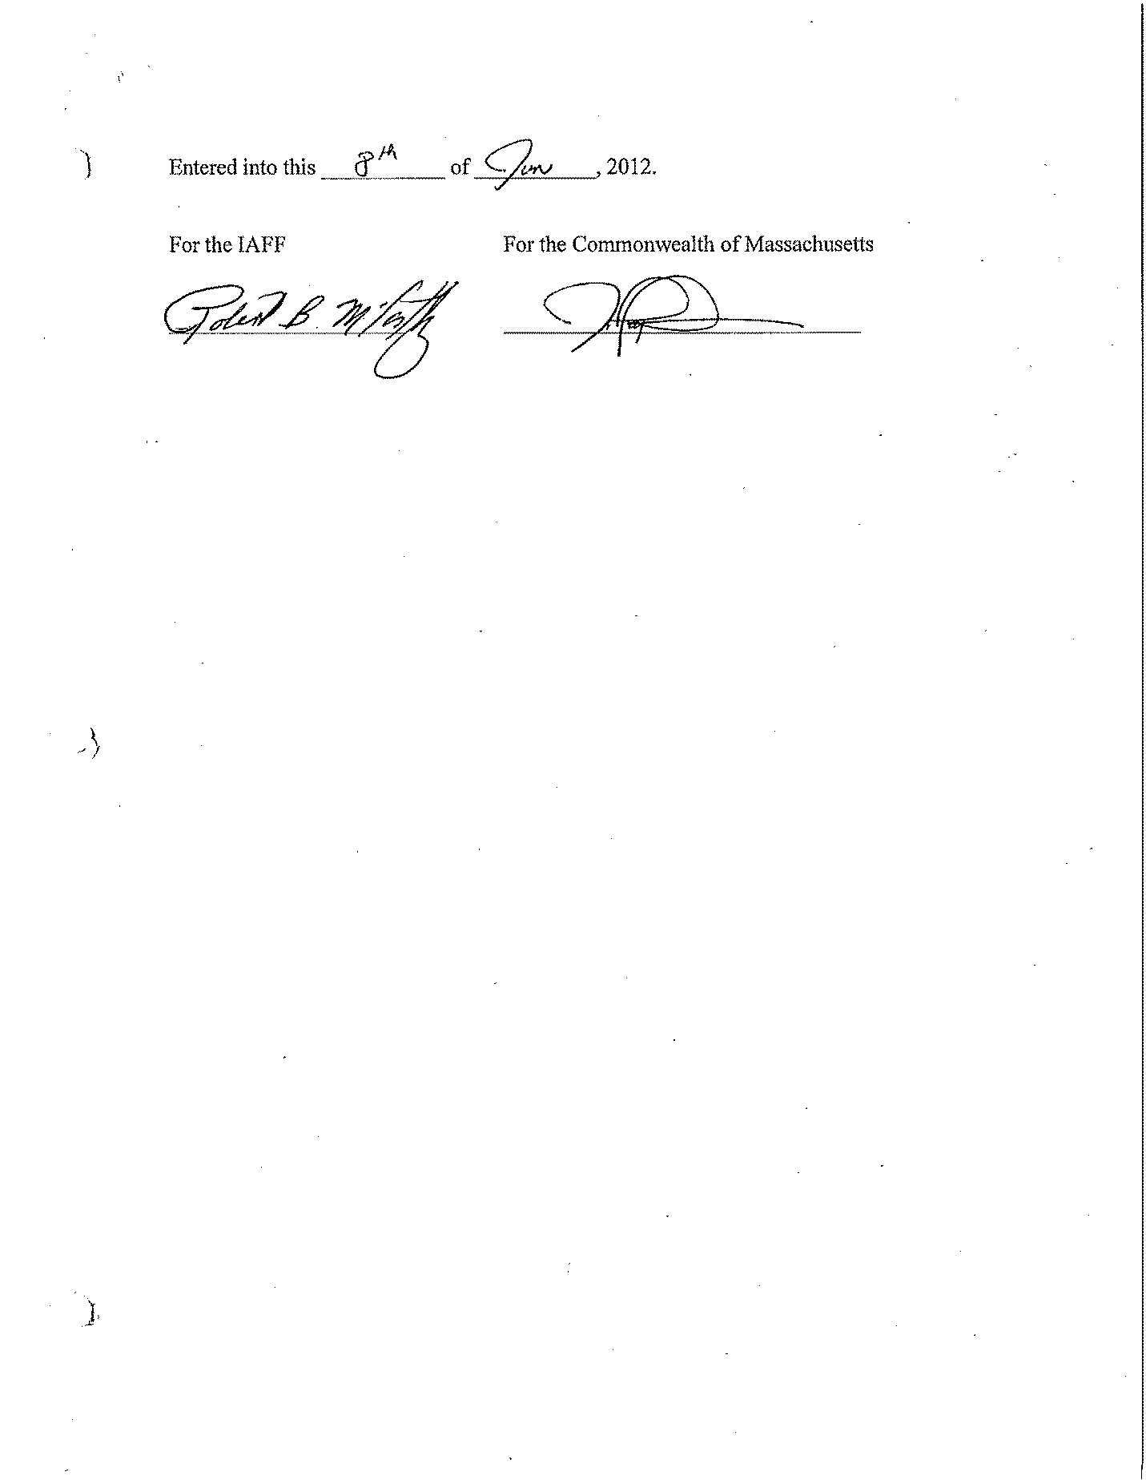

MEMORANDUM OF UNDERSTANDING
BETWEEN THE
COMMONWEALTH OF MASSACHUSETTS
AND
THE UNION, LOCAL S-28 OF THE IAFF

The Parties agree that the employees covered by this Collective Bargaining Agreement will be permitted to participate in the Employer's Adoption Assistance Program.

MEMORANDUM OF AGREEMENT
BETWEEN THE
COMMONWEALTH OF MASSACHUSETTS
AND THE
THE UNION, LOCAL S-28 OF THE IAFF

Uniforms and Appearance

This Memorandum of Understanding is entered into by the Commonwealth of Massachusetts (“Commonwealth”) and the Professional Firefighters of Massachusetts, Local S28. The purpose of the Memorandum of Understanding is to clarify certain understandings reached during collective bargaining negotiations regarding uniforms and appearance. The parties understand and agree to the following:

1. Employees shall maintain a neat, well-groomed appearance.

- Employees shall not wear jewelry, pins, necklaces, or bracelets of any kind with the uniform. Exceptions, if conservative, include the following: ring(s); a wristwatch; a union pin; a Medic Alert bracelet; and necklace(s) or religious medallions worn discreetly beneath the shirt. No facial jewelry of any type shall be worn.

- Cosmetics, if worn, shall be conservative, subdued and blended to match the natural skin color.

- Hair shall be clean, neat, and well groomed. Hair shall not interfere with the wearing of any standard headgear. Wigs or hairpieces may be worn if they conform to the above standards.

The provisions of this Memorandum of Understanding shall be coterminous with the duration of this collective bargaining agreement as provided in Article 28.

MEMORANDUM OF AGREEMENT
BETWEEN THE
COMMONWEALTH OF MASSACHUSETTS
AND THE
THE UNION, LOCAL S-28 OF THE IAFF

Uniform Allowance – S-28

Effective July 1, 2011, each employee shall be issued a $500 clothing credit once per fiscal year to be used for the purchase of uniforms. Effective in July of 2011, each employee shall also be issued, on the first pay-period in July, an annual cash payment of $100 to be used for the sole purpose of cleaning and maintaining their work attire, or for the purchase of additional uniform materials.

New employees will be issued the $500 credit and a prorated amount of the $100 annual cash payment upon hire. On the first pay-period of July following their hire, such employees will be issued a clothing credit that is reduced by a prorated amount depending on their date of hire. For example, an employee who was hired on January 1st will be issued a $500 credit and a $50 cash payment. During the following July, the employee will receive a $250 credit and a $100 cash payment.

MEMORANDUM OF AGREEMENT
BETWEEN THE
COMMONWEALTH OF MASSACHUSETTS
AND THE
THE UNION, LOCAL S-29 OF THE IAFF

Uniform Allowance – S-29

Effective the first full pay period in July of 2016, each employee shall be issued a $500 clothing credit once per fiscal year to be used for the purchase of uniforms. Effective in July of 2016, each employee shall also be issued, on the first pay-period in July, an annual cash payment of $400 to be used for the sole purpose of cleaning and maintaining their work attire, or for the purchase of additional uniform materials.

Effective the first full pay period in July of 2017, each employee shall be issued a $700 clothing credit once per fiscal year to be used for the purchase of uniforms. Effective in July of 2017, each employee shall also be issued, on the first pay-period in July, an annual cash payment of $400 to be used for the sole purpose of cleaning and maintaining their work attire, or for the purchase of additional uniform materials.

New employees will be issued the clothing credit and a prorated amount of the annual cash payment upon hire. On the first full pay-period of July following their hire, such employees will be issued a clothing credit that is reduced by a prorated amount depending on their date of hire. For example, an employee who was hired on January 1st will be issued the full clothing credit and half the cash payment. During the following July, the employee will receive half the clothing credit and the full cash payment.

