## LEGUMES FISH

#### Massachusetts WIC is changing how some WIC food items are issued to

Old Unit: Pkg/Can New Unit: Pound (LB) Old Unit: Can New Unit: Ounces (OZ)

#### participants. Based on new food package rules, these changes will provide greater choice, variety, and flexibility when shopping. For some types of WIC foods, families will be able to make choices at the store and not ahead of time with WIC staff. See below for details!

For more shopping tips and to view all

SHOPPING TIP

If your benefits show **1 LB Peanut Butter/Dry or Canned Beans**, you can buy:

### OR OR

SHOPPING TIP

If your benefits show **30 OZ Fish**, you can buy:

### OR

#### authorized brands, please refer to the WIC Approved Food Guide or the WIC

ONE (1)

jar

ONE (1)

bag

FOUR (4)

cans**\***

SIX (6)

5 OZ

FOUR (4)

3.75 OZ

THREE (3)

5 OZ

**+**

#### Shopper App.

**OR** any size combination to add up to your benefit amount

**\***For each can of beans purchased, 0.25 LB will be deducted from your benefit balance.

**OR** any size combination to add up to your benefit amount for tuna, salmon and sardines

## CHEESE WHOLE GRAINS/BREAD JUICE

Old Unit: Pkg New Unit: Ounces (OZ)

Old Unit: Pkg New Unit: Ounces (OZ)

Old Unit: Can/Bottle New Unit: Container (CNT)

SHOPPING TIP

If your benefits show **16 OZ Cheese**, you can buy:

SHOPPING TIP

If your benefits show **32 OZ Whole Wheat Bread/ Whole Grains**, you can buy:

SHOPPING TIP

If your benefits show **1 CNT 100% Fruit Juice,** you can buy:

### OR OR OR OR

TWO (2)

8 OZ

ONE (1)

12 OZ

ONE (1)

16 OZ

ONE (1)

16 OZ

**+**

ONE (1)

16 OZ

ONE (1)

20 OZ

ONE (1)

12 OZ

**+**

ONE (1)

Frozen can 12 OZ

ONE (1)

Bottle 64 OZ

**OR** any size combination to add up to your benefit amount

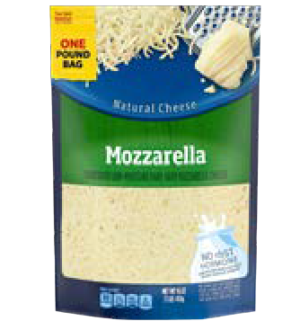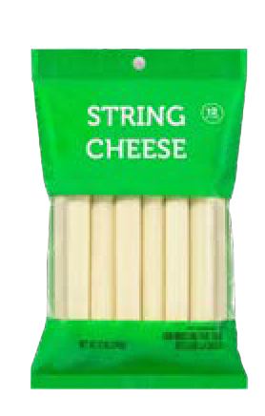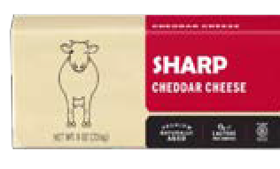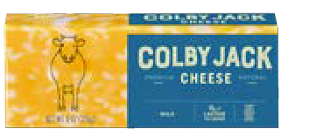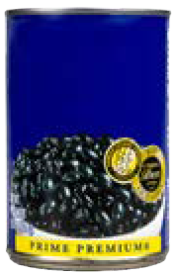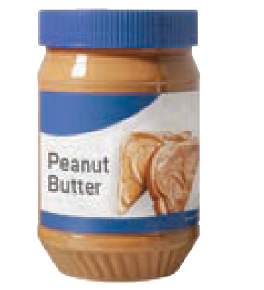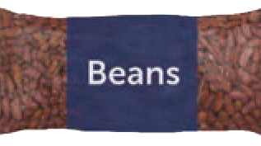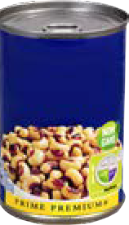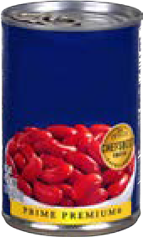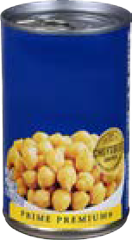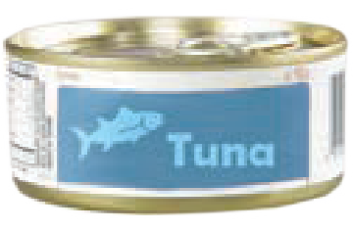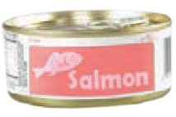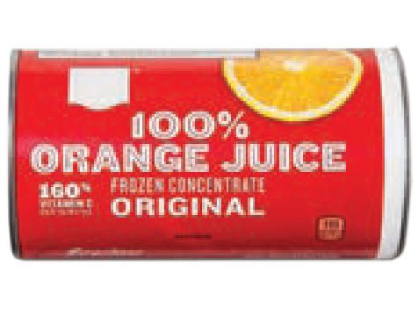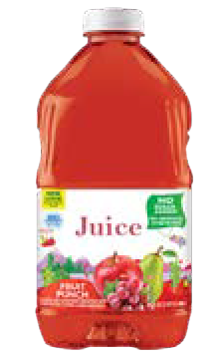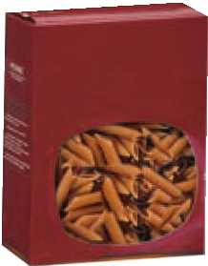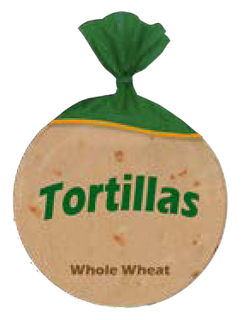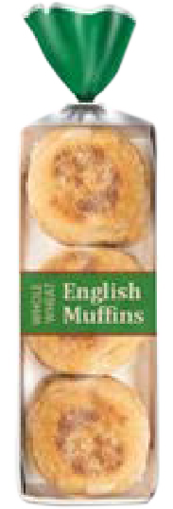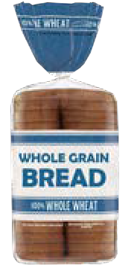

**Black Black Red**

**Kidney Chickpeas**

**Beans Eyed**

**Peas**

**Beans**

**OR** any size combination to add up to your benefit amount

**OR** any size combination to add up to your benefit amount

## YOGURT

Lowfat yogurt may be purchased for children under the age of 2 as of the effective date of these changes.

SHOPPING TIP

If your benefits show **32 OZ Whole/Lowfat Yogurt**, you can buy:

**INFANT FRUITS & VEGETABLES**

Old Unit: Jar New Unit: Ounces (OZ)

SHOPPING TIP

If your benefits show **128 OZ Infant Fruits + Veg,**

you can buy:

[**www.mass.gov/wic**](http://www.mass.gov/wic)

# NEW CHANGES

**OR OR OR**

# TO WIC BENEFITS

ONE (1)

whole milk 32 OZ

ONE (1)

low-fat 32 OZ

THIRTY-TWO (32)

4 OZ

THIRTY-TWO (32)

2 OZ two-packs

SIXTEEN (16)

4 OZ two-packs

**OR** any size combination to add up to your benefit amount

## SOY/PLANT-BASED MILK

Old Unit: Half-Gal/Quart New Unit: Container (CNT)

**OR** any size combination to add up to your benefit amount

## INFANT MEATS

Old Unit: Jar New Unit: Ounces (OZ)

SHOPPING TIP

If your benefits show **2 CNT Soy/Plant-Based Milk**, you can buy:

### OR

SHOPPING TIP

If your benefits show **40 OZ Infant Meats,** you can buy:

#### If you have any questions or need additional information, please contact your local WIC program for assistance, or call 1-800-WIC-1007.

TWO (2)

Half-Gallons 64 OZ

FOUR (4)

Quarts 32 OZ

SIXTEEN (16)

2.5 OZ

**@MassWIC**

**OR** any size combination to add up to your benefit amount

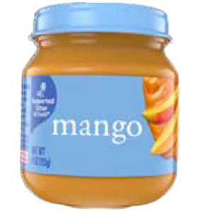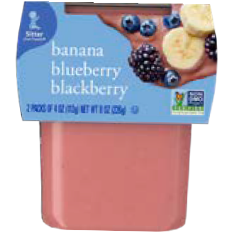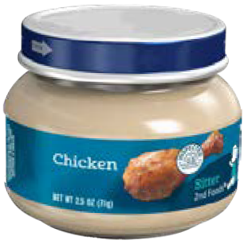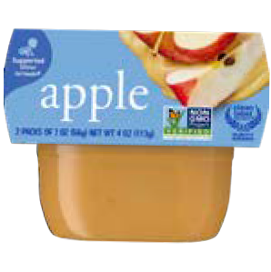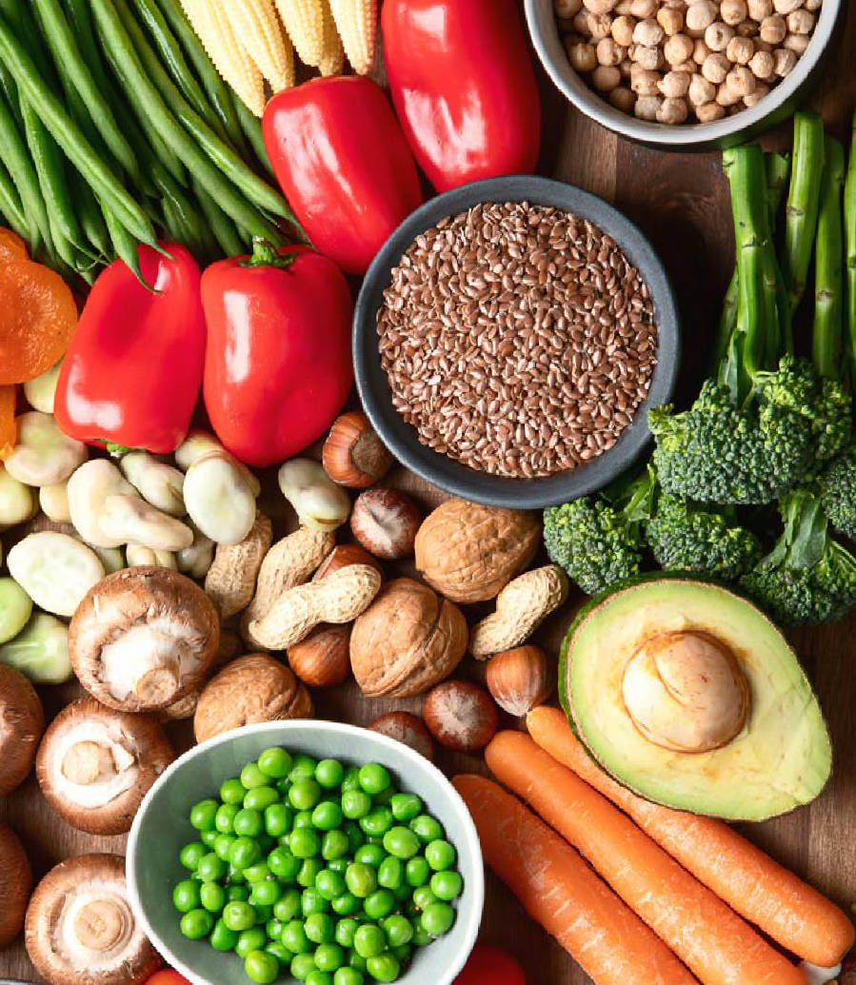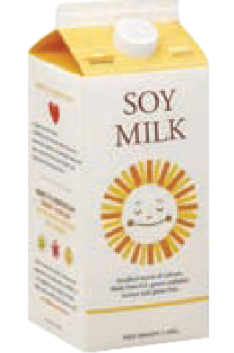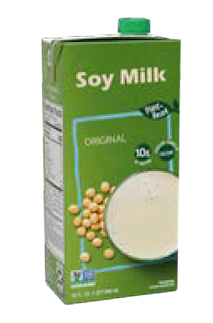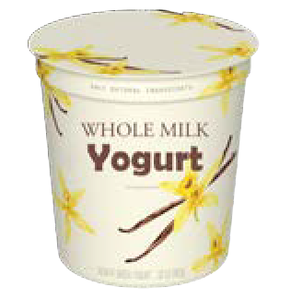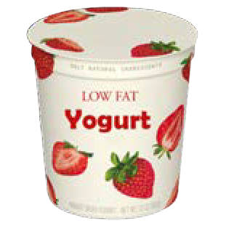

This institution is an equal opportunity provider.